INCREASING THE RATE OF PERTUSSIS IMMUNITY USING THE TDAP IMMUNIZATION IN PRIMARY CARE PATIENTS 19 TO 64 YEARS OF AGE

A Capstone Scholarly Project submitted
by

Dorothy J. Cook, MS, ARNP, FNP-BC

Submitted to the Graduate School of the
University of Massachusetts, Amherst
In partial fulfillment of the requirement for the degree of
DOCTOR IN NURSING PRACTICE

This Capstone Project has been accepted for the faculty of
The School of Nursing by:

Cynthia Jacelon, PhD, RN, CRRN, FAAN, Clinical Assistant Professor
Chair

Jeungok Esther Choi, MPH, PhD, RNC

Committee Member (School of Nursing)

Robert Kitos, MD, PhD

Outside Project Mentor

Abstract
There has been an increase in the preventable communicable disease known as Pertussis as the result of waning immunity in adolescents and adults. Waning immunity is the loss of protective antibodies over a period of time. Despite the availability of a new immunization in 2005, adult immunization rates do not meet Centers for Disease Control (CDC) Healthy People 2020 goal. Adult immunizations remain a challenge. Preventive healthcare is the keystone to providing routine vaccination coverage. It is usually the point of entry into the health care system.
The theoretical model used was the Precaution Adoption Model, which allowed the provider the opportunity to provide immediate information to the patient at the time of the visit. This provided the patient time to make an educated decision at the time of the office visit to receive or decline the Tdap immunization.
The purpose of this project was to implement a process to increase the rate of pertussis immunity with the use of tetanus toxoid, diphtheria toxoid and pertussis immunization (Tdap) to the patients in our practice.
All patients 19 years of age and over who had a scheduled office visits in our practice, with one of our three providers were provided the questionnaire to complete on immunization status. We offered the immunization to both genders 19 years of age and older. Those patients seen by a provider daily 19 to 64 years of age were identified as study participants.
With the use of questionnaire, it was found that 21% to 40% of patients seen during the 8 weeks of project had received their Tdap immunization prior to their office visit. Once the provider offered and if indicated explained the importance of the Tdap immunization an additional 33% to 49% patients were provided the immunization. Though provided the information and recommendation 25% to 35% of those patients seen during their office visit declined the immunization. The visits during the eight week of project increased the rate of Tdap immunizations from 61% to 77% which fell short of the CDC’s goal of 90%, but was found to have a significant increase with the questionnaire.
The questionnaire used was well received by providers, staff and patients and did not increase in time requirements for the patient intake process. There were two limitations to administer the Tdap immunization in our office. The first is insurance carriers. Medicaid does not allow us to administer any immunizations in the office, so those patients with that specific insurance were unable to receive, even they wanted it. Next is those patients who rely on Medicare for payment, Medicare will not cover the Tdap administration for prevention. The second limitation is those patients who have no insurance and are self-pay refused to take due to cost. At present there is no program in our company to assist patients with financial needs to receive a reduction in cost.
This Capstone experience concluded that the primary care office and the patient’s office visit is an effective site for implementing immunization administration of Tdap to increase the public health issue of declining immunity of pertussis and the indication for immunizations.

CONTENTS
Abstract……………………………………………………………………………………….…2
Table of Contents………………………………………………………………………………..4
Introduction……………………………………………………………………………………...7
Background/Significance…………………………………. ………………………………….…7
Problem Statement…………………………………………………………………..……….…..9
Aims of Project……………………………………………………………………………..…...11
Review of Literature…………………………………………………………………………..…12
Study Significance……………………………………………………………………….12
Causative Agent………………………………………………………………………….13
Economic burden………………………………………………………………………...15
Vaccination of Adults……………………………………………………………………16
Adult Immunization Practice……………………………………………………………………16
Table I; Standard Adult Immunization Practice………………………………………..17
Theoretical Model
The Precaution Adoption Process Model…………………………………….…………18
Method……………………………………………………………………………….……..…...19
Project Site……………………………………………………………………………....20
Patient Encounter……………………………………………………………………..…21
Figure I
Case diagram for Adult Immunizations in Primary Care Practice………………....22
Organizational Analysis of Project Site…………………………………………………..……23
Resources Project Site………………………………………………………………….……...25
CONTENTS
Protocol for Project and Intervention Tailoring……………………………………….……..25
Project Design and Feasibility…………………………………………………………….....26
Goals/Objectives/Outcomes/Measurable Goals………………………………………..….…27
Costs ……………………………………………………………………………………..…..27
IRB approval and ethical consideration……………………………………………………..28
Plan for Implementation/Evaluation…………………………………………………………29
Figure 2 Timeline:
Immunization of Adults 19-64 years of age with Tdap………….……………………30
Findings……………………………………………………………………………………..31
Table 2: Costs/Revenues…………………………………………………………….32
Population Demographics…………………………………...………………………33
Figure 3: Patient population…………………………………………………….…….34
Figure 4: Tdap status and administration…………………………………….……….34
Table 3: percentage of Tdap immunization…………………………………….……35
Graph 1: percentage of immunization status…………………...……………………36
Evaluation of Translation Project…………………………………………………………..36
Strengths and Weaknesses of Project………………………………………………………38
Special Recommendations for Project Site………………………………………….……..39
Special Recommendations for all seven sites in local company………………………..….39
Conclusion………………………………………………………………………………….40
References……………………………………………………………………………….…41
Appendix A: Letter from ANA………………………………………………………….…46
Appendix B: Patient Questionnaire…………………………………………………….…47
CONTENTS
Appendix C: VIS………………………………………………………………….………49
Appendix D: Regional Structure…………………………………………………………..51
Appendix E: Local Structure………………………………………………………………42
Appendix F: Medical Directors Letter of Support………………………………………..53
Appendix G: Power Point Presentation/staff……………………………………………..54
Appendix H: Immunization Consent Form……………………………………………….61
Appendix I: CDC’s Immunization Schedule…………………………………………......62
Acknowledgements………………………………………………………………………..63

Increasing the Rate of Pertussis Immunity Using the Tdap Immunization in Primary Care for Patients 19 to 64 Years of Age
Public health initiatives have had great success in the implementation of immunization programs leading to the eradication of communicable diseases with the use of vaccination such as smallpox, polio and diphtheria (CDC, 2009). Childhood mortality has been reduced by 99% for those patients over the age of twelve months, who have been immunized at scheduled intervals established by the CDC. Since 1976 the number of cases of pertussis has risen with the greatest increase seen in children and adults due to waning of immunity and increased awareness of the disease in these age groups. In the adult population there continues to be to an estimated 25,000 cases per year of pertussis as a result of waned immunity (Cortese, et al, 2007). Waning of immunity is the gradual loss of immunity over time. Waning of pertussis immunity in adults increases the risk to infants of Pertussis when exposed to adults with an active case of Pertussis. Infants too young to have received the first three doses of pertussis-containing vaccine are at the biggest risk for illness related to exposure to circulating pertussis (Plotkin et al., 2008). Evidence based information indicates that infants are at greatest risk for pertussis infection from family members and close contacts who are infected and have the potential of transmission of infection to the infant (Gerbie & Tan, 2009).
Background/Significance
Prior to widespread use of whole-cell pertussis vaccine, there were as many as 270,000 cases of pertussis reported each year in the United States, with ten thousand deaths (Cherry et al., 1988). The first recorded description of an outbreak of pertussis is that of Guillamume De Baillou during the summer of 1578 in Paris, France. The causative bacteria was not identified until 1906 (Atkinson et al., 2011) with the first pertussis vaccine made available in the early 1940’s (CDC, 2009). Bordetella pertussis is solely as a human pathogen. It is the primary cause of clinical whooping cough and readily transmitted by aerosolized droplets (Yeh & Mink, 2012).
With the introduction of whole cell pertussis vaccine administered to children in the mid twentieth century there was a decrease in the occurrence of pertussis. The lowest annual infection rate was in 1976 when just 1000 cases were reported (ACIP, 1997). With a decrease in American adults not getting vaccines updated they need to prevent developing and spreading preventable diseases, 25,827 cases of pertussis climbed in 2004, the highest since 1959 (Kessinger, et al, 2006).
Pertussis is associated with significant morbidity and mortality, specifically among the very young and very old. Ninety percent of pertussis related deaths affect infants under the age of six months (Mikelova et al, 2003). The new recommendation from the CDC is to immunize adults 19 to 64 years of age who come in close contact with infants under twelve months with pertussis in the form of Tdap immunization. Household members are responsible for up to 83% of the pertussis bacteria exposure to infants under twelve months (Wendelboe et al., 2007).
In 2005, the CDC recommended that individuals between 19 to 64 years of age be immunized once with Tdap. Despite the recommendation the CDC’s October 15, 2010 Morbidity and Mortality Weekly Report revealed that, in 2008 only 5.9% of individuals 19 to 64 years of age had received the Tdap immunization. In addition only 5% of adults with infants had been vaccinated with the Tdap immunization (CDC, 2010). The American Nurses Association (ANA) (Appendix A) proposed a letter to receive support from other health organizations to increase the rate of Tdap immunizations nationwide with many of the leading medical organizations signing the letter to commit to immunizing.
The literature search for this project failed to uncover any report of the percentage of health care providers who routinely offer the Tdap vaccine during office visits. However, despite the availability of Tdap since 2005 in the United States, the vaccine remains underutilized (Kirchner, 2011). The reasons for underutilization of the vaccine in primary care include the cost of purchasing, storing, administration and documentation required of immunizations (Davis et al., 2003). In a survey of obstetricians, who are a direct link to adults in contact or soon to be in contact with infants, 81% of the 183 obstetricians, reported that primary care providers failed to administer the Tdap immunization when patient was seen in their office (Clark et al., 2006).
Problem Statement
Pertussis is a highly contagious respiratory infection. Public health data indicates a significant increase in cases during the last two decades. The current standard of care for immunization administration for adults who are 19 to 64 years old should receive a 1-time dose of Tdap in place of Tetanus-diphtheria (Td) booster that is recommended to receive every 10 years (Appendix A). There is no need to wait till the next Td is scheduled it is recommended that the Tdap be given at next office visit with a health care provider. Pregnant women who have not been preciously vaccinated with Tdap should get one dose of during the late second to third trimester or immediately postpartum. By getting Tdap during pregnancy, maternal pertussis antibodies transfer to the newborn, thus proving protection against pertussis in early infancy (CDC, 2012). Without the implementation of the adult immunization of Tdap, pertussis is expected to double in the next twenty years (Wendelboe, et al, 2005).
There are an estimated 25,000 reported cases of Pertussis annually in the United States caused by exposure to the contagion to individuals without sufficient immunity (Cortese et al., 2007). A significant increase in cases has been observed since the early 2000’s. Adolescents and adults are a primary source of infection to infants under the age of twelve months who have not completed the immunization series (Zastrow, 2011). Infants and the elderly are at highest risk for pertussis complications and death (Biscard et al., 2004).
The Advisory Committee on Immunization Practices (ACIP) recommends the routine use of a single dose of Tdap for 19 to 64 year olds to prevent transmission of pertussis to others (Kretsinger et al., 2006). The CDC added in 2010 that those individuals 65 years of age and older should also receive the Tdap immunization. Medicare does not pay for the Tdap immunization and will only pay for tetanus diphtheria if there is evidence of a puncture wound, even though the CDC recommends this population to be immunized. Health care workers are called to implement immunization recommendations from ACIP to protect themselves, their patients, and the community from pertussis. This project was designed to increase the rate of immunization of pertussis with the use of the Tdap immunization in primary care practices. There is a lack of documented information to identify the percentage of health care providers who educate and provide Tdap immunizations with their patients during an office visit. Recent discussion with Nathan Grossman, MD Medical Director of the Marion County Health Department indicated that there is no statistical documentation related to the percentage of Tdap immunizations given in primary care offices in Marion County.
The National Immunization Survey (NIS, the Behavioral Risk Factor Surveillance Survey (BRFSS), and the National Health Interview Survey (NHIS) have added Tdap coverage to their surveillance assessments of immunization status. Since the Tdap vaccine for adults 19 to 64 years of age has only recently been licensed in 2005, many facilities are currently just beginning to gather immunization information.
Tracking and reminder system is difficult if the medical office does not have electronic medical records (EMR). At present time our office does not have EMR. It is anticipated that we will go companywide in June of 2013, but until then a paper questionnaire was utilized with documentation on yellow patient information divider in each chart.
The waning of pertussis immunity in adults has increased over the past two decades and is expected to continue to increase. The waning of pertussis immunity increases the risk of disease in non-immunized individuals especially infants under 12 months of age.
Aims of Project
There continues to be an increase in cases of pertussis caused by a combination of exposure to the bacteria and a waning of immunity in adolescents and adults. Primary care providers have the greatest opportunity to immunize these individuals during visit. However, healthcare providers have limited time to assess the patient, address new findings and then address the concerns of the patient may not remember at that time to discuss updating the immunization of pertussis. The evidence available has shown that there is a decrease in cases of pertussis when immunizations are introduced.
The aim of this research translation project was to standardize use of the Centers for Disease Control recommendation to immunize individuals between 19 and 64 years of age with the Tdap immunization without increasing time demands on the healthcare provider. Application of the guidelines have increased the rate of immunization of the target population, but have not yet succeeded in attaining the goal of 90% of the population immunized against pertussis with the Tdap immunization.
The increase in pertussis rate during the past two decades is the result of waning immunity in adults 19 to 64 years of age with expected rate of pertussis to increase in the next two decades. The increase in pertussis as the result of waning immunity causes a greater risk to those infants under the age of 12 months.
Review of Literature
Study Significance
Pertussis is a disease differentiated from other respiratory illnesses by the classic symptoms of severe coughing, which has a whooping characteristic, and post-intrusive vomiting, which can last for weeks (Atkinson, et al., 2011). One of the most beneficial and cost effective prevention measures is the use of immunizations. Pertussis once thought of as a childhood immunization is also used in combination with tetanus and diphtheria as a vaccination to provide immunization to those over the age of 19 years (Maciosek et al., 2006).
Pertussis, commonly known as whooping cough is an acute, communicable respiratory illness caused by the Bordetella bacterium. It continues to be endemic in spite of childhood immunizations (Kretsinger et al., 2006). Without immunizing adults over 19 years of age, it is expected that Pertussis cases will double in the next twenty years (Wendelboe et al., 2005). Pertussis immunizations were first provided in the 1940’s after the bacterium was identified in the early 20th century (Atkinson et al., 2011). With the introduction and regular administration of the vaccination there was a decline in annual cases from 200,000 in the 1940’s to a low of 1,010 cases in 1976 (Farizo et al., 1992). In 2004 the CDC reported 7,008 cases of pertussis in adolescents and adults (Center for Disease Control, 2006).
Childhood immunizations account for a reduction in mortality rates of 99% from the communicable diseases that they are used for, however, pertussis continues to see an average of 25,000 cases annually due to waning of immunity (McCullers, 2007). Pertussis that affects adolescents and adults accounts for approximately 90 percent (Mikelova et al., 2003) of the incidence and mortality among exposed infants less than four months of age who are without immunity to pertussis. With increased awareness of waning immunity after ten years, adolescents and adults are thought to be the reservoir of the bacteria and the source of transmission to infants who have not completed the child pertussis immunization series (Lee, et al., 2005).
In 2005, the CDC, along with the ACIP, recommended immunization to pertussis in the form of Tdap to those 19 to 64 years of age (Spratling & Carmon, 2010). In October 2010 the CDC, along with ACIP, added a single dose of Tdap for adults over 65 years of age to be immunized against pertussis (Centers for Disease Control, 2011). The United States Food and Drug Administration (FDA) have approved a booster vaccine to include adults 65 years of age and older (Lowes, 2011). There is no well-defined cyclic relationship among humans, although there may be the possibility of an increase in summer and fall (Atkinson, et al., 2011). The syndrome’s appearance can range from mild symptoms to the classic presentation (Vitek et al., 2003).
Causative Agent
The fastidious gram-negative coccobacillus Bordetella pertussis bacteria are transmitted from person to person from the respiratory tract in the form of aerosol droplets expelled during the act of coughing or sneezing. It is estimated those who are not immune are exposed by infected contacts up to 90% of the time, and the individual’s home is the usual exposure environment (Murphy et al., 2008). The incubation period once a person is exposed to the bacterium is seven to ten days but can range from six to twenty days (Duclos & Halperin, 2008).
There are three classic phases of pertussis, catarrhal, paroxysmal and convalescence (CDC, 2011& Murphy et al., 2008).
- Pertussis in the catarrhal phase (initial) last two to three weeks and is highly communicable. The insidious onset of symptoms is comparable to an illness of the respiratory tract which one would expect to observe watery nasal discharge, frequent cough, and sneezing and conjunctiva injection. The cough is observed to be short, hacking and isolated, and can occur night and day. Fever is not common in any phase of pertussis. If there is a fever an underlying infection should be suspected.
- The next stage is paroxysmal. It is during this time of the symptoms that pertussis is suspected and tested for. This phase lasts from two to six weeks and unlike the catarrhal phase has intermittent intense (paroxysms) that alternate with periods of normal respiratory rate (during which time they appear to be reasonably well). Paroxysms present as spasms and coughing with post-tussive vomiting and inspirational whoop, thus resulting in the common name of whooping cough. Infants and young children during this phase can become quite ill and even need hospitalization. It is during this phase that testing should be initiated.
- The third and final stage is convalescent. This phase may last from two to six weeks, with gradual recovery, but symptoms may be present for up to six months.
The most common complication and the cause of most pertussis-related deaths is secondary bacterial pneumonia. Infants under six months of age are at highest risk for acquiring these complications. Data from 2000 indicates that pneumonia occurred in 5.2 percentages of all reported pertussis cases, and among 11.8 percentages of cases in infants under than six months of age (Halperin et al., 1999). Most recent data from the years of 2004 to 2008 a total of 111 deaths were reported for the four year period. Infants three months of age and younger accounted for 92 (83%) of those deaths (Brooks & Clover, 2006).
Healthcare workers add another dimension to those in direct contact with those individuals who are not immunized or whose immunity has waned over the years since the last immunization. One hospital reported seventeen symptomatic cases of pertussis resulted from just a 24 hour exposure to an infant; pertussis was confirmed 16 days later. When the investigation was completed there were 307 exposed cases among patients, family members and friends of the initial health care worker. The direct and indirect costs borne by the hospital due to the nosocomial infection was $74,870 (Calugar et al., 2006).
Economic Burden
The full economic burden of pertussis is limited due to the lack of reliable data if effectiveness of immunization. The direct costs of pertussis, varies with age and the severity of disease. There are both direct and indirect costs that impacts society. An uncomplicated case of disease cost around $135 but a complicated case requiring hospitalization can increase to $6337. The indirect costs are considerable when assessing the variables. Parents may not be able to work when caring for a child who is sick which may require a long recuperation period which is estimated as much as 73% of the total cost of pertussis (Lee & Pichichero, 2000). Since pertussis may present comparably to other cough and respiratory diseases, it may take up to two to three visits to the healthcare provider until a definitive diagnosis is identified (DeSerres et al., 2000).
A literary search found limited studies assessing rates of pertussis administration with Tdap in out of hospital sites known as primary care and internal medicine offices. These health care offices are responsible for the health of a large portion of the community’s population. Programs have been established in hospitals and public health facilities to require the use of Tdap. In schools legislation requires immunizations to be up to date throughout the student’s time in public schools and eventually entry into secondary education.
Vaccination of Adults
Nationally, children have been provided immunizations since the first legislative efforts during the 1950’s with the polio vaccine (Engel, 2006). During the first administration of the polio vaccination every child was taken to designated immunization sites and received the vaccination which was in a sugar cube. The federal government provides funding under legislation known as Vaccines for Children (VFC) entitlement program but there is no such program for adults. As a result of the lack of financial assistance from federal mandated programs, health care provider’s not offering immunization services in private office and the cost of immunizations at the health department (Engel, 2006); there is limited access for those without insurance to receive the immunization. It is reported that the immunization rate of adults 19 years and older range from 3 percent to 32 percent (CDC, 2011). This is far below the CDC’s and Healthy People 2020 for 90 percent of those 19 years of age and older to be immunized with pertussis in the form of Tdap.
Adult Immunization Practice
The first published standards for the administration of adult immunizations was in 1990, with the most current revision being in 2003 as the result of dramatically changing health care system. There is a shift toward managed care with changes in provider incentives and reimbursement for preventive health services. The revised standards are a collaborative effort for more than 100 people and 60 organizations (Poland et al., 2003).
Table I: Revised standards for adult immunization practices
Standard | Approach
Make vaccinations available | - Adult vaccination services are readily available.  - Barriers to receiving vaccines are identified and minimized.  - Patient “out-of-pocket” vaccination costs are minimized.
Assess patients’ vaccination status | - Health care professionals routinely review the vaccination status of patients.  - Health care professionals assess for valid contraindications.
Communicate effectively with patients | - Patients are educated about risks and benefits of vaccination in easy-to-understand language.
Administer and document vaccinations properly | - Written vaccination protocols are available at all locations were vaccines are administered.  - Persons who administer vaccines are properly trained.  - Healthcare professionals recommend simultaneous administration of indicated vaccine doses.  - Vaccination records for patients are accurate and easily accessible.  - All personal that have contact with patients are appropriately vaccinated.
Implement strategies to improve vaccination rates. | - Systems are developed and used to remind patients and healthcare professionals when vaccinations are due and to recall patients who are overdue.  - Standing orders for vaccinations are employed.  - Regular assessments of vaccination coverage levels are conducted in a provider’s practice.
Partner with the community | - Patient-oriented and community-based approaches are used to reach target populations.
http://www.azdhs.gov/phs/immun/pdf/immunications/winter07/InsertA_Winter2007.pdf
Theoretical Model
The Precaution Adoption Process Model (PAPM) offers seven distinct actions to move from being unaware of an issue to maintenance of a behavior (Weinstein & Sandman, 1992). Each distinct action provides a specific approach to meet the final objective of increasing the awareness of pertussis, thus increasing the rate of herd immunity and decreasing the incidence of pertussis and mortality rates of infants less than six months of age.
During the patient visit the health care provider provided education material and answered patient questions related to pertussis. It was expected by the end of the office encounter that the patient understands the importance of receiving the immunizations and agrees to act upon the information and knowledge.
- Stage I-Unaware of issue: Patient was exposed to information regarding the immunization Tdap on closed circuit television in lobby of primary care office. The patient was taken to the examination room and was provided written and verbal information regarding pertussis.
- Stage II-Unengaged by issue: Patient will be provided additional information regarding the transmission of pertussis and the increase effects on infants under twelve months old.
- Stage III-undecided about acting: It is upon the completion of stage I and II: the provider will ask if the patient has decided to receive the immunization today while at office.
- Stage IV-Decided not to act: Patient at this time with all information if they decide they do not want immunization at this time. There will be documentation on chart of refusal
- Stage V-Decided to Act: The patient will now be provided with the required Vaccination Immunization Statement, patient will be asked to sign all information.
- Stage VI- Acting: At this time immunization will be administered.
- Stage VII-Maintenance: The patient will be provided printed and verbal information regarding treatment of soreness or elevated temperature. The patient will be given an immunization card and phone number to call for treatment of possible side effects. Repeat Td in ten years.
The Precaution Adoption Process Model provides the health care provider to assess the patient he/she is seeing at an office visit regarding their knowledge of pertussis and the recommendations of the CDC. The steps provide a quick guide for entry into discussion. It is a quick assessment and can be obtained in less than 5 minutes which does not utilize a great deal of time at the office visit.
Method
In 2005, the ACIP recommended that adults 19 to 64 years of age be immunized against pertussis in a single dose of pertussis in the form of a Tdap (Kretsinger, et al., 2006). The target population for this project will be all adult patients age 19 to 64 years that are seen in Ocala II (OII) primary care office for a scheduled appointment with the provider at proposed site each day for two months.
Project Site
The proposed site is one of seven offices associated with Hospital Corporation of America (HCA) located in central Florida. The site for the purpose of this project will be done at OII. The community at large has a population of 331,298 from the 2010 census (Quickfacts, 2010). The county is comprised of 81.0 percent of white persons, 12.3 percent of black persons, 0.4 percent of American Indian and Alaska native persons, 1.3% Asian persons, and 10.9% persons of Hispanic or Latino (United States Census Bureau, 2010). The practice site that participated in the project has 70 percent white persons, 24 percent black persons, 5 percent Hispanics and 1 percent all others. The site takes most insurance coverage, except traditional Medicaid and couple of Medicare HMO’s. The office case mix is composed of 50 percent Medicare, 40 percent commercial and 10 percent self-pay. A convenience sample of all patients aged 19 to 64 years of age at one site of a seven site company in Ocala, Florida with commercial insurance was used for this program to evaluate the outcome results of increasing the rate of pertussis immunization administration.
In 2005, the CDC recommended that individuals between the age of 19 to 64 years of age to be vaccinated against pertussis, tetanus and diphtheria. Despite this recommendation, the CDC’s October 15 Morbidity and Mortality Weekly Report revealed that, in 2008 only 5.9% of individuals 19 to 64 years of age had received the Tdap immunization. In addition only 5% of adults with infants had been vaccinated with the Tdap immunization (CDC, 2010). The American Nurses Association (Appendix A) proposed a letter to receive support from other health organizations to increase the rate of Tdap immunizations nationwide with many of the leading medical organizations signing the letter to commit to immunizing.
The ideal situation would have been to have a computerized electronic medical record. But at this time the company involved in this capstone project does not have access to medical records. The purpose of this project was to program a clinical practice guideline for Tdap administration into a decision support system connected to the patient’s hard copy chart.
Patient Encounter
The patient received a questionnaire (Appendix B) at the time of check-in to check status of Tdap immunization, if patient was unable to read the questionnaire than a staff member assisted them with the questionnaire, but did not influence any of responses. The medical assistant calls patient by salutation and last name from the waiting room. The medical assistant escorts the patient back to the examination room and during the triage encounter; an assessment of immunization status was completed. If the patient did not have a Tdap immunization since 2005 they were provided a Vaccination Information Sheet (VIS) (Appendix C). The CDC requires that if a vaccine is to be given that the patient is provided information on the risks and benefits of the vaccination before administration. As a result the CDC has standardized in formation in the form of the VIS (Appendix C). These forms can be easily accessible at the CDC website (www.cdc.gov/vaccines/pubs/vis/vis-downloads.htm) or at the Immunization Actions Coalition website (www.immunize.org). The VIS forms are written at a 5th grade level and are in multi-languages.
The provider then provided additional information and explanation with time allotted to answer any questions. The healthcare provider then evaluated if there was any contraindications that would prevent the patient from receiving the Tdap immunization at this appointment. If patient is unable to receive due to contraindication, but would be eligible for it later. The questionnaire is to be placed in front of the patient’s chart until next office visit. If the patient has had a Tdap vaccination since 2005, documentation of this information was entered into patient profile form. The patient with evidence of not receiving the Tdap vaccination who spoke with their healthcare provider and agreed to receive the immunization, the healthcare provider provided an order to administer during the visit.
The immunization was administered, documentation was completed on the patient was given an immunization card. The medical assistant entered the data into Florida Shots, which is the required data base for all immunizations in Florida. The healthcare provider finalized the visit and discharged the patient home. Once the company implements EMR, a program will be included for immunizations, along with a printed out immunization record for the patient upon discharge.
The following algorithm allowed the staff to review the process of intake for immunizations. It will be used as part of the orientation process for all new employees. The staff was provided a copy of algorithm and it was placed in the clinic’s policy and procedure book. It will be reviewed on a yearly basis with the office manager, medical director and nurse practitioner for any changes in association with the CDC and ACIP.
Figure I: Case diagram for Adult Immunizations in Primary Care Practice
Patient signs in for appointment: given questionnaire

Patient medical record obtained, with confirming DOB

Review immunization record
MA compares record and questionnaire for current status of Tdap

Immunization Needed
NO
Continue With Treatment Plan
Yes
Check for Contraindications
Yes

No
Administer Vaccine and Document

Patient checks out at completion of appointment

Organizational Analysis of Project Site
The proposed site is one of the seven primary care sites within the national organization located in central Florida. There are two hospitals available to patients owned by the same national organization. There are seven primary care sites, two hospitals, and twenty-eight providers. The healthcare providers associated with the company consist of two doctors of osteopathic medicine, two internal medicine, one hospitalist, fifteen medical doctors, eight advance practice nurses (arnp), with two holding a doctorate of nursing practice. The corporation has a medical director, there are regional medical directors, and each office has a medical director. Each primary care office is encouraged to maintain their individual practice styles. There are four practice managers who are responsible for the offices in our local group (Appendix D). The providers who work at OII which is the targets site, is one internal medicine physician with a PhD., one medical physician, and one nurse practitioner a doctoral candidate in nursing practice from University of Massachusetts, Amherst.
The national corporation that is responsible for our operating budget has allowed each primary site to operate independently. Each site is responsible for practice policies, management of staff for growth and development. The practice (Ocala II) site has a medical director and an internal medicine physician who are considered the stake holders and a nurse practitioner.
The medical director of the project site is responsible for this individual office site; he graduated from medical school 23 years ago and did his residency in family practice. He has served as medical director for ten years. He also serves on the board for the technical school, provides health care at a local extended care facility, is a preceptor for University of Florida medical students and sees an average of 28 patients per day.
The other stakeholder is an internal medicine physician who graduated 35 years ago from medical school and has a second degree as a PhD of biology. He also sees patients in six nursing homes weekly and serves as medical director for three of the long term care facilities that he attends. He currently sees an average of 23 patients per day.
The ARNP is certified in family practice and pain management works with both physicians and maintains her own practice. She has been a nurse practitioner for 16 years and has practiced as a nurse for 42 years. She is a preceptor with the University of Florida for nurse practitioners and speaks on health care issues in the community. She sees an average of 25 patients per day.
The office manager is responsible for two of the seven offices. There are 15 support staff members for OII. Four staff members in the front office are responsible for check in, insurance verification, prior authorizations, and check out. Three staff members are responsible for medical records, and two staff members answer phones, schedule appointments and take messages. The internal medicine physician has a registered nurse and medical assistant; the other two providers have two medical assistants each (Appendix E).
The study participants were the patients of Ocala II’s practice who were seen by one of the three providers at scheduled appointments daily Monday thru Friday. The participants seeing one of the three providers for a scheduled appointment were provided a questionnaire (Appendix B) later discussed in this paper. Once the age of the patient was determined those patients 65 years and older were excused from the study. Those patients 65 years of age and older can receive immunization as recommended by the CDC in October of 2010 if they come in contact with infants under 12 months of age. Unfortunately Medicare insurance and Medicare HMO’s will not cover the cost of the immunization. These patients will be offered the immunization, but they will have to pay for it. It is important to note that those patients 65 years of age and older are not part of the targeted population, but if they desire the Tdap immunization they will be provided it.
Resources/Constraints/Facilitators/Implementation-at Project Site
The project site has supplies ordered every two weeks, and the supply of immunizations has been maintained to meet the needs of the patients without interruption of supplies. There is unlimited accessibility to printer and printer supplies. There was support from management, physicians and clinical staff for this project. A letter of support from the medical director (Appendix F) related to the importance of this timely capstone is included.
Protocol for Project and Intervention Tailoring
With the identification of the need for improved administration of pertussis, there is evidence of need to increase the rate of immunization at the patients scheduled office visit with their primary care provider. With each patient who was 19 years and older that had a scheduled visit with their health care provider were provided a short questionnaire to answer (Appendix B) to assess their immunization status. If the patient has not been immunized since 2005, and there are no contraindications the provider proceeded to place the patient into the sample. The patient was provided time to ask questions at the time of the visit. If the patient consented, then Tdap was administered. The Vaccination Immunization Statement (Appendix C) will be provided. Upon administration a shot card will be provided and information will be entered into Florida Shots, the required state run immunization registry.
Project Design and Feasibility
The design of this project was to examine the effectiveness of providing a reminder system on the chart prior to the provider seeing the patient at site (Ocala II) and providing education and information regarding pertussis and the immunization Tdap. The staff in the project site was provided a training session. The training session reviewed the tools to be used with rationale for project. The use of a power point presentation was used to provide the staff the ability to return to the training session if needed (Appendix G). During the training session the staff was provided time to familiarize them with the questionnaire, required paperwork and documentation for administrating the Tdap immunization. Staff members who participated in this project consisted of check-in, medical assistants, Registered Nurse and providers, which was a total of 7 who were in direct patient care.
The completed training instruction session for the staff signaled the initiation of the project. The program is feasible and approved by the stake holders, there are enough supplies, and the medical director was in agreement that the administration of the pertussis vaccine in the form of Tdap was done during the office visit without a negative effect on the flow in the office.
Check in staff at solo site in project (Ocala II) distributed the questionnaire (Appendix B) to all patients checking in for visits with one of the three providers. The patient was asked to complete the questionnaire and then returned it to the provider when once in examination room. It was during the visit that the provider reviewed the questionnaire and provided information regarding the value of the Tdap vaccination and offered the patient the immunization. When the patient agreed to receive the immunization, the provider then wrote the order for the medical assistant to administer once visit is complete. The medical assistant provided the patient with the VIS (Appendix II) information and encouraged them to read the contents. Once the patient had completed reading the VIS (Appendix C) and agreed to administration the medical assistant had the release signed by the patient (Appendix H). The medical assistant then administered the immunization and the patient stayed in office for 15 minutes after administration. The immunization card was provided to the patient to maintain as a permanent record. In addition documentation was made in the patient’s permanent medical record and was entered into the state immunization site (Florida Shots).
Goals/Objectives/Outcomes/Measurable Goals
The objective of this program is to increase the administration of the Tdap immunization to adults 19 to 64 years of age. With the increase of adult immunization, there should be a decrease in exposure incidence and mortality to infants under twelve months of age. The measurable goal is to increase adult immunization rates of Tdap in adults 19 to 64 years of age to 90 percent in this practice. This goal is established by the CDC and Healthy People 2020 that a minimum of 90 percent immunization rate is achieved, with current estimates from three percent to 33 percent of 19 to 64 years of age currently immunized with Tdap (CDC, 2011). There is limited information with a literature search and contact with Dr. Nathan Grossman (Marion County Health Department) related to percentage of Tdaps administered in primary care and the percentage of residents 19 to 64 years of age immunized with Tdap.
The ARNP provided instructions to the front office to provide every patient over the age of 19 the questionnaire (Appendix B) to be completed. The patient then returned the questionnaire to the health care provider during visit. Those patients unsure of vaccination status had their immunization status looked up on Florida Shots. The state of Florida requires data input of all residents receiving immunizations. Upon the direction of the provider and agreement of patient to receive immunization, the medical assistant administered the Tdap vaccine. The goal of this project is to increase pertussis immunity in the form of Tdap to 90% per CDC and ATIP recommendation.
This project was being initiated in one office for eight weeks and results were reported back to corporate leaders and the medical directors. The projected budget is as follows and stakeholders/office manager will request weekly accounts receivable from business office to ensure budget is maintained:
- Number of patients 19 to 64 years of age who were assessed for their immunization status during four weeks of program for three providers, five days a week was 1010 patients.
- This number was a little lower than expected; the ARNP was out one day weekly for practicum clinical. The rest of the clinical practicum hours were after work and on weekends to decrease her absence in the office.
- One of the physicians sees residents at a local long term care facility and is out of office one day a week. This physician also was out for extended weekends two times.
- The other physician was out for a long weekend, the other weeks he leaves one afternoon each week to make rounds at a long term care facility.
IRB approval and ethical consideration
The Family Care Specialist (FCS), site I (OII) employs the project facilitator who is a University of Massachusetts Doctor of Nursing Practice (DNP) candidate, a board certified Family Nurse Practitioner with over 40 years of nursing experience. Review of the University of Massachusetts Amherst Institution Board (IRB) Guidelines (www.umass.edu/research/). concluded that this project falls under the “exempt” category. IRB is not needed for the implementation of the immunization project at FCS (OII) site. This project is not intended for research; it is an application of knowledge into practice. This project does not need informed consent beyond what patients already provide within the purview of normal patient care by primary health care provider. Data gathered from the implementation of this project will be applied for the Nurse Practitioner’s educational requirements in partial fulfillment of the DNP degree and actions taken by the NP in the course of this project are governed by the NP’s professional license and collaboration agreement with mentor advisor to practice.
Implementation/Evaluation
The stakeholders have approved the project with a letter from the medical director with support (appendix VIII) the staff will be given instructions and provided with the project tools to complete the immunization administration with proper documentation. Evaluation and effectiveness of the program will be evaluated with meeting the CDC and Healthy People 2020 goal of 90 percent of population 19 to 64 years of age immunized against Pertussis (CDC, 2011). The project will last for eight weeks with the expectation to initiate in the offices locally and eventually nationwide in all HCA facilities.
The data gathered was the number of patients seen daily by all providers, the number of patients that are 19 to 64 years of age, the number of patients who have previously been immunized with Tdap, the number of patients who received immunization on date of visit and those who have refused. Analysis was comparing number of patients receiving immunization compared to the number of patients seen in office ages 19 to 64 years.
Figure 2 Timeline: Immunization of Adults 19-64 years of age with Tdap
Activity  Week | 12/15/11 | 1/3/12 | 1/4/12 | 1/17/12 | 1/25/12 | 3/16/12 | 3/29/12 | 4/3/12
Importance R/T scientific evidence
Presentation to Stakeholders
Power Point presentation-staff education
Program initiated in practice
Compile data daily and feedback
Present to stakeholders-peers
Presentation to regional management

The timeline was constructed after the proposal was approved and accepted by the committee for this project.
- The initial step was to provide information for the stakeholders and members of the team that this project is based on scientific evidence. During the entire project continued review of literature and CDC guidelines were continuously reviewed for any changes or updates.
- The second step was to meet with the stakeholders to explain the project, their interest in improving healthcare. This project was presented at a luncheon and the stakeholders approved this project.
- Third step was providing a power point presentation to the staff as they were the major link in this project’s success. The office manager, stakeholders and regional manager were provided the same information that staff was given. The staff was the initial encounter in the office fir the patient and eventually if indicated and agreed to be administering the immunization. Presentation was given at lunch, staff was encouraged to ask questions, all were answered and staff felt they understood the process associated with the project. The staff was encouraged that if any questions they could address them immediately and they would receive the answer at the time.
- Fourth step was the initiation of the project. The staff began giving out questionnaire to the patients being seen by one of the three providers. The staff at the end of the appointment for each patient will place completed questionnaires in ARNP’s office in designated space.
- Fifth step was daily compiling of data and any feedback that was needed to staff regarding process, documentation etc. I placed all data in a secure site on computer with using no identifying information if computer is compromised.
- The sixth step was the presentation to the stakeholders at lunch.
- The final step is seven and this was a larger presentation to my peers of ARNP’s, two DNP’s, two physicians, one medical director, regional manager, and three managers who are in charge of the other primary care offices in our local company.
Findings
Most companies are concerned with revenue and the cost on their part. Though no one disagrees that immunizations are essential, the medical office must be fiscally responsible to the stakeholder. Table 2 provided an examination of all costs for purchasing, education material, and staff costs for Site I, Ocala II. Medical assistants administered the immunizations once the provider wrote the orders. Their time was approximately 5 minutes to administer and document immunization. There are 4 pieces of paper that were involved in the administration of the immunization; VIS, immunization release form that is required by our company, and questionnaire. The next was to purchase the Tdap immunization, which was purchased bi-monthly and amount purchased was approved by office manager. One syringe was used for each immunization when administered. With each immunization administration two needles were used one for withdrawing from vial and then the needle was changed prior to administration. There are two alcohol swabs used for each immunization administration one to wipe vial prior to withdrawing fluid, then one was used to wipe the patient’s site before administration. We do charge for the process of injection.
Table 2: Costs/Revenues
Service | # of patients | Cost | Unit |  | Total | Fee charged | Total | Re  Imbursed | Total
MA/time | 359 | $10.00 | 12 |  | $299.17
Handouts | 359 | $13.56 | Ream 500 page |  | $38.94
Tdap purchase | 359 | $41.60 | One vial |  | $14,934.40
Syringe purchase | 359 | $18.66 | Box-100 |  | $66.99
Needle purchase | 718  (2 per pt) | $3.49 | Box-100 |  | $25.06
Alcohol wipes | 718 (2 per pt) | $1.29 | Box-200 |  | $13.03
Tdap immunization | 359 |  | 1 |  |  | $79.30 | $28,468.70
Tdap injection | 359 |  | 1 |  |  | $48.57 | $3,076.63
Tdap immunization | 359 |  | 1 |  |  |  |  | $43.00 | $15,437.00
Tdap injection | 359 |  | 1 |  |  |  |  | $27.33 | $9,811.47
Total | XX | XX | XX | $15,377.59 |  | XX | $31,545.33 | XX | $25,248.47

Cost evaluation significant to stake holders and corporate board of directors shows a net gain of $9,870.88 for 359 patients receiving Tdap in the office. Receptionist provided the office manager with reports of immunizations report at end of day from computer system when balancing A/R.
Demographics of study participants
There were 2,328 patients that had scheduled appointments at OII, with one of the three primary healthcare providers who received the questionnaire at time of the appointment for eight weeks in 2012. The target population was those patients seen in medical office at time of visit with the healthcare provider. To obtain the target population Medicare payer patients were eliminated, though the CDC states they should also be immunized, their insurance will not pay. Of those patients 1,268 were identified for using Medicare as their primary payer source, they did not have to be over 65 years of age to utilize this insurance. One provider is Internal Medicine with his practice being predominately Medicare based. Of the remaining 1060 patients 50 were under the age of 19 years of age leaving a total of 1,010 patients eligible to participate in this research translation project.
Figure 3 provides the information related to the number of total patients seen in the office during the eight week time span. It looks at the number of Medicare patients seen during the same week period and then eventually those 19 years of age and younger were eliminated and those patients 19 to 64 years of age who are eligible for participation.

Figure 3: Total of patients seen in office for 8 weeks

Figure 4; Tdap status and administration

The three categories displayed in Figure 4 incorporate the Tdap immunization and the patient’s status during the eight weeks of translation project. When the patients completed the questionnaire, 1010 patients were to be included in project with 293 (29%) had already completed the booster Tdap immunization since the year 2005 when this immunization became available and the CDC recommended immunizing 19 to 64 years of age individuals. Of those patients who after talking with the health care provider, 359 (36%) of patients opted to receive the Tdap immunization. A significant finding is the 278 (28%) of the patients still did not want to have their immunization updated even after the health care provided discussed it with them at time of their visit.
Though on the questionnaire we did not ask why the patient declined the immunization on that date, we as providers did ask and submitted into our dictation. The males refused until they talked it over with their wives, those were the majority. Other males stated they do not like needles. Females that refused stated different reasons, but the majority believe that immunizations cause illnesses. Others had not reason and stated they will just think about it.
We as providers met at the completion of the eight weeks to discuss how we can make an additional impact on those patients who declined the immunization and the results of the project. We will be seeking assistance from corporate to put an announcement on our inner office media network that the patients see in all our offices while in waiting room. We will also place a reminder in patients chart to revisit at next office visit. We also will meet monthly to review why people decline and address proactively. We have also decided to change the questionnaire to include all adult immunizations.
Percentage of Tdap Immunization
Table 3 and graph 1 provide the percentage of those who had already received their Tdap prior to their current visit, those who received their immunization at the time of their visit and finally those who declined the immunization and those with no insurance. The Center for Disease Center and Immunization Action Coalition recommend that the goal for immunization be at 90%. Though we were able to increase the rate of immunization of Tdap from an average of 29.5% to 66.4%, it still did not meet the recommendations.
Table 3: percentage of Tdap immunization
 | Current | Given | Total | Declined | no insurance
Week 1 | 30 | 35 | 65 | 25 | 10
Week 2 | 31 | 30 | 61 | 31 | 8
Week 3 | 26 | 41 | 67 | 23 | 10
Week 4 | 25 | 49 | 74 | 26 | 0
Week 5 | 38 | 39 | 77 | 23 | 0
Week 6 | 40 | 34 | 74 | 26 | 0
Week 7 | 30 | 38 | 68 | 32 | 0
Week 8 | 21 | 40 | 61 | 32 | 7

Graph 1; percentage of immunization status

Evaluation of Translation Project
Summary
The stated objective for this translation project was to increase the rate of immunity with the use of the Tdap immunization for ages 19 to 64 years. Three healthcare providers participated at Site I, Ocala II which is part of a national corporation with seven local offices. Each week there was administration of Tdap immunizations during the eight weeks of the project. Though there were immunizations administrated the increase was unsuccessful to reach the goal of 90% recommended by the CDC.
The inability to obtain 90% of patients to be immunized per CDC guideline is multi-facet. Initially, as providers we had to assess if the patient had insurance and once that was accomplished was the need to assess if the insurance would cover administration of Tdap in the office and without any puncture wounds. Those patients on Medicare under the age of 65 do not have the coverage unless there is a puncture wound, but even with a puncture wound the immunization that must be given is a Tetanus Diphtheria (Td) versus Tdap which has also has the component of pertussis. This alone will always be a deferent to reaching 90%.
Secondly, the lack of third party insurance or government assistance is twofold. Those patients without insurance will not take on additional costs during a visit. They are provided the address to the county health department, but most refuse to go there for reasons that are their own. The next is government assistance which we only take Healthease, which is a form of Medicaid. Healthease adults are to go to the health department to receive all immunizations. Many of these patients do not have access to transportation. If they use county transportation which costs them $2.00 each way per trip they have to spend hours waiting for pick-up.
Finally, part of the group who declined did so because of various reasons. One of the reasons is the same as those parents who decline for their children, fear of side effects that may cause long lasting problems. The next was some of the males wanted to talk to their wives first. The others just did not know at the time of the office visit.
After week four, one of the physicians was gone for a conference for eight working days. The other physician was gone for 5 days during the next four weeks. There was continued administration of Tdap.
Those staff members that worked with ARNP with the program demonstrated ownership and commitment to their participation with introducing the concept of immunizations to the patient as the result of the questionnaire to open the door to questions from the patient. There was confirmation from corporate that there was an increase in revenue thus there was no limitation on amount of Tdap immunizations that were ordered and maintained in the practice site for project.
Strengths and Weaknesses of Project
There were multiple strengths of this project that provided a cocoon effect of immunity within the community. By increasing the rate of immunizations we increased the rate of pertussis immunity.
The collaborative cooperation was the main frame produced such positive results. The medical director, regional manager, office manager and internal medicine physician were on board from the conception of the translation project. Their support was principal for success, if approval from this group was not granted, then the protocol established would not have been permitted to proceed. The majority members of the staff were supportive and verbalized that the need for a protocol for Tdap immunization was needed. Two of the staff members did not have the same commitment but they did not have negative results as they were not in direct patient care related to the administration of the Tdap immunization. Use of the questionnaire with patient information provided information regarding the immunization and was able to take home the information to share. There were positive results when we received calls from family members to receive their Tdap immunization.
Weaknesses of this translation project arose from the inability to create an educational component to provide all the information needed without having to wait for months from corporate lawyers. The piece that was written was approved by regional manager as to proceed with project. A larger participation from the other 6 offices would allow a greater look at outcomes the regional manager felt it was too much to add to such a busy practice in all seven sites...
The lack of electronic medical records increases the use of paper, which can be misplaced, the medical assistance would not transcribe to the appropriate place in permanent record. The whole process of tracking is dependent on the front office as initial contact of patient to provide questionnaire.
An additional weakness was the inability to obtain community information from the health department director and local hospitals regarding numbers of actual pertussis admissions and the percentage of individuals 19 to 4 years of age who have been immunized with Tdap. The final weakness is that those individuals without insurance, who declined to accept the immunization at time of appointment due to cost. They were referred to the health department but they declined to use that service, stating they do not like going to the health department.
Special Recommendations for Project Site
- Continue to practice by immunizing those patients who are not current.
- Develop standing orders with the medical director, so if patient is at office for other services that the medical assistant can initiate the discussion of immunization administration even if the patient is not scheduled to see the healthcare provider.
- Maintain adequate supplies.
Special Recommendations for all seven sites in local company
- Improve the administration of Tdap immunizations in all seven sites with 28 providers participating.
- Provide patient education material in waiting rooms and examination rooms to explain the importance of immunizations.
- Utilize inner office television system to encourage immunization updates.
- Collaborate with local primary care healthcare providers and obstetricians and gynecologist to provide patient education and increase the rate on administration.
- Collaborate with local healthcare providers to develop documents for screening of patients before appointment to assess status of immunization.
- Develop local panel of professionals to oversee the project in community.
- Providing Immunization Schedule to all practices to display in patient areas (Appendix H).
Conclusion
The utilization of the questionnaire during the patient’s office visit increased the rate of Tdap immunization. Though we did not obtain the CDC’s goal of 90% of individuals to be immunized for Tdap age 19 to 64 years of age, the increase was substantial in developing cocoon immunity. Continued emphasis is placed daily for updating immunization in office.

References
Advisory Committee on Immunization Practices (1997). Pertussis vaccination; use of acellular pertussis vaccines among infants and young children. MMWR, 46(RR-7), 1-25.
American Nurses Association (n.d.). Pertussis-a vaccine-preventable disease-is killing vulnerable infants. Retrieved December 1, 2011, from http://www.anaimmunize.org/Main-menu-Catefory/Clinical-Tools/Recommendations-and-Guidelines/Tdap-letter.aspx
Atkinson, W., Wolfe, S., & Hamborsky, J. (2011). Epidemiology and prevention of vaccine-preventable diseases (12th ed., Rev.). : Public Health Foundation.
Atkinson, W., Wolfe, S., Hamborsky, J., & McIntyre, L. (2011). Pertussis (12th Ed.). : Public Health Foundation.
Biscard, K. M., Baughman, A. L., Brown, K., & Srivastava, P. (2004). Infant pertussis' who was the source? Pediatric Infectious Disease, 23, 785-789.
Brooks, D. A., & Clover, R. (2006). Pertussis infection in the United States: Role for vaccination of adolescents and adults. Journal of the American Board of Family Medicine, 19, 603-611.
Calugar, A., Ortega-Sanchez, I. R., Tiwari, T., Oakes, L., Jahre, J. A., & Murphy, T. V. (2006). Nosocomial pertussis: costs for an outbreak and benefits of vaccinating health care
Centers for Disease Control (2012, January 26). Retrieved March 21, 2012, from http://www.cdc.gov/pertussis/outbreaks-faqs.html
Cherry, J., Brunnel, P., & Golden, G. (1988) Report of the task force on pertussis and pertussis immunization. Pediatrics, 81, 933-984.
Census Bureau (2010). Quickfacts for Marion County. Retrieved from http://quickfacts.census.gov/qfd/states/12/12083.html
Center for Disease Control and Prevention (2006). Summary of notifiable disease, United States. MMWR 53, 1-79. Retrieved April 5, 2011, from http://www.cdc.gov/mmwr/preview/mmwrhtml/mm5553a1.htm
Center for Disease Control and Prevention (2011). Pinkbook/Pertussis (12th ed., Rev.). Atlanta, GA: Center for Disease Control and Prevention.
Center for Disease Control and Prevention (1999). Achievements in public health, 1900-1999: impact of vaccines universally recommended for children-United States 1990-1998. MMRW Morbidity Mortality Weekly Report, 48, 243-48.
Centers for Disease Control and Prevention (2100, January 14). Updated recommendations for use of tetanus toxoid, reduced diphtheria toxoid and accellular pertussis (Tdap) vaccine from the advisory committee on immunization practices, 2010. Retrieved December 1, 2011, from: http://www.cdc.gov/mmwr/preview/mmwrhtml/mm6001a4.htm.
Clark, S. J., Aldolphe, S., Davis, M. M., Cown, A. E., & Kretsinger, K. (2006). Attitudes of US obstetricians toward a combined tetanus-diphtheria-acellular-pertussis vaccine for adults. Infectious Diseases in Obstetrics and Gynecology, 1-5.
Cortese, M. M., Baughman, A. L., Brown, K., & Srivastava, M. S. (2007). A "new age" in pertussis prevention: New opportunities through adult vaccination. American Journal of Preventive Medicine, 32(3), 177-185.
Davis, M. M., Ndiaye, S. M., Freed, G. I., Kim, C. S., & Clark, S. I. (2003). Influence of insurance status and vaccine cost on physicians' administration of pneumococcal conjugate vaccine. Pediatrics, 112(3), 521-526.
DeSerres, G., Shadmani, R., Duval, B., Bouilianne, N., Dery, P., & Douville, F. M. (2000). Morbidity of pertussis in adoloscents and adults. The Journal of Infectious Disease, 182(1), 174-179.
Duclos, P., & Halperin, S. (2008). Control of Communicable Diseases Manual (19th ed., Rev.). : American Public Health Association.
Engel, J. (2006). Poor People's Medicine: Medicaid and American charity care since 1965. Durham, N.C.: Duke University Press.
Farizo, K. M., Cochi, S. L., Zell, E. R., Brink, E. W., Wassilak, S. G., & Patriarca, P. A. (1992). Epidemiological features of pertussis in the United States. Clinical Infectious Disease, 14, 708-719.
Gerbie, M. V., & Tan, T. Q. (2009). Pertussis disease in new mothers: Effect on young infants and strategies for prevention. Obstetrics and Gynecology, 24(5), S55-57.
Halperin, S. A., Wang, E. E., & Law, B. (1999). Epidemiological features of pertussis in hospitalized patients in Canada. Clinical Infectious Disease, 28, 1328-1243.
Kirchner, J. T. (2011). Tdap vaccine: current indications for adolescent and adult patients in the United States. The Journal of the American Osteopathic Association, 111(10), 7-9.
Kretsinger, K., Broder, K., Cortese, M., Joyce, P., Ortega-Sanchez, I., Lee, G., & Murphy, T. (2006). Preventing Tetanus, Diphtheria and Pertussis among adults: Use of tetanus toxoid, reduced diphtheria toxoid and Accellular Pertussis Vaccine. Retrieved June 23, 2011, from http://www.cdc.gov.mmwr/preciew/mmwrhtml/rr5517al.htm
Lee, G., Lebaron, C., Murphy, T., Lett, S., Shauer, S., & Lieu, T. (2005). Pertussis in adolescents and adults: Should we vaccinate? Pediatrics, 115(6), 1675-1684.
Lee, L. H., & Pichichero, M. E. (2000). Costs of illness due of Bordetella pertussis in families. Archives of Family Medicine, 9, 989-996.
Lowes, R. (2011, July 8). FDA approves Tdap booster for seniors. Retrieved July 8, 2011, from http://www.medscape.com/viewarticle746061?sssdmh=dm1.701471&src=nl_newalert
Maciosek, M. V., Coffield, A. B., & Edwards, N. M. (2006). Priorities among effective clinical preventive services: results of a systematic review and analysis. American Journal of Preventive Medicine, 31, 52-61.
McCullers, J. (2007). Evolution, benefits, and shortcomings of vaccine management. Journal of Managed Pharmacy, 13(7), S2-S20.
Mikelova, L. K., Halperin, S. A., Scheifele, D., Smith, D., Ford-Jones, E., Vaudry, W.,...Moore, D. (2003). Predictors of death in infants hospitalized with pertussis: a case-control study of 16 pertussis deaths in Canada. Journal of Pediatrics, 143, 576-581.
Murphy, T. V., Slade, B. A., Broder, K. R., Kretsinger, K., Iskander, J. K., & Moran, J. S. (2008, May 30). Retrieved July 2, 2011, from http://cdc.gov/mmwr/PDF/rr/rr5704.pdf
Plotkin, S. A., Orenstein, W. A., & Offit, P. A. (2008). Vaccines (5th Ed.) Chapter 21. Pertussis Vaccines. China: Saunders Elsevier Press.
Poland, G., Shefer, A., McCauley, M., Webster, P., Whitley-Williams, P., & Peter, G. (2003). Standards for adult immunization practices. American Journal of Preventive Medicine, 25(2), 144-150.
Spratling, R., & Carmon, M. (2010). Pertussis: An overview of the disease, immunization, and trends for nurses. Pediatric Nursing, 36(5), 239-245.
Vitek, C. R., Pacaual, F. B., Baughman, A. L., & Murphy, T. V. (2003). Increase in deaths from pertussis among young adults in the United States in the 1990's. Pediatric Infectious Disease Journal, 22, 628-634.
Weinstien, N. D., & Sandman, P. M. (1992). A model of the precaution adoption process: Evidence from home radon testing. Health Psychology, 11(13), 170-180.
Wendelboe, A. M., Niamkepo, E., Bourillon, A., Floret, D. D., Gaudelus, J., Gerber, M.,Van Rie, A. (2007). Transmission of Bordetella pertussis to young infants. Pediatric Infectious Disease Journal, 26(4), 293-299.
Wendelboe, A. M., Van Rie, A., Salmaso, S., & Englund, J. A. (2005). Duration of immunity against pertussis after natural infection or vaccination. Pediatric Infectious Disease, 24, 58-61.
Yeh, S. H., & Mink, C. M. (2012). Netter's Infectious Disease (1st Ed.). Philadelphia, PA: Elsevier Saunders.
Zastrow, R. L. (2011). Pertussis on the rise. American Journal of Nursing, 111(6), 51-56.

Appendix A; Letter from American Nurses Association
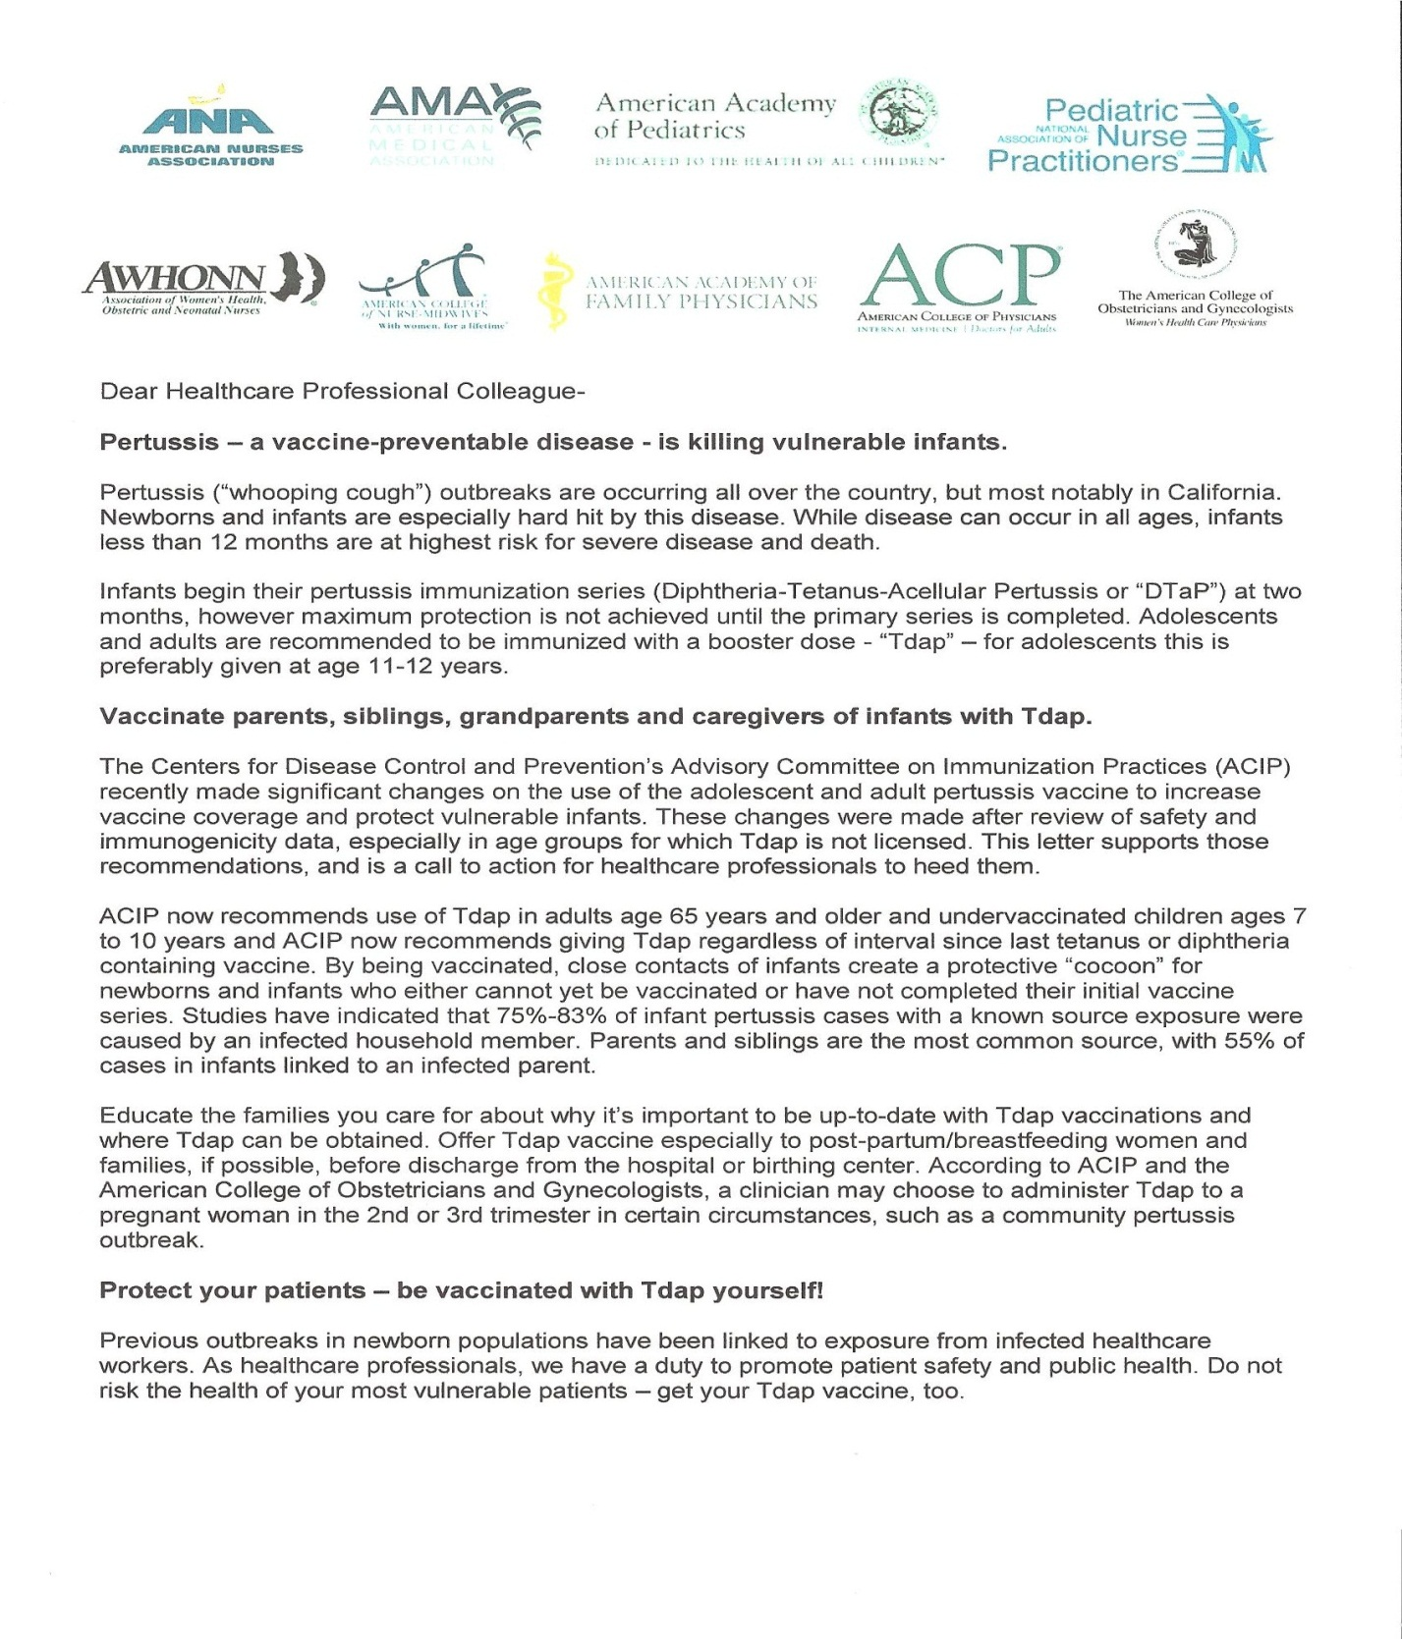

Appendix B; Patient Questionnaire
FAMILY CARE SPECIALISTS
FRANK FUSCO, MD ROBERT KITOS, MD DOROTHY COOK, ARNP
Patient Questionnaire for Pertussis Status
To Our patients,
We are seeing an increase in Pertussis (whooping cough) in the United States. This is a highly contagious respiratory disease that affects all ages but with the greatest impact on infants under 12 months of age. Professional organizations and the Centers for Disease Control are recommending a booster injection. We at Family Care Specialists also recommend that you have a booster. Please answer the following questions, and return to your health care provider during your visit so we can discuss this with you today. Thank you for allowing us to be part of your team to meet your health care needs.
PATIENT TO FILL THIS PORTION:
NAME: _________________________ __________ Date of Birth: ______________ AGE: ________
Have you received the immunization Tdap? NO _______ YES______
what year: __________
Do you have direct or indirect contact with infants less than 12 months?
NO ________ YES________
Do you work or volunteer in health care? NO ______ YES_______
Do you work at the school district or in education? NO ______ YES ________
Are you employed in law enforcement? NO _______ YES_________
Are you a grandparent, great grandparent, aunt, uncle or cousin to an infant less than 12 months of age? YES _________ NO ________
STAFF TO COMPLETE:
Patient ID#: _______________________________
Tdap given today: YES ________ NO___________
Previously given date: _____________________________
Staff signature: _______________________________________

RETURN TO DOTTIE AT THE COMPLETION OF THE WORK DAY. THANK YOU FOR YOUR ASSISTANCE

Appendix C; Vaccination Immunization Sheet
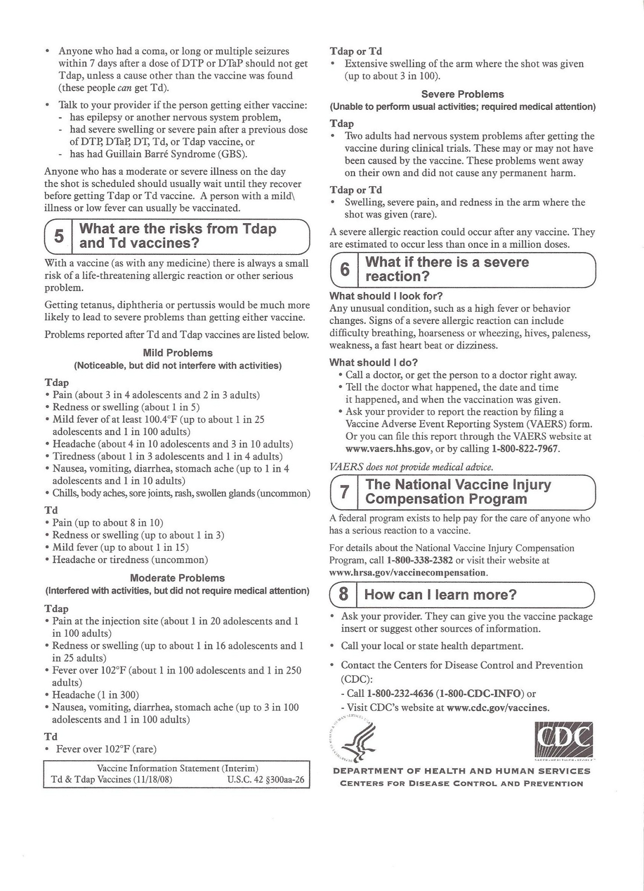
Appendix D; regional structure
REGIONAL STRUCTURE

Site 1
ARNP
MD
MD
u/c 2
Clinic B
clinic west
clinic II
clinic III
U/C 1
Manager 4
Manager 3
Manager 2
Manager 1
wmch
ormc
REGIONAL MEDICAL DIRECTOR

HOSPITALS
PHYSICIAN PRACTICES

Main-clinic I

Appendix E; Local structure
Clinic Ocala II

MD
MD Medical Director
Manager
ARNP

MA
RN
MA
MA
MA
MA

Runner
Auth
Med Rec
Phones
Check in
MR-1
REC-1
Insur auth
LAB
MR-2
REC-2
Check out
Legion
Insur auth-Insurance authorization MA-Medical Assistant
Rec-1,2 – Receptionist MD-Medical Doctor
Med Rec. MR 1, 2 – Medical Records ARNP-Advanced Registered
Auths-Prior authorization for testing Nurse Practitioner
Registered Nurse

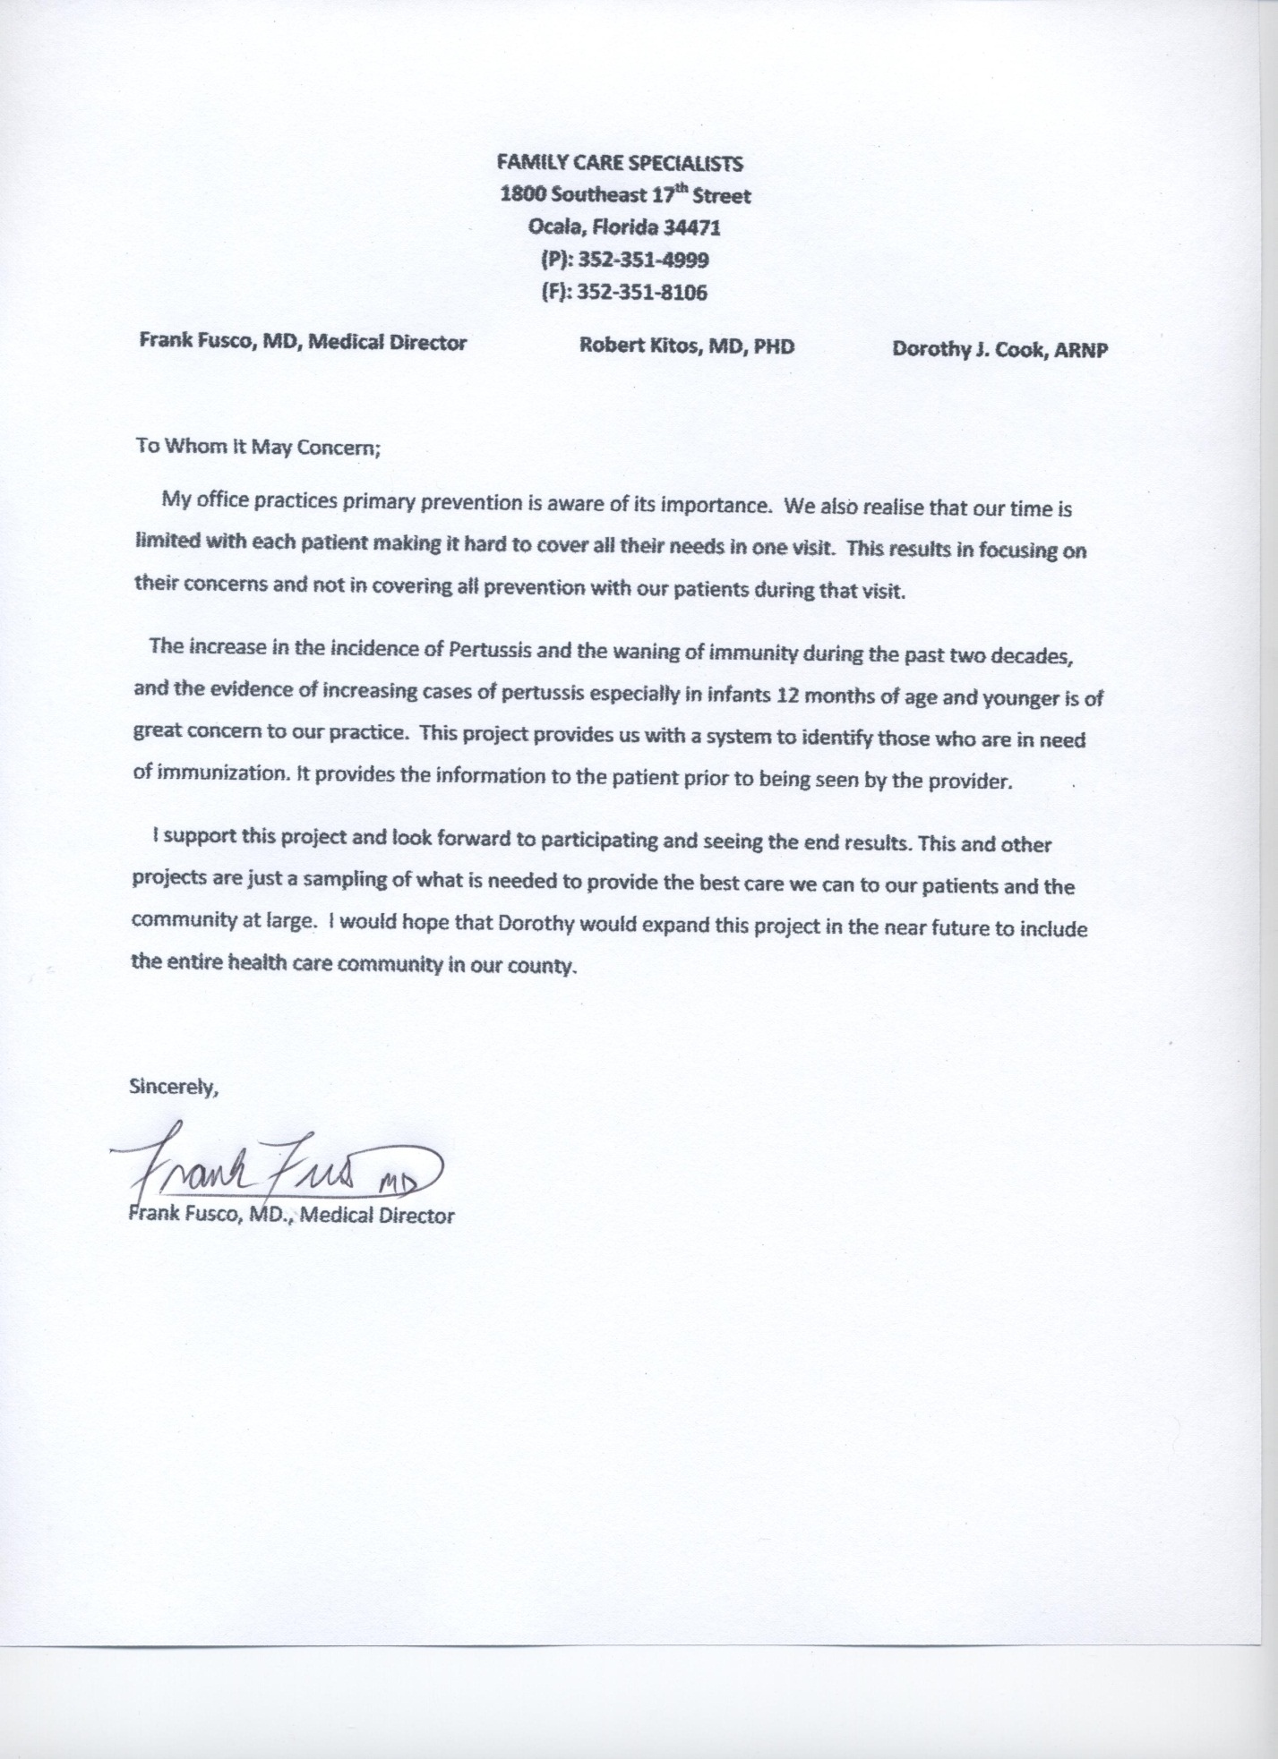
Appendix F; Medical Director Letter of Support

Appendix G; Power Point Presentation for Staff
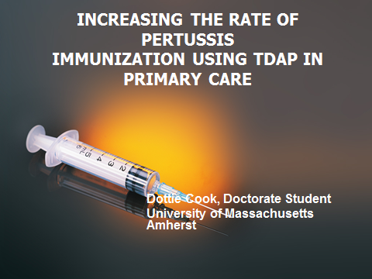
S
L
I
D
E
I

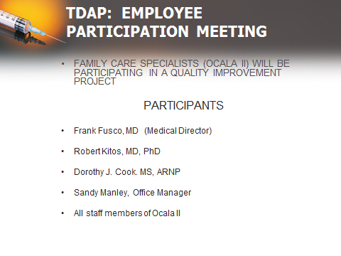
S
L
I
D
E
II

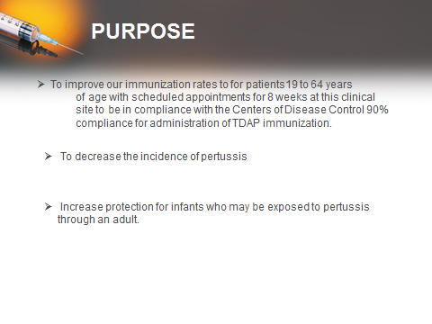
S
L
I
D
E
III

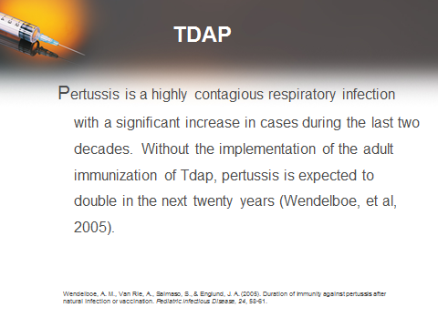
S
L
I
D
E
IV
S
L
I
D
E
V
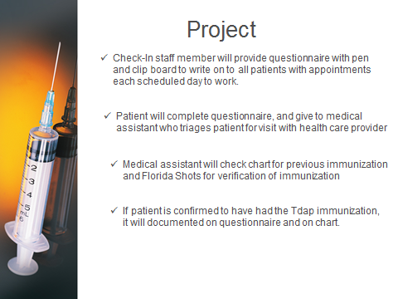
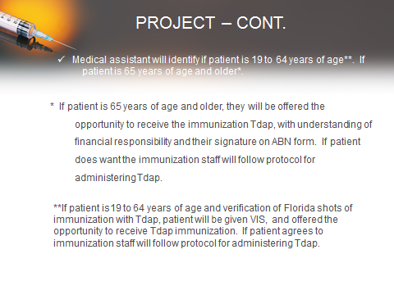
S
L
I
D
E
VI

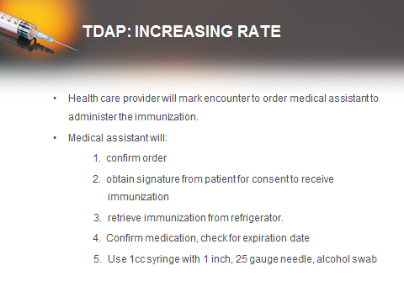
S
L
I
D
E
VII

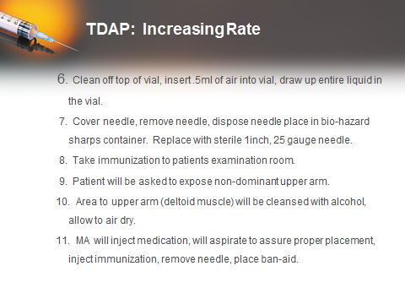
S
L
I
D
E
VIII
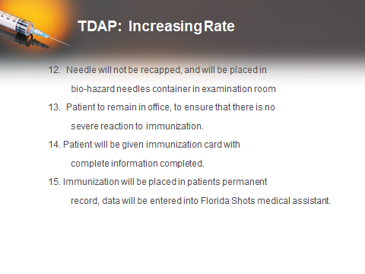
S
L
I
D
E
IX

IMMUNIZATION CONSENT FORM: ADULTS
Appendix H; Immunization Consent
Immunization | Date | Manufacture | Lot # | Expiration Date | Person administering | Patient signature

Patient Name: ____________________________ Patient #: ____________________

Appendix I: Adult Immunization Schedule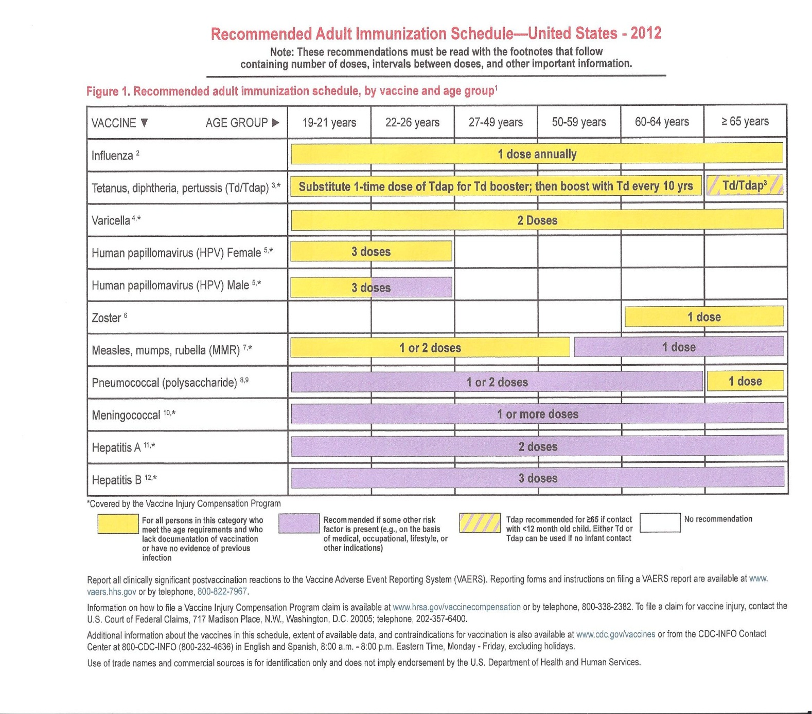
http://www.cdc.gov/vaccines/recs/schedules/downloads/adult/adult-schedule.pdf

Appendix J: Thanks
My thanks to the following people for implementation of Project
Frank Fusco, MD, Medical Director
Robert Kitos, MD, Internal Medicine
Windy Kemp, Market Regional Manager
Sandy Manley, Ocala II Office Manager
Sharon Lunakis, Check-In
Stephanie Jones, Medical Assistant
Erika Johnson, Medical Assistant
Monique Harris, Medical Assistant
Kathy Greathouse, Registered Nurse

Author’s Note
Journey can defined as traveling from one place to another. This defines how I have viewed my education at University of Massachusetts, Amherst. There is a piece of structure that I have in my purse and I read as I get in the car each day to continue my journey.

Isaiah 41:10
Fear not, for I am with you; be not dismayed, for I am your God; I will strengthen you, I will help you, I will uphold you with my righteous right hand.

I would like to acknowledge those in my life who have been supportive as I completed my journey. The two physicians (Dr. Fusco and Dr. Kitos) who I have the privilege to work with on a daily basis who gave me encouragement, Sandy Manley, office manager who was able to break through my wall to give me the hugs when I needed one. To Dr. Myra Sherman, DNP who on the other side of the phone provided me the prayers I needed to keep focused. To Dr. Cynthia Jacelon, my chair that provided support and kindness when the paper looked like it would never come together. Finally, my two Australian Shepherds (Charlie Girl and Gracie) for sitting at my side and listening to me read my paper, staying up late at night when they wanted so to go to bed.

My work is dedicated to my grandmother Mary Gray , who I spent wonderful time with when I was younger, who with her cancer, I knew I wanted to be a nurse and take care of people.

Comments may be addressed to the author at grspcg2009@gmail.com

