COMPETITION CLIMBING AS SERIOUS LEISURE

Abstract (150 words or less)

Serious Leisure has received considerable attention in the leisure research for the past forty years. Building on recent efforts to operationalize serious leisure constructs, this study examined the relationship between serious leisure characteristics and rewards in the context of indoor competition climbing, a sport recognized as a potential serious leisure pursuit. The purposes of the study were to validate the 18-item Serious Leisure Inventory Measure (SLIM) as well as the three-factor model of serious leisure proposed by previous researchers. A national sample of 646 indoor competition climbers completed a 59-item survey. Results suggest partial validation of the 18-Item SLIM and a three factor model of serious leisure characteristics and rewards. Serious leisure characteristics significantly, positively contributed to personal and social rewards in the structural model, confirming the relationships and distinctions between these constructs. Further replication and validation of the 18-Item SLIM with different populations is recommended.

Keywords

Indoor competition climbing, serious leisure, confirmatory factor analysis, path analysis, serious leisure inventory measure

The authors would like to thank Kynan Waggoner of USA Climbing, Dr. James Gould of the University of Northern Colorado, and Dr. DeWayne Moore of Clemson University for their help with this study.

Competition Climbing as Serious Leisure

Serious Leisure (SL) is described as an enduring, career-like pursuit of and identification with a leisure activity (Stebbins, 1992). Since its conception in 1973, Robert Stebbins’ SL framework has been actively embraced and rigorously employed by leisure scholars to investigate leisure behavior across the human lifespan, in a variety of leisure contexts. For example, the SL framework has been used to describe participation and programming in the arts (Bendle & Patterson, 2008; Campbell, 2009), sport (Apostle, 1992; Heo & Lee, 2010), outdoor-adventure recreation (Higham & Hinch, 2009), therapeutic recreation (Axelson, 2009; Fenech, 2010; Stebbins, 2000), online gaming (Holt, 2011) and volunteering (Benoit & Perkins, 1997; Bramante, 2004). Additionally, the SL framework has been used to explain and explore an array of leisure issues including couples’ leisure involvement (Hultsman, 2012), constraints to leisure participation (Kennelly, Moyle, & Lamont, 2013), socio-cultural factorsrelated to gender, aging, or ethnicity (Arora, 2012; Bartram, 2001; Brown, McGuire, & Voelkl, 2008), and youth sport participation (Phillips & Fairley, 2014).

Investigations of SL have primarily been qualitative in nature, adding richness to our understanding of the framework, while inhibiting generalizability of findings due to small sample sizes (Gould, Moore, McGuire, & Stebbins, 2008). Responding to the absence of quantitative studies of SL, Gould et al. (2008) developed the 72-Item Serious Leisure Inventory Measure (SLIM), an instrument that operationalizes and quantifies the characteristics of SL. Subsequent studies reduced the instrument to 54 items and even further to the 18 ‘best performing’ items (Gould et al. 2011; Lee, Ewert, Chancellor, Piatt, & Rutkowski, 2013); however, the revised SLIM is relatively new and remains untested despite Gould et al.’s (2008) call for replication and external validation. Additionally, as SL theory and the SLIM instrument have evolved, efforts have been made to distinguish between SL characteristics and SL benefits (it is argued that the SLIM instrument measures both, see Gould et al., 2008), though this research is in its infancy (Gould et al., 2011). Thus, the purposes this study are: to expand the quantitative investigation and validation of the SL framework and SLIM, and to test the relationship between SL characteristics and benefits in the context of the emerging sport of indoor competition climbing.

Serious Leisure
SL is the antithesis of everyday or casual leisure (CL) and defined by Stebbins (1997) as an “immediately, intrinsically rewarding, relatively short-lived pleasurable activity requiring little or no special training to enjoy it” (p. 18). Where casual leisure is usually simplistic and devoid of effort, serious leisure is recognized as “the steady pursuit of an amateur, hobbyist, or career volunteer activity that captivates its participants with its complexity and many challenges” (Stebbins, 2001, p. 54). Stebbins (1982) identified six characteristics of SL including: (1) the need to persevere, (2) a career-like focus, (3) the need to invest significant personal effort, (4) the enjoyment of eight identified, durable benefits, (5) a unique ethos, and (6) a tendency to identify strongly with an activity (pp. 256-257). SL participation results in a variety of reward-related outcomes that include personal (non-financial) rewards (e.g., self-actualization), social rewards (e.g., group attraction), and financial rewards (e.g., remuneration or reimbursement), though financial remuneration is arguably the least important of these (Stebbins, 1982; Gould et al., 2008). SL has historically been studied qualitatively using the traditional five methodological approaches identified by Creswell (2007), including, auto-ethnography (Anderson, 2011; Presser & Taylor, 2011), phenomenology (Allen-Collinson & Hockey, 2015), narrative (Davidson, 2012), grounded theory (Bartram, 2001; Stalp, 2006) and case study (Hartel, 2010; Stevens-Ratchford, 2014) as well as emergent methodologies such as photo elicitation (Kerstetter et al., 2012). While these studies draw our attention to specialized and sometimes overlooked leisure activities such as surfing or curling, and delve into the deep meanings and lived experiences associated with participation in these activities, they have limited the ability of researchers to generalize findings, test hypotheses, examine relationships, or expand the SL framework in meaningful ways. Hence the need for and subsequent development of a quantitative measure of SL, the Serious Leisure Inventory Measure.

The Development of the Serious Leisure Inventory Measure
The Serious Leisure Inventory Measure (SLIM) was developed to enhance understanding of the SL concept, differentiate between casual and serious leisure participation, and quantify SL characteristics (Gould et al., 2008). In order to develop the instrument, Gould et al. (2008) generated a pool of items (182) from existing measures, with 6-10 items representing each SL characteristic. A Q-sort, where trained individuals attempt to match a limited number of items to a specific set of defined constructs, was utilized to link the 182 items to potential factors, and high performing items (most frequently matched) were retained. A panel of experts (including Robert Stebbins, the author of the SL framework) reviewed the 120 highest performing items and definitions for face and content validity—21 additional items were then added per their recommendations. Two populations were identified, sampled, and surveyed to establish the reliability of the 141-Item instrument. First, a convenience sample of 450 students was surveyed and secondly, a sample of 485 athletes who participated in ‘serious’ sports was assessed. A confirmatory factor analysis (CFA) as opposed to an exploratory factor analysis (EFA) was used to analyze the data since the researchers had foundational knowledge of the framework in question and had pre-identified factors.

The approach outlined in Gould et al. (2008) generated 69 ‘good’ items, however, the final SLIM was comprised of 18 factors and 72 items (three additional items were retained to reach the recommended 4-Items per factor) and 54-Items (3-item per factor short-form) operating on a 9-point Likert scale (1 - Completely Disagree to 9 - Completely Agree). The scale includes items such as: “There are moments within my experience as a climber that have significantly influenced my involvement in the sport” or “I share many ideas, values, and lifestyles with the culture of climbers.”

The 18-Item SLIM. Later, Gould et al. (2011) sought to “confirm the factors of the SLIM in a sample of chess players, assess the effect of method bias in the sample, and propose a set of best performing items” (p. 228). As a result of Gould et al.’s (2011) study, the authors determined that a third of the variance in each factor was explained by method bias. Method bias is a form of measurement error that occurs when a construct’s measured value and its true value are not equivalent (Dodge, 2006). Method bias is common in self-report surveys that contain more than one construct measured using the same method (e.g., both constructs measured using five point Likert scales) and represents a subconscious effort on the part of the respondent to avoid “cognitive dissonance” or dissimilarity between responses, “which is likely to produce a spurious correlation between the two [constructs]” (Kamakura, 2010, para. 1). During this study, the Gould et al. validated the 54-Item SLIM and developed an abbreviated, 18-Item SLIM (one item per factor) which would allow for easier data collection, reduced method bias, and opportunities for more robust analyses (Gould et al., 2011). As a result of this study Gould et al. (2011) contended that beyond the six items that primarily measure seriousness there was a “12-Item inventory... [which was] not an additive indication of seriousness but rather a quantitative inventory of outcomes that vary by seriousness,” (p. 339) essentially breaking the measure down into two factors, one measuring seriousness and the other measuring serious leisure rewards. The hypothesized, predictive relationship between these two factors has yet to be tested.

Following Gould et al.’s (2008; 2011) work, Lee et al. (2013) used the 18-Item SLIM in a study of rock climber motivations, and further deconstructed the two-factor model proposed by Gould et al. (2011) into three factors, distinguishing between personal and social rewards of serious leisure, and seriousness. Using confirmatory factor analysis (CFA), Lee et al. (2013) found that seven of the 12 items could be parceled together to represent non-monetary personal rewards and that coupled with financial rewards, the 8 total items loaded well on a final personal rewards factor. The four remaining items loaded to the social rewards factor. Lee (2014) also used logistic regression to determine whether personal and social rewards were predicted by intrinsic and extrinsic climbing motivations and found that “intrinsic, identified, and introjected motivations are considered to have positive effects on rewards, whereas external motivation and amotivation have negative impact” (p. 77). In sum, Lee at al.’s (2013; 2014) studies built on some aspects of Gould et al.’s (2008; 2011) research and made progress toward modeling serious leisure rewards; however, it did little to validate the original 54-Item SLIM or the revised 18-Item SLIM. Hence, the authors of this study sought to validate the 18-Item SLIM and three factor model of seriousness and serious leisure rewards with a population of indoor competition climbers.

Indoor Competition Climbing
Since its inception, the sport of climbing has adopted a variety of forms including ice climbing, sport climbing, and indoor competition climbing (Breivik, 2010; Selters, 2012). While rock climbing has generally been recognized as a potential serious leisure pursuit in the works of Stebbins (1982) and Gould et al. (2008), climbing has only been formally studied as such by Lee et al. (2013; 2014). Furthermore, SL has not been studied within a population of indoor competition climbers. Indoor competition climbing (ICC) is undergoing a shift from a fringe, lifestyle pursuit to a mainstream sport (USA Climbing, 2014), as evidenced by an increase in gyms, growing membership, prominent media vignettes, and the oversight of a formalized governing body (Climbing Business Journal, 2014). ICC is differentiated from other forms of climbing by four characteristics: (1) formalized competition structure, (2) primarily indoor setting, (3) public awareness and acceptance (when compared to other climbing forms), and (4) its distinct sub-sports (e.g., bouldering, sport (lead) climbing, and speed climbing) (USA Climbing, 2014).

The progression of ICC’s athletes from novice climbers to event competitors strongly resembles Stebbin’s conceptualization of a serious leisurist. For example, indoor competition climbers often start in a recreational climbing program and transition to a competitive team where they hone technical skills, acquire specialized equipment, and are socialized into the ‘elite’ ICC culture. The process of specialization or seriousness is also due in part to the nature of adventure or so-called ‘lifestyle’ sports, which generally have unique cultures that encourage group identification as well as and niche participation (Wheaton, 2004). The competitive structure of ICC, which promotes competition against oneself self and the climbing wall, rather than against an opponent, allows for continuous challenge, growth, and rewards associated with SL as well (Gagnon, Stone, & Garst, 2015). Furthermore, the recent growth and formalization of the sport have created an additional element of seriousness; for example, team and training structures have emerged that encourage and promote commitment to and progress in the sport. Specifically, the existence of new and developed team structures has allowed individuals who might not have progressed as quickly in the sport to be formally trained, enhancing their technical skill and social supports. Thus, the growing number of teams and coaches also produce social rewards such as group achievement—through collective efforts to complete a tough climbing route, and personal rewards, such as self-enrichment—through the mentored development of climbing discipline and work ethic.

Studies of climbing to date have emphasized the physiological (Giles, Rhodes, & Taunton, 2006; Phillips, Sassaman, & Smoliga, 2012) and psychological (Schattke, Brandstatter, Taylor, & Kehr, 2014; Young, Eklund, Tenenbaum, Glueckauf, & Thompson, 2014) aspects of the sport with a few studies beginning to explore the sport’s social domains (Kurten, 2009; Rapelje, 2004). Thus, investigating the 18-Item SLIM in a climbing context was believed to have the potential to add to the limited body of climbing scholarship in addition to furthering our understanding of SL and the SLIM. Therefore, the dual purposes of the present study were to: (1) investigate and validate the 18-Item SLIM with a new population and (2) to test the theoretical modeling of SL characteristics and rewards proposed by Gould et al. (2011), using indoor competition climbing as the leisure context to be studied.

Methods & Analysis

The authors of the present study collaborated with USA Climbing (USAC), the national governing body for indoor competition climbing, to elicit study participants from the USAC membership list. Respondents (N = 965) completed a 59-item electronic Qualtrics questionnaire and were recruited via social media through a link posted on USAC’s Facebook page (four posts over 21 days) and two emails to USAC’s membership list. An entry into a drawing for one of three $250 outdoor equipment packages was used to incentivize participation in the survey. These recruitment and incentive strategies resulted in 482 unique viewings of the Facebook announcement, 1,008 openings of the questionnaire via one of the two emails, and a 64.77% response rate to the survey. Skip logic was used to remove non-climbers (e.g., parents, coaches) from the questionnaire. Data were screened for outliers using critical values and scree plots of Cook’s D, Mahalanobis Distance, and Studentized Deleted Residuals, which resulted in the removal of nine cases. After removing these outliers and non-climbers, the “cleaned” dataset contained 646 respondents who completed the full 18-item SLIM. The questionnaire requested demographic information, economic impact of competition climbing data, parent involvement questions, a few open-ended questions, and the 18-Item SLIM (a total of 59 questions). For a comprehensive explanation of the sample descriptives see Table 1.

As the dual purposes of this study were to test and validate the SLIM and to better understand the potential relationship between SL characteristics and benefits, a CFA was conducted (for testing and validation) and a path analysis utilized to explore the potential relationship between SL characteristics and benefits. SPSS software was used for parallel analysis, the process of determining the number of factors to retain in an exploratory factor analysis (EFA), and EQS 6.2 software used for Structural Equation Modeling (SEM).

-Table 1 about Here-

Results

SLIM Validation. Confirmatory factor analysis (CFA) was employed to verify the three-factor model proposed by Lee et al. (2013) and Gould et al. (2011). Factor analysis uses observed variables (i.e., survey questions) to measure unobserved (i.e., latent) variables (Brown, 2015). CFA assumes an a priori model with a fixed number of latent factors, a fixed number of items (questions) loading on corresponding factors, and is supported by previous research and theory (Brown, 2015). Before conducting the CFA of the 18-item measure, one item was removed relating to personal rewards (financial return), “I have received financial payment as a result of my climbing efforts.” This was due to the work of Lee (2014) who treated this item as a standalone construct in his work. The authors of the present study likewise treated this item as a standalone construct in the path analysis, explained later in this abstract.

Based on prior theory and empirical evidence supporting the current model of SL a three-factor model was specified including seriousness (F1), personal rewards (F2), and social rewards (F3). To see which items loaded onto which factor see Table 2. Additionally, Figure 1 depicts the complete specification of the three-factor model. The measurement model contained no double-loading indicators, and all measurement error was presumed to be uncorrelated (orthogonal).

As noted in the “methods” section the SLIM was administered to 646 respondents. The data were screened for outliers using leverage values, examination of scree plots, and normality of data; nine cases were removed due to their outlier status. After conducting the initial CFA, five items were removed from the model either due to cross-dimensionality (loading onto multiple factors), poor loadings (low loadings onto a factor), or a combination of both. This led to the removal of three items from the seriousness factor (F1) (career contingency, unique ethos, and identity with pursuit), and two items from the personal rewards factor (F2) (self-gratification-enjoyment and re-creation). Thus the final CFA model contained 12 total items (F1, 3 items; F2, 3 items; F3, 6 items). For a listing of the remaining twelve items and their corresponding descriptive statistics, please see Table 2.

The sample variance-covariance matrix was analyzed with EQS 6.2 software and the maximum likelihood minimization function. Goodness of fit was estimated by using the Root Mean Square Error of Approximation (RMSEA), its 90% confidence interval, and the Comparative Fit Index (CFI). Used together these indices provide a conservative and reliable evaluation of the three-factor solution. Each of the overall goodness-of-fit indices suggested that the three-factor model fit the data well: χ²(50) = 158.2389, p ≤ .001, RMSEA = .059, CFI = .95. Convergent validity, examined by looking at statistics such as factor loadings and reliability, is the degree of agreement between two or more measures of the same latent variable (Byrne, 2006). All three factors reported good convergent validity as evidenced by the Average Variance Extracted (AVE) scores with seriousness (F1) with an AVE of .583, personal rewards (F2) with an AVE of .552, and social rewards (F3) with an AVE of .557, all above a .5 threshold. The three factors also reported good reliability as evidenced by Joreskog’s Rho (ϱ) and Cronbach’s Alphas (α) with F1 reporting alphas of ϱ = .805, α = .792 (3 items), F2 reporting alphas of ϱ = .880, α = .789 (3 items), and F3 reporting alphas of ϱ = .790, α = .884 (6 items). Please note the authors only report Cronbach’s due to its heavy use in the social sciences. Joreskog’s Rho is a better reliability measure than Cronbach’s alpha in SEM, as it is based on factor loadings rather than correlations between observed variables (for more information see Chin, 1998). Discriminant validity is the degree to which items measure distinct factors, determined by examining correlations between factors, with low correlations indicating better discriminant validity (Brown, 2015; Byrne, 2006). Discriminant validity between factors was evidenced by low correlations between factors (F1 and F2 r = .543, F1 and F3 r = .189, and F2 and F3 r = .226) (see Figure 1 for visual representation of relationships). In summary, there was evidence of both convergent and discriminant validity of the 12-item SLIM, therefore, it was appropriate to proceed with a path analysis to test the relationships between seriousness and personal, social, and financial rewards. Please reference Table 2 for a description of items and descriptive statistics.

-Table 2 about here-

Relationship Testing. A path analysis (a form of SEM) was conducted with the three now validated and reliable factors to test Gould et al.’s (2011) proposition that reported seriousness level may predict increases in the personal and social rewards of participation in a serious leisure activity, in this case, indoor competition climbing. Path analysis is generally used to test and explain potential causal relationships between variables (Byrne, 2006). Overall goodness-of-fit indices suggested that the model of seriousness fit the data well: χ²(60) = 182.74, p ≤ .001, RMSEA = .006, CFI = .95.

-Figure 1 about here-

In Figure 2 the relationship between seriousness, personal rewards, social rewards, and financial rewards is provided. Results indicate that seriousness significantly predicted (p ≤ .001) both the combination of social and personal rewards and to a lesser extent (due to a weak relationship, but still significant p ≤ .001) financial rewards. These results indicate that as a person increases in their seriousness score, they are more likely to experience social, personal, and to a lesser degree financial rewards as a result of activity participation.

Discussion
The present study represents the authors’ first knowledge of research following Gould et al.’s (2011) recommendations to validate the 18-Item SLIM and examine the relationship between serious leisure characteristics and rewards. Results suggest partial validation of Gould et al.’s (2011) and Lee’s (2014) 18-Item SLIM and three factor modeling of SL characteristics and rewards. Serious leisure characteristics both significantly and positively contributed to personal and social rewards in the SEM model, confirming the relationship and distinction between these constructs. Further replication and validation of the 18-Item SLIM and original 54-Item and 72-Item SLIMs is recommended.

-Figure 2 about Here-

Limitations
Although this study used contemporary methods for both analysis and recruitment, a few limitations are worth noting. First, the response rate of the participants may not be accurate. Study participants could have received a notification via both social media in the form of a Facebook post and an email from USAC, therefore the participants could have foreseeably been recruited twice. Thus, the response rate may be deflated in this study; however, the authors cannot follow up with study participants to determine which modality ‘“worked’” to get them to participate due to the anonymous nature of the survey.

Another potential limitation of this study relates to the ages of respondents, specifically those who were youth. To determine if youth respondents answered questions differently than adults (i.e., persons 19 or more years old) a one-way ANOVA was conducted to determine if SL score was different between youth and adults. The results were non-significant indicating no statistical difference in how youth responded to the SLIM when compared to adults.

Some studies are limited by the homogeneity of the sample. In this study the sample was nearly 90% White. While the authors are not aware of any studies that specifically examine how differing racial or ethnic groups perceive SL, this may be a limitation. However, the authors believe that this racial breakdown is representative of the ICC community and, therefore, demonstrative of the appropriateness of the sample’s ethnic distribution.

Finally, the financial rewards item, “I have received financial payment as a result of my climbing efforts” had a much higher standard deviation (3.16) than the 12 items incorporated into the revised SLIM (M = 1.35). Upon investigating the normality curve for this item, it appears bi-modal, indicating that about half of the sample did not receive remuneration for their climbing efforts whereas about half of the sample did. The research team suspects this is why in a preliminary model (not a part of this study) the financial rewards item did not ‘“fit’” with the personal rewards factor as Gould et al. (2008) hypothesized.

Implications and Future Directions

Revisiting the development of the 18-Item SLIM. Our results suggested that the 18 best performing items proposed by Lee (2014) may not have been representative of the population examined in the present study. Rather our findings indicated that only 12 of the 18 recommended items ‘worked’ in this study as evidenced by the CFA. Future studies should consider replicating Gould et al.’s (2011) approach with different populations. Specifically, researchers should administer the original 54-item SLIM and apply Gould et al.’s (2011) method to reduce that measure to the 18 best performing items. The resultant abridged scales could be compared across studies to validate or question the universal application of the revised, short order SLIM. Additionally, certain items did not conform to their assigned factor structures and were therefore dropped from the study. Future studies should investigate the construct and measurement validity of these items or why these particular items did not load well in the forced, confirmatory factor model of this study.

The intersection of serious leisure, recreation specialization, and the mainstreamization of lifestyle sport. Another concept that has recently been studied in conjunction with serious leisure is that of recreation specialization. Recreation specialization places leisurists on a “continuum from general interest and low involvement to specialized interest and high involvement” (Bryan, 1977; Bryan, 2000). Involvement and specialization are manifest by increased time directed toward the activity and the acquisition of expertise, knowledge, skills, and up-to-date equipment related to the leisure activity. Where serious leisure describes a level, type, or quality of leisure— ‘seriousness’, recreation specialization seems to describe the process that one engages in order to progress from casual to serious leisurist (Stebbins, 2006; Scott, 2012). Lee and Scott (2013) have suggested that these concepts, serious leisure and recreation specialization, appear to describe the same phenomena or that they at least have linked attributes, meanings, or applications (Scott & Shafer, 2001). The authors generally concur with this view, and further argue that the two concepts ought to be merged to reduce redundancy and enhance the precision and validity of the resultant construct (Scott, 2012). Using the revised SLIM and measures of recreation specialization in the same study may be one way of assessing the likeness of these two frameworks and start the merging process. An earlier study conducted by Tsaur and Liang (2008) investigated whether or not an empirical relationship between recreation specialization and serious leisure existed and found that the concepts were significantly, positively related. Taken a step further, this study recommends blending the two scales into a new, hybrid concept and instrument. Specifically, exploratory factor analysis could be used to determine how and where items between the two instruments/scales are cross loading or loading on the same factors. A new instrument and construct might emerge that represent the marriage proposed by Scott (2012). Additionally, these frameworks might align with and shed light on the mainstreamization process, where lifestyle sports undergo a process that resembles that of recreation specialization and move from an unorganized, often fringe activity towards institutionalized competition and social structures.

Enhancing theoretical understanding through robust analysis. As Gould et al. (2011) proposed, developing a universal, revised SLIM may act as a tool to explore relationships between serious leisure and other variables that have been identified in qualitative studies of the concept, including identity, social support, and familial conflict. In other words, the SLIM may allow for robust quantitative testing of qualitative patterns and trends. Validating the instrument, may also allow for comparison of seriousness across leisure activities and the identification of benchmarks that separate serious participants from non-serious participants or that pinpoint the location of individuals on the spectrum of seriousness or specialization. Thus, replication of this study and prior works by SL scholars, across populations, is recommended.

References

Allen-Collinson, J., & Hockey, J. (2015). From a certain point of view: Sensory phenomenological envisionings of running space and place. Journal of Contemporary Ethnography, 44(1), 63–83.
Anderson, L. (2011). Time is of the essence: An analytic autoethnography of family, work, and serious leisure. Symbolic Interaction, 34(2), 133-157.
Arora, P. (2012). The leisure divide: Can the ‘Third World’ come out to play? Information Development, 28(2), 93-101.
Axelson, M. (2009). The power of leisure: “I was an anorexic; I’m now a healthy triathlete.” Leisure Sciences, 31(4), 330-346.
Apostle, R. (1992). Curling for cash: The “professionalization” of a popular Canadian sport. Culture, 12(2), 17-28.
Bartram, S. A. (2001). Serious leisure careers among whitewater kayakers: A feminist perspective. World Leisure Journal, 43(2), 4-11.
Bendle, L., & Patterson, I. (2008). Serious leisure, career volunteering and the organization of arts events in a regional Australian city. International Journal of Event Management Research, 4 (1), 1-11.
Benoit, J., & Perkins, K. B. (1997). Volunteer fire-fighting activity in North America as serious leisure. World Leisure & Recreation, 39(3), 23-29.
Bramante, A. C. (2004). Fostering human resources in the leisure field: “Serious leisure” and the potential role of volunteers. A proposal for developing countries. In R. A. Stebbins, & M. M. Graham (Eds.), Volunteering as leisure/leisure as volunteering: An international assessment (pp. 13-30). Wallingford, Oxon, UK: CAB International.
Breivik, G. (2010). Trends in adventure sports in a post-modern society. Sport in Society, 13(2), 260-273.
Brown, C. A., McGuire, F. A., & Voelkl, J. (2008). The link between successful aging and serious leisure. International Journal of Aging & Human Development, 66(1), 73-95.
Brown, T. A. (2015). Confirmatory factor analysis for applied research (2nd ed.). New York, NY: The Guilford Press.
Bryan, H. (1977). Leisure value-systems and recreational specialization-Case of trout fishermen. Journal of leisure research, 9(3), 174-187.
Bryan, H. (2000). Recreation specialization revisited. Journal of Leisure Research, 32(1), 18-21.
Byrne, B. M. (2006). Structural equation modeling with EQS: Basic concepts, applications, and programming (2nd ed.). New York, NY: Pyschology Press: Taylor & Francis Group.
Campbell, A. (2009). The importance of being valued: Solo ‘grey nomads’ as volunteers at the National Folk Festival. Annals of Leisure Research, 12(3-4), 277-293.
Chin, W. W. (1998). The partial least squares approach for structural equation modeling. In G. A. Marcoulides (Ed.), Modern methods for business research (pp. 295-236). London: Lawrence Erlbaum Associates.
Climbing Business Journal. (2014, December 29). Climbing gyms and trends. Retrieved from http://www.climbingbusinessjournal.com/2014-climbing-gyms-trends/
Creswell, J. W. (2007). Qualitative enquiry and research design: Choosing among five approaches. Thousand Oaks, CA: Sage.
Davidson, L. (2012). The calculable and the incalculable: Narratives of safety and danger in the mountains. Leisure Sciences, 34(4), 298-313.
Dodge, Y. (2006). The Oxford dictionary of statistical terms. Oxford University Press.
Fenech, A. (2010). Inspiring transformations through participation in drama for individuals with neuropalliative conditions. Journal of Applied Arts and Health, 1(1), 63-80.
Gagnon, R. J., Stone, G. A., & Garst, B. A. (2015). The state of the sport: Report and analysis of USA Climbing Winter 2014-Spring 2015 Data. USA Climbing Research and Assessment Team.
Giles, L. V., Rhodes, E. C., & Taunton, J. E. (2006). The physiology of rock climbing. Sports Medicine, 36(6), 529-545.
Gould, J., Moore, D., McGuire, F., & Stebbins, R. A. (2008). Development of the serious leisure inventory and measure. Journal of Leisure Research, 40 (1), 47-68.
Gould, J. Moore, D., Karlin, N. J. Gaede, D. B., Walker, J. & Dotterweich, A. R. (2011). Measuring serious leisure in chess: Model confirmation and method bias. Leisure Sciences, 33(4), 332-340.
Hartel, J. (2010). Managing documents at home for serious leisure: A case study of the hobby of gourmet cooking. Journal of Documentation, 66(6), pp. 847-874.
Heo, J., & Lee, Y. (2010). Serious leisure, heath perception, dispositional optimism, and life satisfaction of Senior Games participants. Educational Gerontology, 36(2), 112-126.
Higham, J., & Hinch, T. (2009). Mountain climbing and serious leisure. In J. Higham & T. Hinch (Eds.), Sport and Tourism: Globalisation, Mobility, and Identity (pp. 125-142). Oxford, UK: Elsevier Butterworth Heinemann.
Holt, N. A. (2011). Deep involvement in the World of Warcraft: An elfnography (Doctoral dissertation). University of Georgia, Athens, GA.
Hultsman, W. Z. (2012). Couple involvement in serious leisure: examining participation in dog agility. Leisure Studies, 31(2), 231-253.
Kamakura, W. A. (2010). Common methods bias. Wiley International Encyclopedia of Marketing.
Kennelly, M., Moyle, B., & Lamont, M. (2013). Constraint negotiation in serious leisure: A study of amateur triathletes. Journal of Leisure Research, 45(4), 466-484.
Kerstetter, D., Stansfield, M., Dombroski, P., Bae, S. Y., Usher, L., & McKinney, M. (2012). The multiple meanings associated with the football tailgating ritual. In C. L. Fisher & C. E. Watts (Eds.), Proceedings of the 2010 Northeastern Recreation Research Symposium (pp. 38-44). Newton Square, PA: U.S. Department of Agriculture, Forest Service, Northern Research Station.
Kurten, J. H. (2009). Who are climbing the walls? An exploration of the social world of indoor rock climbing (Doctoral dissertation. Texas A&M University, College Station, TX.
Lee, K., Ewert, A., Chancellor, C., Piatt, J., & Rutkowski, L. (2013). An examination of the motivations of serious leisure in rock climbing: A structural equation modeling study (Unpublished doctoral dissertation). Indiana University, Bloomington, IN.
Lee, K. (2014). Motivation and seriousness of committed climbers: A logistic regression model. In E. Gomez & J. Sibthorp (Eds.), Abstracts from The 2014 Leisure Research Symposium (pp. 142-144). Charlotte, NC: National Recreation and Parks Association.
Lee, S., & Scott, D. (2013). Empirical linkages between serious leisure and recreational specialization. Human Dimensions of Wildlife, 18(6), 450-462.
Phillips, K. C., Sassaman, J. M., & Smoliga, J. M. (2012). Optimizing rock climbing performance through sport-specific strength and conditioning. Strength & Conditioning Journal, 34(3), 1-18.
Phillips, P., & Fairley, S. (2014). Umpiring: A serious leisure choice. Journal of Leisure Research, 46(2), 184-202.
Presser, L., & Taylor, W.V. (2011). An autoethnography of hunting. Crime, Law & Social Change, 55(5), 483-494.
Rapelje, B. W. (2004). Rock climbing sub-worlds: a segmentation study (Doctoral dissertation. Texas A&M University, College Station, TX.
Schattke, K., Brandstätter, V., Taylor, G., & Kehr, H. M. (2014). Flow on the rocks: Motive-incentive congruence enhances flow in rock climbing. International Journal of Sport Psychology, 45(6), 603-620.
Scott, D. (2012). Serious leisure and recreation specialization: An uneasy marriage. Leisure Sciences, 34(4), 366-371.
Scott, D., & Shafer, C. S. (2001). Recreational specialization: A critical look at the construct. Journal of Leisure Research, 33(3), 319-343.
Selters, A. (2012). Glacier travel and crevasse rescue (2nd ed.). Seattle, WA: Mountaineers.
Stalp, M. C. (2006). Negotiating time and space for serious leisure: Quilting in the modern US home. Journal of Leisure Research, 38(1), 104.
Stebbins, R. A. (1982). Serious leisure a conceptual statement. Sociological Perspectives, 25(2), 251-272.
Stebbins, R. A. (1992). Amateurs, professionals and serious leisure. Montreal, QC: McGill-Queen’s University Press.
Stebbins, R. A. (1997). Casual leisure: A conceptual statement. Leisure Studies, 16(1), 17-25.
Stebbins, R. A. (2000). Serious leisure for people with disabilities. In A. Sivan & H. Ruskin (Eds.), Leisure education community development, and populations with special needs (pp. 101-108). Wallingford, Oxon, UK: CAB International.
Stebbins, R. A. (2001). Serious leisure. Society, 38(4), 53-57.
Stebbins, R. A. (2006). Serious leisure. In C. Rojek, S.M. Shaw, and A.J. Veal (Eds.) A handbook of leisure studies (pp. 448-456). London, UK: Palgrave Macmillan.
Stevens-Ratchford, R.G. (2014). Serious leisure: A case study of model railroading in relation to successful aging. Activities, Adaptation & Aging, 38(2), 113-137.
Tsaur, S-H., & Liang, Y-W. (2008). Serious leisure and recreation specialization. Leisure Sciences, 30(4), 325-341.
USA Climbing. (2014, December 29). About us. Retrieved from: http://www.usaclimbing.net.
Wheaton, B. (Ed.). (2004). Understanding lifestyle sport: Consumption, identity and difference. Routledge.
Young, P. R., Eklund, R. C., Tenenbaum, G., Glueckauf, R. L., & Thompson, B. (2014). Not so risky business: The use of planning within rock climbing. Leisure/Loisir, 38(1), 21-33.

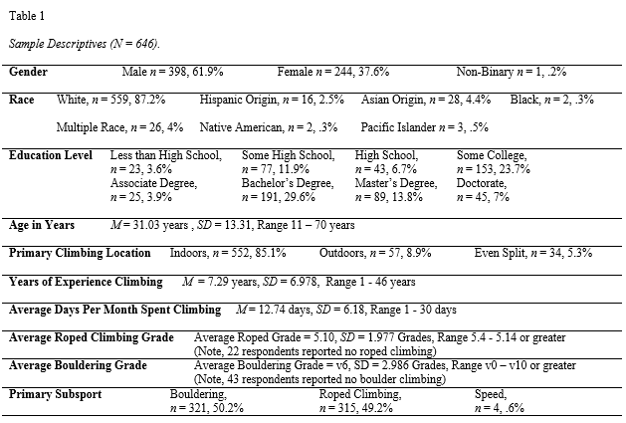
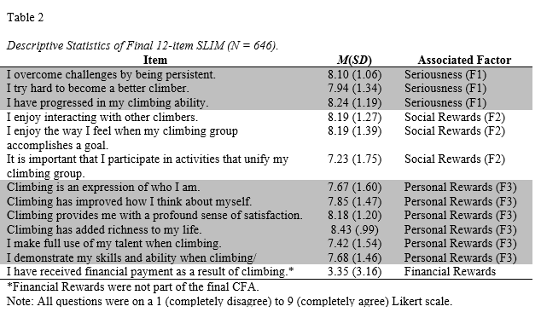

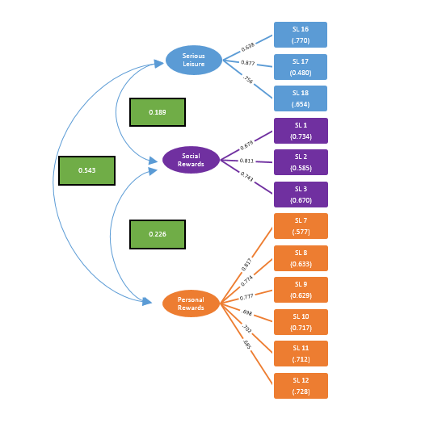

Figure 1. Structural Model of Confirmatory Factor Analysis of the SLIM minus items with poor fit or multidimensionality (N = 646).

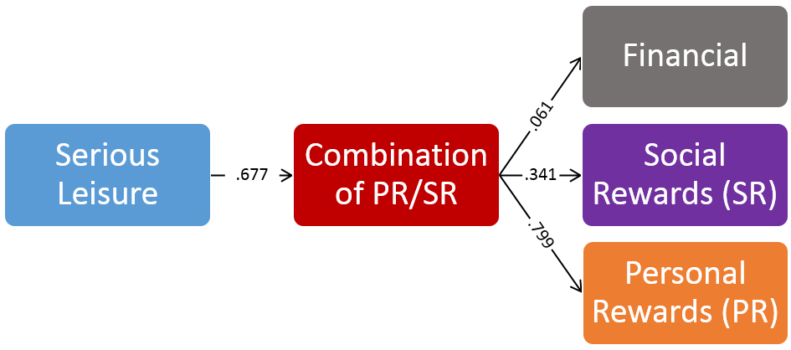

Figure 2. Path Analysis of Relationship between Seriousness and Rewards (N = 646). **Note: Numbers on arrows represent path coefficients, which are equivalent in this case to a regression coefficient (β).

