

January 12th, 2016

Dr. Thomas Wickham, Editor
The 2015 Northeast Recreational Research Symposium Conference Proceedings

Dear Dr. Wickham,

My co-authors and I thank you again for the opportunity to submit our article, “Measuring Self-Reported Fidelity in Recreation: The Facilitator Characteristics and Program Contributions Scale.” Based on the reviewer’s feedback and recommendations, the following revisions were made to the manuscript, we have combined both reviewer feedback in the manuscript and in this letter. Again, thank you for accepting our manuscript for publication.

Overall
- We have updated the title to reflect reviewer recommendations.
- We have corrected grammatical issues throughout the manuscript.
- We have corrected formatting issues in the reference list

Introduction and Review of Literature
- We have made minor revisions to formatting and content.

Methods
- We have briefly expanded the rationale for Confirmatory Factor Analysis.

Results
- We updated the results section to reflect the additional proposed fit indices proposed by the reviewer
- We have removed the CFA figure and replaced it with a table that more clearly communicates the CFA results

Discussion & Conclusions
- Per the reviewer recommendations we have expanded our discussion of the implications and potential future directions of this study.

Please contact me if any further changes are needed or if there are any questions I can answer.

Sincerely,

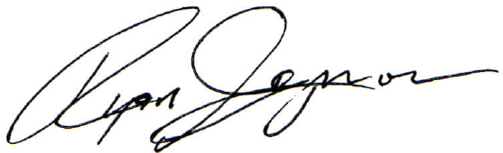

Ryan J. Gagnon
Graduate Teaching and Research Assistant
Department of Parks, Recreation, & Tourism Management
College of Health, Education, and Human Development
Clemson University
rjgagno@g.clemson.edu

