LANDSCAPE PREDICTORS OF CURRENT AND FUTURE DISTRIBUTION OF MOUNTAIN GORILLAS (Gorilla beringei beringei) IN BWINDI IMPENETRABLE NATIONAL PARK, UGANDA

A Dissertation Presented
By
DENNIS BABAASA

Submitted to the Graduate School of the
University of Massachusetts, Amherst, in partial fulfillment
of the requirements for the degree of

DOCTOR OF PHILOSOPHY

September 2014

Environmental Conservation

© Copyright by Dennis Babaasa 2014
All Rights Reserved

LANDSCAPE PREDICTORS OF CURRENT AND FUTURE DISTRIBUTION OF

MOUNTAIN GORILLAS (Gorilla beringei beringei) IN BWINDI

IMPENETRABLE NATIONAL PARK, UGANDA

A Dissertation Presented

by

DENNIS BABAASA

Approved as to style and content by:

__________________________________
Charles M. Schweik, Chair

__________________________________
Todd K. Fuller, Member

__________________________________
Laurie R. Godfrey, Member

__________________________________
Curtice R. Griffin, Head
Department of Environmental Conservation

DEDICATION
To all those who ensure the long-term survival of the remaining mountain gorillas

ACKNOWLEDGEMENTS
I would like to thank my advisors Charles Schweik and Todd Fuller for the great support I was offered right from the study design stage, proposal writing, fund raising, data analysis to completion of writing the dissertation. Many of their thought provoking questions and ideas stimulated me to seek more information and be critical of what I was writing. I also greatly appreciate the assistance offered by John ‘Jack’ Finn of the Department of Environmental Conservation, University of Massachusetts, Amherst, in statistical analyses and use of R code. Laurie Godfrey from the Department of Anthropology, University of Massachusetts, Amherst, was the outside member of my dissertation committee. She offered some useful insights into species distribution with respect to human activities of the recent past.
Funding support was provided by Wildlife Conservation Society (WCS) for the two year coursework at the University of Massachusetts, Amherst, International Foundation for Science (IFS) for the scientific field equipment and vegetation sampling field data collection, Mohammed bin Zayed (MBZ) for vegetation field data sampling and compiling of gorilla occurrence data, British Ecological Society (BES) for the initial vegetation data collection and laptop computer. The University of Massachusetts, Amherst, Graduate School offered a fellowship that aided me during data analysis and dissertation write-up.
Mountain gorilla location data was kindly provided by the Uganda Wildlife Authority from their Ranger Based Monitoring (RBM) data and Institute of Tropical Forest Conservation from the gorilla census data bank. I would like to appreciate the help of Pontious Ezuma, the Conservation Area Manager, for permitting me to use RBM data from Bwindi Impenetrable National Park, Uganda.
I gained considerable knowledge from my interaction with faculty, staff and fellow graduate students of the Department of Environmental Conservation, University of Massachusetts, Amherst. Their companionship and encouragement during the time I was at the campus was great.
Last but not least, I would like to thank my family – wife Charity Nyongyeirwe and children Isabella Babaasa, Melissa Atukunda, Daniella Ainembabazi and Raymond Ayebare - who patiently endured my periodic long absences from home. I am also very grateful to my parents – Fred Rushanyuka and my late mother Margret, who introduced me to the wonders of education. Their early efforts laid a strong foundation for me to reach the pinnacle of my education career.

ABSTRACT
LANDSCAPE PREDICTORS OF CURRENT AND FUTURE DISTRIBUTION OF MOUNTAIN GORILLAS (Gorilla beringei beringei) IN BWINDI IMPENETRABLE NATIONAL PARK, UGANDA
SEPTEMBER 2014
DENNIS BABAASA, B.S., MAKERERE UNIVERSITY
M.S., MAKERERE UNIVERSITY
M.S., UNIVERSITY OF MASSACHUSETTS AMHERST
Ph.D., UNIVERSITY OF MASSACHUSETTS AMHERST
Directed by: Dr. Charles Schweik
The impacts of ecological, anthropogenic and future climate change on the distribution of wild mountain gorillas (Gorilla beringei beringei) are of ongoing concern. Knowing the factors that determine gorilla habitat suitability now and in future is essential for conservation planning. The mountain gorilla is recognized by IUCN Red Data Book as critically endangered and a great tourist attraction. However, the factors that impact on their spatial use of Bwindi are poorly understood.
The study aimed at determining the major factors that determine gorilla distribution, predict the wild gorilla habitat suitability and establish the vulnerability index of the gorillas to future (2050) climate change throughout Bwindi using different tools and comparing the results.
I used seven independent environmental variables that are thought to affect gorilla distribution in Bwindi. I made a vegetation map from plant inventory data collected from stratified random transects, high resolution aerial photos and a 30m Aster Global Digital Elevation Model (GDEM). Slope steepness and surface curvature were derived the Aster GDEM. Variable ‘distance from roads within the park’, and ‘distance from park boundary’ were generated from the Bwindi GIS database, and levels from human activity were from the gorilla census data of 1997. Wild gorilla groups presence data points were compiled from Ranger Based Monitoring data of Uganda Wildlife Authority (1999 to 2011) and five-year interval gorilla census data of 1997, 2002, 2006 and 2011. Background points to describe a set of conditions available to the wild gorillas in the whole park were generated randomly in R program. The intention of providing background sample is not to pretend that the species is absent at the selected sites, but to provide a sample of conditions available to gorillas in the whole of Bwindi. Then the environments where the gorillas are known to occur were related to the environments across the rest of Bwindi (the ‘background’). Both wild gorilla presence and background data were randomly divided into training and testing data sets. Four algorithms – logistic regression, maximum entropy, random forest and boosted regression trees were used to fit the gorilla presence and background data, produce maps predicting wild gorilla habitat suitability and evaluate the accuracy of the prediction. I used the Nature Serve Climate Change Vulnerability tool (CCVI) to integrate information on gorillas to 18 natural and distribution factors that are associated with sensitivity to climate change and projections of climate changes for Bwindi area based on published literature to determine the vulnerability of gorillas to climate change.
All the four algorithms showed that vegetation and some form of human activity (roads, park edge, and level of human activity within the park) were the most important environmental factors in determining wild gorilla habitat suitability. All models performed better than random in the accuracy of their predictions (average area under the ROC curve, AUC = 0.7). The difference in their AUC scores was very small (≤0.02) meaning that all the algorithms had more or less the same predictive ability. However, model predictions of gorilla habitat suitability among the four algorithms differed substantially. Logistic regression model predicted that nearly the whole park was suitable for gorillas except part of the northeast. The other three models, however, predicted that most of Bwindi was unsuitable gorilla habitat with the northern sector and the edges of the southern sector being wholly unsuitable. The center of the south sector of the park was predicted to be the core habitat but with varying levels of suitability for each model. Logistic regression model predicted that much of the south sector was highly suitable wild gorilla habitat, while Maxent model showed that only the interior of the south sector was highly suitable. Random forest and boosted regression tree models gave the area in the interior of the south sector low suitability, with a few, small, scattered areas being highly suitable gorilla habitat. Using the climate projections for the A2 emission scenario and average ensemble of 16 global circulation models (GCMs), combined with sensitivity factor inputs, the CCVI tool ranked the gorillas “Not vulnerable/Presumed Stable (PS)” to climate change in Bwindi. This means that the available evidence did not suggest that the abundance and/or range extent within Bwindi assessment area will change (increase/decrease) substantially by year 2050. But the actual boundaries may change. This would make the gorillas adjust to climate-mediated changes in their habitat. This suggests that assisted migration of the gorillas may not be required. Factors that were identified as contributing to vulnerability included physiological thermal niche, physiological hydro niche and disturbance regime while those decreasing vulnerability were dispersal or movement, physical habitat restrictions and genetic variation. Seven factors were either unknown or irrelevant.
Gorillas may have occupied the south-east and south-west parts of Bwindi but were probably exterminated by hunters. They could be prevented or deterred from re-colonizing these areas because of feeding traditions or habitat preferences since the vegetation of Bwindi is spatially structured. The spread of gorillas in Bwindi is relatively recent and from south of the park. It is probable that they have not had enough time to occupy all the forested areas available to them. That could be one reason why there are no reports of gorillas in the north of the park. The northern part of the park also has the highest level of human disturbance and a road that separates it from the southern sector. These could have contributed to gorillas not occupying the northern parts of Bwindi.
Human disturbance seems to be a major important factor driving wild gorilla distribution in Bwindi and also likely to contribute significantly to the vulnerability of the gorillas to future climate change. Park management needs to increase law enforcement patrols, reexamine the multiple-use program and relocate the road outside the park. This could improve the prospects of long-term survival of the wild gorillas in an island habitat.

TABLE OF CONTENTS
Page
ACKNOWLEDGEMENTS………………………………………………………….........v
ABSTRACT………………………………………………………………………..........vii
LIST OF TABLES………………………………………………………………….......xvii
LIST OF FIGURES……………………………………………………………………xviii
PREFACE……………………………………………………………………………....xxii
CHAPTER
1. BACKGROUND INFORMATION TO THE STUDY………………………………...1
1.1 Introduction………………………………………………………………....................1
1.2 Geography…………………………………………………………………………......2
1.3 Vegetation……………………………………………………………………..............4
1.4 Human population…………………………………………………………………......5
1.5 Poverty………………………………………………………………………...............7
1.6 Conservation activities around Bwindi working with the local community…………..8
1.7 Statement of the problem…………………………………………………………….11
1.8 Theoretical framework……………………………………………………………….12
1.8.1 Geographical versus environmental space………...……………………………….13
1.8.2 Estimating niches and distributions………………………………………………..15
1.8.3 Uses of species’ distribution models……………………………………………….19
1.9 Objectives…………………………………………………………………………....20
1.10 Research questions………………………………………………………………….21
1.11 Hypothesis…………………………………………………………………..............22
1.12 Scope of the study…………………………………………………………..............22
1.13 Significance of the study…………………………………………………................23
1.14 Bibliography………………………………………………………………..............24
2. LANDSCAPE INFLUENCES ON SPACE USE BY MOUNTAIN GORILLAS IN BWINDI IMPENETRABLE NATIONAL PARK, UGANDA………….………………32
2.1 Introduction…………………………………………………………………………..32
2.2 Gorilla status……………………………………………………………………........34
2.3 Taxonomy and distribution…………………………………………………………..36
2.4 Impact of feeding ecology on gorilla distribution……………………………………38
2.5 Impact of ranging patterns on gorilla distribution…………………………………...40
2.6 Impact of population trends and dynamics on gorilla distribution…………………..41
2.7 Impact of human disturbance on gorilla distribution………………………………...44
2.7.1 Deforestation……………………………………………………………….45
2.7.3 Logging……………………………………………….................................45
2.7.4 Mining/prospecting………………………………………………………...48
2.7.5 Harvesting of non-timber forest products………………………………….49
2.7.6 Tourism and research………………………………………………………50
2.7.7 Roads and trails…………………………………………………………….50
2.7.8 Comparison of human disturbance in Bwindi and Virunga Massif………..51
2.8 Impact of physical barriers on gorilla distribution…………………………………...53
2.9 Impact of projected climate changes on gorilla distribution…………………………53
2.10 Synthesis……………………………………………………………………………56
2.11 Bibliography………………………………………………………………………..60
3. RELATIONSHIP BETWEEN VEGETATION SPATIAL PATTERNS AND MOUNTAIN GORILLA DISTRIBUTION IN BWINDI IMPENENTRABLE NATIONAL PARK, UGANDA…………………………………………………………72
3.1 Introduction…………………………………………………………………………..72
3.2 Objectives……………………………………………………………………………74
3.3 Research questions…………………………………………………………………...74
3.4 Methods………………………………………………………………………………74
3.4.1 Study area stratification……………………………………………………74
3.4.2 Field data collection………………………………………………………..75
3.4.3 Data entry………………..…………………………………………………76
3.5 Data analysis…………………………………………………………………………77
3.5.1 Analysis strategy…………………………………………………………...77
3.5.2 Sampling adequancy……………………………………………………….77
3.5.3 Ecological distance………………………………………………………...78
3.5.4 Cluster analysis…………………………………………………………….78
3.5.5 Ordination………………………………………………………………….79
3.5.6 Central location, ANOVA, RDA, Mantel and ANISOM tests…………….80
3.5.7 Community summaries…………………………………………………….80
3.5.8 Evaluation of cluster validity………………………………………………80
3.5.9 Chi-squared and presence/absence analyses……………………………….81
3.6 Results………………………………………………………………………………..81
3.6.1 Sample size adequacy and analysis of tree species richness……………….82
3.6.2 Analysis of differences in tree species richness……………………………83
3.6.3 Distribution of vegetation classes across the strata………………………...84
3.6.4 Clustering and ordination…………………………………………………..85
3.6.5 Evaluating the stability of the cluster solution……………………………..86
3.6.6 Vegetation map…………………………………………………………….87
3.6.7 Relationship between vegetation class spatial pattern and mountain gorilla distribution……………………………………………………………………….88
3.7. Discussion……………………………………………………………………….......89
3.7.1 Vegetation classification and description………………………………….90
3.7.2 Landscape gorilla distribution in relation to vegetation spatial patterns…..95
3.8 Bibliography…………………………………………………………………………96
4. HABITAT SUITABILITY MODELING FOR THE WILD GROUPS OF MOUNTAIN GORILLAS IN BWINDI IMPENENTRABLE NATIONAL PARK, UGANDA………………………………………………………………………………122
4.1 Introduction…………………………………………………………………………122
4.2 Objectives…………………………………………………………………………..127
4.3 Research questions………………………………………………………………….127
4.4 Hypothesis…………………………………………………………………………..127
4.5 Methods……………………………………………………………………………..128
4.5.1 Study area and mountain gorilla distribution……………………………..128
4.5.2 Data preparation…………………………………………………………..129
4.5.2.1 Gorilla occurrence data and background points………………...129
4.5.2.2 Environmental data……………………………………………..130
4.5.3 Extracting values from rasters……………………………………………133
4.5.4 Model fitting, prediction and evaluation………………………………….133
4.5.4.1 Model fitting……………………………………………………133
4.5.4.2 Model evaluation……………………………………………….134
4.5.5 Modeling methods………………………………………………………..135
4.5.5.1 Regression models ……………………………………………..135
4.5.5.2 Machine learning methods (ML)……………………………….137
4.6 Results……………………………………………………………………………....141
4.6.1 Mountain gorilla presence points and background points………………..141
4.6.2 Environmental variables………………………………………………….142
4.6.3.1 Species Distribution Models (SDM)……………………………143
4.6.3.2 Generalised linear model (GLM)……………………………….143
4.6.3.3 Random forest…………………………………………………..145
4.6.3.5 Boosted Regression Trees (BRT)……………………………....146
4.6.3.5 Model averaging………………………………………………..147
4.6.3.5 Model contrast………………………………………………….148
4.7 Discussion…………………………………………………………………………..149
4.7.1 Comparison of modeling algorithms……………………………………..149
4.7.2 Habitat suitability and environmental variables………………………….150
4.8 Bibliography………………………………………………………………………..153
5. CLIMATE CHANGE VULNERABILITY ASSESSMENT OF MOUNTAIN GORILLAS IN BWINDI IMPENETRABLE NATIONAL PARK, UGANDA……….175
5.1 Introduction…………………………………………………………………………175
5.2 Objectives…………………………………………………………………………..179
5.3 Methods……………………………………………………………………………..180
5.4 Results……………………………………………………………………………....184
5.4.1 Distribution data…………………………………………………………..184
5.2 Climate exposure…………………………………………………………...184
5.4.3 Indirect exposure………………………………………………………….185
5.4.3.1 Natural barriers (B2a)…………………………………………..185
5.4.3.2 Anthropogenic factors (B2b)…………………………………...186
5.4.3.3 Human response to climate change (B3)………………………186
5.4.4 Species sensitivity………………………………………………………...186
5.4.4.1 Dispersal/movement (C1)………………………………………186
5.4.4.2 Historical thermal niche (C2ai)…………………………………186
5.4.4.3 Physiological thermal niche (C2aii)…………………………….187
5.4.4.4 Historical hydrologic niche (C2bi)……………………………..187
5.4.4.5 Physiological hydrologic niche (C2bii)………………………...188
5.4.4.6 Disturbance regime (C2c)………………………………………188
5.4.4.7 Physical habitat restrictions (C3)……………………………….188
5.4.4.8 Biotic habitat dependence (C4a)…………………………..........189
5.4.4.9 Dietary versatility (C4b)………………………………………..189
5.4.4.10 Biotic dispersal dependence (C4d)……………………………189
5.4.4.11 Interactions with other species (C4e)………………………….189
5.4.4.12 Genetic variation (C5a)………………………………………..189
5.4.5 Modeled response to climate change……………………………………..190
5.4.5.1 Modeled future (2050) change (D2)……………………………190
5.4.5.2 Overlap of future (2050) and current range (D3)……………….190
5.4.5.3 Occurrence in protected area of future distribution (D4)……….190
5.4.6 Climate change vulnerability index………………………………………191
5.4.7 Sensitivity analysis of the vulnerability index……………………………191
5.4.7.1 Temperature…………………………………………………….192
5.4.7.2 Moisture………………………………………………………...192
5.4.7.3 Anthropogenic factors (B2b)…………………………………...192
5.4.7.4 Human response to climate change (B3)……………………….193
5.4.8 Confidence in information about gorillas………………………...193
5.5 Discussion…………………………………………………..…………………........193
5.5.1 Climate change vulnerability of mountain gorillas……………………….194
5.5.2 Information gaps………………………………………………………….197
5.5.3 Limitations of the CCVI tool……………………………………………..198
5.5.4 Conclusion………………………………………………………………..200
5.6 Bibliography………………………………………………………………………..201
6. SUMMARY, CONCLUSIONS AND RECOMMENDATIONS…………………...215
6.1 Introduction…………………………………………………………………………215
6.2 General conclusions………………………………………………………………...220
6.3 Recommendations…………………………………………………………………..224
6.4 Bibliography………………………………………………………………………..225
BIBLIOGRAPHY………………………………………………………………………229

LIST OF TABLES
Table Page
3.1 Vegetation classes, their indicator species and frequency of occurrence in each stratum in Bwindi Impenetrable National Park, Uganda. The tree species richness is also shown...............................................................................................................................103
3.2 Vegetation classes and altitudinal ranges in Bwindi Impenetrable National Park, Uganda.............................................................................................................................106
3.3 Vegetation type classes, their frequency distribution and chi-squared standardized residuals in areas occupied and unoccupied....................................................................108
4.1 Logistic regression model parameters for gorilla habitat suitability in Bwindi Impenetrable National Park, Uganda………..………………………………………… 159
4.2 Relative contribution of the environmental variables to the models fit….................161
5.1 Exposure weightings for sensitivity and indirect exposure factors….......................206
5.2 Numerical index score thresholds and corresponding vulnerability categories (degree of vulnerability) as assigned by the CCVII……………………………………..............207
5.3 Projected temperature exposure for gorillas in Bwindi, Uganda………….……..... 208
5.4 Projected moisture exposure (based on the hamon AET:PET aridity index) for gorillas in Bwindi…………………………………………………..……………...........209
5.5 Climate change vulnerability factors and ratings for the mountain gorilla in Bwindi Impenetrable National Park, Uganda……………………….………..............................210

LIST OF FIGURES
Figure Page
1.1 Location of Bwindi Impenetrable National Park, Uganda and its environs..............................................................................................................................30
1.2 Location of the multiple-use areas in Bwindi Impenetrable National Park, Uganda...............................................................................................................................31
2.1 The distribution of mountain gorillas in Bwindi Impenetrable National Park, Uganda, based on recordings from 1997 to 2011………………………………………………….69
2.2 The road through the Bwindi Impenetrable National Park, Uganda...............................................................................................................................70
2.3 Bwindi Impenetrable National Park, Uganda, and other protected areas in the region.................................................................................................................................67
3.1 Location of the vegetation sampling plots among the strata. The plots are superimposed on a digital elevation model of Bwindi Impenetrable National Park, Uganda…….....................................................................................................................111
3.2 A portion of the digitised aerial photo of Bwindi Impenetrable National Park, Uganda.............................................................................................................................112
3.3 Species accumulation curve for the entire tree dataset scaled by number of sites..................................................................................................................................113
3.4 Species accumulation curve for the entire tree dataset scaled by average number of trees per accumulated site…………………………………............................................113
3.5 Species accumulation curves for different strata plotting species richness against accumulated number of sites….......................................................................................114
3.6 Species accumulation curves for different strata plotting species richness against accumulated number of trees……………………………...............................................114
3.7 Dendrogram showing the sites clustered in 18 groups using a hierarchical average-linkage clustering algorithm and Bray-Curtis coefficient as the similarity measure…………………………………………............................................................115
3.8 Box plots of the altitude environmental factor by 18 vegetation classes for Bwindi Impenetrable National Park, Uganda...............................................................................116
3.9 Box plots of topographic position environmental factor by 18 vegetation classes for Bwindi Impenetrable National Park, Uganda…..............................................................117
3.10 NMDS ordination graph of 358 tree plots with the confidence ellipses showing where 95% of sites of the same class are expected to occur.................................................................................................................................118
3.11 Potential vegetation classes in Bwindi Impenetrable National Park, Uganda.............................................................................................................................119
3.12 Mountain gorilla occupied and unoccupied habitats in Bwindi Impenetrable National Park, Uganda....................................................................................................................120
3.13 Location of vegetation sampling plots in gorilla occupied and unoccupied habitats in Bwindi Impenetrable National Park, Uganda..................................................................121
4.1 Mountain gorilla presence training and testing points in Bwindi Impenetrable National Park, Uganda. The training point set is shown in green while the testing set is blue...................................................................................................................................162
4.2 Background data for training and testing set in Bwindi Impenetrable National Park, Uganda.............................................................................................................................163
4.3 Grid maps of environmental variables used to determine habitat suitability for gorillas in Bwindi Impenetrable National Park, Uganda………………………………………..164
4.4 Test of colinearity using pairwise scatter plots among the seven environmental variables used to determine habitat suitability for gorillas in Bwindi Impenetrable National Park, Uganda.....................................................................................................165
4.5 The logistic regression model prediction of gorilla habitat suitability in Bwindi Impenetrable national Park, Uganda……………………………………........................166
4.6 Relative contributions of the environmental variables to the maxent model................................................................................................................................167
4.7 A prediction map of gorilla habitat suitability in Bwindi Impenetrable National Park, Uganda, by Maxent..........................................................................................................168
4.8 Variable importance plots for predictor variables for RF classifications used for predicting potential gorilla distribution in Bwindi Impenetrable National Park, Uganda. the most important factors are the ones on top of the graph on the left....................................................................................................................................169
4.9 Random forest model prediction of gorilla habitat suitability in Bwindi Impenetrable National Park, Uganda………………………………….................................................160
4.10 Summary of the relative contribution (%) of predictor variables for BRT..................................................................................................................................171
4.11 The BRT model prediction of gorilla habitat suitability in Bwindi Impenetrable National Park, Uganda…….............................................................................................172
4.12 Weighted mean of the logistic regression and random forest for gorilla habitat suitability in Bwindi Impenetrable National Park, Uganda.............................................................................................................................173
4.13 Predictions for gorilla habitat suitability for the four models (glm = logistic regression, rf0 = random forest, brf = boosted regression trees, max = maxent). light colors represent poor suitability and dark colors represent high confidence in habitat suitability for gorillas…...................................................................................................174
5.1 The relationship of the key components in determining climate change vulnerability index (Source: Young et al. 2013)...................................................................................212
5.2 Schematic of the nature serve climate change vulnerability index (CCVI). the vulnerability score based on the exposure/sensitivity sum is calculated as σfiwi, where f is the value assigned to each factor according to how it influences sensitivity and w is the specific exposure weighting for each factor i.......................................................................................................................................213
5.3 Mountain gorilla distribution in Bwindi Impenetrable National Park, Uganda.............................................................................................................................214

PREFACE
This study was about the ecological, anthropogenic and climate change factors determining mountain gorilla landscape level distribution, now and in future, in Bwindi Impenetrable National Park, Uganda. The dissertation is divided into six chapters. Each chapter is described in the sections that follow.
Chapter One is the background to the study. It has information on the geography, vegetation, human population, levels of poverty and conservation activities in and around Bwindi working with the local communities. It also has the problem statement, the theoretical framework, objectives, research questions, hypothesis, scope of the study, and the significance of the study.
Chapter Two is a review of literature on what is known to influence space use by gorillas in Bwindi. It gives a description of the gorilla status in relation to other great apes. It also describes the current taxonomy and distribution of Genus Gorilla. Then reviews literature related to gorilla distribution in Bwindi in relation to biological, physical, human and climate change factors. It concludes by synthesizing the needed research from the reviewed literature.
Chapter Three presents the findings and discussion on how plant communities are structured and distributed in Bwindi. It also discusses the factors that determine the structure and distribution of the vegetation type. It derives a predictive vegetation map for Bwindi and relates the vegetation spatial patterns to mountain gorilla distribution. It concludes that plant communities have a strong bearing on gorilla distribution in Bwindi.
Chapter Four shows the gorilla habitat suitability for Bwindi using four ‘standard’ modeling algorithms and compares and contrasts the model prediction results. It discusses the factors responsible for determining gorilla habitat suitability. It concludes that vegetation and all forms of human activity in and around Bwindi are the major contributors to the present gorilla distribution.
Chapter Five is an assessment of the vulnerability of mountain gorilla to climate change. It uses a rapid vulnerability tool to evaluate the contribution of specific factors contributing to climate change vulnerability index ranking of mountain gorillas in Bwindi. The gorillas in Bwindi were ranked as “Not vulnerable/Presumed Stable (PS)” to future climate change.
Chapter Six synthesizes the information presented and discussed in the previous chapters to give the implications and conclusions about the impacts of natural, human and climate change on mountain gorilla distribution in Bwindi. Recommendations to management and for further research are suggested.

CHAPTER 1

BACKGROUND INFORMATION TO THE STUDY

1.1 Introduction
The mountain gorilla (Gorilla beringei beringei) is a high priority subspecies for conservation and may bring attention of government, wildlife managers, conservationists and the general public to the impacts of human disturbance and future climate change in Uganda and the Albertine Rift region. Mountain gorillas are a highly endangered flagship subspecies and remain in just two protected areas in Africa (Robbins 2011). In Uganda, which harbors half of the world’s population of mountain gorillas, eco-tourism revenue from gorilla visitations funds the entire operating costs of protecting gorilla habitat in Bwindi Impenetrable National Park, offers financial incentives to the poor rural communities living- and local governments operating- adjacent to the park, and largely contributes to the costs of maintaining all other protected areas in the country (Macfie and Williamson 2010). Despite their conservation and economic importance, the present geographic distribution patterns of gorillas in Bwindi are poorly understood and likely future impacts on them are not known. Because of past encroachment and disturbance, mainly from the adjacent fast-growing human population, the protected area is now a forest island in a matrix of human cultivation and habitation, further threatening the small gorilla population through isolation (Butynski 1984). The loss of the gorillas from this forest would undoubtedly mean a loss of a major influence on this ecosystem (Watts 1987), an important key species of tourist attraction (Butynski & Kalina 1998), and would be devastating to what remains of this globally high-profile subspecies.
Gorillas do not inhabit all areas of the park and their densities are concentrated in some areas of the park but not others (Harcourt 1981; Butynski 1984; McNeilage et al. 2001, 2006). Though the park is protected and there are no natural gorilla predators in the Bwindi landscape, there are varying levels of legal and illegal human activities and disturbance. There is therefore an immediate need to understand ecological and anthropogenic factors influencing gorilla space use decisions (McNeilage et al. 2006; Stanford 2008).
This study was undertaken on the population of mountain gorillas in Bwindi Impenetrable National Park, Uganda. The major goal was to determine the factors responsible for the present clumped distribution of the gorillas in the park and whether areas that are currently avoided are suitable gorilla habitats that can be occupied in future.

1.2 Geography
Bwindi Impenetrable is located in southwest Uganda, in the Rukiga Highlands of the eastern edge of the Western Rift Valley. Covering an area of 331 km², it lies within Kabale, Kanungu and Kisoro Districts near the borders of Rwanda and DR Congo; between latitude 0º53´- 0º8´S and longitude 29º35´- 29º50´E (Figure 1.1). In 1991, the forest attained National Park status (previously it was a Forest Reserve, administered by the Forest Department, and an Animal Sanctuary, with the same boundaries as the Forest Reserve, administered by the Game Department). Very little forest now lies outside the National Park. The forest is approximately oval in shape (South Sector) with a northern extension (the North Sector sometimes known as Kayonza Forest), attached by a narrow forest neck (Figure 1.1).
The forest lies on shales and phyllites, with quartzite bands, belonging to the Precambarian Karagwe-Ankolean System. The soils of the forest are classified into Mafuga and Ntendule Series (Harrop 1960). They are ferralitic clay loams and silt clay loams, of poor structure, moderately to very acidic (pH 2.9-5.2; Chenery 1960) and very deficient in bases (Leggat and Osmaston 1961). They are liable to erosion when vegetation cover is removed.
The topography is extremely rugged and much dissected, especially in the higher South Sector. Elevation is highest in the south-east (Rwamunyonyi 2,607m) descending to 1,160 m in the North Sector, resulting in a broad altitudinal range for the forest, which is probably unique in East Africa. There is one extensive (1 km²) swamp, Omubwindi (2,070 m), situated in the South Sector. The forest is a major catchment at the headwaters of the river Nile.
Daily temperatures and rainfall levels have been collected over a 20-year period (1987-2006) at the Institute of Tropical Forest Conservation, Ruhija station (2,350 m elevation; Kasangaki et al. 2012). Mean monthly figures for the period indicate an average precipitation of 1,378 mm. There are two rainfall peaks (March-May and September-November) and two dry season troughs (December-January and June-July). This annual bimodal system is common to most areas of the Albertine Rift and suggests a relatively simple and well-defined hydrological system at Bwindi. In marked contrast, the sub-monthly pattern, based on 7-day running means, reveals a remarkably robust intra-seasonal variability in precipitation, whereby the March-May wet season and, to a lesser degree, the September-November wet season are interrupted by intense maxima flanked by temporary minima. The exact nature and significance of these patterns has yet to be determined. The mean maximum and minimum temperatures recorded monthly at Ruhija showed little seasonal variation. The mean maximum temperature followed a bimodal pattern, broadly coinciding with that of precipitation, peaking in February-April and August-October. The degree of change was small however, mean maxima varying between 18.0 and 19.1ºC, while mean minima varied between 13.4 and 14.4ºC.

1.3 Vegetation
Virtually all of Bwindi is still covered by evergreen submontane to (moist lower) montane forest, with a few deciduous canopy trees at lower altitudes. There is much variation associated with altitude, topographic position and soil depth (Leggat and Osmaston 1961, which includes data on timber species from an inventory). A forest type map prepared from aerial photographs is given by Cahusac (1958) and descriptions of the vegetation by Hamilton (1969) and Lind and Morrison (1974). In addition to the evergreen green forest, there is a small (0.4 km²) patch of mountain bamboo (Sinarundinaria alpina), at a high altitude in the southeast. Omubwindi Swamp is of considerable importance as an example of natural swamp vegetation, most of the numerous swamps in the region outside the forest having been drained and cleared for agriculture.
An outstanding feature of Bwindi is its altitudinal range extending from near the upper boundary of lowland forest to well within the montane forest belt. It is very important for investigations of altitudinal variations in forest ecosystems in equatorial Africa.
One critical missing piece of information for Bwindi has been an up-to-date vegetation type map. The last forest type map was made in 1958 (Cahusac 1958) based largely on timber trees and to be used for decision making on concessions. This study has produced a new one based on an intensive and extensive plant data collection and predictive vegetation mapping based on aerial photos taken in 2003 and altitudinal topographic characteristic derived from an Aster Global Digital Elevation Model.

1.4 Human population
It is believed that the south-western part of Uganda, formerly called Rukiga Highlands, used to be covered by thick forests, which have been cleared by people for settlement, leaving relic forests such as Bwindi. Old people in the area remember that the forest area has, indeed, been significantly reduced, citing that most of the areas currently settled upon, all used to be forested (Namara et al. 2001). Human population increase in south-western Uganda has significantly transformed the landscape since the early 1950s. The population of Kabale (then including the present Kisoro and Rukungiri districts) increased by 90% between 1948 and 1980, and by 1980 the region was cited as one of the most crowded rural areas in Africa (Butynski 1984).
The 1991 population census indicated densities at 275 people/km² in Kisoro District, 256 people/km² in Kabale District and 125 people/km² in Kanungu District. These densities were higher in some areas immediately adjacent to the park. The provisional results of the 2002 Housing and Population Census indicate that Kabale District has an average population density of 290/km², and this density has increased by 34 people/km² since 1991. Kisoro District has an average population density of 160/km², and this density has increased by 48 people/km² since 1991. Kanungu District has an average population density of 160/km², and this density has increased by 35 people/km² since 1991. The annual population growth rate of these districts, however, decreased between 1991 and 2002. The annual population rate of Kabale District was at 2.17% between 1980 and 1991, and decreased to 1.05% between 1991 and 2002. The annual population growth rate for Kisoro District was at 3.53% between 1980 and 1991, and decreased to 1.39% between 1991 and 2002. The annual population growth rate of Kanungu District was at 2.76% between 1980 and 1991, and it decreased to 2.09% between 1991 and 2002. All the three districts are below the national population growth rate of 3.39%. However, the population densities in these three districts are much higher than the national density at 85 people/km² and these districts are still some of the most densely populated in the country. The trend in the annual population growth rates however, indicates that the population is now more stable, with no immigration, and may indicate that people are actually moving to less populated areas of Uganda. However, such high human population densities living a substance lifestyle puts a lot of pressure on the remaining natural forest.
Around Bwindi, Bakiga are the main ethnic group, accounting for about 90% of the population, Bafumbira account for about 9.5%, plus other smaller groups including the Batwa, Bahororo and Bahunde. The Bakiga and Bafumbira are primarily agriculturalists, with a few households owning a few numbers of livestock. Traditionally, they also carried out logging/pit sawing, hunting in the forest and mining was also a major economic activity. Bee keeping is also common secondary activity that has traditionally been carried out in and around the forests. The folklore of the Bakiga and Bafumbira as well as other ethnic groups neighboring the protected area, depicts a traditional dependence on the forest resources for household implements, agriculture and medicine. The activities of beekeepers, healers, blacksmiths and craftspeople are still closely associated with the protected area.

1.5 Poverty
The areas around Bwindi are inhabited by some of the poorest people in Uganda. Poor people are likely to have limited economic alternatives. The poor cannot even access locally available channels of improving livelihoods, e.g., the local Community Based Organisations (CBOs), like credit and savings groups, because they are excluded due to the fact that they can’t afford the conditions of membership like fees and periodic contributions. They are, therefore, less likely to benefit from the interventions by NGOs if they are not given priority (Kjersgard 1997; Blomley et al. 2010). The negative impact that the protected areas have on the community hits the poor hardest, especially crop damage from wildlife and restricted resource access to forest products. In addition, they are also more dependent on protected areas for their subsistence, or as an income source where they are used by richer people to exploit protected areas. As such, the poorest people seem to become significantly more negative towards the protected areas when they are restricted from accessing the resources therein, or when they suffer the costs associated with protected areas (Blomley et al. 2010).

1.6 Conservation activities around Bwindi working with local communities
The main conservation problem that has faced Bwindi is the conflict of interest over land use, where the local communities desire to utilize the resources as they want. Increased protection accorded to Bwindi Forest by government led to increased hostility between the park authorities and local communities. In addition to restricted access to the forest resources, local people incur high losses in the form of crop damage and livestock loss to wildlife as mentioned above.
To address these conflicts, a number of conservation and development interventions, addressing community needs relating to the conservation of the forests, have been implemented by Uganda Wildlife Authority (UWA) in partnership with other organizations. UWA has, amongst other programs, implemented a conservation education program, mainly implemented by the Community Conservation Units in the park. Education Programs sensitize the community on conservation and protected area values, and assists in the implementation of benefit-sharing programs and community-protected area conflict resolution (e.g., wildlife damage and illegal resource use). There is also a program to enlist community participation in the park management. Under this program, parish representatives are elected into an institution called the Community Protected Area Institution (CPI), which is an institution through which communities channel their views to park management and vice versa. These institutions also supervise and monitor benefit-sharing programs.
Park authorities have implemented benefit-sharing programs since the early 1990s. These include controlled access to park resources and revenue-sharing. A program to allow local communities to access park resources in a controlled manner, locally known as the “multiple use program”, has been initiated to allow communities to access specified park resources including weaving material, honey and medicinal plants. The program is implemented in about half of the parishes around Bwindi (Figure 1.2). Under the revenue sharing program, the wildlife statute allocates 20% of the gate entry fees to local governments around the parks. The community share of the revenue has mainly been used to develop social infrastructure, like schools, health centers, and rain water harvesting tanks, which was initially largely lacking in the area in the past. The communities prioritize the projects to be funded themselves.
The Bwindi Mgahinga Conservation Trust (BMCT) has also worked to direct a proportion of conservation revenues for community development. BMCT is an endowment fund and the original money for the endowment came from GEF through the World Bank. It also got funding from USAID and Netherlands Government to support its running costs and program at various times. However, the fund has in the recent past been affected by fluctuations in the capital markets by changes in the global economy.
CARE-Uganda had, until 2002, been implementing the sustainable agriculture programs, aimed at reducing the demand for protected area resources and on-farm substitution of bamboo and trees, hoping to reduce the demand of park resources. The agriculture program involved the promotion of improved livestock breeds, high-yielding crop varieties, soil conservation technologies and agriculture produce marketing. The tree and bamboo-planting program involved the promotion of tree varieties for soil conservation, subsistence and commercial use. Farmers were allowed to get rhizomes from the park and planted bamboo on their farms.
A program was also developed to enhance community participation in the tourism industry, mainly supported by the International Gorilla Conservation Program (IGCP). Under the program, local communities have been supported or encouraged by conservation organizations to actively tap tourism benefits around Buhoma parish. Recently, IGCP has started some activities in and around Bwindi like Human-Wildlife Conflict resolution, support to community projects like rain water harvesting, income-generating projects like making and marketing crafts.
Much has been done in recent years to improve protection and management of the national park and considerable support from international conservation organizations has been provided (Butynski and Kalina 1993; Hamilton et al. 2000; Lanjouw et al. 2001). However, the small size of Bwindi, coupled with intense pressure from the surrounding human population, still presents considerable challenges to the park managers. Continuing immediate threats to the forests and their wildlife include use of forest resources (poaching, logging and firewood collection), encroachment and demand for land, human-induced fires, invasive exotic species, and human-wildlife disease transmission (Babaasa et al. 1999; ARCOS 2004; Olupot et al. 2009, Blomley et al. 2010; Sandbrook and Semple 2006). In addition past hunting and logging still have an impact on the forest, with greatly reduced canopy cover, altered vegetation composition and a few large herbivores remaining. These current and historic threats raise questions about the ability of this island forest to survive and regenerate in the long-term, and emphasize the importance of close monitoring of the forests and the wildlife populations they support, especially the endangered ones like the mountain gorilla. Therefore, the problem investigated in this study stems from the observation that mountain gorillas avoid close to 35 percent of the park area. Whether the areas avoided are because they have a different flora or climate, or simply because humans in and around the park have had different impact in different parts of the forest was unclear.

1.7 Statement of the problem
Current loss, fragmentation and degradation of natural habitats and the resultant susceptibility of species of conservation concern require empirical information to understand relationships between wildlife species and their changing environments’ influence on their behavior. More critical is the identification and understanding of the factors that influence spatial and temporal patterns of rare wildlife species’ distribution. It is a fundamental question in many ecological studies because of its implications for effective conservation. Although some studies have been conducted on gorilla behavioral ecology, feeding ecology, population numbers, home range size, and genetic structure, no attempt has been made to determine the ecological and anthropogenic factors that influence gorilla distribution in Bwindi landscape. While the current clumped spatial distribution of wild gorillas in the park is largely attributed to past and present levels of human land-use activities, the evidence presented in past studies was largely anecdotal as no ecological factors were simultaneously investigated. At broad spatial scales, distributions of species are determined by a combination of both natural habitat availability and anthropogenic impacts. Lack of knowledge on factors influencing wild gorilla spatial distribution in Bwindi is a critical missing piece of information vital in designing conservation priorities for this critically endangered and high profile species.
Understanding the factors behind the observed spatial patterns of wild gorilla distribution will provide empirical information for managers and policy makers to make informed decisions, and evaluate and adjust gorilla conservation policies or help design a legislation and program that could effectively protect the population. It will also contribute significantly to the understanding of gorilla ecology such as why gorillas occur where they do and predicting where they are likely to occur. This information will be useful in protecting critical habitats and guiding spatially explicit human activities within the park so that there is less human-gorilla conflict and the forest can maintain the present gorilla population and even support a larger population.

1.8 Theoretical framework
Correlative Species Distribution Models (SDMs) utilizes associations between environmental variables and known species’ occurrence records to identify suitable environmental conditions within which populations can be maintained, then identify where suitable environments are distributed in space (Pearson 2007). This is done by entering species occurrence records and environmental variables into an algorithm that aims to identify environmental conditions that are associated with species occurrence. In practice, algorithms that integrate more than two environmental variables are chosen since species are in reality likely to respond to multiple factors. Algorithms that incorporate interactions among the variables are preferable (Elith et al. 2006). Having run the modeling algorithm, a map is produced showing the predicted species’ distribution and a test of the predictive ability of the model is done using a set of species occurrence records that have not previously been used in the modeling. Use of the term ‘species distribution modeling’ is widespread but misleading since it is actually the distribution of suitable environments that is being modeled, rather than the species’ distribution per se (Pearson 2007).

1.8.1 Geographical versus environmental space
Species occur in environmental space, which is a conceptual space defined by the environmental variables to which a species responds. The concept of environmental space has its foundations in ecological niche theory. Although there are many different definitions of an ecological niche, Hutchinson’s (1957) definition is the most relevant to SDMs. Hutchison defined the fundamental niche of a species as the set of environmental conditions within which a species can survive and persist. The fundamental niche may be thought of as an “n-dimensional hypervolume”, every point in which corresponds to a state of the environment that would permit the species to exist indefinitely (Hutchinson 1957). It is the axes of this n-dimensional hypervolume that define environmental space.
The observed localities constitute all that is known about the species’ actual distribution, but the species is likely to occur in other areas in which it has not yet been detected. If the actual distribution is plotted in the environmental space then we identify that part of environmental space that is occupied by the species, which we can define as the occupied niche. Hutchison described realized niche as comprising that portion of the fundamental niche from which a species is not excluded due to biotic competition. The definition of occupied niche used in this study broadens this concept to include geographical and historical constraints resulting from a species’ limited ability to reach or re-occupy all suitable areas, along with biotic interactions of all forms (competition, predation, symbiosis, and parasitism). Thus, the occupied niche reflects all constraints imposed on the actual distribution, including spatial constraints due to limited dispersal ability, and multiple interactions with other organisms. If the environmental conditions encapsulated within the fundamental niche are plotted in geographical space then we have the potential distribution. Some areas of potential distribution may not be inhabited by the species either because the species is excluded from the area by biotic interactions like presence of a competitor or absence of a food source, the species has not dispersed into the area may be due to geographic barrier to dispersal, or there has been insufficient time for dispersal or the species was extirpated from the area.
The environmental variables used in a distribution model are unlikely to define all possible dimensions of environmental space. Hutchison (1957) originally proposed that all variables, “both physical and biological” are required to define the fundamental niche. However, the variables available for modeling are likely to represent only a subset of possible environmental factors that influence the distribution of the species. Variables used in modeling most commonly describe the physical environment, though aspects of the biological environment are sometimes incorporated.
Another important factor is the “source-sink” dynamics. “Source-sink” refers to the situation whereby an area (the “sink”) may not provide the necessary environmental conditions to support a viable population, yet may be frequently visited by individuals that have dispersed from a nearby area that does support a viable population (the “source”). In this situation, species occurrence may be recorded in sink areas that do not represent suitable habitat, meaning that the species is present outside its fundamental niche (Pulliam 2000). This situation may occur most frequently in species with high dispersal ability, such as birds. In such cases, it is useful to only utilize records for modeling that are known to be from breeding distributions, rather than migrating individuals. Because correlative species distribution models utilize observed species occurrence records to identify suitable habitat, inclusion of occurrence localities from sink populations is problematic. However, it is often assumed that observations from source areas will be much more frequent than observations from sink areas, so this source of potential error is commonly overlooked.

1.8.2 Estimating niches and distributions
If we assume that the model algorithm is excellent at defining the relationship between observed occurrence localities and environmental variables, then we can focus on understanding the ecological assumptions underlying distribution models. Correlative species’ distribution models rely on observed occurrence records for providing information on the niche and distribution of a species. Two key factors are important when considering the degree to which observed species occurrence records can be used to estimate the niche and distribution of a species:
- The degree to which the species is at ‘equilibrium’ with current environmental conditions
A species is said to be at equilibrium with physical environmental if it occurs in all suitable areas, while being absent from all unsuitable areas. The degree of equilibrium depends both on biotic interactions e.g., competitive exclusion from an area, and dispersal ability – organisms with higher dispersal ability are expected to be closer to equilibrium than organisms with lower dispersal ability (Araujo and Pearson 2005). When using the concept of ‘equilibrium’, we should remember that species distributions change over time, so the term should not be used to imply stasis. However, the concept is useful to understand that some species are more likely than others to occupy areas that are abiotically suitable.
- The extent to which observed occurrence records provide a sample of the environmental space occupied by the species
In cases where very few occurrence records are available, perhaps due to limited survey effort (Anderson and Martinez-Meyer 2004) or low probability of detection (Pearson et al. 2007), the available records are unlikely to provide sufficient sample to enable the full range of environmental conditions occupied by the species to be identified. In other cases, surveys may provide extensive occurrence records that provide an accurate picture as to the environments inhabited by a species in a particular region (Gibbons et al. 1993). It should be noted that there is not necessarily a direct relationship between sampling in geographical space and in environmental space.
Each of these factors needs to be carefully considered to ensure appropriate use of a species’ distribution model. In reality, species are unlikely to be at equilibrium and occurrence records will not completely reflect the range of environments occupied by the species. The model is calibrated in environmental space and then projected into geographical space. In environmental space, the model, identifies neither the occupied niche nor the fundamental niche, instead, the model fits only to that portion of the niche that is represented by the observed records. Similarly, the model identifies only some parts of the actual and potential distributions when projected back into geographical space. Therefore, it should not be expected that species’ distribution models are able to predict the full extent of either the actual distribution or the potential distribution.
This observation may be regarded as a failure of the modeling approach (Woodward and Beerling 1997; Lawton 2000; Hampe 2004). However, we can identify three types of model predictions that yield important biogeographical information: species’ distribution models may identify i) the area around the observed occurrence records that is expected to be occupied; ii) a part of the actual distribution that is currently unknown; and/or iii) part of the potential distribution that is not occupied. Prediction types (ii) and (iii) can prove very useful in a range of applications as shown in the following section.
- Hypotheses regarding consequences of recent of recent human activities on species distribution
Various hypotheses regarding the consequences of recent human activities on species distribution have been proposed. The principle of competitive release predicts that surviving species have expanded or shifted into the dietary niches vacated by potential competitors (Grant 1972; Dayan and Simberloff 2005; Brown and Wilson 1956).
However, if the disappearance of competitors resulted from factors that also affected available resources, or if survivors lacked the capacity to expand their resource use to exploit vacated niche space, then competitive release could be dampened. Collectively, the survivors might instead occupy a constricted niche space relative to the entire pre-extinction community, exploiting a subset of the resources formerly used by the intact community (Dayan and Simberloff 2005). Such scenario represents classic niche contraction. A third possibility that has received little attention is ecological retreat (Crowley et al. 2012). This is when ecosystem collapse forces survivors to exploit new habitats or resources (e.g. introduced plant species) then niche contraction may be accompanied by a community-wide shift into marginal or previously unfilled ‘novel’ niche space (Miller et al. 2005; Layman et al. 2007). The ecological retreat hypothesis means that an endangered animal may be squeezed into habitats that are quite distinct from those they originally preferred, but that are preferred today simply because they are protected (Crowley et al. 2012). This could lead to evolutionary disequilibrium (van Schaik and Kappeler 1996). For example, Cuozzo and Sauther (2006) shows evidence that ring-tailed lemurs (Lemur catta) living today in the riparian reserves are eating considerable amounts of a food (the fruit of the tamarind trees) that their teeth are not prepared to handle (the enamel too thin). This has resulted in the ring-tailed lemur suffering from dental pathologies as a result of excessive dependence on a resource that actually destroys their teeth (Cuozzo and Sauther 2006; Godfrey et al. 2012). Such disequilibrium is largely invisible to ecologists studying the behavior of animals in their present environments.

1.8.3 Uses of species’ distribution models
Models can identify part of the actual distribution for which no occurrence records have been collected. Although the model will not predict the full extent of the actual distribution, additional sampling in the area identified may yield new occurrence records. A number of studies have demonstrated the utility of species’ distribution modeling for guiding field surveys towards areas where there is an increased probability of finding new populations of known species (Fleishman et al. 2002; Bourg et al. 2005; Guisan et al. 2006). Accelerating the discovery of new populations in this way may prove extremely useful for conservation planning, especially in poorly known and highly threatened landscapes.
Models can also identify areas of potential distribution that is environmentally similar to where the species is known to occur, but which are inhabited. The full extent of the potential distribution is not predicted, but the model can be useful for identifying sites that may be suitable for reintroduction of a species (Pearce and Lindenmayer 1998) or sites where a species is most likely to become invasive (if it overcomes dispersal barriers and if biotic completion does not prevent establishment; Peterson 2003). Model predictions of this type also have the potential to accelerate the discovery of previously unknown species that are closely related to the model species and that occupy similar environmental space but different geographical space (Raxworthy et al. 2003).
Model predictions therefore have the potential to yield useful information, even though species are not expected to inhabit all suitable locations and sampling may be poor. Additional uses of species’ distribution modeling include identifying potential areas for disease outbreaks (Peterson et al. 2006), examining niche evolution (Peterson et al. 1999; Kozak and Wiens 2006) and informing taxonomy (Raxworthy et al. 2007). However, some potential applications require estimation of the actual distribution of a species. For example, if a model is being used with the purpose of selecting priority sites for conservation, then an estimate of the actual species’ distribution is desired since it would be inefficient to conserve sites where the species is not present (Loiselle et al. 2003). In such cases, it should be remembered that modeled distributions represent environmentally suitable areas but do not necessarily correspond closely with actual distribution. Additional processing of model output may be required to improve predictions of the actual distribution. For example, predicted areas that are isolated from observed occurrence records by a dispersal barrier may be removed (Peterson et al. 2002) and the influence of competing species may be incorporated (Anderson et al. 2002).
This study was primarily about determining the habitat suitability of wild mountain gorillas in Bwindi Impenetrable National Park Uganda. However, one important environmental variable was missing – the vegetation type cover map of the park and the vulnerability of the gorillas to future climate change was little known. Against this background, the study had the following objectives:

1.9 Objectives
The specific objectives of this study were:
Chapter 3
- determine the plant species associations in the vegetation;
- determine how the derived plant communities are arranged in space and along major environmental gradients;
- relate the spatial variation of the plant communities to mountain gorilla distribution;
Chapter 4
- understand the environmental factors responsible for the present day gorilla distribution;
- identify the core area for gorilla conservation;
- predict the likelihood of gorilla spatial distribution across the park;
- compare and contrast the model predictions of the four algorithms used;
Chapter 5
- provide climate change vulnerability index ranking for the mountain gorilla;
- evaluate the relative contribution of specific factors to vulnerability of gorillas to climate change;
- identify data gaps that need to be filled to make the assessment more rigorous; and
- appraise the effectiveness of the Nature Serve climate change vulnerability index (CCVI tool in this assessment.

1.10 Research questions
Chapter 3
- Are the forest vegetation types floristically and structurally distinct?
- How are the gorillas distributed with respect to the spatial structure and composition of the forest vegetation?
Chapter 4
- What determines the present distribution of gorillas?
- Is there room where additional gorilla groups can survive?
- Do the predictions of the four modeling algorithms agree?

1.11 Hypothesis
Chapter 4
I predict that current spatial distribution patterns of wild gorillas reflect past and current human disturbance intensity (more people = less gorillas) rather than the environmental variables.

1.12 Scope of the study
This study was concerned with the mountain gorilla groups in the entire Bwindi Impenetrable National Park, a montane forest covering about 331 km² and ranging between 1,160 and 2,607 m altitude. The sampling units were the gorilla presence location points covering the whole range of the gorilla groups and the randomly generated background points covering the entire park. The sampling frame covered as much of the protected area as possible so that any inferences drawn from the modeling results of gorilla presence and background data were applicable to the whole protected area and its mountain gorilla population.

1.13 Significance of the study
This study's unique feature is its focus on the big picture, and not just on individual gorilla groups. Thus, within the Bwindi landscape, the project will identify critical gorilla habitats that must be preserved if we want to assure the conservation of gorillas for future generations. The project will take guesswork out of managing Bwindi and provide scientifically sound information as a basis for proactive planning as well as conflict resolution. The results of the project will be used, for example, in development of habitat protection ordinances, zoning to protect critical habitats, management guidelines for gorilla protection, managing resource extraction by local people, and planning of areas for ecotourism. Proper planning with accurate and scientifically sound information will result in less conflict as less time will be wasted, and less money spent attempting to resolve mountain gorilla and other threatenend species issues. The information from this study will be used to predict what will happen to the gorilla distribution under a variety conditions. This may entail altering some aspects of their environment such as improvements of the road through the park. Prediction is the basis of good management. This study also begins a process by which we can model for the effects of climate change in the later phases of the research to identify locations, habitats, and rare species that will be most affected.

1.14 Bibliography
Anderson, R., & Martinez-Meyer. (2004). Modeling species' geographic distributions for conservation assessments: an implementation with the spiny pocket mice (Heteromys) of Ecuador. Biological Conservation, 116, 167-179.
Anderson, R., Gomez-Laverde, M., & Peterson, A. (2002). Using niche-based GIS modeling to test geographic predictions of competitive exclusion and competitive release in south American pocket mice. Oikos, 98, 3-16.
Araujo, M., & Pearson, R. (2005). Equilibrium of species' distribution with climate. Ecography, 28, 693-695.
ARCOS. (2004). A Framework for Conservation in the Albertine Rift . Kampala, Uganda: Albertine Rift Conservation Society.
Babaasa, D., Kasangaki, A., & Bitariho, R. (1999). Fire control and prevention in Bwindi Impenetrable and Mgahinga Gorilla National Park. Kabale: Unpublished report, Institute of Tropical Forest Conservation.
Blomley, T., Namara, A., McNeilage, A., Franks, P., Rainer, H., Donaldson, A., . . . Infield, M. (2010). Development and gorillas: Assessing fifteen years of integrated conservation and development in south-western Uganda. Natural Resource Issues No 23.
Bourg, N., McShea, W., & Gill, D. (2005). Putting the cart before the search: successful habitat prediction for a rare forest herb. Ecology, 86, 2793-2804.
Brown Jr, W., & Wilson, E. (1956). Character displacement. Systematic Zoology, 5, 49-64.
Butynski, T. (1984). Ecological Survey of the Impenetrable (Bwindi) Forest, Uganda, and Recommendations for its Conservation and Management. Unpublished report to the Uganda Government.
Butynski, T., & Kalina, J. (1993). Three new mountain national parks for Uganda. Oryx, 27, 214-224.
Cahusac, A. (1958). Impenetrable CFR forest types (Interpretation Report No. 6). Reference map no. KI/45. . In G. Leggat, & H. Osmaston, Appendix G in working Plan for the Impenetrable CFR. Entebbe: Uganda Forest Department.
Chenery, E. (1960). An introduction to the soils of Uganda Protectorate. Mem. Res. Div. Series 1, No. 1. Entebbe: Department of Agriculture.
Crowley, B., Godfrey, L., Guilderson, T., Zermeno, P., Koch, P., & Dominy, N. (2012). Extinction and ecological retreat in a community of primates. Proceedings of the Royal Society of Biological Sciences, 279, 3597-3605.
Cuozzo, F., & Sauther, M. (2006). Severe wear and tooth loss in wild ring-tailed lemurs (Lemur catta): a function of feeding ecology, dental structure, and individual life history. Journal of Human Evolution, 51, 490-505.
Dayan, T., & Simberloff, D. (2005). Ecological and community-wide character displacement: the next genenration. Ecology Letters, 8, 875-894.
Elith, J., Graham, C., & group, a. t. (2006). Novel methods improve prediction of species' distributions from occurrence data. Ecography, 29, 165-175.
Fleishman, E., Mac Nally, R., & Fay, J. (2002). Validation tests of predictive models of butterfly occurrence based on environmental variables. Conservation Biology, 17, 806-817.
Gibbons, D., Reid, J., & Chapman, R. (1993). The new atlas of breeding birds in Britain and Ireland: 1988-1991. London: Poyser.
Godfrey, L., Winchester, J., King, S., Boyer, D., & Jernvall, J. (2012). Dental topography indicates ecological contraction of lemur communities. American Journal of Physical Anthropology, 148, 215-227.
Grant, P. (1972). Convergent and divergent character displacement. Biological Journal of Linnean Society, 4, 39-68.
Guisan, A., Broennimann, O., Engler, R., Vust, M., Yoccoz, N., Lehman, A., & Zimmermann, N. (2006). Using niche-based models to improve the sampling of rare species. Conservation Biology, 20, 501-511.
Hamilton, A. (1969). The vegetation of south-west Uganda. Uganda Journal, 33, 175-199.
Hamilton, A., Cunningham, A., Byarugaba, D., & Kayanja, F. (2000). Conservation in a region of political instability: Bwindi Impenetrable National Park, Uganda. Conservation Biology, 14, 1722-1725.
Hampe, A. (2004). Bioclimatic models: what they detect and what they hide. Global Ecology and Biogeography, 11, 469-471.
Harcourt, A. (1981). Can Uganda's gorillas survive? A survey of the Bwindi Forest Reserve. Biological Conservation, 19, 269-282.
Harrop, J. (1960). The soils of the Western Province of Uganda. Mem. Res. Div. Series 1, No. 6. Entebbe: Department of Agriculture, Uganda.
Hutchinson, G. (1957). Concluding remarks. Cold spring Harbor Symposium on Quantitative Biology, 415-457.
Kasangaki, A., Bitariho, R., Shaw, P., Robbins, M., & McNeilage, A. (2012). Long-term ecological and socioeconomic changes in and around Bwindi Impenetrable National Park, south-western Uganda. In A. Plumptre, The Ecological Impact of Long-term Changes in Africa's Rift Valley (pp. 106-124). New York: Nova Science Publisher, Inc.
Kjersgard, L. (1997). People's participation in community and local government institutions around Bwindi Impenetrable National Park, Uganda. Kabale: CARE-DTC.
Kozak, J., & Wiens, J. (2006). Does niche conservatism promote speciation? A case study in North american salamanders. Evolution, 60, 2604-2621.
Lanjouw, A., Kayitare, A., Rainer, H., Rutagarama, E., Sivha, M., Asuma, A., & Kalpers, J. (2001). Beyond Boundaries: Transboundary Natural Resource Management for Mountain Gorillas in the Virunga-Bwindi Region. Washington, DC, US: Biodiversity Support Program.
Lawton, J. (2000). Concluding remarks: a review of some open questions. In M. Hutchings, E. John, & A. Stewart, Ecological consequences of heterogeneity (pp. 401-424). Cambridge: Cambridge University Press.
Layman, C., Quattrochi, J., Peyer, C., & Allgeier, J. (2007). Niche width collapse in a resilient top predator following ecosystem fragmentation. Ecology Letters, 10, 937-944.
Leggat, G., & Osmaston, H. (1961). Working Plan for the Impenetrable Central Forest Reserve, Kigezi District, Western Province, Uganda. Entebbe: Uganda Forest Department.
Lind, E., & Morrison, M. (1974). East African Vegetation. London: Longman.
Loiselle, B., Howell, C., Graham, C., Goerck, J., Brooks, T., Smith, K., & Williams, P. (2003). Avoiding pitfalls of using species distribution models in conservation planning. Conservation Biology, 17, 1591-1600.
Macfie, E., & Williamson, E. (2010). Best Practise Guidelines for Great Ape Tourism. Gland, Switzerland: IUCN/SSC Primate Specialist Group (PSG).
McNeilage, A., Plumptre, A., Brock-Doyle, A., & Vedder, A. (2001). Bwindi Impenetrable National Park, Uganda: gorilla census 1997. Oryx, 35, 39-47.
McNeilage, A., Robbins, M. M., Gray, M., Olupot, W., Babaasa, D., Bitariho, R., . . . Baker, J. (2006). Census of the mountain gorilla Gorilla beringei beringei population in Bwindi Impenetrable National Park, Uganda. Oryx, 40, 419-427.
Miller, G., Fogel, M., Magee, J., Gagan, M., Clarke, S., & Johnson, B. (2005). Ecosystem collapse in Pleistocene Australia and a human role in megafaunal extinction. Science, 309, 287-290.
Namara, A., Gray, M., & McNeilage, A. (2001). People and Bwindi Forest: A historical Account as given by Local Community Members. Kabale, Uganda: Institute of Tropical Forest Conservation.
Olupot, W., Barigyira, R., & Chapman, C. A. (2009). The status of anthropogenic threat at the people-park interface of Bwindi Impenetrable National Park, Uganda. Environmental Conservation, 36, 41-50.
Pearce, J., & Lindenmayer, D. (1998). Bioclimatic analysis to enhance reintroduction biology of the endangered helmeted honeyeater (Lichenostomus melanops cassidix) in south-eastern Australia. Restoration Ecology, 6, 238-243.
Pearson, R. (2007). Species distribution modeling for conservation educators and practioners. New York, NY, US. From http://ncep.amnh.org/linc
Pearson, R., Raxworthy, C., Nakamura, M., & Peterson, A. (2007). Predicting species' distributions from small numbers of occurrence records: A test case using crypitic geckos in Madagascar. Journal of Biogeography, 34, 102-117.
Peterson, A. (2003). Predicting the geography of species' invasions via ecological niche modeling. Quarterly Review of Biology, 78, 419-433.
Peterson, A., Lash, R., Carrroll, D., & Johnson, K. (2006). Geographic potential for outbreaks of Marburg hemorrhagic fever. American Journal of Tropical Medicine & Hygiene, 75, 9-15.
Peterson, A., Ortega-Huerta, M., Bartley, J., Sanchez-Cordero, V., Soberon, J., Buddemeier, R., & Stockwell, D. (2002). Future projections for mexican faunas under global climate change scenarios. Nature, 416, 626-629.
Peterson, A., Soberon, J., & Sanchez-Cordero, V. (1999). Conservatism of Ecological Niches in Evolutionary Time. Science, 285, 1265-1267.
Pulliam, H. (2000). On the relationship between niche and distribution. Ecology Letters, 3, 349-361.
Raxworthy, C., Ingram, C., Rabibosa, N., & Pearson, R. (2007). Species delimitation applications for ecological niche modeling: a review and empirical evaluation using Phelsuma day gecko groups from Madagascar. Systematic Biology .
Raxworthy, C., Martinez_Meyer, E., Horning, N., Nussbaum, R., Schneider, G., Ortega-Huerta, M., & Peterson, A. (2003). Predicting distributions of known and unknown reptile species in Madagascar. Nature, 426, 837-841.
Robbins, M. (2011). Gorillas: diversity in ecology and behavior. In C. J. Campbell, A. Fuentes, K. C. MacKinnon, C. K. Bearder, & R. M. Stumpf, Primates in Perspective (pp. 326-339). Oxford: Oxford University Press.
Sandbrook, C., & Semple, S. (2006). The rules and the reality of mountain gorilla Gorilla gorilla tracking: how close do tourists get? Oryx, 41, 428-433.
Stanford, C. (2008). Apes of the Impenetrable Forest: The Behavioral Ecology of Sympatric Chimpanzees and Gorillas. New Jersey: Prentice Hall.
van Schaik, C. P., Terborgh, J. W., & Wright, S. J. (1993). The phenology of tropical forests: adpative significance and consequences for primary consumers. Annual Review of Ecology and Systematics, 24, 353-377.
Watts, D. (1987). The influence of mountain gorilla foraging activities on the productivity of their food species. African Journal of Ecology, 25, 155-163.
Woodward, F., & Beerling, D. (1997). The dynamics of vegetation change: health warnings for equilibrium 'dodo' models. Global Ecology and Biogeography, 6, 413-418.

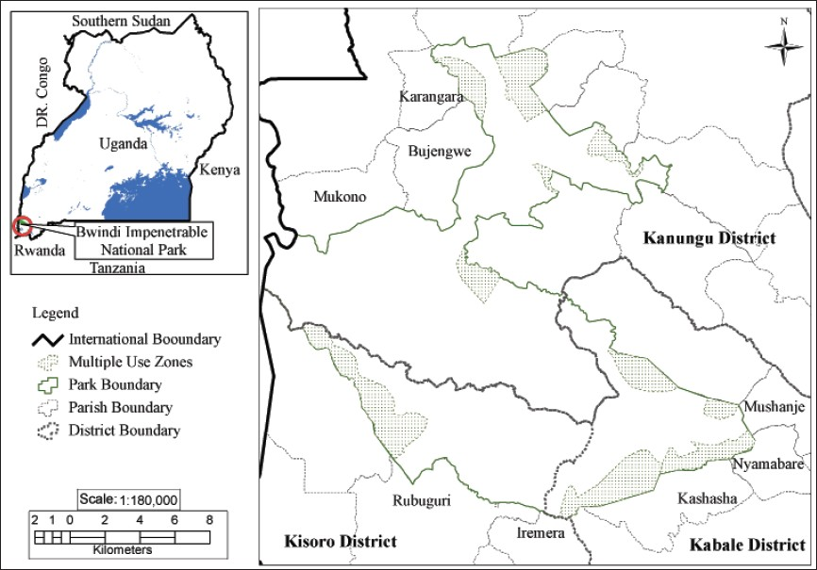
Figure 1.1 Location of Bwindi Impenetrable National Park, Uganda and its environs

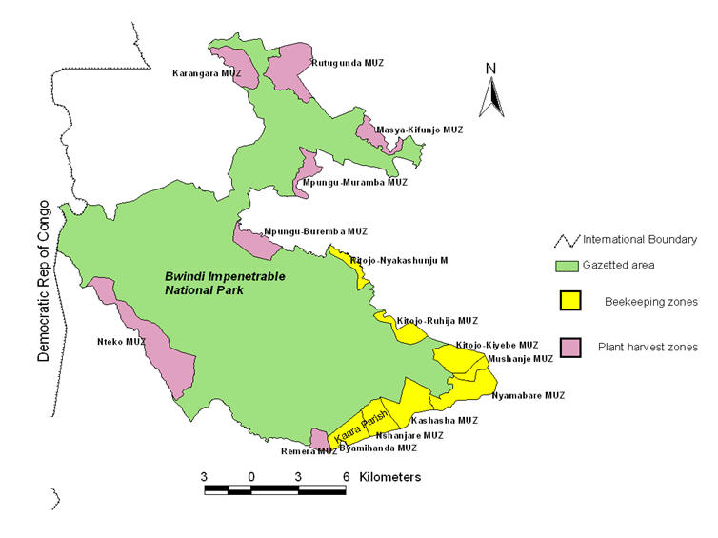
Figure 1.2 Location of the multiple-use areas in Bwindi Impenetrable National Park, Uganda

CHAPTER 2

LANDSCAPE INFLUENCES ON SPACE USE BY MOUNTAIN GORILLAS IN BWINDI IMPENETRABLE NATIONAL PARK, UGANDA

2.1 Introduction
Various aspects of mountain gorilla (Gorilla beringei beringei) ecology and conservation are fundamental to understanding how present and future use of space by gorillas in Bwindi Impenetrable National Park, Uganda, are or can be impacted by the natural, anthropogenic, and the projected future global climate changes. To conserve a species, we need to know its biology and its potential response to the threats it faces (Harcourt 2003). Knowledge of mountain gorilla ecology and behavior comes from landmark studies of Schaller (1963) and Fossey (1983) in the Virunga Volcanoes of Rwanda, Uganda and DR Congo. A majority of the subsequent information on the behavioral ecology of mountain gorillas comes from a long-term study of the gorilla social groups that Fossey monitored beginning in 1967 and continue up to today, making it one of the longest studies of any wild primate anywhere in the world (Robbins et al. 2001). In Bwindi, the mountain gorilla population has been observed since late 1990s, after the initial short surveys by Harcourt (1981) and Butynski (1984, 1985). Ongoing research has allowed comparisons to be made between the Bwindi and the Virunga Massif gorilla populations (e.g., Goldsmith, 2003; Robbins, et al., 2006; Rothman, et al., 2007). These studies provide good quality information on the ecology, behavior, and conservation status of mountain gorillas and allow an assessment of the susceptibility of the gorillas to human-induced threats and anticipated climate changes in the Bwindi landscape. Here, I synthesize the effects human-induced disturbance and climate change may have on some key aspects of mountain gorilla ecology such as the spatial and temporal distribution. Based on this assessment, I suggest that further research is needed to fill the gaps and inadequacies in the knowledge required to understand current and future distribution of gorillas in Bwindi.
Mountain gorillas are an ideal subspecies to study in a landscape context because their home ranges are wide (yearly home range for habituated groups in Bwindi is 23-33 km²; Robbins and McNeilage 2003; Ganas and Robbins 2005), use a wide array of vegetation types (Nkurunungi et al. 2004) and often help shape the ecosystems they live in (Watts 1987). In addition, gorillas live primarily in stable groups that are non territorial, have overlapping home ranges (Ganas and Robbins 2005), which are linked in space and time by dispersing individuals (Robbins 1995). Given the dynamic connectedness of the gorilla groups, human activities can fragment and disconnect the gorilla population if they are not planned from a landscape perspective. Since all the natural forest outside Bwindi is already lost, it is vital to understand the critical role the remaining forest habitat play in supporting the existing gorilla population and in ensuring potential future growth. In addition, the mountain gorillas are of highest conservation concern by virtue of being a critically endangered flagship subspecies and limited to a restricted range and habitat. As a result, its conservation status is likely to be profoundly affected by even a slight change in habitat conditions, yet our understanding of how these changes affect the mountain gorillas remains quite superficial. The gorillas are the focus of current and anticipated conservation and management plans and therefore the need for efficient conservation methods is a priority. For example, eco-tourism revenue from gorilla visitation funds the entire operating costs of protecting gorilla habitat in Bwindi; it offers financial incentives to the poor local communities and governments adjacent the park and largely contributes to the costs of maintaining all other protected areas in the country. But because of past encroachment and extensive as well as intensive disturbance, mainly from the adjacent fast-growing human population, Bwindi is now a forest island in a sea of human cultivation and habitation, further threatening the small gorilla population through isolation. Loss of the mountain gorilla from Bwindi forest is expected to have strong ecological and economic implications. A new threat of global climate change is likely to exacerbate the condition of the Bwindi ecosystem by interacting and likely acting synergistically with the current human impacts. However, there is paucity of information on how the subspecies will respond to projected changes. Because of this, conservation planning for the gorillas in light of human disturbance and climate change is still in its infancy.

2.2 Gorilla status
Gorillas are found only in equatorial Africa. They belong to the same taxonomic family (Hominidae) as humans, the orangutans (Pongo pygmaeus in Borneo and P. abelii in Sumatra) chimpanzee (Pan troglodytes) and bonobos (Pan paniscus). The orangutans, confined to the islands of Borneo and Sumatra, are Asia’s only surviving great ape (Knott & Kahlenberg, 2011). Mainly solitary and arboreal, it is the largest tree-dwelling primate. Large males can weigh 90 kg (200 lb) or more. Orangutans are sparsely covered in long hair, which darkens with age and ranges in color from bright orange to dark brown.
Chimpanzees and gorillas – are covered with short, coarse, black hair. Although they are accomplished climbers, they are equally at home on the ground. They are knuckle walkers, but will walk short distances on two legs.
Chimpanzees are mainly found in tropical rainforest, though some frequent savannah woodland. They usually live in loose groups of thirty or more individuals and are extremely vocal communicators. Adult chimpanzees stand about 1.2 m (4 ft) tall and weigh around 45 kg (100 lb). The bonobo, or pygmy chimpanzee, is slightly smaller and more upright than the “common” chimpanzee. Less comfortable on the ground, it is the most arboreal of Africa’s great apes and is confined to the left bank of the Congo River in the swampy forests of the Democratic Republic of Congo (Stumpf, 2011).
The comparative ecology and behavior of the gorilla is summarized by Robbins (2011). The gorilla is the largest of all primates. An adult male can weigh over 180 kg (400 lb). When mature, males develop a silver-grey saddle, hence the name ’silverback’. Adult females weigh about 90 kg (200 lb). Lowland gorillas occur in Angola, Cameroon, Central African Republic, the Democratic Republic of Congo (DRC), Equatorial Guinea, Gabon, Nigeria and the Republic of Congo.
The western lowland gorilla Gorilla gorilla has an estimated population of 10,000. Although it is the most widespread gorilla, numbers are decreasing rapidly. Its population is currently threatened not only by deforestation and the bushmeat trade, but also by potentially devastating outbreaks of the Ebola virus. It lives in flexible social groupings and, in that respect, more closely resembles chimpanzees than other gorillas. It also has a broader diet and consumes a larger proportion of fruit. As with all apes, logging and the bushmeat trade have taken a heavy toll and led to severe fragmentation of the population. The eastern lowland gorilla (G. beringei graueri), found only in eastern DRC, is less well known. Its population is thought not to exceed 7,000. By virtue of its location, it is highly vulnerable and has been severely affected by both war and illegal mining.
Mountain gorillas (G. b. beringei) are generally larger than their lowland counterparts. They are confined to two small, protected patches of afromontane forest in Uganda’s Bwindi Impenetrable National Park and the Virunga Volcano Region where Rwanda, Uganda and DR Congo meet.
Along with the Cross River subspecies of the western lowland gorilla (G. gorilla diehli), the mountain gorilla is one of the two most endangered apes in the world. These gorilla subspecies are threatened primarily by human activities. As human populations increase, the available habitat for these apes is decreasing and they are coming into contact with humans much more than they used to. Each gorilla population is threatened by different factors but all as a result from increasing human populations (Plumptre, et al., 2003).

2.3 Taxonomy and distribution
For over thirty years, gorillas were considered to be one species with three subspecies - western lowland gorillas (G. gorilla gorilla), eastern lowland gorillas (G. g. graueri), and mountain gorillas (G. g. beringei) (Groves 1970). However, Groves (2001) has reclassified the genus Gorilla into two species and four subspecies. Western gorillas include G. gorilla gorilla (western lowland gorilla) found in Equatorial Guinea, Gabon, Angola, Cameroon, central African Republic, and DR Congo, and G. g. diehli (Cross River gorilla), found in a handful of small populations in Nigeria and Cameroon. Eastern gorillas include G. beringei graueri (eastern lowland or Grauer’s gorilla), found in the east of DR Congo, and G. b. beringei (mountain gorilla), found in two small populations at the Virunga volcanoes of Uganda, Rwanda, and DR Congo. There has been strong argument that the Bwindi and Virunga gorillas should themselves be split into two taxa based on external features like hair length, skeletal measures, degree of arboreality, degree of frugivory, nesting behavior and daily travel distance (Sarmiento, et al., 1996). However, evidence of genetic (Garner and Ryder 1996; Jensen-Seaman and Kidd 2001), combined with anatomical, morphological, and ecological (Stanford 2001; Elgart 2010) studies does not support the split. Bwindi and the Virunga Volcanoes Conservation Area are, at their point of closest contact, not more than 30 km apart. The land separating the two forest tracts is today under intensive agriculture and human habitation. This inter-forest area is believed to have been cleared only 400-500 years ago (Hamilton, et al. 1986). These two gorilla populations are thus naturally one, made allopatric only by very recent human activity. The small size of the remaining mountain gorilla populations and the small number of samples available for examination make it more difficult than usual to determine whether the variation between populations is greater than variation within them (Ferriss et al. 2005).
The most recent gorilla census conducted late 2011 in Bwindi found a total of 400 individuals living in the park (Robbins et al 2011), making the world population of mountain gorillas to currently stand at 880 individuals. This implies this relatively small size gorilla population, coupled with the high human stresses in and around Bwindi, makes gorillas highly vulnerable to habitat changes. As the gorillas live at near uniform density across the area they currently occupy (Ferriss et al. 2005), population size is likely to decrease in proportion to the decrease in the size of the forest.

2.4 Impact of feeding ecology on gorilla distribution
How food resources influence the ecology and distribution of primates has been a central question of primate research since the first field studies begun, and a critical problem involves temporal and spatial changes in food availability (Chapman et al. 2012). Mountain gorillas are primarily herbivores. They eat non-reproductive plant parts (leaves, stems, pith, and bark) but prefer fruit, when available, to foliage (Goldsmith, 2003; Robbins & McNeilage, 2003; Stanford & Nkurunungi, 2003). They eat fruit approximately 60–80% of the days (Robbins and McNeilage 2003; Ganas et al. 2004) and may spend about 11% of their foraging time eating fruit (but may be as much as 60% of time in any given month; Robbins 2008). What is not clear is the proportion and quantity of the gorilla diet that is fruit versus herbaceous (Robbins 2011). However, the degree of frugivory decreases as altitude increases because of reduced fruit availability (Goldsmith 2003; Ganas et al. 2004). Occasionally gorillas feed on ants (Ganas and Robbins 2004) and decaying wood as a major source of sodium (Rothman et al 2006). During times of fruit scarcity, gorillas rely on fibrous foods as fallback foods. The number of herb species fed consumed by gorillas also decrease as altitude increases because of decreased plant diversity as altitude increases. Much as bamboo is available in Bwindi it is not fed on by gorillas (Ganas et al. 2004), in contrast to the Virunga Volcanoes where it is important component of the diet for some gorilla groups (Watts 1984; McNeilage 2001). Bwindi gorillas have also shown to be selective in their feeding behavior (Ganas et al. 2004). Even though much of their diet is influenced by availability of plant resources, gorillas also seek out foods with particular nutritional compositions and often forage on rare species. Gorillas select leaves and herbaceous materials that are high in protein and fruits that are high in soluble sugars (Ganas et al. 2008, 2009). Though the gorillas have strong seasonal preferences for certain food plants (Ganas et al 2004; Ganas et al. 2009; Robbins 2008; Rothman et al. 2011), it is not clear that they require certain plant species as there are spatial variability in the food plant species that different groups of mountain gorillas eat.
Differences in plant species use by different groups of gorillas could be one major factor that is contributing to present day gorilla distribution in Bwindi. There are two peripheral areas of Bwindi have not been utilized for nearly three and half decades (Figure 2.1; Harcourt 1981, Robbins et al. 2011). One is characterized by high altitude and has a patch of bamboo that occurs nowhere else in the forest (Butynski 1984; WWF & IUCN 1994). The other is situated at the lowest altitudinal range for the park and has vegetation that is different from the rest of the park (Leggat & Osmaston 1961; WWF & IUCN 1994). Although many factors, including high levels of human disturbance, may explain absence of gorillas in these areas (Harcourt 1981; Butynski 1985; McNeilage et al. 2001; 2006), food availability, plant species composition as well as their nutrient and energy content (food profitability) and/or group feeding traditions (Watts 1984; McNeilage 2001; Ganas et al. 2004) and unfamiliarity with available food resources may hinder gorillas from recolonizing these regions (Guschanski et al. 2008). In many animal taxa, including gorillas, the natural recolonization of areas abandoned because of past hunting pressures, or epidemics may be prevented or slowed down by habitat preferences, if vegetation or other important environmental influences are spatially structured. Guschanski et al. (2008) argued that that for effective dispersal to occur, even for a continuously distributed species like Bwindi gorillas, there must be suitable habitats that are of the preferred type. Areas outside the natal range may not be barriers to gorilla distributional shifts but may be regarded as unsuitable habitat; i.e., habitat through which the species can disperse or move but that does not support reproduction or long-term survival.

2.5 Impact of ranging patterns on gorilla distribution
An important theoretical challenge in primatology and pressing issue in primate conservation is to understand how primates are distributed with respect to the temporal and spatial variation of food resources (Chapman et al. 2012). The temporal and spatial availability of ripe fruits and young leaves of high quality varies considerably (van Schaik, et al. 1993; Worman & Chapman 2005), and faced with this variation, animals must move across their landscape and adjust their diet. Mountain gorilla ranging patterns are strongly influenced by diet and availability of food resources. Gorillas are not territorial and have overlapping home ranges (Ganas & Robbins 2005). They do not feed on fruits opportunistically but rather pursue fruit with daily travel distance positively correlated to fruit consumption (Ganas & Robbins 2005). Although the relationship between frugivory and home range size is not clear (Robbins 2011), there is a positive relationship between group size, daily travel distance, and home range size (Ganas & Robbins 2005). Solitary males travel farther per day and have larger home ranges than necessary to sustain a single individual because their movement patterns are also influenced by mate-acquisition strategies (Watts 1994). Mate competition can cause a drastic change in the sizes of gorilla home ranges. For example, Robbins and McNeilage (2003) found that the gorilla research group (Kyagurilo) in Bwindi dramatically increased its annual home range from ca. 21 km² in the first two years to 40 km² in the third year more likely because of the return of a silverback male to the group and subsequent conflict with the dominant male for alpha position. This implies that home range size and utilization in Bwindi probably depends on a complex relationship between the distribution and abundance of both fruit and herbaceous vegetation, and social factors such as competition for mates (Robbins & McNeilage 2003; Ganas & Robbins 2005). With better protection, it is anticipated that both the number of individual gorillas and the number of groups will increase. If this happens, we will perhaps witness gorillas expanding their distribution either through expansion or shift of home ranges for large groups, or colonization of un-utilized areas to avoid intergroup feeding and male-male mating competition.

2.6 Impact of population trends and dynamics on gorilla distribution
Mountain gorillas are one species for which repeated censuses in Bwindi have been carried out. The population was estimated at 300 gorillas within sections of the park repeatedly surveyed during 1987-1993 (Butynski & Kalina 1993). In 1997, the entire park was surveyed over a two-month period using the same systematic ‘sweep census’ that was used in the Virunga Volcanoes (McNeilage et al., 2001; Gray et al 2009). It was estimated that the entire park contained 300 gorillas, suggesting that either the earlier survey overestimated the population size, or that it had remained stable during the decade. Another ‘sweep census’ was conducted in 2002, with the population increasing to 320 gorillas, representing small annual population growth (McNeilage et al., 2006). However, these results were called into question following another sweep census in 2006 that also incorporated genetic analysis as a method to identify individuals of the population. Genotypes of the gorillas, obtained from faeces left in the night nests, led to the finding that some gorillas make more than one nest each night and that some groups were counted twice; thus, it was not possible to discriminate among individuals using the data obtained from the nest sites alone. While the nest count results suggested that the population had increased to 340, in combination with the more precise and accurate genetic analyses, the population was estimated to be only 300 (Guschanski et al. 2009). In 2011, the population was censused using a modified ‘mark-recapture’ method, which involved two sweeps of the entire park and incorporation of genetic analyses, and the population was estimated at 400 individuals (Robbins et al. 2011). Because of the possibility of both over- and undercounting of gorillas due to a variety of factors in earlier censuses, it is difficult to conclude the populations’ trend over the past two decades. However, in all likelihood, the population has been relatively stable for at least the past two decades.
Several patterns have, however, emerged concerning the distribution of gorillas in the park. The gorillas were found to be concentrated more in the center of the southern sector of the park, although groups were located along the edge in many locations (Figure 2.1). The eastern region was devoid of gorillas in the 1997, 2002, and 2006 censuses, despite it containing seemingly suitable vegetation. Anecdotal evidence from the local people indicates that gorillas were poached out of this area in the 1970s and 1980s. The northern sector of Bwindi, long considered unsuitable habitat for the gorillas because of the lower altitude, was not known to contain any gorillas until one of the groups habituated for tourism began to use the southern portion of it in 2006. It is not known how many gorillas the northern sector could support.
Analysis of the life history data from known individuals in the gorilla groups habituated for research or tourism from 1993 to 2007, and comparisons with the mountain gorillas of the Virunga Volcanoes, add some insight into the population dynamics of the Bwindi mountain gorillas (Robbins et al., 2009). The Bwindi gorillas have a significantly lower birth rate and longer inter-birth intervals than their Virunga counterparts. Unfortunately, not enough data exist to calculate mortality rates per age class, except for infants (< 3 years old). Infant mortality in Bwindi was not significantly different from that of the Virunga mountain gorillas. Using the birth rate from Bwindi and the mortality rates from the Virungas, Leslie matrix models predict that the population should be growing at an annual rate of 2.5-4% (depending on whether unexplained ‘disappearances’ from the habituated groups were of gorillas that either dispersed or died). However, even with the inaccuracies inherent in the sweep census method, it is unlikely that the entire population could be growing at this rate. For example, had there been 300 gorillas in 1986, with an annual population growth rate of 3%, there would have been 540 gorillas in the park in 2006. These results suggest that the habituated groups may be faring better than the wild groups, perhaps due to better monitoring and protection. It is possible that the population is at or near to carrying capacity, even though there are areas of the park currently under-utilized by the gorillas (e.g., the eastern region). Further analyses are necessary to understand the complex interactions among human disturbance, ecology, and the gorillas’ population dynamics.

2.7 Impact of human disturbance on gorilla distribution
Bwindi has been under human pressure for a very long time and different types of human disturbances seem to be responsible for the present day mountain gorilla distribution. Albrecht (1976), in July/August 1972, observed rapid destruction of the remaining natural forest outside the forest reserve, high frequency of unlicensed pitsaws inside the reserve, abundance of snares and traps and scarcity of wild animals and concluded that the forest and its wildlife were in a bad state. In all the subsequent forest-wide surveys of Bwindi, gorillas were found to have little or no overlap with areas of intense human activity (Harcourt 1981; Butynski 1984, 1985; McNeilage et al. 2001, 2006; Guschanski et al. 2009; Robbins et al. 2011). Two major blocks of the forest, the northern part and eastern part of southern lobe of the forest, are devoid of gorillas (Figure 2.1). Also, much of the fringe of the park is avoided by wild gorillas or is used infrequently. Areas without gorillas experienced the highest levels of human activity and human activity is also concentrated at the periphery of the park and decreases as one moves into the interior of the forest. Major human activities that are believed have an impact on gorilla distribution are reviewed below.

2.7.1 Deforestation
In 1933/34, Pitman (1935) observed nearly 40 to 50 gorillas living in a forest tract that was contiguous with the south-west boundary of the then forest reserve. Since then, this tract has been lost to agriculture and gorillas eliminated (Butynski 1984). In 1954, the total natural forest area in Bwindi region was 427.7 km². By 1990, this had been reduced to 324.9 km², a reduction of 27% (Scott 1992). Pockets of forest that remained by 1990 were too isolated from Bwindi itself to be considered part of the continuous forest vegetation. Today, little or no natural forest remains outside the protected area. The park is a forest island in an agricultural and human settlement landscape, with the park boundary forming a hard edge. This has implications for gorilla distribution. There is no more natural habitat for the gorilla that is not restricted to the protected area. When the gorillas move out the forest, they cause conflict with the local communities as they destroy crops in the gardens and/or cause injury or even death to community members. This has sometimes led to the killing of crop-raiding gorillas by the local communities (Butynski 1985, Robbins et al. 2009). Wild gorillas may therefore avoid the periphery of the park as it is near areas of high human activity and habitation. Since all the natural forest outside Bwindi has been lost, it is vital to understand the critical role the remaining forest habitat play in supporting the existing gorilla population and in ensuring potential for future growth.

2.7.2 Logging
Commercial logging activity began in 1947 (Leggat & Osmaston 1961) and continued for a period of nearly 45 years up to 1991 when Bwindi was declared a national park (Cunningham 1996). It is an activity that was common and widespread (Harcourt 1981; Butynski 1984) and had a great impact on the forest structure and composition. Logging, most of it illegal, occurred throughout the forest with only less than 10% of the park area being relatively unaffected (Howard 1991). The effects of logging extend further than a pit-saw site. For example, logging created very large open areas that are now covered with dense tangle of semi-woody herbaceous climbers like Mimulopsis solsmii, Sericostachys scandens, Pteridium aquilinum and a variety of semi-woody climbers, shrubs and herbaceous plants, showing little sign of tree regeneration (Babaasa et al. 2004; Eilu & Obua 2005). Harcourt (1981) found little overlap between logged areas and gorilla use of the areas. Even in previously logged areas that had luxuriant secondary vegetation that is reported to be preferred by gorillas (Schaller 1963), no gorillas or their signs were found. Because logging decreased from the periphery of the forest to the interior, and gorillas were concentrated in the interior of the forest, Butynski (1985) concluded that gorillas may prefer less altered habitats and/or are intolerant of people. Loggers were also observed going into the forest with spears and dogs (Butynski 1984, 1985). Much as the intention could have been to poach wildlife, it could also be that loggers were carrying spears and accompanied by dogs to scare away gorillas from the pit-saw sites.

2.7.3 Hunting/poaching
Another common and widespread activity that historically occurred throughout the park was poaching/hunting (Harcourt 1981; Butynski 1984). The target animals were mainly bush pigs (Potamochoerus larvatus) and duikers (Cephalophus spp.) and there was no real evidence of traps set for primates as the communities around Bwindi do not consume primates as bushmeat. This gives gorillas some degree of protection from direct poaching. Even though hunters target antelopes and pigs, hunting leaves behind artifacts like snares in which gorillas can be later trapped and injured, sometimes leading to death (Plumptre et al. 1997; Mudakikwa et al. 2001). Hunters did use spears and dogs, but wire and rope snares were more prevalent and this activity continues today though at a much lower intensity (McNeilage et al. 2001, 2006; Robbins 2011; Mugerwa et al., 2012). Butynski (1984) found 89 snares while walking nearly 200 km with only one or two guides, 62 snares were found in over 500 km walked during the 1997 gorilla census (McNeilage et al. 2001), 76 snares found in approximately 600 km of trails walked in 2006 and 74 snares found in about 700 km of trails covered in 2011 (Robbins et al. 2011). This clearly indicates that fewer snares are being encountered. Poachers carrying spears, machetes and bags, as well as several hunting dogs, were captured at some camera trap survey locations in 2010 and 2012 (Mugerwa, et al., 2012; Badru Mugerwa pers commun). Gorillas are known to show a special antipathy toward dogs (Schaller 1963), so that the gorillas are sometimes killed or seriously wounded when the poachers are trying to rescue their hunting dogs. Also, gorillas are killed when they crop raid. So far there have been four incidences of killing of gorillas from the habituated groups (4 in March 1995, 3 in late 1997, 1 in 2009 and 1 in June 2011) by poachers/farmers in an effort to save their dogs or crops (Gorilla Gazette, 1995; Robbins et al. 2009; IGCP, 2011). Such killings are more likely to have been going on for long in Bwindi but were not recorded. For example, Pitman (1935) reports that a group of gorillas was nearly eliminated by the local communities in 1933 shortly after he had visited it. Butynski (1985) also received repeated reports of two gorillas being killed in 1981 after raiding a banana plantation. Although hunting in Bwindi does not specifically target gorillas (Harcourt 1981; Butynski 1985), unconfirmed incidental killings of gorillas in the past could be responsible for large areas of Bwindi being devoid of the apes (Robbins et al. 2009).
Prevalence of poaching has been reduced by greater law enforcement and tourism activities, and to a small extent by community projects that implemented in the local communities by the park and several conservation organizations (Blomley et al. 2010). But still surveys show that there are more snares in the interior of the forest than at the periphery (McNeilage et al. 2001, 2006; Robbins et al. 2011), probably reflecting higher densities of animals, especially pigs and duikers, in the interior. Butynski (1984) noted that poachers are willing to invest considerable time and effort, while at the same time experience low rates of hunting success, in attempts to capture the few remaining large mammals and fowl from extensive tracts of Bwindi. Thus, poachers are not only capable of reducing wildlife populations, but they are also capable of eliminating them. This indicates that gorillas are still susceptible to the activities of poachers and hunters.

2.7.4 Mining/prospecting
Mining and prospecting for minerals, primarily gold, was another human activity that was common throughout the forest before it was made a national park (Harcourt 1981; Butynski 1984). The likely negative impacts of uncontrolled mineral prospecting within the forest on gorillas were first made in 1933/34 by Pitman (1935). Pitman (1935) at the same time received complaints from miners about gorillas being too near their working sites for comfort. Mining/panning was mainly concentrated in valleys, along water courses, areas that are most favored by gorillas largely for feeding, thus likely displacing them. Mining also severely damaged the soil, watershed and the surrounding vegetation (Butynski 1984). Miners were also observed to be carrying spears and accompanied by dogs (Harcourt, 1981; Butynski, 1984). The reason for this was either to hunt antelopes or scare gorillas away from the mining sites. The fact that mining was mainly concentrated in the interior of forest, and in the valleys, the areas most favored by gorillas (Harcourt, 1981; Butynski, 1984) meant that mining had a disruptive effect on gorilla distribution far out proportion to its extent (Harcourt 1981).

2.7.5 Harvesting of non-timber forest products
People around the park depend on the park for natural resources (Cunningham 1996). Removal of minor forest products like poles, fuel wood, basketry materials, bamboo and honey used to be common (Butynski 1984). Some resources, like those used for basketry materials, medicine, and bee keeping, are still permitted to be harvested from areas <2 km from the edge, known as multiple-use areas. However, the proposed changes to the management zoning of the park will result in reduction of the number and areal extent of the multiple-use areas within the park (UWA, 2012). Because of the large number of local people that were involved in harvesting the non-timber forest products and/or the high frequency of removal in the past, the cumulative effects of the activity was becoming apparent and serious with greater damage to vegetation and wildlife (Olupot, et al., 2009). Gorillas rarely use the edge of the park, probably because of high human use of the areas (Butynski 1985, McNeilage et al. 2001, 2006). Much as the forest on the periphery of the park is not destroyed, it may be lost as suitable gorilla habitat if human disturbance is severe enough.

2.7.6 Tourism and research
Some areas in Bwindi are used for tourism and research. Human presence, whether by tourists, researchers, park staff and local community members, in such areas is likely to deter wild gorillas from utilizing those sites (McNeilage et al. 2001). However, there is little quantifiable signs in the forest to indicate tourism and research forest use. Also, habituation of gorillas for tourism and research potentially increases the risk of disease transmission between humans and the gorillas (Butynski & Kalina, 1998; Homsy, 1999; Woodford et al. 2002). An outbreak of scabies in gorillas occurred in the Nkuringo sector in 1997 and 2000 (Kalema-Zikusoka et al. 2002), where tourism gorillas regularly range around the edge of the park and comes into contact with the local communities. However, there was no evidence that this caused mortality in the gorilla population. Although disease transmission from humans and livestock is now regarded as one of the greatest threat to gorillas (Plumptre, et al., 2003), little is known about the potential impact of diseases on the population.

2.7.7 Roads and trails
The Rubanda-Kitahurira road enters the Reserve in the south-east corner of the South Sector, rises to 2,400 m in the bamboo zone and continues through the park until about 1.5 km north-west of Ruhija where it forms the eastern boundary of the park. This road runs through the park for about 14 km. The road enters the park for the second time as it passes through that narrow neck of forest which demarcates the South Sector of the park from the North Sector (Figure 2.2). Here the road passes through the forest for 3 km. The road is heavily walked by local community members, and many heavy trucks carrying people, supplies and agricultural produce, especially tea, use the road; now with the growing tourism, there is increased vehicular traffic, as well. In addition, there are open, well-used footpaths that are used by more than a person per day and many less distinct paths within the park, especially in areas less than 2 km from the park boundary (Olupot et al. 2009). Gorillas are likely to shun areas that are in the vicinity of the roads and heavily used paths. The road crossing through the narrow neck between the northern and southern parts of Bwindi could be the reason gorillas are not using the northern part of Bwindi (Butynski 1984; McNeilage et al. 2001; 2006) or the size of the ‘neck’ itself could limit access to the northern part (Robbins et al 2009). The road through eastern part of the southern sector could also contribute to the area being not utilized by gorillas.

2.7.8 Comparison of human disturbance in Bwindi and Virunga Massif
Most of the published threats to mountain gorillas (e.g., Plumptre, et al., 2003) are largely based on assessments made for the Virunga Massif. This is because Bwindi gorilla population faces far less severe threats in comparison to the Virunga population. For example, fewer snares were found in Bwindi compared to the Virunga Massif during the censuses; 74 snares were found in 778 km of reconnaissance trails for an overall encounter rate of 0.095 snares per km walked in Bwindi in 2011 compared to the Virunga Massif where 218 snares were found in 1,141 km of reconnaissance trails for an overall encounter rate of 0.191 snare per km walked in the in 2010 (Robbins et al. 2011) and 241 snares encountered in 810 km of reconnaissance trails giving an encounter rate of 0.298 snare per km walked in 2003 (Gray et al. 2006). In 1997 gorilla census, 62 snares were found in Bwindi compared to the 1989 Virunga gorilla census where 414 snares were located (McNeilage et al. 2001).
Whereas only nine gorillas are known to have been killed in Bwindi over a period of 18 years, Kalpers et al. (2003) and Jenkins (2008) report nearly 40 gorillas killed over the same time span in Virunga Massif. This is largely attributed to the war, political instability and insecurity the Virunga region that has been facing for over two decades (Plumptre, et al., 2003). Much as it possible that some killings may have been missed, it is unlikely given the high density of people that live adjacent the protected areas and the local knowledge of the value of gorillas, especially for tourism (Robbins et al. 2009).
Livestock grazing is not among the major problems Bwindi has faced compared to the Virunga (Harcourt 1981). Although Butynski (1984) found evidence of signs livestock in the areas he surveyed, most of the signs were of livestock being driven along the roads and trails through the forest. It is only in the northern sector that there were signs of grazing and burning to improve pasture. This activity was not reported at all in subsequent surveys of Bwindi. Livestock grazing still takes place in the Virunga Massif (Gray, et al., 2005). There are also no reports of agricultural encroachment in Bwindi apart from small infringements at the forest boundary (Butynski 1984; Olupot et al. 2009). However, in the Virunga, 54% of the protected area was lost to agriculture between 1958 and 1979 (Weber 1987) and is probably partly responsible for the decline in the gorilla population from the 1960s to the 80s (Harcourt, et al., 1983). Although habitat loss has been close to zero in recent years, there were extended periods of human presence in the Virunga during the 1990s and early 2000s as refugees and armed groups took harbor in the forest environment (Jenkins 2008). The people were cutting vegetation for building houses, fuel wood and charcoal. These activities had considerable impact on the gorillas as they resulted in many of their deaths. Armed groups still occupy the DR Congo side of the Virunga today. Such heavy human presence in the protected area may cause direct disturbance to gorillas and result in shifts in ranging patterns as gorillas avoid areas of human activity. Thus, both the Bwindi and Virunga mountain gorilla populations are threatened by human factors but which vary in type and/or intensity.

2.8 Impact of physical barriers on gorilla distribution
There are no known physical factors (e.g., topographical characteristics, wide and deep rivers, temperature or rainfall) that limit significantly the distribution of gorillas within Bwindi. The only physical factor could be altitude, but it likely affects gorilla distribution only indirectly by being correlated with the vegetation composition of locally available food resources (see section 2.3). Thus the spatial distribution of gorillas in Bwindi could be influenced by a variety of factors including ecological conditions and levels of human disturbance (past and present), as well as the natural movement of individual groups whose annual home ranges overlap.

2.9 Impact of projected climate changes on future gorilla distribution
Thorne et al. (2013) used correlative species distribution models (SDM) to predict shifts in climate suitability for the mountain gorillas throughout their range. They estimated the current climate suitable areas for the mountain gorillas by associating geo-referenced occurrence data for the entire range, which consists of Bwindi (Uganda) and the three contiguous parks in the Virunga Volcanoes area: Mgahinga Gorilla National Park (Uganda), Parc National des Volcans (Rwanda), and the Mikeno Sector of Parc National des Virunga (DR Congo; Figure 2.3) with sets of current climatic variables [monthly temperature minimum, maximum and precipitation] from WorldClim (Hijmans, et al., 2005). The derived model was then used to predict geographic areas that will have the same climate conditions as observed mountain gorilla sites for different time periods with future climate change for three SRES (IPCC 2000) greenhouse gas emission scenarios: A2, A1B and B1 for two time periods: 2041-60 (‘2050´), and 2081-2100 (‘2090´); using five global climate models (GCMs). The SDMs used represent four sets of biological assumptions: 1) the “standard” approach, which used mountain gorilla occurrence sites and climate data with two SDM algorithms (Bioclim and Maxent) and two sets of climatic predictor variables (either 18 or three); 2) the “niche conservatism” models, which are the same as the standard models except that they use the entire eastern gorilla species as unit of analysis, i.e., combining the presence of mountain gorilla with that of the eastern lowland gorilla, G. b. graueri; 3) the “behavioral” model, a climate driven gorilla time-management model; and 4) the “limiting-factor” model, which predicts that mountain gorilla can survive in any environment where plant productivity is at least as high as the areas where they currently occur, i.e., at least as warm and humid as these areas.
The ‘standard’ models showed that the mountain gorilla parks, and by extension the whole of the Albertine Rift ecoregion, will not be climatically suitable for the subspecies by 2050. But Thorne et al. (2013) were quick to add that this result could be because these models assume that a species can only occur in areas with a climate that is similar to that of the sites where it is currently observed. This is unlikely to be the case with mountain gorillas as we know that their range is presently restricted by non-climatic factors, particularly expanding human populations and other human-related dispersal barriers. So the standard SDMs may not reflect the entire ecological niche of a species. Because the mountain gorilla has been effectively isolated in its mountain refuges by human encroachment and by the geographic barrier of the Rift Valley, it is possible that the species currently occurs at the cold end of what it can tolerate. If that is so, then the mountain gorilla might not be affected by some warming as long as rainfall remains high and well distributed, such that net primary productivity is maintained throughout the year.
The Niche conservatism models and the limiting factor modes predicted that suitability of the parks would not be much affected in 2050 or 2090. The behavior model showed intermediate predictions, and had the largest decrease of suitable area between 2050 and 2090. The differences among the model predictions for areas immediately outside (less than 5km) were comparable to those for the parks. The limiting factor and behavior models predicted much more area to be suitable in the future in other areas of the Albertine Rift ecoregion.
Rather than relying on a single “best” model, some authors (e.g., Thuiller, 2003) have argued for using many models and applying some sort of model averaging. When Thorne et al. (2013) applied the model averaging, a number of areas that might be climatically suitable in 2090 were revealed. These include most of the parks and areas outside the parks, especially areas to the south and west. Additional areas appear to be suitable now and in the future. These include areas in the Ruwenzori Mountains in Uganda and the DR Congo, to the west of the Mikeno Sector of the Virunga National Park (Mt Nyamulagira area in Virunga National Park, DR Congo), Nyungwe National Park in Rwanda and Kibira National Park in Burundi. Lands suitable for park expansion were found in most directions from existing protected areas. Areas downslope of the current parks in the Virungas appear to currently be, and will remain, suitable, particularly regions in Rwanda. For Bwindi, the area most suitable for expansion appears to be the west of the southern lobe of that park. In addition, Gishwati forest in Rwanda, a relic ancient rainforest, directly south of the Virunga Massif, was deemed suitable in about 60% of the future model runs.
Differences in model predictions point to gaps in our knowledge that could be used to guide more research. For example, areas identified as unsuitable in one model but suitable in another, like the northern part of Bwindi which is at the lower and warmer areas of the park and is currently available but unoccupied by gorillas, could become a focus of further study (Thorne et al. 2013).

2.10. Synthesis
There is much variation in the physical environment of Bwindi, therefore gorillas utilize a range of habitats in the park. There are also different types of human disturbances in the park that occur singly in particular locations or in combination in other locations. Human disturbance occurs in the whole park but is unevenly distributed and different disturbances are concentrated in different areas. Historical disturbances like logging and mining still have a legacy in terms of wildlife distribution. It is therefore difficult to point out a single environmental factor responsible for gorilla distribution. Given that wild gorillas rapidly flee from people and may increase the distance they travel per day (Cipolletta 2003), the gorillas might respond by shifting their home ranges away from areas with high levels of human presence and direct disturbance. I therefore would postulate that levels of human activity in and around Bwindi are responsible for the present distribution of wild gorillas in the park rather than ecological factors.

2.11 Needed research
Due to the various land-use practices occurring within Bwindi and their long-term effects on ecosystems, as well as research projects on mountain gorillas undertaken in the park, it is deemed important to undertake a vegetation description and classification of Bwindi. A study of a population of a species can have little practical value without adequate description of the associated vegetation and its correlation with the environment. Vegetation structure and composition of an area is regarded as representing the habitat conditions for wildlife living in an area. In all the surveys done in Bwindi, no detailed vegetation study has been conducted. This could confound the results of relating gorilla distribution to human disturbance since much of the human activity occurred at the edge of the park and majority of the gorilla groups are in the center of the park. This could also be a result of divergent preferences, humans for the periphery of the park and gorillas’ for the centre. My current work involves producing a vegetation type cover map of the park and will take into account the vegetation structure and composition in the analysis of gorilla distribution in Bwindi.
Results of past surveys were analysed by comparing individually the types of human activity and gorilla distribution. While no part of Bwindi seemed to have been free from human disturbance, human activities were, in the past and now, not evenly distributed over the forest. The spatial distribution of different types of disturbance were/are in some cases similar and several different types of illegal activity may be carried out together. Therefore, it may not be possible to draw conclusions about differential impacts of particular types of disturbance of gorilla distribution within the park. Even when human activity type is considered individually, the densities of human disturbance become so low that they produce insignificant results in correlative analyses. But we are well aware that wild gorillas will rapidly flee from people, irrespective of which activity they are engaged in, which may increase the distance they travel in a day and may also result in gorillas shifting their home ranges away from areas of continuous high human disturbance (Cipolletta, 2003). Although much of human activities of the past no longer occur in the park, or occur at a lower intensity, their signs are still visible in the forest and may still have a legacy in terms of the areas favored by gorillas (McNeilage et al. 2001, 2006). If an area has been subjected to high levels of disturbance over the several preceding years, the gorillas might not yet have started using that area again, even if the disturbance had been eliminated. Therefore, I intend to analyze all forms of human disturbances including those which no longer occur in the park (like logging and mining) and those not considered before like roads, deforestation outside the park, and ecological factors such as vegetation cover type simultaneously to find out which factor(s) influence gorilla distribution most.
Most assessments of climate change tend to focus on single factors, such as changes in distribution (e.g., from bioclimatic envelope models) or changes in phenology and the potential for phenological mismatches. These models assume that species distributions are solely governed by climate rather than by ecological interactions or historical factors. There is a lot of variation in the way in which species respond to climate change, calling into question the validity of the distributional changes derived from bioclimatic models. The bioclimatic envelope approaches rely on current distributional data to infer future changes but do not necessarily have evidence of actual shifts. For example, in Bwindi, mountain gorilla range is presently restricted by non-climatic factors, especially expanding human populations (Thorne, et al., 2013). Lastly, bioclimatic models are designed to apply on large spatial scales so that if you a species restricted to a small area, even the downgraded models (to 0.5º – 1º high resolution), may not be suitable. To this end in Chapter 5, I plan to use the “climate change vulnerability index” developed by Nature Serve [www.natureserve.org/climatechange] (Young, et al., 2011, 2013) to define the degree to which mountain gorillas in Bwindi are susceptible to climate change. It is a multifaceted rapid assessment tool that relies on natural history and distribution factors that are associated with sensitivity to climate change and projections of climatic changes for the assessment area. The index can handle missing data and uncertainty in species sensitivity measures and inputs from studies that document vulnerability or project future suitable ranges, when available. Its output includes both a vulnerability category for the species of interest and a report on the key factors that have contributed to the ranking, which can inform conservation actions that increase the resilience of species to climate change. The climate change vulnerability index will complement other available information on climate change assessment done using the bioclimatic envelopes and conservation status assessments from the IUCN Red Data List.

2.11 Bibliography
Akcakaya, H. R., & Ginzburg, L. R. (1991). Ecological risk analysis for single and multiple populations. In A. Seitz, & V. Loeschke, Species Conservation: Population-Biology Approach (pp. 73-87). Basel: Birkhauser Verlag.
Albrecht, H. (1976). Chimpanzees in Uganda. Oryx , 13, 357-361.
Baker, J., Bitariho, R., Gordon-Maclean, A., Kasoma, P., Roe, D., Sheil, D., et al. (2013). Linking protected area conservation with poverty alleviation in Uganda: Integrated Conservation and Development Projects at Bwindi Impenetrable National Park. In J. B. Smith, National Parks (pp. 47-103). Nova Science Publishers, Inc.
Blomley, T., Namara, A., McNeilage, A., Franks, P., Rainer, H., Donaldson, A., et al. (2010). Development and gorillas: Assessing fifteen years of integrated conservation and development in south-western Uganda. Natural Resource Issues No 23 .
Butynski, T. (1984). Ecological Survey of the Impenetrable (Bwindi) Forest, Uganda, and Recommendations for its Conservation and Management. Unpublished report to the Uganda Government.
Butynski, T. (1985). Primates and their conservation in the Impenetrable (Bwindi) Forest, Uganda. Primate Conservation , 6, 68-72.
Butynski, T., & Kalina, J. (1998). Gorilla tourism: A critical look. In M. J. Milner-Gulland, & R. Mace, Conservation of Biological Resources (pp. 292-313). Oxford: Blackwell Sciences.
Chapman, C., Rothman, J. M., & Lambert, J. E. (2012). Food as a selective force in primates. In J. C. Mitani, C. J. C, P. M. Kappeler, R. A. Palombit, & J. B. Silk, The Evolution of Primate Societies (pp. 149-168). Chicago: The University of Chicago Press.
Cipolletta, C. (2003). Ranging patterns of a western group during habituation to humans in the Dzanga-Nkozi National Park, Central African Republic. International Journal of Primatology , 24, 1207-1226.
Cunningham, A. B. (1996). People and plant use: Recommendations for multiple use zones and development alternatives around Bwindi Impenetrable National Park, Uganda. Paris: UNESCO Working Paper No. 4.
Durant, S. M., & Mace, G. M. (1994). Species difference and population structure in population viability analysis. In P. G. Olney, G. M. Mace, & A. T. Feistner, Creative Conservation. Interactive Management of wild and Captive Animals (pp. 67-91). London: Chapman and Hall.
Elgart, A. (2010). Are the gorillas in Bwindi Impenetrable National Park "True" mountain gorillas? American Journal of Physical Anthropology , 141, 561-570.
Feriss, S., Robbins, M., & Williamson, E. (2005). Eastern gorilla (Gorilla beringei). In J. Caldecott, & L. Miles, World Atlas of Great Apes and their Conservation. Berkeley: UNEP-WCMC.
Fossey, D. (1983). Gorillas in the Mist. London: Hodder and Stoughton.
Ganas, J., & Robbins, M. M. (2004). Intrapopulation differences in ant eating in the mountain gorillas of Bwindi Impenetrable National Park, Uganda. Primates , 45, 275-279.
Ganas, J., & Robbins, M. M. (2005). Ranging behavior of the mountain gorilla (Gorilla beringei beringei) in Bwindi Impenetrable National Park, Uganda: a test of the ecological constraints model. Behavioral Ecology and Sociobiology , 58, 277-288.
Ganas, J., Ortmann, S., & Robbins, M. M. (2009). Food choices of the mountain gorilla in Bwindi Impenetrable National Park, Uganda: the influence of nutrients, phenolics, and availability. Journal of Tropical Ecology , 25, 123-134.
Ganas, J., Ortmann, S., & Robbins, M. M. (2008). Food preferences of wild mountain gorillas. American Journal of Primatology , 70, 1-12.
Ganas, J., Robbins, M. M., Nkurunungi, J. B., Kaplin, B. A., & McNeilage, A. (2004). Dietary variability of mountain gorillas in Bwindi Impenetrable National Park, Uganda. International Journal of Primatology , 70, 1-12.
Garner, K., & Ryder, O. (1996). Mitochondrial DNA diversity in gorillas. Molecular Phylogenetics and Evolution , 6, 39-48.
Goldsmith, M. L. (2003). Comparitive behavioral ecology of a lowland and highland gorilla population: where do Bwindi gorillas fit? In A. B. Taylor, & M. L. Goldsmith, Gorilla Biology: A Multidisciplinary Perspective (pp. 358-384). Cambridge: Cambridge University Press.
Gorilla Gazette. (1995). Retrieved from http://pin.primate.wisc.edu/news/journals/GorillaGazette/gaz1995/gazettedec95.pdf
Government of Uganda. (2012). Uganda National Climate Change Policy. Kampala: Ministry of Water and Environment.
Graczyk, T. K., Cranfield, M. R., & Eilenberger, U. (2001). Hyperkeratotic mange caused by Sarcoptes scabiei [Acariformes: Sarcoptidae] in juvenile human-habituated mountain gorillas [gorilla gorilla beringei]. Parasitology Research , 87 (12), 1024-1028.
Gray, M., McNeilage, A., Fawcett, K., Robbins, M. M., Ssebide, B., Mbula, D., et al. (2003). Virunga Volcanoes Range Mountain Gorilla Census, 2003. Kampala, Uganda: UWA/ORTPN/ICCN.
Gray, M., McNeilage, A., Fawcett, K., Robbins, M. M., Ssebide, B., Mbula, D., et al. (2005). Virunga Volcanoes Range Mountain Gorilla Census, 2003. Joint Organisers' Report. UWA/ORTPN/ICCN.
Grooves. (2001). Primate taxonomy. Washington DC: Smithsonian Institute Press.
Groves, C. P. (1970). Population systematic of gorilla. Journal of Zoology, London , 161, 287-300.
Guschanski, K., Caillaud, D., Robbins, M. M., & Vigilant, L. (2008). Female shape the genetic structure of a gorilla population. Current Biology , 18 (22), 1809-1814.
Guschanski, K., Vigilant, L., McNeilage, A., Gray, M., Kagoda, E., & Robbins, M. (2009). Counting elusive animals: comparing field and genetic census of the entire mountain gorilla population of Bwindi Impenetrable National Park, Uganda. Biological Conservation , 142, 290-300.
Hamilton, A., Taylor, D., & Vogel, J. (1986). Early forest clearance and environmental degradation in south-west Uganda. Nature , 320, 164-167.
Harcourt, A. (1981). Can Uganda's gorillas survive? A survey of the Bwindi Forest Reserve. Biological Conservation , 19, 269-282.
Harcourt, A., Kineman, J., Campbell, G., Yamagiwa, J., Redmond, I., Aveling, C., et al. (1983). Conservation of the Virunga gorilla population. African Journal of Ecology , 21, 139-142.
Hijmans, R., E, C. S., Parra, J. L., Jones, P. C., & Jarvis, A. (2005). Very high resolution interpolated climate surfaces for global land areas. International Journal of Climatology , 25, 1965-1978.
Homsy, J. (1999). Ape tourism and human diseases: How close should we get? Kampala, Uganda: International gorilla Conservation Program.
International Gorilla Conservation Program. (2011, June). Retrieved from http://www.igcp.org/mountain-gorilla-killed-by-poachers-in-bwindi-impenetrable-national-park-uganda/
Jenkins, M. (2008). Who murdered the Virunga gorillas? National Geographic , 214, 34-65.
Jensen-Seaman, M. I., & Kidd, K. K. (2001). Mitochondrial DNA variation and biography of eastern gorillas. Molecular Ecology , 10, 2241-2247.
Kalema-Zikusoka, G., Kock, R. A., & Macfie, E. J. (2002). Scabies in free ranging gorilla [Gorilla beringei beringei] in Bwindi Impenetrable National Park, Uganda. The Veterinary Record , 150, 12-15.
Kalpers, J., A, W. E., M, R. M., A, M., Nzamurambaho, A., Ndakasi, L., et al. (2003). Gorillas in the crossfire: assessment of population dynamics of the Virunga Mountain Gorillas over the past three decades. Oryx , 37, 326-337.
Lukas, D., Bradley, B. J., M, N. A., Doran-Sheehy, D., Robbins, M. M., & Vigilant, L. (2004). Major histocompatibility complex and microsatellite variation in two populations of wild gorillas. Molecular Ecology , 13 (11), 3389-3402.
McNeilage, A., Plumptre, A., Brock-Doyle, A., & Vedder, A. (2001). Bwindi Impenetrable National Park, Uganda: gorilla census 1997. Oryx , 35, 39-47.
McNeilage, A., Robbins, M. M., Gray, M., Olupot, W., Babaasa, D., Bitariho, R., et al. (2006). Census of the mountain gorilla Gorilla beringei beringei population in Bwindi Impenetrable National Park, Uganda. Oryx , 40, 419-427.
McNeilage, C. (2001). Diet and habitat use of two mountain gorilla groups in contrasting habitats in the virungas. In M. M. Robbins, P. Sicotte, & K. J. Stewart, Mountain Gorillas: Three Decades of Research at Karisoke (pp. 265-292). Cambridge: Cambridge University Press.
Mudakikwa, A. B., Cranfield, M. R., Sleeman, J. M., & Eilenberger, U. (2001). clinical medicine, preventive health care and research on mountain gorillas in the virunga Volcanoes region. In M. M. Robbins, P. Sicotte, & S. K. J, Mountain Gorillla: Three Decades of Research at Karisoke (pp. 342-360). Cambridge, UK: Cambridge University Press.
Mugerwa, B., Sheil, D., Ssekiranda, P., van Heist, M., & Ezuma, P. (2012). A camera trap assessment of terrestrial vertebrates in Bwindi Impenetrable National Park, Uganda. African Journal of Ecology , 51, 21-37.
Olupot, W., Barigyira, R., & Chapman, C. A. (2009). The status of anthropogenic threat at the people-park interface of Bwindi Impenetrable National Park, Uganda. Environmental Conservation , 36, 41-50.
Pitman, C. R. (1937). The gorillas of the Kayonsa region, western Kigezi, southwest Uganda. Annual Report Smithsonian Institution, 1936 , 253-275.
Plumptre, A. J., Bizumuremyi, J. B., Uwimana, F., & Ndaruhebeye, J. D. (1997). the effects of the Rwandan civil war on poaching of ungulates in the Parc National des Volcans. Oryx , 31, 265-273.
Plumptre, A. J., McNeilage, A., Hall, J. S., & A, W. E. (2003). The current status of gorillas and threats to their existance at the beginning of a new millennium. In T. A. B, & G. M. L, Gorilla Biology: A Multidisplinary Perspective (pp. 414-430). Cambridge: Cambridge University Press.
Robbins, M. (2011). Gorillas: diversity in ecology and behavior. In C. J. Campbell, A. Fuentes, K. C. MacKinnon, C. K. Bearder, & R. M. Stumpf, Primates in Perspective (pp. 326-339). Oxford: Oxford University Press.
Robbins, M. M. (2008). Feeding competition and female social relationships in mountain gorillas of Bwindi Impenetrable National Park, Uganda. International Journal Primatology , 29, 999-1018.
Robbins, M. M. (2003). Home range and frugivory patterns of mountain gorillas in Bwindi Impenetrable National Park, Uganda. International Journal of Primatology , 24, 467-491.
Robbins, M. M., Gray, M., Kagoda, E., & Robbins, A. M. (2009). Population dynamics of the Bwindi mountain gorillas. Biological Conservation , 142, 2886-2895.
Robbins, M. M., Nkurunungi, J. B., & McNeilage, A. (2006). Variability of the feeding ecology of Eastern gorillas. In G. Hohmann, M. M. Robbins, & C. Boesch, Feeding ecology od apes and other primates (pp. 25-47). Cambridge: Cambridge University Press.
Robbins, M. M., Roy, J., Wright, E., Kato, R., Kabano, P., Basabose, A., et al. (2011). Bwindi mountain gorilla census 2011 - summary of results. Kabale, Uganda: Uganda Wildlife Authority.
Rothman, J. M., Plumptre, A. J., Dierenfeld, E. S., & Pell, A. N. (2007). Nutritional composition of the diet of the gorilla (Gorilla beringei): a comparison between two montane habitats. Journal of Tropical Ecology , 23, 673-682.
Rothman, J. M., Van Soest, P. J., & Pell, A. N. (2006). Decaying wood is a sodium source for mountain gorillas. Biology Letters , 2, 321-324.
Sarmiento, E. T., Butynski, T., & Kalina, J. (1996). Ecological, morphological, and behavioural aspects of gorillas of Bwindi Impenetrable and Virunga National Parks, with implications for gorilla taxonomic affinities. American Journal of Primatology , 40, 1-21.
Schaller, G. B. (1963). The Mountain Gorilla: Ecology and Behaviour. Chicago: University of Chicago.
Seimon, A., & Phillips, G. P. (2010). Projected climatological and ecological changes in the 21st century across the mountain gorilla range. In A. Belfiore, The implications of global climate change for mountain gorilla conservation in the Albertine Rift (pp. 10-21). Washington, D C: African Wildlife Foundation.
Stanford, C. B., & Nkurunungi, J. B. (2003). Behavioral ecology of sympatric chimpanzees and gorillas in Bwindi Impenetrable National Park, Uganda: diet. International Journal of Primatology , 24, 901-918.
Stanford, C. (2001). The subspecies concept in primatology: the case of mountain gorillas. Primates , 42, 309-318.
Tenywa, G. (2013, October 31). Climate change policy delayed. New Vision .
Thorne, J. H., Seo, C., Basabose, A., Gray, M., Belfiore, N. M., & Hijmans, R. J. (2013). Alternative biological assumptions strongly influence models of climate change effects on mountain gorillas. Ecosphere , 4 (9), 1-17.
Thuiller, W. (2003). BIOMOD - optimising predictions of species distributions and projecting potential future shifts under global change. Global Change Biology , 9, 1353-1362.
Twongyirwe, R., Majaliwa, J. G., Ebanya, T. P., Tenywa, M. M., Sheil, D., van Heist, M., et al. (2011). Dynamics of forest conversion in and around Bwindi Impenetrable Forest, SW Uganda. Journal of Applied Science and Environmental Management , 15 (1), 189-195.
UWA. (2012). Bwindi Impenetrable National Park, Mgahinga Gorilla National Park (Bwindi/Mgahinga Conservation Area, Draft General Management Plan (July 2012-June 2022). Kampala: Uganda Wildlife Authority.
van Schaik, C. P., Terborgh, J. W., & Wright, S. J. (1993). The phenology of tropical forests: adpative significance and consequences for primary consumers. Annual Review of Ecology and Systematics , 24, 353-377.
Watts, D. (1984). Composition and variability of mountain gorilla diets in the Central Virungas. American Journal of Primatology , 7, 323-356.
Weber, W. (1987). Ruhengeri and its Resources: An Environmental Profile of the Ruhengeri Prefecture, Rwanda. United States Agency for International Development: 92.
Woodford, M. H., Butynski, T. M., & Karesh, W. B. (2002). Habituating the great apes: the disease risks. Oryx , 36, 153-160.
Worman, T. H., & Chapman, C. A. (2005). Seasonal variation in the quality of a tropical ripe fruit and the response of three frugivores. Journal of Tropical Ecology , 21, 689-697.
WWF, & IUCN. (1994). Centres of Plant Diversity: A Guide and Strategy for their Conservation. Volume 1, Europe, Africa, SW Asia and Middle East. Cambridge: IUCN.
Young, B. E., Hall, K. R., Byers, E., Gravuer, K., Hammerson, G., Redder, A., et al. (2013). Rapid assessment of plant and animal vulnerability to climate change. In J. F. Brodie, E. Post, & D. F. Doak, Widlife Conservation in a Changing Climate (pp. 129-150). Chicago: The Chicago University Press.

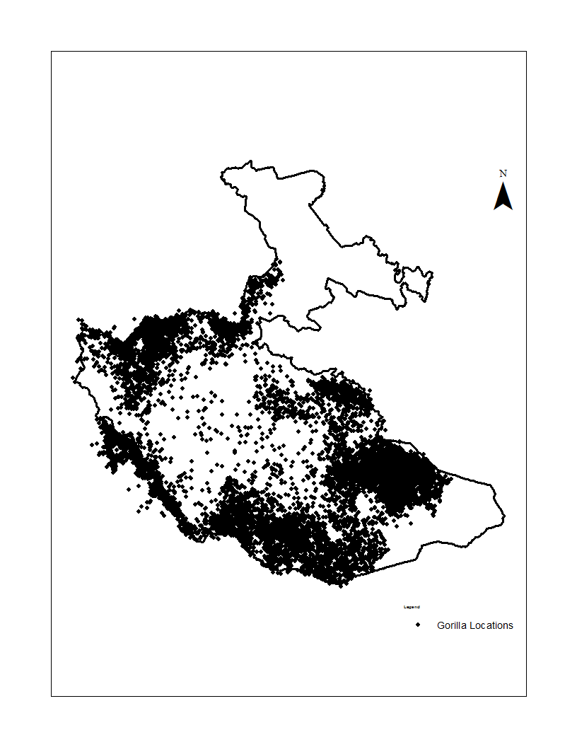
Figure 2.1 The distribution of mountain gorillas in Bwindi Impenetrable National Park, Uganda, based on recordings from 1997 to 2011.

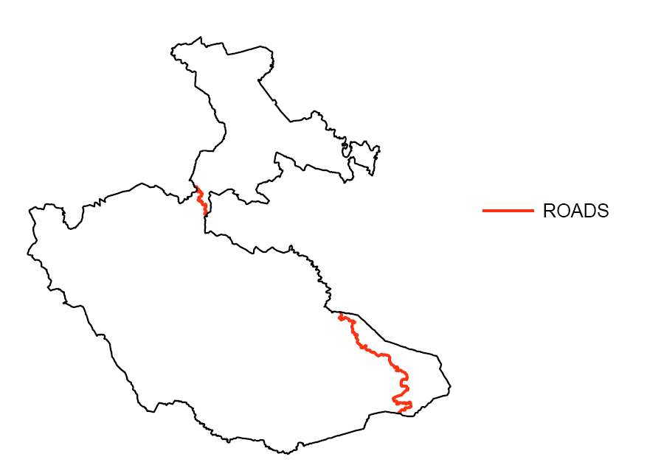
Figure 2.2 The road through the Bwindi Impenetrable National Park, Uganda

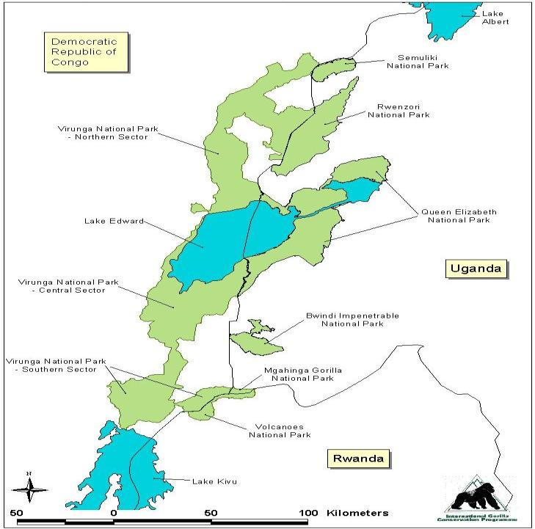
Figure 2.3 Bwindi Impenetrable National Park, Uganda, and other protected areas in the region

CHAPTER 3

RELATIONSHIP BETWEEN VEGETATION SPATIAL PATTERNS AND MOUNTAIN GORILLA DISTRIBUTION IN BWINDI IMPENETRABLE NATIONAL PARK, UGANDA

3.1 Introduction
Habitat selection is regarded as a multi-level, hierarchical process through multiple spatial scales from a geographic range to a food item (Johnson 1980). First-order selection is the selection of the geographic range of a species. Second-order selection is the process through which an individual selects its home range within a landscape. Third-order selection relates to the selection of the habitat components or resource patches within a home-range. Finally, fourth-order selection is the selection of an item (e.g., food item) or microhabitat among available ones within the habitat component selected or patches (Johnson 1980). Patterns observed at one scale are not necessarily good predictors of patterns obtained at other scales (McLoughlin et al. 2002, 2004). For example, a species feeding preferentially on a given plant might not select, at a higher spatial scale, the habitats where this plant is the most abundant (Morin et al. 2005). This can occur if the best feeding habitats do not satisfy other needs such as shelter or security. In habitat selection studies, a multi-scale approach is considered necessary to ensure that all elements of selection are depicted and that management decisions accurately reflect the needs of the species under study (Morin et al. 2005). Decisions at coarser scales, like population range, home range, may strongly reveal those factors that are avoided in order to increase individual fitness (Rettie and McLoughlin 1999; Rettie and Messier 2000). Less important limiting factors may influence habitat selection patterns only at smaller scales of selection like within the home range. For example, the relative importance of plant-herbivore interactions may decline at larger spatial scales, as abiotic factors increase in importance (Senft et al. 1987). Failure to view habitat selection as a hierarchical process could result in a narrow and possibly misleading perception of the value of habitats to animals.
In spite of the uneven distribution of mountain gorillas in Bwindi Impenetrable National Park, SW Uganda, no study has been conducted at the landscape second-order level to determine why some habitats are selected and others avoided. Previous studies of gorillas have all focused on third- and fourth order habitat selection levels (e.g., Robbins and McNeilage 2003; Goldsmith 2003; Nkurunungi et al. 2004; Ganas et al. 2004; Ganas and Robbins 2005; Guschanski et al. 2008). Attempts at describing habitat selection at landscape level (e.g., Harcourt 1981; Butynski 1984, 1985; McNeilage et al. 2001, 2006) were delimited by lack of an ecological description of the vegetation for the whole park. An earlier description of the vegetation (Cahusac 1958) was designed specifically for logging operations, thus rendering it of little practical value in ecological applications. Later descriptions of the forest vegetation by Leggat and Osmaston (1961), Hamilton (1969), Lind and Morrison (1974), and Howard (1981) were limited in scope as they concentrated only on trees and from a few accessible sites of the forest. To this end, one important product of this research is an up-to-date detailed description of the vegetation and its spatial distribution patterns in Bwindi based on plant community structure and floristic composition. My classification is mainly based on numerical analysis of associations among plant species, particularly the large trees (≥20cm dbh) and the shrub/herbaceous layer in the open areas of the forest. Since all the natural forest outside Bwindi is already lost, it is vital that we understand more the critical role the remaining forest habitat is playing in supporting the existing mountain gorilla population and in ensuring potential for future growth.

3.2 Objectives
i. Determine the plant species associations in the vegetation;
ii. Determine how the derived plant communities are arranged in space and along major environmental gradients; and
iii. Relate the spatial variation of the plant communities to mountain gorilla distribution

3.3 Research questions
i. Are the forest vegetation types floristically and structurally distinct?; and
ii. How are the gorillas distributed with respect to the spatial structure and composition of the forest vegetation?

3.4 Methods

3.4.1 Study area stratification
A stratified sampling approach was employed to guide the vegetation sampling process. The park was divided into five strata based on geological formations visible on the Digital Elevation Model (DEM) of Bwindi (Figure 3.1). This was based on the assumption that different vegetation types, with different species compositions, occur on different rock types, and that a new and more information on vegetation types could be produced by subdividing the broad primary vegetation zones on the basis of rock type on which they occur (Du Puy and Moat 1996). Several transects were then drawn in each stratum. The compass direction of each transect depended on the shape of the ridges where it was drawn. Transects were drawn to cut across the ridges so as to capture the expected rapid transition in vegetation types and environmental gradients based on topography and park edge to the interior. Transects to be sampled were randomly chosen and the number and length varied with area and shape of the strata. This approach was based on the assumption that stratifying a sample of geographic locations across environmental gradients will locate most species, species assemblages, and vegetation communities, and yield an adequate number of observations of each of them.

3.4.2 Field data collection
The random transects were superimposed on the high resolution (0.5m) true color, digital aerial photographs of Bwindi. The aerial photos were then visually interpreted along the selected random transects, by drawing polygons around areas perceived to be uniform vegetation community structure based on differences in tone and texture (Figure 3.2). This allowed the sampling units to be placed, as far as possible, in a uniform community in the field. I carried a printed copy of the digitized polygons, overlaid with a coordinate grid, to locate the polygons in the field using a Global Positioning System (GPS). A random point within each digitized polygon was located in the field for vegetation sampling. At the random sample point within the polygon, I used the point-to-tree distance technique or plotless sampling method to sample the vegetation. This technique involved choosing a random center-point and then selecting the nearest 15 trees ≥ 20 cm (dbh), identified to species level and measured the exact dbh of each sample tree. The distance from the center-point to the farthest 15th tree was measured and regarded as the radius of circular plot. This procedure is especially suitable for rapid and robust assessments of tropical rain forest composition compared to fixed area plot methods (Hall 1991; Sheil et al. 2003; Klein and Vilcko 2006). Other lesser plant life forms were sampled in nested plots set up within the large tree sampling plot: poles (5 to 20cm dbh) in 20 by 10m plot and saplings and shrubs in 2.5 by 2m plot, while herbs were sampled in a 1 by 1m plot. An effort was made to identify all the plants sampled to species level. I also recorded the environmental variables known to affect the floristic composition at the center point location – altitude using an altimeter, aspect – as the compass direction facing downslope, steepness of the slope using a clinometer and topographic position of the slope – valley, lower slope, mid-slope, upper slope, hill top, gully and ridge. Also indicators of the site related to past and present disturbances such as fire, human dwelling, enrichment planting, tree crops, and agricultural encroachment were visually assessed and qualitatively recorded.

3.4.3 Data entry
Field data was entered into an Microsoft© Excel spreadsheet and used to convert dbh measurements to ones of basal area for each sample tree, which were summed up for each species for each sample plot. The floristic composition of the plot was weighted by the relative contribution of the basal area of each species to the area of the plot (measured as square meters per hectare).

3.5 Data analysis

3.5.1 Analysis strategy
I report on the vegetation types and their distribution in Bwindi. I also related the vegetation spatial patterns with mountain gorilla distribution. I started by determining whether the tree species sample sizes were adequate for subsequent analyses. I then quantitatively characterized how different the tree sample sites were in species from each using ecological distance measures between all pairs of sample sites. I derived the vegetation classes from sample site data using cluster analysis to group sample sites with the same tree species together. The vegetation classes were then plotted as points in a space of two dimensions to show the extent of tree species dissimilarity among the sample sites. The closer the sample sites the more similar they were in tree species composition. I also determined the relative strengths of the environmental factors in influencing tree species composition of the sample sites. I determined the indicator tree species for each vegetation class, to which the clusters were named. The vegetation classes were then related to gorilla spatial distribution to determine if there were any relationships.

3.5.2 Sampling adequacy
In order to determine whether my sample size was adequate for the subsequent analyses, I plotted species richness against pooled sites and pooled individual plants. I used the species richness accumulation curves used to check the adequacy of my sample size for the whole forest and for each stratum.

3.5.3 Ecological distance
This is a concept that characterizes, on a quantitative scale, how different vegetation sample sites are in species composition from each other. It was applied to the entire tree species data matrix by calculating the ecological distances between all pairs of sites. I used the Bray-Curtis index of floristic dissimilarity on the relative basal area by tree (>20 cm dbh) species. The Bray-Curtis dissimilarity index restricts distances within a range of zero (when two sites are completely similar for every species) to one (when two sites do not share any species). Bray-Curtis distance was used because it is commonly used in analysis of community data since it not influenced differently by the species with smaller abundances than the species with larger abundances. It also has space conserving properties. The Bray-Curtis distance between sites A and C is defined as follows:
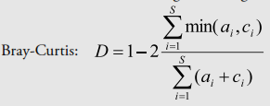
Where abundances of the species in site A are indicated by a_{i} and those of site C are indicated by c_{i}.

3.5.4 Cluster analysis
I performed a cluster analysis on the tree floristic composition of the sample sites. I used the standard, hierarchical average-linkage clustering algorithm. This algorithm initially assigns each site to a separate group, at each iteration, the clustering routine unites the two groups that have the smallest mean dissimilarity i.e., floristic dissimilarity measured via Bray-Curtis distance, between them. The algorithm is complete when all the sites are united into one group. The results of this analysis were plotted in a dendrogram. The average-linkage clustering makes no a priori assumptions about underlying structure in the data.
Tree species that occurred in less than 5 percent (20 sites) of the total sites sampled were deemed to be rare and removed from the data set. Deleting rare species is a useful way of reducing the bulk and noise in a data set (i.e., unnaturally increase number of clusters) without losing much information and often enhances the detection of patterns in community data (McCune & Grace 2002). Also, clusters with ≤5 sample sites were removed from the data set because the sites within those clusters were found to be dominated by one or two large sized trees. Few large sized trees influence the analysis because the Bray-Curtis distance measure will mainly reflect the differences for those big-sized tree species only (Kindt and Coe 2005).

3.5.5 Ordination
The vegetation classes identified by the cluster analysis were subjected to a non-metric multidimensional distance scaling (NMDS) ordination. In NMDS, sites are plotted as points in a space comprised of two dimensions, with distance between points in the ordination space representing dissimilarity between those points (Kindt and Coe 2005). I used Bray-Curtis dissimilarity as distance measure.

3.5.6 Central location, ANOVA, RDA, Mantel and ANOSIM tests
These were used to investigate the relative strengths of ecologic distance versus the environmental factors as determinants of floristic composition. The relationship between the Bray-Curtis distance matrix and the quantitative variables – altitude, slope aspect, and slope steepness – were analysed with a box plots, parametric ANOVA and Mantel tests. The Euclidean distance was used as the distance index for the environmental variables because it depends on the quantity of the variables (Kindt and Coe 2005). For the categorical environmental variable – topographic slope position – I used the box plots, non-parametric redundancy analysis, and ANISOM (Analysis of Similarity) test. The method examined whether the sites within categories are more similar than sites in different categories.

3.5.7 Community summaries
The community composition of the vegetation classes from the cluster solution was summarized using the indicator species analysis. This analysis combines the frequency tables and mean abundance tables and finds the species that are significantly concentrated into specific classes. The clusters are then named using one or more of these dominant species.

3.5.8 Evaluation of cluster validity
The stability of the derived vegetation classes by cluster analysis were tested whether they were ‘real’ i.e., if a data set drawn from the original data gives rise to more or less similar clustering. I used the Cluster Bootstrap and Subsetting approaches to generate a Jaccard coefficient (Henning 2007) that was interpreted to determine the validity cluster stability.

3.5.9 Chi-squared and presence/absence analyses
The clusters derived from above were mapped and compared to the distribution of mountain gorilla sighting locations since 1997 (Figure 3.13). The presence or absence of each cluster type in areas occupied and unoccupied by gorillas was noted and their frequency determined separately for gorilla occupied and unoccupied areas. The frequencies of the vegetation classes between areas occupied and unoccupied by gorillas were analyzed by chi-square test and the binomial General Linear Model with logit link. Logistic regression modeling is a common statistical method used to calculate resource selection probability functions, whereby the probability that a location or area is used by an animal is a function of a set of habitat variables associated with that location (Manly et al. 1993).
All the analyses were implemented in R 3.0.3 environment (R Core Team 2014) using functions from R packages ‘vegan’ (Oksanen et al. 2013), ‘labdsv’ (Roberts 2013), ‘cluster’ (Maechler et al. 2013), “fpc’ (Hennig, 2013), ‘BiodiversityR’ (Kindt and Coe 2005) and biostats.R (McGarigal 2014).

3.6 Results
A total of 468 variable area plots were sampled for the various plant forms in Bwindi. Of these, 393 plots were dominated by the large trees (≥20cm dbh), 53 by herbaceous plants (dominated mostly by woody vines Mimulopsis solmsii and Sericostachys scandens), 13 by bracken fern, 7 by bamboo, and swamp and grassland by one each. Since the plots with large trees were the most abundant, more widespread, but with the least apparent floristic patterns, they were subjected to further analyses to obtain associations among the tree species.

3.6.1 Sample size adequacy and analysis of tree species richness
The tree dominated 393 plots contained a total of 126 species. Each plot had 15 individual trees with the number of species ranging from one to 13 and an average of 7 species per plot. I used the species accumulation curves for the entire survey and then per stratum to evaluate the adequacy of the sample size of the data set and to contrast total species richness of the strata. Species accumulation curves show species richness for combinations of sites. The curves portray the average pooled species richness when 1, 2, ...., all sites are combined together or 1, 2, …, all sampled plants (individuals). The reason that the average pooled species richness is calculated is that different combinations will have different species richness.
These two curves (Figure 3.3 and 3.4) are a plot of the number of tree species richness as a function of the number of samples or individual trees. On the left, the steep slope indicated that a large fraction of the species diversity remained to be discovered. When the curve became flatter to the right, it meant that a reasonable number of individual samples had been taken: more intensive sampling was likely to yield only few additional species. Therefore my sampling and sample sizes can be regarded as adequate and sufficient for the whole forest and for each of the strata.
The species accumulation curves allow comparison of species richness at the same sample size. For example we can compare the five strata of 40 sites (Figure 3.5) or of 500 accumulated plants (Figure 3.6). The lower altitude (<2000m) strata (North and West) had more tree species richness than the other three high altitude (>2000) strata (Central, East, and South). Also, because the species accumulation curves for each of the five strata approached the asymptote, the sampling and sample size was considered adequate for each stratum.

3.6.2 Analysis of differences in tree species composition
I analyzed 5,370 individual trees (>20cm dbh) in 358 plots representing 40 tree species within variable-area plots. This was after dropping the rare tree species that occurred in less than five percent of the plots and 35 plots that had a few individual trees that were excessively large sized compared to the rest of the trees in a plot. The tree species were grouped in 18 categories of similar species following the natural groupings as portrayed by a dendrogram or clustering tree (Figure 3.7) and shown in Table 3.1. I used the vegetation classes derived from cluster analysis for prediction of external environmental factors. Since the classes are from and describe community composition, they can be assumed to predict environmental conditions. Box plots were used to look for differences in the environmental factor, in this case, altitude (Figure 3.8).
The height of the box is equal to the interquartile distance (IQD) which is the difference between the third and first quartile of the data. The whiskers extend to the extreme values of the data or 1.5× IQD from the center, whichever is less. The notches represent the median altitude for each vegetation class. Since the box plots are at unequal location and spread, the medians probably are different at p<0.05. This was rigorously tested by looking at the relationship between the distance matrix of the vegetation plots and the distance matrix of altitude measures were highly significant (p<0.001) in both parametric ANOVA and Mantel test confirming that there is variation and correlation in tree species composition with altitude.
The relationship between topographic position on the slope and the vegetation classes derived from cluster analysis was also investigated. From Figure 3.9, the box plots are at unequal location and spread, therefore, the medians probably are different at p<0.05. This means that there is variation in tree species composition with topographic position on the slope. This was confirmed using a non-parametric permutation test i.e., the redundancy analysis and ANISOM test. The results for both tests were significant at p<0.01.
Lastly, the box plots for the all the vegetation classes did not extend to gullies and valleys. This implies that those topographic positions are largely open with few or no trees at all. Other environmental factors seem not seem to have had any effect on the tree species composition of the vegetation classes – ANOVA: slope aspect and slope steepness at p>0.05.

3.6.3 Distribution of vegetation classes across the strata
Table 3.1 shows the 18 tree dominated vegetation classes and their indicator species. The table also includes an additional five vegetation types that were not represented in the cluster analysis but are separately recognized due to their distinctive botany and physiography. These were open areas (>30 m in diameter and without trees ≥20cm dbh) and were dominated by swamp, bracken fern, herbaceous climbers, bamboo or grassland. There was no significant differences in the frequency of the occurrence in the vegetation classes among the strata (ANOVA p>0.05). About 70 percent (n=23) of the vegetation classes occurred in at least three or more strata.
Only four vegetation classes were restricted to one stratum – Bamboo in the East, Swamp in the Central, the grassland and Macaranga barteri in the North. Those which were present in all the five strata were Bracken fern, herbaceous growth, Prunus africana and Polyscias fulva.
The low to medium altitude areas in the north and western part of Bwindi were dominated by vegetation classes of Syzigium guineense, Newtonia buchananii, Strombosia scheffleri, Parinari exclesa, Carapa grandiflora, and Lepitonychia mildbraedii, while the high altitude central, east and south ends were dominated by Chysophyllum albidum, Cassipourea gummiflua, Olinia rachetiana, Podocarpus milinjianus, Teclea noblis, and Faurea saligna.

3.6.4 Clustering and ordination
I used ordination to display the observed dissimilarities among vegetation plots using non-metric multidimensional distance scaling (NMDS). NMDS maps observed dissimilarities linearly onto low-dimensional graph. The individual vegetation plots points as well as the vegetation class centroids and average dispersions were displayed as points and ellipses respectively (Figure 3.10). NMDS ordination produced a dense cluster of plots stretching generally along an altitudinal axis from the high altitude sites from the East stratum through the Central and South strata on to low altitude sites in the West and North strata. Examination of the NMDS graph reveals that the individual points from the same stratum or a neighboring one were closer together than those from the strata that were a distance apart. Consequently, plots that are furthest apart in species composition also show the greatest difference in altitude and geographical distance. Accordingly, plots in the lower altitude north or west parts of the park that were closer (Figure 3.1) had tree species compositions that are far different from those in the higher altitude south, central or east sites that are a distance from them and vice versa. Another striking feature in the NMDS graph (Figure 3.10) is that the neighboring ellipses greatly overlap. This means that the vegetation classes are not distinct but are vague with intermediate and untypical vegetation plots. This means that they are ‘fuzzy.’ This fuzzy classification means that each plot has a certain probability of belonging to a vegetation class. In the crisp case, it has probability 1 of belonging to one vegetation class and probability 0 of belonging to any other class. In a fuzzy case, it has probability <1 for the best class, and probabilities >0 for several other classes (and the sum of these probabilities is 1).

3.6.5 Evaluating the stability of the cluster solution
The 18 vegetation classes obtained by cluster analysis were evaluated for their stability. The tree species data set was resampled via bootstrapping and a cluster analysis performed on each bootstrap sample separately. Also the data set was randomly subset and a cluster analysis done on each subset sample separately. The Clusterwise Jaccard bootstrap means were all <0.5 and the Clusterwise Jaccard subsetting had only one mean >0.75. This means that both the both the Bootstrap and Subsetting approaches agree that the tree data set is not clearly structured, meaning that the clusters derived from the analyses were generally unstable as will be discussed later in Section 3.7.1.

3.6.6 Vegetation map
All the analyses - boxplots, parametric ANOVA and Mantel test as well the NMDS plot - showed a highly significant variation and correlation of tree species composition with altitude. Altitudal intervals were therefore used as a proxy for potential vegetation classes since altitude showed a very strong influence on plant species availability, distribution and composition in Bwindi. Using a 30m grid Global Digital Elevation Model (GDEM) derived from ASTER satellite images (downloaded from web page http://asterweb.jpl.nasa.gov/gdem-wist.asp), I delineated nine altitudinal intervals using ArcMap’s Jenk’s optimization method of classifying groupings and patterns inherent in the GDEM data. These altitudinal intervals were then related and used to describe the potential vegetation classes of Bwindi as shown in Figure 3.11. Geographically, Bwindi is elongated from south-east to north-west, exhibiting an altitudinal cline in the same direction. As already mentioned, differences in plant community composition were also found to increase along the south-east to north-west direction The vegetation classes were simplified by aggregating them into the smallest number of classes that are ecologically relevant and well represented by the data (Table 3.2). It can be seen from Table 3.2 that each altitudinal interval was a mixture of two or more potential vegetation classes confirming the ‘fuzzy’ nature of Bwindi vegetation.

3.6.7 Relationships between the vegetation class spatial pattern and mountain gorilla distribution
I mapped recorded daily gorilla location observations from Uganda Wildlife Authority Ranger Based Monitoring data from 1999 to 2011 and four five-year interval gorilla census location data conducted by the Institute of Tropical Forest Conservation since 1997 (Figure 3.12). Mountain gorillas do not range in the whole park. They are located in the central portion of the southern lobe of the park. There are large portions of the park where gorillas have not been encountered like in the northern, the extreme south west corner and eastern parts of the forest. The gorilla location data was collected independently from the vegetation data, and the two were combined by overlaying the polygon representing gorilla distribution range on to the vegetation sampling sites (Figure 3.13). Relationships between the vegetation types in areas gorillas occupy and those they avoid were investigated. The results of the frequency distribution of the vegetation classes in relation to gorilla occupancy are presented in Table 3.3.
The frequencies of vegetation types were found to be significantly associated with gorilla occupancy (χ-squared = 115.2, df = 22, p-value <<0.01). I explored the pattern of standardized residuals to reveal which cross classifications deviate from the expected values and thus contribute greatest to the lack of independence between vegetation types and gorilla occupancy (Table 3.2). Large residuals (in magnitude) indicate large deviations from what is expected when the null hypothesis is true and thus also indicate large influences (contributions) to the overall association. The sign (+/-) the residuals indicates whether the frequencies were higher or lower than expected. All the clusters contributed to the rejection of the null hypothesis with varying magnitude. Those with largest deviations were: Cluster 3 (Strombosia scheffleri) and Cluster 9 (Leptonychia mildbraedii) – both with fewer plots than expected. I also related gorilla occupancy (or presence-absence) against the vegetation type at each sampled site using a binomial General Linear Model with logit link or the logistic regression model. The results of logistic regression model agree with those of chi-squared test that there is great significant evidence that vegetation type influence gorilla presence-absence (ANOVA df=22, p<<0.01). This means that mountain gorillas either prefer or avoid some vegetation classes in Bwindi.

3.7 Discussion
This is the first systematic study to develop detailed floristic definitions of the vegetation classes using data from intensive and extensive field plots as well as numerical classification of associations among plant species in an African montane tropical forest. No similar vegetation descriptions have been made for Bwindi and this study provides valuable data on the habitats present. Previous vegetation studies in Bwindi were conducted at only a few sites (e.g., Leggat and Osmaston 1961; Hamilton 1969; Howard 1991; Davenport et al. 1996; Eilu and Obua 2004; Ganas et al. 2009) and therefore could not be used to describe vegetation patterns for the whole forest. The community composition of the vegetation classes derived during this study was correlated with some major environmental factors to determine the causes of vegetation variation. Given that vegetation is an important environmental factor in determining animal distribution (Morrison et al. 2006), this study utilized the recorded gorilla presence locations to relate vegetation compositional spatial patterns with gorilla distribution in Bwindi. This permitted an insight into landscape relationships between gorilla occupancy and vegetation spatial patterns in Bwindi.

3.7.1 Vegetation classification and description
Sites in the strata in the North and West of Bwindi had a higher species richness of large trees compared to the rest of the park. These areas are in the low- to mid-altitude tropical forest belt (<2000m asl) and are therefore expected to have a richer plant diversity compared to other sites in the park that are in a high altitude montane forest belt. Altitude strongly influences plant species richness. Temperature decrease and wind speed tends to increase in a linear fashion with altitude (Lieberman et al. 1996). Rainfall tends to decrease (though not linearly), excessive moisture occurs from fog cover at higher altitudes (Grubb and Whitmore 1996). These general trends result in altitudinal differences in plant structure and availability, with canopy height and species diversity being greatest at lower elevations, and forests that are shorter in stature and poorer in species and family richness at higher elevations (Richards 1996; Lieberman et al. 1996).
Tree species composition in Bwindi was confirmed to be spatially structured by two major physical factors – altitude and topographic position on the slopes. This has been reported before by Leggat and Osmaston (1961) and Hamilton (1969). Geographically, Bwindi is elongated from south-east to north-west, exhibiting an altitudinal gradual change in the same direction. Differences in plant community composition also increase along the south-east to north-west direction. As already mentioned, altitude affects plant growth through the amounts of rainfall received and changes in temperature as well as wind speeds at different elevations. The effect of topographic position on vegetation composition structuring is due to differences in tree species’ preferences for different levels of moisture, and ability to survive on poorly structured, nutrient deficient soils and withstand drought-prone ridge tops (Ghazoul and Sheil 2010). This makes the vegetation composition of Bwindi change over short spatial scales. The valleys and gullies are dominated by dense herbaceous growth and are largely devoid of trees because they are water logged most of the time (Hamilton 1969). Topographical characteristics are therefore responsible for the very diverse habitats in Bwindi. However, other factors likely to also affect species composition in Bwindi are the geology, soil attributes, species competition, human and animal disturbance, among others but were not investigated.
This study demonstrated that there is substantial variation in vegetation in Bwindi. Twenty-three major natural vegetation classes were identified, eighteen of which were dominated by large trees (≥20cm dbh) and five were of lesser plant forms. The vegetation at the extreme ends of the park (low altitude North and West strata, and high altitude East stratum) clearly had contrasting floristic assemblages. However, in between these two extremes, is perhaps a continuum of gradually changing species composition. Evidence for this pattern of variation is shown on the NMDS ordination graph, where many of vegetation sampling plots cannot be assigned to vegetation classes that are mutually exclusive and exhaustive but can reasonably belong to more than one vegetation category. This is the main reason why the results of the cluster stability evaluation indicate that the clusters derived are not stable. Whittaker (1967) provides a reason for this phenomenon. No two species, with a few exceptions, have the same distributions. Each species has a unique way of being distributed in relation to the environmental factors it encounters. This result in forest types along a continuous gradient like topography and soil to bear resemble to and grade into other community types. Such forest compositions are generally described as ‘fuzzy’ as it is sometimes difficult to identify a single best community type for any given forest location observed in the field (Gopal and Woodcock 1994; Townsend and Walsh 2001). Sharp boundaries in vegetation communities occur where there is a steep environmental gradient and at places with strong fluctuations in environmental conditions (Shipley and Keddy 1987). In Bwindi, there were some few sites with sharp boundaries where vegetation types like where swamp and pure bamboo occur.
Comparison of the frequencies of the vegetation classes among the strata resulted in no clear differences. Majority of the vegetation classes (70%) were found to occur in more than three strata, meaning that some tree species have a wider distributional range than that of an individual stratum or combinations of neighboring strata. Another major reason for lack of differences in frequency of the vegetation classes among the strata could be because of the rugged nature of Bwindi. This results in altitudinal differences among the strata not being a real phenomenon, since the ridges within each stratum provide multiple elevations where similar species of trees may occur. The final outcome of all this is a patchy distribution of plant species and the vegetation classes they belong to. The forest communities of Bwindi are therefore, naturally heterogeneous and highly variable, grading into each other in both species composition and environmental characteristics.
The description of the parks’ vegetation structure and composition was further complicated by the heavy and unevenly distributed, human disturbance, especially the intensive logging that went on for close to 45 years in over 90 percent of the forest (Howard 1991). This made the forest to be a complex mosaic of vegetation patches at various stages of growth and succession and mature forest. Therefore, the effects of logging in the past are superimposed on differences caused by topography and other factors like soil type (Cunningham 1996). This tends to obscure vegetation variation due to natural environmental gradients, making compelling comparisons between different areas of the forest difficult. Since logging was highly selective in terms of tree species and sizes harvested, it could have affected both the forest tree species composition and the structure of the forest. For example, Podocarpus latifolius, previously common on all the ridges in the southeast of the park has now largely been cut out from all the accessible areas (Hamilton 1994). Cutting of large trees created large open areas dominated by dense tangle of herbaceous growth and bracken fern (Babaasa et al. 2004). These open herbaceous and bracken fern areas are preferred by elephants for foraging (Babaasa 2000), thus maintaining them and even increasing biomass of the herbaceous vegetation in them (Babaasa et al. 2004). In areas where the ridges are very steep like the stratum in the east of the park, landslides are common and are likely to be maintaining the open areas and even leading to an increase in their size (Babaasa et al. 2004). These localized elephant activities and landslide events may result in decreased forest regeneration owing to their extended period of disturbance (Struhsaker et al. 1996). The impact of large mammals, like elephants and the gorillas, on vegetation composition is largely unknown. This requires a long term studies where enclosure plots as controls are step up to exclude the large mammals and compare the vegetation with areas that are still utilized by the large animals.
The fuzzy nature of the vegetation makes mapping of plant communities a very complicated task because of lack of a known one-to-one relationship between the vegetation community type and plant species. Multispectral remote sensing is not effective in identifying individual plant species even when “hyperspectral” imaging spectrometer data is available as species do not have unique spectral signatures (Franklin 2009; Kerr and Ostrovsky 2003). The map representing potential vegetation classes of Bwindi (Figure 3.11) is a small-scale site map that was prepared by using the present-day vegetation composition as an indicator. For its preparation, I used terrain following Franklin (1995) and Franklin et al. (2000) who proposed that topographical variables can be used to improve predictions of forest species composition through implicit or explicit use of models. This study showed that plant species were strongly correlated with altitude. Potential vegetation classes can only be constructed (Mueller-Dombois and Ellenberg 1974). Such vegetation will never exist in the form projected on the map. This is because the potential natural vegetation is a conceptual abstraction that was established from knowledge of the existing vegetation, its development tendencies and its site relationships. Therefore, a potential natural vegetation map provides a mirror-image of the current state of knowledge with respect to the present vegetation potential of Bwindi. If these limitations are taken into account, such map can be used to advantage, either for practical purposes or as starting bases for research.

3.7.2 Landscape gorilla distribution in relation to vegetation spatial patterns
Previous studies on mountain gorillas in Bwindi have been in a form of in-depth studies on a small number of groups located at the higher elevation in the east and lower elevation in the west. Field studies on gorilla food plants at these two extreme ends of gorilla range showed that the two sites were obviously different in plant community composition (Ganas et al. 2004; Nkurunungi et al. 2004; Ganas et al. 2009). However, the ecological information from these studies could not be extrapolated to other areas of Bwindi to determine potential gorilla habitat given the uncertain patterns of variation in vegetation in the forest. This study illustrated how gorillas occupy quite a wide range of habitats than has been previously documented. Such a variety of habitats provides gorillas with a wide choice. In terms of vegetation structure and composition, gorillas were found occupy all vegetation types except two located at the extreme ends of the park – grassland in the North and Bamboo in the East. There were significant differences in the vegetation types in areas occupied and those avoided by gorillas. Given that the vegetation types found in areas occupied by gorillas still occur in areas unoccupied, there is a strong possibility that the avoided areas could be potential good gorilla habitats in terms of food and shelter. The northern part long considered unsuitable habitat for gorillas because of lower altitude and differences in vegetation, was not known to contain any gorillas until one the groups habituated for tourism began to use the southern portion of it in 2006. Recent research in Bwindi shows that gorillas will eat bamboo shoots when encountered (John Bosco Nkurunungi pers. commun. in McNeilage et al. 2001), though at present, the gorillas do not utilize the restricted bamboo area in the unoccupied eastern part of the park. Anecdotal evidence from the local people indicates that gorillas may have ranged in the eastern part of Bwindi but were killed overtime probably from the 1950s or even earlier to 1980s. Other gorilla populations occupy comparable habitats at low altitude in Kahuzi-Biega National Park in eastern DR Congo (Hall et al. 1998) and high altitude in the Virunga Volcanoes (McNeilage 2001). For these reasons, gorillas are likely to colonise areas currently avoided in future. Gorillas in Bwindi have very slow growth and reproduction rates and could still be below the carrying capacity in the areas they occupy (Robbins et al. 2009), therefore do not have the urge to occupy new areas. Gorilla group feeding traditions (Watts 1984; McNeilage 2001; Ganas et al. 2004) and unfamiliarity with available food resources may hinder gorillas from recolonizing the unoccupied regions (Guschanski et al. 2008). In many animal taxa, including gorillas, the natural re-colonization of areas abandoned because of past hunting pressures, or epidemics may be prevented or slowed down by habitat preferences, if vegetation or other important environmental influences are spatially structured. There is also a possibility that other factors other than differences in vegetation composition could be preventing the gorillas from utilizing the large areas they are avoiding now. This can occur if the best feeding habitats do not satisfy other needs such as shelter or security (Morin et al. 2005).

3.8 Bibliography
Babaasa, D. (2000). Habitat selection by elephants in Bwindi Impenetrable National Park, Uganda. African Journal of Ecology, 38, 116-122.
Babaasa, D., Eilu, G., Kasangaki, A., Bitariho, R., & McNeilage, A. (2004). Gap characteristics and regeneration in Bwindi Impenetrable National Park, Uganda. African Journal of Ecology, 42, 217-224.
Butynski, T. (1984). Ecological Survey of the Impenetrable (Bwindi) Forest, Uganda, and Recommendations for its Conservation and Management. Unpublished report to the Uganda Government.
Butynski, T. (1985). Primates and their conservation in the Impenetrable (Bwindi) Forest, Uganda. Primate Conservation, 6, 68-72.
Cahusac, A. (1958). Impenetrable C.F.R. Forest Types (Interpretation Report No. 6) Reference Map No. KI/45. In G. Leggat, & O. HA, Working Plan for the Impenetrable C.F.R. (p. Appendix G). Uganda Forest Dept, Report, Entebbe.
Cunningham, A. (1996). People, park, and plant use: Recommendations for multiple use zones and development alternatives around Bwindi Impenetrable National Park, Uganda. People and Plants working paper No. 4. Paris: UNESCO.
Davenport, T., Howard, P., & Matthews, R. (1996). Bwindi Impenetrable National Park Biodiversity Report . Kampala: Uganda Forest Dept, Report No. 19.
Du Puy, D., & Moat, J. (1996). A refined classification of the primary vegetation of Madagascar based on the underlying geology. Using GIS to map its distribution and to assess its conservation status. In W. Lourenco (Ed.), Proceedings of the International Symposium on the biogeography of Madagascar (pp. 205-218). Paris: Editions de IORS TOM.
Eilu, G., & Obua, J. (2005). Tree condition and natural regeneration in disturbed sites of Bwindi Impenetrable Forest National Park, SW Uganda. Tropical Ecology, 46(1), 99-111.
Franklin, J. (1995). Predictive vegetation mapping: geographic modeling of biospatial patterns in relation to environmental gradients. Progress in Physical Geography, 19, 474-499.
Franklin, J. (2009). Mapping species distributions: Spatial Inference and Prediction. Cambridge: Cambridge University Press.
Franklin, J., McCullough, P., & Gray, C. (2000). Terrain variables used for predictive mapping of vegetation communities in southern California. In J. Wilson, & J. Gallant, Terrain Analysis: Principles and Applications (pp. 331-353). New York: John Wiley and sons, Inc.
Ganas, J., & Robbins, M. M. (2005). Ranging behavior of the mountain gorilla (Gorilla beringei beringei) in Bwindi Impenetrable National Park, Uganda: a test of the ecological constraints model. Behavioral Ecology and Sociobiology, 58, 277-288.
Ganas, J., Nkurunungi, J., & Robbins, M. (2009). A preliminary study of the temporal and spatial biomass patterns of herbaceous vegetation consumed by mountain gorillas in an Afromontane rain forest. Biotropica, 41(1), 37-46.
Ganas, J., Robbins, M. M., Nkurunungi, J. B., Kaplin, B. A., & McNeilage, A. (2004). Dietary variability of mountain gorillas in Bwindi Impenetrable National Park, Uganda. International Journal of Primatology, 70, 1-12.
Ghazoul, J., & Sheil, D. (2010). Tropical rain forest ecology, diversity, and conservation. New York: Oxford.
Goldsmith, M. L. (2003). Comparitive behavioral ecology of a lowland and highland gorilla population: where do Bwindi gorillas fit? In A. B. Taylor, & M. L. Goldsmith, Gorilla Biology: A Multidisciplinary Perspective (pp. 358-384). Cambridge: Cambridge University Press.
Gopal, S., & Woodcock, C. (1994). Theory and methods for accuracy assessment of thematic maps using fuzzy sets. Photogrammetric Engineering and Remote Sensing, 60(2), 181-188.
Grubb, P., & Whitmore, T. (1966). A comparison of montane and lowland rain forest in Equador. II: climate and its effects on the distribution and physiognomy of the forests. Journal of Ecology, 54, 303-333.
Guschanski, K., Caillaud, D., Robbins, M. M., & Vigilant, L. (2008). Female shape the genetic structure of a gorilla population. Current Biology, 18(22), 1809-1814.
Hall, J. (1991). Multiple-nearest-tree sampling in an ecological survey of Afromontane catchments forests. Forest Ecology and Management, 42, 245-266.
Hall, J., White, L., Inogwabini, b., & al, e. (1998). A survey of Grauer's gorillas (Gorilla gorilla graueri) and chimpanzees (Pan troglodytes schweinfurthi) in the Kahuzi Biega National Park lowland sector and adjacent forest in eastern Congo. International Journal of Primatology, 19, 207-235.
Hamilton, A. (1969). The vegetation of south-west Kigezi. Uganda Journal, 33, 175-199.
Hamilton, A. (1994). Bwindi (Impenetrable) Forest, Uganda. In S. Davis, V. Heywood, & A. Hamilton, Centres of Plant Diversity: A Guide to their Conservation. Volume 1, Europe, Africa, Southwest Asia and Middle East (pp. 174-179). Cambridge: IUCN.
Harcourt, A. (1981). Can Uganda's gorillas survive? A survey of the Bwindi Forest Reserve. Biological Conservation, 19, 269-282.
Hennig, C. (2013). fpc: Flexible procedures for clustering. R package version 2.1-6. Retrieved from http://CRAN.R-project.org/package=fpc
Howard, P. (1991). Nature Conservation in Uganda's Tropical Forest Reserves. Gland: IUCN.
Johnson, D. (1980). The comparison of usage and availability measurements for evaluations of resource preference. Ecology, 61, 65-71.
Kerr, J., & M, O. (2003). From space to species: ecological applications for remote sensing. Trends in Ecology and Evolution, 16, 299-305.
Kindt, R., & Coe, R. (2005). Tree diversity analysis. A manual and software for common statistical methods for ecological and biodiversity studies. Retrieved from http://www.worldagroforestry.org/treesandmarkets/tree_diversity_analysis.asp
Kleinn, C., & Vilcko, F. (2006). A new empirical approach for estimation in k-tree sampling. Forest Ecology and Management, 237, 522-533.
Lieberman, D., Lieberman, M., Peralta, R., & Harshorn, G. (1996). Tropical forest structure and composition on a large-scale altitudinal gradient in Costa Rica. Journal of Ecology, 84, 137-152.
Lind, E., & Morrison, M. (1974). East African Vegetation. London: Longman.
Maechler, M., Rousseeuw, P., Struyf, A., Hubert, M., & Hornik, K. (2013). cluster: Cluster Analysis Basics and Extensions. R package version 1.14.4.
Manly, B., McDonald, L., & DL, T. (1993). Resource selection by animals: statistical design and analysis for field studies. London: Chapman & Hall.
McCune, B., & Grace, J. (2002). Analysis of ecological communities. Oregon: MjM Software Design, Gleneden Beach .
McGarigal, K. (2014). biostats package. Retrieved from http://www.umass.edu/landeco/teaching/ecodata/labs/biostats.R
McLoughlin, P., Case, R., Gau, R., Cluff, H., Mulders, R., & Messier, F. (2002). Hierarchical habitat selection by barren-ground grizzly bears in the central Canadian Artic. Oecologia, 132, 102-108.
McLoughlin, P., Walton, L., Cluff, H., Paquet, P., & Ramsay, M. (2004). Hierarchical habitat selection by tundra wolves. Journal of Mammalogy, 85, 576-580.
McNeilage, A. (2001). Diet and habitat use of two mountain gorilla groups in contrasting habitats in the Virunga. In M. Robbins, P. Sicotte, & K. Stewart, Mountain Gorillas (pp. 265-292). Cambridge: Cambridge.
McNeilage, A., Plumptre, A., Brock-Doyle, A., & Vedder, A. (2001). Bwindi Impenetrable National Park, Uganda: gorilla census 1997. Oryx, 35, 39-47.
McNeilage, A., Robbins, M. M., Gray, M., Olupot, W., Babaasa, D., Bitariho, R., . . . Baker, J. (2006). Census of the mountain gorilla Gorilla beringei beringei population in Bwindi Impenetrable National Park, Uganda. Oryx, 40, 419-427.
Morin, P., Berteaux, D., & Klvana, I. (2005). Hierarchical habitat selection by North American porcupines in southern boreal forest. Canadian Journal of Zoology, 83, 1333-1342.
Morrison, M., Marcot, B., & Mannan, R. (2006). Wildlife-Habitat relationships: Concepts and Applications (3rd ed.). Washington: Island Press.
Mueller-Dombois, D., & Ellenberg, H. (1974). Aims and Methods of Vegetation Ecology. New York: John Wiley and Sons, Ltd.
Oksanen, J., Blanchet, F., Kindt, R., Legendre, P., Minchin, P., O'Hara, R., . . . Wagner, H. (2013). vegan: Community Ecology Package. R package version 2.0-10. Retrieved from http://CRAN.R-project.org/package=vegan
R Core Team. (2013, Sept 5). R: A language and environment for statistical computing. (R Foundation for Statistical Computing, Vienna, Austria) Retrieved from http://www.R-project.org
Rettie, W., & McLoughlin, P. (1999). Overcoming radiotelemetry bias in habitat-selection studies. Canadian Journal of Zoology, 77, 1175-1184.
Rettie, W., & Messier, F. (2000). Hierarchical habitat selection by woodland caribou: its relationship to limiting factors. Ecography, 23, 466-478.
Richards, J. (1996). The tropical rain forest: an ecological study (2nd ed.). London: Cambridge.
Robbins, M. M., & McNeilage, A. (2003). Home range and frugivory patterns of mountain gorillas in Bwindi Impenetrable National Park, Uganda. International Journal of Primatology, 24, 467-491.
Robbins, M., Gray, M., Kagoda, E., & Robbins, A. (2009). Population dynamics of the Bwindi mountain gorillas. Biological Conservation, 142, 2886-2895.
Robbins, M., J, R., Wright, E., Kato, R., Kabano, P., Basabose, A., . . . Gray, M. (2011). Bwindi mountain gorilla census 2011 - Summary of results. Kabale: Uganda Wildlife Authority.
Roberts, D. (2013). labdsv: Ordination and Multivariate Analysis for Ecology. R package version 1.6-1. Retrieved from http://CRAN.R-project.org/package=labdsv.
Senft, R., Coughenour, M., Bailey, D., Rittenhouse, L., Sala, O., & Swift, D. (1987). Large herbivore foraging and ecological hierarchies. Bioscience, 37, 789-795.
Shipley, B., & Keddy, P. (1987). The individualistic and community-unit concepts as falsiable hypotheses. Vegetatio, 69, 47-55.
Struhsaker, T., Lwanga, J., & Kasenene, J. (1996). Elephants, selective logging and forest regeneration in the Kibale Forest, Uganda. Journal of Tropical Ecology, 12, 45-64.
Townsend, P., & Walsh, S. (2001). Remote sensing of forested wetlands: application of multitemporal and multispectral satellite imagery to determine plant community composition and structure in southeastern USA. Plant Ecology, 157, 129-149.
Whittaker, R. (1967). Gradient analysis in vegetation. Biological Review, 42, 207-264.

Table 3.1 Vegetation classes, their indicator species and frequency of occurrence in each stratum in Bwindi Impenetrable National Park, Uganda. The tree species richness is also shown.
Vegetation class | Indicator species | East | Central | West | South | North
1 | Syzigium guineense | 4 | 11 | 15 | 6 | 10
2 | Newtonia buchananii | 0 | 1 | 22 | 3 | 13
3 | Strombosia scheffleri | 3 | 2 | 6 | 5 | 20
4 | Parinari excels, Carapa grandiflora | 0 | 1 | 9 | 0 | 12
5 | Chrysophyllum albidum, Cassipourea gummiflua | 12 | 16 | 2 | 4 | 1
6 | Alangium chinense | 5 | 4 | 3 | 10 | 1
7 | Psychotria mahonii, Olea capensis | 6 | 5 | 1 | 2 | 0
8 | Ficalhoa laurifolia | 0 | 0 | 1 | 9 | 0
9 | Leptonychia mildbraedii | 0 | 0 | 9 | 4 | 20
10 | Sapium ellipticum, Myrianthus holstii, Funtumia africana | 0 | 0 | 5 | 3 | 8
11 | Symphonia globulifera, Ilex mitis | 1 | 4 | 1 | 2 | 0
12 | Cassipourea congensis, Tabernaemontana holstii, Neoboutonia macrocalyx, Maesa lanceolata | 0 | 3 | 2 | 4 | 0
13 | Trichilia rubescens, Rawsonia lucida | 0 | 0 | 2 | 2 | 2
14 | Xymalos monospora | 2 | 0 | 1 | 5 | 0
15 | Macaranga kilimascharica | 2 | 0 | 0 | 0 | 2
16 | Prunus africana, Polyscias fulva | 8 | 3 | 3 | 4 | 7
17 | Olinia rachetiana, Teclea nobilis, Faurea saligna, Podocarpus milanjianus | 10 | 0 | 0 | 0 | 0
18 | Macaranga barteri | 0 | 0 | 0 | 0 | 10
19 | Bracken fern | 4 | 3 | 1 | 3 | 1
20 | Grassland | 0 | 0 | 0 | 0 | 1
21 | Herbaceous | 18 | 11 | 10 | 12 | 2
22 | Bamboo | 7 | 0 | 0 | 0 | 0
23 | Swamp | 0 | 1 | 0 | 0 | 0
Totals |  | 82 | 65 | 93 | 78 | 110
Number of tree species (≥20cm dbh) |  | 60 | 48 | 86 | 71 | 93

Table 3.2 Vegetation classes and altitudinal ranges in Bwindi Impenetrable National Park, Uganda
Legend number | Altitudinal range (m) | Major vegetation classes
1 | <1,469 | Strombosia scheffleri; Macaranga barteri
2 | 1,469-1,598 | Leptonychia mildbraedii; Strombosia scheffleri; Macaranga barteri; Newtonia buchananii; Sapium ellipticum,Myriathus holstii/Funtumia africana
3 | 1,598-1,730 | Strombosia scheffleri; Leptonychia mildbraedii; Parinari excelsa/Carapa grandiflora
4 | 1,730-1,875 | Newtonia buchananii; Strombosia scheffleri; Syzigium guineense; Herbaceous
5 | 1,875-2,008 | Strombosia scheffleri; Newtonia buchananii;, Herbaceous
6 | 2,008-2,118 | Syzigium guineense; Alangium chinense; Cassipourea congensi/Tabernaemontana holstii/Neoboutonia macrocalyx/Maesa lanceolata; Swamp; Herbaceous
7 | 2,118-2,223 | Chysophyllum albidum/Cassipourea gummiflua; Alangium chinense; Herbaceous
8 | 2,223-2,345 | Psyochotria mahonii/Olea capensis; Olinia rachetiana/Teclea nobilis/Faurea saligna/Podocarpus milanjianus; Herbaceous
9 | >2,345 | Olinia rachetiana/Teclea nobilis/Faurea; Bamboo; Mixed bamboo; Herbaceous

Table 3.3 Vegetation type classes, their frequency distribution and chi-squared standardized residuals in areas occupied and unoccupied by gorillas
Vegetation class | Indicator species | Vegetation plots in areas occupied by gorillas | Vegetation plots in areas unoccupied by gorillas | χ² standardized residuals
1 | Syzigium guineense | 36 | 10 | 2.236
2 | Newtonia buchananii | 28 | 11 | 2.683
3 | Strombosia scheffleri | 21 | 16 | 4.919
4 | Parinari excelsa/Carapa grandiflora | 12 | 11 | 2.683
5 | Chrysophyllum albidum/Cassipourea gummiflua | 36 | 1 | -1.789
6 | Alangium chinense | 23 | 0 | -2.236
7 | Psychotria mahonii/Olea capensis | 13 | 1 | -1.789
8 | Ficalhoa laurifolia | 10 | 0 | -2.236
9 | Leptonychia mildbraedii | 17 | 15 | 4.472
10 | Sapium ellipticum/Myrianthus holstii/Funtumia africana | 8 | 8 | 1.342
11 | Symphonia globulifera/Ilex mitis | 7 | 1 | -1.789
12 | Cassipourea congensis/Tabernaemontana holstii/Neoboutonia macrocalyx/Maesa lanceolata | 9 | 0 | -2.236
13 | Trichilia rubescens/Rawsonia lucida | 4 | 2 | -1.342
14 | Xymalos monospora | 8 | 0 | -2.236
15 | Macaranga kilimascharica | 4 | 3 | -0.894
16 | Prunus africana/Polyscias fulva | 12 | 9 | 1.342
17 | Olinia rachetiana/Teclea nobilis/Faurea saligna/Podocarpus milanjianus | 6 | 4 | -0.447
18 | Macaranga barteri | 1 | 9 | 1.789
19 | Bracken | 12 | 1 | -1.789
20 | Grassland | 0 | 1 | -1.789
21 | Herbaceous | 46 | 7 | 0.447
22 | Bamboo | 0 | 7 | 0.894
23 | Swamp | 1 | 0 | 2.236

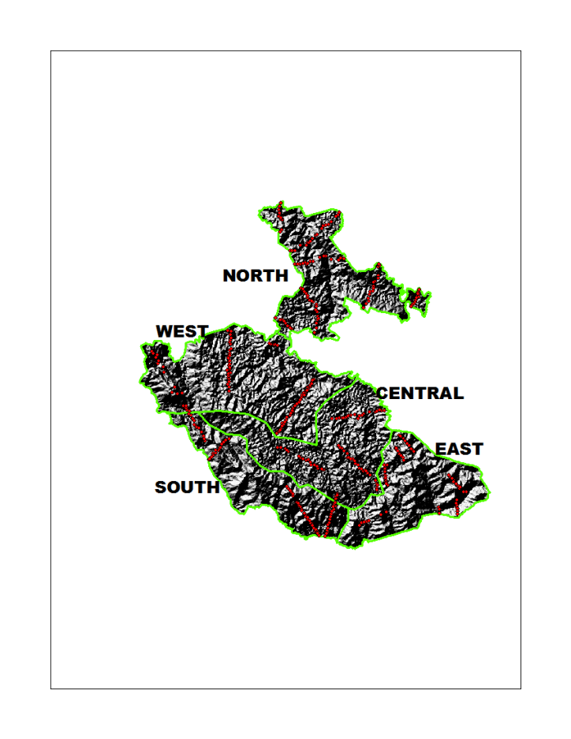
Figure 3.1 Location of the vegetation sampling plots among the strata. The plots are superimposed on a Digital Elevation Model of Bwindi Impenetrable National Park, Uganda
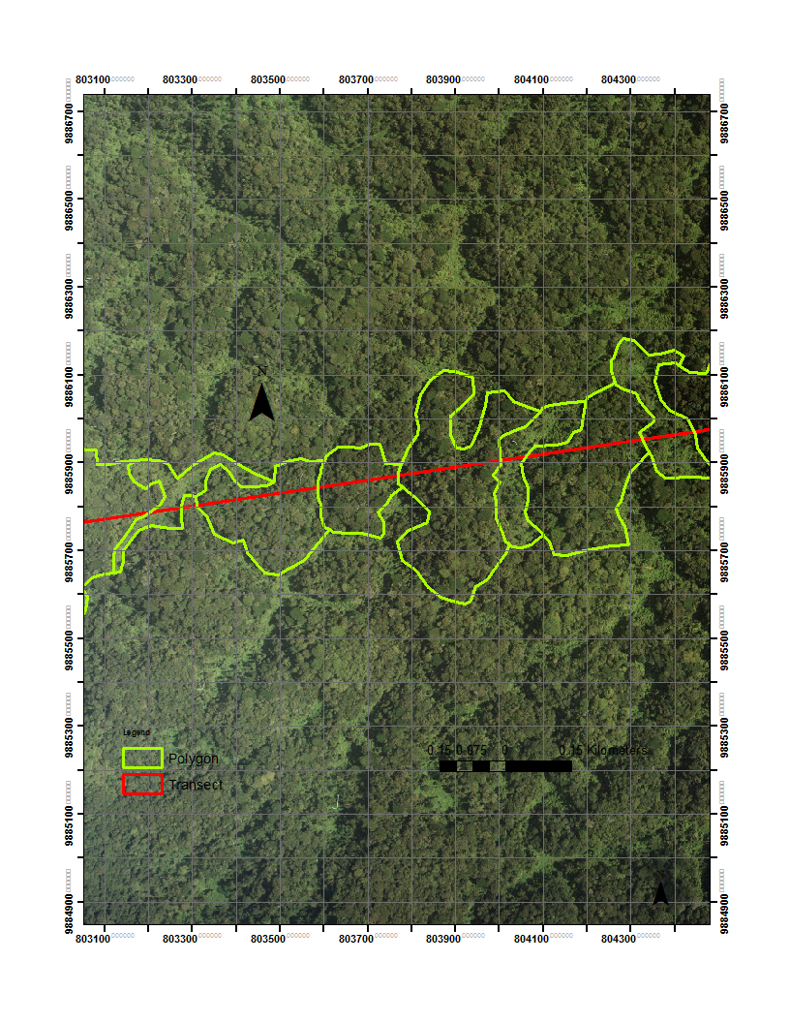
Figure 3.2 A portion of the digitised aerial photo of Bwindi Impenetrable National Park, Uganda

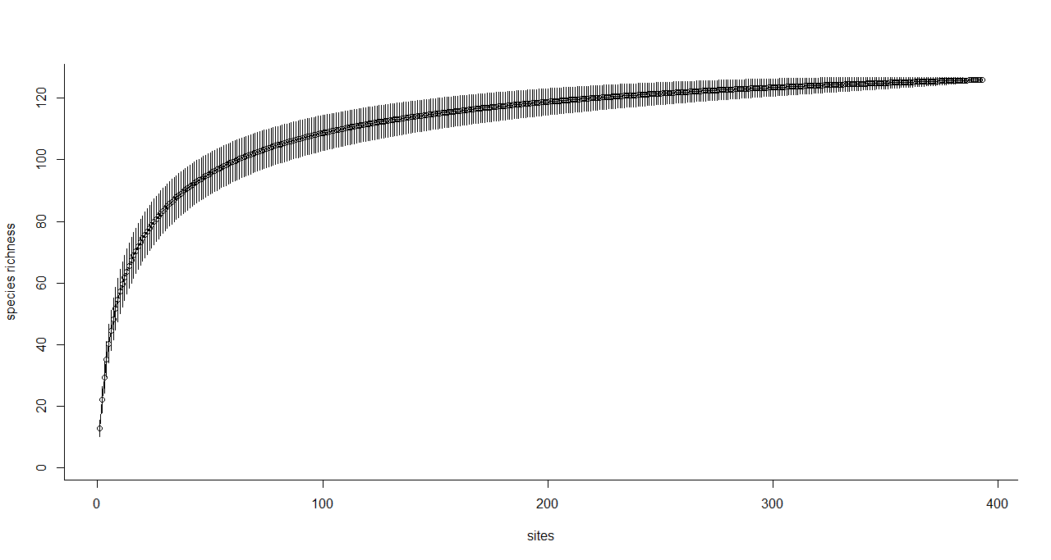
Figure 3.3 Species accumulation curve for the entire tree dataset scaled by number of sites

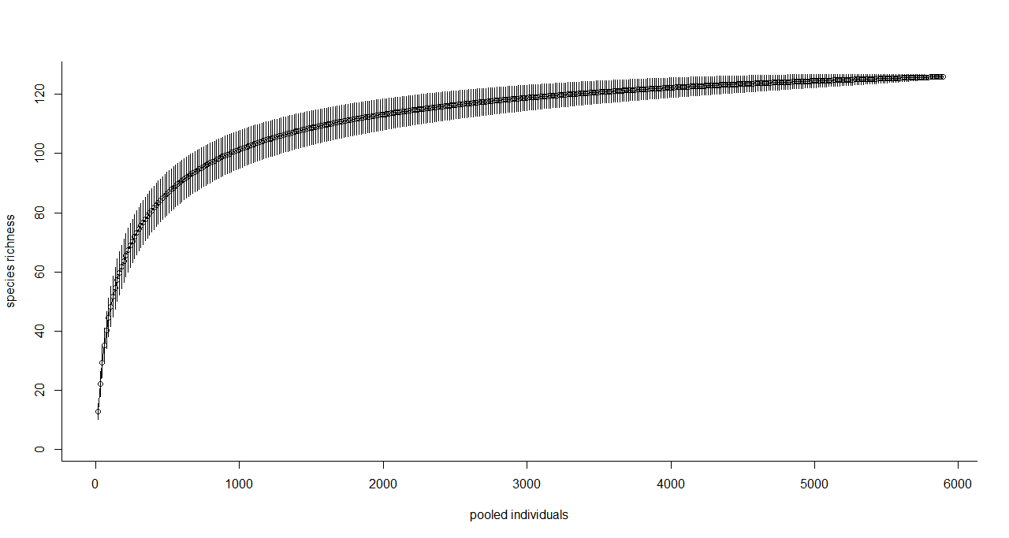
Figure 3.4 Species accumulation curve for the entire tree dataset scaled by average number of trees per accumulated site

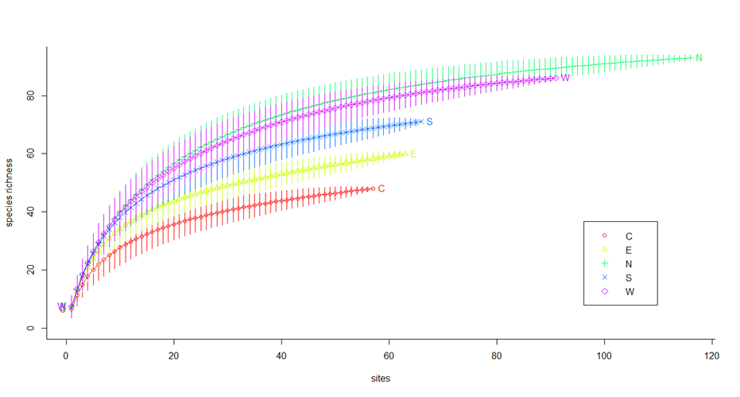
Figure 3.5 Species accumulation curves for different strata plotting species richness against accumulated number of sites

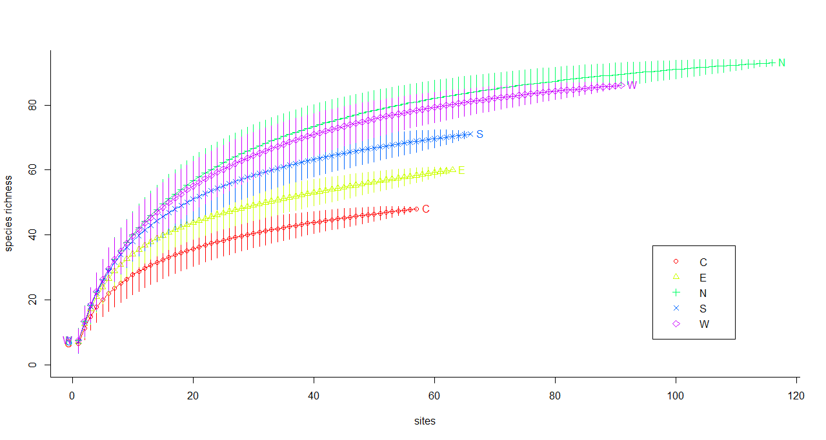
Figure 3.6 Species accumulation curves for different strata plotting species richness against accumulated number of trees

Cophenetic distance = 0.62
Figure 3.7 Dendrogram showing the sites clustered in 18 groups using a hierarchical average-linkage clustering algorithm and Bray-Curtis coefficient as the similarity measure

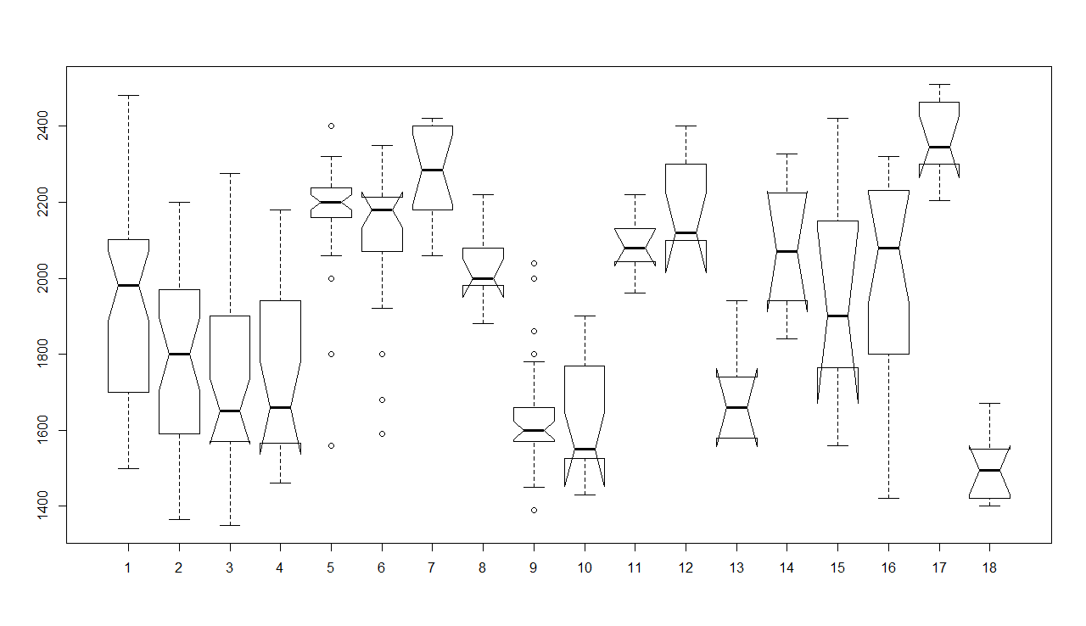
For the description of the vegetation class number see Table 3.1.
Figure 3.8 Box plots of the altitude environmental factor by 18 vegetation classes for Bwindi Impenetrable National Park, Uganda

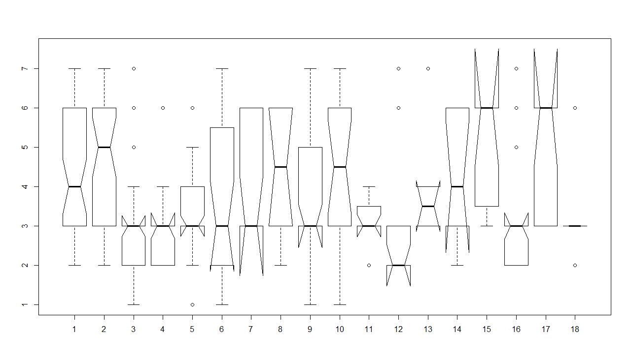
1-Gully, 2-Lower slope, 3-Mid slope, 4-Ridge, 5-Hill top, 6-Upper slopes, 7-Valley bottoms
Figure 3.9 Box plots of topographic position environmental factor by 18 vegetation classes for Bwindi Impenetrable National Park, Uganda

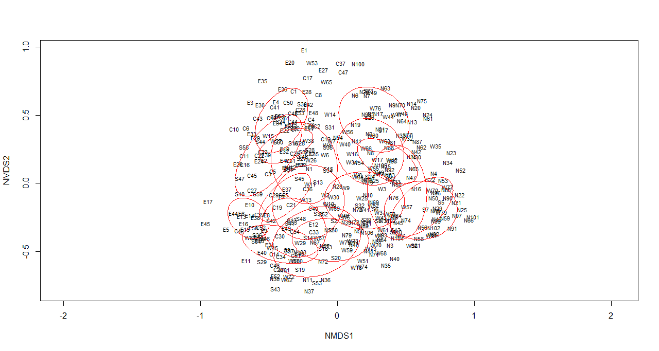
Sites in East stratum represented by E_{i}; Central stratum by C_{i}; South stratum by S_{i}; West stratum by W_{i}; and North stratum by N_{i}
Figure 3.10 NMDS ordination graph of 358 tree plots with the confidence ellipses showing where 95% of sites of the same class are expected to occur

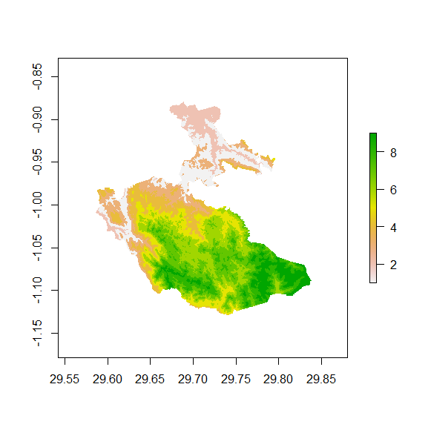
For the description of the vegetation class number see Table 3.2
Figure 3.11 Potential vegetation classes in Bwindi Impenetrable National Park, Uganda

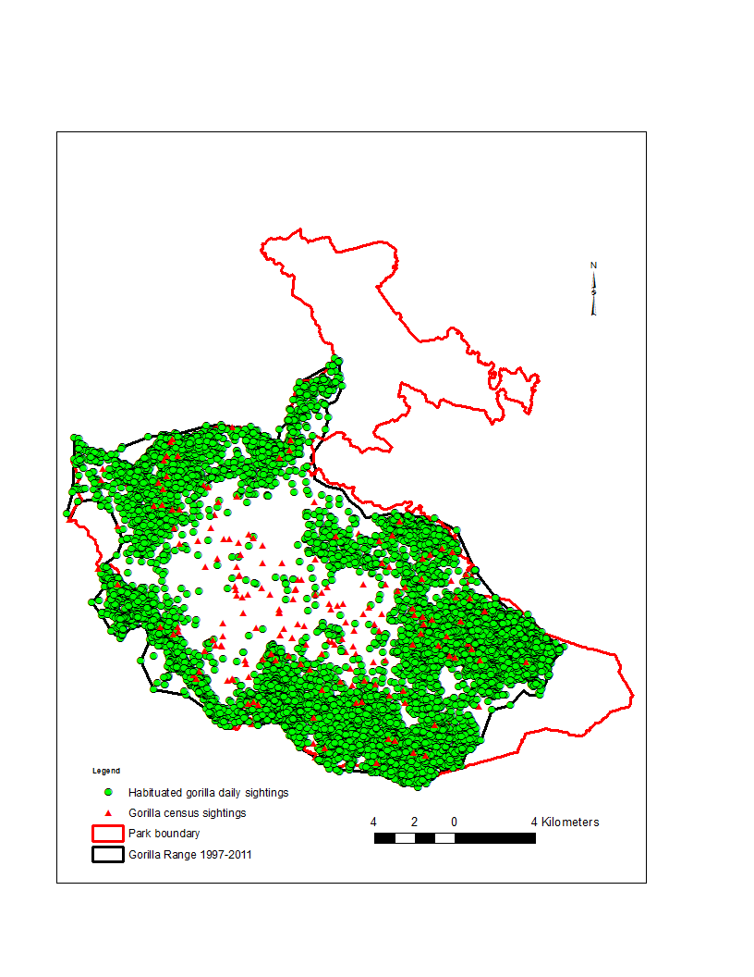
Figure 3.12 Mountain gorilla occupied and unoccupied habitats in Bwindi Impenetrable National Park, Uganda

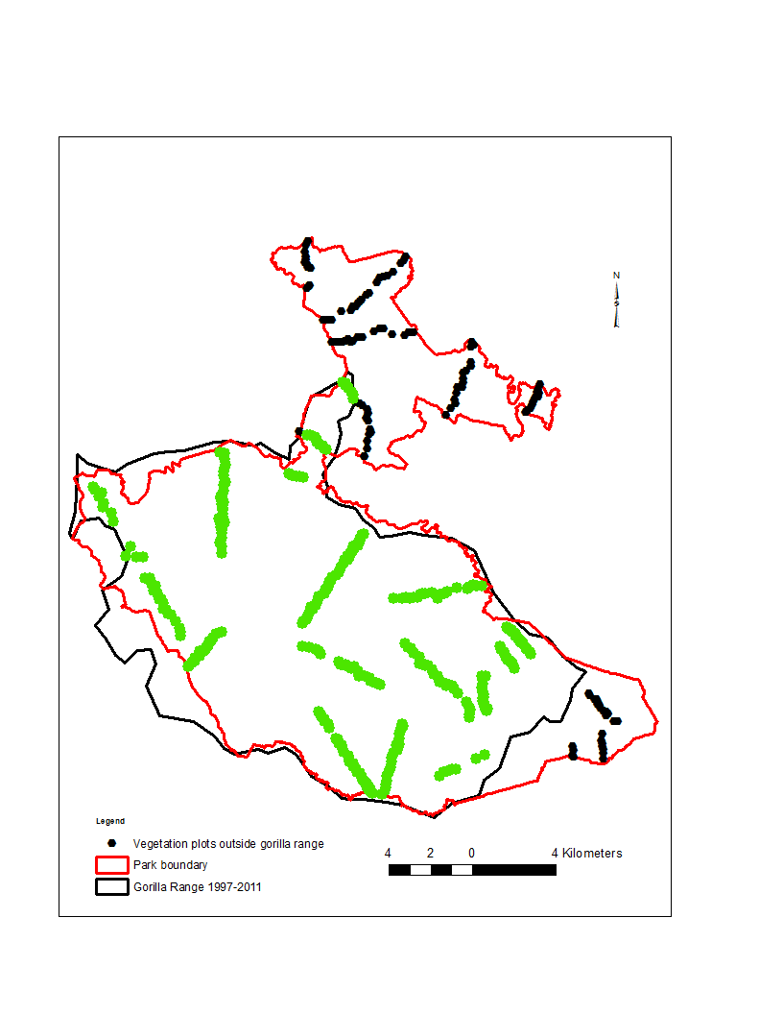
Figure 3.13 Location of vegetation sampling plots in gorilla occupied and unoccupied habitats in Bwindi Impenetrable National Park, Uganda

CHAPTER 4

HABITAT SUITABILITY MODELING FOR THE WILD GROUPS OF MOUNTAIN GORILLAS IN BWINDI IMPENETRABLE NATIONAL PARK, UGANDA

4.1 Introduction
Current loss, fragmentation and/or degradation of natural habitats and the resultant susceptibility of species of conservation concern require empirical information to understand relationships between wildlife species and their changing environments’ influence on their behavior. More critical is the identification and understanding of the factors that influence spatial and temporal patterns of threatened wildlife species’ distribution as it is fundamental question in many ecological studies because of the implications for effective conservation (Rushton et al. 2004). This involves knowledge of the species’ distribution patterns and habitat relationships, which can to be inferred from available sighting data (Palma et al. 1999). Such information can be used to develop ‘landscape-scale’ models that are useful in identifying suitable habitats that are unoccupied (Manly et al. 2002) and is valuable in predicting or modeling the likely effects of future changes such as the responses of wildlife to alterations in their habitat (Ray 2007). Wildlife populations are known to respond to environmental variables at variety of broad scales, from activity sites to landscapes (Fernandez et al. 2003; McGrath et al. 2003). For rare species with big home ranges and requiring large tracts of land to support viable populations, examining habitat features at larger spatial scales may be particularly important. This is because a landscape experienced by a population is comprised of a mosaic of good and poor quality habitats for the species. The growth or decline of the population is determined not only by the quality of the individual activity sites occupied, but also by the spatial distribution and arrangement of suitable and unsuitable activity sites or patches of habitat (Tapia et al. 2007).
With the exception of Bwindi and Virunga, mountain gorilla absence from the rain forests of the Albertine Rift, stretching from the Rwenzori to the eastern shore of Lake Tanganyika, remains unexplained (Schaller 1963). Within Bwindi forest, gorillas now use approximately 215 km² of the south sector of the park (McNeilage et al. 2001, 2006). This is about 83 percent of the south sector, or 65 percent of the whole park. To date, there is no reference to the occurrence of gorillas in the north sector of Bwindi but it is far from certain whether this area is unsuitable habitat for gorillas. Harcourt (1981), Butynski (1984) and McNeilage et al. (2001, 2006) argue that the great amount of human activity that occurs in the narrow neck of forest connecting the south sector with the north sector may be preventing gorillas from using the north sector. Areas of the south sector of the park not used by gorillas are along the periphery of the park and a dirt road. These areas appear suitable for gorillas but are subjected to considerable human use (Butynski 1984; McNeilage et al. 2001, 2006). High levels of human activity are probably preventing gorillas from making full use of the south sector.
Whereas studies have been conducted on gorilla behavioral ecology (Goldsmith 2003; Ganas and Robbins 2005), feeding ecology (Nkurunungi et al. 2004; Robbins and McNeilage 2003; Robbins et al. 2006), population numbers and structure (McNeilage et al. 2001, 2006); home range size (Robbins and McNeilage 2003; Ganas and Robbins 2005), and genetic structure (Guschanski et al. 2009) and are still ongoing, little has been done on the factors that influence gorilla population distribution at a landscape level (McNeilage et al. 2001, 2006; Stanford 2008). While the current spatial distribution of gorillas in the park is largely attributed to past and present levels of human land-use activities (Schaller 1963; Harcourt 1981; Butynski 1984; McNeilage et al. 2001, 2006), the evidence presented in all these studies is largely anecdotal as no ecological factors were simultaneously investigated. The effects of habitat heterogeneity and human activity, which together determine ‘suitable habitat’, on gorilla behavior and biology deserve significantly more research effort. At broad spatial scales, distributions of species are determined by a combination of both natural habitat availability and anthropogenic impacts (Mladenoff et al. 1995; Apps et al. 2004). Therefore, understanding the spatial influence of ecological and anthropogenic processes on gorilla distribution is crucial for making spatially explicit decisions about conservation actions.
Gorillas are an ideal species to study in a landscape context because their home ranges are wide (yearly home range for habituated groups in Bwindi is 23-33 km²; Robbins and McNeilage 2003; Ganas and Robbins 2005), use a wide array of vegetation types (Nkurunungi et al. 2004) and often help shape the ecosystems they live in (Watts 1987). In addition, gorillas live primarily in stable groups that are non territorial, have overlapping home ranges (Ganas and Robbins 2005), which are linked in space and time by dispersing individuals (Robbins 1995). Given the dynamic connectedness of the gorilla groups, human activities can fragment and disconnect the gorilla population if they are not planned from a landscape perspective. Since all the natural forest outside Bwindi is already lost, it is vital to understand the critical role the remaining forest habitat play in supporting the existing gorilla population and in ensuring potential future growth.
Different algorithms within the same framework can be used to produce potential distribution models and maps of potential habitat suitability for a species. In this study, I compared four ‘standard’ algorithms in the modeling of mountain gorilla habitat suitability. The algorithms compared were: Logistic regression, Maximum Entropy, Random Forest and Boosted Regression Trees. Such species-habitat predictive spatial models are relevant to studies of mountain gorillas in Bwindi which have restricted distribution within the forest. The reason for gorilla absence in large parts of Bwindi has been a matter for speculation. First, the spread of the mountain gorilla into Bwindi is relatively recent – probably within the past several hundred years (Schaller 1963). It is probable that the whole of Bwindi forest is good gorilla habitat but gorillas being slow dispersers, could be still expanding their range and have not had enough time to occupy all the suitable habitats available to them. This is largely based on anecdotal evidence that the altitudinal ranges avoided by gorillas in Bwindi are utilized by gorillas in other areas like in Kahuzi-Biega in DR Congo and the Virunga Volcanoes in Rwanda. It is assumed that if gorillas had penetrated Bwindi area much earlier, they would be occupying all the suitable habitats available to them. Second, the quality of the vegetation in areas avoided could be poor for gorilla foraging (McNeilage et al. 2001, 2006). The areas avoided by gorillas occur mostly at the two extreme ends of the forest altitudinal range – the lowest and highest – which have a significantly different vegetation structure and composition from the areas currently utilized by gorillas. However, it is not conclusive that gorillas cannot utilize these avoided habitats because the right food plants do not occur there. For example, even though bamboo is a preferred food plant for the Virunga gorillas, the Bwindi gorillas do not utilize the bamboo zone. Third, they could be physical barriers to gorilla spread like the narrow forest strip between the north and south sectors of Bwindi, wide and deep rivers, steep slopes, and roads (Schaller 1963; Harcourt 1981; Butynski 1985; McNeilage et al. 2001, 2006). The road through the highest elevations of the forest and the narrow strip of forest connecting the north and south parts could, at least in part, be responsible for the absence of gorillas from the bamboo zone and northern areas of Bwindi respectively due to continuous human and vehicular traffic. Last, gorillas could be avoiding forest areas such as the northern and south eastern parts because of high levels of human activity (Harcourt 1981; Butynski 1985; McNeilage et al. 2001, 2006). Disturbance is not evenly distributed over the park and different disturbances are concentrated in different areas. Such human disturbances could have an impact on gorilla use of particular areas.
However, the ‘standard’ algorithms used in gorilla suitability modeling are based on the assumption that a species can only occur in areas with the environments that are similar to that of the sites where it is currently observed. For the wild mountain gorilla, this is unlikely to be the case. While I do not have reliable historical maps or evidence from fossils, it is clear that the mountain gorilla population is presently squeezed in Bwindi because it is protected. It may not the preferred habitat but just the last refuge for the gorillas.
Successful conservation of an endangered species depends on understanding interactions between the organism and its environment. Spatially-explicit, probabilistic distribution models are important tools for examining this relationship, which is central to ecology (Guisan and Zimmermann 2000). Such models are increasingly used to map species actual and potential distributions, and to understand the factors influencing the distributions (Guisan and Zimmermann 2000; Rushton et al. 2004). The primary objective of this chapter was to map gorilla actual and potential habitat selection and distribution throughout the forest using spatial distribution models and to understand the factors influencing habitat suitability.

4.2 Objectives
i. Understand the environmental factors responsible for the present day wild gorilla distribution;
ii. Identify the core area for conservation;
iii Predict the likelihood of gorilla spatial distribution across the entire park; and
iv Compare and contrast the model predictions of the four approaches used.

4.3 Research questions
i. What determines the present distribution of wild gorillas? and
ii. Is there room where additional wild gorilla groups can survive?
iii. Do the predictions of the four modeling algorithms agree?

4.4 Hypothesis
I hypothesize that current wild gorilla spatial distribution patterns reflect past and current human disturbance intensity (more people = less gorillas) rather than the environmental variables

4.5 Methods

4.5.1 Study area and mountain gorilla population
The Bwindi Impenetrable National Park is a montane forest ranging from 1,160 to 2,607 m altitude in south-western Uganda (0º53´-1º08´S, 29º35´-29°50´E). The forest was initially gazetted as a forest reserve in 1932 (Leggat and Osmaston, 1961; Howard, 1991) and animal sanctuary in 1961 (Butynski, 1984) and became a national park in 1991 to protect its rich plant and bird diversity and population of the endangered mountain gorillas (Butynski and Kalina, 1993). The park is approximately 331 sq km of extremely rugged country characterized by numerous steep-sided hills and narrow valleys. A narrow neck of forest of about 1 km, traversed by a road, divides the park into northern and southern parts. The park is surrounded by a high human population, which in 2002 averaged 290-323 people per sq km, growing at a rate of 1.05-1.39% (Plumptre et al. 2004). Human use of this forest was extensive in the past, with logging causing the greatest damage (Howard 1991). When Bwindi became a national park, all logging was banned. However, multiple-use zones were established for harvesting of basketry fiber, medicinal plants and bee-keeping (Wild and Mutebi 1996). Zones for tourism in the form of gorilla visits and forest walks were also created (Gubelman et al. 1995). Other human activities like logging, fuel wood and pole collection, wild honey harvesting, poaching of forest antelopes by snaring or hunting with dogs, all illegal, and occasional killing of gorillas, still occur in the park.
The recent total count of the gorillas of 2011 in Bwindi is estimated at least 400 individuals, living in 36 social groups and 16 solitary males (Robbins et al. 2011). Of these social groups, 10 have been progressively habituated for tourism since 1992. Sixteen lone silverbacks were also encountered. The gorillas, especially the wild groups, were found in the central region of the park, whereas the habituated ones mostly inhabit along the periphery of the park. The habituated groups, with a total of 168 individuals, are monitored on a daily basis for either research or tourism and their locations recorded. The wild groups locations are only recorded when they are encountered during the regular anti-poaching patrols, when conducting tourism hikes and during the regular five-year interval gorilla censuses.

4.5.2 Data preparation

4.5.2.1 Gorilla occurrence data and background points
I used the occurrence data of confirmed wild mountain gorilla group locations or their fresh signs like nests, feeding sites or trails in Bwindi since, compared to the habituated groups, they are spatial distribution is thought to be constrained by human activity. Also, compared to the habituated groups which are actively managed for tourism and research and also receive veterinary care, little is known about the wild gorilla groups. Gorilla location data were routinely collected by park rangers on law enforcement patrols and during the five year interval mountain gorilla censuses. A hand-held GPS was used in the field to collect location information in a common projection system (UTM Arc1960 35S) and recorded as coordinates (pairs of Eastings/Northings), though during the analyses I converted them to “longitude latitude WGS84” to match other data layers derived from global spatial databases. Accuracy was reported for each coordinates’ recording and when the offset greater than 20 m was reported, I discarded the recording. All wild gorilla occurrence data used was collected between 1997 and 2011. Wild gorilla occurrence location data coordinates were stored in a spreadsheet (.csv file) and then imported into R statistical program for analysis.
I used background data to characterize the environments in the entire Bwindi. The intention of providing background sample is not to pretend that the species is absent at the selected sites, but to provide a sample of conditions available to gorillas in the whole of Bwindi. Then the environments where the wild gorillas are known to occur were related to the environments across the rest of Bwindi (the ‘background’). Gorilla occurrence localities were also included as part of the background. Background data was preferred over other methods such as those of generating absence and “pseudo-species” data because background data required fewer assumptions and had some coherent statistical methods for dealing with “overlap” between presence and background points (Ward et al. 2009; Phillips and Elith 2011).
Background data for training and testing sets was generated randomly using R program (R Core Team 2013). R package “dismo” has a function to sample random points (background data) from a study area. One of the environmental data layers imported in R program was used as a ‘mask’ to ensure that the random points only occur within the spatial extent of the rasters, and within cells that are not NA (Not Available) and that there is only a single absence point per cell.

4.5.2.2 Environmental data
The predictor variables chosen were those that are relevant to gorilla spatial ecology. Maps of predictor variables were prepared in ESRI ArcGIS 10.1 as raster (grid) files. Each predictor variable was a “raster” representing a variable of interest. These data were stored in files in a GIS format. All the grid layers were made to have same spatial extent, resolution, and projection. The grid files were then imported into R program using the “dismo” package. The following were chosen as predictor variables for gorilla distribution in Bwindi:
Vegetation types – Vegetation is an important resource for animals (Morrison et al. 2006). It is used for food, nesting, shelter, travel and hiding from potential prey/enemies. In Bwindi, the gorilla population seems to be genetically structured, influenced partly by plant community composition (Guschanski et al. 2008). Therefore gorillas seem to prefer to live in their natal habitats, where they are used to specific food plant species. Nine vegetation types derived using predictive vegetation mapping by reclassifying an Aster 30m GDEM using ArcGIS tools (see Chapter 3) were used as the vegetation layer.
Local topographic features could affect the distribution of gorillas through terrain characteristics such as slope steepness and curvature. Given the rugged nature of the Bwindi topography, particular terrain characteristics could be pose difficulties for gorillas to utilize certain areas so as to avoid spending unnecessary energy going over/to them. These were represented by: curvature – concavity/convexity or surface roughness and slope steepness of Bwindi. Both layers were derived from Aster GDEM using ArcGIS Spatial Analyst tool.
Human activity sign density – the data was collected during the 1997 gorilla census. As discussed in Chapter Two, levels of human activity seem to influence distribution of wild gorilla groups. Human signs were analyzed as encounter rates per km walked in each of the sectors used in the gorilla census. There were, in some cases, large differences in the encounter rates of human signs between adjacent sectors. Where there was a particularly high incidence of disturbance in a particular sector, it was expected to have an impact on wildlife distribution even in neighboring sectors, particularly for a highly mobile species such as gorillas. A neighborhood analysis using focal statistics in the Spatial Analyst tool of ArcGIS was used and had an effect of spreading the impact of disturbance in a particular sector across neighboring sectors. In this procedure, the encounter rate in a given sector was replaced by the average of the encounter rates in that sector together with all the directly adjoining sectors, which smoothed out the distributions and removed sharp differences between adjoining sectors.
Other forms of human disturbance were roads within the park and the sharp edge of the park. These were prepared as Euclidean distances from roads within the park and park border using ArcGIS Spatial Analyst tool.
Euclidean distances from the valleys - valleys were represented by streams derived from an Aster GDEM using the Hydrology tool in ArcGIS Spatial Analyst. Gorillas in Bwindi prefer foraging in the valleys and gullies, and moving across the ridges with little sign of foraging (Harcourt 1981). Caillaud (2008) estimates that gorillas spend approximately five days before they move out of an area and avoid crossing ridges more than necessary. They also seem to return once the herbaceous vegetation has recovered. Valleys and gullies are open forests mainly with dense herbaceous vegetation with little or no tree cover (see Chapter 3).
Before being used in the models, the predictor variables were visually investigated for colinearity at the presence and background points using a pairs plot generated in R program.

4.5.3 Extracting values from rasters
After having a set of predictor variables (rasters) and gorilla occurrence and background points in R program, the next step was to extract the values of the predictors at the locations of the gorilla occurrence and background points. This was done using the “extract” function from the R package “raster”. The function “extract” was first used for gorilla occurrence points and then for random background points. These were then combined into a single data frame in which the first column (variable “pb”) indicates whether this is a presence or a background point. Vegetation type was made a categorical variable (called a “factor” in R) so that it was not treated like any other numerical variable.

4.5.4 Model fitting, prediction and evaluation

4.5.4.1 Model fitting
Model fitting/estimation/calibration means estimation of model parameters e.g., coefficients in a regression model, the splitting rules in Machine learning etc. Most methods took a “formula” (except Maxent) identifying the dependent and independent variables, accompanied with a data frame that held these variables. The data frame used for all the models was the one generated above in the section on “Extracting values from rasters”.

4.5.4.2 Model prediction
Different modeling methods returned different type of ‘model’ objects. All these ‘model’ objects, irrespective of their exact class, were used with the R “predict” function to make predictions for any combination of values of the independent variables. Since the purpose of SDM was to create a map of suitability scores, the “predict” function was provided with a Raster object (having names of the predictors) and a model object.

4.5.4.3 Model evaluation
Evaluation is a measure of how well the model fits the data. In this case since my models were to be used for prediction, the evaluation was focused on how well the models predicted to points not used in model training. I used a five-fold cross-validation approach to estimate the accuracy of the predicted models. The cross validation was implemented following Hastie et al. (2001). First, the gorilla presence data frame was randomly partitioned into five subsets of equal size using R “dismo” package function “kfold”. Second, each subset was in turn used for accuracy testing and the remaining four subsets for training, therefore my models were fitted and tested five times. Finally, the results were stored in a list called ‘e’. I used Area Under Receiver Operator Curve (AUROC, further abbreviated to AUC) to evaluate the quality of the prediction. AUC is a measure of rank-correlation. In unbiased data, a high AUC indicates that sites with predicted suitability values tend to be areas of known presence and locations with lower model prediction values tend to be areas where the species is not known to present (absent or a random guess). AUC values were then be extracted from the objects in ‘e’. A perfect model has an area under the ROC curve of 1.0. An AUC score of 0.5 means that the model is as good as a random guess and below 0.5 are obtained in systematically wrong predictions.

4.5.5 Modeling methods
I used and compared four algorithms to predict gorilla habitat suitability. They all used the same gorilla presence and background data prepared as above.

4.5.5.1 Regression models
These techniques depend on the maximum likelihood principle in which models chosen and parameters for this model are estimated from the data. We judge the model on the basis how likely the data would be if the model was correct.

4.5.5.1.1 Generalized Linear Models – logistic regression
General linear models (GLM) are extensions of linear models that can cope with non-normal distributions of the response variables (Venables and Ripley 1994). If the response assumes two states, such presence/absence, as in my gorilla location data, it may be described by a binomial distribution. The linear model is generalized using the link function that describes how the mean of the response variable Y depends on linear predictors, and a variance function that describes how the variance of Y depends on the mean (Chambers and Hastie 1992). The generalized linear model can be expressed as:
g(E(Y))=LP=ß˳+∑X_{j}ß_{j}+ε
Where the predictor variables (far right side of the equation) are combined to produce a linear predictor, LP, and the expected value of Y, E(Y), is related to the LP through the link function, g(). So, formulating a generalized linear model for SDM includes selecting the response distribution and the link function, the variance function, and the predictor.
The link function or inverse function describes how the mean of Y depends on the linear predictor, or “links” the expected values of Y to the predictors. In this study, since the response is binary, the binomial distribution was used to describe the distribution of Y, which is gorilla presence or absence, and the logit link was used. A GLM with a binomial family (logit link) is commonly called “logistic regression.” The logit link is:
LP=log(μ/1-μ)
or “logit” μ – the “log odds” ratio of the probabilities of class 1 and 0 – where μ=E(Y) is the probability of class 1, and (1-μ) is the probability of class zero, e.g., the probabilities of class 1 and class 0 must sum to one.
The coefficients (ß) of the predictors in a logistic regression model can be conveniently interpreted in the probability of species presence.
In logistic regression, the LP produces fitted values and predictions are on the logit (log odds) scale. An inverse transform is then applied to the LP in order to predict the values on the response scale (in units of the response variable). In logistic regression we are often interested in the predicted probability of a class, μ – in this case probability of gorilla occurrence rather than the log odds ratio, so by inverting the above equation we can solve for μ.
μ=(е^{LP}/1+е^{LP})
The variance function describes how the variance of Y depends on the mean. The binomial variance function for the logistic regression model is:
V(μ)=μ(1-μ).
Non-linear responses can be achieved by including additional transformations of the predictors. Flexibility in the specification of predictor variables in GLM can be achieved by specifying a piecewise linear function (X>t) (X-t) where t is a threshold value of X, below which there is no effect of X on Y (ß=0) and above which a linear coefficient (X-t) is estimated. I implemented logistic regression model in R package “dismo”.

4.5.5.2 Machine learning methods (ML)
The goal of the Machine Learning Methods is to learn from the data and build a model that can make accurate predictions. Hastie et al. (2009) refers to this as the supervised learning problem or sometimes referred to as data mining. ML approach assumes that the data generating process is complex and unknown and tries to learn the response by observing inputs and responses and finding dominant patterns.

4.5.5.2.1 Maximum Entropy (Maxent)
Maxent has been called both a general machine learning method and a statistical method, so Phillips et al. (2006) refers to it as a statistical learning method. Maxent software was specifically developed to develop SDMs with “presence-only” species occurrence data (Dudik et al. 2007). In maximum entropy, the multivariate distribution of suitable habitat conditions in environmental feature-space is estimated according to the principle of maximum entropy that states that the best approximation of an unknown distribution is the one with maximum entropy (the most spread out) subject to known constraints. The constraints are defined by the expected value of the distribution, which is estimated from a set of species presence observations.
Maxent has been described as a generative modeling approach (as opposed to discriminative Phillips and Dudik 2008), that models the species distribution directly by estimating the density of environmental covariates conditional on species presence. The raw output of Maxent is an exponential function that assigns a probability to each site. Raw values are dependent on the number of background and occurrence sites used because they must sum to one, and so they are converted to a cumulative probability (Phillips et al. 2006). In the cumulative format values from 0-100 represent the range of probabilities predicted by the model. The cumulative format, while scale independent, is not necessary proportional to the probability of presence, for example, if probability values are similar across the entire region, e.g., for a generalist species. Maxent has a logistic output format that estimates the probability of presence (Phillips and Dudik 2008). The logistic output format addresses the problem by the use of an exponential model for probabilities which can give very large predicted values for conditions that are outside the range of those found in the data used to develop the model. This model was generated using ‘maxent’ function of ‘dismo’ package in R program.

4.5.5.2.2 Random Forest (RF)
RF (Breiman 2001) method is an extension of the classification and regression trees (CART; Breiman 1984). These procedures are useful for exploration, description and prediction of species-environment relationships (De’ath 2002). They are nonparametric therefore make no assumption about the form of the relationships between species and their environment. They are a form of multivariate regression in that the response is explained, and can be predicted, by the explanatory variables. They divide the data by recursive partitioning of the data space such that the ‘populations’ within each partition become more and more homogeneous based on the ranges of values of predictor variables. They are a method of constrained cluster analysis because they determine clusters that are similar in a chosen measure of species dissimilarity e.g., presence/absence, with each cluster being defined by a set of environmental values e.g., vegetation type. At each node, the tree algorithm searches through the variables one by one, beginning with x₁ and continuing up to x_{M}. For each predictor variable it finds the best split (minimizes the total sum of squares or sums of absolute deviations about the median). Then it compares the M best single-variable splits and selects the best of the best. They recursively partition each node until a large number of trees (500 to 2,000) are grown, hence a ‘forest’ of trees. The same procedure is applied to the subsets of the data, again using all the predictor variables to search for candidate splits.
In order to avoid developing a tree model that is over-fit to the training data, bootstrap aggregation or “bagging” works repeatedly (say, 30-80 times) sampling the data with replacement (bootstrapping) and developing trees for each dataset using some stopping rule but without pruning. Typically about 1/3 of the data are held out of each sample (“out-of-bag”) and used to evaluate the model, while other data are replicated to bring the “in-bag” sample to full size. In addition, each split in each tree model is also developed with a random subset of candidate predictor variables, hence the name “random” forests. Then predictions based on all of the trees are averaged using a plurality voting rule in the case of a categorical response such a species presence/absence. In other words each of the many models is used to make a prediction for each observation in a new dataset, and these predictions are averaged.
Variable importance is estimated in two ways for RF. For each decision tree there is a mean error rate calculated from the out-of-bag sample. The difference between this error rate and the error rate calculated by randomly assigning the values of a predictor variable, and then passing the test data down the tree to get new predictions, is a measure of the importance of that predictor. This decrease in accuracy if the variable were randomly permuted, the difference between the error rates or mean squares errors, divided by the standard error, is calculated as one measure of variable importance. Another measure of variable importance, based on the training (in-the-bag) data, is the reduction in sum of squares (deviance) achieved by all splits in the tree that use that variable, averaged across all the trees. I implemented RF in R package “randomForest”.

4.5.5.2.3 Boosted Regression Trees (BRT)
BRT is an improvement over classification and regression trees (CART; Elith et al. 2008). BRT uses two algorithms: regression trees are from classification and regression tree (decision tree) group models, and boosting builds and combines a collection of models. Boosting is a method for improving model accuracy, based on the idea that it is easier to find and average many rough rules of thumb, than to find a single, highly accurate prediction rule (Schapire 2003). Boosting is sequential: it is a forward, stagewise procedure. In boosting, models (e.g. decision trees) are fitted iteratively to the training data, using appropriate methods gradually to increase emphasis on observations modeled poorly by the existing collection of trees. Boosting in regression problems is a form of “functional gradient descent”. Boosting is a numerical optimization technique for minimizing the loss of function by adding, at each step, a new tree that best reduces (steps down the gradient of) the loss function. For BRT, the first regression tree is the one that, for the selected tree size, maximally reduces the loss function. For each following step, the focus is on the residuals: on variation in the response that is not so far explained by the model. The second step, a tree is fitted to the residuals of the first tree, and that second tree is fitted to the residuals of the first tree, and that second tree could contain quite different variables and split points compared to the first. The model is then updated to contain two trees (two trees), and the residuals from this two-term model are calculated, and so on. The process is stagewise (not stepwise), meaning that existing trees are left unchanged as the model is enlarged. Only the fitted value for each observation is re-estimated at each step to reflect the contribution of the newly added tree. The final BRT model is a linear combination of many trees (usually hundreds to thousands) that can be thought of as a regression model where each term is a tree. BRT model was fitted with ‘gbm’ function in R package “dismo”
For each method, I fitted the model, evaluated it and made a prediction.

4.6 Results

4.6.1 Mountain gorilla presence points and background points
All wild mountain gorilla occurrence points (201 records) were compiled from Uganda Wildlife Authority Ranger Based Monitoring data of 1999 – 2011 and four gorilla census data (1997, 2002, 2006, and 2011). These represent gorilla presence data and were used to establish under which conditions a gorilla was more likely to be present than average. The points were randomly divided into training and testing sets (Figure 4.1). The training points were used to derive gorilla habitat suitability, while the testing points were used in validate the suitability results of the testing set.
Two thousand background points were randomly generated using R ‘dismo’ package. Background data was used to characterize environment in the study area. The background points were also divided into training and testing sets as shown in Figure 4.2. The training set was used to determine habitat suitability while the testing set was used to validate the suitability prediction derived using the testing set.
The gorilla and background training data sets were used to determine habitat suitability while the gorilla and background testing points were used to validate the results produced by the training data sets.

4.6.2 Environmental variables
The seven environmental variables thought to affect gorilla distribution were prepared in a grid map format. Figure 4.3 shows the grid maps of vegetation types (vegn1), smoothed human sign density (human1), distance from the valleys (valleydist), the concavity/convexity of the Bwindi surface (curva), slope steepness (slope), distance from the park border (borderdist), and distance from the roads within the park (roaddist).
The environmental variables were investigated for colinearity at the presence and background points. From a visual assessment of the pairwise scatter plots (Figure 4.4), none of the factors showed any colinearity with the other. Therefore, all the environmental variables were declared independent and were maintained in all subsequent modeling procedures.

4.6.3 Species Distribution Models (SDM)
The corresponding environmental conditions associated with each gorilla occurrence points and background points were extracted using R package ‘dismo’ converted into a data frame then used to fit the four models using the extracted values. The fitted models were used to predict areas in Bwindi where gorillas may potentially be able to survive and their predictions were evaluated for accuracy.

4.6.3.1 Generalized linear model (GLM)
A GLM in the form of logistic regression was applied to gorilla location data, background data and the environmental variables and the resulting model was evaluated and made to predict habitat suitability for gorillas in Bwindi.
Model fitting
Logistic regression model showed that vegetation type, distance from the roads, and level of human activity were the most important environmental factors affecting gorilla habitat suitability in Bwindi (Table 4.1). Not all the nine vegetation were important in contributing to the model. Four vegetation types, corresponding to gorilla presence points, were the most important in contributing to the model.
Model prediction
The potential gorilla habitat suitability map based on the prediction of the generated logistic regression model is shown in Figure 4.5. In the distribution map, light colors represent absence of the gorillas and dark colors represent a high confidence in the presence of the gorilla. Intermediate colors represent different degrees of confidence in the presence of gorillas in a given area. The model predicted that much of Bwindi was suitable for gorillas except an area in the north east part of the park. This unsuitable area coincides with an area with highest level of human activity in the park. The middle of the southern lobe of the park is ranked the best area for gorilla habitation and corresponds to the area covered by gorilla presence points.
Model evaluation
The AUC score for the logistic regression model was 0.71. This means that the model performed better than random to predict gorilla habitat suitability.

4.6.3.2 Maximum entropy
Data on gorilla presence locations and grid files of the seven environmental variables were imported into R program ‘dismo’ package that had a function ‘maxent’ that communicates with this program. Maxent model gives two important results: relative contribution of the environmental variables to the Maxent model and a predictive habitat suitability map.
Model fitting
The results of Maxent model showed that the level of human activity and vegetation type were the most important environmental variables determining gorilla habitat suitability (Figure 4.6). They both contributed more than 70% to the model. The other variables contribution to the model was negligible.
Model prediction
Figure 4.7 is a representation of the Maxent model for potential gorilla distribution in Bwindi. On the map, light colors represent absence of the gorilla and dark colors represent a high confidence in the presence of the gorilla. Intermediate colors represent different degrees of confidence in the presence of gorillas in a given area. Visual inspection of the Maxent predictive map shows that better conditions are found in the center of the southern lobe of the park. Low habitat suitability predictions are observed in the northern lobe of the park, and southeast part of the park. These areas correspond to areas with no observed gorilla occurrence. Low suitability is also observed in the western part of the southern lobe of the park. It is mainly only the habituated tourism groups that range in this area with very few wild groups.
Model evaluation
The AUC score for the Maxent model test data was 0.69. This means that the model performed better than random to predict mountain gorilla habitat suitability.

4.6.3.3 Random forest
A random forest model was fitted with gorilla location data, background data and the environmental variables and the resulting model was evaluated and made to predict habitat suitability for gorillas for Bwindi.
Model fitting
Random forest computed the mean decrease in accuracy for the predictor variables (Graph on the left; Figure 4.8). RF model predicted that distance from the roads, distance from the park border, level of human activity and vegetation type were the major factors determining gorilla habitat suitability.
Model prediction
The potential gorilla habitat suitability map based on the prediction of the generated random forest model is shown in Figure 4.9. On the map, light colors represent absence of the gorillas and dark colors represent a high confidence in the presence of the gorilla. Intermediate colors represent different degrees of confidence in the presence of gorillas in a given area. RF predicts that much of Bwindi as not suitable for gorillas except in the center of the southern lobe of the forest (Figure 4.9). Even then, the predicted suitability is low. The areas ranked as very poor for gorillas coincide with areas with high level of human activity. The RF model was particularly sensitive to any form of human activity – park border, roads and human activity within the park.
Model evaluation
The AUC score for random forest model was approximately 0.69. This means that the model performed better than random in predicting gorilla habitat suitability.

4.6.3.4 Boosted Regression Trees (BRT)
A BRT model was fitted with gorilla location data, background data and the environmental variables and the resulting model was evaluated and made to predict habitat suitability for gorillas for Bwindi.
Model fitting
In order of decreasing importance to BRT model prediction were variables - Vegetation, distance from park border, distance from roads, slope steepness, level of human activity within the park, surface curvature, and distance from the valleys (Figure 4.10).
Model prediction
The potential gorilla distribution map based on the predictions of the generated BRT model is shown in Figure 4.11. In the distribution map, light colors represent absence of the gorillas and dark colors represent a high confidence in the presence of the gorilla. Intermediate colors represent different degrees of confidence in the presence of gorillas in a given area. The model predicted that the park was generally of low suitability and the only highly suitable areas were very small and scattered in the southern lobe of the park.
Model evaluation
The AUC score for BRT model was 0.71. This means that the BRT model performed better than random in predicting gorilla habitat suitability.

4.6.3.5 Model averaging
Because the models yielded different prediction results, I applied model averaging. But only two models – logistic regression and random forest models – could be averaged because they were fitted using the same extracted data frame while the Maxent function extracted the data frame itself from a raster-stack and points and BRT model required the test data matrix to have a column of gorilla presence/absence. The two models were combined weighted by their AUC values. To create the weights, I subtracted 0.5 (the random expectation) and squared the result to give further weight to higher AUC values. A resulting habitat suitability average weighted map is shown in Figure 4.12.
The average model predicts that nearly the whole park is suitable for gorillas. The only exception is the area in the northeast section of the park. This unsuitable area coincides with an area with the highest level of human activity in the park. The central part of the southern lobe of the park is predicted to be of very high habitat suitability for gorillas.

4.6.3.5 Model contrast
Model predictions of gorilla habitat suitability among the four algorithms (Figure 4.13) differed substantially. The logistic regression model predicted that nearly the whole park was suitable for gorillas except an area in the northeast. The other three models, however, predicted that most of the park is unsuitable habitat with the whole northern part and the edges of the south lobe of the park being completely unsuitable. The center of the south part of the park was predicted to have varying levels of suitability for each algorithm. Logistic regression predicted that much of it is highly suitable, while Maxent model showed that it only the interior of the south sector that is highly suitable. Random forest and boosted regression trees models gave the interior the south sector low suitability with a few, scattered, small areas being highly suitable.
Except for the order of ranking in importance, there are no major differences in the environmental variables that contribute most to the models. Vegetation type and levels of human activity in the park are shown to be the common contributing factors for all the four models (Table 4.2). Roads are common in three models – logistic regression, random forest and boosted regression trees and distance from the park edge being important in two models – random forest and boosted regression trees. What can be concluded therefore was that variation in vegetation composition and various forms of human activity in or adjacent to the park seem to contribute to gorilla habitat suitability.

4.7 Discussion
Ecologists frequently use models to detect and describe patterns or to predict to new situations. Models can be used to identify variables with most explanatory power, indicate optimal conditions and predict to new cases. Regression models are often used as tools for quantifying the relationship between one variable and others upon which it depends (Elith et al. 2008). In this study, all the SDM techniques I used, with the exception of Maxent, the used regression technique in data fitting.

4.7.1 Comparison of the modeling algorithms
All the four algorithms performed better than random, based on the area under the ROC curve (average AUC = 7.0). There were small differences (≤0.02) in the AUC scores meaning that the models had more or less the same predictive ability. Variation in the models laid in their prediction outputs in areas of gorilla habitat suitability. Therefore, rather than rely on a single “best” model, model averaging has been proposed to cope with variation among SDM predictions associated with SDM algorithms (Thuiller 2003, 2004). However, model averaging has the disadvantage that it may interpreted as akin to averaging over independently obtained estimates with random error, or the situation where, as in machine learning, the combination of many ‘weak models’ may result in a ‘strong model’ (Thorne et al. 2013). The variation in my modeling results suggests that they are representing strongly different views of reality, and some models predictions may be wrong. In this case model contrasting is more useful (Thorne et al. 2013). Differences in model predictions point at gaps in our knowledge that could be used to guide research and adaptive learning and management. In the case of mountain gorillas, areas identified as unsuitable in one model but suitable in another could be a focus of further study. Areas in the north, west and east of the park that are currently not occupied by gorillas should be the center focus. Management to promote gorilla use of and monitoring changes in the occupancy of these areas could serve to determine what limits gorillas use of these areas. One lead is the habituated gorilla group currently utilizing of the southern part of north sector of the park since 2006.

4.7.2 Habitat suitability and environmental variables
Levels of human activity and variation in vegetation composition were the only factors that were shown to be very important in determining habitat suitability across all the four models. Roads were important in three models – logistic regression, random forest and BRT, while park border in two models – random forest and BRT. Random forest and BRT models were particularly sensitive to all human disturbance related variables - roads, park border and levels of human activity within the park. All in all, vegetation and all forms of human disturbance affect gorilla habitat suitability substantially.
Differences in plant community composition in Bwindi were found to increase along the south-east to north-west direction (see Chapter 3). This spatial structuring in vegetation composition in Bwindi seems to have an impact on how gorillas are distributed. Studies that compare diets of different groups attribute differences in food choice not only to the abundance and distribution of the plant species but also the feeding traditions (Ganas et al. 2004; Watts 1984; McNeilage 2001). Guschanski et al. (2008) found that altitude and plant species composition were closely correlated to the female population genetic structure. They concluded that even though the habitat may be continuous, spatial structuring of the vegetation may limit how far the gorillas range because of feeding traditions and familiarity with available food. Altitude greatly influences mountain gorilla feeding ecology by shaping the availability and distribution of gorilla food plants (Goldsmith 2003; Nkurunungi et al. 2004; Ganas et al. 2004; Ganas et al. 2009). This implies that the gorillas, especially the females, remain in their natal habitat or disperse to groups that range in habitats characterized by same vegetation type (Guschanski et al. 2008).
There is anecdotal evidence that gorillas were exterminated in areas unoccupied in the south sector of the park. Pitman (1935) reports that a group of gorillas in area adjacent the unoccupied site in the south west was nearly eliminated by the local communities in 1933 shortly after he had visited it. He reports that people were complaining about gorillas being near and a threat to their farm gardens. Given that there was little protection of gorillas in terms of personnel to control poaching and killing of the crop-raiders, it is likely the gorillas were eliminated from that patch. The same reason could apply to the south eastern part of Bwindi. I received a report of a large group of gorillas being eliminated in 1976 because it was foraging in area that had been cleared of brush in preparation for cultivation (Benon Twehikire, Field research assistant, Institute of Tropical Forest Conservation). I had also earlier received a report of local people killings gorillas in 1959 because they often killed or wounded their hunting dogs (Fred Nsenkuye, R.I.P., former local village leader, Ndego). Given the consistency of reports of gorilla killings in the area given to other researchers (Robbins et al. 2009), it is highly likely that the gorillas were actually killed in the area. Since the poachers were using local tools, like spears and sticks, not guns, to kill the gorillas, it is probable that the killings went on for a long time for the gorillas to be actually eliminated from the area. Gorillas are still being killed in areas where they occur now. So far, there have been four incidences of killing of gorillas from the habituated groups (4 in March 1995, 3 in late 1997, 1 in 2009 and 1 in June 2011) by poachers/farmers in an effort to save their dogs or crops (Gorilla Gazette, 1995; Robbins et al. 2009; IGCP, 2011). High levels of human of human activity (McNeilage et al. 2001, 2006; Robbins et al. 2011) and/or unfamiliarity with available food resources may hinder gorillas from re-colonizing these regions. In many animal taxa, including gorillas, the natural decolonization of areas abandoned because of past hunting pressures, or epidemics may be prevented or slowed down by habitat preferences, if vegetation or other important environmental influences are spatially structured (Guschanski et al. 2008). There are no reports of gorillas ever utilizing the northern part of Bwindi in the past. Schaller (1963) notes that the spread of gorillas into Bwindi is relatively recent and from the south of the park, that the ape is or was until recently expanding its range and has not had enough time to occupy all the forested areas available to it. Gorillas in Bwindi have a very a long life-history and could still be below the carrying capacity of their habitat (Robbins et al. 2009), therefore do not have the urge to occupy new areas. It should be noted that the northern part of Bwindi has been consistently found to harbor the highest levels of human disturbance in the park (McNeilage et al. 2001, 2006; Robbins et al. 2011) and there is no reason not to believe that it could have been much higher in the past.

4.8 Bibliography
Apps, C., McLellan, B., Woods, J., & Proctor, M. (2004). Estimating grizzly bear distribution and abundance relative to habitat and human influence. Journal of Wildlife Management, 68, 138-152.
Breiman, L. (2001). Random forests. Machine Learning, 45, 15-32.
Breiman, L., Friedman, J., Olshen, R., & Stone, C. (1984). Classification and Regression Trees. Belmont, CA: Wadsworth.
Butynski, T. (1984). Ecological Survey of the Impenetrable (Bwindi) Forest, Uganda, and Recommendations for its Conservation and Management. Unpublished report to the Uganda Government.
Butynski, T. (1985). Primates and their conservation in the Impenetrable (Bwindi) Forest, Uganda. Primate Conservation, 6, 68-72.
Butynski, T., & Kalina, J. (1993). Three new mountain national parks for Uganda. Oryx, 27, 214-224.
Caillaud, D., Gray, M., Ganas, J., Kagoda, E., Tumukunde, A., Nkurunungi, J., . . . Robbins, M. (2008). Assessment of the future demography of Bwindi mountain gorillas. ITFC Annual Workshop for Managers. Jopfan Hotel, Kabale: ITFC.
Chambers, J., & Hastie, T. (1992). Statistical Models in S. S. Pacific Grove: Wadsworth.
De'ath, G. (2002). Multivariate regression trees: a new technique for modeling species-environment relationships. Ecology, 83, 1105-1117.
Dudik, M., Phillips, S., & Schapire, R. (2007). Maximum entropy density estimation with generalised regularisation and an application to species distribution modeling. Journal of Machine Learning Research, 8, 1217-1260.
Elith, J., Leathwick, J., & Hastie, T. (2008). A working guide to boosted regression trees. Journal of Animal Ecology, 77, 802-813.
Fernandez, G., Posse, G., Ferretti, V., & Gabelli, F. (2003). Bird-habitat relationship for the declining Pampas meadow lark populations. Biological Conservation, 115, 139-148.
Ganas, J., & Robbins, M. M. (2005). Ranging behavior of the mountain gorilla (Gorilla beringei beringei) in Bwindi Impenetrable National Park, Uganda: a test of the ecological constraints model. Behavioral Ecology and Sociobiology, 58, 277-288.
Ganas, J., Ortmann, S., & Robbins, M. M. (2009). Food choices of the mountain gorilla in Bwindi Impenetrable National Park, Uganda: the influence of nutrients, phenolics, and availability. Journal of Tropical Ecology, 25, 123-134.
Ganas, J., Robbins, M. M., Nkurunungi, J. B., Kaplin, B. A., & McNeilage, A. (2004). Dietary variability of mountain gorillas in Bwindi Impenetrable National Park, Uganda. International Journal of Primatology, 70, 1-12.
Goldsmith, M. L. (2003). Comparitive behavioral ecology of a lowland and highland gorilla population: where do Bwindi gorillas fit? In A. B. Taylor, & M. L. Goldsmith, Gorilla Biology: A Multidisciplinary Perspective (pp. 358-384). Cambridge: Cambridge University Press.
Gorilla Gazette. (1995). Retrieved from http://pin.primate.wisc.edu/news/journals/GorillaGazette/gaz1995/gazettedec95.pdf
Gubelman, E., Schoorl, J., & Achoka, I. (1995). Bwindi Impenetrable National Park Management Plan 1995-99. Kampala: Uganda Wildlife Authority.
Guisan, A., & Zimmermann, N. (2000). Predictive habitat distribution in ecology. Ecological Modelling, 135, 147-186.
Guschanski, K., Caillaud, D., Robbins, M. M., & Vigilant, L. (2008). Female shape the genetic structure of a gorilla population. Current Biology, 18(22), 1809-1814.
Harcourt, A. (1981). Can Uganda's gorillas survive? A survey of the Bwindi Forest Reserve. Biological Conservation, 19, 269-282.
Hastie, T., Tibshirani, R., & Friedman, J. (2009). The Elements of Statistical Learning: Data Mining, Inference and Prediction (Second ed.). New York: Springer-Verlag.
Howard, P. (1991). Nature Conservation in Uganda's Tropical Forest Reserves. Gland: IUCN.
International Gorilla Conservation Program. (2011, June). Retrieved from http://www.igcp.org/mountain-gorilla-killed-by-poachers-in-bwindi-impenetrable-national-park-uganda/
Leggat, G., & Osmaston, H. (1961). Working Plan for the Impenetrable Central Forest Reserve, Kigezi District, Western Province, Uganda. Entebbe: Uganda Forest Department.
Manly, B., McDonald, L., Thomas, D., McDonald, T., & Erickson, W. (2002). Resource Selection by Animals: Statistical Design and Analysis for Field Studies (Second ed.). Norwell: Kluwer Academic Publishers.
McGrath, M., DeStefano, S., Riggs, R., Irwin, L., & Roloff, G. (2003). Spatially explicit influences on northern goshawk nesting habitat in the interior Pacific Northwest. Wildlife Monographs, 154.
McNeilage, A. (2001). Diet and habitat use of two mountain gorilla groups in contrasting habitats in the Virunga. In M. Robbins, P. Sicotte, & K. Stewart, Mountain Gorillas: Three Decades of Research at Karisoke (pp. 265-292). Cambridge: Cambridge University Press.
McNeilage, A., Plumptre, A., Brock-Doyle, A., & Vedder, A. (2001). Bwindi Impenetrable National Park, Uganda: gorilla census 1997. Oryx, 35, 39-47.
McNeilage, A., Robbins, M. M., Gray, M., Olupot, W., Babaasa, D., Bitariho, R., . . . Baker, J. (2006). Census of the mountain gorilla Gorilla beringei beringei population in Bwindi Impenetrable National Park, Uganda. Oryx, 40, 419-427.
Mladenoff, D., Sickley, T., Haight, R., & Wydeven, A. (1995). A Regional Landscape Analysis and Prediction of Favorable Gray Wolf Habitat in the Northern Great Lakes Region. Conservation Biology, 9, 279-294.
Morrison, M., Marcot, B., & Mannan, R. (2006). Wildlife-Habitat Relationships: Concepts and Applications (Third ed.). Madison: University of Wisconsin Press.
Nkurunungi, J., Ganas, J., Robbins, M., & Stanford, C. (2004). A comparison of two mountain gorilla habitats in Bwindi Impenetrable National Park, Uganda. African Journal of Ecology, 42, 289-297.
Palma, L., Beja, P., & Rodrigues, M. (1999). The use of sighting data to analyse Iberian lynx habitat and distribution. Journal of Applied of Ecology, 36, 812-824.
Phillips, S., & Dudik, M. (2008). Modeling of species distributions with Maxent: new extensions and a comprehensive evaluation. Ecography, 31, 161-175.
Phillips, S., & Elith, J. (2011). Logistic methods for resource selection functions and presence-only species distribution models. San Francisco, US: AAAI (Association for the Advancement of Artificial Intelligence).
Pitman, C. R. (1937). The gorillas of the Kayonsa region, western Kigezi, southwest Uganda. Annual Report Smithsonian Institution, 1936, 253-275.
Plumptre, A., Kayitare, A., Rainer, H., Gray, M., Munanura, I., Barakabuye, N., . . . Namara, A. (2004). The socio-economic status of people living near protected areas in central Albertine Rift. Albertine Rift Technical Reports No. 4.
R Core Team. (2013, Sept 5). R: A language and environment for statistical computing. (R Foundation for Statistical Computing, Vienna, Austria) Retrieved from http://www.R-project.org
Ray, E. (2007). Research questions. In C. Campbell, A. Fuentes, K. P. Mackinnon, & S. Beader, Primates in Perspective (pp. 346-355). New York: Oxford.
Robbins, M. (1995). A demographic analysis of the male life-history and social structure of mountain gorillas. Behaviour, 132, 21-47.
Robbins, M. M., & McNeilage, A. (2003). Home range and frugivory patterns of mountain gorillas in Bwindi Impenetrable National Park, Uganda. International Journal of Primatology, 24, 467-491.
Robbins, M. M., Gray, M., Kagoda, E., & Robbins, A. M. (2009). Population dynamics of the Bwindi mountain gorillas. Biological Conservation, 142, 2886-2895.
Robbins, M., Gray, M., Kagoda, E., & Robbins, A. (2009). Population dynamics of the Bwindi mountain gorillas. Biological Conservation, 142, 2886-2895.
Robbins, M., Roy, J., Wright, E., Kato, R., Kabano, P., Basabose, A., . . . Gray, M. (2011). Bwindi mountain gorilla census 2011 - summary of results. Kabale, Uganda: Uganda Wildlife Authority.
Rushton, S., Ormerod, S., & Kerby, G. (2004). New paradigms for modeling species distributions. Journal of Applied Ecology, 41, 193-200.
Schaller, G. B. (1963). The Mountain Gorilla: Ecology and Behaviour. Chicago: University of Chicago.
Schapire, R. (2003). The boosting approach to machine learning. In D. Denison, M. Hansen, C. Holmes, B. Mallick, & B. Yu, MSRI Workshop on Nonlinear Estimation and Classification, 2002. New York: Springer.
Stanford, C. (2008). Apes of the Impenetrable Forest: The Behavioral Ecology of Sympatric Chimpanzees and Gorillas. New Jersey: Prentice Hall.
Tapia, L., Dominguez, J., & Rodriguez, L. (2007). Modeling habitat use and distribution of golden eagles Aquila chrysaetos in a low density area of the Iberian Peninsula. Biodiversity and Conservation, 16, 3559-3574.
Thorne, J. H., Seo, C., Basabose, A., Gray, M., Belfiore, N. M., & Hijmans, R. J. (2013). Alternative biological assumptions strongly influence models of climate change effects on mountain gorillas. Ecosphere, 4(9), 1-17.
Thuiller, W. (2003). BIOMOD - optimising predictions of species distributions and projecting potential future shifts under global change. Global Change Biology, 9, 1353-1362.
Thuiller, W. (2004). Patterns and uncertainities of species' range shifts under climate change. Global Change Biology, 10, 2220-2227.
Venables, W., & Ripley, B. (1994). Modern Applied Statistics with S-Plus. New York: Springer-Verlag.
Ward, G., Hastie, T., Barry, S., Elith, J., & Leathwick, J. (2009). Presence-only data and the EM algorithm. Biometrics, 65, 554-563.
Watts, D. (1984). Composition and variability of mountain gorilla diets in the Central Virungas. American Journal of Primatology, 7, 323-356.
Watts, D. (1987). The influence of mountain gorilla foraging activities on the productivity of their food species. African Journal of Ecology, 25, 155-163.
Wild, R., & Mutebi, J. (1996). Conservation through community use of plant resources : establishing collaborative management at Bwindi Impenetrable and Mgahinga Gorilla National Parks, Uganda. People and Plants Working Paper No. 5.

Table 4.1 Logistic regression model parameters for gorilla habitat suitability in Bwindi Impenetrable National Park, Uganda
Covariates | Estimate | Standard error | P-value | Significance level
Intercept | 4.569e+00 | 8.025e-01 | 1.24e-08 | ***
Vegetation 2 | -3.883e-01 | 1.237e+00 | 0.75363
Vegetation 3 | -2.063e-01 | 1.011e+00 | 0.83841
Vegetation 4 | 1.523e+00 | 7.765e-01 | 0.04987 | *
Vegetation 5 | 1.832e+00 | 7.686e-01 | 0.01717 | *
Vegetation 6 | 2.443e+00 | 7.569e-01 | 0.00125 | **
Vegetation 7 | 2.404e+00 | 7.566e-01 | 0.00149 | **
Vegetation 8 | 2.446e+00 | 7.565e-01 | 0.00122 | **
Vegetation 9 | 1.101e+00 | 9.427e-01 | 0.24285
Distance from park border | 1.090e+01 | 7.535e+00 | 0.14792
Distance from in-park road | 9.495e+00 | 3.584e+00 | 0.00807 | **
Distance from valley | 6.888e+01 | 4.672e+01 | 0.14040
Curvature | 4.849e-12 | 4.400e-12 | 0.27036
Slope steepness | -1.658e-08 | 3.817e-08 | 0.66398
Human activity density | -1.118e+00 | 2.622e-01 | 2.02e-05 | ***
Significance codes: 0 ‘***’ 0.001 ‘**’ 0.01 ‘*’ 0.05 ‘.’ 0.1 ‘ ’ 1

Table 4.2 Relative contribution of the environmental variables to the models fit
Logistic regression | Random forest | MaxEnt | BRT
Human activity | Roads | Human activity | Vegetation
Roads | Park border | Vegetation | Park border
Vegetation | Human activity | Vegetation | Roads
Vegetation | Vegetation | Vegetation | Slope
Vegetation | Vegetation | Vegetation | Human activity
AUC = 0.71 | AUC = 0.69 | AUC = 0.69 | AUC = 0.71

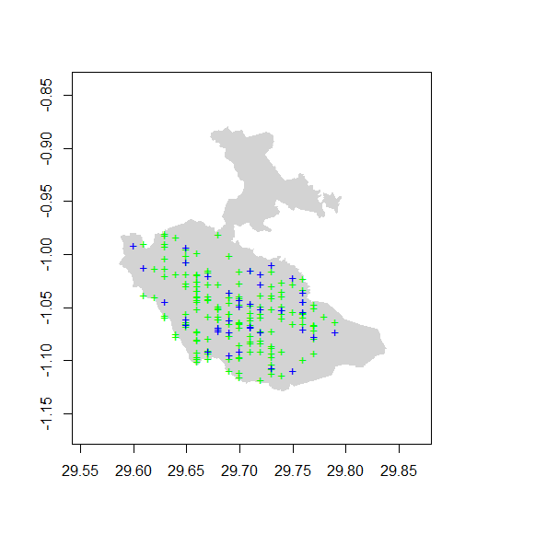
Figure 4.1 Mountain gorilla presence training and testing points in Bwindi Impenetrable National Park, Uganda. The training point set is shown in green while the testing set is blue.

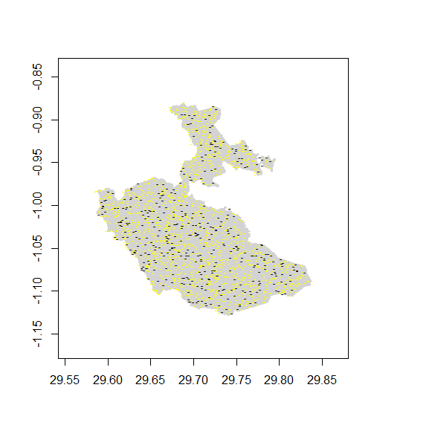
Figure 4.2 Background data for training and testing set in Bwindi Impenetrable National Park, Uganda. The training set is shown in yellow while the testing set is shown in black. Note that the background points characterize the whole study including areas where the gorillas were present

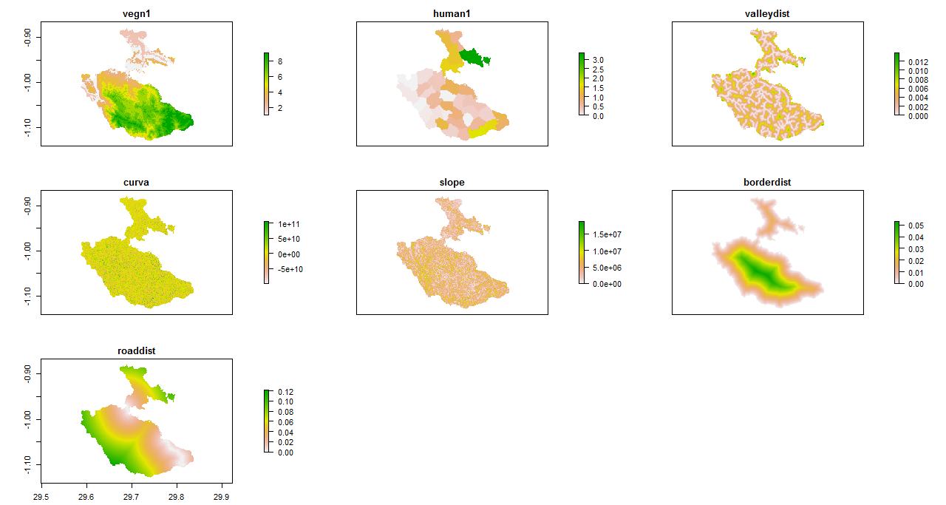
Figure 4.3 Grid maps of environmental variables used to determine habitat suitability for gorillas in Bwindi Impenetrable National Park, Uganda

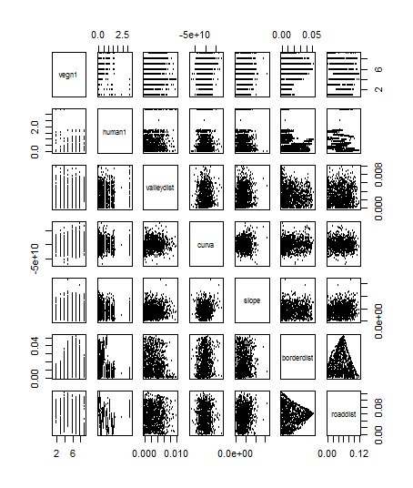
Figure 4.4 Test of colinearity using pairwise scatter plots among the seven environmental variables used to determine habitat suitability for gorillas in Bwindi Impenetrable National Park, Uganda

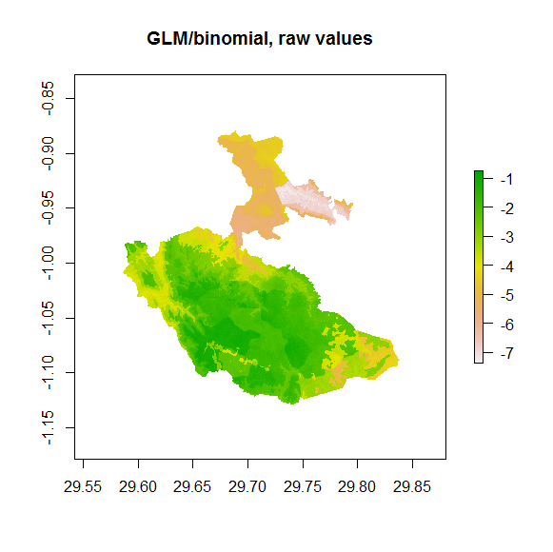
Figure 4.5 The logistic regression model prediction of gorilla habitat suitability in Bwindi Impenetrable National Park, Uganda

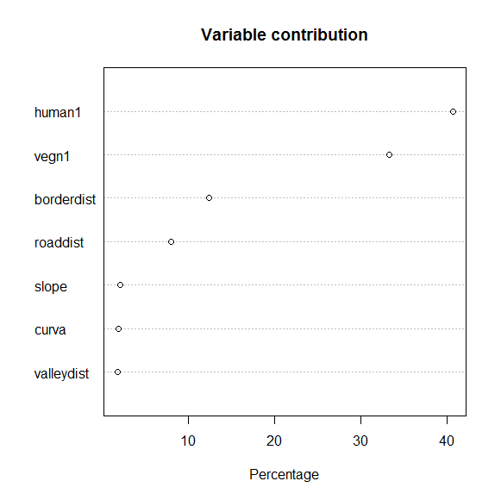
Figure 4.6 Relative contributions of the environmental variables to the Maxent model

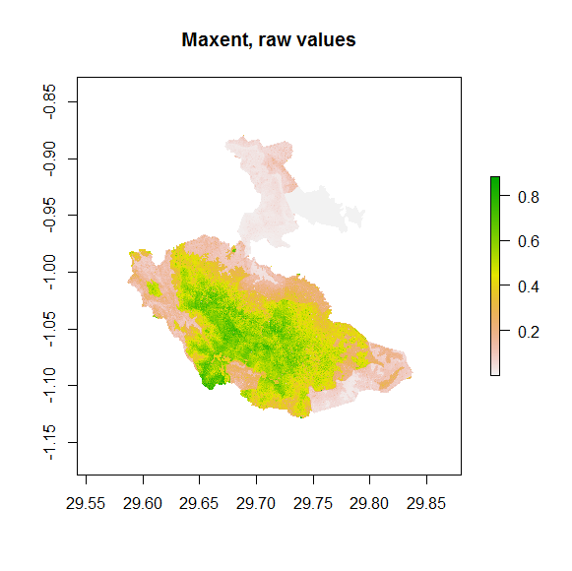
Figure 4.7 A prediction map of gorilla habitat suitability in Bwindi Impenetrable National Park, Uganda, by Maxent

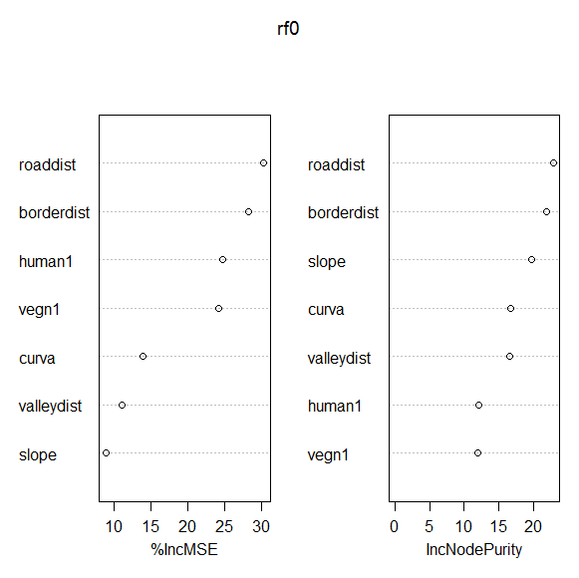
Figure 4.8 Variable importance plots for predictor variables for RF classifications used for predicting potential gorilla distribution in Bwindi Impenetrable National Park, Uganda. The most important factors are the ones on top of the graph on the left

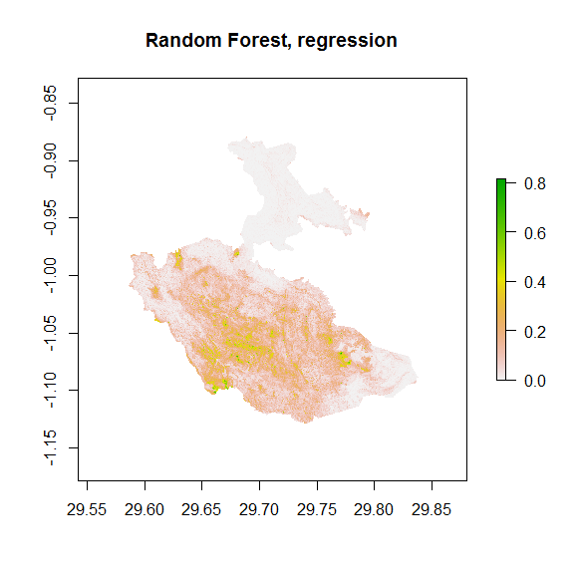
Figure 4.9 Random forest model prediction of gorilla habitat suitability in Bwindi Impenetrable National Park, Uganda

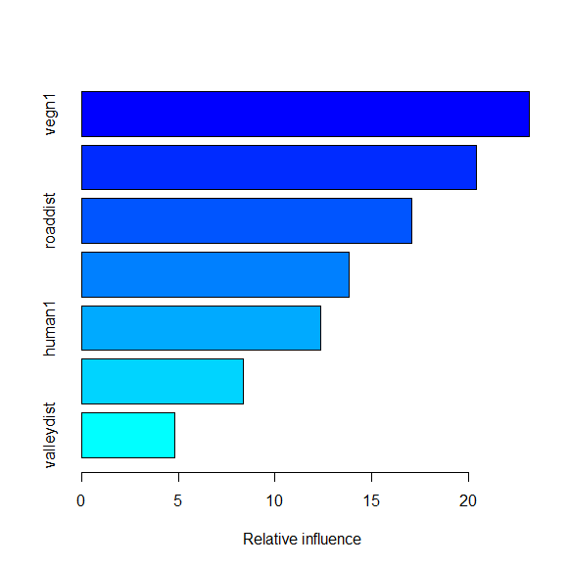
Figure 4.10 Summary of the relative contribution (%) of predictor variables for BRT

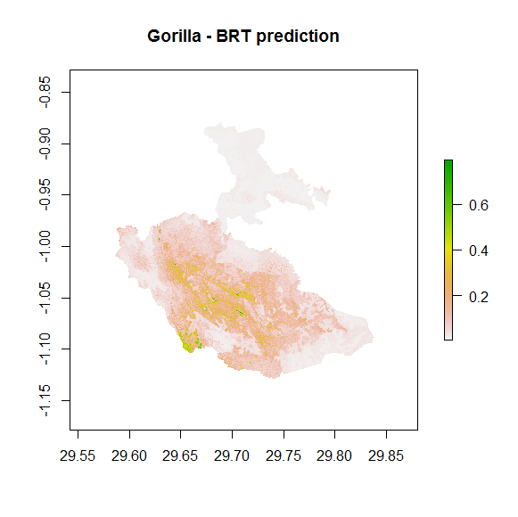
Figure 4.11 The BRT model prediction of gorilla habitat suitability in Bwindi Impenetrable National Park, Uganda

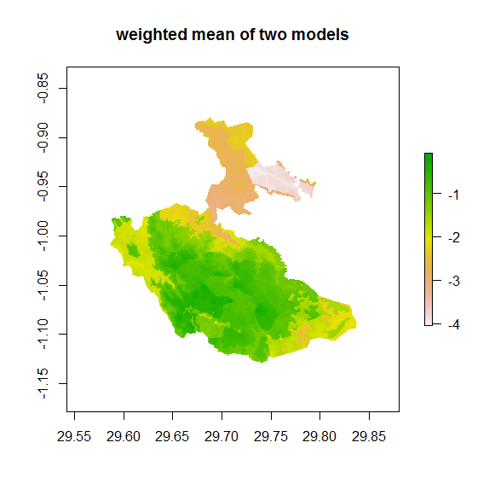
Figure 4.12 Weighted mean of the logistic regression and random forest for gorilla habitat suitability in Bwindi Impenetrable National Park, Uganda

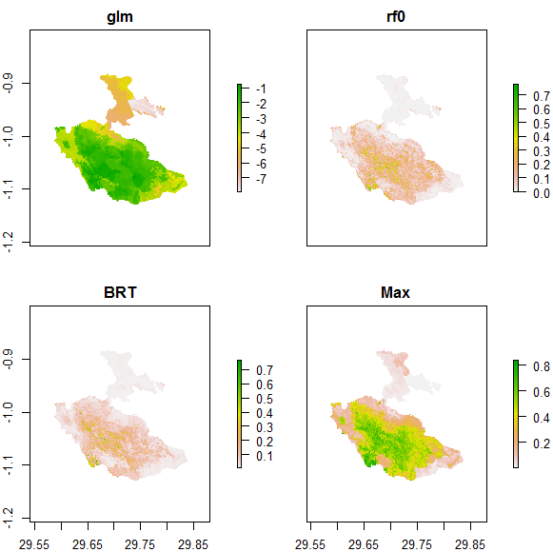
Figure 4.13 Predictions for gorilla habitat suitability for the four models (glm = logistic regression, rf0 = random forest, BRF = Boosted Regression Trees, Max = Maxent). Light colors represent poor suitability and dark colors represent high confidence in habitat suitability for gorillas

CHAPTER 5

5. A CLIMATE CHANGE VULNERABILITY ASSESSMENT OF MOUNTAIN GORILLAS IN BWINDI IMPENETRABLE NATIONAL PARK, UGANDA

5.1 Introduction
Most natural resource planning, management and monitoring strategies in place today are based on an assumption that species distributions and ecological processes will remain relatively stable over time. This assumption, however, has been challenged in the face of rapid climatic changes that are altering mainly temperature and precipitation (Hansen et al. 2010). Increasingly, wildlife and natural resource agencies are being challenged to address the impacts of climate change on the resources they strive to protect.
Globally, Africa has been identified as a continent most vulnerable to climate change (Lovett et al. 2005; IPCC 2007). Current predictions of global warming for the continent range between 3.5ºC and 6.5ºC (IPCC 2007) and a 15% increase in precipitation by year 2100 (Wentz et al. 2007). Already there are recorded cases where species or populations have shifted their range or natural history characteristics in response to climate change (Pounds et al. 1999; Parmesan & Yohe 2003). Africa is a home to four species of great apes that are all endangered or critically endangered (IUCN 2012), with the most vulnerable being those that have highly restricted ranges, have a slow growth and reproduction and a large body mass (Cowlishaw and Dunbar 2000; Chapman et al. 2006). The mountain gorilla (Gorilla beringei beringei) demonstrates all these characteristics. Present day distribution pattern of mountain gorillas is patchy and heavily influenced by human activities and could be driven closer to extinction as human populations expand (Chapman et al. 2006). Therefore, the mountain gorilla is a high priority species for conservation, especially in the face of the emerging threat of climate change. However, lack of vital information on whether the gorillas could adjust to new conditions via ecological or evolutionary adaptation, exhibit range shifts as their distributions track changing climatic conditions or will be unable to respond to changing climates and simply go extinct, prevents wildlife managers from developing strategies to save mountain gorillas from the adverse effects of climate change.
The Government of Uganda recently developed a national climate change policy in response to the need for reducing the country’s vulnerability to climate change, and as the most appropriate way to adjust to and cope with the projected impacts of climate change on the nation (Government of Uganda 2012). One of the policy priority sectors is the wildlife and tourism sector, which aim at ensuring the conservation of wildlife resources and planning for improved resilience of tourism resources and infrastructure to climate change. One of the strategies for tackling this sectoral policy priority is the development of a national wildlife adaptation strategy that includes well-assessed climate change adaptation strategies. But before potential adaptation strategies are developed, there is a need to understand how climate change may impact a given species or biological system. Vulnerability to climate change refers to the degree to which an ecological community or individual species is likely to experience harm as a result of changes in climate (Schneider et al. 2007). Vulnerability is a function of exposure to climate change – the magnitude, intensity and duration of the climate changes experienced, the sensitivity of the species or community to these changes, and the capacity of the system to adapt (IPCC 2007). A vulnerability assessment can help to identify which species or systems are likely to be most strongly affected by projected changes in climate and provide a framework for understanding why particular species or systems are likely to be vulnerable (Glick et al. 2011). Such an assessment informs conservation planning by identifying climate-related threats and resulting stresses, which then become part of the decision-making process undertaken to identify and prioritize conservation strategies.
Some species may be quite sensitive to changes in climate, but will experience little exposure, and thus their realised vulnerability is low. Other species may experience relatively high exposure but be able to respond to these changes with few impacts. But for many species, biological factors (i.e., sensitivities) - often combined with barriers to dispersal or other landscape features – will limit their ability to adjust to projected changes in climate. It is these species that will be most vulnerable to climate change. Such is the case with the world’s largest primate, the endangered mountain gorilla, whose range is geographically constrained to two tropical montane forest remnants in the Albertine Rift of equatorial Africa, the Bwindi Impenetrable Forest in Uganda and the slopes of the Virunga Volcanoes nearby, shared by Uganda, Rwanda and DR Congo. The cool, moist and frequently rainy climate provides the habitat to which this species is eminently adapted and supports the rich vegetation that provides its nourishment. The stability of the regional climate is therefore a critical factor in sustaining the mountain gorilla and its viability within its native habitat. Human-influenced global climate change is of growing concern to the long-term prospects of the survival of the species, especially due to the potential for climatic changes to drive vegetation shifts that may render its range less favourable for the species over time. Climate change is also likely to provoke human responses, which may in turn negatively affect the species and long-term viability of its habitat. In this chapter, I provide an assessment to determine the degree to which the mountain gorilla is vulnerable to the projected climate changes and the reasons why the species is likely to be vulnerable. Understanding why the mountain gorilla is vulnerable to future climate change provides a basis for developing appropriate management responses.
Most assessments to climate change have tended to focus on single factors, such as changes in distribution (e.g., from bioclimatic envelope models) or changes in phenology and the potential for phenological mismatches. These models assume that species distributions are solely governed by climate rather than by ecological interactions or historical factors (Brodie et al. 2013). If other factors are suitable, species may have broader climatic tolerance than indicated by the models. The bioclimatic envelope approaches rely on current distributional data to infer future changes but do not have evidence of actual shifts. The models may over or under-estimate the extent of species distributions when applied to future climate scenarios (Sinclair et al. 2010), particularly in situations in which species distributions are primarily limited by non-climatic variables. Also, bioclimatic models are designed to apply on large spatial scales on the order of one degree of latitude and longitude. While this is very useful for understanding global patterns of climate change, the scale may be too broad when trying to understand fine-scale variation in climate change like across a protected area.
To overcome these shortcomings, a “climate change vulnerability index” (hereafter ‘index’) was developed by Nature Serve [www.natureserve.org/climatechange] (Young, et al., 2010, 2013) to define the degree to which species are susceptible to climate change. It is a multifaceted rapid assessment tool that relies on natural history, distribution, and ecological factors that are associated with sensitivity to climate change and projections of climatic changes for the assessment area. The index can handle missing data and uncertainty in species sensitivity measures and inputs from studies that document vulnerability or project future suitable ranges, when available. Its output includes both a vulnerability category for the species of interest and a report on the key factors that have contributed to the ranking, which can inform conservation actions that increase the resilience of species to climate change. Young et al., (2011, 2013) gives a description of the conceptual basis of the Index. Vulnerability is divided into exposure to changes in climate and species sensitivity. Exposure is defined as the magnitude of the projected climate change across the portion of the range of the focal species that lies within the geographic area considered. Species sensitivity includes intrinsic factors such as natural and life history traits that promote resilience to change e.g., dietary versatility or identification as a habitat generalist, traits that indicate increased risk, e.g., strong potential for disruption of key species interactions, and traits that indicate capacity to adapt to change e.g., dispersal ability and genetic variation. The index scores a species in relation to multiple intrinsic and extrinsic sensitivity factors and then weights the score depending on the magnitude of climate change projected. Any information available on documented responses of the species to climate change is then combined with the vulnerability score to produce a final score (Figure 5.1).

5.2 Objectives
The main objective of this assessment is to determine the level of mountain gorilla population vulnerability to future climate change in Bwindi by year 2050. The year 2050 is considered a date far enough in the future for significant changes to have occurred, but before temperature projections from different emissions scenarios and global circulation models diverge substantially (Meehl et al. 2007). The specific objectives were:
- provide a climate change vulnerability index ranking for the mountain gorilla;
- evaluate the relative contribution of specific factors to vulnerability of mountain gorilla to climate change;
- identify data gaps that need to be filled to make the assessment more rigorous; and
- appraise the effectiveness of the Nature Serve Climate Change Vulnerability Index (CCVI) tool in this assessment.
This is the first time the rapid vulnerability assessment for the mountain gorilla is attempted in Bwindi. It is anticipated that the climate change vulnerability index derived will complement the bioclimatic envelope study that has already been done for gorillas in Bwindi and the Virunga region (Thorne et al. 2013) and conservation status of gorillas as determined by the IUCN Red List. This information will be useful in contributing to national strategies that address threats and mitigation measures against climate change.

5.3 Methods
I used the Nature Serve Climate Change Vulnerability Index tool (CCVI Release 2.1) that was designed to provide a relatively rapid assessment climate change vulnerability of species (Young et al. 2011). CCVI tool is a spreadsheet based algorithm (available at www.natureserve.org/climatechange) that integrates information on species sensitivity: direct exposure to projected atmospheric changes in climate (temperature and moisture); indirect exposure to climate change including sea level rise, potential impact of barriers on species’ range shifts, and potential impacts of land use changes resulting from human responses to climate change; species-specific factors that determine sensitivity (e.g. dispersal ability, physiological constraints, physical habitat specificity, interaction with other species interactions, and genetic factors); and modeled response to climate change. User inputs to the sensitivity and indirect factors were guided by descriptions provided by the tool developers to help assign a “score” for each factor on an ordinal scale that ranges from “greatly increases” (3), ‘increases” (2), “slightly increases”(1) vulnerability to “slight decreases” (-1) and “decreases” (-2) vulnerability. There is a neutral (0) option for those factors with little relevance to the species’ response to climate change. A choice for “insufficient data” may also be selected where necessary. Not all factors can be assigned the full range of scores. For example, allowable scores for the factor related to dietary versatility range from “increases vulnerability” to “somewhat decreases vulnerability.” As a result, some factors have the potential to more heavily influence the overall index score. Factors may be scored at more than one level in the ordinal scale if there is uncertainty about the effects on species response. When this happens, the tool uses the average of the entered values to calculate the vulnerability index. Numerical scores for the sensitivity factors are weighted by the climate exposure (using the atmospheric temperature and moisture reflecting the interaction of precipitation and temperature to describe the potential for drying) based on the magnitude of change projected for the portion of the species range that falls within the assessment area (Figure 5.2 and Table 5.1). The averages of the sensitivity score for a factor, weighted by the exposure factors, are added to compute an overall numerical vulnerability index for a species. The tool also generates 1000 Monte Carlo simulations of the numerical index. These simulations are of particular interest when multiple scores are selected for a given sensitivity factor. Each simulation uses only one of the multiple levels originally selected, generating a range of vulnerability index results by assuming that each level is equally likely to represent the “true” value. Numerical indices are converted to categorical inputs based on thresholds associated with various combinations of sensitivity and exposure (Table 5.2). The categorical outputs facilitate ranking by degree of vulnerability. The tool-assigned “confidence level” results from the Monte Carlo simulations, and the numerical index score.
I also performed a sensitivity analysis of the tool output to uncertainties in both climate and indirect climate exposure factor inputs. This was done by scoring each climate and indirect climate exposure factors for a possible range of the scores while the other factors remained constant.
Geospatial data provided inputs for contributions on projected temperature change, historical temperature regime, and historical hydrological regime. All data for this assessment were processed and analyzed using ESRI ArcGIS/ArcMap software. Geospatial information was incorporated into the algorithm from the outputs of overlay analysis and classification tools.
Gorilla range data for Bwindi was obtained from the Ranger Based Monitoring records of Uganda Wildlife Authority. The data are considered accurate as it has been collected since 1997 by different groups of park staff located in different stations around the park.
The primary source for historical and future climate data inputs (except moisture change) was the products available on Nature Serve website (available at www.climatewizard.org/#). Because moisture change maps for Uganda were not available on Nature Serve website, I used modeled results from the Lund-Potsdam-Jena model (LPJ: Sitch et al 2003) to estimate moisture change. Future climate projections averaged for the period 2040-2069 were used to represent 2050 to account for year-to-year variation.
Because I was interested in the influence of different climate projections on CCVI tool results, I ran the tool with data generated by six different scenarios of future climate based on five global circulation models (representing the average and extreme of individual models), and two emission scenarios (A1B and A2). I observed no differences in the vulnerability results using different climate projection inputs. For this reason, I report only results from exposure inputs that capture the range of future climate from A2 SRES and average ensemble model. The emerging consensus since the IPCC Fourth Assessment report is that the severe A2 scenario (though not extreme) is more likely to be representative of future climate conditions than the more moderate emission scenarios.
Sensitivity factors were scored based on published literature on gorillas, more particularly those of Bwindi. Some three gorilla groups in Bwindi have been intensively monitored since 1998, so there is considerable information about their biology. Supplemental information used was from the Virunga Massif gorillas that have been observed since 1967 and some general information from the lowland gorillas of western Africa.

5.4 Results
The CCVI tool lists 25 possible factors that can be assessed and scored in terms of how they contribute to mountain gorilla vulnerability to climate change in Bwindi. Five factors (sea level rise, ice and snow habitats, genetic bottlenecks, and phonological response) were scored as irrelevant or were unknown as to how they affect gorilla vulnerability to climate change. Except for the exposure factors (magnitude of temperature and moisture change expected), Table 4.5 summarizes the results of the assessment of the remaining 18 factors that were actually scored and rated from the CCVI tool. Details of how each factor was assessed and the underlying information that was used to score each factor are given.

5.4.1 Distribution data
The CCVI tool utilized distribution/occurrence data to calculate estimates of relative exposure for the gorillas. Data considered as part of this assessment included gorilla encounter point locations from Bwindi Range Based Monitoring reports of Uganda Wildlife Authority staff from 1997 to 2012. The data was considered to reflect accurately the current area of occupancy for the gorillas (Figure 5.3).

5.2 Climate exposure
Global Circulation Models (GCMs) work at relatively coarse scales, so when examining the impact of climate change on any given species, it is necessary to downscale to a spatial and temporal resolution that will be of use to the user. I obtained downscaled data (to 0.5 degree latitude-longitude grid) for Uganda from the Climate Wizard (www.climatewizard.org/#) for mid-century projections based on the average ensemble of 16 GCMs under the A2 emission scenario. To use the CCVI tool, the percentage of the distribution that is exposed to a particular range of projected change in temperature was calculated in ArcGIS by overlaying the exposure data on the occurrence data. For Bwindi, the magnitude of the projected warming for year 2050 timeframe (2040-2069 average) for the A2 emission scenario and mean ensemble model was 2.2ºC. This temperature change falls in the lowest category of temperature changes on the CCVI tool (Table 5.3).
Maps of projected changes in moisture (as measured by the Hamon AET:PET aridity index) between the historical and future time period were not available for Bwindi area on Nature Serve website as recommended by the CCVI tool guidelines. However, from published literature, the Lund-Potsdam-Jena (LPJ: Sitch et al. 2003) model output under the A2 scenario projects a downward trend in evapotranspiration (Seimon and Phillips 2010). This occurs despite strong increases in temperature, which should greatly increase rates of evaporation, and increasing rainfall, which provides additional moisture inputs to sustain higher evaporation rates. Based on this, moisture change was lightly weighted in this assessment and placed in the category of “No change” in the CCVI tool (Table 5.4).

5.4.3 Indirect exposure

5.4.3.1 Natural barriers (B2a)
In the Bwindi landscape, there are no known natural barriers like topographical characteristics of mountains, wide rivers and so on that would significantly impair distributional shifts of gorillas with climate change. The continuity of the habitat as well as the continuous distribution of gorilla groups suggests an absence of obvious barriers or unfavorable habitats. The natural barriers were scored as “neutral.”

5.4.3.2 Anthropogenic factors (B2b)
Owing to the relatively large human footprint, there are many anthropogenic barriers that negatively affect gorilla movements in their current area of occupancy. These include complete deforestation outside the protected and its replacement of the forest with agriculture and human habitation, and within the protected area, roads and high human activity, especially on the park periphery. But, climate change will not necessarily increase the negative impact already imposed by these barriers. I therefore scored anthropogenic barriers as “neutral.”

5.4.3.3 Human response to climate change (B3)
Human activities around Bwindi that can be regarded as climate change mitigation-related land uses, in particular, planting of exotic tree species, soil and water conservation technologies, growing fast maturing but drought resistant crops, are highly localized and are likely to remain so even in the near future. They were assigned a score of “neutral.”

5.4.4 Species sensitivity

5.4.4.1 Dispersal/Movement (C1)
Gorillas have “excellent” dispersal and movement abilities. In Bwindi, they travel 500m to 1km day journey length and their home range size range from 16km² to 40km² (Robbins 2011). Gorillas are one of the few primate species where both females and males disperse (Harcourt and Stewart 2007). Since gorillas are highly mobile, this factor was scored as “decreases vulnerability.”

5.4.4.2 Historical thermal niche (C2ai)
The historical thermal niche factor is intended to approximate the species’ temperature tolerance at a broad scale by looking at large-scale temperature variation that a species has experienced in the past 50 years within the assessment area. This is calculated as the difference between the highest mean monthly maximum temperature and lowest mean monthly minimum temperature for each cell. I assessed this from the maps provided by Climate Wizard. The mean seasonal temperature variation for the gorilla occupied areas was very small for the past 50 years (<20.8ºC). This means that gorillas have been living in stable temperature and are vulnerable if they increase due to climate change. The score on the CCVI tool corresponds to “greatly increases vulnerability.”

5.4.4.3 Physiological thermal niche (C2aii)
Gorillas survive best in rain forest habitats whose monthly mean temperatures are relatively constant throughout the year (Lehmann et al. 2010), therefore they may have a small range of physiological thermal tolerance. In CCVI tool, gorillas were scored as “greatly increase vulnerability” to temperature warming as they are completely or almost completely restricted to cool tropical rain forest environments that may be lost or reduced as a result of climate change.

5.4.4.4 Historical hydrologic niche (C2bi)
The historical hydrologic niche factor is intended to capture the species’ exposure to past variation in precipitation as a proxy for tolerance to large-scale variation in precipitation. The factor is assessed by calculating the range in mean annual precipitation for the period of 1951-2006 observed across the species’ distribution in the assessment area. I overlaid the species’ distribution with the maps provided by Climate Wizard to assess this factor. The calculated values for variation in precipitation correspond to “greatly increase vulnerability.”

5.4.4.5 Physiological hydrologic niche (C2bii)
Though gorillas are able to cope with a wide range of annual rainfall regimes compared to temperature (Lehmann et al. 2010), the expected changes in precipitation (drier/wetter) with global warming are still likely to reduce the apes’ distribution, abundance, or habitat quality and are ranked one category less vulnerable than temperature at “increase vulnerability” score. Gorillas do not cope well with arid regions because they have a small range of tolerance as well as small group sizes, compared for example, to chimpanzees.

5.4.4.6 Disturbance regime (C2c)
Climate-mediated disturbance events, namely wild fires, could register some potentially significant deleterious impacts upon gorilla habitat like modification and loss, as well as some degree of fire threat to the gorillas themselves. Fire has long been considered a conservation problem at Bwindi particularly in dry years. Although Bwindi is too wet to burn, considerable areas have been burnt in the driest years of 1960/61 (Leggat & Osmaston 1961), 1984 (Butynski, 1984), 1992 and 1999 (Babaasa, et al., 2000). Given that in the next several decades rainfall is anticipated to decrease during the dry seasons (Seimon and Phillips 2010), wild fires could increase in frequency, severity and /or extent because of enhanced desiccation of the vegetation. Fire disturbance was scored “increase vulnerability.”

5.4.4.7 Physical habitat restrictions (C3)
If the idea of specificity to a particular geologic feature or derivative was particularly not relevant to gorillas, the CCIV tool required to choose a score of “somewhat decrease vulnerability.”

5.4.4.8 Biotic habitat dependence (C4a)
The required habitat for the gorilla was not considered to be dependent on a small number of species. I assigned a score “neutral” to this factor.

5.4.4.9 Dietary versatility (C4b)
Gorilla diet is very flexible – feeding on a wide range of plant species (140) and a variety plant parts (fruits, flowers, leaves, bark, pith, stems) (Robbins 2011). This factor was scored “neutral.”

5.4.4.10 Biotic dispersal dependence (C4d)
Gorillas disperse on their own. They do not require an agent to disperse. This factor was scored “neutral.”

5.4.4.11 Interactions with other species (C4e)
Additional interspecific interactions that might affect vulnerability were not identified. This factor was also scored “neutral.”

5.4.4.12 Genetic variation (C5a)
Bwindi gorilla genetic variation was assessed relative to that measured for the lowland western gorillas using similar methods on wild populations from several social groups within defined geographical areas. A comparison of Bwindi gorillas and western lowland gorillas in Central African Republic and Republic of Congo shows minimal reduction of genetic variability (heterozygosity) despite the small size of Bwindi gorillas (Lukas, et al., 2004). This factor was scored “somewhat decreases vulnerability.”

5.4.5 Modeled response to climate change
Most of the models used by Thorne et al. 2013 suggested that Bwindi was likely to retain suitable conditions in at least large parts of their current distribution.

5.4.5.1 Modeled future (2050) change (D2)
Based on future (2050) change in gorilla range using A2 storyline and model averaging, predicted future range showed no greater than a 20% change relative to current gorilla range within the Bwindi landscape (Thorne, et al., 2013). This factor was scored “neutral.”

5.4.5.2 Overlap of future (2050) and current range (D3)
Thorne, et al., (2013) showed that the predicted future ranges overlaps the current range by >60%, therefore gorillas may not significantly shift their home ranges or disperse in response to future change. More than 30% of the modeled future distribution is within Bwindi and the adjacent Sarambwe Reserve in the DR Congo, which gorillas use infrequently. This factor was scored “neutral.”

5.4.5.3 Occurrence in protected area of future distribution (D4)
Being protected, these two conservation areas of Bwindi and Sarambwe are relatively not vulnerable to outright habitat destruction from human activities and likely to provide suitable conditions for the existence of viable populations of mountain gorillas. Basing on these factors, Thorne et al (2013) concluded that the future (2050) change will have little impact on climatic conditions suitable for gorillas in the Bwindi landscape. This factor was scored “neutral.”

5.4.6 Climate change vulnerability index
Using the climate projections for the A2 emission scenario and average ensemble of 16 GCMs, combined with sensitivity factor inputs, the CCVI tool ranked the mountain gorillas as “Not Vulnerable/ Presumed Stable (PS)” to climate change in Bwindi. This means that the available evidence does not suggest that the abundance and/or range extent within Bwindi assessment area will change (increase/decrease) substantially by year 2050. But the actual range boundaries may change. This will make the gorillas adjust to climate-mediated changes in their habitat. Factors that were identified as contributing to vulnerability included physiological thermal niche, physiological hydro niche and disturbance regime while those decreasing vulnerability were dispersal or movement, physical habitat restrictions and genetic variation. Seven factors were either unknown or irrelevant.

5.4.7 Sensitivity analysis of the vulnerability index
I explored uncertainty of the vulnerability factors by assigning different scores to the factors in separate model runs, generating scenarios based on different assumptions of projected change and exploring the effect on the resulting vulnerability index. I explored the sensitivity of the index to all the possible scores on the CCVI tool to climate (Section 4.6.2) and indirect exposures factors (Section 4.6.3) as these are the vulnerability factors that cannot be predicted accurately because of uncertainties in climate drivers, climate systems and downscaling process.

5.4.7.1 Temperature
I created a scenario in which I assigned scores based on the assumption that temperature change would increase more in respect to climate change. Increase in temperature change to just the next higher category (from <2.2ºC to >2.2ºC but < 3.1ºC) would shift the vulnerability index from “Presumed Stable” as best-case scenario to “Moderately Vulnerable” as a middle-case scenario, while temperature change >3.1ºC would make the gorillas “Highly Vulnerable” to climate change as the worst-case scenario.

5.4.7.2 Moisture
Like temperature, I also created a scenario in which I assigned scores based on the assumption that Bwindi would be drier with climate change. Moisture change to just the next higher category (from >-0.028 to >-0.028 but >0.119) would shift the vulnerability index to from “Presumed Stable” as best-case scenario to “Moderately Vulnerable” as middle-case scenario while moisture change <-0.119 would make gorillas “Highly Vulnerable” to climate change as the worst-case scenario.

5.4.7.3 Anthropogenic factors (B2b)
A scenario where anthropogenic barriers are likely to contribute to vulnerability to climate-induced range shifts with changes in response to climate was scored. This could arise if local communities forcefully invaded the gorilla park for natural resources because climate change has caused the depletion of resources people require outside the park. If the factor was scored “Increase vulnerability” from “neutral” then the vulnerability index would shift from “Presumed Stable” as best-case scenario to “Moderately Vulnerable” as middle-case scenario. The same change in vulnerability index would occur if the anthropogenic barriers were to be scored “Greatly increase vulnerability” as a worst-case scenario.

5.4.7.4 Human response to climate change (B3)
In a scenario where the human climate mitigation are incompatible with the requirements of the gorillas within and/or potential future range, and was scored as “Increases vulnerability” from “neutral”, the vulnerability index would shift from “Presumed Stable” to “Moderately Vulnerable.”
Natural barriers were not considered in the sensitivity analysis as they are not a vulnerability factor for gorillas in Bwindi.

5.4.8 Confidence in information about gorillas
There was sufficient information on many aspects of gorilla biology that was used to fill the CCVI tool. The information was largely relevant to the assessed vulnerability factors and was from peer-reviewed literature. No factor was assigned multiple scores. Therefore, CCVI tool evaluated the information provided for the vulnerability factors as being “Very High in Confidence.”

5.5 Discussion
This is yet another effort, after bioclimatic envelope modeling by Thorne, et al., (2013), at characterizing the vulnerability of mountain gorillas to climate change. The primary value of this assessment lies in the process of breaking a complex phenomenon into constituent parts so that we can begin to identify why gorillas in Bwindi are vulnerable, whether there are actions we can take to address those vulnerabilities, and what data gaps may exist. This assessment therefore differs from the bioclimatic envelope models which assume that species ranges are governed solely or primarily by climate rather than by ecological interactions or historical factors (Brodie et al. 2013).

5.5.1 Climate change vulnerability of mountain gorillas
This assessment scores the mountain gorilla as “Presumed Stable” with the anticipated climate changes in year 2050. It is important to recognize that a score of “Presumed Stable” for the gorilla only applies to the gorillas’ current distribution in Bwindi. It may not adequately capture climate-related vulnerability for other gorilla populations, for example, in Virunga Massif, since there may be variation in the degree to which climate change factors impact each gorilla population. The Bwindi gorillas are still critically threatened by other factors, such as habitat alteration and potential disease transmission, as evidenced by the species conservation status in the IUCN Red List. The CCVI tool is not designed to capture factors incorporated in other conservation status assessments, such as population size, and/or demographic factors which may magnify species’ vulnerability to climate change (Young et al. 2013).
The CCVI tool flagged the Bwindi gorillas as potentially shifting in their range, indicating that the gorillas have a potential to move to areas which will still have climatic conditions as they are today. Because gorillas were scored as exposed to no barriers and having good dispersal capability, they generally fall into this category, but does not account for the fact that substantial barriers exist. The scores assigned to barriers are based on the assumption that these barriers are not likely to contribute significantly to a reduction or loss of the gorilla area of occupancy with projected climate change given that Bwindi is a protected area. Relaxing this assumption, by assigning scores of “increase vulnerability” for anthropogenic barriers, increased the vulnerability rank to “Moderately Vulnerable.” This situation is could arise if the local communities, desperate for resources like fuel wood, timber, and other plant and animal resources or land, forcefully invade Bwindi since it would be the only source of the natural resources due to climate change.
Any slight change in any of the climate exposure factors is likely to increase the vulnerability of gorillas to climate change. Increasing temperature and moisture change by just one category higher on the CCVI tool, results in a change of the gorilla vulnerability rank to “Moderately Vulnerable” from “Presumed Stable.” The sensitivity analysis for vulnerability rank using change climate exposure factors is important since the exact extent to which climate will change is not known and is heavily debated as well as the finding that temperature variation and annual rainfall are the most important determinants of ape feeding and moving time and hence distributions (Lehmann et al. 2010). In a ‘worst-case scenario’, Lehmann et al. (2010) shows that an increase of temperature by 5.2ºC and a 15% increase in precipitation in comparison with predictions under present climate conditions will cause genus Gorilla to lose 75% of their habitat within their present distribution area in Africa by year 2100. However, it is more informative to look at the mechanisms, rather than the actual values of temperature and precipitation change, by which climate change may affect the ability of gorillas to survive in Bwindi. Because gorillas live in small groups, there at a high risk of extinction, so that changes in global climate might be expected to have a strong effect on gorilla biogeography. Changes in habitat suitability will make them need more time for moving and resting following a change in climate determined by food abundance and distribution. To cope with such changes due to global warming, Lehmann et al. (2010) argued that gorillas would have to be solitary, a behavioral trait that they do not possess to-date or alternatively, they might change from a largely folivorous to a predominantly frugivorous diet, though Bwindi can hardly support frugivory because of low fruit density.
Sensitivity analyses of the vulnerability rank increased the rigor of my assessment. They show that while the mountain gorilla has been assessed as “Presumed Stable” in relation to future climate change, it is at the “Moderately Vulnerable” threshold. This means a change in just a single vulnerability factor has the potential of being detrimental to gorillas even when that change is of a very small magnitude.
Related to warming is the fire disturbance regime. Mid-year burning is expected is likely to intensify due to rainfall decreases during the dry season, while warming will enhance seasonal desiccation of vegetation (Seimon and Phillips 2010). If this happens, fire as a recurrent disturbance in mountain gorilla habitat would be a new but hazardous phenomenon as tropical rain forests have not evolved with fire (Nepstad et al. 1999; Cochrane 2001).
According to the CCVI tool, Bwindi gorillas are safe from climate change from the point of view of their genetic variation. The same conclusion has been arrived at independently by two studies that the Virunga gorilla population, which is nearly of the same size and composition as Bwindi population, is likely to be safe from genetic problems for 400 years or more (Akcakaya and Ginzburg 1991; Durant and Mace 1994). However, this genetic resilience to future climate change is likely to be eroded given small population size, potential inbreeding, restricted habitat, lack of habitat connectivity and gene flow between the Bwindi and Virunga gorilla populations or any other eastern gorilla population.
Though not directly comparable, the CCVI tool and bioclimatic envelope model (Thorne et al. 2013) both reach a conclusion that can be considered similar. Thorne, et al., (2013), using bioclimatic envelope models on mountain gorillas, with model averaging and A2 SRES, concluded that most of the Bwindi park, and areas within 5 km outside the park boundary will still be climatically suitable by year 2050. The CCVI tool in this study using A2 SRES and average ensemble of 16 GCMs concludes that the range extent of gorillas may not change substantially (“Presumed Stable”) or under ‘worst-case scenario’, the range extent of gorillas is likely to decrease (“Moderately Vulnerable”) by year 2050. This means that Bwindi will still, to a large extent, be suitable for gorillas for reproduction, cover, food and ranging.

5.5.2 Information gaps
There is insufficient information on what is exactly likely to happen to the vegetation of Bwindi with climate change. Focus has been largely to what happens to the wildlife species, yet the animals largely depend on vegetation for survival. Changes in climate that impact the timing, growth, and composition of plants in turn influence the quality and quantity of forage for herbivores by altering habitat structure and availability of food resources. Also, climate change may result in significant distributional shifts of entire ecosystems, and the creation of new community associations as plant species respond to new conditions in an individualistic manner. Therefore, what affects the vegetation is also likely to affect the animals even if the animals themselves are not vulnerable to climate change.
More research is needed on the significance of fire risk to the gorilla habitat to better understand the extent and potential of the threat. In addition to the projected climate change threat, more than 90 percent of Bwindi was disturbed by heavy logging (Howard 1991). This makes the forest susceptible to drying during prolonged periods of drought because of the large open gaps that are dominated by herbaceous and climber plants (Babaasa et al. 2004).
Changes in the climate will also interact with other drivers determining primate population sizes. Human medical professionals have recently become concerned as to whether global warming will cause increased rates of infectious diseases and, with their wealth of clinical data, are well ahead of primate ecologists at documenting trends. For example, connections between weather and disease are well established, and many diseases occur during certain seasons or erupt in association with seasonable conditions. For example, in sub-Saharan Africa, meningococcal meningitis epidemics erupt during the hot dry season and subside soon after the onset of the rains (Patz et al. 1996). Similar links between environment and diseases likely exist for primates, suggesting climate change may modify how current diseases affect primate populations as well, therefore needs to be investigated.

5.5.3 Limitations of the CCVI tool
Climate change vulnerability indices are one approach to understanding the effects of climate on species (see Rowland et al. 2011). As with all approaches, there are limitations to the Nature Serve CCVI tool and how it is applied. Liebezeit et al (2012) points out that the CCVI tool does not examine statistical or mechanistic relationships between the species traits and their exposure to climate change. Rather, the tool was designed to offer a relatively coarse, quick, and consistent look at the potential vulnerability of multiple species in a way that accounts for numerous factors. It is structured to readily add new information and revise the assessments as knowledge of the species and system increases and may be used to identify need for more targeted research efforts.
The CCVI tool may also lead to an overestimation of the effects of climate change. The downscaled models used on Climate Wizard were at a scale of 0.5 degree latitude-longitude grid. Bwindi is within two 0.5 degree grids. There can be high habitat heterogeneity within a 0.5 degree cell and gorillas can survive periods of climatic extremes in small refugia. For example, gorillas in Bwindi prefer feeding in the valleys, which in most cases have water courses, therefore are likely to be little affected by severe droughts. Such microclimates at finer scales than this assessment may provide refugia for small groups of gorillas.
Non-inclusion of other vulnerability factors, like potential disease threat due to climate change as discussed above, in computing the vulnerability index may underestimate the adverse impacts of climate change.
Also, the CCVI tool was developed to consider a wide range of both plant and animals species in an area. My narrow focus on the mountain gorillas tested its ability to evaluate sensitivities and vulnerability on one species only. The generalized language on sensitivity factors on the CCVI guidance was sometimes challenging to relate to gorillas living in a tropical rain forest and, in a few cases, irrelevant altogether. Differential weighing of particular sensitivity factors on vulnerability outcomes should be allowed. Liebezeit et al. (2012), for example, questioned whether factors such as disturbance effects and genetic influence on climate change should carry equal weight. They also argue that in some instances, changes in some types of climate-related disturbance regimes might benefit a species while others might be detrimental, making a net effect difficult to determine and score.
It is clear that the current distribution of mountain gorilla is restricted by human-induced factors rather than climate. It is possible that the gorillas could probably live at different temperatures and moisture regimes than is currently the case. For example it seems perusable that the mountain gorilla could persist at much warmer areas like the eastern lowland gorilla. Therefore, the current range of mountain gorillas may be constrained by low temperatures rather than high temperatures (within a reasonable range Thorne et al. 2013). It therefore possible that exposure to increased temperature (and rainfall) due to climate may be overestimated by the CCVI tool unless the increases substantially affect habitat factors like the structure and composition of the forest vegetation.

5.5.4 Conclusion
Despite obvious challenges, this assessment represents a starting point to help prioritize management actions and conservation planning efforts with respect to mountain gorillas in Bwindi. Through this assessment, I have been able to search for data that was used to fill the CCVI tool. I perhaps better understand which factors likely to contribute to climate change vulnerability for the mountain gorillas in Bwindi. I also identified important gaps in our knowledge specific to climate change impacts. The last two accomplishments can help inform subsequent research efforts through prioritization and hypothesis development. While climate change will greatly challenge wildlife and habitats in Bwindi, this effort provides one tool useful in safeguarding these valuable resources.

5.6 Bibliography
Akcakaya, H. R., & Ginzburg, L. R. (1991). Ecological risk analysis for single and multiple populations. In A. Seitz, & V. Loeschke, Species Conservation: Population-Biology Approach (pp. 73-87). Basel: Birkhauser Verlag.
Babaasa, D., Kasangaki, A., & Bitariho, R. (1999). Fire control and prevention in Bwindi Impenetrable and Mgahinga Gorilla National Park. Kabale: Unpublished report, Institute of Tropical Forest Conservation.
Brodie, J., Post, E., & Doak, D. (2013). Wildlife conservation in a changing climate. Chicago: University of Chicago.
Chapman, C., Lawes, M., & Eeley, H. (2006). What hope for African primate diversity? African Journal of Ecology, 44, 116-133.
Cochrane, M. (2001). Synergistic interactions between habitat fragmentation and fire in evergreen tropical forests. Conservation Biology, 15(6), 1515-1521.
Cowlishaw, G., & Dunbar, R. (2000). Primate Conservation Biology. Chicago: University of Chicago.
Durant, S. M., & Mace, G. M. (1994). Species difference and population structure in population viability analysis. In P. G. Olney, G. M. Mace, & A. T. Feistner, Creative Conservation. Interactive Management of wild and Captive Animals (pp. 67-91). London: Chapman and Hall.
Glick, P., Clough, J., & Nunley, B. (2011). Scanning the Conservation Horizon: A Guide to Climate Change Vulnerability Assessment. Washington: National Wildlife Federation.
Government of Uganda. (2012). Uganda National Climate Change Policy. Final version for approval. Kampala: Ministry of Water and Environment.
Government, U. (2012). Uganda National Climate Change Policy. Final version for approval. Kampala: Ministry of Water and Environment.
Guschanski, K., Caillaud, D., Robbins, M. M., & Vigilant, L. (2008). Female shape the genetic structure of a gorilla population. Current Biology, 18(22), 1809-1814.
Hansen, L., Hoffman, J., Drewes, C., & Mielbrecht, E. (2010). Designing climate-smart conservation: guidance and case studies. Conservation Biology, 24, 63-69.
Harcourt, A., & Stewart, K. (2007). Gorilla Society: Conflict, Compromise, and Cooperation between the Sexes. Chicago: University of Chicago.
IPCC. (2007). Contribution of Working Group I to the fourth assessment report of the Intergovernmental Panel on Climate Change, 2007. Cambridge: Cambridge.
IUCN. (2013). IUCN Red List of Threatened Species. Version 2013.2. Retrieved March 18, 2014, from www.iucnredlist.org
Lehmann, J., Korstjens, A., & Dunbar, J. (2010). Apes in a changing world - the effects of global waqrming on the behaviour and distribution of Afican apes. Journal of Biogeography, 2217-2231.
Liebezeit, J., Rowland, E., Cross, M., & Zack, S. (2012). Assessing climate change vulnerability of breeding birds in Artic Alaska. A report prepared for the Artic Landscape Conservation Cooperative. Bozeman, MT: Wildlife Conservation Society, North America Program .
Lovett, J., Midgley, G., & Barnard, P. (2005). Climate change and ecology in Africa. African Journal of Ecology, 43, 167-169.
Lukas, D., Bradley, B. J., M, N. A., Doran-Sheehy, D., Robbins, M. M., & Vigilant, L. (2004). Major histocompatibility complex and microsatellite variation in two populations of wild gorillas. Molecular Ecology, 13(11), 3389-3402.
Meehl, G., Stocker, T., Collins, W., Friedlingstein, P., Gaye, A., Gregory, J., . . . Zhao, Z. (2007). Global climate projections. In S. Solomon, D. Qin, M. Manning, Z. Chen, M. Marquis, K. Averyt, . . . H. Miller, Climate change 2007: The physical science basis.Contribution of working Group I to the Fourth assessment report of the intergovernmental panel on climate change (pp. 747-845). New York: Cambridge University Press.
Nepstad, D., Verissimo, A., Alencar, A., Nobre, C., Lima, E., Lefebore, P., . . . Brooks, V. (1999). Large-scale impoverishment of Amazonian forests by logging and fire. Nature, 505-508.
Parmesan, C., & Yohe, G. (2003). A globally coherent fingerprint of climate change across natural systems. Nature, 42, 37-42.
Patz, J., Epstein, P., Burke, T., & Balbus, J. (1996). Global climate change and emerging infectious diseases. The Journal of the American Medical Association, 275(3), 217-223.
Pounds, J., Fogden, M., & Campbell, J. (1999). Biological responses to climate change on a tropical mountain. Nature, 398, 611-615.
Rowland, E., Davison, J., & Graumlich, L. (2011). Approaches to evaluating climate change impacts on species: A guide to initiating the adaptation planning process. Environmental Management, 47, 322-337.
Schneider, S., Semenov, S., Patwardhan, A., Burton, I., Magadza, C., Oppenheimer, M., . . . Yamin, F. (2007). Assessing key vulnerabities and the risk from climate change. In M. Parry, O. Canziani, J. Palutikof, P. van der Linden, & C. Hanson, Impacts, Adaptation, and Vulnerability. Contribution of Working Group II to the Fourth Assessment Report of the Intergovernmental Panel on Climate Change (pp. 779-810). Cambridge: Cambridge University Press.
Seimon, A., & Phillips, G. P. (2010). Projected climatological and ecological changes in the 21st century across the mountain gorilla range. In A. Belfiore, The implications of global climate change for mountain gorilla conservation in the Albertine Rift (pp. 10-21). Washington, D C: African Wildlife Foundation.
Sinclair, S., White, M., & Newell, G. (2010). How useful are species distribution models for managing biodiversity under future climates? Ecology and Society, 15, 8.
Sitch, S., Smith, B., Prentice, I., Arneth, A., Bondeau, A., Cramer, W., . . . Venevsky, S. (2003). Evaluation of ecosystem dynamics, plant geography and terrestrial carbon cycling in the LPJ Dynamic Vegetation Model. Global Change Biology, 9, 161-185.
Tenywa, G. (2013, October 31). Climate change policy delayed. New Vision. Retrieved from http://www.newvision.co.ug/news/648999-climate-change-policy-delayed.html
Thorne, J. H., Seo, C., Basabose, A., Gray, M., Belfiore, N. M., & Hijmans, R. J. (2013). Alternative biological assumptions strongly influence models of climate change effects on mountain gorillas. Ecosphere, 4(9), 1-17.
Twongyirwe, R., Majaliwa, J. G., Ebanya, T. P., Tenywa, M. M., Sheil, D., van Heist, M., . . . Kumar, L. (2011). Dynamics of forest conversion in and around Bwindi Impenetrable Forest, SW Uganda. Journal of Applied Science and Environmental Management, 15(1), 189-195.
Wentz, F., Ricciardulli, L., Hilburn, K., & Mears, C. (2007). How much more rain will global warming bring? Science, 317, 233-235.
Young, B., Byers, E., Gravuer, K., Hall, K., Hammerson, G., & Redder, A. (2010). Guidelines for using the NatureServe climate vulnerability index. Retrieved from www.natureserve.org/climatechange
Young, B., Hall, E., Byers, E., Gravuer, K., Hammerson, G., Redder, A., & Szabo, K. (2013). Rapid assessment of plant and animal vulnerability to climate change. In J. Brodie, E. Post, & D. Doak, Wildlife Conservation in a Changing Climate (pp. 129-150). Chicago: University of Chicago.

Table 5.1 Exposure weightings for sensitivity and indirect exposure factors. Weights for temperature and moisture are assigned 1.0, 1.5, 2.0, depending on the number of standard deviations the projected change for the range of a given species is above the average
Combined Climate Weighting | Temperature Change Weight Only | Moisture Change Weight Only
Natural barriers  Human response to CC  Association with the disturbance regime  Physical habitat restrictions  Biotic habitat dependence  Dietary versatility  Interactions with other species  Genetic variation  Modeled response to CC | Physiological thermal niche  Historical thermal niche | Physiological hydrological niche  Historical hydrological niche

Table 5.2 Numerical index score thresholds and corresponding vulnerability categories (degree of vulnerability) as assigned by the CCVI. Vulnerability thresholds are based on hypothetical examples of exposure and sensitivity combinations that might lead to different levels of vulnerability (Young et al. 2013)
Index Score | Vulnerability Category
>10.0  7.0-9.9  4.0-6.9  -2-3.99  <-2.0 | Extremely Vulnerable (EV)  Highly Vulnerable (HV)  Moderately Vulnerable (MV)  Presumed Stable (PS)  Increase Likely

Table 5.3 Projected temperature exposure for gorillas in Bwindi, Uganda
Temperature change (ºC warmer) | Gorilla distribution (% area)
>3.1 | 0
2.8-3.1 | 0
2.5-2.7 | 0
2.2-2.4 | 0
<2.2 | 100

Table 5.4 Projected moisture exposure (based on the Hamon AET:PET Aridity Index) for gorillas in Bwindi
Moisture change | Gorilla distribution (% area)
<-0.119(Driest) | 0
-0.119- -0.097 | 0
-0.096 - -0.074 | 0
-0.073 - -0.051 | 0
-0.050 - -0.028 | 0
>-0.028 (No change) | 100

Table 5.5 Climate Change vulnerability factors and ratings for the mountain gorilla in Bwindi Impenetrable National Park, Uganda
Vulnerability Factors | D | SD | N | SI | I | GI | Unknown or N/A
Indirect exposure
B1. Sea level rise |  |  |  |  |  |  | *
B2a. Natural barriers |  |  | *
B2b. Anthropogenic factors |  |  | *
B3. Human response to CC |  |  | *
Species sensitivity
C1. Dispersal/Movement | *
C2ai. Historical thermal niche |  |  |  |  |  | *
C2aii. Physiological thermal niche |  |  |  |  |  | *
C2bi. Historical hydro niche |  |  |  |  |  | *
C2bii. Physiological hydro niche |  |  |  |  | *
C2c. Disturbance regime |  |  |  |  | *
C2d. Ice & Snow habitats |  |  |  |  |  |  | *
C3. Physical habitat restrictions |  | *
C4a. Biotic habitat dependence |  |  | *
C4b. Dietary versatility |  |  | *
C4d. Biotic dispersal dependence |  |  | *
C4e. Interactions with other species |  |  | *
C5a. Genetic variation |  | *
C5b. Genetic bottlenecks |  |  |  |  |  |  | *
C6. Phenological response |  |  |  |  |  |  | *
Documented or modeled response to climate change
D1. CC-related distribution response |  |  |  |  |  |  | *
D2. Modeled future (2050) change |  |  | *
D3. Overlap of future (2050) and current range |  |  | *
D4. Occurrence in PA of future distribution (2050) |  |  | *
D=Decrease vulnerability, SD=Somewhat decrease vulnerability, N=Neutral effect, SI=Slightly increase vulnerability, I=Increase vulnerability, GI = Greatly increase vulnerability
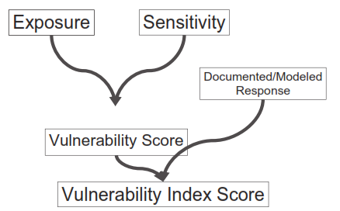
Figure 5.1 The relationship of the key components in determining climate change vulnerability index (Source: Young et al. 2013)

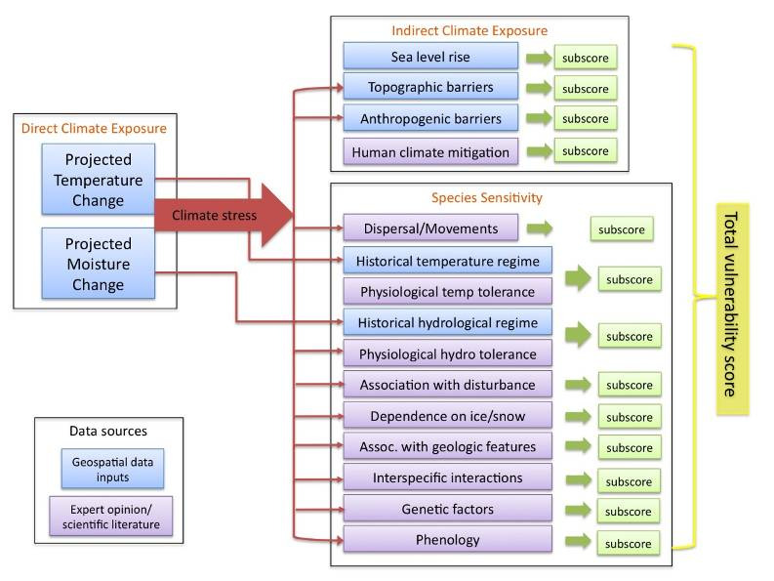
Figure 5.2 Schematic of the Nature Serve Climate Change Vulnerability Index (CCVI). The vulnerability score based on the exposure/sensitivity sum is calculated as ∑f_{i}w_{i}, where f is the value assigned to each factor according to how it influences sensitivity and w is the specific exposure weighting for each factor i

Figure 5.3 Mountain gorilla distribution in Bwindi Impenetrable National Park, Uganda

CHAPTER 6

SUMMARY, CONCLUSIONS AND RECOMMENDATIONS

6.1 Introduction
This study showed the landscape predictors of current and future distribution of mountain gorillas in Bwindi Impenetrable National Park, Uganda. The gorilla-environment relation was examined by relating known gorilla occurrence records complied from Uganda Wildlife Authority Ranger Based Monitoring data and five-interval gorilla census data from the Institute of Tropical Forest Conservation. The gorilla location data was from 1997 to mid-2011. The environmental variables included vegetation types based on the forest floristic composition, distance from the roads, and park edge, distance from valleys, levels of human activity within the park, topographical surface curvature, and slope steepness. These are the factors that are thought to constrain the current distribution of gorillas, particularly the wild ones. Also, a climate change vulnerability index for the gorillas in Bwindi for the year 2050 was established. Thus far, I can now make informed conclusions about mountain gorilla determinants of current and future distribution in Bwindi and other aspects of gorilla ecology and its habitat according to the study objectives as stated in Chapter 1.
- Determine the plant species associations in the vegetation
Twenty-three vegetation classes, based on species composition and basal area, were identified. Of these, 18 were dominated by big trees (>20 cm dbh) while five classes were dominated by herbaceous growth comprised of swamp, bracken fern, herbaceous climbers, bamboo and grassland. Sites in the north and west parts of Bwindi had a higher species richness of trees compared to the rest of the park. Areas of high species richness areas were located in the low to mid-altitude tropical rain forest belt (<2,000 m asl).
- Determine how the derived plant communities are arranged in space and along major environmental gradients
Tree species composition was spatially structured by two major physical factors – altitude and topographic position on the slopes. Altitude affects plant growth through the amounts of rainfall received and changes in temperature as well as wind speeds. The effect of topographic position on vegetation composition is due to differences in tree species preferences for different levels of moisture, and ability to survive on poorly structured, nutrient deficient soils and withstanding drought-prone ridge tops. The vegetation communities at the two extreme ends of the park (in the north and west and east, south) had contrasting floristic assemblages. However, areas located in-between these extremes had a continuum of gradually changing species composition. This was shown by many of the vegetation sample plots belonging to more than one vegetation class. The reason for this is that each plant species has a unique way of being distributed in relation to the environment it encounters. This results in vegetation classes along continuous gradients like topography and soil to bear resemblance and grade into other community classes. Such forest communities are described as ‘fuzzy’ as it is sometimes difficult to identify a single best class type for any given forest location observed in the field.
- Relate the spatial variation of the plant communities to mountain gorilla distribution
They were significant differences in the vegetation types found in areas occupied by gorillas. Given that the vegetation composition is spatially structured, areas avoided by gorillas had a different plant composition compared to areas they occupy. Vegetation composition could therefore contribute to gorillas avoiding some areas of the park.
- Understand the environmental factors responsible for present day wild gorilla distribution
Different algorithms (logistic regression, random forest, Maxent and boosted regression trees) show differences in the relative importance of environmental factors responsible gorilla habitat suitability. However, all the algorithms include levels of human activity within the park and variation in the vegetation composition as the most important factors in determining wild gorilla habitat suitability.
- Identify the core area for gorilla conservation
The core area for conservation was identified by all the algorithms as the area located in the center of the southern part of the park. The core area varied in habitat suitability levels from being highly suitable in logistic regression and maxent models to having low level suitability in random forest and boosted regression trees models. The core area coincides with the present distribution of gorillas.
- Predict the likelihood of mountain gorilla distribution in Bwindi
Logistic regression model predicted that nearly the whole of Bwindi, with the exception of the northeast part, had good gorilla habitat suitability. Maxent model identified the central portion of the southern part of the park as the only area with good gorilla habitat. Random forest and boosted regression trees predicted that most of park as unsuitable as gorilla habitat with small pockets of suitable habitats scattered in the center of the southern part of the park.
- Compare and contrast the model predictions of the four algorithms used
Based on their AUC values, all the four models had the same predictive accuracy. However, all the models yielded different gorilla suitability prediction results. Average weighted model prediction was similar to that of logistic regression model. Model contrast shows that differences in predictions were mainly in the northern part and periphery of the park with logistic regression predicting that these areas are suitable while the remaining models predicted that the areas were unsuitable habitat.
- Provide climate change vulnerability index ranking for the mountain gorilla
Using the climate projections for the A2 emission scenario and average ensemble of 16 GCMs, combined with sensitivity factor inputs, the CCVI tool ranked the mountain gorillas as “Not Vulnerable/ Presumed Stable (PS)” to climate change in Bwindi. This means that the available evidence does not suggest that the abundance and/or range extent within Bwindi assessment area will change (increase/decrease) substantially by year 2050. But the actual range boundaries may change. This will make the gorillas adjust to climate-mediated changes in their habitat.
- Evaluate the relative contribution of specific factors to vulnerability of gorillas to climate change
Factors that were identified as contributing to vulnerability of the gorillas to climate change included physiological thermal niche, physiological hydro niche and disturbance regime while those decreasing vulnerability were dispersal or movement, physical habitat restrictions and genetic variation.
- Identify data gaps that need to be filled to make the assessment more rigorous
There insufficient information on the responses of Bwindi vegetation to climate change. Yet it is one of the resources which all the wildlife species depend on. More research is also needed on the significance of fire risk to gorilla habitat to understand the potential risk of the threat. Seasonality and diseases in gorillas also needs to be understood so that it can be used to predict what diseases are likely to affect gorillas related to climate change.
- Appraisal of the effectiveness of Nature Serve climate change vulnerability
The CCVI tool does not examine the statistical or mechanistic relationships between gorilla traits and their exposure to climate change. It is only a coarse, quick and consistent look at the potential vulnerability of multiple species in a way that accounts for numerous factors. The tool may also overestimate the effects of climate change. The downscaled models used are still too coarse for species that live in small areas and prefer to utilize microhabitats such as valleys for the case of gorillas in Bwindi. Non-inclusion of the potential disease factor due to climate change may underestimate the adverse impacts of climate change. The generalized language of sensitivity factors on the CCVI tool guidance were sometimes challenging to relate to gorillas in Bwindi. Some factors contribute differentially to climate change vulnerability so it is questionable whether it should be given the same weight. Given that the gorillas in Bwindi are restricted by human-induced factors rather than climate, it is possible that exposure to increased temperature and rainfall due climate change may be overestimated by the CCVI tool unless the increases substantially affect habitat factors like structure and composition of the forest vegetation.

6.2 General conclusions
The impacts of human disturbance on the distribution of wildlife species in Africa are well documented (Noss 1995, 1998; Barnes et al. 1997; Lahm et al. 1998; Blom et al. 2001). The effect of human activities varies greatly, depending on their nature and intensity, and understanding their interaction is essential for managing protected areas (Prins and Reitsma 1989; White 1994; Fitzgibbon et al. 1995; Oates 1996; Hall et al. 1998). However, large mammal densities are also influenced by a range of ecological factors, not least vegetation (Barnes et al. 1991; White 1994).
The main objective of this study was to determine the relative effect of human disturbance and ecological factors on the distribution of wild mountain gorillas in Bwindi Impenetrable National Park, Uganda. By looking at the levels and distribution of human activities and ecological factors, my aim was to obtain a better understanding of how ecological and human activities influenced wild gorilla distribution. This study builds up on information that has been generated from earlier surveys (Harcourt 1981; Butynski 1984, 1985) and the five year interval gorilla censuses (McNeilage et al. 2001, 2006; Guschanski et al. 2009; Robbins et al. 2011) that have consistently found gorillas to be located in particular areas and avoiding large parts of the park.
The results show that the northern, southwest and southeast areas of the park and nearly the all the edge of the park as being of low suitability or totally unsuitable as gorilla habitat. This could be correlated to habitat differences such as variation in vegetation, given that gorillas have been known to exhibit group feeding traditions (Watts 1994; McNeilage 2001; Ganas et al. 2004; Guschanski et al. 2008). However, the fact that habituated gorilla have been utilizing some parts of these areas that were generally avoided in the past point to other factors influencing gorilla space use decisions in Bwindi. The importance of factors like distance from roads, distance from the park border and the intensity of human activity within park provide additional evidence that probably habitat differences may not be the only ones influencing gorilla distribution. Given that human related activities are more common in some parts of the park than others, it makes it easier to relate gorilla distribution with human disturbance when the latter is considered as the only environmental variables. But it becomes difficult when other habitat factors are simultaneously considered with human disturbance. Areas with high human disturbance have, at the same time, different plant communities from areas currently occupied by gorillas. This is further complicated by the SDM algorithms that yielded different predictions of gorilla habitat suitability in different places but have very similar accuracy estimates based on AUC scores. The main reasons for the differences among predictions from alternative algorithms are whether the algorithm is parametric or non-parametric (Segurado and Araujo 2004) and how the models ‘extrapolate’ beyond the range of gorilla occurrence data used in their calibration (Pearson et al. 2006). Given that the gorillas in Bwindi have small but overlapping ranges, high habitat specificity and low local abundance where they are found, could have an effect on SDM performance. As noted from the theoretical framework (Pearson 2007), models identify only some parts of actual and potential distributions when projected in geographic space. Therefore, it should not be expected that species’ distribution models are able to predict the full extent of either actual or the potential distribution. The models need to be interpreted bearing in mind other information available on a species’ distribution. In the case of Bwindi, there is anecdotal information that the gorillas once occupied areas southeast and southwest of the park that are currently avoided. If this is true, then it follows what has been observed in many animal taxa, including gorillas, that they are prevented or slowed down colonizing areas where they were exterminated, or made to abandon by human pressures, or diseases because of habitat preferences if vegetation or other important environmental influences are spatially structured, as is the case with Bwindi (Guschanski et al. 2008). There are no reports of gorillas ever utilizing the northern part of Bwindi in the past. Schaller (1963) notes that the spread of gorillas into Bwindi is relatively recent and from the south of the park, that the ape is or was until recently expanding its range and has not had enough time to occupy all the forested areas available to it. Gorillas in Bwindi have a very a long life-history and could still be below the carrying capacity of their habitat (Robbins et al. 2009), therefore do not have the urge to occupy new areas. It should be noted that the northern part of Bwindi has been consistently found to harbor the highest levels of human disturbance in the park (McNeilage et al. 2001, 2006; Robbins et al. 2011) and there is no reason not to believe that it could have been much higher in the past.
However, we also need to take into consideration that the present mountain gorilla are restricted to protected areas primarily because of expanding human populations. The gorilla populations are likely to be in an evolutionary disequilibrium (van Schaik and Kappeler 1996). The gorillas might be occupying a constricted niche space relative to their former range, exploiting a subset of resources formerly used by the previous gorilla communities (Dayan and Simberloff 2005) or they may be exploiting new habitats or resources (e.g. introduced species and human food crops). This could mean that niche contraction has been accompanied by a community-wide shift into marginal or previously unfilled ‘novel’ niche space (Miller et al. 2005; Layman et al. 2007), there is an ecological retreat scenario (Crowly et al. 2012). Because of lack of historical gorilla range maps and fossils, I am unable to provide evidence for these hypotheses about impacts of recent human activities on current gorilla distribution and behavior.
All the four modeling algorithms give the relative influence of the different input variables on the model’s predictive capacity. The models still give differing relative influences of the environmental variables on gorilla habitat suitability. However, they are in general agreement that vegetation and human disturbance, of any kind, are the major factors that affect gorilla habitat suitability. Since little can be done by park management on vegetation, then the focus should be on human activity within and without the park.
The desired outcome of Uganda’s national climate change policy is the development of a national wildlife adaptation strategy that includes well-assessed climate change adaptation strategies. This study shows that changes in the anthropogenic factors and the human response to climate could make the gorillas vulnerability index shift from ‘Presumed Stable’ to a higher index of ‘Moderately Vulnerable’. This again points to the need to address human activities within and outside the park, as is the case with SDMs.

6.3 Recommendations
Inside the park conservation measures should focus on improving habitat suitability by increasing the law enforcement patrols. This would deter many of the illegal activities that currently go on within the park. Blomley et al. (2010) in their assessment of the 15 years of Integrated Conservation and Development Projects (ICDPs) indicated that the single most important factor that has led to the perceived decrease in illegal activities within the park had much more to do with law enforcement by park staff. In areas where tourism and research gorilla groups range, human activity is at its lowest because of daily visits of park staff accompanying tourists and researchers. Also, the multiple-use program needs to be controlled and maybe eliminated in some parts of the park. The multiple-use program was supposed to be a stop gap measure when Bwindi was declared a park and people were abruptly stopped from accessing resources they used to harvest from the forest (Wild and Mutebi 1996). The program now needs to be thoroughly reexamined. The road within the park needs to be relocated from the park to community land. Currently, the road within the park has negative impacts on the ecosystem and does little to serve the local communities.
Any reduction in the area or fragmentation of the park should be avoided, while connectivity between protected areas should be encouraged. Two peripheral areas of the park – at the lowest and highest altitude range - where gorillas have not been encountered for more than three decades (Harcourt 1981; Butynski 1984, 1985; McNeilage et al. 2001, 2006, Guschanski et al. 2009; Robbins et al. 2011) and Sarambwe Reserve in DR Congo which is adjacent to Bwindi, where a few of the habituated Bwindi gorillas periodically range but are not resident, should be more protected. Maintaining connectivity could be one of the measures that could make Bwindi gorillas disperse to these unoccupied. Proactively conserving and supplementing habitat for gorillas are essential strategies for the long-term persistence of gorillas.
Outside the park, decreasing the motivation of the local people to enter the park should be continued. Improving the economic status of the local communities could reduce their dependency on the natural resources within the park. The park authorities also need to address the problem of habituated gorillas getting out of the park and crop raiding local community’s gardens. This has a huge impact on the local attitudes and behavior towards the park and gorillas in particular.
Animal density is generally considered as a measure of the health of a population. The higher the density, the better for the endangered species. But this is not necessarily the case. High density may be an artifact of crowding into protected areas or favored areas. In this case, health indicators that can measure the degree to which the endangered species is adapting to its environment need to be considered and assessed on a regular basis.

6.4 Bibliography
Barnes, R., Barnes, K., Alers, M., & Blom, A. (1991). Man determines the distribution of elephants in the rain forests of northeastern Gabon. African Journal of Ecology, 29, 54-63.
Barnes, R., Beardsley, K., Michelmore, F., Barnes, K., Alers, M., & Blom, A. (1997). Estimating forest elephant numbers with dung counts and a geographic information system. Journal of Wildlife Management, 61, 1384-1383.
Blom, A., Almasi, A., Heitkonig, I., Kpanou, J., & Prins, H. (2001). A survey of the apes in the Dzanga-Ndoki National Park, Central African Republic. African Journal of Ecology, 39, 98-105.
Blomley, T., Namara, A., McNeilage, A., Franks, P., Rainer, H., Donaldson, A., . . . Infield, M. (2010). Development and gorillas: Assessing fifteen years of integrated conservation and development in south-western Uganda. Natural Resource Issues No 23.
Butynski, T. (1984). Ecological Survey of the Impenetrable (Bwindi) Forest, Uganda, and Recommendations for its Conservation and Management. Unpublished report to the Uganda Government.
Butynski, T. (1985). Primates and their conservation in the Impenetrable (Bwindi) Forest, Uganda. Primate Conservation, 6, 68-72.
Fitzgibbon, C., Mogoka, H., & Fanshawe, J. (1995). Subsistence hunting in Arabuko-Sokoke Forest, Kenya and its effects on mammal populations. Conservation Biology, 5, 1116-1126.
Ganas, J., Robbins, M. M., Nkurunungi, J. B., Kaplin, B. A., & McNeilage, A. (2004). Dietary variability of mountain gorillas in Bwindi Impenetrable National Park, Uganda. International Journal of Primatology, 70, 1-12.
Guschanski, K., Caillaud, D., Robbins, M. M., & Vigilant, L. (2008). Female shape the genetic structure of a gorilla population. Current Biology, 18(22), 1809-1814.
Guschanski, K., Vigilant, L., McNeilage, A., Gray, M., Kagoda, E., & Robbins, M. (2009). Counting elusive animals: comparing field and genetic census of the entire mountain gorilla population of Bwindi Impenetrable National Park, Uganda. Biological Conservation, 142, 290-300.
Hall, J., White, L., Inogwabini, b., & al, e. (1998). A survey of Grauer's gorillas (Gorilla gorilla graueri) and chimpanzees (Pan troglodytes schweinfurthi) in the Kahuzi Biega National Park lowland sector and adjacent forest in eastern Congo. International Journal of Primatology, 19, 207-235.
Harcourt, A. (1981). Can Uganda's gorillas survive? A survey of the Bwindi Forest Reserve. Biological Conservation, 19, 269-282.
Lahm, S., Barnes, R. B., & Cervinka. (1998). A method for censunsing the greater white-nosed monkey in northeastern Gabon using the population density gradient in relation to roads. Journal of Tropical Ecology, 14, 629-643.
McNeilage, A. (2001). Diet and habitat use of two mountain gorilla groups in contrasting habitats in the Virunga. In M. Robbins, P. Sicotte, & K. Stewart, Mountain Gorillas: Three Decades of Research at Karisoke (pp. 265-292). Cambridge: Cambridge University Press.
McNeilage, A., Plumptre, A., Brock-Doyle, A., & Vedder, A. (2001). Bwindi Impenetrable National Park, Uganda: gorilla census 1997. Oryx, 35, 39-47.
McNeilage, A., Robbins, M. M., Gray, M., Olupot, W., Babaasa, D., Bitariho, R., . . . Baker, J. (2006). Census of the mountain gorilla Gorilla beringei beringei population in Bwindi Impenetrable National Park, Uganda. Oryx, 40, 419-427.
Noss, A. (1998). The impacts of cable snare hunting on wildlife populations in the forests of the Central African Republic. Conservation Biology, 12, 390-398.
Oates, J. (1996). Habitat alterations, hunting and the conservation of folivorous primates in the African forests. Australian Journal of Ecology, 21, 1-19.
Pearson, R. (2007). Species distribution modeling for conservation educators and practioners. New York, NY, US. Retrieved from http://ncep.amnh.org/linc
Pearson, R., Thuiller, W., Araujo, M., Martinez-Meyer, E., Brotons, L., McClean, C., . . . Lees, D. (2006). Model-based uncertainty in species' range prediction. Journal of Biogeography, 33, 1704-1711.
Prins, H., & Reitsma, J. (1989). Mammalian biomass in an African Equatorial rain forest. Journal of Animal Ecology, 58, 851-861.
Robbins, M., Gray, M., Kagoda, E., & Robbins, A. (2009). Population dynamics of the Bwindi mountain gorillas. Biological Conservation, 142, 2886-2895.
Robbins, M., Roy, J., Wright, E., Kato, R., Kabano, P., Basabose, A., . . . Gray, M. (2011). Bwindi mountain gorilla census 2011 - summary of results. Kabale, Uganda: Uganda Wildlife Authority.
Schaller, G. B. (1963). The Mountain Gorilla: Ecology and Behaviour. Chicago: University of Chicago.
Segurado, P., & Araujo, M. (2004). An evaluation of methods for modelling species distributions. Journal of Biogeography, 31, 1555-1568.
Watts, D. (1984). Composition and variability of mountain gorilla diets in the Central Virungas. American Journal of Primatology, 7, 323-356.
White, L. (1994). Biomass of rainforest mammals in the Lope reserve, Gabon. Journal of Animal Ecology, 63, 499-512.
Wild, R., & Mutebi, J. (1996). Conservation through community use of plant resources : establishing collaborative management at Bwindi Impenetrable and Mgahinga Gorilla National Parks, Uganda. People and Plants Working Paper No. 5.

BIBLIOGRAPHY
Akcakaya, H. R., & Ginzburg, L. R. (1991). Ecological risk analysis for single and multiple populations. In A. Seitz, & V. Loeschke, Species Conservation: Population-Biology Approach (pp. 73-87). Basel: Birkhauser Verlag.
Akcakaya, H. R., & Ginzburg, L. R. (1991). Ecological risk analysis fro single and multiple populations. In A. Seitz, & V. Loeschke, Species Conservation: Population-Biology Approach (pp. 73-87). Basel: Birkhauser Verlag.
Albrecht, H. (1976). Chimpanzees in Uganda. Oryx, 13, 357-361.
Anderson, R., & Martinez-Meyer. (2004). Modeling species' geographic distributions for conservation assessments: an implementation with the spiny pocket mice (Heteromys) of Ecuador. Biological Conservation, 116, 167-179.
Anderson, R., Gomez-Laverde, M., & Peterson, A. (2002). Using niche-based GIS modeling to test geographic predictions of competitive exclusion and competitive release in south American pocket mice. Oikos, 98, 3-16.
Apps, C., McLellan, B., woods, J., & Proctor, M. (2004). Estimating grizzly bear distribution and abundance relative to habitat and human influence. Journal of Wildlife Management, 68, 138-152.
Araujo, M., & Pearson, R. (2005). Equilibrium of species' distribution with climate. Ecography, 28, 693-695.
ARCOS. (2004). A Framework for Conservation in the Albertine Rift . Kampala, Uganda: Albertine Rift Conservation Society.
Babaasa, D. (2000). Habitat selection by elephants in Bwindi Impenetrable National Park, Uganda. African Journal of Ecology, 38, 116-122.
Babaasa, D., Eilu, G., Kasangaki, A., Bitariho, R., & McNeilage, A. (2004). Gap characteristics and regeneration in Bwindi Impenetrable National Park, Uganda. African Journal of Ecology, 42, 217-224.
Babaasa, D., Kasangaki, A., & Bitariho, R. (1999). Fire control and prevention in Bwindi Impenetrable and Mgahinga Gorilla National Park. Kabale: Unpublished report, Institute of Tropical Forest Conservation.
Baker, J., Bitariho, R., Gordon-Maclean, A., Kasoma, P., Roe, D., Sheil, D., . . . Weiland, M. (2013). Linking protected area conservation with poverty alleviation in Uganda: Integrated Conservation and Development Projects at Bwindi Impenetrable National Park. In J. B. Smith, National Parks (pp. 47-103). Nova Science Publishers, Inc.
Barnes, R., Barnes, K., Alers, M., & Blom, A. (1991). Man determines the distribution of elephants in the rain forests of northeastern Gabon. African Journal of Ecology, 29, 54-63.
Barnes, R., Beardsley, K., Michelmore, F., Barnes, K., Alers, M., & Blom, A. (1997). Estimating forest elephant numbers with dung counts and a geographic information system. Journal of Wildlife Management, 61, 1384-1383.
Blom, A., Almasi, A., Heitkonig, I., Kpanou, J., & Prins, H. (2001). A survey of the apes in the Dzanga-Ndoki National Park, Central African Republic. African Journal of Ecology, 39, 98-105.
Blomley, T., Namara, A., McNeilage, A., Franks, P., Rainer, H., Donaldson, A., . . . Infield, M. (2010). Development and gorillas: Assessing fifteen years of integrated conservation and development in south-western Uganda. Natural Resource Issues No 23.
Bourg, N., McShea, W., & Gill, D. (2005). Putting the cart before the search: successful habitat prediction for a rare forest herb. Ecology, 86, 2793-2804.
Breiman, L. (2001). Random forests. Machine Learning, 45, 15-32.
Breiman, L., Friedman, J., Olshen, R., & Stone, C. (1984). Classification and Regression Trees. Belmont, CA: Wadsworth.
Brodie, J., Post, E., & Doak, D. (2013). Wildlife conservation in a changing climate. Chicago: University of Chicago.
Brown Jr, W., & Wilson, E. (1956). Character displacement. Systematic Zoology, 5, 49-64.
Butynski, T. (1984). Ecological Survey of the Impenetrable (Bwindi) Forest, Uganda, and Recommendations for its Conservation and Management. Unpublished report to the Uganda Government.
Butynski, T. (1985). Primates and their conservation in the Impenetrable (Bwindi) Forest, Uganda. Primate Conservation, 6, 68-72.
Butynski, T., & Kalina, J. (1993). Three new mountain national parks for Uganda. Oryx, 27, 214-224.
Butynski, T., & Kalina, J. (1998). Gorilla tourism: A critical look. In M. J. Milner-Gulland, & R. Mace, Conservation of Biological Resources (pp. 292-313). Oxford: Blackwell Sciences.
Cahusac, A. (1958). Impenetrable C.F.R. Forest Types (Interpretation Report No. 6) Reference Map No. KI/45. In G. Leggat, & O. HA, Working Plan for the Impenetrable C.F.R. (p. Appendix G). Uganda Forest Dept, Report, Entebbe.
Cahusac, A. (1958). Impenetrable CFR forest types (Interpretation Report No. 6). Reference map no. KI/45. . In G. Leggat, & H. Osmaston, Appendix G in working Plan for the Impenetrable CFR. Entebbe: Uganda Forest Department.
Caillaud, D., Gray, M., Ganas, J., Kagoda, E., Tumukunde, A., Nkurunungi, J., . . . Robbins, M. (2008). Assessment of the future demography of Bwindi mountain gorillas. ITFC Annual Workshop for Managers. Jopfan Hotel, Kabale: ITFC.
Chambers, J., & Hastie, T. (1992). Statistical Models in S. S. Pacific Grove: Wadsworth.
Chapman, C., Lawes, M., & Eeley, H. (2006). What hope for African primate diversity? African Journal of Ecology, 44, 116-133.
Chapman, C., Rothman, J. M., & Lambert, J. E. (2012). Food as a selective force in primates. In J. C. Mitani, C. J. C, P. M. Kappeler, R. A. Palombit, & J. B. Silk, The Evolution of Primate Societies (pp. 149-168). Chicago: The University of Chicago Press.
Chenery, E. (1960). An introduction to the soils of Uganda Protectorate. Mem. Res. Div. Series 1, No. 1. Entebbe: Department of Agriculture.
Cipolletta, C. (2003). Ranging patterns of a western group during habituation to humans in the Dzanga-Nkozi National Park, Central African Republic. International Journal of Primatology, 24, 1207-1226.
Cochrane, M. (2001). Synergistic interactions between habitat fragmentation and fire in evergreen tropical forests. Conservation Biology, 15(6), 1515-1521.
Cowlishaw, G., & Dunbar, R. (2000). Primate Conservation Biology. Chicago: University of Chicago.
Cunningham, A. (1996). People, park, and plant use: Recommendations for multiple use zones and development alternatives around Bwindi Impenetrable National Park, Uganda. People and Plants working paper No. 4. Paris: UNESCO.
Cunningham, A. B. (1996). People and plant use: Recommendations for multiple use zones and development alternatives around Bwindi Impenetrable National Park, Uganda. Paris: UNESCO Working Paper No. 4.
Davenport, T., Howard, P., & Matthews, R. (1996). Bwindi Impenetrable National Park Biodiversity Report . Kampala: Uganda Forest Dept, Report No. 19.
Dayan, T., & Simberloff, D. (2005). Ecological and community-wide character displacement: the next genenration. Ecology Letters, 8, 875-894.
De'ath, G. (2002). Multivariate regression trees: a new technique for modeling species-environment relationships. Ecology, 83, 1105-1117.
Du Puy, D., & Moat, J. (1996). A refined classification of the primary vegetation of Madagascar based on the underlying geology. Using GIS to map its distribution and to assess its conservation status. In W. Lourenco (Ed.), Proceedings of the International Symposium on the biogeography of Madagascar (pp. 205-218). Paris: Editions de IORS TOM.
Dudik, M., Phillips, S., & Schapire, R. (2007). Maximum entropy density estimation with generalised regularisation and an application to species distribution modeling. Journal of Machine Learning Research, 8, 1217-1260.
Durant, S. M., & Mace, G. M. (1994). Species difference and population structure in population viability analysis. In P. G. Olney, G. M. Mace, & A. T. Feistner, Creative Conservation. Interactive Management of wild and Captive Animals (pp. 67-91). London: Chapman and Hall.
Eilu, G., & Obua, J. (2005). Tree condition and natural regeneration in disturbed sites of Bwindi Impenetrable Forest National Park, SW Uganda. Tropical Ecology, 46(1), 99-111.
Elgart, A. (2010). Are the gorillas in Bwindi Impenetrable National Park "True" mountain gorillas? American Journal of Physical Anthropology, 141, 561-570.
Elith, J., Graham, C., & group, a. t. (2006). Novel methods improve prediction of species' distributions from occurrence data. Ecography, 29, 165-175.
Elith, J., Leathwick, J., & Hastie, T. (2008). A working guide to boosted regression trees. Journal of Animal Ecology, 77, 802-813.
Feriss, S., Robbins, M., & Williamson, E. (2005). Eastern gorilla (Gorilla beringei). In J. Caldecott, & L. Miles, World Atlas of Great Apes and their Conservation. Berkeley: UNEP-WCMC.
Fernandez, G., Posse, G., Ferretti, V., & Gabelli, F. (2003). Bird-habitat relationship for the declining Pampas meadow lark populations. Biological Conservation, 115, 139-148.
Fitzgibbon, C., Mogoka, H., & Fanshawe, J. (1995). Subsistence hunting in Arabuko-Sokoke Forest, Kenya and its effects on mammal populations. Conservation Biology, 5, 1116-1126.
Fleishman, E., Mac Nally, R., & Fay, J. (2002). Validation tests of predictive models of butterfly occurrence based on environmental variables. Conservation Biology, 17, 806-817.
Fossey, D. (1983). Gorillas in the Mist. London: Hodder and Stoughton.
Franklin, J. (1995). Predictive vegetation mapping: geographic modeling of biospatial patterns in relation to environmental gradients. Progress in Physical Geography, 19, 474-499.
Franklin, J. (2009). Mapping species distributions: Spatial Inference and Prediction. Cambridge: Cambridge University Press.
Franklin, J., McCullough, P., & Gray, C. (2000). Terrain variables used for predictive mapping of vegetation communities in southern California. In J. Wilson, & J. Gallant, Terrain Analysis: Principles and Applications (pp. 331-353). New York: John Wiley and sons, Inc.
Ganas, J., & Robbins, M. M. (2004). Intrapopulation differences in ant eating in the mountain gorillas of Bwindi Impenetrable National Park, Uganda. Primates, 45, 275-279.
Ganas, J., & Robbins, M. M. (2005). Ranging behavior of the mountain gorilla (Gorilla beringei beringei) in Bwindi Impenetrable National Park, Uganda: a test of the ecological constraints model. Behavioral Ecology and Sociobiology, 58, 277-288.
Ganas, J., Nkurunungi, J., & Robbins, M. (2009). A preliminary study of the temporal and spatial biomass patterns of herbaceous vegetation consumed by mountain gorillas in an Afromontane rain forest. Biotropica, 41(1), 37-46.
Ganas, J., Ortmann, S., & Robbins, M. M. (2008). Food preferences of wild mountain gorillas. American Journal of Primatology, 70, 1-12.
Ganas, J., Ortmann, S., & Robbins, M. M. (2009). Food choices of the mountain gorilla in Bwindi Impenetrable National Park, Uganda: the influence of nutrients, phenolics, and availability. Journal of Tropical Ecology, 25, 123-134.
Ganas, J., Robbins, M. M., Nkurunungi, J. B., Kaplin, B. A., & McNeilage, A. (2004). Dietary variability of mountain gorillas in Bwindi Impenetrable National Park, Uganda. International Journal of Primatology, 70, 1-12.
Garner, K., & Ryder, O. (1996). Mitochondrial DNA diversity in gorillas. Molecular Phylogenetics and Evolution, 6, 39-48.
Ghazoul, J., & Sheil, D. (2010). Tropical rain forest ecology, diversity, and conservation. New York: Oxford.
Gibbons, D., Reid, J., & Chapman, R. (1993). The new atlas of breeding birds in Britain and Ireland: 1988-1991. London: Poyser.
Glick, P., Clough, J., & Nunley, B. (2011). Scanning the Conservation Horizon: A Guide to Climate Change Vulnerability Assessment. Washington: National Wildlife Federation.
Godfrey, L., Winchester, J., King, S., Boyer, D., & Jernvall, J. (2012). Dental topography indicates ecological contraction of lemur communities. American Journal of Physical Anthropology, 148, 215-227.
Goldsmith, M. L. (2003). Comparative behavioral ecology of a lowland and highland gorilla population: where do Bwindi gorillas fit? In A. B. Taylor, & M. L. Goldsmith, Gorilla Biology: A Multidisciplinary Perspective (pp. 358-384). Cambridge: Cambridge University Press.
Goldsmith, M. L. (2003). Comparitive behavioral ecology of a lowland and highland gorilla population: where do Bwindi gorillas fit? In A. B. Taylor, & M. L. Goldsmith, Gorilla Biology: A Multidisciplinary Perspective (pp. 358-384). Cambridge: Cambridge University Press.
Gopal, S., & Woodcock, C. (1994). Theory and methods for accuracy assessment of thematic maps using fuzzy sets. Photogrammetric Engineering and Remote Sensing, 60(2), 181-188.
Gorilla Gazette. (1995). Retrieved from http://pin.primate.wisc.edu/news/journals/GorillaGazette/gaz1995/gazettedec95.pdf
Government of Uganda. (2012). Uganda National Climate Change Policy. Final version for approval. Kampala: Ministry of Water and Environment.
Government of Uganda. (2012). Uganda National Climate Change Policy. Final version for approval. Kampala: Ministry of Water and Environment.
Government, U. (2012). Uganda National Climate Change Policy. Final version for approval. Kampala: Ministry of Water and Environment.
Graczyk, T. K., Cranfield, M. R., & Eilenberger, U. (2001). Hyperkeratotic mange caused by Sarcoptes scabiei [Acariformes: Sarcoptidae] in juvenile human-habituated mountain gorillas [gorilla gorilla beringei]. Parasitology Research, 87(12), 1024-1028.
Grant, P. (1972). Convergent and divergent character displacement. Biological Journal of Linnean Society, 4, 39-68.
Gray, M., McNeilage, A., Fawcett, K., Robbins, M. M., Ssebide, B., Mbula, D., & Uwingeli, P. (2003). Virunga Volcanoes Range Mountain Gorilla Census, 2003. Kampala, Uganda: UWA/ORTPN/ICCN.
Gray, M., McNeilage, A., Fawcett, K., Robbins, M. M., Ssebide, B., Mbula, D., & Uwingeli, P. (2005). Virunga Volcanoes Range Mountain Gorilla Census, 2003. Joint Organisers' Report. UWA/ORTPN/ICCN.
Grooves. (2001). Primate taxonomy. Washington DC: Smithsonian Institute Press.
Groves, C. P. (1970). Population systematic of gorilla. Journal of Zoology, London, 161, 287-300.
Grubb, P., & Whitmore, T. (1966). A comparison of montane and lowland rain forest in Equador. II: climate and its effects on the distribution and physiognomy of the forests. Journal of Ecology, 54, 303-333.
Gubelman, E., Schoorl, J., & Achoka, I. (1995). Bwindi Impenetrable National Park Management Plan 1995-99. Kampala: Uganda Wildlife Authority.
Guisan, A., & Zimmermann, N. (2000). Predictive habitat distribution in ecology. Ecological Modelling, 135, 147-186.
Guisan, A., Broennimann, O., Engler, R., Vust, M., Yoccoz, N., Lehman, A., & Zimmermann, N. (2006). Using niche-based models to improve the sampling of rare species. Conservation Biology, 20, 501-511.
Guschanski, K., Caillaud, D., Robbins, M. M., & Vigilant, L. (2008). Female shape the genetic structure of a gorilla population. Current Biology, 18(22), 1809-1814.
Guschanski, K., Vigilant, L., McNeilage, A., Gray, M., Kagoda, E., & Robbins, M. (2009). Counting elusive animals: comparing field and genetic census of the entire mountain gorilla population of Bwindi Impenetrable National Park, Uganda. Biological Conservation, 142, 290-300.
Hall, J. (1991). Multiple-nearest-tree sampling in an ecological survey of Afromontane catchments forests. Forest Ecology and Management, 42, 245-266.
Hall, J., White, L., Inogwabini, b., & al, e. (1998). A survey of Grauer's gorillas (Gorilla gorilla graueri) and chimpanzees (Pan troglodytes schweinfurthi) in the Kahuzi Biega National Park lowland sector and adjacent forest in eastern Congo. International Journal of Primatology, 19, 207-235.
Hamilton, A. (1969). The vegetation of south-west Kigezi. Uganda Journal, 33, 175-199.
Hamilton, A. (1969). The vegetation of south-west Uganda. Uganda Journal, 33, 175-199.
Hamilton, A. (1994). Bwindi (Impenetrable) Forest, Uganda. In S. Davis, V. Heywood, & A. Hamilton, Centres of Plant Diversity: A Guide to their Conservation. Volume 1, Europe, Africa, Southwest Asia and Middle East (pp. 174-179). Cambridge: IUCN.
Hamilton, A., Cunningham, A., Byarugaba, D., & Kayanja, F. (2000). Conservation in a region of political instability: Bwindi Impenetrable National Park, Uganda. Conservation Biology, 14, 1722-1725.
Hamilton, A., Taylor, D., & Vogel, J. (1986). Early forest clearance and environmental degradation in south-west Uganda. Nature, 320, 164-167.
Hampe, A. (2004). Bioclimatic models: what they detect and what they hide. Global Ecology and Biogeography, 11, 469-471.
Hansen, L., Hoffman, J., Drewes, C., & Mielbrecht, E. (2010). Designing climate-smart conservation: guidance and case studies. Conservation Biology, 24, 63-69.
Harcourt, A. (1981). Can Uganda's gorillas survive? A survey of the Bwindi Forest Reserve. Biological Conservation, 19, 269-282.
Harcourt, A., & Stewart, K. (2007). Gorilla Society: Conflict, Compromise, and Cooperation between the Sexes. Chicago: University of Chicago.
Harcourt, A., Kineman, J., Campbell, G., Yamagiwa, J., Redmond, I., Aveling, C., & Condiotti, M. (1983). Conservation of the Virunga gorilla population. African Journal of Ecology, 21, 139-142.
Harrop, J. (1960). The soils of the Western Province of Uganda. Mem. Res. Div. Series 1, No. 6. Entebbe: Department of Agriculture, Uganda.
Hastie, T., Tibshirani, R., & Friedman, J. (2009). The Elements of Statistical Learning: Data Mining, Inference and Prediction (Second ed.). New York: Springer-Verlag.
Hennig, C. (2013). fpc: Flexible procedures for clustering. R package version 2.1-6. Retrieved from http://CRAN.R-project.org/package=fpc
Hijmans, R., E, C. S., Parra, J. L., Jones, P. C., & Jarvis, A. (2005). Very high resolution interpolated climate surfaces for global land areas. International Journal of Climatology, 25, 1965-1978.
Homsy, J. (1999). Ape tourism and human diseases: How close should we get? Kampala, Uganda: International gorilla Conservation Program.
Howard, P. (1991). Nature Conservation in Uganda's Tropical Forest Reserves. Gland: IUCN.
Hutchinson, G. (1957). Concluding remarks. Cold spring Harbor Symposium on Quantitative Biology, 415-457.
International Gorilla Conservation Program. (2011, June). Retrieved from http://www.igcp.org/mountain-gorilla-killed-by-poachers-in-bwindi-impenetrable-national-park-uganda/
IPCC. (2007). Contribution of Working Group I to the fourth assessment report of the Intergovernmental Panel on Climate Change, 2007. Cambridge: Cambridge.
IUCN. (2013). IUCN Red List of Threatened Species. Version 2013.2. Retrieved March 18, 2014, from www.iucnredlist.org
Jenkins, M. (2008). Who murdered the Virunga gorillas? National Geographic, 214, 34-65.
Jensen-Seaman, M. I., & Kidd, K. K. (2001). Mitochondrial DNA variation and biography of eastern gorillas. Molecular Ecology, 10, 2241-2247.
Johnson, D. (1980). The comparison of usage and availability measurements for evaluations of resource preference. Ecology, 61, 65-71.
Kalema-Zikusoka, G., Kock, R. A., & Macfie, E. J. (2002). Scabies in free ranging gorilla [Gorilla beringei beringei] in Bwindi Impenetrable National Park, Uganda. The Veterinary Record, 150, 12-15.
Kalpers, J., A, W. E., M, R. M., A, M., Nzamurambaho, A., Ndakasi, L., & Mugiri, G. (2003). Gorillas in the crossfire: assessment of population dynamics of the Virunga Mountain Gorillas over the past three decades. Oryx, 37, 326-337.
Kasangaki, A., Bitariho, R., Shaw, P., Robbins, M., & McNeilage, A. (2012). Long-term ecological and socioeconomic changes in and around Bwindi Impenetrable National Park, south-western Uganda. In A. Plumptre, The Ecological Impact of Long-term Changes in Africa's Rift Valley (pp. 106-124). New York: Nova Science Publisher, Inc.
Kerr, J., & M, O. (2003). From space to species: ecological applications for remote sensing. Trends in Ecology and Evolution, 16, 299-305.
Kindt, R., & Coe, R. (2005). Tree diversity analysis. A manual and software for common statistical methods for ecological and biodiversity studies. Retrieved from http://www.worldagroforestry.org/treesandmarkets/tree_diversity_analysis.asp
Kjersgard, L. (1997). People's participation in community and local government institutions around Bwindi Impenetrable National Park, Uganda. Kabale: CARE-DTC.
Kleinn, C., & Vilcko, F. (2006). A new empirical approach for estimation in k-tree sampling. Forest Ecology and Management, 237, 522-533.
Kozak, J., & Wiens, J. (2006). Does niche conservatism promote speciation? A case study in North american salamanders. Evolution, 60, 2604-2621.
Lahm, S., Barnes, R. B., & Cervinka. (1998). A method for censunsing the greater white-nosed monkey in northeastern Gabon using the population density gradient in relation to roads. Journal of Tropical Ecology, 14, 629-643.
Lanjouw, A., Kayitare, A., Rainer, H., Rutagarama, E., Sivha, M., Asuma, A., & Kalpers, J. (2001). Beyond Boundaries: Transboundary Natural Resource Management for Mountain Gorillas in the Virunga-Bwindi Region. Washington, DC, US: Biodiversity Support Program.
Lawton, J. (2000). Concluding remarks: a review of some open questions. In M. Hutchings, E. John, & A. Stewart, Ecological consequences of heterogeneity (pp. 401-424). Cambridge: Cambridge University Press.
Layman, C., Quattrochi, J., Peyer, C., & Allgeier, J. (2007). Niche width collapse in a resilient top predator following ecosystem fragmentation. Ecology Letters, 10, 937-944.
Leggat, G., & Osmaston, H. (1961). Working Plan for the Impenetrable Central Forest Reserve, Kigezi District, Western Province, Uganda. Entebbe: Uganda Forest Department.
Lehmann, J., Korstjens, A., & Dunbar, J. (2010). Apes in a changing world - the effects of global waqrming on the behaviour and distribution of Afican apes. Journal of Biogeography, 2217-2231.
Lieberman, D., Lieberman, M., Peralta, R., & Harshorn, G. (1996). Tropical forest structure and composition on a large-scale altitudinal gradient in Costa Rica. Journal of Ecology, 84, 137-152.
Liebezeit, J., Rowland, E., Cross, M., & Zack, S. (2012). Assessing climate change vulnerability of breeding birds in Artic Alaska. A report prepared for the Artic Landscape Conservation Cooperative. Bozeman, MT: Wildlife Conservation Society, North America Program .
Lind, E., & Morrison, M. (1974). East African Vegetation. London: Longman.
Lind, E., & Morrison, M. (1974). East African Vegetation. London: Longman.
Loiselle, B., Howell, C., Graham, C., Goerck, J., Brooks, T., Smith, K., & Williams, P. (2003). Avoiding pitfalls of using species distribution models in conservation planning. Conservation Biology, 17, 1591-1600.
Lovett, J., Midgley, G., & Barnard, P. (2005). Climate change and ecology in Africa. African Journal of Ecology, 43, 167-169.
Lukas, D., Bradley, B. J., M, N. A., Doran-Sheehy, D., Robbins, M. M., & Vigilant, L. (2004). Major histocompatibility complex and microsatellite variation in two populations of wild gorillas. Molecular Ecology, 13(11), 3389-3402.
Macfie, E., & Williamson, E. (2010). Best Practise Guidelines for Great Ape Tourism. Gland, Switzerland: IUCN/SSC Primate Specialist Group (PSG).
Maechler, M., Rousseeuw, P., Struyf, A., Hubert, M., & Hornik, K. (2013). cluster: Cluster Analysis Basics and Extensions. R package version 1.14.4.
Manly, B., McDonald, L., & DL, T. (1993). Resource selection by animals: statistical design and analysis for field studies. London: Chapman & Hall.
Manly, B., McDonald, L., Thomas, D., McDonald, T., & Erickson, W. (2002). Resource Selection by Animals: Statistical Design and Analysis for Field Studies (Second ed.). Norwell: Kluwer Academic Publishers.
McCune, B., & Grace, J. (2002). Analysis of ecological communities. Oregon: MjM Software Design, Gleneden Beach .
McGarigal, K. (2014). biostats package. Retrieved from http://www.umass.edu/landeco/teaching/ecodata/labs/biostats.R
McGrath, M., DeStefano, S., Riggs, R., Irwin, L., & Roloff, G. (2003). Spatially explicit influences on northern goshawk nesting habitat in the interior Pacific Northwest. Wildlife Monographs, 154.
McLoughlin, P., Case, R., Gau, R., Cluff, H., Mulders, R., & Messier, F. (2002). Hierarchical habitat selection by barren-ground grizzly bears in the central Canadian Artic. Oecologia, 132, 102-108.
McLoughlin, P., Walton, L., Cluff, H., Paquet, P., & Ramsay, M. (2004). Hierarchical habitat selection by tundra wolves. Journal of Mammalogy, 85, 576-580.
McNeilage, A. (2001). Diet and habitat use of two mountain gorilla groups in contrasting habitats in the Virunga. In M. Robbins, P. Sicotte, & K. Stewart, Mountain Gorillas: Three Decades of Research at Karisoke (pp. 265-292). Cambridge: Cambridge University Press.
McNeilage, A. (2001). Diet and habitat use of two mountain gorilla groups in contrasting habitats in the Virunga. In M. Robbins, P. Sicotte, & K. Stewart, Mountain Gorillas: Three Decades of Research at Karisoke (pp. 265-292). Cambridge: Cambridge University Press.
McNeilage, A. (2001). Diet and habitat use of two mountain gorilla groups in contrasting habitats in the Virunga. In M. Robbins, P. Sicotte, & K. Stewart, Mountain Gorillas (pp. 265-292). Cambridge: Cambridge.
McNeilage, A., Plumptre, A., Brock-Doyle, A., & Vedder, A. (2001). Bwindi Impenetrable National Park, Uganda: gorilla census 1997. Oryx, 35, 39-47.
McNeilage, A., Robbins, M. M., Gray, M., Olupot, W., Babaasa, D., Bitariho, R., . . . Baker, J. (2006). Census of the mountain gorilla Gorilla beringei beringei population in Bwindi Impenetrable National Park, Uganda. Oryx, 40, 419-427.
Meehl, G., Stocker, T., Collins, W., Friedlingstein, P., Gaye, A., Gregory, J., . . . Zhao, Z. (2007). Global climate projections. In S. Solomon, D. Qin, M. Manning, Z. Chen, M. Marquis, K. Averyt, . . . H. Miller, Climate change 2007: The physical science basis.Contribution of working Group I to the Fourth assessment report of the intergovernmental panel on climate change (pp. 747-845). New York: Cambridge University Press.
Miller, G., Fogel, M., Magee, J., Gagan, M., Clarke, S., & Johnson, B. (2005). Ecosystem collapse in Pleistocene Australia and a human role in megafaunal extinction. Science, 309, 287-290.
Mladenoff, D., Sickley, T., Haight, R., & Wydeven, A. (1995). A Regional Landscape Analysis and Prediction of Favorable Gray Wolf Habitat in the Northern Great Lakes Region. Conservation Biology, 9, 279-294.
Morin, P., Berteaux, D., & Klvana, I. (2005). Hierarchical habitat selection by North American porcupines in southern boreal forest. Canadian Journal of Zoology, 83, 1333-1342.
Morrison, M., Marcot, B., & Mannan, R. (2006). Wildlife-Habitat relationships: Concepts and Applications (3rd ed.). Washington: Island Press.
Morrison, M., Marcot, B., & Mannan, R. (2006). Wildlife-Habitat Relationships: Concepts and Applications (Third ed.). Madison: University of Wisconsin Press.
Mudakikwa, A. B., Cranfield, M. R., Sleeman, J. M., & Eilenberger, U. (2001). clinical medicine, preventive health care and research on mountain gorillas in the virunga Volcanoes region. In M. M. Robbins, P. Sicotte, & S. K. J, Mountain Gorillla: Three Decades of Research at Karisoke (pp. 342-360). Cambridge, UK: Cambridge University Press.
Mueller-Dombois, D., & Ellenberg, H. (1974). Aims and Methods of Vegetation Ecology. New York: John Wiley and Sons, Ltd.
Mugerwa, B., Sheil, D., Ssekiranda, P., van Heist, M., & Ezuma, P. (2012). A camera trap assessment of terrestrial vertebrates in Bwindi Impenetrable National Park, Uganda. African Journal of Ecology, 51, 21-37.
Namara, A., Gray, M., & McNeilage, A. (2001). People and Bwindi Forest: A historical Account as given by Local Community Members. Kabale, Uganda: Institute of Tropical Forest Conservation.
Nepstad, D., Verissimo, A., Alencar, A., Nobre, C., Lima, E., Lefebore, P., . . . Brooks, V. (1999). Large-scale impoverishment of Amazonian forests by logging and fire. Nature, 505-508.
Nkurunungi, J., Ganas, J., Robbins, M., & Stanford, C. (2004). A comparison of two mountain gorilla habitats in Bwindi Impenetrable National Park, Uganda. African Journal of Ecology, 42, 289-297.
Noss, A. (1998). The impacts of cable snare hunting on wildlife populations in the forests of the Central African Republic. Conservation Biology, 12, 390-398.
Oates, J. (1996). Habitat alterations, hunting and the conservation of folivorous primates in the African forests. Australian Journal of Ecology, 21, 1-19.
Oksanen, J., Blanchet, F., Kindt, R., Legendre, P., Minchin, P., O'Hara, R., . . . Wagner, H. (2013). vegan: Community Ecology Package. R package version 2.0-10. Retrieved from http://CRAN.R-project.org/package=vegan
Olupot, W., Barigyira, R., & Chapman, C. A. (2009). The status of anthropogenic threat at the people-park interface of Bwindi Impenetrable National Park, Uganda. Environmental Conservation, 36, 41-50.
Palma, L., Beja, P., & Rodrigues, M. (1999). The use of sighting data to analyse Iberian lynx habitat and distribution. Journal of Applied of Ecology, 36, 812-824.
Parmesan, C., & Yohe, G. (2003). A globally coherent fingerprint of climate change across natural systems. Nature, 42, 37-42.
Patz, J., Epstein, P., Burke, T., & Balbus, J. (1996). Global climate change and emerging infectious diseases. The Journal of the American Medical Association, 275(3), 217-223.
Pearce, J., & Lindenmayer, D. (1998). Bioclimatic analysis to enhance reintroduction biology of the endangered helmeted honeyeater (Lichenostomus melanops cassidix) in south-eastern Australia. Restoration Ecology, 6, 238-243.
Pearson, R. (2007). Species distribution modeling for conservation educators and practioners. New York, NY, US. Retrieved from http://ncep.amnh.org/linc
Pearson, R., Raxworthy, C., Nakamura, M., & Peterson, A. (2007). Predicting species' distributions from small numbers of occurrence records: A test case using crypitic geckos in Madagascar. Journal of Biogeography, 34, 102-117.
Pearson, R., Thuiller, W., Araujo, M., Martinez-Meyer, E., Brotons, L., McClean, C., . . . Lees, D. (2006). Model-based uncertainty in species' range prediction. Journal of Biogeography, 33, 1704-1711.
Peterson, A. (2003). Predicting the geography of species' invasions via ecological niche modeling. Quarterly Review of Biology, 78, 419-433.
Peterson, A., Lash, R., Carrroll, D., & Johnson, K. (2006). Geographic potential for outbreaks of Marburg hemorrhagic fever. American Journal of Tropical Medicine & Hygiene, 75, 9-15.
Peterson, A., Ortega-Huerta, M., Bartley, J., Sanchez-Cordero, V., Soberon, J., Buddemeier, R., & Stockwell, D. (2002). Future projections for mexican faunas under global climate change scenarios. Nature, 416, 626-629.
Peterson, A., Soberon, J., & Sanchez-Cordero, V. (1999). Conservatism of Ecological Niches in Evolutionary Time. Science, 285, 1265-1267.
Phillips, S., & Dudik, M. (2008). Modeling of species distributions with Maxent: new extensions and a comprehensive evaluation. Ecography, 31, 161-175.
Phillips, S., & Elith, J. (2011). Logistic methods for resource selection functions and presence-only species distribution models. San Francisco, US: AAAI (Association for the Advancement of Artificial Intelligence).
Phillips, S., Anderson, R., & Schapire, R. (2006). Maximum entropy modeling of species geographic distributions. Ecological Modeling, 190, 231-259.
Pitman, C. R. (1937). The gorillas of the Kayonsa region, western Kigezi, southwest Uganda. Annual Report Smithsonian Institution, 1936, 253-275.
Plumptre, A. J., Bizumuremyi, J. B., Uwimana, F., & Ndaruhebeye, J. D. (1997). the effects of the Rwandan civil war on poaching of ungulates in the Parc National des Volcans. Oryx, 31, 265-273.
Plumptre, A. J., McNeilage, A., Hall, J. S., & A, W. E. (2003). The current status of gorillas and threats to their existance at the beginning of a new millennium. In T. A. B, & G. M. L, Gorilla Biology: A Multidisplinary Perspective (pp. 414-430). Cambridge: Cambridge University Press.
Plumptre, A., Kayitare, A., Rainer, H., Gray, M., Munanura, I., Barakabuye, N., . . . Namara, A. (2004). The socio-economic status of people living near protected areas in central Albertine Rift. Albertine Rift Technical Reports No. 4.
pounds, J., Fogden, M., & Campbell, J. (1999). Biological responses to climate change on a tropical mountain. Nature, 398, 611-615.
Prins, H., & Reitsma, J. (1989). Mammalian biomass in an African Equatorial rain forest. Journal of Animal Ecology, 58, 851-861.
Pulliam, H. (2000). On the relationship between niche and distribution. Ecology Letters, 3, 349-361.
R Core Team. (2013, Sept 5). R: A language and environment for statistical computing. (R Foundation for Statistical Computing, Vienna, Austria) Retrieved from http://www.R-project.org
Raxworthy, C., Ingram, C., Rabibosa, N., & Pearson, R. (n.d.). Species delimitation applications for ecological niche modeling: a review and empirical evaluation using Phelsuma day gecko groups from Madagascar. Systematic Biology .
Raxworthy, C., Martinez_Meyer, E., Horning, N., Nussbaum, R., Schneider, G., Ortega-Huerta, M., & Peterson, A. (2003). Predicting distributions of known and unknown reptile species in Madagascar. Nature, 426, 837-841.
Ray, E. (2007). Research questions. In C. Campbell, A. Fuentes, K. P. Mackinnon, & S. Beader, Primates in Perspective (pp. 346-355). New York: Oxford.
Ray, E. (n.d.). r.
Rettie, W., & McLoughlin, P. (1999). Overcoming radiotelemetry bias in habitat-selection studies. Canadian Journal of Zoology, 77, 1175-1184.
Rettie, W., & Messier, F. (2000). Hierarchical habitat selection by woodland caribou: its relationship to limiting factors. Ecography, 23, 466-478.
Richards, J. (1996). The tropical rain forest: an ecological study (2nd ed.). London: Cambridge.
Robbins, M. (1995). A demographic analysis of the male life-history and social structure of mountain gorillas. Behaviour, 132, 21-47.
Robbins, M. (2011). Gorillas: diversity in ecology and behavior. In C. J. Campbell, A. Fuentes, K. C. MacKinnon, C. K. Bearder, & R. M. Stumpf, Primates in Perspective (pp. 326-339). Oxford: Oxford University Press.
Robbins, M. M. (2008). Feeding competition and female social relationships in mountain gorillas of Bwindi Impenetrable National Park, Uganda. International Journal Primatology, 29, 999-1018.
Robbins, M. M., & McNeilage, A. (2003). Home range and frugivory patterns of mountain gorillas in Bwindi Impenetrable National Park, Uganda. International Journal of Primatology, 24, 467-491.
Robbins, M. M., & McNeilage, A. (2003). Home range and frugivory patterns of mountain gorillas in Bwindi Impenetrable National Park, Uganda. International Journal of Primatology, 24, 467-491.
Robbins, M. M., Gray, M., Kagoda, E., & Robbins, A. M. (2009). Population dynamics of the Bwindi mountain gorillas. Biological Conservation, 142, 2886-2895.
Robbins, M. M., Nkurunungi, J. B., & McNeilage, A. (2006). Variability of the feeding ecology of Eastern gorillas. In G. Hohmann, M. M. Robbins, & C. Boesch, Feeding ecology od apes and other primates (pp. 25-47). Cambridge: Cambridge University Press.
Robbins, M. M., Roy, J., Wright, E., Kato, R., Kabano, P., Basabose, A., . . . Gray, M. (2011). Bwindi mountain gorilla census 2011 - summary of results. Kabale, Uganda: Uganda Wildlife Authority.
Robbins, M., Gray, M., Kagoda, E., & Robbins, A. (2009). Population dynamics of the Bwindi mountain gorillas. Biological Conservation, 142, 2886-2895.
Robbins, M., J, R., Wright, E., Kato, R., Kabano, P., Basabose, A., . . . Gray, M. (2011). Bwindi mountain gorilla census 2011 - Summary of results. Kabale: Uganda Wildlife Authority.
Robbins, M., Roy, J., Wright, E., Kato, R., Kabano, P., Basabose, A., . . . Gray, M. (2011). Bwindi mountain gorilla census 2011 - summary of results. Kabale, Uganda: Uganda Wildlife Authority.
Roberts, D. (2013). labdsv: Ordination and Multivariate Analysis for Ecology. R package version 1.6-1. Retrieved from http://CRAN.R-project.org/package=labdsv.
Rothman, J. M., Plumptre, A. J., Dierenfeld, E. S., & Pell, A. N. (2007). Nutritional composition of the diet of the gorilla (Gorilla beringei): a comparison between two montane habitats. Journal of Tropical Ecology, 23, 673-682.
Rothman, J. M., Van Soest, P. J., & Pell, A. N. (2006). Decaying wood is a sodium source for mountain gorillas. Biology Letters, 2, 321-324.
Rowland, E., Davison, J., & Graumlich, L. (2011). Approaches to evaluating climate change impacts on species: A guide to initiating the adaptation planning process. Environmental Management, 47, 322-337.
Rushton, S., Ormerod, S., & Kerby, G. (2004). New paradigms for modeling species distributions. Journal of Applied Ecology, 41, 193-200.
Sandbrook, C., & Semple, S. (2006). The rules and the reality of mountain gorilla Gorilla gorilla tracking: how close do tourists get? Oryx, 41, 428-433.
Sarmiento, E. T., Butynski, T., & Kalina, J. (1996). Ecological, morphological, and behavioural aspects of gorillas of Bwindi Impenetrable and Virunga National Parks, with implications for gorilla taxonomic affinities. American Journal of Primatology, 40, 1-21.
Schaller, G. B. (1963). The Mountain Gorilla: Ecology and Behaviour. Chicago: University of Chicago.
Schapire, R. (2003). The boosting approach to machine learning. In D. Denison, M. Hansen, C. Holmes, B. Mallick, & B. Yu, MSRI Workshop on Nonlinear Estimation and Classification, 2002. New York: Springer.
Schneider, S., Semenov, S., Patwardhan, A., Burton, I., Magadza, C., Oppenheimer, M., . . . Yamin, F. (2007). Assessing key vulnerabities and the risk from climate change. In M. Parry, O. Canziani, J. Palutikof, P. van der Linden, & C. Hanson, Impacts, Adaptation, and Vulnerability. Contribution of Working Group II to the Fourth Assessment Report of the Intergovernmental Panel on Climate Change (pp. 779-810). Cambridge: Cambridge University Press.
Segurado, P., & Araujo, M. (2004). An evaluation of methods for modelling species distributions. Journal of Biogeography, 31, 1555-1568.
Seimon, A., & Phillips, G. (2010). Projected climatological and ecological changes in the 21st century across the mountain gorilla's range. In N. Belfiore, The implications of global climate change for mountain gorilla conservation in the Albertine Rift (pp. 10-19). Washington, DC: African Wildlife Foundation.
Seimon, A., & Phillips, G. P. (2010). Projected climatological and ecological changes in the 21st century across the mountain gorilla range. In A. Belfiore, The implications of global climate change for mountain gorilla conservation in the Albertine Rift (pp. 10-21). Washington, D C: African Wildlife Foundation.
Senft, R., Coughenour, M., Bailey, D., Rittenhouse, L., Sala, O., & Swift, D. (1987). Large herbivore foraging and ecological hierarchies. Bioscience, 37, 789-795.
Shipley, B., & Keddy, P. (1987). The individualistic and community-unit concepts as falsiable hypotheses. Vegetatio, 69, 47-55.
Sinclair, S., White, M., & Newell, G. (2010). How useful are species distribution models for managing biodiversity under future climates? Ecology and Society, 15, 8.
Sitch, S., Smith, B., Prentice, I., Arneth, A., Bondeau, A., Cramer, W., . . . Venevsky, S. (2003). Evaluation of ecosystem dynamics, plant geography and terrestrial carbon cycling in the LPJ Dynamic Vegetation Model. Global Change Biology, 9, 161-185.
Stanford, C. (2001). The subspecies concept in primatology: the case of mountain gorillas. Primates, 42, 309-318.
Stanford, C. (2008). Apes of the Impenetrable Forest: The Behavioral Ecology of Sympatric Chimpanzees and Gorillas. New Jersey: Prentice Hall.
Stanford, C. B., & Nkurunungi, J. B. (2003). Behavioral ecology of sympatric chimpanzees and gorillas in Bwindi Impenetrable National Park, Uganda: diet. International Journal of Primatology, 24, 901-918.
Struhsaker, T., Lwanga, J., & Kasenene, J. (1996). Elephants, selective logging and forest regeneration in the Kibale Forest, Uganda. Journal of Tropical Ecology, 12, 45-64.
Tapia, L., Dominguez, J., & Rodriguez, L. (2007). Modeling habitat use and distribution of golden eagles Aquila chrysaetos in a low density area of the Iberian Peninsula. Biodiversity and Conservation, 16, 3559-3574.
Tenywa, G. (2013, October 31). Climate change policy delayed. New Vision. Retrieved from http://www.newvision.co.ug/news/648999-climate-change-policy-delayed.html
Thorne, J. H., Seo, C., Basabose, A., Gray, M., Belfiore, N. M., & Hijmans, R. J. (2013). Alternative biological assumptions strongly influence models of climate change effects on mountain gorillas. Ecosphere, 4(9), 1-17.
Thuiller, W. (2003). BIOMOD - optimising predictions of species distributions and projecting potential future shifts under global change. Global Change Biology, 9, 1353-1362.
Thuiller, W. (2003). BIOMOD - optimising predictions of species distributions and projecting potential future shifts under global change. Global Change Biology, 9, 1353-1362.
Thuiller, W. (2004). Patterns and uncertainities of species' range shifts under climate change. Global Change Biology, 10, 2220-2227.
Townsend, P., & Walsh, S. (2001). Remote sensing of forested wetlands: application of multitemporal and multispectral satellite imagery to determine plant community composition and structure in southeastern USA. Plant Ecology, 157, 129-149.
Twongyirwe, R., Majaliwa, J. G., Ebanya, T. P., Tenywa, M. M., Sheil, D., van Heist, M., . . . Kumar, L. (2011). Dynamics of forest conversion in and around Bwindi Impenetrable Forest, SW Uganda. Journal of Applied Science and Environmental Management, 15(1), 189-195.
UWA. (2012). Bwindi Impenetrable National Park, Mgahinga Gorilla National Park (Bwindi/Mgahinga Conservation Area, Draft General Management Plan (July 2012-June 2022). Kampala: Uganda Wildlife Authority.
van Schaik, C. P., Terborgh, J. W., & Wright, S. J. (1993). The phenology of tropical forests: adpative significance and consequences for primary consumers. Annual Review of Ecology and Systematics, 24, 353-377.
Venables, W., & Ripley, B. (1994). Modern Applied Statistics with S-Plus. New York: Springer-Verlag.
Ward, G., Hastie, T., Barry, S., Elith, J., & Leathwick, J. (2009). Presence-only data and the EM algorithm. Biometrics, 65, 554-563.
Watts, D. (1984). Composition and variability of mountain gorilla diets in the Central Virungas. American Journal of Primatology, 7, 323-356.
Watts, D. (1987). The influence of mountain gorilla foraging activities on the productivity of their food species. African Journal of Ecology, 25, 155-163.
Weber, W. (1987). Ruhengeri and its Resources: An Environmental Profile of the Ruhengeri Prefecture, Rwanda. United States Agency for International Development: 92.
Wentz, F., Ricciardulli, L., Hilburn, K., & Mears, C. (2007). How much more rain will global warming bring? Science, 317, 233-235.
White, L. (1994). Biomass of rainforest mammals in the Lope reserve, Gabon. Journal of Animal Ecology, 63, 499-512.
Whittaker, R. (1967). Gradient analysis in vegetation. Biological Review, 42, 207-264.
Wild, R., & Mutebi, J. (1996). Conservation through community use of plant resources : establishing collaborative management at Bwindi Impenetrable and Mgahinga Gorilla National Parks, Uganda. People and Plants Working Paper No. 5.
Woodford, M. H., Butynski, T. M., & Karesh, W. B. (2002). Habituating the great apes: the disease risks. Oryx, 36, 153-160.
Woodward, F., & Beerling, D. (1997). The dynamics of vegetation change: health warnings for equilibrium 'dodo' models. Global Ecology and Biogeography, 6, 413-418.
Worman, T. H., & Chapman, C. A. (2005). Seasonal variation in the quality of a tropical ripe fruit and the response of three frugivores. Journal of Tropical Ecology, 21, 689-697.
WWF, & IUCN. (1994). Centres of Plant Diversity: A Guide and Strategy for their Conservation. Volume 1, Europe, Africa, SW Asia and Middle East. Cambridge: IUCN.
Young, B. E., Hall, K. R., Byers, E., Gravuer, K., Hammerson, G., Redder, A., & Szabo, K. (2013). Rapid assessment of plant and animal vulnerability to climate change. In J. F. Brodie, E. Post, & D. F. Doak, Widlife Conservation in a Changing Climate (pp. 129-150). Chicago: The Chicago University Press.
Young, B., Byers, E., Gravuer, K., Hall, K., Hammerson, G., & Redder, A. (2010). Guidelines for using the NatureServe climate vulnerability index. Retrieved from www.natureserve.org/climatechange
Young, B., Hall, E., Byers, E., Gravuer, K., Hammerson, G., Redder, A., & Szabo, K. (2013). Rapid assessment of plant and animal vulnerability to climate change. In J. Brodie, E. Post, & D. Doak, Wildlife Conservation in a Changing Climate (pp. 129-150). Chicago: University of Chicago.

