Alireza Firoozfar§, Edward N Bromhead², Alan P. Dykes³, Mir Ahmad Lashteh Neshaei⁴
¹ Department of Civil Engineering, Zanjan Branch, Islamic Azad University, Etemadieh Moalem Street, Zanjan, Iran, 45156-58145, ²Kingston University London, Penrhyn Road, Kingston upon Thames, Surrey, UK, KT1 2EE , ³Kingston University London, Penrhyn Road, Kingston upon Thames, Surrey, UK, KT1 2EE, ⁴Guilan University, Ghazvin Road, Rasht, Guilan, Iran

1. INTRODUCTION
The Caspian Sea is the largest closed body of water on Earth with a surface area of around 380,000 km² and a volume of about 78,000 km³. This volume accounts for approximately 40% of the volume of the world's lake waters (Kaplin and Selivanov, 1995). It is believed that it is a remnant of the Tethys Ocean that became landlocked about 5.5 M years ago due to plate tectonics (Kroonenberg et al., 2007). Five different countries border this sea, namely Iran, Turkmenistan, Kazakhstan, Azerbaijan and Russia (Fig. 1). This sea measures around 1,180 km North-South (between latitudes 36° and 47°) and as much as 480 km East-West (between longitudes 49° and 54°). It has no tides, and its salinity is only one third of that of the oceans, increasing from the north, where the Volga River flows into the sea, to the south ranging from 5 to 13 gr/ litre (Peeters et al., 2000).

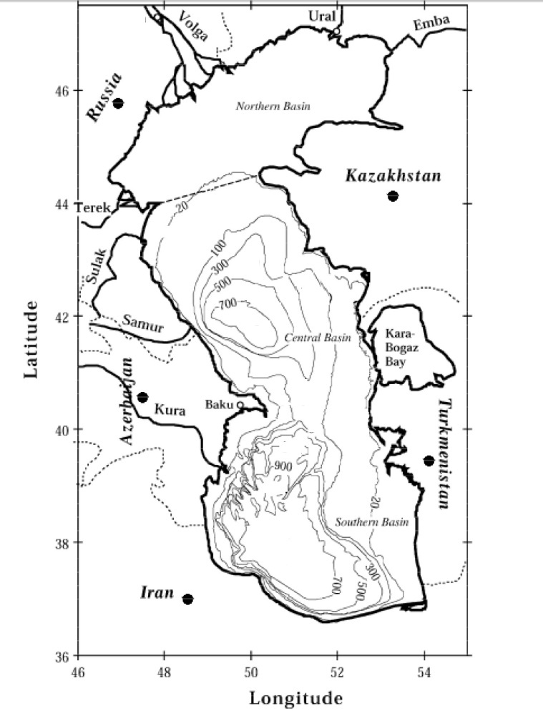
Figure 1. The Caspian Sea bathymetry, bordering countries, subbasins, and major rivers (After Peeters et al., 2000).
The Caspian Sea can be considered as having three parts (Froehlich et al., 1999; Kaplin and Selivanov, 1995): a northern part, with a mean water depth of only 10 m, a central part, where the water depth increases up to 788 m, and a southern part, wherein the water depth increases up to 1025 m.
A range of small and large rivers feed the Caspian Sea mostly from the south, west, and north and variations in their discharge can significantly affect the water volume and therefore the water level.
The considerable drop in the Caspian Sea level began in 1930 prior to which the observed water level had been more constant, fluctuating around -26 m for about 8 decades. In 1929, the water level stood at 26.1 m below oceanic level. This level dropped rapidly by around 1.6 m and reached -27.7 m by 1940. After that the Caspian’s sea level continued to decline but at a slower rate, falling by around 1.4 m within 37 years and reaching -29.1 m by 1977. After 1977, the sea level suddenly began to rise such that a water level of about -26.7 was recorded in 1995 showing an increase of 2.6 m over the period 1977 to 1995. Since 1995 a slow rate of change has continued.
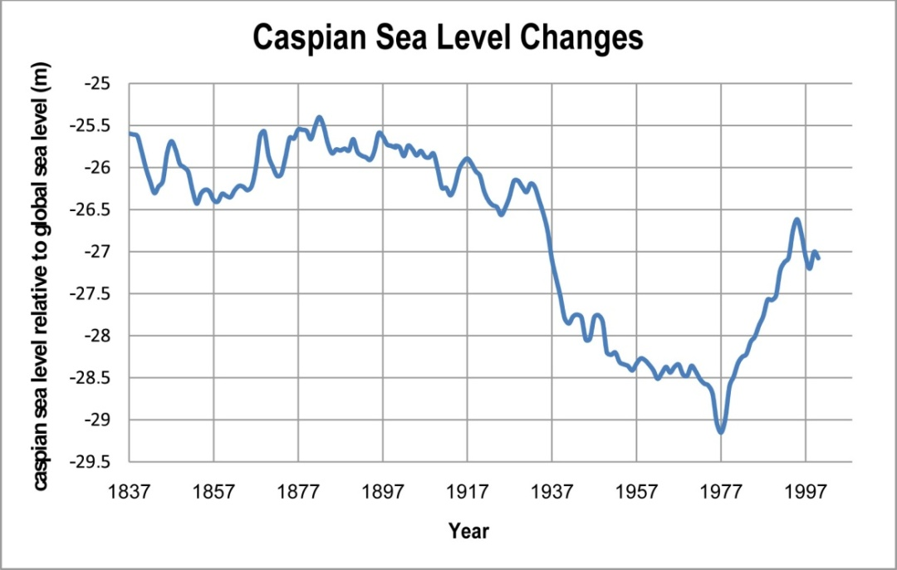
Figure 2. The Caspian Sea level fluctuations during the 20th century (Data based on Baltic Sea level).
Historical repeated water level oscillations in the Caspian Sea, mostly interpreted from sedimentary deposits, have been the subject of several research studies which show the tendency of the Caspian to change its water level. For example, biostratigraphical and radiometric investigations of the Kura Delta and its Holocene deposits show a repeated alternation between deltaic and marine environments resulting from high frequency changes in the Caspian Sea surface level representing four episodes of delta progradation followed by erosional transgressive surfaces (Hoogendoorn et al., 2005). The Volga Delta was also surveyed by Kroonenberg et al. (1997) and five magnitudes were recognized through stratigraphical studies for the Quaternary Caspian Sea water level variations. They found that a highstand (Caspian Sea level reached 50 m above global sea level) in the early Pleistocene linked the Caspian Sea and the Black Sea. As another example, lagoonal deposits and barrier-lagoon systems can indicate past oscillations in the Caspian Sea as well as deltaic deposits. Kroonenberg et al. (2007) studied the Holocene barrier along the Dagestan coast and found that the last notable highstands took place around 2600 BP.
The causes of fluctuations in Caspian Sea level are not yet entirely clear (Kroonenberg et al., 2007; Boomer et al., 2005). Most studies, however, emphasize the climate change and anthropogenic factors (Shiklomanov et al., 1995), rejecting the geological and tectonical effects (for example Rychagov, 1997; Golitsyn, 1995). Aspects of Caspian Sea level change have been the subject of various research studies related to hydrology, geomorphology, biology, and so on, but the effect of these changes on the seismic regime in the Caspian Sea region has not, so far, been studied in detail. The recent Caspian Sea level changes have created a new system of beach deposits and profiles. While these coastal evolutions under conditions of sea level change have been studied on the northern and western Caspian Sea coastline (Kaplin and Selivanov, 1995; Kroonenberg et al., 2007; Kroonenberg et al., 2000), the southern Iranian Caspian Sea coast has not been adequately explored. This research was aimed at investigating the impact of the 20th century changes in Caspian Sea level on the Iranian Coast of the Caspian Sea.
2. SEA LEVEL VARIATION AND COASTLINE CHANGES
Prediction of coastal changes as sea level changes is fraught with a number of difficulties. On one hand, predictive models are not being reliably generated due to a lack of knowledge of the interaction between coasts and energy sources. On the other hand, a model which is developed to forecast the behaviour of a particular coast cannot be applied to another because natural processes depend on coastal features which differ from one coast to another. Bruun (1962) proposed that the equilibrium beach profile does not change in response to sea level variations (Bruun Rule). In his view, in the case of sea level changes only a given volume of sand will move from the upper part of the profile and this volume of sand will lie over the lower part of the profile; the accumulated volume is equal to the eroded volume (Fig. 3).
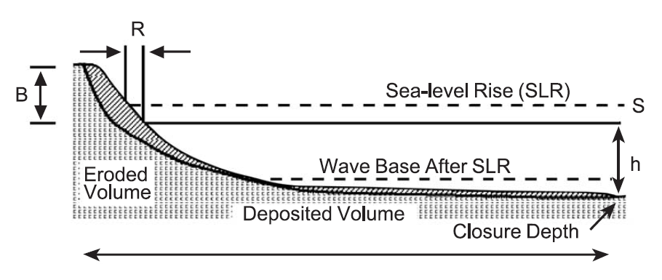
Figure 3. Shoreline erosion under rising sea level conditions, the Bruun Rule (Andrew et al., 2004).
Based on the Bruun Rule, since the shore-normal geometry of beaches remains unchanged under sea level rise conditions the amount of shoreline retreat can be calculated if the amplitude of sea level rise and the form of the original profile are known. This is a geometric model and can be applied if assumed geometric rules are valid. Andrew et al. (2004) concluded that due to three major categories of reasons the Bruun Rule does not work and should be abandoned:
Firstly, there are some assumptions which cannot be found in nature. For example, longshore transport is omitted in this two dimensional model. Secondly, this rule ignores some main variables such as other particle sizes existing on beaches, bottom currents, and bedforms. Finally, the concepts providing the foundation for the Bruun Rule are known to be outdated.
Other researchers, such as Leatherman et al. (2000), have confirmed the Bruun Rule by modelling a number of coasts, for example the New Jersey coast in the United States. However, their claim was very soon rejected by Sallenger et al. (2000) and Pilkey et al. (2000) who claimed that the data had been selected with a view to validating the Bruun Rule.
All in all, the aforementioned critical study of Andrew et al. (2004) is convincing because they evaluated almost all studies conducted on the Bruun Rule. Furthermore, Kaplin and Selivanov (1995) estimated the shoreline retreat for three depositional coasts of the Caspian Sea over the period of the Caspian Sea level rise. In some cases their study showed overestimations of up to 600 percent by the Bruun Rule. For instance, the field data was showing 20-25 m shoreline retreat on the Lenkoran coast of Azerbaijan but the Bruun Rule estimated it at around 130-150 m. Even with some modification this estimation only decreased to around 90-105 m.
The effect of sea level change on coastal morphology is based on reconstructions not on real time observations because, firstly, the rate of present sea level change is so slight, about 10-20 cm per century. Secondly, the present sea level has an upward trend and the last lowstand deposits can only be investigated by drilling or deep sounding and other similar methods. Furthermore, it is necessary to validate numerical models using real time data and laboratory simulations are hindered by some drawbacks such as downscaling (Kroonenberg, 2000). While the linkage between sea level changes and coastal landforms has not yet been completely understood (Andrew, 2004) the Caspian Sea can play an important role in enhancing our knowledge of coastal behaviours in response to sea level variations. This is because of its significant water level changes and approximately 7,000 km of coastline which are available for investigation.
It is no exaggeration to introduce the Caspian Sea as the best natural laboratory for studies related to coastal response to sea level changes. Present coasts of the Caspian Sea were formed in response to its repetitive level variations during the New Caspian transgression which began 8,000 yrs B.P. These coasts can be classified into four categories (Kaplin and Selivanov, 1995): Mud flats; Depositional coasts composed of bars, spits, etc.; Erosional coasts; and Deltaic coasts. The Caspian Sea possesses, approximately, all of the different coastal types which can be found along the world's coastlines and these coasts show different behaviour in response to sea level changes depending on their nature.
3. THE CASPIAN SEA COAST UNDER RECENT WATER LEVEL VARIATIONS
The Caspian’s various coastal types were introduced in the previous section. Their responses to Caspian Sea level changes are discussed in this section.
3.1 Mud flats
Mud flats tend to lie beside the lowland areas and stretched along the northeastern, southeastern corner, and northwestern coasts of the Caspian Sea during the period of Caspian Sea level fall from 1930 to 1977. Also, in this period, mad flats surrounded all Bays of the Caspian Sea including Kirov Bay, Krasnovodsk Bay, Kizlyar Bay, and Komsomoletz Bay. The rate of shoreline migration differed. For example, the shoreline of Kizlyar Bay advanced by 150-200 m/yr while the rate of shoreline migration in Komsomoletz Bay was 700-800 m/yr (Kaplin and Selivanov, 1995).
3.2 Depositional coasts
The period during which the Caspian Sea level showed a decreasing trend is marked by an increase in the size and volume of depositional bodies such as dunes, barriers, and spits, except those which were being supplied by cliff erosion, because in this period cliffs were inactive resulting in a decrease in longshore drift causing erosion to spits. On the coasts where nearshore slope was relatively gentle (tangent slope 0.0005-0.005), landward migration of these bodies occurred while their geometry remained almost unchanged (Kaplin and Selivanov, 1995). Moderate nearshore bottom slopes (tangent 0.005-0.01) usually mark barrier coasts (Roy et al., 1994) and under the Caspian Sea level fall its barriers increased their width and volume. Under rising sea level conditions however, sand ridges emerged on the coasts and a rise in the groundwater table formed a lagoon behind the ridges. On the coasts with a steep backshore (tangent slope over 0.03-0.05) lagoons did not form. Steep nearshore bottom slopes (tangent slope over 0.01) caused intensive erosion to beaches leading to the formation of scarps of up to 1-1.5 m (Kaplin and Selivanov, 1995). A proper example of barrier coasts was comprehensively studied by Kroonenberg et al. (2000). They investigated the barrier coast of Kaspiisk in Russia at the western Caspian Sea coast which had been monitored during the period of recent Caspian Sea level changes.
3.3 Deltaic coasts
When the sea level began to decrease a passive emergence occurred on the deltaic coasts. The Kura delta and the Sulak delta expanded up to 50-60 and 100-200 m/yr, respectively. The Volga delta together with the Ural delta located on the northern Caspian Sea coasts experienced a considerable expansion and caused the shoreline to move ahead by hundreds of kilometres. When the trend reversed and the Caspian Sea level started to increase deltaic shorelines retreated. The rate of the shoreline retreat was not as much as the shorelines’ advance in some deltas. While some areas were completely inundated the Volga delta retreated by only 2-4 m/yr. A main reason for this was the increase in sediment discharge. It is suggested that Volga sediment discharge increased by 33 percent due to an increase in its water discharge during the 1980s (Kaplin and Selvianov, 1995). Volga sediment discharge is composed of silt, clay, and very fine sand forming a gently sloping coast. Sea level rise and increasing Volga discharge worked together to vertically grow sediment bodies while sea level fall increased channel erosion leading to fast shoreline advances (Kroonenberg et al., 1997). The maximum level that the Caspian Sea experienced during the past century was 25 m below global sea level and it has been suggested that it may increase to near this level again. If this is the case, a wide area will be inundated (Li et al., 2004). The present day Kura delta is composed of sandy and clayey bodies. The aggradation process, during the period of water level increase in the Caspian Sea resulting from flooding of the Kura River delta, and progradation over the period of sea level fall, both control the Kura River delta as much as do river dynamics (Hoogendroon, 2005).
3.4 Erosional coasts
These can be observed in the coasts of Azerbaijan, Russia, Kazakhstan, and Turkmenistan. During the period of sea level fall the cliffs were left behind and cliff erosion ceased because the causative waves broke over the newly emerged area. When this area was submerged again by an increasing sea level, erosive waves attacked the cliffs and the result was an increase in the length of the erosional coasts of the Caspian Sea such that, for example, in Azerbaijan there was an increase from 20 to 55 percent along the whole coastline (Kaplin and Selvianov, 1995).
4. SOUTHERN COASTS OF THE CASPIAN SEA UNDER WATER LEVEL VARIATIONS
These segments of coastline similar to other coasts had appropriate responses to the sea level changes but published data from them is in relatively short supply (Kazanci et al., 2004). These coasts can be morphologically categorized into five zones. The morphodynamics of each zone were characterized to evaluate vulnerability of beaches and for hazard assessment by Khoshravan (2007) and hazardous areas were marked. His study showed that nearshore slope, shore morphology, and sediment characteristics vary along the southern Caspian Sea coastline. There exist several lagoons and bays along the Southern Caspian coast the most important ones being Anzali lagoon in the west and Gorgan Bay in the east (Fig. 4). The recent Caspian Sea level rise, which occurred between 1977 and 1995, doubled the Anzali lagoon surface from 80 to 160 km2 (Kazanci et al., 2004). The Alborz mountain range governs the shore width throughout the coastline and the rivers feeding the Caspian Sea from the south contribute great amounts of sediment to the shores to expand their width.
In the east, where the coast is composed of fine grain sediment, waves are prevented from reaching the shore due to the gentle slope of the nearshore zone. Sandy beaches have stretched along the hundreds of kilometers of the southern Caspian Sea coastline and coarse grain beaches can be observed in some segments. These coasts were affected by the Caspian Sea level rise in accordance with their offshore and onshore slopes (Lahijani et al., 2007).
Fig. 4 illustrates the formation of southern Caspian Sea coasts under conditions of rising sea level. The variety of behaviours is due to the differences between offshore and shore gradients (Lahijani, 2009, Pers. Comm.).
Studies related to the sea level rise conducted on the southern coasts of the Caspian Sea are limited and there is a gap in the information available for this area. Although Fig. 4 is a schematic representation of the behaviours prevailing on some coasts it is not sufficient for a coastline of 700 km in length which has a wide variety of features.
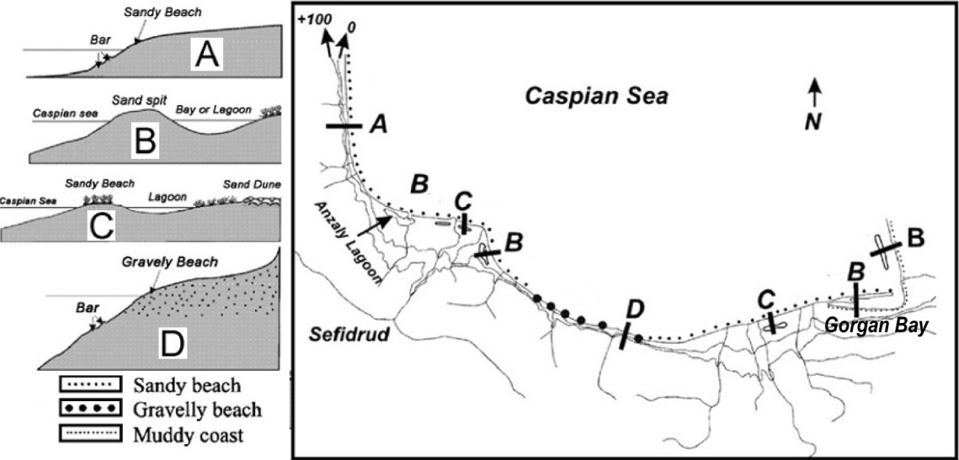
Figure 4. Southern Caspian Sea coasts’ behaviour in response to sea level rise (After Lahijani et al., 2007).
5. METHODOLOGY
The ultimate goal of this research is to investigate the effects of the Caspian Sea water level variations on the Iranian Coast of the Caspian Sea. For this reason factors determining the coastal response to sea level changes, namely nearshore gradient, sediment supply, wave regime, and sea level rate, introduced by Roy et al. (1994), together with shore slope are discussed for the southern Caspian Sea coasts. Finally, the response of the southern coast to the water level variations will be discussed.
The flowchart illustrated in Fig. 5 shows the process applied in this research to achieve the desired goal. The diagram shows how this research was carried out in four main steps: the first, the second, and the third field surveys together with the final data analysis. Firstly, by reviewing the literature and background of the subject, the factors affecting the Caspian Sea coasts were recognized. On the basis of the achieved knowledge, the first field survey was conducted.
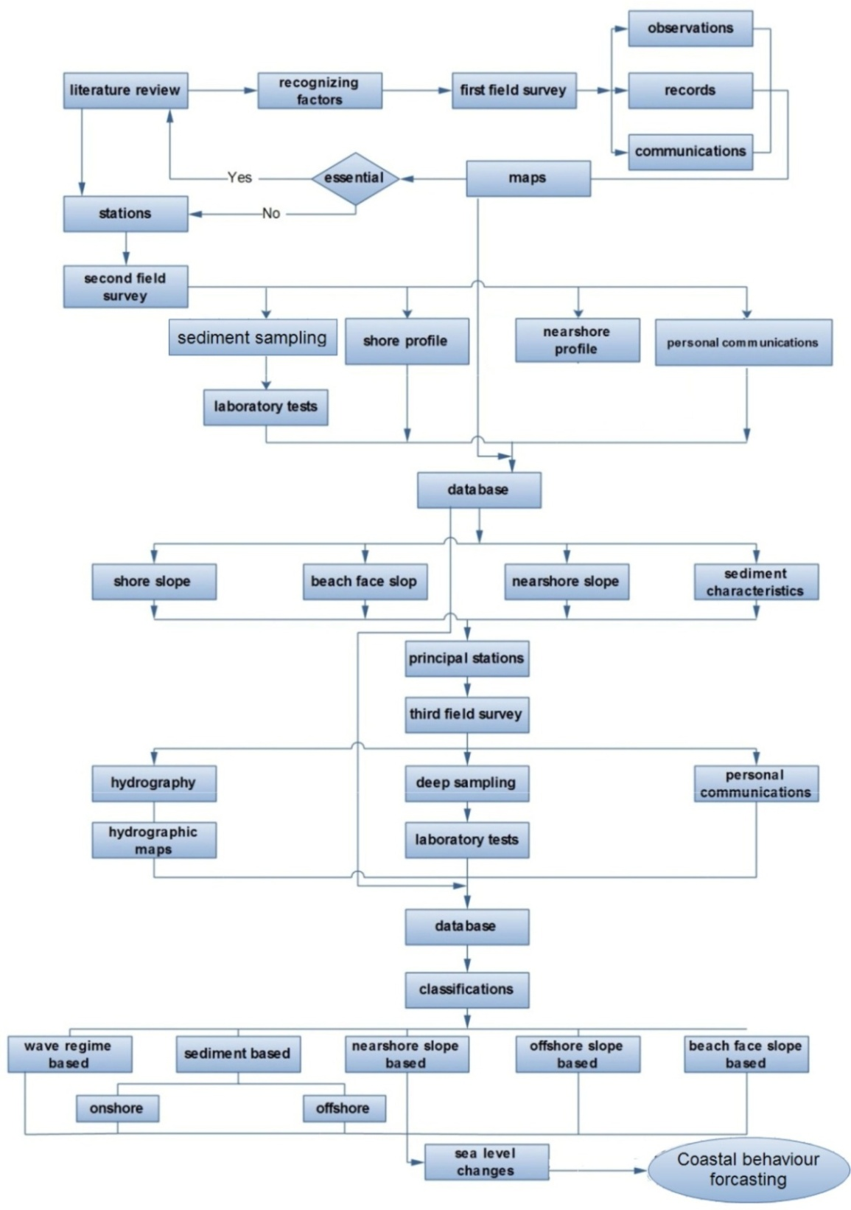
Figure 5. Applied process to examine the impacts of the Caspian Sea level changes on Iran's Caspian Sea coast.
The major objective of this field work was to gather appropriate information needed to comprehend the study area. For this reason, all observations were documented and locations taken. Also, interviews with coastal residents were performed throughout the survey. Obtained information was compared with the available maps to avoid any error. If sufficient, this information was to pave the way for the second survey. If not, the information would be completed by returning to the literature. Finally, the stations of the second survey were chosen.
The second step was to conduct the second survey. During this survey the information came from nearshore sediment sampling, offshore hydrography, onshore topography, and personal communications and provided a database for the whole coastline consisting of sediment characteristics, beach profiles, and a general view of each segment of the coastline. Beach profiles provide shore slopes, beach face slopes, and nearshore slopes. All are important for final analysis and by performing a suit of laboratory tests on sediment samples a database was made up of the results. On the basis of the field reconnaissance, principal sampling stations of the third survey were chosen.
The third survey aimed to evaluate deep sediment characteristics of the southern Caspian Sea coast and made up the third stage of this project. Also, at this stage hydrographic profiles were surveyed from the shoreline to a depth of 10 m. These profiles were compared with the available hydrographic maps and a set of laboratory tests were conducted on the sediments sampled by divers along profiles at certain depths. The results emerging from this step along with the information obtained from the previous stages created a comprehensive database.
In the final stage, data was analyzed. Several classifications were conducted based on wave regime, shore slope, beach face slope, nearshore slope, offshore slope, and sediment characteristics. Finally, the effect of Caspian Sea level changes on Iran's Caspian Sea coasts was evaluated for use in forecasting the behaviour of these coasts in response to future sea level changes in the Caspian.
6. THE FIRST SURVEY
Having studied other published works, the way was paved for the first piece of field work. Since field observations play an important role in comprehending the problem, to take full advantage of this stage it was decided to study all of the available information, morphological, hydrographic and topographic maps on the scale of 1/100000, before beginning the work (these pieces of information were provided by the Iranian Caspian Sea National Research Centre, Iran's National Cartographic Centre, the Geological Survey of Iran, and the Iranian National Institute for Oceanography).
With regard to Fig. 6, the northern part of Iran, where the Southern Caspian Sea coast lies, is divided into three provinces; Guilan, Mazandaran, and Golestan. Guilan province extends from Astara, northeast of Iran where it has a common border with Azerbaijan, to Ramsar, which marks Mazandaran province’s border. Guilan is home to cities such as, Astara and Talesh in the west, Anzali, Dastak and Kiashahr in the centre, and Kelachay in the east.
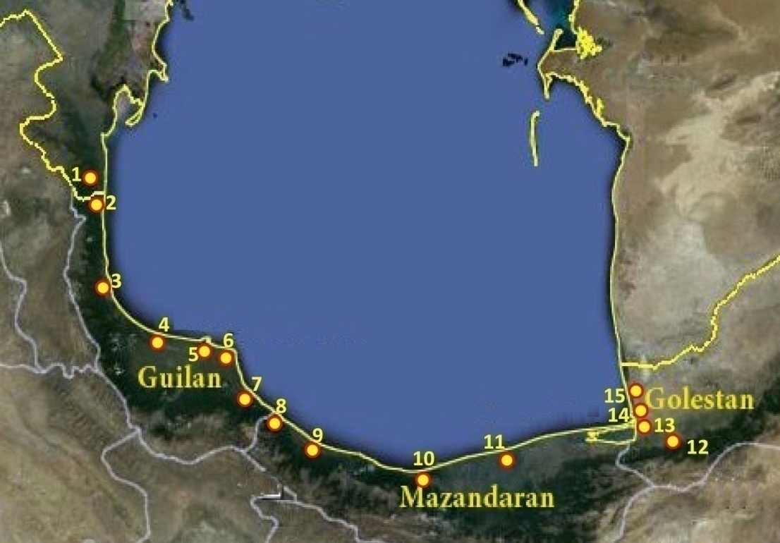
Figure 6. Three of Iran's provinces bordering the Caspian Sea, 1: Azerbaijan; 2: Astara; 3: Talesh 4: Anzali; 5: Kiashahr; 6: Dastak; 7: Kelachay; 8: Ramsar; 9: Nashtarood; 10: Noor; 11: Babolsar; 12: Gorgan; 13: Bandar Torkaman; 14: Gorganrood; 15: Gomishan.

Mazandaran province is bounded by Ramsar in the west and to the east it shares its border with Golestan province. The western coasts of Mazandaran are home to cities such as Nashtarood and Ramsar, while Noor is situated in the centre; Eastern Mazandaran is famous for cities such as Babolsar.
Golestan province, the most important city of which is Gorgan, lies on the south eastern coast of the Caspian Sea; its Bandar Torkaman, Gorganrood and Gomishan coasts are amongst those which are important to this study.
The reason why the northern regions of Iran have been described is that the rest of this study and the classifications of coasts use these proper names. Moreover, most of the stations selected in this research are introduced by the names of the cities in which they are situated.
This field survey began in Astara in the west. In almost every region, where even the slightest possibility of access to the coast existed, a survey was carried out. All the observations were documented, and the coordinates of the spots which seemed to be important in later stages were recorded by a hand GPS. For consequent stages of research, some pictures were taken, while other places where mere pictures could not explain the overall situation were filmed.
Communications with local people were important and helpful in understanding the region. For instance, locals, especially fishermen, had a working knowledge of sandy bars on the nearshore bottom; therefore, practical information was obtained from them. This survey began on 1st May 2009 and finished on 11th May 2009 in Gomishan on the east of Iran’s northern coast. It covered almost all of the 700 km length of the southern coast of the Caspian Sea. The following are the results of the observations:
- The morphological phenomena mentioned in section 8.2 are rarely seen all together in one region;
- Shore sediments and nearshore sediments vary along the coast based on their type, and where the overall width of the coast (the distance between mountain and sea) lessens, the sediments grow coarser.
- Shore slope varies from place to place;
- In some parts, the beach face slope is different from the general beach face slope observed along these coasts, that is, the coarser the sediments around the shoreline, the steeper the beach face slope;
- With just a little attention to the way onshore bars have been formed, one can identify the dominant direction of the sediment transport in some regions;
- Waves reach the coast at an angle to a line perpendicular to the coastline. This angle varies at different points; as one moves towards the central areas of the coastline, this angle lessens;
- Observations on landforms from sea to mountain, as well as the information obtained from coastal residents about offshore slope, along with previous information obtained from hydrographical and topographic maps, show that both the offshore slope and shore slope are changing along the coast, and these two slopes are substantially different in most regions.
In fact, during this survey, the overall morphology of the region was evaluated, and in a general view it can be said that the most outstanding tectonic phenomenon of the region is the Alborz mountain range, by which the whole length of Iran’s northern coast is southerly bounded (see Chapter 5, section 5). Also, on the western coastline the Talesh mountain range is oriented in a south-north direction. Obviously, the distance of these mountain ranges from the sea in different areas of the coastline determines the width of the shore. At some points, the shore width is very narrow, nearly 1 km (for example western Mazandaran, around Ramsar), while in other places such as the eastern parts it exceeds 60km.
Shore width is one of the factors determining the shore slope, and therefore, it should be paid an appropriate level of attention in this study. In some regions great rivers (for example the Sefid-Rud in central Guilan) which flow into the Caspian Sea expand the shore width. More than 50 rivers flow into the Caspian Sea from the south, the sediments of which have affected the morphology of the shore and in some cases posed problems for the locals. For example, at a certain point in Kelachay, the local fishermen talked about an obstacle at a depth of around 2.5 m that would tear their fishing nets. Later, in the third field survey, this problem was investigated. On this shore, fishermen would cast their fishing nets in 3–5 m depths of water and after a specified time would drag them out with tractors to gather in the fish. By diving, it was proved that this was a very thin, locally created layer of cohesive clay probably formed by sediments transported by several small rivers running close to each other. While being dragged along the seabed, the fishing nets must have been torn by this layer.
Onshore sandy bars are not seen in every region. They are mostly seen at the coast at Guilan and eastern Mazandaran, while nearshore sandy bars are formed in most regions, except Golestan (Pers. Comm. with local people, 2009). Small and relatively big lagoons can be seen in eastern Mazandaran and central Guilan. Coastal sediments are mainly sand, except for at the western Mazandaran coast in some segments of which gravelly beaches can be seen, and on the Golestan coast where coastal sediments are mostly clay.
After obtaining a general view of the region, it was necessary to match the acquired information with the available maps. Also, it was necessary that studies previously conducted on similar coasts be reviewed more accurately so that the methodology could be exactly defined.
7. THE SECOND SURVEY
This survey was conducted in order to acquire the information necessary for evaluating Iran’s coast. Due to the information obtained from the first survey and supplementary studies, 24 stations were selected along the coast. In Fig. 7 the locations of these stations have been specified. Equipment required for sampling the sediments and surveying was prepared. This field work started on 4th June 2009 in Astara in the west and finished on 15th June 2009 on the Gorganrood coast. During this survey foreshore profiles were mapped, beach sediments were sampled, and observations of shore features were documented. Furthermore, past information about the Caspian Sea level changes and its impacts on coastal geomorphology were collected by personal communications with southern Caspian Sea coast residents.
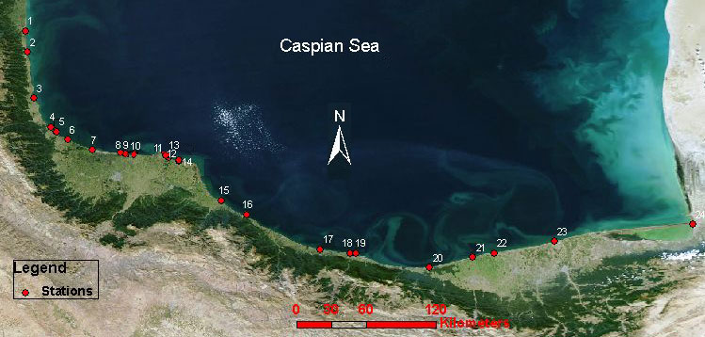
Figure 7. Twenty-four stations selected during the second survey, 1: Astara; 2: Landvil; 3: Talesh; 4: Parrehsar(1); 5: Parrehsar(2); 6: Kapourchal; 7: Anzali (Bashman); 8: Golshan(1); 9: Golshan(2); 10: Golshan(3); 11: Kiashahr(1); 12: Kiashahr(2); 13: Kiashahr (3); 14: Dastak; 15: Kelachay; 16: Ramsar; 17: Nashtarood; 18: Chalus; 19: Noshahr; 20: Noor; 21: Mahmood Abad; 22: Babolsar; 23: Larim; 24: Gorganrood.
Sediments were sampled along profiles at backshore and surf zone locations in each station. These samples were taken ‘disturbed’, and of course, in this research no undisturbed samples were required because the main goal was to determine the grading of the sediments. Cross shore profiles were surveyed within a distance of 150–300m from the shoreline, dependent on shore slope and landforms. Also, the nearshore profile up to a depth of 1.5m was mapped by wading.
Selecting 24 stations along 700 km of coastline (that is, one station every 30km if an average distance is calculated) helped the researcher to gather more complete information about the coast, to be used in later studies. The high number of selected stations as well as the prolonged timeframe of the whole operation brought about some problems. For example, by taking sediment samples in each station, and each sample weighing about 1 kg, at the end of the operation about 70 kg of theses samples was being transported. Moreover, in some places, access to the shore was problematic; some parts of the southern coast of the Caspian Sea are owned by private companies or governmental institutes. In some other places, vehicles could not access the points which were considered important for this research, so the equipment had to be carried by survey personnel (for example on the shores around the estuary of the Sefirud River near Kiashahr).
While determining the stations, it was decided to select locations which were representative of the general situation thereabouts. After carrying the samples to the laboratory, a series of experiments were carried out on them, which will be presented in the following sections. Finally, comprehensive information about shore sediments, nearshore sediments, shore slope, nearshore slope, and beach face slope was acquired. Therefore, of the whole information about the region, only information about deep sediments and overall slope of the seabed was missing. Of course, this overall slope could be extracted from available hydrographic maps; however, it was decided that in the next survey as deep sediments are being sampled, the hydrography of the seabed should also be carried out.
8. THE THIRD SURVEY
So far all the information about the shore and nearshore shallow depths had been acquired. It seemed that with some information about great depths offshore, the information necessary for conducting this research would be complete; therefore, the third survey was planned. The aim of this survey was to sample sea bottom sediments up to a depth of 10 m and to acquire information concerning the hydrography of the seabed. For the following reasons, this task was in some respects more difficult than the previous two:
- The need for boats at specified stations along 700km of the coast;
- The need to dive to a depth of up to 10m;
- Essential need for the sea to be calm both for diving and for hydrography;
- The need to obtain required permits for diving and offshore hydrography from local authorities;
- Identification of more suitable stations which, although fewer in number, would be representative of the whole region;
- The air capsules needed to be filled with compressed air at each station because the divers were using the air not only for breathing but also to fill their specialist diving suits to help them rise to the surface after sampling.
After reviewing previous data and studies conducted by Iran's Caspian Sea National Research Centre and the Iranian National Institute for Oceanography, eight principal sampling stations were chosen (Fig. 8).
The required permits were obtained from local authorities, and two divers were hired for sampling operations. After the climatic status of the two provinces of Mazandaran and Guilan as forecast by weather forecasting centre was reviewed, the 20th December 2010 was chosen for the beginning of this survey.
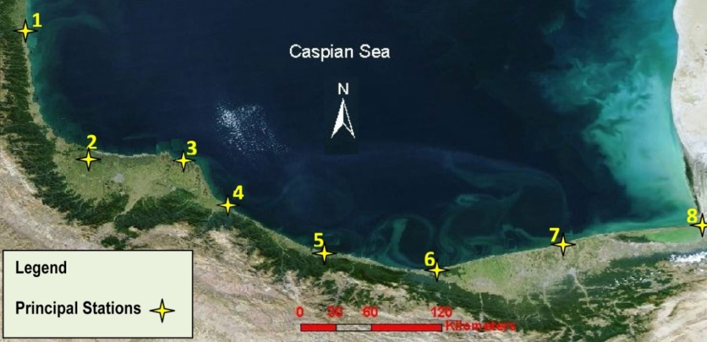
Figure 8. Principal stations, 1: Astara; 2: Anzali; 3: Dastak; 4: Kelachay; 5: Nashtarood; 6: Noor; 7: Babolsar; 8: Gorganrood.
As far as boats were concerned, the locals provided useful information that, since it was the fishing season, it was possible to find boats for hire at the stations or nearby; then the work began.
In each station, sediments were sampled by divers along profiles at right angles to the coast at five depths (2, 4, 6, 8, and 10m). Hydrographic profiles were surveyed by sounding up to a depth of 10m.
After five days five stations had been surveyed - Astara, Anzali, Dastak, Kelachay, and Nashtarood - and the survey team arrived at Chalus, a city near to Noor which was the sixth station. At this stage a typhoon began to blow and work stopped and started again after the storm. Finally, the survey finished at the last station which was on the Gorganrood coast. On this coast, sediments were sampled only at depths of 2 and 4 m. The beach profile was also surveyed to a depth of 4 m because of the very gentle slope of the shore and offshore. To reach a depth of 10 m in this area, a distance of at least 30 km must be navigated (according to the available hydrographic maps) which was not possible for the research group because of the lack of available facilities. The sediment samples were carried to a laboratory and laboratory tests were conducted on them. It was decided that it was appropriate to wash the samples with fresh water to remove the salts. Since some sediment samples had a portion of very fine grained particles the first experiment damaged one sample by removing the finer particles, so this approach was abandoned. Of course, the Caspian Sea salinity is not as great as that of the oceans; hence the existing salts should not have a serious effect on the result. Finally, with the information acquired from this field survey, the required research database was completed.
9. THE COAST CATEGORIZATION
Based on the observations, measurements, and information obtained from reviewing the available maps the southern Caspian Sea coast was divided into 5 distinct areas (Fig. 9):
      - The area located in the west of Guilan Province, from Astara to around Anzali is called West Guilan;
      - From Anzali to around Kelachay, is called Central Guilan;
      - The areas located in eastern Guilan and western Mazandaran have common features and have been merged to create a zone known as West Mazandaran. Thus, West Mazandaran includes areas from around Kelachay to Noor.
      - From Noor to Gorgan Bay a wide coast can be seen which is called East Mazandaran;
      - The eastern coasts which are situated in Golestan Province are called Golestan.
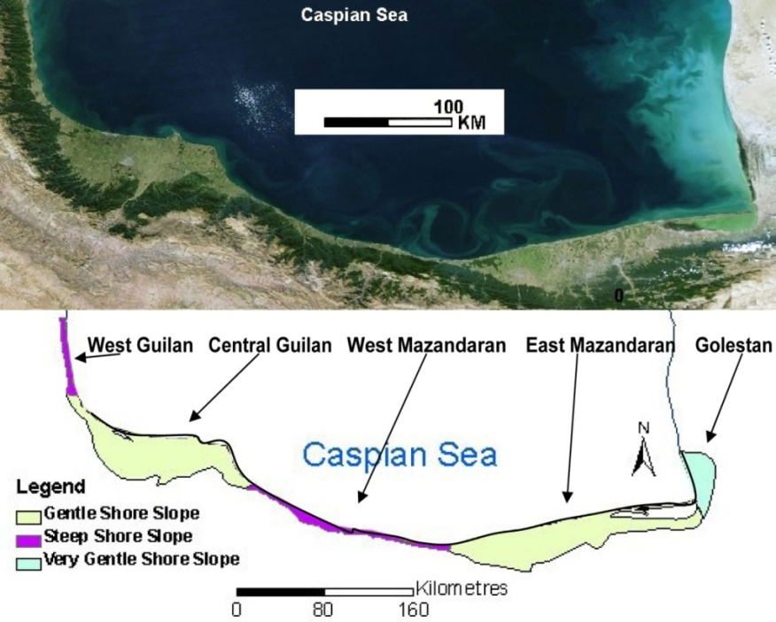
Figure 9. Iran's Caspian Sea coast classification into five areas based on shore slope. Correlation between shore width and shore slope (Data from observations, measurements, and available maps provided by the Geological Survey of Iran, and the Iranian National Institute for Oceanography).
Nearshore gradient, sediment supply, wave regime, and sea level change rate introduced by Roy et al. (1994), together with shore slope factors are discussed for these coasts.
10. SHORE SLOPE
The database of information obtained from the three surveys and available maps shows that Iran's Caspian Sea Coast can be subdivided into three groups of areas on the basis of the shore gradient (tangent of the shore slope angle):
- Areas with a steep gradient (0.01 to 0.07) including West Guilan and West Mazandaran,
- Areas with a gentle gradient (0.003 to 0.009) including Central Guilan and East Mazandaran,
- Areas with a very gentle gradient (less than 0.001) which can be observed on the Golestan coasts.
Considering Fig. 9 a narrow coastline is observable in the western shoreline. Due to a short distance between the mountains and the Caspian Sea in the West Guilan, the shore slope in this zone is steep. In contrast, gently sloping coasts mark Central Guilan. The steep slope of the coast of West Guilan can be observed in West Mazandaran, reaching 1 km at some points. While a gently sloping coast can be found in East Mazandaran, in some parts the shore width exceeds 60 km; Golestan is marked by its very gently sloping coasts. Fig. 9 shows a classification of coastal areas according to their slopes. This figure was produced by combining two maps to show the relation between the location of the mountains, shore width and shore slope. In this research, it is believed that the shore slope plays an important role in determining the coastal behaviour in response to sea level changes which was rarely taken into consideration in the other published studies.
11. NEARSHORE BOTTOM SLOPE
Kaplin (1989) suggested that nearshore bottom slope is the factor which most substantially affects coastal behaviour in response to sea level rise. Later, this idea was confirmed by other researchers such as Ignatov et al. (1993), Roy et al. (1994), Kaplin and Selivanov (1995), and Kroonenberg et al. (2000). It refers to the fact that nearshore bottom slope determines not only the location of the wave breaking zone and the nature of the breaking process but the patterns of coastal evolution (Bauch et al., 2005).
Considering Fig. 10 sediment movements are affected by nearshore slope. It shows that under sea level rise, a passive inundation occurs on very gently sloping coasts (a). On coasts with a gentle nearshore slope the dominant direction of sediment transport is landward (b and c), while on the steeper coasts sediments tend to move seaward (d and e).
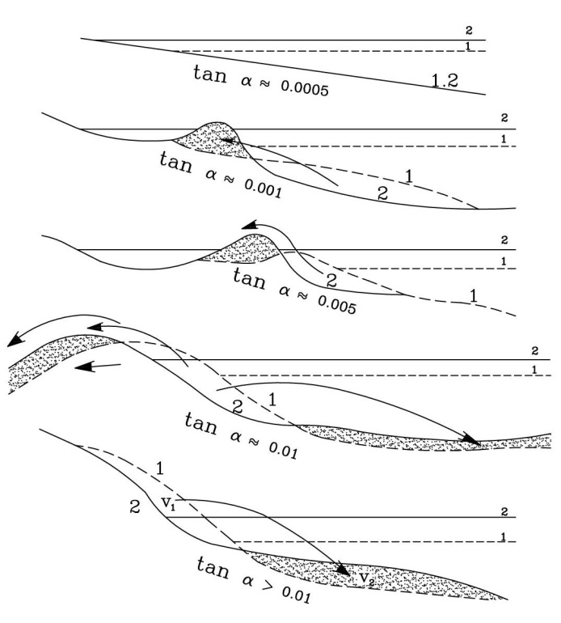
Figure 10. The dominant direction of sediment transport determined by nearshore bottom slope when the sea level rises from the dotted line to the solid line (1 to 2). Dashed areas indicate deposited parts and arrows show the dominant direction of sediment movement (Redrawn after Bauch et al., 2005).
Kaplin and Selivanov (1995) suggested different patterns of coastal evolution during the period of sea level rise in the Caspian Sea (Fig. 11).
They suggested four patterns for natural evolution of the Caspian Sea coasts under conditions of rising sea level. Their study revealed that a passive shoreline retreat was marked by a very gently sloping coast (tangent nearshore slope,$∝$ , < 0.0005) as sea levels rose. On the relatively steep coasts ($tan∝ ≅0.0005 to 0.005$), however, depositional submarine bodies (sandy bars) moved landward. Coasts with a steeper nearshore zone ($tan∝ ≅0.005 to 0.01)$ showed another type of response. On these coasts lagoons were formed as a result of both the landward movement of the beach ridge and the rising groundwater table, while on the very steep coasts ($tan∝ >0.01)$ the dominant direction of the sediment movement was seaward, causing the beach face to erode.
Iran's Caspian Sea displayed specific behaviours, mostly due to the considerable differences between shore slope and nearshore slope on these coasts. For example, in west Guilan around Astara, based on Fig. 11, onshore depositional bodies and lagoons are expected due to the gentle slope of the nearshore zone ($tan∝ ≅0.001 to 0.005,$ based on field data) but during three field surveys, what was observed on this coast were mostly erosional scarps because of the steep slope of the shore.
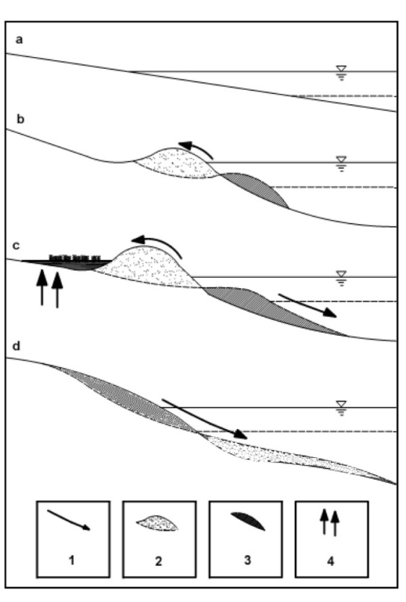
Figure 11. Different types of coastal response to the Caspian Sea level rise, a: passive shoreline retreat on very gentle coasts ( $tan∝$ , < 0.0005); b: landward movement of sediments and sandy bars on relatively steep coasts ($tan∝ ≅0.0005 to 0.005$); c: formation of barrier-lagoon system on the steeper coasts ($tan∝ ≅0.005 to 0.01)$; d: seaward movement of sediments on very steep coasts $(tan∝ >0.01)$; 1: dominant direction of the sediment movement; 2: eroding parts; 3: depositional parts; 4: groundwater table rise (modified after Kaplin and Selivanov, 1995).
Iran's Caspian Sea coast can be divided into three areas based on the nearshore slope. Fig. 12 shows the classification of the southern Caspian Sea coasts according to their nearshore slope. It can be clearly seen that a gently sloping nearshore zone marks West Guilan. Coasts with a steep nearshore slope stretched along Central Guilan, West Mazandaran, and East Mazandaran while, low-lying lands of the Golestan coasts are marked by very gentle nearshore slopes.
Also, Fig. 12 shows an obvious difference between the nearshore slope and shore slope throughout Iran's Caspian Sea coastline. Based on this figure the areas defined in section 9 can be characterized as follows:
- West Guilan: gentle nearshore slope (tangent slope ~ 0.001 to 0.005) and steep shore slope;
- Central Guilan and East Mazandran: steep nearshore slope (tangent slope ~ 0.005 to 0.009) and gentle shore slope;
- West Mazandaran: steep nearshore slope (tangent slope angle ~ 0.008 to 0.02) and steep shore slope; and
- Golestan: very gentle nearshore slope (tangent slope less than ~ 0.0009) and very gentle shore slope.
Considering Fig. 13 a classification based on offshore gradient results in three zones. Coasts with a gentle offshore gradient are exemplified by West Guilan. In this zone the point at which water depth reaches 100 m is approximately 20-40 km from the shore. This distance decreases to around 6-13 km in Central Guilan, West Mazandaran, and East Mazandaran which have steep offshore gradients, and increases dramatically to around 65-75 km in Golestan which is marked by very gentle offshore gradients. Also, through comparison of Figs. 12 and 13 it is understood that offshore gradient in each region governs nearshore gradient.
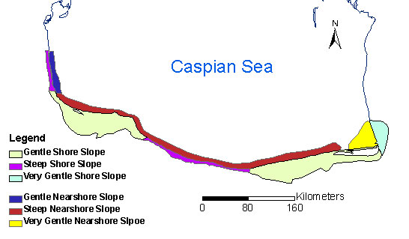
Figure 12. Coastal classification based on nearshore bottom slope, the width of the nearshore zone is not drawn to scale (data from field surveys and available maps).

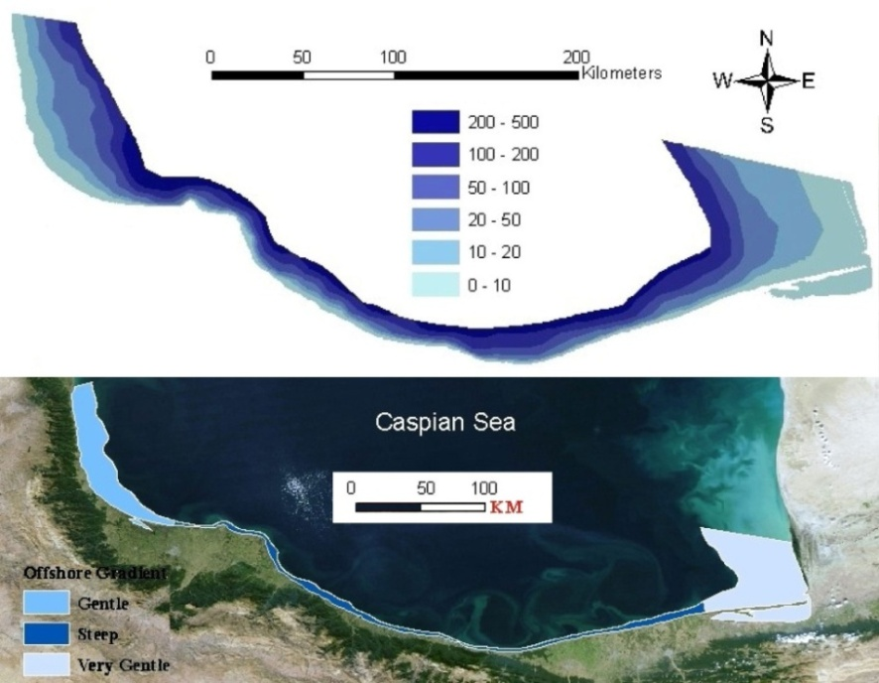
Figure 13. Caspian Sea bathymetry (data from Iran's Caspian Sea National Research Centre) (top). Coastal classification based on offshore gradient along Iran's Caspian Sea coast (bottom).
12. WAVE REGIME AND CURRENTS
Waves and currents are driving forces behind many of the coastal processes by which coastal areas are formed. These energy sources are important parameters in the Caspian Sea which influence the morphology of its coasts. The relief of the Caspian Sea bottom isolates three sub-basins from each other which may be one of the causes of water circulation. Rivers feeding the sea are another cause among which the Volga has the most important role because of its considerable discharge (Fig. 14).
The North basin is marked by low energy waves and the South basin is characterized by moderate waves. In the Middle Caspian basin however waves have higher energy. Generally, the southern Caspian Sea coasts are exposed to waves which come from the north, northeast and the northwest. The waves coming from the north and northeast reach the western part of the coastline, namely West Guilan, Central Guilan, and West Mazandaran, while the waves reaching the eastern part including East Mazandaran and Golestan come from the North and Northwest (Lahijani et al., 2007). As a result of these waves longshore currents can be observed in a North-South direction along the western and eastern coasts of the south basin and along Iran's Caspian Sea coast a prevailing eastward longshore current flows, the effects of which can be observed in the formation of Gorgan Bay (Fig. 4 and 14).
As a result of field observations the southern Caspian Sea coast is mostly dominated by spilling breakers especially in Central Guilan, West Mazandaran, and East Mazandaran. In Golestan the closure depth point is far from the shore, as is the wave breaking point, due to the low beach gradient. As a result, the waves are prevented from approaching the shoreline and do not have a significant impact on the coasts. In West Guilan, nearshore zone is steeper than that of Golestan and waves lose a portion of their energy before reaching the shore, while waves are breaking close to the shore in the other segments of the southern Caspian Sea coastline as a result of the steep gradient of the nearshore zone (Fig. 12).
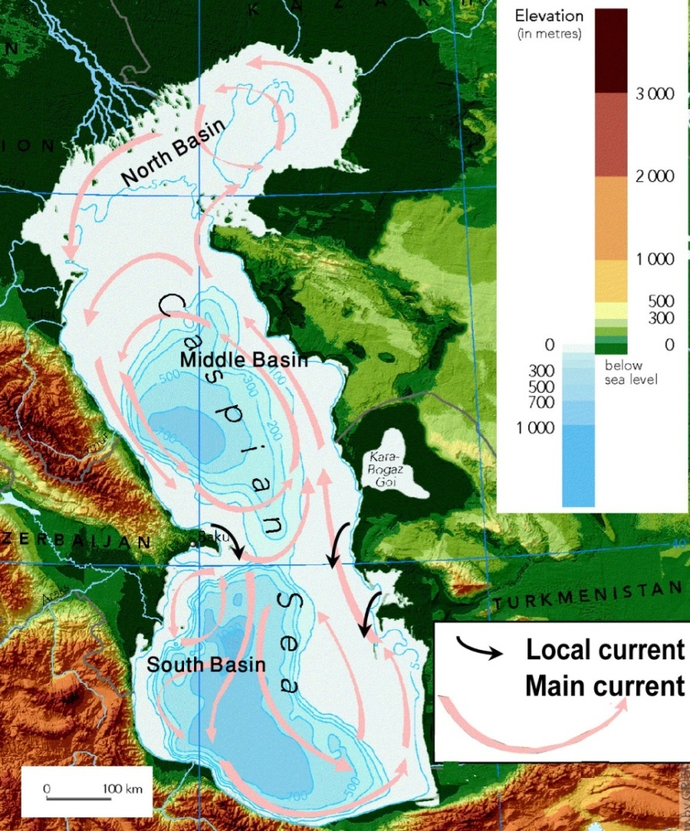
Figure 14. Caspian Sea basins including bathymetry, relief of the surrounding areas, and currents. Local currents are interpreted from headlands (After European Environment Agency).
13. SEDIMENT CHARACTERESTICS OF IRAN'S CASPIAN SEA COAST
A necessary part of any coastal investigation is the analysis of sediments sampled from both the shore and offshore. This analysis helps the researchers not only to forecast the future movements and coastal evolution but also to interpret past processes. For this reason all the sediment samples taken from the shore and offshore during the surveys were carried to a laboratory where sieving tests were performed on them (Guilan University for the second survey's samples and Azad University of Zanjan for the third survey's samples). Sieve analyses were performed in accordance with ASTM C136.
Generally Iran's Caspian Sea coast can be classified into three areas based on onshore sediments:
- Sandy beaches: West Guilan, Central Guilan, and East Mazandaran;
- Gravelly beaches: West Mazandaran (in some segments; not the whole coastline); and
- Muddy beaches: Golestan.
Nearshore sediment is mostly sand throughout the Caspian Sea coast of Iran except that of Golestan which is clay and silt dominated. Also, in some segments of West Mazandaran gravelly particles are seen even at depths of up to 4 m. Moreover, clay and silt particles can be observed at depths along the profiles. In West Guilan clay and silt are observed at depths of over 2 m (the percentage of silt and clay along the profile of the first station of the third survey (Astara) was: 38%, 36%, 40%, 25%, and 15% at depths of 10, 8, 6, 4, and 2 m, respectively). In the other stations however, the presence of silt and clay along the profiles surveyed during the third period of field work were as follows:
- Anzali: after a depth of 6m (around 2.5% at 6 m, 13% at 8 m, and 18% at 10 m), Central Guilan;
- Dastak: after a depth of 4 m (around 5% at 4 m, increasing seaward), Central Guilan;
- Kelachay: after a depth of 2 m (around 3% at 2 m, 11% for 4 m, and 15% for 6 m, increasing seaward), Central Guilan;
- Nashtarood: after a depth of 6 m (around 9% at 6 m, increasing seaward), West Mazandaran;
- Noor: no clay and silt observed until a depth of 10 m, West Mazandaran;
- Babolsar: after a depth of 6 m (around 25% at 6 m, increasing seaward), East Mazandaran.
Generally, silt and clay along the Caspian Sea coast of Iran can be observed from a depth of 2 m seaward in West Guilan. In Central Guilan and East Mazandaran the depth at which clay and silt exists is 6 m while for West Mazandarn usually there is no clay and silt in the samples taken from depths up to 10 m. In Golestan both shore and nearshore sediments are dominated by clay and silt.
14. ANALYSIS OF THE IRANIAN CASPIAN SEA COAST AND FUTURE FORCASTING
This study classifies the southern Caspian Sea coast into four groups - West Guilan, Central Guilan-East Mazandaran, West Mazandaran, and Golestan - each of which will be discussed here to characterize its nature and to forecast its evolution under conditions of probable future sea level change (for details see previous sections; suggestions for the coastal evolution under condition of falling sea level are mostly based on personal communications with local persons who experienced the period of recent sea level fall).
West Guilan: generally this coastal zone has a steep shore slope (tangent slope angle ~ 0.01 to 0.05) and gentle nearshore slope (tangent slope angle ~ 0.001 to 0.005) which follows the gentle offshore gradient in this area (Fig. 13). Based on Fig. 11, this zone falls into group b of Kaplin and Selivanov’s (1995) classification but the steep slope of the shore forms erosional scarps on the beach face. It is suggested that, given future sea level rise in this zone, erosional scarps and submarine sandy bars will be formed, specifically from Astara to around Talesh, and in some areas, specifically from Talesh to Anzali, small lagoon-barrier systems will be created around the mouths of the small rivers entering the Caspian Sea where the shore slope is becoming relatively lower and coarse grained material is provided by rivers. Under conditions of falling sea level however, the shore would widen and consequently onshore sandy bars would form. No lagoon is expected to form except for a few very small lagoons around the river mouths.
Central Guilan-East Mazandaran: since gently sloping shores (tangent slope angle ~ 0.003 to 0.009) but steep nearshore slopes (tangent slope angle ~ 0.005 to 0.009) mark this zone, this group of areas mostly fall into group c of Kaplin and Selivanov’s (1995) classification. On shore and submarine sandy bars together with sandy dunes are seen in these areas and as a result of formation and landward movement of barriers several big lagoons and a notable number of small lagoons were formed during the recent sea level rise. With future rises in sea level these conditions are expected to continue and lagoons may increase in size due to the gentle shore slope of this area and the existence of a wide shore which will allow the lagoons to extend. When the sea level falls, no big lagoons are formed and existing lagoons lose their size (personal communication with East Mazandaran residents). Submarine depositional bars emerge and other bars are formed by storms.
West Mazandaran: having both steep shore and nearshore gradients (tangent shore slope angle ~ 0.01 to 0.07 and tangent nearshore slope angle ~ 0.008 to 0.02) this coastal zone mostly falls into group d of Kaplin and Selivanov’s (1995) classification and, in a few segments, into group c. Hence, in this zone the steep gradient of the nearshore zone prevents the sediment from moving shoreward and onshore bars are very rare (observations agree with this). As a result of seaward movements of the sediments multiple bars are formed on the nearshore bottom. Given a future rise in sea level more sediments can be expected to move seaward and under an accelerated sea level fall depositional submarine bars may emerge without losing their size.
Golestan: in this zone both the nearshore and shore slopes are very gentle (tangent nearshore slope angle less than ~ 0.0009 and tangent shore slope angle less than ~ 0.001) and a passive shoreline regression and transgression occurs under sea level changes.
15. CONCLUSION
Recent Caspian Sea level changes make this sea a unique natural laboratory for studies related to coastal response patterns. This research examined the Iranian coast of the Caspian Sea to introduce its behaviour in response to sea level changes which can be applied to predict future evolutions. All available maps were reviewed and three field surveys were performed: the first survey provided useful information and gave a general insight into the study area; the second was aimed at nearshore sediment sampling, nearshore hydrography, and shore topography; and the third survey evaluated deep sediment characteristics and provided hydrographic profiles surveyed from the shoreline to a depth of 10 m. A database was created including information about: shore slopes, nearshore bottom slopes, sediment characteristics, and longshore current regime. This research classified the southern Caspian Sea coast into four categories with respect to their response to sea level change: West Guilan with gentle nearshore slope and steep shore slope; Central Guilan and East Mazandaran with steep nearshore slope and gentle shore slope; West Mazandaran with steep nearshore slope and steep shore slope; and Golestan with very gentle nearshore slope and very gentle shore slope.
16. REFERENCES
Andrew, J., Cooper G. and Pilke, O.H. (2004) ‘Sea-level rise and shoreline retreat: time to abandon the Bruun Rule’ Global and Planetary Change, 43, PP. 157–171.
Bauch, H., Pavlidis, Y., Polyakova, Y., Matishov, G.G. and Koç, N., eds. (2005) Pechora Sea Environments: Past, Present, and the Future. Reports on Polar and Marine Research, 501, Kamloth, Bremen.
Boomer. I., Grafenstein U.V., Guichard F. and Bieda S. (2005) ‘Modern and Holocene sublittoral ostracod assemblages (Crustacea) from the Caspian Sea: A unique brackish, deep-water environment’ Palaeogeography Palaeoclimatology Palaeoecology, 225, pp. 173– 186.
Bruun, P. (1962) ‘Sea-level rise as a cause of shore erosion’ Proceedings of the American Society of Civil Engineers. Journal of the Waterways and Harbors Division, 88, pp. 117–130.
European Environment Agency. Available at: http://www.eea.europa.eu/data-and-maps/figures/caspian-sea-physiography-depth-distribution-and-main-currents (Accessed 1 June 2011).
Froehlich, K., Rozanski, K., Povinec, P., Oregioni, B. and Gastaud, J. (1999) ‘Isotope studies in the Caspian Sea’ The Science of the Total Environment, 237/238, pp. 419-427.
Golitsyn, G.S. (1995) ‘The Caspian Sea Level as a problem of diagnosis and prognosis of the regional climate change’ Atmospheric and Oceanic Physics, English Translation, 31(3), pp. 366-372
Hoogendoorn, R.M., Boels, J.F., Kroonenberg, S.B., Simmons, M.D., Aliyeva, E., Babazadeh, A.D. and Huseynov, D. (2005) ‘Development of the Kura delta, Azerbaijan; a record of Holocene Caspian sea level changes’ Marine Geology, 222–223, pp. 359–380.
Ignatov, E.I., Kaplin, P.A., Lukyanova, S.A. and Soloviova, G.D. (1993) ‘Influence of the recent transgression of the Caspian Sea on its coastal dynamics’ Journal of Coastal Research,
Kaplin, P.A. (1989) ‘Shoreline evolution during the twentieth century’ In: Ayala-Castanares, A., Wooster, W. and Yanez- Arancibia, A. (eds), Oceanography . Mexico Auton University, Mexico City, pp. 59-64.
Kaplin, P.A. and Selivanov, A.O. (1995) ‘Recent coastal evolution of the Caspian Sea as a natural model for coastal response to the possible acceleration of global sea-level rise’ Marine Geology, 124, pp. 161-175.
Kazanci, N., Gulbabazadeh, T., Leroy, S. and Ileri, O. (2004) ‘Sedimentary and environmental characteristics of the Gilan-Mazenderan plain, northern Iran: influence of long- and short-term Caspian water level fluctuations on geomorphology’ Journal of Marine Systems, 46, pp. 145-168.
Khoshravan, H. (2007) ‘Beach sediments, morphodynamics, and risk assessment, Caspian Sea coast, Iran’ Quaternary International, 167-168, pp. 35-39.
Kroonenberg, S.B., Abdurakhmanov, G.M., Badyukova, E.N., van der Borg, K., Kalashnikov, A., Kasimov, N.S., Rychagov, G.I., Svitoch, A.A., Vonhof, H.B. and Wesselingh, F.P. (2007) ‘Solar-forced 2600 BP and Little Ice Age Highstands of the Caspian Sea’ Quaternary International, 173-174, pp. 137-143.
Kroonenberg, S.B., Badyukova, E.M., Storms, J.E.A., Ignatov, E.I. and Kasimov, N.S. (2000) ‘A full sea-level cycle in 65 years: barrier dynamics along Caspian shores’ Sedimentary Geology, 134(3-4), pp. 257-274.
Kroonenberg, S.B., Rusakov, G.V. and Svitoch, A.A. (1997) ‘The wandering of the Volga delta: a response to rapid Caspian Sea-level changes’ Sedimentary Geology, 107, pp. 189–209.
Lahijani, H., Rahimpour-Bonab, H., Tavakoli, V. and Hosseindoost, M. (2007) ‘Evidence for late Holocene highstands in Central GuilaneEast Mazanderan, South Caspian coast, Iran’ Quaternary International, 197(1-2), pp. 55-71.
Leatherman, S.P., Zhang, K. and Douglas, B.C. (2000) ‘Sea-level rise shown to drive coastal erosion’ EOS Transaction, 81, pp. 55– 57.
Li, C.X., Ivanov, V., Fan, D.D., Korotaev, V., Yang, S.Y., Chalov, R. and Liu S.G. (2004) ‘Development of the Volga Delta in response to Caspian sea-level fluctuation during last 100 years’ Journal of Coastal Research, 20, pp. 401-414.
Peeters, F., Kipfer, R., Achermann, D., Hofer, M., Aeschbach-Hertig, W., Beyerle, U., Imboden, D.M., Rozanski, K. and Fröhlich, K. (2000) ‘Analysis of deep-water exchange in the Caspian Sea based on environmental tracers’ Deep-Sea Research , 47, pp. 621-654.
Pilkey, O.H., Young, R.S. and Bush, D.M. (2000) ‘Comment on Seal evel rise by Leatherman et al.’ EOS Transaction, 81.
Roy, P.S., Cowell, P.J., Ferland, M.A. and Thom, B.G. (1994) Wave-dominated coasts. In: Carter, R.W.G. and Woodroffe, C.D. (eds), Coastal Evolution. Cambridge University Press, pp. 121-186.
Rychagov, G.I. (1997) ‘Holocene oscillations of the Caspian Sea, and forecasts based on palaeogeographical reconstructions’ Quaternary International, 41/42, pp. 167-172.
Sallenger, A.H., Morton, R., Fletcher, C., Thieler, R. and Howd, P. (2000) ‘Comment on Sea-level rise by Leatherman et al.’ EOS Transaction, 81.
Shiklomanov I.A., Georgievski, V. and Kopaliani, Z.D. (1995) ‘Water balance of the Caspian Sea and reasons of water level rise in the Caspian Sea’ UNESCO-IHP-IOC-IAEA Workshop on Sea level rise and the multidisciplinary studies of environmental processes in the Caspian Sea region, Intergovernmental Oceanographic Commission, Workshop Report 108-Supplement, UNESCO, Paris, pp. 1–27.

