A STUDY OF THE VIDEO GAME INDUSTRY IN U.S METROPOLITAN AREAS USING OCCUPATIONAL ANALYSIS

A Thesis Presented

By

HINLAN P. WONG

Submitted to the Graduate School of the
University of Massachusetts Amherst in partial fulfillment
Of the requirements for the degree of

MASTER OF REGIONAL PLANNING

SEPTEMBER 2011

Department of Landscape Architecture and Regional Planning

© Copyright by Hinlan P. Wong 2011

All Rights Reserved
A STUDY OF THE VIDEO GAME INDUSTRY IN U.S METROPOLITAN AREAS USING OCCUPATIONAL ANALYSIS

A Thesis Presented

By

HINLAN P. WONG

Approved as to style and content by:

Henry C. Renski, Chair

Pacey Foster, Member

Rebecca Loveland, Member

Elizabeth Brabec, Department Head
Department of Landscape Architecture and Regional Planning

ACKNOWLEDGEMENTS
This research would not have been made possible without support from my committee: Professor Pacey Foster’s strong business and creative research interests, Rebecca Loveland’s strong professional and creative background in economic development, and my chair, Professor Henry Renski’s unyielding passion and dedication in research and for his students. I also want to thank my family and friends, Agnes, Fai, Junie, Benjamin, Teresa Tse Thomas, Ron Chau, and Jameson Yee for their support.

ABSTRACT

A STUDY OF THE VIDEO GAME INDUSTRY IN U.S METROPOLITAN AREAS USING OCCUPATIONAL ANALYSIS

SEPTEMBER 2011

HINLAN P. WONG, B.A., UNIVERSITY OF MASSACHUSETTS AMHERST

M.R.P., UNIVERSITY OF MASSACHUSETTS AMHERST

Directed by: Professor Henry C. Renski

The video game industry is a billion dollar industry with an ever-growing fan base. Massachusetts, along with other states, has begun to take an interest in further developing this dynamic industry. A problem facing many policy makers and economic developers is accurately defining the video game industry, determining the types of workers that form of human capital within its workforce and where these businesses are located. This study helps to solve this problem by converting video game credits, found in all video games, into Standard Occupational Codes to identify the types of workers who comprise the industry and by conducting spatial analysis using Public Use Microdata Samples (PUMS). It also uses the Occupational Information Network to evaluate what forms of human capital comprises the video game industry. The results show the video game workforce comprises both creative workers such as artists and musicians, but also computer programmers, engineers, and business management and marketing professionals. This workforce tends to be concentrated not only in larger U.S. metropolitan areas but also in regions with a significant high-technology workforce, college towns, and government laboratories. Also, as this diverse workforce contains a wide variety of skills and abilities, a common theme is being able to work together as a team to develop a product. This study is part of a growing body of research and initiatives to identify and to locate new, creative industries within metropolitan regions. This research will contribute to future research using occupational analysis to identify new and growing industries.
TABLE OF CONTENTS

Page

ACKNOWLEDGEMENTS iv
ABSTRACT v
LIST OF TABLES xi
LIST OF FIGURES xiii
CHAPTER
1. INTRODUCTION 1
1.1 Video Games Are a Big Business 1
1.2 Contributions 3
1.3 Research Questions 4
1.4 Goals and Objectives 5
1.5 Statement of Hypotheses 6
1.6 Chapter Outline 6
2. A REVIEW OF RELEVANT LITERATURE 8
2.1 Defining Video Games 8
2.2 A Brief History of Video Games 8
2.3 Production 13
2.3.1 Production Cycle 13
3. WHERE VIDEO GAME FIT IN ECONOMIC DEVELOPMENT THEORY 16
3.1 Human Capital 16
3.2 Creativity in Economic Development 17
3.3 Regional Approaches to Economic Development 20
4. WORKFORCE ANALYSIS 23
4.1 Study Approach 23
4.2 Limitations of Data 25
4.3 Rankings in O*NET 25
4.4 Methodology 29
4.5 Selecting Occupational Titles Using Video Game Credits 30
4.6 Extracting Occupational Data from Video Game Titles 32
4.6.1 Refining the Data 33
4.7 Domains of Video Game Occupations 34
4.7.1 Occupations Related to Production 35
4.7.2 Occupations Related to Audio 37
4.7.3 Occupations Related to Design 39
4.7.4 Occupations Related to Programming & Engineering 40
4.8 O*NET Methodology & Results 41
4.8.1 Types of Abilities 42
4.8.2 Types of Knowledge 43
4.8.3 Types of Skills 45
4.8.4 Work Activities 48
4.9 Discussion: Understanding Basic Fundamentals 50
5. IDENTIFYING METROPOLITAN REGIONS 52
5.1 Introduction 52
5.2 Types of Occupational Data: Occupational Employment Statistics 52
5.3 Types of Occupational Data: Public-Use Microdata Samples 53
5.4 Drawbacks to PUMS 54
5.5 Research Design Methodology 55
5.6 Core Occupations in the Video Game Industry 55
5.7 Formulating the Location Quotient 58
5.8 Spatial Correlation of Core Video Game Occupations 59
5.9 Where the Current Video Game Workforce is Located Across the Country 60
5.10 Looking at Trends of the Core Video Game Occupations over Time 64
5.11 Methodology of Locating Video Game Companies across the United States 67
5.12 Spatial Analysis Comparing Video Game Businesses & Workforce Locations 67
5.13 Comparing Location of Video Game Companies to the Location Quotient 68
5.14 Analysis 70
6. CONCLUSION 72
6.1 Summary 72
6.2 Policy Implications 72
6.2 Place Based Initiatives 74
APPENDICES
A. SELECTED O*NET DEFINITIONS 76
B. CREATED MAPS 87
C. METROPOLITAN TABLES 92
BIBLIOGRAPHY 98

LIST OF TABLES
Table Page

Table 1: Occupational Information Network Content Model 24
Table 2: The Rankings of O*NET Descriptors 27
Table 3: Selected Video Game Titles 31
Table 4: Occupational Titles from Angry Birds 33
Table 5: Production Related Video Game Occupations 37
Table 6: Sound & Audio Related Video Game Occupations 38
Table 7: Design Related Video Game Occupations 40
Table 8: Programming and Engineering Related Video Game Occupations 41
Table 9: Key Abilities of the Video Game Industry Workforce 43
Table 10: Key Knowledge Domains of the Video Game Industry Workforce 44
Table 11: Key Skills Domains of the Video Game Industry Workforce 47
Table 12: Key Work Activities of the Video Game Industry Workforce 48
Table 13: Core Video Game Occupations 57
Table 14: Comparing Video Game Core Occupations in U.S. Metropolitan Areas (Pearson's Correlation Coefficient), U.S Census 2000 60
Table 15: Comparing Video Game Core Occupations in U.S. Metropolitan Areas (Pearson's Correlation Coefficient), ACS, 2006-2008 60
Table 16: Ratio of Video Game Workforce in Metropolitan Regions, 2006-2008 63
Table 17: The Top 15 Metropolitan Areas for Video Game Occupations Ranked By Current Location Quotient 66
Table 18: The Top 50 Overall Ratio of Video Game Occupations in U.S. Metropolitan Areas in 2006-2008 92
Table 19: Top 50 Overall Core Video Game Occupations in U.S. Metropolitan Regions, 2006-2008 95

LIST OF FIGURES
Figure Page

Figure 1: Businesses Created or Managed by Former Atari Employees 12
Figure 2: Production Cycle of a Video Game 14
Figure 3: Location of Video Game Workforce in the United States, ACS 2006-2008 61
Figure 4: Location Ratio of the Video Game Workforce in the United States, ACS 2006-2008 62
Figure 5 Comparing Location of Video Game Workforce and Companies in the United States 68
Figure 6: Comparing Video Game Company Location to the Ratio of the Workforce 69
Figure 7: Massachusetts In-Flow Migration 87
Figure 8: Massachusetts Out-Flow Migration 87
Figure 9: Number of Audio Workers in the United States, 2006-2008 88
Figure 10: Location Quotient of Audio Workers in the United States, 2006-2008 88
Figure 11: Number of Design Workers in the United States, 2006-2008 89
Figure 12: Location Quotient of Design Workers in the United States, 2006-2008 89
Figure 13: Number of Production Workers in the United States, 2006-2008 90
Figure 14: Location Quotient of Production Workers in the United States, 2006-2008 90
Figure 15: Number of Programming Workers in the United States, 2006-2008 91
Figure 16: Location Quotient of Programming Workers in the United States, 2006-2008 91

CHAPTER 1

INTRODUCTION

1.1 Video Games Are a Big Business
Long gone are the days when hobbyist bedroom coders, with access to digital computers and “how to” articles of basic video game code, jumpstarted the formation of the video game industry (Wolf and Perron 2003; Izushi and Aoyama 2006). From enthusiasts developing and sharing their own video game ‘hacks’ to $.25 per play arcade games and game consoles, the video game industry has evolved into a multi-billion dollar industry.
Shattering numerous records, Santa Monica based video game developer Treyarch, owned by video game publisher Activision, released the game Call of Duty: Black Ops where it set the highest opening day record for the gaming industry by selling almost 5.6 million copies for $360 million (Snider 2010). These first day sales exceeded the best opening day box office ticket sales of $73 million held by Twilight Saga: New Moon. Call of Duty: Black Ops outsold its former predecessor, also within the Call of Duty series, Call of Duty: Modern Warfare 2, by generating $310 million on its first day of availability. Another notable first for Call of Duty: Black Ops was making an estimated $650 million in the first five days it was available to consumers and reaching $1 billion worldwide in sales in six weeks (Reisinger 2010).
Not only has the game industry shattered numerous sales records; it made large contributions to the economy. In 2009, the U.S. video game industry added $4.9 billion to the U.S. Gross Domestic Product [GDP], attained $10.5 billion in retail sales, and both directly and indirectly employed over 120,000 people (Siwek 2010).
The video game industry is also highly concentrated in the following states: California, Texas, Washington, New York and Massachusetts (Siwek 2010). In 2008, the video game industry in Massachusetts employed 1,200 workers, while earning almost $2 billion in annual revenue (Brown 2010). Even with low industry employment, compared to the rest of the nation, Massachusetts has a rich and fascinating relationship with the video game industry.
Drawing from his love of science fiction, Massachusetts Institute of Technology student Steve Russell, in 1961, created one of the earliest known video games, Spacewar (Kent 2001). Russell’s affiliation with the Tech Model Railroad Club [TMRC] at MIT allowed revisions or ‘hacks’ by members that included integral game elements such as computing for virtual gravity and stars. The members of TMRC were also credited with creating the first game controller that could be plugged into a computer and have dedicated knobs and switches to play Spacewar (Kent 2001). These plastic knobs and switch controllers, created by the MIT hobbyists, evolved into playable, instrumental controllers for the video game Rock Band 3 developed by Harmonix Music Systems Inc. of Cambridge, MA (Simons 2007; Brown 2010).
Massachusetts’s strong relationship to the video game industry solidified through hosting one of the largest gamer enthusiast festivals, Penny Arcade Expo [PAX]. The annual game festival, with origins in Seattle, WA, held its first East Coast conference in March of 2010 in Boston. The event drew more than 52,000 attendees and contributed an estimated $16 - $19 million to the Greater Boston economy (Brown 2010).
Recently, a handful of local universities in Massachusetts interested in the video game industry, recently created curriculums focusing on video gaming. Worcester Polytechnic and Becker College ranked in the Top 8 Undergraduate Game Design Programs by The Princeton Review (Glasser 2010). In 2006, MIT collaborated with the Republic of Singapore to develop the Gamers, Aesthetics, Mechanics, Business, Innovation, and Technology [GAMBIT] Labs. Located within the MIT Humanities Department, this research lab creates partnerships between MIT and students from Singapore to develop games that incorporate methodologies and theories that are not yet ripe for commercialization (BostInnovation 2010). The Berklee College of Music, located in the heart of Boston, offers classes for video game production and composition within their Film Scoring Department and also sponsors the Video Game Orchestra that plays popular video game scores (Kahn 2010).
Even state government has taken an interest in the video game industry. Massachusetts’s governor Deval Patrick and his administration declared the month of June as Innovation Month in 2010. This dedication commemorated the rich history of the video gaming industry as well as acknowledged the accomplishments of Cambridge based Harmonix Music Systems. The Massachusetts legislature, at one point, proposed to include tax incentives for the video game industry (Brown 2010). Worcester, MA, a city outside of Metro Boston, will be the site of Massachusetts Digital Games Institute. Unveiled on April 26, 2011, this organization hopes to make Worcester the ‘hub of video gaming in Massachusetts.’

1.2 Contributions
This growing industry has become important economically and politically, but surprisingly, little published research has closely examined the location requirements and the motivations of the video game industry in the United States. This lack of literature creates an excellent opportunity to examine how the industry began, the types of occupations needed to produce a video game, the needs of the video game workforce and the locations of these occupational clusters within U.S Metropolitan Areas.
This research takes an occupational approach to the video game industry. Economic development policy is focusing more and more on the creativity of an individual and the types of outputs an individual or group of people will produce (Feser 2003; Koo 2005; Markusen, Wassall et al. 2008; Nolan, Morrison et al. 2011). This research focuses on the idea of the creative economy as a form of economic development. The investigation will first attempt to identify the key occupations needed to produce a video game from conception to distribution and to identify the types of occupations within the industry for analysis. An occupational approach in regional economy gives policy makers an idea of what a region is already capable of producing with the existing labor force. For the video game industry, this research examines what forms of human capital these key occupations are capable of generating.
Identifying what forms of human capital these key occupations are producing is just as important as locating where the highest concentrations of the video game workforce are in metropolitan areas. The location of the workforce informs policy makers on the best approach to increase regional success through examining other regions. In addition, knowing the forms of human capital of the video game workforce helps formulate policies to reflect job creation.

1.3 Research Questions
This study addresses the following research question:
- What forms of human capital are necessary to support the video game industry in a regional economy?
  - What is human capital in terms of the creative economy?
  - Which occupations define the video game industry?
  - What types of human capital comprise the video game industry?
- What location requirements motivate the modern video game industry?

1.4 Goals and Objectives
To help answer these questions, this research defines a number of goals and objectives that will structure this research and its ideas. This includes:
- Conducting a historical analysis of the development and evolution of the modern day video game industry.
- Identifying the structural production process of a video game from conception to distribution.
- Creating a definition of the video game industry and its relationship to the theories economic development in the creative economy.
- Identifying key occupations in the video game industry.
  - The identification of key occupations will be conducted using external sources such as a literature review and video game credits.
- Identifying the location of key video occupations within metropolitan areas in the U.S.
- Discussing the policy implications for policy makers in Massachusetts.

1.5 Statement of Hypotheses
Video game companies have a strong historical relationship to computer science and engineering. Because of this relationship, the industry is naturally gravitates to locations that have pre-existing engineering and computer-related establishments. Traditional locations, such as Boston, San Francisco, and Seattle are examples of areas with high concentrations of these companies. As video games are entertainment products, there is an expectation that they are located in areas of traditional entertainment production areas like New York City and Los Angeles. There might also be a strong correlation between where the video game workforce and proximity to higher-education institutions.
A highly concentrated, educated workforce is a reason why the gaming industries are located in areas like San Francisco, Boston, and Seattle, and Austin. This labor force is not only vastly technical but contains other skills that make it unique compared to other industries. In part, this might be due to a variety of components, such as sound, graphics, and technical programming as well as sales and marketing that contribute to the creation of a video game. With this varying degree of talent, the video game industry has the capacity to affect other similar industries in the area.

1.6 Chapter Outline
The subsequent chapters answer the previously outlined research questions. Chapter 2 begins with a literature review looking at the current definition of video games. This includes a brief history of the video game industry from its inception to the modern day. An examination of the history of the video game industry forms a foundation of the production cycle of a video game. This production cycle is important for subsequent chapters, which, in turn, create a basis for the occupational analysis.
After a review of the video game industry, Chapter 3 focuses on the relationship of the industry to current economic development theory, particularly the creative economy. Chapter 4 defines what types of occupations comprise the video game industry and the methodology behind it. This chapter spotlights what forms of human capital comprise key video game occupations and if there are any similarities or differences. Chapter 5 examines which metropolitan areas are suitable environments for video game businesses. Finally, Chapter 6 discusses the policy implications of this research.

CHAPTER 2

A REVIEW OF RELEVANT LITERATURE

2.1 Defining Video Games
Academic literature defines video games as interactive media, electronic games, or entertainment software. Jennifer Johns (2006), defines video games as interactive media. She argues products like games span a range of products not confined to the video or computer screen. Mark Wolf and Bernard Perron (2003) argue, that terms such as electronic software, electronic games, entertainment software and other referenced phrases used to describe video games are too broad and could include any game that has electronic components. They refer to Milton Bradley’s physical board games that often have electronic components, whose only electronic part is a blinking light. They also argue that the 1979 board game Stop Thief and other board games use handheld computers to make sounds related to actions on the board are in fact computer games but not video games. In addition, a variety of academic, policy, and popular texts use the term video games more often than the previously mentioned definitions. For that purpose, this paper uses the term video game.

2.2 A Brief History of Video Games
Computer technology was primarily intended for serious calculations and other research that eventually turned into a medium for the video game industry (Haddon 1988). In the 1950’s, ‘Computer Science’ at The Massachusetts Institute of Technology was beginning to become a scholarly discipline. At around the same period, the university started to teach a course and created a department on ‘Artificial Intelligence.’ Coincidentally, the National Aeronautics and Space Administration [NASA] began increasing support and funding for basic computer research furthering the development of Artificial Intelligence, and the university received, as a gift, a minicomputer, the very first generation of personal computers (Haddon 1988).
Support from the private and public sectors allowed the first generation of game developers in the United States to flourish. The MIT Tech Model Railroad Club, a student group, began developing software while continually testing, modifying, and enhancing programs and the minicomputer. These alterations were termed ‘hacks.’ Prior to Steve Russell’s development of Spacewar, various other games were currently being hacked by the TMRC These computer games included chess, a version of table tennis, and a basic form of solitaire. However, these games were not as visually stunning or as interactive at the time as Spacewar. As one-interviewee mentions:

The first years of Spacewar at MIT were the best. The game was in a rough state, students were working their hearts out improving it, and the faculty was nodding benignly as they watched the students learning computer theory faster and more painlessly than they'd seen before. And a background of real time interactive programming was being built up that anybody in school could draw on; one of the largest problems in the development of the game was how to talk to a computer program and have it answer back (Haddon 1988).

Russell’s video game Spacewars, developed on the DEC minicomputer was shown to the public in 1962 by MIT. DEC acquired a copy and began supplying the game to their clients and used by their sales force as a marketing tool. Although not originally intended for distribution, Spacewar has been written into the history books as the first developed video game (Haddon 1988).
In 1971, Nolan Bushnell moved Spacewar from minicomputers into coin operated machines in what known later as arcade games. Prior to developing Spacewar as an arcade game, Bushnell an engineering student at the University of Utah, had some exposure to Spacewar in 1962. In 1970, Bushnell, along with Ted Dabney, created a machine that connected to the television in order to play Spacewar. He called the game Computer Space. Bushnell, who was then working for Nutting Associates, manufactured the Computer Space game in 1971 and sold it along with a television screen. It did not become a success as players found it too difficult to play. Bushnell left the company a year later when he and Daney subsequently established their own company to develop video games, called Atari. In the same year, Bushnell hired Al Alcorn and developed a video tennis game called, Pong. They field-tested a coin operated machine version of the game in a local bar. In less than a month, the machine broke down due to being overwhelmed with quarters (Kent 2001).
The success of Pong gave rise to one of the first large video game companies in the United States. In the late 1970’s, other companies followed. Nintendo, a Japanese company that previously sold game cards, released a video game called Othello into the U.S. market. Another company from Japan, Midway, imported the video game Space Invaders from Japan for the American public, which then broke all known sales records around that time (Kent 2001).
Since their inception, video games have evolved with new technological advancements (Johns 2006). Computer chips and circuit boards revolutionized computer technology in the late 1970’s and 1980’s. The early games required the consumer to purchase an entire console with an embedded chip that would only play one or a few games. The evolution of the microprocessor allowed game companies to create chips inside portable cartridges. The cartridges only went into the appropriate personal gaming console. These cartridges were eventually replaced by compact discs, the current standard for all of the best selling game consoles today (Kent 2001).
Not only were game consoles evolving, so was the personal computer. Advancements in sound and video cards and processing chips made computers more appealing for gaming. The computer-disc read-only memory [CD-ROM], a powerful portable disc, opened the door for entrepreneurs, giving them the opportunity to create games for the personal computer. Games like Myst developed by Cyan Studios, Wing Commander developed by Origin Systems, and Ultima Underworld by Looking Glass turned the PC into a game console. Other mediums, like the internet, allowed the user to play Massively-Multiplayer Online Role Playing Games [MMORPGs] (Ducheneaut, Yee et al. 2006), while mobile devices can now support high-resolution video games, (Soh and Tan 2008) and recent advancements allows for three dimensional spatial interactions through platforms such as the Nintento Wii and Kinect for Microsoft Xbox (LaViola Jr 2008; Gaudiosi 2010).
The video game industry has also expanded to other industries, and early leaders have created many spinoffs and subsidiaries as former workers have started their own companies. Figure 1, represents a small representation of how some of the larger video game companies, like Atari, created or had previous workers who were influential in other businesses and industries. For example, programmers from Atari, who were dissatisfied with not having their name displayed in game credits, left and formed Activision. The company, Activision, might have been the industry’s first third-party game developer. One of the co-founders of Atari, Nolan Bushnell, ventured into the restaurant business; he named the business enterprise Pizza Time Theaters and called the restaurants Chuck E. Cheese. The Seattle Mariners, a Major League Baseball team, had plans to move to Florida, until Nintendo of America bought a majority stake
Figure 1: Businesses Created or Managed by Former Atari Employees
Source: (Kent 2001), Business and Company Resource Center, gamasutra.com
FE=Former Employee(s) creating establishments

in the team. Former employees of Atari and Nintendo have moved to other game businesses like Sony and Microsoft. While this is not a complete picture of the video game industry, it does show the evolution and expansion of a growing industry with no signs of stopping.

2.3 Production
With various platforms and operating systems on the market, anyone looking to create a video game has a variety of outlets. Video game companies must pay royalties to produce a video game depending on the operating system or platform (Kerr 2006). Called first-party developers, they create games in-house, so they need not pay royalties. First-party developers are typically game publishers who own the platform and have the capabilities to develop a game in-house. A second-party developer, are independent companies who contract with a publisher to produce games from their own specified concepts. Third-party developers are companies that produce the game independently from other actors. These publishing companies are not mutually exclusive. Time Warner, for example, owns game studios or development companies. These publishing firms are known to buy companies if they are able to create a worthwhile product (Kerr 2006).

2.3.1 Production Cycle
Jennifer Johns (2006), classified the video game industry into seven different stages of production. The process starts from financing, then on to development, production, publishing, distribution, retailing, and finally consumption from interested parties. Figure 2, follows in the same format as Johns, but unlike her production cycle model, this focuses more on production of games for a variety of platforms instead of exclusively for video game consoles.
Figure 2: Production Cycle of a Video Game

Distribution

DEVELOPMENT
FINANCING

PRODUCTION

PUBLISHING
TIME
Quality Assurance
Engineering
Concept
Marketing
Genres
Budgeting
Programming
Final Version
Audio
Graphics
Source: (Johns 2006), interviews with businesses

With any company, it is important when financing an operation, to identify what type of game to produce to make a profit. In discussions with some of the smaller game companies for mobile devices, the marketing and sales department identifies what type of game is marketable for distribution. The next stage is the development stage where concept ideas are of either a new storyboard design or a remake of a popular game from a different platform. In the development stage, engineering includes deciding upon the type of video game platform. The engineering department tries to determine possible limitations to the video game development process. From development, the game moves on to production where multiple actors enter the process. Graphics represent professions that convert the concepts into visuals. The audio portion, now common in almost all video games, ranges from musical ensembles to sound effects. From the audio and graphics portions, comes the programming that binds these separate parts and converts them into code to form tangible products. An essential part of the production phase is the quality assurance and game testing as working with multiple actors on the formulation inevitably introduces flaws into the product. The quality assurance looks for any flaws within the game and sends these issues to various divisions for refinement.

CHAPTER 3

WHERE VIDEO GAME FIT IN ECONOMIC DEVELOPMENT THEORY

3.1 Human Capital
The video game industry has a number of moving components; it must create a storyline, use relevant technologies in its conception, and create a product for to the consumer. Examining the product cycle of the video game industry, one must assume occupations within the industry require highly skilled and well-educated individuals. From a development theory standpoint, it has been long recognized that regions are more than just concentrations of capital and labor but are the space within which human interactions form socioeconomic and creative innovation that lead to economic growth and development (Jacobs 1984; Hall 1998). Research has shown a relationship between increased economic growth and human capital (Glaeser 1998). The clustering of individuals effectively increases human capital which leads to growing invention, knowledge, and technology (Lucas 1988).
Vijay Mathur (1999) best explains human capital in regional development as a build-up of skills and talents that manifest itself in an educated and skilled workforce. Human capital can increase through education and/or on-the-job training. Mathur’s formation of definition is drawn from theory of endogenous growth from Theodore Schultz (1961) found that investments in education and training greatly improves the level and value of production and Gary Becker (1965) who examines educational attainment in relation to incomes. In modern literature, Lucas’s (1988) seminal work on the significance of growth of human capital has been supported by other research focusing on levels of education as an explanation for growth rates in countries (Barro 1991; Mankiw, Romer et al. 1992).
Research has also focused on the various reason and effects of losing human capital or a highly skilled individuals in a region or country, otherwise known as brain drain (Miyagiwa 1991; Mountford 1997; Beine, Docquier et al. 2001). When defining brain drain, it is usually the migration of doctors, engineers, scientists or other highly skilled professionals from a region. However, it basically means the mass departure of a portion of the populace that is reasonably highly educated as compared to the average population within that area (Beine, Docquier et al. 2001).

3.2 Creativity in Economic Development
Human capital theory leads to new research examining the creativity of individuals and their relationship to economic development also known as the Creative Class or Creative Economy. The creative economy, industry, and class are terms attempting to measure and define what ‘creative’ businesses or persons are. Those definitions are continually fluctuating and problematic within academic and policy literature. One thing is for certain between these arguments are the value these selected industries have within our economy and society.
Richard Caves (2000) defined creative industries as establishments delivering goods and services associated with cultural, artistic, or entertainment value. These industries include the visual arts, the performing arts, cinema and television films, book and magazine publishing, fashion, and toys and games. Caves notes creative industries are difficult to study because of the high level of uncertainty of the creative product a person produces will be in demand. This level of uncertainty is why investors who decide to invest into a creative worker’s product require a contractual agreement in case new information may not make a product sellable.
Creative products also commonly require a combination of skills from various persons to create the desired product. A classic example would be a band, where each band member receives a different level of compensation. Should the lead singer receive more money compared to the drummer or the songwriter?
Caves’s work introduces the idea that creative industries have some similarities with the video game industry. Video games are sales driven, like the idea of Caves, and it is impossible to forecast whether a game will be successful or a failure (Tschang 2005). Also the presence of intermediaries, that form legal agreements in the arts and music are overtly present in video games, as development of a game requires substantial funding (Tschang 2010). Also, the continual modification from one creative worker to another strikes a chord with the first video game, Spacewars and the large testing and quality assurance careers.
John Howkins ( 2002), like Caves, saw the importance of creativity within the economy. In a similar definition as Caves, he defines the creative economy as an economy based on a person’s idea that is translated into the copyright, trademark, patent, and design industries. His analysis focuses not on what an industry produces but on an individual’s capacity to be creative, to dream and making those dreams into a reality. In other words, he suggests that anyone can be creative, that it is open to all and entails nothing. He finds a clear distinction between creativity and innovation, where creativity is personal while innovation is competitively group led. He mentions creativity can lead towards innovation but innovation seldom leads to creativity.
Howkins focuses on the preservation of a few talented individuals, like artists, musicians, and inventors. A small number of people, who invest into these creative products as well as science and technology related industries, are heavily involved in patent and copyright laws for their products. He formulates that the creative economy focuses more on the individual than on a particular industry.
Along this time, Richard Florida’s The Rise of the Creative Class: And How It's Transforming Work, Leisure and Everyday Life (Florida 2002) and his subsequent follow-up Cities and the Creative Class (Florida 2005) added on to the already confusing definition of creative industries and economies. Florida redefines creative industries and economies as the creative class. These include traditional professions such as the arts, design, and music and like Howkins, include science and engineering, architecture and design. Florida defines his Creative Class as people who engage complex problem solving with a great deal of independent judgment and high levels of education. He identifies the video game industry as a ‘cross-fertilization’ of artistry and culture with technology and economics. Industries like publishing, music, film, and video games are social and cultural environments that, ”provides a mechanism for attracting new and different kinds of people and facilitating the rapid transmission of knowledge and ideas” (Florida 2002).
Many industries Florida recognizes are very similar to that of Howkins. Both Howkins (2002) and Florida (2002) expand on the idea that units of measure should not be on the industry but on the individual person. Florida further expands on the idea that those who are highly skilled and transient people who engage in complex problem solving with a high degree of education would qualify within his category of the creative class.
Florida is highly critical of the current ‘top-down hierarchy’ corporate structure, where all of its workers are required to think ‘inside the box’. Both Howkins and Florida emphasis a key component of the creative economy is the innovative importance from a singular individual. For the video game industry a combination of talented creative individuals from marketing professionals to artists and musicians to computer engineers, each contributes to the formation of a creative product. It is almost impossible now for a popular video game to create by one individual because of the variety of components needed to produce and distribute a game. Both Howkins and Florida place the video game industry within the creative economy, but the video game industry’s success is through collaboration of different skilled individuals not one creative person.

3.3 Regional Approaches to Economic Development
Regional science has always been interested in measuring a region by the types of specialized industries within their specified geography as a litmus test of performance and prospected wealth. Early regional science acknowledged the importance of indentifying key industry sectors as their capacity to export within a region (Mattila and Thompson 1955; Isard 1960).
The occupational analysis of regions was brought up two decades ago by Wilbur and Philip Thompson who co-wrote a paper arguing that occupational analysis within a region is just as important, if not more, than an industry analysis (Thompson and Thompson 1987). Their iconic phrase in regards to local economies is that they should differentiate “what they make and what they do,” meaning regions should identify local industries [what they make] and local occupations [what they do] to give a meaningful snapshot of the economy for analysis (Thompson and Thompson 1987).
As regions begin to target human capital as a strategy of economic development, many prefer occupational studies to industry studies as a way of targeting human capital and creative economies. Ann Markusen (2002) gives a variety of explanations for utilizing an occupational approach to analyzing economic development. Firstly, not only should regions conduct a traditional industry analysis, it should also embed occupational analysis to further understand, identify, and improve skill sets and talents of its workforce to attract firms. Firms are also more likely to move to an already trained labor pool as the cost of training workers increase. There is an increasing, large crossover of skills among a region’s workforce as marketing, sales, and engineers are in various industry sectors (Walker 1985). Workers are more interested in a region’s amenities than commitment to a firm or particular industry (Markusen 1996; Florida 2002; Markusen, King et al. 2003; Markusen and Schrock 2006).
Richard Florida co-wrote a paper with Louis Mustante and Kevin Stolarick (2005) in selecting Montreal, QC as a case study to analyze regional economic growth with Florida’s creative class idea of locations that are suitable for having a diverse and tolerable location that are open to original thoughts. In their analysis, they recognize the need for industry and occupational analysis give a better assessment of creative assets and stress to policy makers and business leaders to learn more about misunderstood and largely unobserved sectors of the economy (Stolarick, Florida et al. 2005).
Occupational data is also used to locate concentrations of likely employees within the high-tech industry (Chapple, Markusen et al. 2004). Occupational analysis can identify emerging and traditional sectors. Recognizing these areas becomes practical to provide resources for training laid-off workers into resilient regional occupations. Instead of targeting specific industries, research suggests a practitioner prepares the future workforce in skills for use across sectors. One such way is through workforce development approaches like educational preparation and training.
Practitioners have taken this idea and groomed the fostering of human capital by promoting creative individuals into their policies. Massachusetts, for example, has established the Creative Economy Council and a Creative Economy Industry Director in the Massachusetts Office of Business Development. Cities, towns, regions, counties, and states across the country have latched on to the idea of attracting and retaining creative individuals and creative industries. This has also brought accompanying research into analyzing human capital in regional science. Research has also used cluster analysis and a dataset known as the “Occupational Information Network” or O*NET for short to analyze human capital. Ed Feser (2003) uses O*NET to identify knowledge-based occupation clusters that can be useful in providing explanatory profiles of local labor and its inputs in regional growth while delineating the changes that deal with expanding their knowledge-intensive and high technology industries. Feser’s work has influenced other research in examining knowledge and human capital in regions (Jaison and Todd 2008; Wallace 2010; Nolan, Morrison et al. 2011), the use of his occupational approach to analyzing a region’s economy (Koo 2005), and analyzing the growth of creative occupations in metropolitan areas (Todd 2009). The importance of human capital is an important function of economic development. This research’s direction into the selection of occupational analysis is not only a proven and reliable measure of examining human capital; it also provides another angle into looking at regional and economic development.
CHAPTER 4

WORKFORCE ANALYSIS

4.1 Study Approach
This study’s design is to present a perspective of the video game workforce by organizing the video game industry into occupational clusters. Koo (2005), describes three models of regional occupational analysis: overview analysis, occupation cluster analysis, and occupation-based industry targeting analysis. Koo describes the framework of occupational data as being equally powerful as industry data for policy makers. Using his description of occupation cluster analysis, data from the Occupational Information Network [O*NET] was used to examine the video game workforce as well as create occupational clusters of the industry.
O*NET is a qualitative database rating human capital and work-related activities of individual occupations that are defined by the Standard Occupational Classification [SOC]. Individual ratings of over 1,000 occupations are developed and rated through interviews and surveys of willing participants. As seen in Table 1, the ratings in O*NET organizes itself into a string of expansive categories, specifically: abilities, interests, skills, knowledge, work activity, work context, and work values.

Table 1: Occupational Information Network Content Model
Domains | Categories | Descriptors | Description of Categories
Worker Characteristics | Abilities | 52 | Cognitive, physical, and sensory abilities
 | Interests | 6 | Preferred work environments
 | Work Styles | 16 | Personal characteristics that affected job performance
 | Work Values | 21 | Specific needs important to the worker’s satisfaction
Worker Requirements | Knowledge | 33 | Systematically organized principles and empirical information
 | Skills | 35 | Developed capacities, both basic and cross-functional, that affected job performance
Occupational Requirements | Work Activity | 41 | Forms of action/behavior needed to carry out work
 | Work Context | 57 | Physical and social attributes of work activities
Source: http://www.onetcenter.org/content.html

This research uses these major domains in Table 1 to analyze the video game industry. From the worker characteristics section, I focus on abilities category since this focuses more on human capital than other attributes. I use both knowledge and skills from the worker requirements domain. Employers require its current and future workforce to have functional talents and knowledgeable work processes to be effective for whatever selected job function is needed. It is important to show what types of worker requirements are important for a potential video game workforce as well as seeing if O*NET really does match with discussions from colleges and universities who train future workers.
The final category, occupational requirements, this research will use is work activity. Work activity is more aligned with the research question of the video game industry because it is based on the human capital of the individual while work context relates more to the applied physical and social side of work activities.

4.2 Limitations of Data
Researchers have acknowledged a large amount of redundancy in some of O*NET’s datasets (Scott and Mantegna 2009). Some strengths and weaknesses of the O*NET system are the redundancy between the databases scoring system called Importance and Level scales. A possible reason for this is not a reflection of design but a lack of organization in the structure from an extensive survey. Many domain items are themselves overly complex, jargon-laden and have statistical issues with the scale. Regardless of these issues, the data still represents a window into the degree of task deviations in the professions (Handel 2009).

4.3 Rankings in O*NET
The ratings of the O*NET are ranked to a scale such as Importance, Level, and Extent. Table 2 represents the various scales O*NET uses with a corresponding category [i.e. knowledge, skills, etc] and a brief definition. Each scale has a high and low value. The scale of Importance from 1-5 and Level would be ranked from 0-7. For example, the ranking for math in both accounting and physics is a 4.0 in the Importance category because occupations use mathematics regularly in their work. If comparing mathematics in accounting and physics in the Level section, accounting would be a 3.0 while the ranking for physics is a 5.0. To account for the variation, understanding the rationale between real-world mathematical applications is necessary. An idea of such rationale is that accountants, while using mathematics regularly, do not use complex mathematical processes that a physicist uses.
Table 2: The Rankings of O*NET Descriptors (continued on next page)
Scale | Rank | Domains | Definition
Importance | 1-5 | Tasks, Knowledge, Skills, Abilities, Work Activities, Work Styles | This rating indicates the degree of importance a particular descriptor is to the occupation. The possible ratings range from "Not Important" [1] to "Extremely Important" [5]
Level | 0-7 | Knowledge, Skills, Abilities, and Work Activities | This rating indicates the degree, or point along a continuum, to which a particular descriptor is required or needed to perform the occupation
Relevance | 0-100 | Tasks | The percentages reported for relevance refers to the proportion of job incumbents who rated the provided task relevant to his/her job
Frequency | 0-100 | Tasks | Frequency refers to how often a task occurs within a given time period. Values of "frequently", "occasionally", and "rarely" are used to report the percentage of time that job incumbents reported that a given task was performed
 |  |  | Frequently - includes daily, several times a day, hourly or more
 |  |  | Occasionally - includes more than once a month, more than once a week
 |  |  | Rarely - includes once a year or less, more than once a year
Occupational Interest | 1-7 | Interests | O*NET occupations are rated on 6 types of interests: Realistic, Investigative, Artistic, Social, Enterprising, and Conventional and are compatible with Holland's R-I-A-S-E-C Interest Structure
Extent | 1-7 | Work Values and Work Needs | This rating indicates the degree to which an item affects the nature of an occupation
Context | 1-5 or 1-100 | Work Context | Context includes a variety of scales with some unique and specific work context variables
Source: http://www.onetonline.org/help/online/scales

4.4 Methodology
The selected categories used in this research use the Importance and Level scales for their occupational titles. It is difficult to compare both Importance and Level directly as they are ranked differently. Scott and Mantegna (2009) used a factor analysis from O*NET to analyze human capital and work activities in metropolitan areas in the United States. In their analysis, they selected the Importance rating as being relevant for examining human capital. Comparing the ratings on a number of SOC codes showed there was no discrepancy between Level and Importance. Similar to that of Scott and Mantegna, Importance ratings will be used to examine human capital among the various SOC codes in O*NET.
SOC codes from the U.S Census and Bureau of Labor Statistics do not align perfectly to the corresponding SOC codes in O*NET. Another issue with using O*NET, is both the BLS and Census have switched to the 2010 Standard Occupational Classification system. The current version of O*NET being used now [v15.0], still uses the 2000 SOC system. O*NET would also not be a useful measure to look at occupations over time since occupational codes change and since the data continually adds new occupation titles into the database unless researchers created consistent occupations.
The selection of occupational codes for the video gaming industry proved difficult. Although video game designers have a dedicated occupation code, O*NET has yet to collect data of this level of detail. It is anticipated within the near future that occupational data on video game designers will become available on O*NET. With limited academic research identifying occupational codes for the video game industry, this presents an opportunity to look at the types of occupations from an alternative data source.
During the initial collection and data analysis of data, I also conducted informal interviews with area video game companies within Massachusetts when attending conventions and roundtable discussions. I also interviewed at area colleges and universities that have a specialized focus on teaching eager students some aspect of the video game industry. These interviews gave more insight into the industry as well as providing some legitimacy to the O*NET results which will be discussed later on.

4.5 Selecting Occupational Titles Using Video Game Credits
Although a designated code exists for video game designers, hosts of other occupations are critical to the creation of a video game. Lacking a better source with limited research on occupational types of information, I used the credits of video games as a means to identify relevant occupations. Video game credits are similar to the motion picture industry in that closing credits in games offer detailed information on the cast and production staff that produced these games. It is up to the decisions of the video game company to decide how detailed they want to be in crediting production staff. These credits are also important for individuals as it legitimizes them to other potential employers and displays the type of work they were conducting for a product.
Each year, there are thousands of video game titles sold in the United States and around the world. To select video games to use for identifying occupations, I looked only at a subsample of titles. Table 3 lists the number of video game titles used for analyzing occupations within the industry. This exhibit used nine video game titles in an attempt to gain a variety of genre, production and company size. Each of the titles selected has some accolade in the form of either an award or surpassing sales expectations. A handful of these games are extremely popular within the country but were developed out of the United States.
Table 3: Selected Video Game Titles
Title | Developer | Country | Awards
Rock Band 3 | Harmonix Music Systems | USA | 14th Annual Interactive Achievement Awards: Outstanding Achievement in Soundtrack
Call of Duty: Black Ops | Treyarch & Activision-Blizzard | USA | All time highest opening day sales
World of Warcraft | Activision-Blizzard | USA | 59th Technology & Engineering Emmy Awards: The Development of Massively Multiplayer Online Graphical Role Playing Games
Plants v. Zombies | PopCap Games | USA | 10th Annual Game Developers Choice Awards: Nominee
Angry Birds | Rovio Mobile | Finland | 7th Annual International Mobile Gaming  Awards: Best Casual Game
LIMBO | Playdead Studios | Denmark | 14th Annual Interactive Achievement Awards: Adventure Game of the Year & Outstanding Achievement in Sound Design
Nancy Drew: Trail of the Twister | Her Interactive | USA | Fall 2010 Parents' Choice Award Winners: Software
Amnesia: The Dark Descent | Frictional Games | Sweden | 2011 Independent Games Festival: Excellence in Audio, Technical Excellence, and Direct2Drive Visions Award
Waker | Singapore-MIT GAMBIT | USA | 2010 Indie Game Challenge: Finalist
Sources: Indie Game Challenge, Independent Games Festival, Parents' Choice Award, Annual Interactive Achievement Awards, Annual Game Developers Choice Awards, Technology & Engineering Emmy Awards, Annual Interactive Achievement Awards, (Reisinger 2010)

These titles range from small production and independent studios with a half a dozen employees to larger companies like Activision-Blizzard who employ hundreds of people. The budgets for these games are also substantial with the larger studios spending millions of dollars on game production and other smaller studios spending a fraction of that.

4.6 Extracting Occupational Data from Video Game Titles
The purpose of gathering information from video game credits was to catalog the types of occupations common to the video game industry. Shown through a host of technology platforms, the credits enter into a database for further analysis. In some of the credits, more than one person would have various roles in a game’s development. For example, the credits for John Doe are for designing the background of a wall while also was programming the moving scenery in the background. The data collected would not count John Doe as one person, but as separate occupations, one for programming and one as a designer.
Depending on the company, there will be a contract with another firm to perform various types of work. For example, the credits acknowledged it sought assistance with tattoo artists in some design of their avatars. For purposes of this research, although Harmonix and other companies outsourced businesses or individuals to assist in a video game’s design, another game design company would have hired them fulltime. Included in this study are contractors, subcontractors, or workers from other companies since many video game developers hire them for specific roles.

4.6.1 Refining the Data
The production of a video game, as expected, ranged from having a handful of workers to having hundreds of individuals working on a game. To give a better representation of occupations in video games, I merged similar occupation titles whenever possible. For example, a programmer working on an avatar and a programmer working on a background both classify into the programming occupations. An initial look at the collection of occupations, a wide variety of occupations was present in the production of a video game. As seen in Table 4, programmers, graphic artists, marketing, and upper level management were essential in producing a video game. It became apparent in analyzing the data that I needed to separate the data into different domains. In some instances, it became difficult to arrange occupations together. Angry Birds, for example, had four people listed in the “QA Team.” The data does not specify what specific role the team played in Quality Assurance, apart from being in Quality Assurance. Issues like that give more credence to clustering these occupations together to develop a better representation of the industry.
Table 4: Occupational Titles from Angry Birds (continued on next page)
Occupation Title | Number of Workers
Additional GFX & SFX | 1
Audio & Sound Design | 1
Controller | 1
Executive Producers | 2
Graphic Artist | 1
IT Administrator | 1
Lead Designer | 1
Lead Graphic Artist | 1
Lead Programmer | 1
Level Designers | 3
Marketing & PR | 3
Producer | 2
Programmer | 5
QA Manager | 1
QA Team | 4
Technical Director | 1
Technical Support | 1
Source: Rovio Mobile

4.7 Domains of Video Game Occupations
To separate the different domains of the video game industry, the career guidebook published by Prima Games became useful to categorize these occupations. The guidebook separated job types by focusing on sound, design, programming/engineering, and testing/quality assurance. The sound design field included concentrations in music and sound effects for video games. The design aspect included artistic abilities mainly in computer graphic design. The programming and engineering type focused on the technical capabilities between the interaction of a user and the video game program. The testing and quality assurance concentration, centers on the individuals testing the product to ensure there were no flaws in how the product runs. Following those guidelines, I reclassified each job title into one of four categories, with similar titles except for testing and quality assurance.
- Audio
- Design
- Programming/Engineering
- Production

An additional category, not included but is clearly important, would be the production/business aspect of the industry. This includes occupations needed to produce or manage a video game into the physical production or sales stage for public use. It does not include the actual physical production as many games can be downloaded into various platforms. Meanwhile, the video game industry is dependent on the sale of its product to the public. Some games, like ones created through non-profit institutions, do not have a marketing or public relations division. Directors and producers who manage the various aspects of the video game business as well as video game testers and quality assurance are in this category.
Video game testing and quality assurance are a large component of the video game industry. The essential description is product testing. The occupation level varies from company to company, but the primary types of titles for video game testing are usually computer programmers and computer design graphics. The role they play is to communicate and analyze their product with multiple departments within the video game team or cluster. For this reason, they are included into the production cluster of the video game industry.

4.7.1 Occupations Related to Production
The production area includes a host of occupations related to management of the video game. Table 5 lists occupations to identify the game credits related to production. To represent this, occupations such as executives and directors were included as these positions ensure the company is running smoothly while setting specific deadlines for the products to be completed. Producers are also included in this position as they manage the deadlines of the project. The management framework is very similar to that of the film industry, as for larger video game titles like Call of Duty, producers are hired on to a game to satisfy the needs of the group financing the title (Kerr 2006).
A second group, the sales, marketing, and advertising staff, is integral as they help promote the title after its completion. As a small mobile application, game developer in San Francisco explained his company receiving video game ideas from the marketing, sales and advertising teams as they conducted market research to try to determine the next, in-demand video game.
Lawyers are also included into the production section. The sale of products and the related intellectual property rights are necessary to deter piracy of the video game and ensuring legal ownership. Larger titles have their own legal teams while smaller groups may not.
Writers and scriptwriters are another important group for the video game industry. Depending on the storyline of the video game genre, screenplay writers or storyline developers have the ability to develop vivid stories that are a vital component to the video game industry. While some productions may not require a storyline, a few titles might find this to be beneficial as it can create demand from its fan base for prequels or sequels.

Table 5: Production Related Video Game Occupations
SOC-Code | Title of Occupation
11-1011.00 | Chief Executives
11-2011.00 | Advertising and Promotions Managers
11-2021.00 | Marketing Managers
11-2022.00 | Sales Managers
11-2031.00 | Public Relations and Fundraising Managers
11-3021.00 | Computer and Information Systems Managers
15-1099.01 | Software Quality Assurance Engineers and Testers
15-1099.05 | Web Administrators
23-1011.00 | Lawyers
27-2012.01 | Producers
27-2012.02 | Directors- Stage, Motion Pictures, Television, and Radio
27-2012.03 | Program Directors
27-2012.05 | Technical Directors/Managers
27-3043.04 | Copy Writers
27-3043.05 | Poets, Lyricists and Creative Writers
Source: Occupational Information Network

4.7.2 Occupations Related to Audio
From small units to larger productions, the inclusion of music and sound effects is essential to modern day video games to help envelop the user into the virtual experience. Table 6 represents the occupations identified through the game credits as jobs related to a video game. The audio portion of this section compiles similarly to the film industry. Music composition, singers, and musicians would be the typical groups within this area. Other less known groupings depends on the video game genre where characters can range from actors to athletes, and to various announcers. Often, sports video games, larger titles and games related to movies contain storylines with voice actors. Similarly, these titles would have an abundance of voice scripts.
In examining audio & sound management occupations, the closest type of work that is the sound engineering group. This unit allows for the editing and sound management of the titles. I initially considered placing the music director or composer with the production group. In the end, the decision was to leave the unit in the audio portion due to the specific knowledge and familiarity with the audio related cluster whereas the executive and middle management relates to the business aspect of the firm.

Table 6: Sound & Audio Related Video Game Occupations
SOC-Code | Title of Occupation
27-2011.00 | Actors
27-2021.00 | Athletes and Sports Competitors
27-2041.01 | Music Directors
27-2041.04 | Music Composers and Arrangers
27-2042.01 | Singers
27-2042.02 | Musicians, Instrumental
27-3011.00 | Radio and Television Announcers
27-3012.00 | Public Address System and Other Announcers
27-4014.00 | Sound Engineering Technicians
Source: Occupational Information Network

4.7.3 Occupations Related to Design
Some of the largest represented occupation titles in the video game industry are graphic design, artists and animators. These occupations primarily compose much of the design unit of the video game section. Table 7 identifies occupations related to design and the arts in video games. These include careers in the more creative aspects of the labor force, which includes artists, painters, illustrators, and graphic designers.
Table 7: Design Related Video Game Occupations
SOC-Code | Title of Occupation
27-1011.00 | Art Directors
27-1013.00 | Fine Artists, Including Painters and Illustrators
27-1014.00 | Multimedia Artists and Animators
27-1024.00 | Graphic Designers
27-4021.00 | Photographers
27-4031.00 | Camera Operators
27-4032.00 | Film and Video Editors
Source: Occupational information Network

4.7.4 Occupations Related to Programming & Engineering
Lastly, table 8 is represents occupations related to programming and engineering. The largest composition of the unit is computer programming. Programming is one of the largest groups within the video game industry as shown from the video games credits sample. Within the programming cluster are occupations that are either closely related to software development or computer engineering.
One occupation that relates to both programming and design is web developers. According to the O*NET definition, the web developers’ basic job responsibility is to, “develop and design web applications and web sites. Create and specify architectural and technical parameters. Direct web site content creation, enhancement and maintenance.” Not only must a web developer design the website, they must use programming language to develop their product. It is because a web developer is skilled in understanding programming language that it is located in this category.

Table 8: Programming and Engineering Related Video Game Occupations
SOC-Code | Title of Occupation
15-1021.00 | Computer Programmers
15-1031.00 | Software Developers, Applications
15-1032.00 | Software Developers, Systems Software
17-2061.00 | Computer Hardware Engineers
15-1099.02 | Computer Systems Engineers/Architects
15-1099.03 | Network Designers
15-1099.04 | Web Developers
Source: Occupational Information Network

4.8 O*NET Methodology & Results
The results produced by O*NET ranked the descriptions of occupations by a scale or Importance or Level. As mentioned earlier, the Importance and Level scale are quite similar. For this research and for time constraints, the Importance scale was used following suit with other O*NET based research (Scott and Mantegna 2009). Within the selected occupation codes, I convert Importance scales into a percentage. From the calculated percentages, I parsed occupations above the 75th percentile for further analysis within the characteristic categories of abilities, knowledge, skills and work activities.

4.8.1 Types of Abilities
After separating elements to see which occupations are above the 75th percentile within each of the four groups, a cross sectional table shown in table 9 was developed within each sphere of the group. Of the number of abilities within O*NET, 18 elements were discovered to be essential in their daily work. Of the 18 selected elements, five common elements are important within the four groups. The five abilities include written comprehension, oral comprehension, oral expression, problem sensitivity, and near vision. Thebilities results show within three of the four clusters of the video game industry are speech clarity, fluency of ideas, and originality. A more detailed explanation of how the elements selection for all four clusters as defined by O*NET explains as:
- Oral Comprehension — The ability to listen to and understand information and ideas presented through spoken words and sentences.
- Oral Expression — The ability to communicate information and ideas in speaking so others can understand.
- Problem Sensitivity — The ability to tell when something is wrong or is likely to go wrong. It does not involve problem solving; only recognizing that a problem exists.
- Written Comprehension — The ability to read and understand information and ideas presented in writing.
- Near Vision — The ability to see details at close range [within a few feet of the observer].

Table 9: Key Abilities of the Video Game Industry Workforce
Title | Audio | Design | Production | Programming
Written Comprehension | X | X | X | X
Oral Comprehension | X | X | X | X
Oral Expression | X | X | X | X
Problem Sensitivity | X | X | X | X
Near Vision | X | X | X | X
Speech Clarity | X |  | X | X
Fluency of Ideas | X | X | X
Originality | X | X | X
Speech Recognition | X |  | X
Inductive Reasoning |  |  | X | X
Information Ordering |  |  | X | X
Written Expression |  |  | X | X
Deductive Reasoning |  |  | X
Arm-Hand Steadiness | X
Hearing Sensitivity | X
Memorization | X
Visualization |  | X
Source: Occupational Information Network

4.8.2 Types of Knowledge
The knowledge domain, as seen in table 9, provides a significant impact on the development of the workforce within the United States as this codifies specialties that many higher education and trade schools provide. This study identified 17 knowledge elements out 30 that were within one or more of the four categories within the video game industry. As the data shows, knowledge of computer electronics and the English language are important within all four clusters of the video game industry. Computers and electronics is the knowledge of circuit boards, processors, chips, electronic equipment, and computer hardware and software, including applications and programming. The English language knowledge element involves the structure and content of the English language, including the meaning of words, the rules of composition, the spelling and the grammar.
Audio, design, and production share a number of common knowledge elements such as administration and management, communications and media, customer and personal service, fine arts, as well as sales and marketing. Programming has the least in common with the audio, design, and production categories. Programming also has the least number or occupations within this category.
Table 10: Key Knowledge Domains of the Video Game Industry Workforce (continued on next page)
Title | Audio | Design | Production | Programming
Computers and Electronics | X | X | X | X
English Language | X | X | X | X
Administration and Management | X | X | X
Communications and Media | X | X | X
Customer and Personal Service | X | X | X
Fine Arts | X | X | X
Sales and Marketing | X | X | X
Telecommunications |  |  | X | X
Clerical |  |  | X
Economics and Accounting |  |  | X
Law and Government |  |  | X
Personnel and Human Resources |  |  | X
Production and Processing |  |  | X
Design |  | X
Engineering and Technology | X |  |  | X
Education and Training | X
Mathematics |  |  |  | X
Source: Occupational Information Network

4.8.3 Types of Skills
In the workplace, the skills categories are able to match job applicants with jobs within a company. Table 11 represents the skills elements that are important to the occupations in each group. Two of the most common skill sets within all of the occupations are in electronics, more specifically in computers and command of the English language.
As defined by O*NET, active learning is the understanding the implications of new information for both current and future problem solving and decision-making. Critical thinking means using logic and reasoning to identify the strengths and weaknesses of alternative solutions, the overall approach to problems and the resulting conclusion. Reading comprehension means the understanding of written sentences and paragraphs in work related documents. Elements that represent three of the four categories include, judgment and decision-making, speaking, complex problem solving, and social perceptiveness. Some occupational clusters have distinguishable characters apart from other occupations. Within the Audio cluster, a distinguishable difference is teaching or instructing others. Many professional musicians learned their craft through other highly skilled individuals and they themselves teach future pupils. In the programming occupation, computer programming and analysis are skills needed within the cluster. Within the production cluster, distinguishable traits include skills primarily seen in management, making executive decisions, and being self-starters.
Table 11: Key Skills Domains of the Video Game Industry Workforce
Title | Audio | Design | Production | Programming
Active Listening | X | X | X | X
Critical Thinking | X | X | X | X
Reading Comprehension | X | X | X | X
Judgment and Decision Making | X | X | X
Speaking | X | X | X
Complex Problem Solving |  | X | X | X
Coordination |  | X | X
Management of Personnel Resources |  | X | X
Social Perceptiveness | X |  | X | X
Systems Analysis |  |  | X | X
Systems Evaluation |  |  | X | X
Writing |  |  | X | X
Active Learning |  |  | X
Management of Financial Resources |  |  | X
Monitoring |  |  | X
Negotiation |  |  | X
Persuasion |  |  | X
Service Orientation |  |  | X
Time Management |  |  | X
Instructing | X
Operations Analysis |  |  |  | X
Programming |  |  |  | X
Source: Occupational Information Network

4.8.4 Work Activities
Work activities, as seen in table 12, allows researchers to look into the similarities and differences of various occupations. Some of the most common work activities within all of the selected elements are the ability to communicate either verbally or in a written format. What is also important is the expression of ideas and using an individual’s analytical and problem solving skills. Some of the least common work activity traits are communicating with the public. Some occupational clusters have distinguishable characters apart from other occupations.
The audio and production categories have the most number of work activities within the four groups. Some of the common types of work activities within the two groups include communicating and interacting with people within their own team or with the public. This is different from the design and programming categories. Although both design and programming have less work activities and do include some communication with people at work, they focus more on individualized activities such as such as analyzing information, creative thinking, and identifying objects or events.
Table 12: Key Work Activities of the Video Game Industry Workforce (continued on next page)
Description | Audio | Design | Production | Programming
Communicating with Supervisors, Peers, or Subordinates | X | X | X | X
Establishing and Maintaining Interpersonal Relationships | X | X | X | X
Getting Information | X | X | X | X
Interacting With Computers | X | X | X | X
Making Decisions and Solving Problems | X | X | X | X
Organizing, Planning, and Prioritizing Work | X | X | X | X
Processing Information | X | X | X | X
Thinking Creatively | X | X | X | X
Updating and Using Relevant Knowledge | X | X | X | X
Coaching and Developing Others | X | X | X
Monitor Processes, Materials, or Surroundings | X | X | X
Analyzing Data or Information | X |  | X | X
Developing and Building Teams | X |  | X | X
Documenting/Recording Information | X |  | X | X
Interpreting the Meaning of Information for Others | X |  | X | X
Communicating with Persons Outside Organization | X |  | X
Developing Objectives and Strategies | X |  | X
Guiding, Directing, and Motivating Subordinates | X |  | X
Performing for or Working Directly with the Public | X |  | X
Resolving Conflicts and Negotiating with Others | X |  | X
Scheduling Work and Activities | X |  | X
Selling or Influencing Others | X |  | X
Training and Teaching Others | X |  | X
Provide Consultation and Advice to Others |  |  | X | X
Coordinating the Work and Activities of Others |  |  | X
Evaluating Information to Determine Compliance with Standards |  |  | X
Performing Administrative Activities |  |  | X
Staffing Organizational Units |  |  | X
Identifying Objects, Actions, and Events | X | X |  | X
Inspecting Equipment, Structures, or Material | X | X
Source: Occupational Information Network

4.9 Discussion: Understanding Basic Fundamentals
From the research presented, the video game industry comprises a wide variety of occupations that have obvious differences but combined together, their respective skills and knowledge create one marketable product for the consumers. One barrier of entry to the game industry is having a strong knowledge of computer and technological experience. The research has shown communication as a strength within the video game industry, less so with the public but more so with relating with other team members within a company.
Interviews with colleges and universities, who specialize on producing a highly skilled video game workforce, that teach fundamental computer related skills, like programming and basic software technologies, note that software and technology is constantly evolving. For example, one popular technology can be obsolete within a matter of years. It is difficult, even impossible, for educational institutions to keep up with the ever-changing technologies. It would not make sense for universities to make investments into software or other technologies if they became obsolete within a short time period.
Academia teaches the future video game workforce the basic computer-related fundamentals and trains them to work in a team environment. As data from O*NET suggests, verbal and written communication are common traits within the industry. What academia is teaching is for a student to be self-reliant and adaptable in a changing economy. Many of the schools interviewed, require many of their students to work in small teams with a variety of specialties like design, audio, and programming.
The video game industry requires its workforce to not only have technical skills but also strong communication skills, either verbally and written. What the results indicate is that each cluster conducts a considerable amount of critical thinking in problem solving from the design, engineering, sound, and business side of product development. Being able to communicate ideas to other departments in the creation of the video game is essential to the competitive advantage of the product. In the production phase, this translates into the quality assurance and testing of the product to see what flaws or tweaks needed to make a professional product. Translating the design of a game from conception, blueprint, and into the programming and vice versa requires, as the research shows, establishing and maintaining strong interpersonal relationships. Feedback and collaboration in refining a product is key and essential.

CHAPTER 5

IDENTIFYING METROPOLITAN REGIONS

5.1 Introduction
This chapter examines the geographic concentration and colocation of key occupations in the video game industry. Using the collected SOC clusters, this section will compare which regions have a significant density of workers, the ratio of this workforce compared to the rest of the country, and closely analyze these key regions. This examination does not directly infer that all of these occupations selected already work for the video game industry. What it is being sought is unveiling a relationship between deciphering occupational data with known video game industries to see if there is any spatial correlation. I hypothesis the locations of these clusters will reveal the areas with a high concentration of programming and design as well as ‘university towns’ are ideal locations for video game businesses.
Identifying regions where businesses related to video game development is important for policy makers and planners. Locating these regions helps them develop polices to compete with other localities if they decide to pursue this type of business or to see how competitive they are. For Massachusetts, it will be important to see where the Commonwealth ranks within the development of video games.

5.2 Types of Occupational Data: Occupational Employment Statistics
Two types of datasets are publicly available that contain occupational data, the first is the U.S Bureau of Labor Statistics Occupational Employment Statistics [OES] and the other is the U.S Census Public-Use Microdata Samples [PUMS]. Both datasets are publicly available and use the Standard Occupational Classification (Association) system.
The OES program surveys 1.2 million establishments over three years using North American Industry Classification System [NAICS] and the Standard Occupational Classification (Association) system. The survey collects data from nonfarm industries of all full-time and part-time wage and salary workers. The samples draw from all of the fifty states plus the territories of the United States. The geographic type of the data is broken down into National, State, or Metropolitan or Non-metropolitan Areas. A user is able to access employment and wages through this database.

5.3 Types of Occupational Data: Public-Use Microdata Samples
The U.S Census Public-Use Microdata Samples (PUMS) comes from a larger source called, “microdata.” Microdata are the individual records containing information about each person and housing unit. These are collected from surveys of households and manipulated for census processing. The Census Bureau uses the microdata to produce a variety of summary datasets. The Public Use Microdata Samples are confidential extracts from the microdata transformed in a way to avoid disclosure of information about individuals or households.
The PUMS files contain five or one percent record samples of occupied and vacant housing units and the people occupied in those units across the country. The records includes individual weights for each person and housing unit, which when applied to individual records, enlarge the sample to the relevant whole. For example, one surveyed lawyer in a housing unit might represent 30 lawyers in that geographic area.
PUMS files have the capacity to be spatially analyzed using what is called, “Public Use Microdata Area (PUMA).” A PUMA generally follows the boundary of counties and Census defined areas like a Metropolitan Statistical Area. The spatial analysis of a PUMA requires the two-digit state code and five-digit PUMA code that is then concatenated. The use of this dataset for analysis is important for this research because it matches individuals with where they are spatially located.

5.4 Drawbacks to PUMS
Although this research would greatly benefit from a comparison of OES data and PUMS data, for time constraints, the PUMS data for this research examined where people of a particular occupation lived instead of where their place of work was. As previously mentioned, I spatially analyze the PUMS data using a PUMA code. A downside to the PUMA is that it only includes metropolitan areas with a population of more than 10,000 people; it excludes smaller, more rural populations. The PUMS data is a massive dataset; transcribing PUMS data into a manageable size and concatenating the PUMS geographic reference into metropolitan areas is painstaking (Ellis, Reibel et al. 1999; Reibel 2007; Reibel and Agrawal 2007). The occupational codes within the PUMS dataset, like OES, are general occupation codes. This difficulty is a general drawback when examining the cultural and creative economy (Markusen, Wassall et al. 2008). A graphics designer and fashion designer, for example, are under the occupational title of designer.

5.5 Research Design Methodology
For this research, PUMS data was collected from the Census 2000 5% PUMS and the American Community Survey’s 5% 3-Year 2006-2008 PUMS dataset for analysis. Although there are differences of collection for both the ACS and Census data, it is generally allowable to contrast these two datasets. As previously mentioned, the PUMS dataset is massive and requires statistical software like SPSS, SAS, STATA, or R to analyze the data.

5.6 Core Occupations in the Video Game Industry
This spatial analysis will use the same occupational codes derived from the video game credits and used to analyze the human capital of the video game workforce. Like the previous analysis of O*NET, this portion will use the occupational clusters: audio, design, production and programming to analyze the video game workforce across regions.
As mentioned earlier, the PUMS data uses generalized occupational titles. Using all of the previous occupational codes in the previous section became impossible as the dataset merged more specific occupational into broader occupation titles. For this reason, the occupational codes for each clustered were re-examined and what are thought to be core or essential occupations for the production of a video game were parsed. Many occupations within the previous analysis included occupations found in larger video game firms but not in other smaller firms. Eliminating the more extraneous occupations and focusing more on core titles gives some glimpse into the location of video game firms.
Table 13 lists the core occupations within the video game industry. Within the audio portion, core occupations in this category are actors and musicians. Most, if not all, video games have music and/or sound effects within their games; the 27-2040 occupational title is an ideal candidate representing this selection. Depending on the game product, the use of voice actors gives a more interactive experience with the user.
The core representative occupations in the design and programming categories are computer programmers, software engineers, and artists and designers. Computer programmers and software engineers are the likely candidates for the programming category while within the design category, the occupation title, designers and artists would be representative of the design group.
The production sector represents workers who are able to manage, direct and guide a video game from conception to the marketplace. The ideal occupation for the video game industry would have been software quality assurance. Unfortunately, PUMS did not include the corresponding SOC code in its data. Directors and producers are a vital component of the industry as they guide many of components of the games. Marketing and sales representatives are also important; they are able to market the product for consumption. Writers and authors were also included into this selection. A number of games, like movies, require complex plots and storytelling for its audience. For this reason, workers who focus on this were essential in the production category.
Table 13: Core Video Game Occupations
SOC | Title | Category
27-2011 | Actors | Audio
27-2040 | Musicians, Singers, And Related Workers | Audio
27-1010 | Artists And Related Workers | Design
27-1020 | Designers | Design
11-2020 | Marketing And Sales Managers | Production
27-2012 | Producers And Directors | Production
27-3043 | Writers And Authors | Production
15-1021 | Computer Programmers | Programming
15-1030 | Computer Software Engineers | Programming
Source: Occupational Information Network
As a representative sample, PUMs attaches a weight to each individual record to represent the entire population in an area. The person’s weight, or the variable of that particular occupation within a geographic region, comes from the ACS and Census PUMS data along with geographic region code otherwise known as a Public Use Microdata Areas or PUMA. As the PUMA code is just a number, I concatenate these codes with more recognizable regions called, "Metropolitan Statistical Areas (MSAs),” generally areas with a population of at least 100,000 people and, “Consolidated Metropolitan Statistical Areas (CMSAs),” generally areas over 1,000,000.

5.7 Formulating the Location Quotient
Examining where densities of the video game workforce are located is an initial step to determine where many of the workers are in the country. This analysis alone is not enough to see if the video game industry is relevant for that location. The sheer size of a large metropolitan area will automatically skew these results. To account for this, I used location quotients, defined as the proportion of each occupation cluster’s share of employment within the local economy relative to the share for the national economy. The location quotient is shown in the formula below:
Equation 1: Location Quotient
Whereas
=Location Quotient of Occupational Cluster
= Regional Employment of Cluster
= National Employment of Occupational Cluster
= Total Regional Employment of Cluster
= National Employment

The location quotient, most commonly used for examining industry specialization within a given geographic region, has also been employed using occupational data. Markusen, Wassall, DeNatale, and Cohen (2008) used location quotients to examine the artistic and cultural sector of the creative economy. Similar to this research, quantifying and defining the creative economy became a difficult process with a variety of definitions of what industries and occupations comprise this type of economy. The results of this study showed the vast differences of what organizations and scholars define as the creative economy by examining occupational specialization in Boston area. The research also spatially examined concentrations of where these businesses are located as information gathering techniques for policy makers. Following Markusen et al (2008), I use location quotients to determine where video game companies are located to see if the density of locations are relative to where the density of the workforce is and if the location quotients accurately represent a given area.

5.8 Spatial Correlation of Core Video Game Occupations
Once the core occupations categories were established, the next part was to determine which occupation categories are located within proximity with each other; otherwise known as colocation. For this, I ran a Pearson Correlation with a two-tailed significance test of the audio, production, programming, and design occupation categories to see if there were any significant relationships over time. The results shown in tables 14 and 15 shows that all of the categories are close to one, meaning these occupations have a strong positive relationship with one another other. The results of the test demonstrate the colocation of the core video game occupations; it also appeared in 2000 core audio occupations and programming had the weakest link compared to the other categories. This weakness of the audio and programming remained in 2006-2008.
Table 14: Comparing Video Game Core Occupations in U.S. Metropolitan Areas (Pearson's Correlation Coefficient), U.S Census 2000
Source: U.S Census 2000 Public Use Microdata

Table 15: Comparing Video Game Core Occupations in U.S. Metropolitan Areas (Pearson's Correlation Coefficient), ACS, 2006-2008
Source: U.S Census, American Community Survey 2006-2008 Public Use Microdata

5.9 Where the Current Video Game Workforce is Located Across the Country
In general, there is a significant relationship between the four core video game occupation categories. From this relationship, it is important to look at where the highest concentrations of these core occupations are located. As seen in Figure 3, high concentrations, in shades of blue represent the current locations of where the video game workforce over 100,000. Much of the workforce of high concentration is located in the Northeast and on the Western coast of the United States. Four states, Connecticut, New York, New Jersey, and California currently have the highest concentration, with over 250,000 potential workers.
Figure 3: Location of Video Game Workforce in the United States, ACS 2006-2008
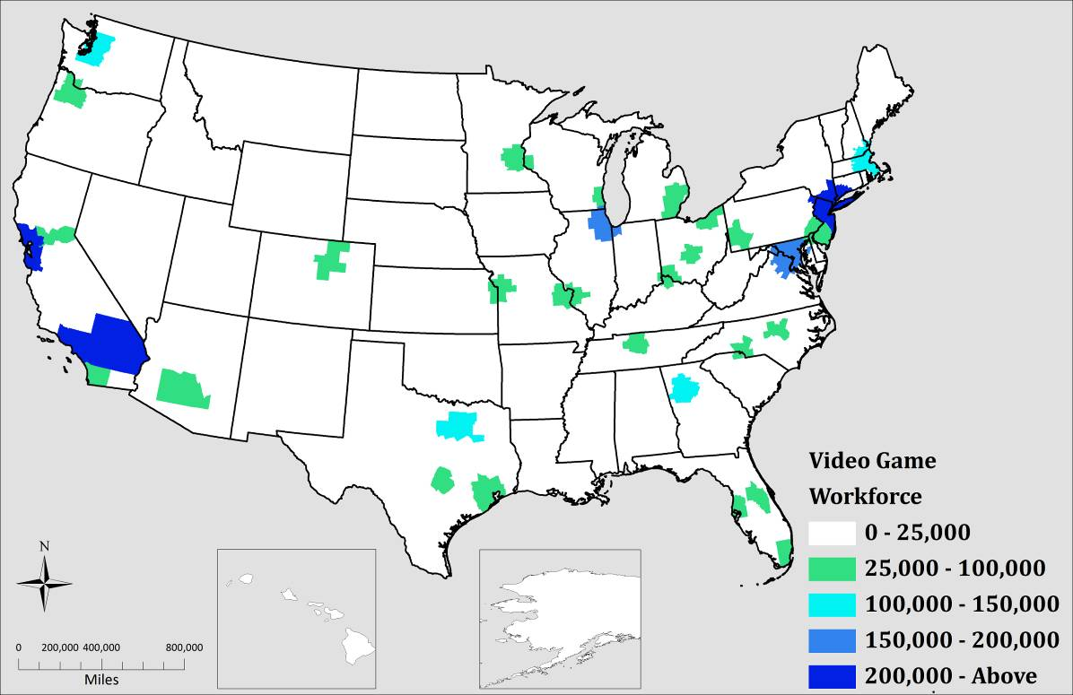
Source: American Community Survey, 2006-2008 Public Use Microdata

There is a skew in this concentration because the highest concentrations of these core occupations represent some of the most highly populated areas in the United States. As mentioned before, the location quotient of major metropolitan areas looks to see if core occupations are significant within these locales. The results of the location quotient are in Figure 4. The darker shades of blue represent metropolitan areas of significance that already has or could potentially have a concentration of a video game workforce. Just looking at Figure 3, many more states and regions across the country have can have a high location quotient of 1.50 or higher. In the Eastern seaboard, Massachusetts, North Carolina, and Maryland including parts of Virginia and Delaware have high concentrations of its workforce in core occupations. In the Central part of the U.S, Central Texas, Colorado, Minnesota, Illinois, and New Mexico are also areas shown to have core video game occupations. On the West Coast, the two highest concentrations of the video game workforce are in Washington and Northern California.
Figure 4: Location Ratio of the Video Game Workforce in the United States, ACS 2006-2008
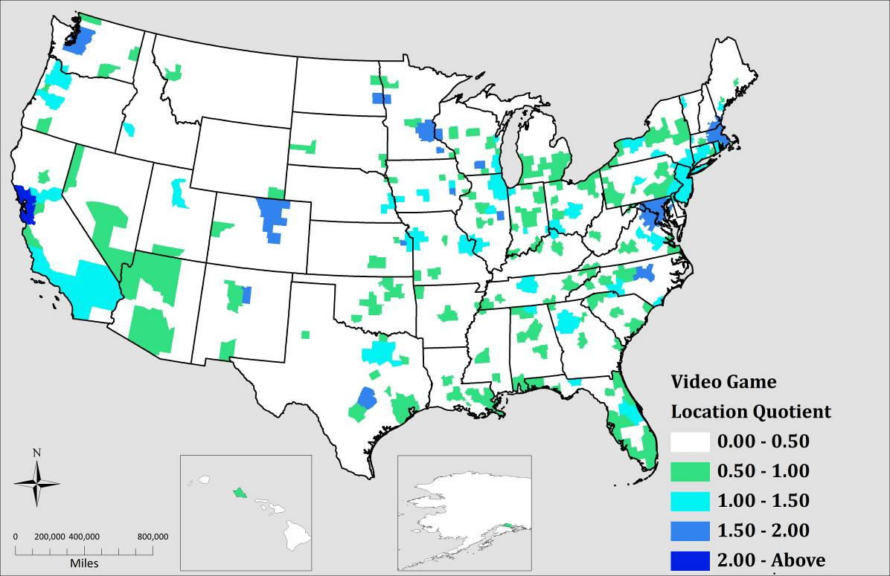
Source: American Community Survey, 2006-2008 Public Use Microdata

In looking at the highest overall location quotient of metropolitan areas, one or more of the four categories of audio, design, production, and programming is more concentrated than the others as seen in table 16. All of the top 15 metro areas except for Santa Fe, NM all have strong programming occupations in their workforce. The San Francisco metropolitan area has highs concentrations of design, production, and programming workforce but has weak audio occupations. San Francisco ranks as one of the highest because of its dense concentration of computer programming related occupations. Two of the smaller metropolitan areas, Iowa City, IA and Santa Fe, NM both show a strong concentration in all four categories particularly in audio and design respectfully. The Boston, MA metro region has a strong specialty in production and programming occupations, but shows weaknesses in the arts, particularly in audio or musical occupations.
Table 16: Ratio of Video Game Workforce in Metropolitan Regions, 2006-2008 (continued on next page)
RANK | METROPOLITIAN AREA | AUDIO | DESIGN | PRODUCTION | PROGRAMMING | OVERALL
1 | San Francisco-Oakland-San Jose, CA | 1.03 | 1.75 | 1.72 | 3.28 | 2.21
2 | Iowa City, IA | 1.83 | 2.01 | 1.56 | 2.13 | 1.90
3 | Santa Fe, NM | 1.58 | 3.19 | 1.31 | 1.36 | 1.88
4 | Austin-San Marcos, TX | 1.54 | 1.42 | 1.67 | 2.50 | 1.87
5 | Rochester, MN | 1.48 | 1.34 | 0.81 | 3.30 | 1.85
6 | Seattle-Tacoma-Bremerton, WA | 1.20 | 1.37 | 1.36 | 2.70 | 1.81
7 | Madison, WI | 0.96 | 1.46 | 1.69 | 2.31 | 1.79
8 | Lawrence, KS | 1.30 | 2.29 | 1.25 | 1.56 | 1.66
9 | Boston-Worcester-Lawrence, MA-NH-ME-CT | 0.89 | 1.17 | 1.53 | 2.31 | 1.65
10 | Raleigh-Durham-Chapel Hill, NC | 0.93 | 0.95 | 1.49 | 2.51 | 1.64
11 | Minneapolis-St. Paul, MN-WI | 1.19 | 1.40 | 1.65 | 1.84 | 1.61
12 | Denver-Boulder-Greeley, CO | 0.83 | 1.39 | 1.40 | 2.07 | 1.58
13 | Washington-Baltimore, DC-MD-VA-WV | 1.12 | 1.06 | 1.35 | 2.28 | 1.57
14 | Fort Collins-Loveland, CO | 0.99 | 1.34 | 1.14 | 2.19 | 1.54
15 | Champaign-Urbana, IL | 1.08 | 1.30 | 1.31 | 2.05 | 1.54
Source: U.S. Census, American Community Survey, 2006-2008 PUMS

5.10 Looking at Trends of the Core Video Game Occupations over Time
In 2000, according to PUMS data from the U.S Census, the largest workforce for the video game industry was in the San Francisco-San Jose Metropolitan area from the examination of Location Quotient shown in Table 17. The spectrum of geographic regions in 2000 ranges from large metropolitan areas like San Francisco, CA Washington-Baltimore, Boston, MA, Denver, CO, and Atlanta, GA to smaller metropolitan areas like Rochester, MN, Provo Orem, UT, and Santa Fe, NM. These trends also show a general decline in the overall potential video game workforce.
Comparing the 2000 PUMs to the more recent data, the 2006-2008 data shows a majority of the metropolitan regions from 2000 are still present today. The San Francisco metro area is still a dominant area with the most current released data. In addition, larger areas like San Francisco, Boston, Seattle, Austin, Minneapolis, and Denver have dense concentrations of high-technology industries.
The major metropolitan areas have seen declines in occupations for the video game industry. The largest metropolitan decline in regional specialization, were the Fort Collins-Loveland, CO area, with a 17% drop and Raleigh-Durham-Chapel Hill, NC with a 16% slump in its workforce. The highest increases were in the smaller metropolitan regions, Iowa City, IA growing 56% and Lawrence, KS growing 44% respectively.
As shown in the previously shown in table 16, many of the regions are highly specialized in computer programming. The United States in the past decade for various reasons has seen a general decline in the Information Technology industry, which includes computer programming and engineering (Thibodeau 2011).
Table 17: The Top 15 Metropolitan Areas for Video Game Occupations Ranked By Current Location Quotient
RANK |  | METROPOLITAN AREAS | LOCATION QUOTIENT |  |  | WORKFORCE
Present | Past | METROPOLITAN AREAS | 2006-2008 | 2000 | Change | 2006-2008 | 2000 | Change
1 | 1 | San Francisco-Oakland-San Jose, CA | 2.21 | 2.28 | -2.99% | 226,252 | 255,135 | -11.32%
2 | 181 | Iowa City, IA | 1.90 | 1.21 | 56.61% | 3,390 | 2,092 | 62.05%
3 | 10 | Santa Fe, NM | 1.88 | 1.62 | 16.17% | 4,298 | 3,828 | 12.28%
4 | 3 | Austin-San Marcos, TX | 1.87 | 1.97 | -4.88% | 43,949 | 41,154 | 6.79%
5 | 2 | Rochester, MN | 1.85 | 2.06 | -10.25% | 3,660 | 4,009 | -8.71%
6 | 11 | Seattle-Tacoma-Bremerton, WA | 1.81 | 1.59 | 13.76% | 102,258 | 92,460 | 10.60%
7 | 7 | Madison, WI | 1.79 | 1.69 | 5.50% | 12,059 | 11,559 | 4.33%
8 | 171 | Lawrence, KS | 1.66 | 1.15 | 44.23% | 3,391 | 2,298 | 47.56%
9 | 8 | Boston-Worcester-Lawrence, MA-NH-ME-CT | 1.65 | 1.69 | -2.68% | 142,825 | 159,390 | -10.39%
10 | 4 | Raleigh-Durham-Chapel Hill, NC | 1.64 | 1.96 | -16.32% | 34,596 | 36,858 | -6.14%
11 | 12 | Minneapolis-St. Paul, MN-WI | 1.61 | 1.51 | 6.72% | 80,511 | 78,368 | 2.73%
12 | 6 | Denver-Boulder-Greeley, CO | 1.58 | 1.70 | -6.73% | 66,288 | 69,929 | -5.21%
13 | 9 | Washington-Baltimore, DC-MD-VA-WV | 1.57 | 1.63 | -4.17% | 190,714 | 204,642 | -6.81%
14 | 75 | Fort Collins-Loveland, CO | 1.54 | 1.94 | -20.34% | 6,005 | 7,243 | -17.09%
15 | 13 | Champaign-Urbana, IL | 1.54 | 1.55 | -0.37% | 4,205 | 4,456 | -5.63%
Source: U.S Census 2000 Public Use Microdata, American Community Survey, 2006-2008 Public Use Microdata

5.11 Methodology of Locating Video Game Companies across the United States
Research has realized the importance of examining a region by their occupations and the types of industries within that region (Florida 2002; Koo 2005). The importance of locating industries with occupational data gives more validity to identifying regions where the video game labor force is located. The sample of video game companies is from the collection of membership data from the trade associations, International Game Developers Association and The Entertainment Software Association. Additional companies are also from the business database Corptech and ReferenceUSA. This list produced 153 companies across the United States. This list grossly underestimates the number of video game related companies within the United States. Even with this small list of companies, the intent of this was to see if these occupations co-located with these listed companies.

5.12 Spatial Analysis Comparing Video Game Businesses & Workforce Locations
With the calculation of the location quotient for metropolitan regions, it will be interesting to see how it compares to video game development companies. The location of the video game workforce compared with the location of video game businesses is in Figure 5. A significant concentration of video game companies is located in the San Francisco metropolitan area and in the Los Angeles area. Large concentrations are also near Austin, TX, Seattle, WA Chicago, IL and Boston, MA metropolitan areas. This looks to be true of the workforce. The denser areas, except for the Atlanta region, have a large concentration of companies along with the workforce, and this is to be expected. Many other clusters of businesses are throughout the country; areas in North Carolina and Virginia have a large density of businesses but not a large workforce. With this limitation, a location quotient looks to see more regions that could support video game companies.
Figure 5 Comparing Location of Video Game Workforce and Companies in the United States
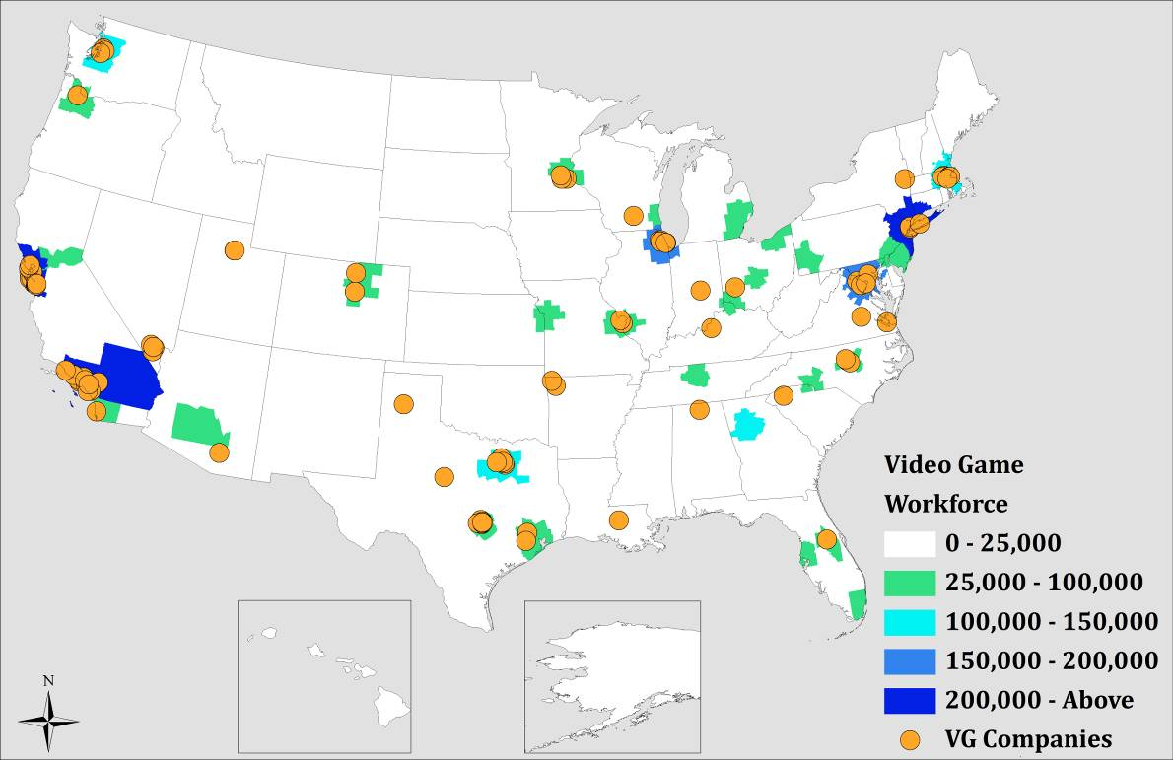
Source: U.S Census, American Community Survey 2006-2008 PUMS, Corptech, ReferenceUSA, International Game Developers Association, and The Entertainment Software Association

5.13 Comparing Location of Video Game Companies to the Location Quotient
Focusing solely on the number of people within a given workforce does not tell the entire story. As seen in Figure 6, a number of businesses were located in areas that did not have a large workforce. Thus, a location quotient or ratio was used to see whether those regions’ local workforce is specialized enough to qualify for video game companies. The various shades of blue represent areas of 1.25 or greater where the selected clusters are a large component of the economy of that region. This expands the number of metropolitan regions who have a density of video game companies with the ratio of the number of workers within that area. For example Seattle, as mentioned in interviews, has a large video game presence. Although the workforce of the area is relatively small, the ratio of the number of workers within that area is relatively high and significant. This is also true for areas in and around New York City, NY Denver, CO, Raleigh-Durham, NC, and Minneapolis, MN.
A larger number of smaller metropolitan areas have a significant workforce but for this examination, comparing the selected businesses showed no businesses within that area. For example, Atlanta, GA has both a large workforce and a location quotient that shows these clusters are significant within the area. That is not to say these smaller metropolitan regions and Atlanta, GA do not have any video game companies at all; this is to show a small sample size of businesses relative to the validity of the location quotient.
Figure 6: Comparing Video Game Company Location to the Ratio of the Workforce
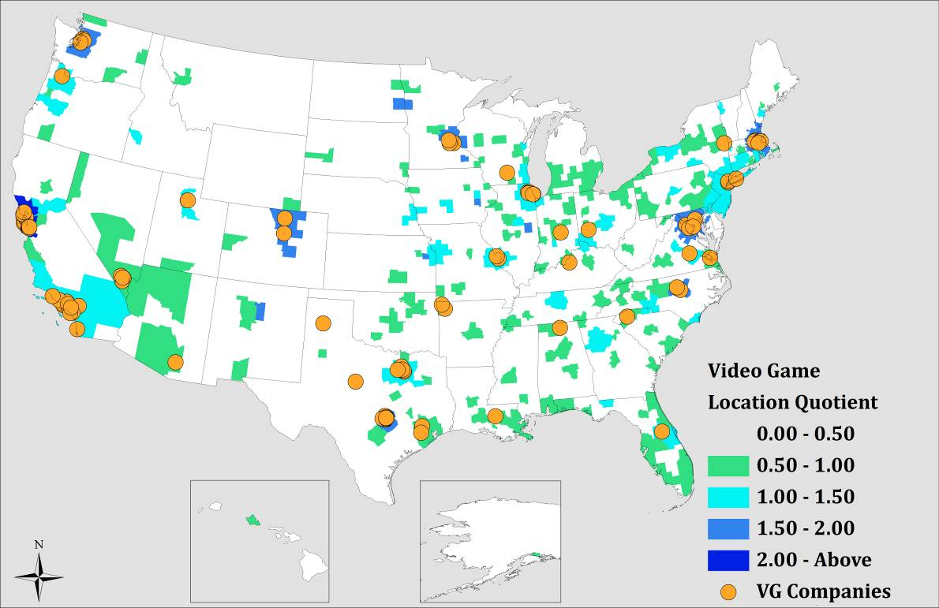
Source: U.S. Census, American Community Survey 2006-2008 PUMS, Corptech, ReferenceUSA, International Game Developers Association, and The Entertainment Software Association

5.14 Analysis
The use of occupational data to locate significant video game regions appears to match with the interviews of industry experts. These individuals identified the following regions they felt were influential locations for video game businesses:
- Austin, TX
- Boston, MA
- Los Angeles, CA
- New York City, NY
- San Francisco, CA
- Seattle, WA

The locations mentioned by these experts acknowledged a close relationship between the high-technology industries and video game clusters. Steve Jobs, for example, co-founder and CEO of Apple Inc, in his earlier career in the 1970’s, worked for the legendary video game company Atari. Historically, many video game companies come through experienced individuals working for programming and software engineering companies. Early video games come through programmers or hackers who modified video game codes to produce their own video games in their own homes. The history of many of the founders of popular video game titles had their humble origins from large software and engineering firms in these areas. It is, then, of no surprise that they like to remain in those areas where they consider home.
The occupational data also suggests that some smaller metropolitan regions possess the capacity to play host to a concentration of video game companies by having the raw talent in the labor force. The smaller metropolitan areas with a high location quotient but an obvious smaller workforce compared to the larger metropolitan regions have well established and recognized universities. Iowa City, IA, for example, is home to the University of Iowa while the University of Wisconsin is located in Madison, WI and the University of Kansas is located in Lawrence, KS. IBM and the Mayo Clinic, a renowned healthcare organization, both have major business operations in Rochester, MN. The Santa Fe, NM region is located near two of the nation’s prominent federal research laboratories, the Sandia National Laboratories and Los Alamos National Laboratory.
The data points to smaller regions that have a number of large universities as an anchor for businesses within that particular region. Future research into video games may want to examine the relationship into the development of video games as associated to colleges and universities. Remember, one of the first published video games came not through a company but through the hallways of the Massachusetts Institute of Technology. With a history of the development of video games, these regions with high location quotients could possibly become centers for video game businesses.

CHAPTER 6

CONCLUSION

6.1 Summary
The video game industry is a multifaceted industry, collecting a number of different talents and skills that ultimately produce a product for public consumption. This industry is heavily rooted in the knowledge of computer and technology related material. From this research, the video game industry also includes talented individuals in business and from the audio and visual arts. Since this industry has a diverse workforce, this research has shown communication when working in a teamwork environment is important to be successful in the video game business. Also self-learning, the ability to teach yourself new and innovative technologies is important to solve complex problems within the industry.
Self-learning and working as a team aligns closely with traditional high-tech regions within metropolitan areas. From this research’s spatial analysis, much of the workforce is in traditional high-tech regions within the United States. The potential video game workforce relates closely to colleges, universities, and research facilities that have a strong foundation in the arts and sciences.

6.2 Policy Implications
Massachusetts, as seen in the research, possesses the capacity to handle the needs of labor for video game businesses. The state has excellent institutions that have a focus on one or more of the clusters identified for the production of a video game. For its size relative to other areas, like California, Texas, and New York, Massachusetts, particularly the Boston Metro region has the capacity to compete with other regions. These regions have a high propensity to have a concentration of high-tech occupations such as engineering and computer programming (Saxenian 1986; Saxenian 2002; Bresnahan and Gambardella 2004). Even with this concentration of high-tech businesses and college students, local media has reported ‘brain drain’ across the Commonwealth of Massachusetts (Witkowski 2005; Reed 2006; Cramer 2007; Lee 2011). The loss of a workforce and of video game enterprises to other regions is why Massachusetts will be establishing a Video Game Institute in Worcester, MA, housed within Becker College (Dayal 2010).
The collection of O*NET data, with a spatial analysis of the video game industry, gives policy makers in Massachusetts an opportunity to continue to foster and develop their industry. Looking at the results from O*NET, there is a need to train a potential labor force who is interested with working in the video game industry with computer skills. This is through workforce training in our colleges and universities. What the O*NET data also recognizes, as do industry experts, is the importance of interpersonal skills and communication as an important trait among its workforce. This realization also forms the foundation that the strength of this workforce is in the need for it to communicate within its widely diverse and skilled workforce. As this business has some similarities with the film and software industries, it is essential the future workforce can be able to communicate with these different roles.
Workforce development programs can focus on basic computer skills for participants interested in the field of video games. Video game platforms are ever changing in this competitive market. Not only should universities teach basic computer skills but also foundations and techniques to have the future of the workforce to self-teach themselves the new and upcoming technologies.

6.2 Place Based Initiatives
The Entertainment Software Association pointed out a vast majority of the population has played at least one video game in their lifetime. What Massachusetts has seen a lack of until recently is fostering the culture of video games. It was not until recently that the Penny Arcade Expo (PAX) selected Massachusetts as its first East Coast video game convention location. The Video Game Orchestra has also begun to perform yearly in the Boston area and will be playing alongside the Boston Pops. This recognition of Boston is not only important for the tourism in the area but gives policy makers an opportunity to connect a talented labor force with potential companies or even foster start-ups though the interactions of these individuals.
The recent success of the Penny Arcade Expo underscores the importance of the video game culture in the State. Apart from various tax incentives which some researchers question its effectiveness (Buss 2001; Gurley-Calvez, Gilbert et al. 2009; Hanson and Rohlin 2011), Massachusetts should look for more creative solutions to attain venues for this creative talent pool to come together to express ideas. Conventions are only events that happen yearly and each of the major video game hubs has one or more video game conventions in their city. Even though PAX East has signed a multi-year contract to have their video game expo held in Boston, they have the opportunity to move to other East Coast areas like New York City (Bray 2011).
Richard Florida’s work popularized place-based initiatives to attract and retain a population within a region. Massachusetts should look for alternative solutions to connect its talented labor pool together. Other cities have innovative economic development programs apart from conventions to attract the talented labor pool together. The Seattle Storefront Program, designed to fill its vacant storefronts in its downtown area, allowed for the temporary establishment of the Seattle Pinball Museum. The pinball museum displayed a variety of refurbished pinball machines visitors could play for six months within the downtown area. The Museum of Art and Digital Entertainment, a project currently underway in the San Francisco area, will be an interactive video game museum. In the University of Texas at Austin, The UT Videogame Archive, has documented and preserved various artifacts of the video game industry. They have displayed their work to the public, with a focus on Austin’s contributions to the industry. In Washington DC, The Smithsonian American Art Museum in 2012 will feature The Art of Video Games, an exhibition of 40 years of art within the industry. These creative outlets not only inform the public on the evolution of a video game but also display that region’s strength as a center for video game industries. Massachusetts also needs to find not only policy and relevant incentive solutions for the industry, but also locations and venues that inform the public of its regions contribution to the industry and determine locations where future video game workers can come together.

APPENDIX A

SELECTED O*NET DEFINITIONS
Definitions of Abilities
Written Comprehension — The ability to read and understand information and ideas presented in writing.

Oral Comprehension — The ability to listen to and understand information and ideas presented through spoken words and sentences.

Oral Expression — The ability to communicate information and ideas in speaking so others will understand.

Problem Sensitivity — The ability to tell when something is wrong or is likely to go wrong. It does not involve solving the problem, only recognizing there is a problem.

Near Vision — The ability to see details at close range (within a few feet of the observer).

Speech Clarity — The ability to speak clearly so others can understand you.

Fluency of Ideas — The ability to come up with a number of ideas about a topic (the number of ideas is important, not their quality, correctness, or creativity).

Originality — The ability to come up with unusual or clever ideas about a given topic or situation, or to develop creative ways to solve a problem.

Speech Recognition — The ability to identify and understand the speech of another person.

Inductive Reasoning — The ability to combine pieces of information to form general rules or conclusions (includes finding a relationship among seemingly unrelated events).

Information Ordering — The ability to arrange things or actions in a certain order or pattern according to a specific rule or set of rules (e.g., patterns of numbers, letters, words, pictures, mathematical operations).

Written Expression — The ability to communicate information and ideas in writing so others will understand.

Deductive Reasoning — The ability to apply general rules to specific problems to produce answers that make sense.

Arm-Hand Steadiness — The ability to keep your hand and arm steady while moving your arm or while holding your arm and hand in one position.

Hearing Sensitivity — The ability to detect or tell the differences between sounds that vary in pitch and loudness.

Memorization — The ability to remember information such as words, numbers, pictures, and procedures.

Visualization — The ability to imagine how something will look after it is moved around or when its parts are moved or rearranged.

Definitions of Knowledge’s
Computers and Electronics — Knowledge of circuit boards, processors, chips, electronic equipment, and computer hardware and software, including applications and programming.

English Language — Knowledge of the structure and content of the English language including the meaning and spelling of words, rules of composition, and grammar.

Administration and Management — Knowledge of business and management principles involved in strategic planning, resource allocation, human resources modeling, leadership technique, production methods, and coordination of people and resources.

Communications and Media — Knowledge of media production, communication, and dissemination techniques and methods. This includes alternative ways to inform and entertain via written, oral, and visual media.

Customer and Personal Service — Knowledge of principles and processes for providing customer and personal services. This includes customer needs assessment, meeting quality standards for services, and evaluation of customer satisfaction.

Fine Arts — Knowledge of the theory and techniques required to compose, produce, and perform works of music, dance, visual arts, drama, and sculpture.

Sales and Marketing — Knowledge of principles and methods for showing, promoting, and selling products or services. This includes marketing strategy and tactics, product demonstration, sales techniques, and sales control systems.

Telecommunications — Knowledge of transmission, broadcasting, switching, control, and operation of telecommunications systems.

Clerical — Knowledge of administrative and clerical procedures and systems such as word processing, managing files and records, stenography and transcription, designing forms, and other office procedures and terminology.

Economics and Accounting — Knowledge of economic and accounting principles and practices, the financial markets, banking and the analysis and reporting of financial data.

Law and Government — Knowledge of laws, legal codes, court procedures, precedents, government regulations, executive orders, agency rules, and the democratic political process.

Personnel and Human Resources — Knowledge of principles and procedures for personnel recruitment, selection, training, compensation and benefits, labor relations and negotiation, and personnel information systems.

Production and Processing — Knowledge of raw materials, production processes, quality control, costs, and other techniques for maximizing the effective manufacture and distribution of goods.

Design — Knowledge of design techniques, tools, and principles involved in production of precision technical plans, blueprints, drawings, and models.

Education and Training — Knowledge of principles and methods for curriculum and training design, teaching and instruction for individuals and groups, and the measurement of training effects.

Engineering and Technology — Knowledge of the practical application of engineering science and technology. This includes applying principles, techniques, procedures, and equipment to the design and production of various goods and services.

Mathematics — Knowledge of arithmetic, algebra, geometry, calculus, statistics, and their applications.
Definitions of Skills
Active Learning — Understanding the implications of new information for both current and future problem-solving and decision-making.

Active Listening — Giving full attention to what other people are saying, taking time to understand the points being made, asking questions as appropriate, and not interrupting at inappropriate times.

Critical Thinking — Using logic and reasoning to identify the strengths and weaknesses of alternative solutions, conclusions or approaches to problems.

Reading Comprehension — Understanding written sentences and paragraphs in work related documents.

Judgment and Decision Making — Considering the relative costs and benefits of potential actions to choose the most appropriate one.

Speaking — Talking to others to convey information effectively.

Complex Problem Solving — Identifying complex problems and reviewing related information to develop and evaluate options and implement solutions.

Management of Personnel Resources — Motivating, developing, and directing people as they work, identifying the best people for the job.

Management of Financial Resources — Determining how money will be spent to get the work done, and accounting for these expenditures.

Coordination — Adjusting actions in relation to others' actions.

Social Perceptiveness — Being aware of others' reactions and understanding why they react as they do.

Systems Analysis — Determining how a system should work and how changes in conditions, operations, and the environment will affect outcomes.

Systems Evaluation — Identifying measures or indicators of system performance and the actions needed to improve or correct performance, relative to the goals of the system.

Writing — Communicating effectively in writing as appropriate for the needs of the audience.

Monitoring — Monitoring/Assessing performance of yourself, other individuals, or organizations to make improvements or take corrective action.

Negotiation — Bringing others together and trying to reconcile differences.

Persuasion — Persuading others to change their minds or behavior.

Service Orientation — Actively looking for ways to help people.

Time Management — Managing one's own time and the time of others.

Instructing — Teaching others how to do something.

Operations Analysis — Analyzing needs and product requirements to create a design.

Programming — Writing computer programs for various purposes.

Definitions of Work Activities
Communicating with Supervisors, Peers, or Subordinates — Providing information to supervisors, co-workers, and subordinates by telephone, in written form, e-mail, or in person.

Establishing and Maintaining Interpersonal Relationships — Developing constructive and cooperative working relationships with others, and maintaining them over time.

Getting Information — Observing, receiving, and otherwise obtaining information from all relevant sources.

Interacting With Computers — Using computers and computer systems (including hardware and software) to program, write software, set up functions, enter data, or process information.

Making Decisions and Solving Problems — Analyzing information and evaluating results to choose the best solution and solve problems.

Organizing, Planning, and Prioritizing Work — Developing specific goals and plans to prioritize, organize, and accomplish your work.

Processing Information — Compiling, coding, categorizing, calculating, tabulating, auditing, or verifying information or data.

Scheduling Work and Activities — Scheduling events, programs, and activities, as well as the work of others.

Thinking Creatively — Developing, designing, or creating new applications, ideas, relationships, systems, or products, including artistic contributions.

Updating and Using Relevant Knowledge — Keeping up-to-date technically and applying new knowledge to your job.

Coaching and Developing Others — Identifying the developmental needs of others and coaching, mentoring, or otherwise helping others to improve their knowledge or skills.

Analyzing Data or Information — Identifying the underlying principles, reasons, or facts of information by breaking down information or data into separate parts.

Monitor Processes, Materials, or Surroundings — Monitoring and reviewing information from materials, events, or the environment, to detect or assess problems.

Developing and Building Teams — Encouraging and building mutual trust, respect, and cooperation among team members.

Documenting/Recording Information — Entering, transcribing, recording, storing, or maintaining information in written or electronic/magnetic form.

Communicating with Persons Outside Organization — Communicating with people outside the organization, representing the organization to customers, the public, government, and other external sources. This information can be exchanged in person, in writing, or by telephone or e-mail.
Interpreting the Meaning of Information for Others — Translating or explaining what information means and how it can be used.

Developing Objectives and Strategies — Establishing long-range objectives and specifying the strategies and actions to achieve them.

Guiding, Directing, and Motivating Subordinates — Providing guidance and direction to subordinates, including setting performance standards and monitoring performance.

Performing for or Working Directly with the Public — Performing for people or dealing directly with the public. This includes serving customers in restaurants and stores, and receiving clients or guests.

Resolving Conflicts and Negotiating with Others — Handling complaints, settling disputes, and resolving grievances and conflicts, or otherwise negotiating with others.

Selling or Influencing Others — Convincing others to buy merchandise/goods or to otherwise change their minds or actions.

Staffing Organizational Units — Recruiting, interviewing, selecting, hiring, and promoting employees in an organization.

Training and Teaching Others — Identifying the educational needs of others, developing formal educational or training programs or classes, and teaching or instructing others.

Provide Consultation and Advice to Others — Providing guidance and expert advice to management or other groups on technical, systems-, or process-related topics.

Coordinating the Work and Activities of Others — Getting members of a group to work together to accomplish tasks.

Evaluating Information to Determine Compliance with Standards — Using relevant information and individual judgment to determine whether events or processes comply with laws, regulations, or standards.

Performing Administrative Activities — Performing day-to-day administrative tasks such as maintaining information files and processing paperwork.

Identifying Objects, Actions, and Events — Identifying information by categorizing, estimating, recognizing differences or similarities, and detecting changes in circumstances or events.

Inspecting Equipment, Structures, or Material — Inspecting equipment, structures, or materials to identify the cause of errors or other problems or defects.

APPENDIX B

CREATED MAPS
Figure 7: Massachusetts In-Flow Migration
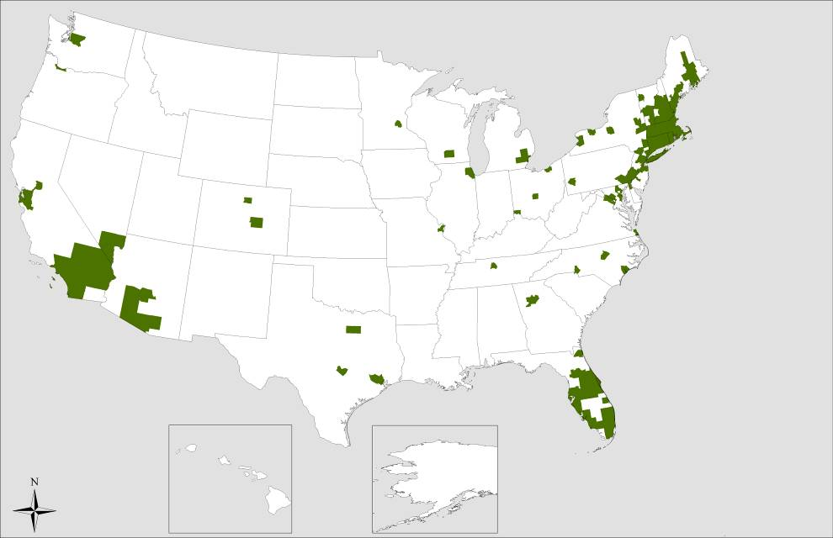
Source: Internal Revenue Service, Statistics of Income Division, U.S. Population Migration Data, 2007-2008
Figure 8: Massachusetts Out-Flow Migration
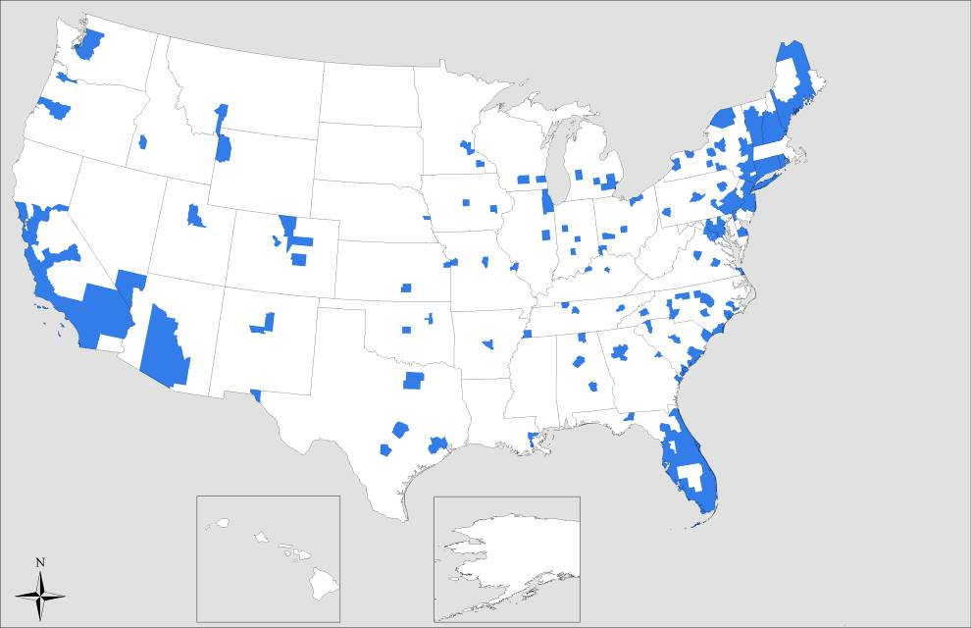
Source: Internal Revenue Service, Statistics of Income Division, U.S. Population Migration Data, 2007-2008
Figure 9: Number of Audio Workers in the United States, 2006-2008
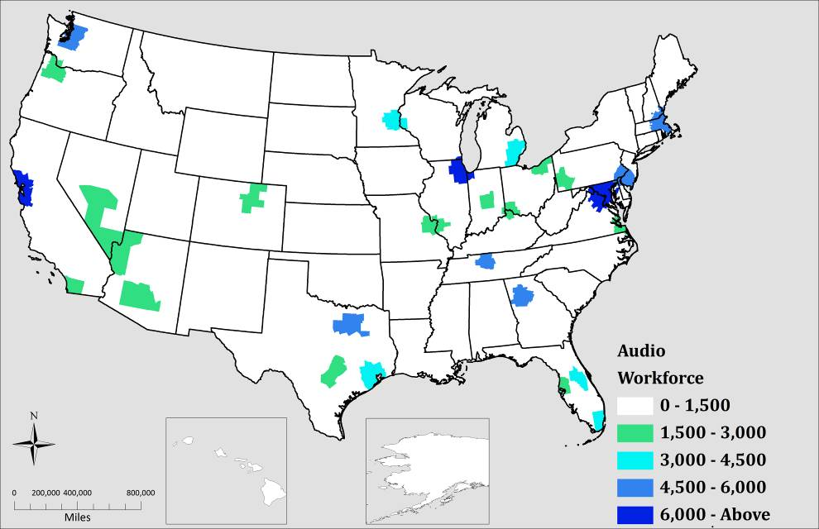
Source: American Community Survey, 2006-2008 Public Use Microdata
Figure 10: Location Quotient of Audio Workers in the United States, 2006-2008
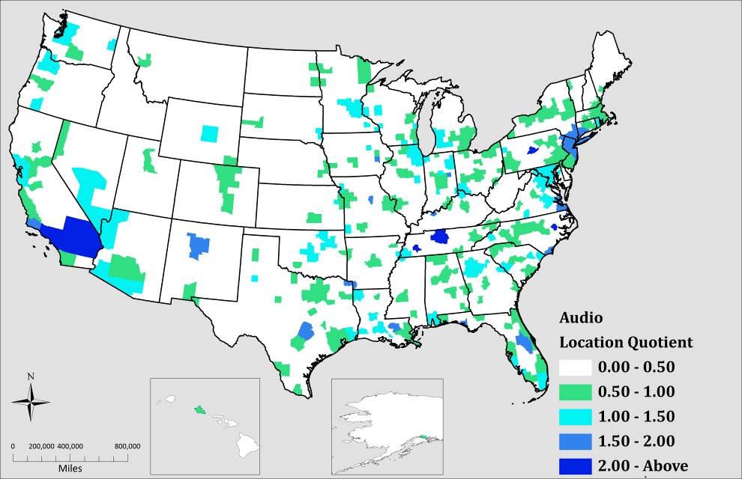
Source: American Community Survey, 2006-2008 Public Use Microdata

Figure 11: Number of Design Workers in the United States, 2006-2008
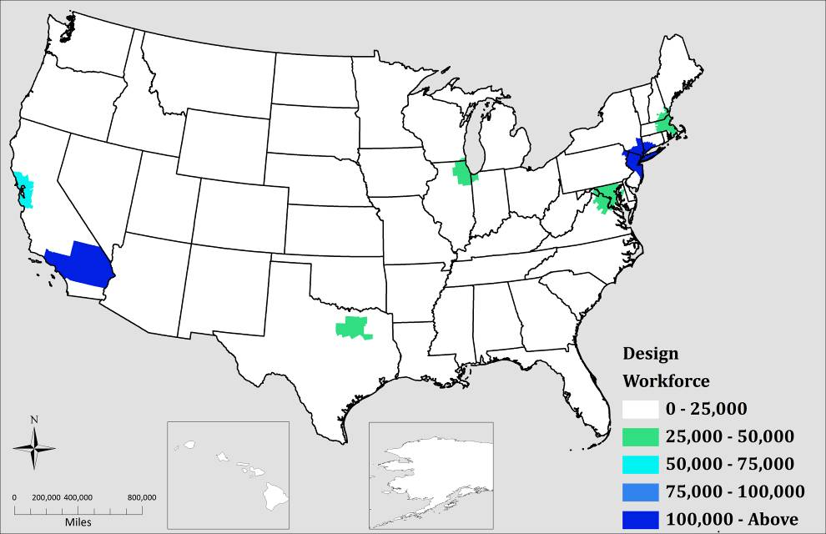
Source: American Community Survey, 2006-2008 Public Use Microdata

Figure 12: Location Quotient of Design Workers in the United States, 2006-2008
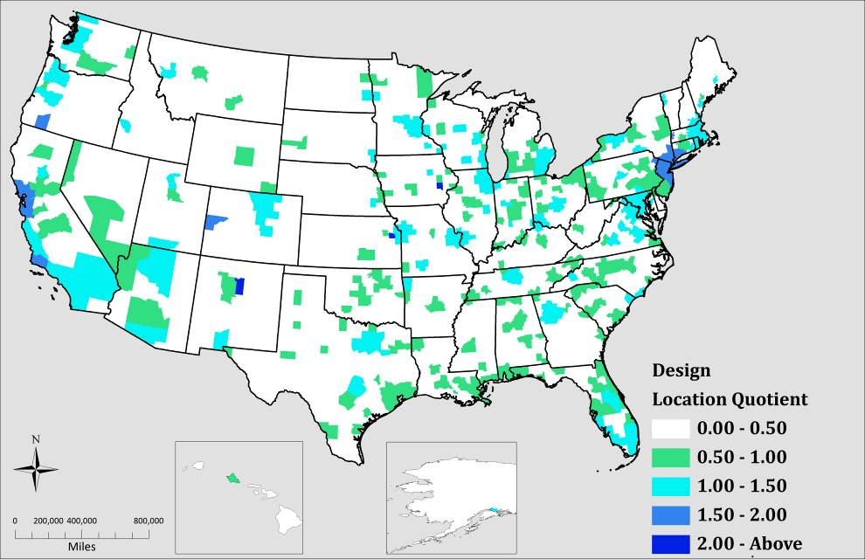
Source: American Community Survey, 2006-2008 Public Use Microdata

Figure 13: Number of Production Workers in the United States, 2006-2008
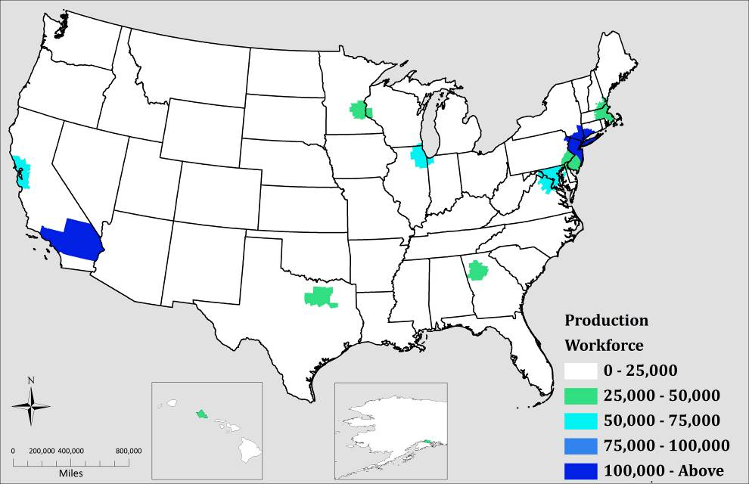
Source: American Community Survey, 2006-2008 Public Use Microdata

Figure 14: Location Quotient of Production Workers in the United States, 2006-2008
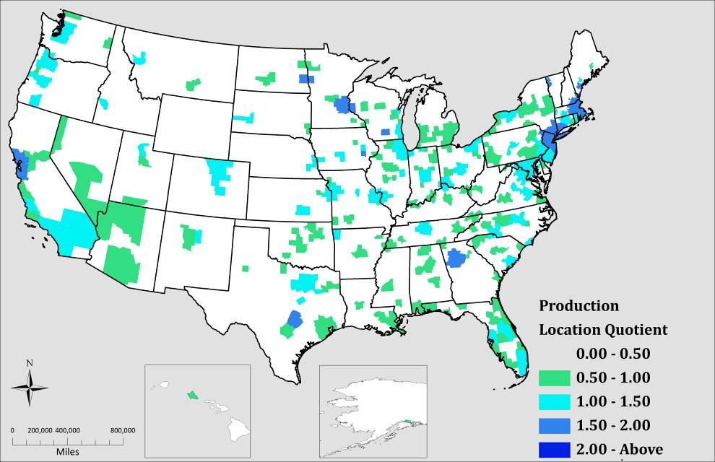
Source: American Community Survey, 2006-2008 Public Use Microdata

Figure 15: Number of Programming Workers in the United States, 2006-2008
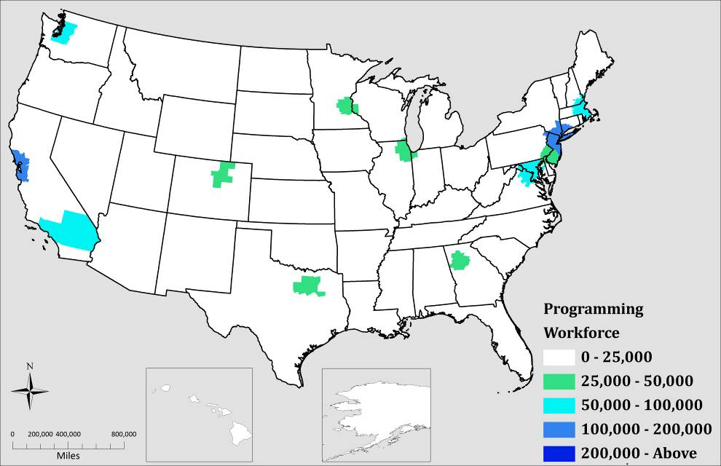
Source: American Community Survey, 2006-2008 Public Use Microdata
Figure 16: Location Quotient of Programming Workers in the United States, 2006-2008
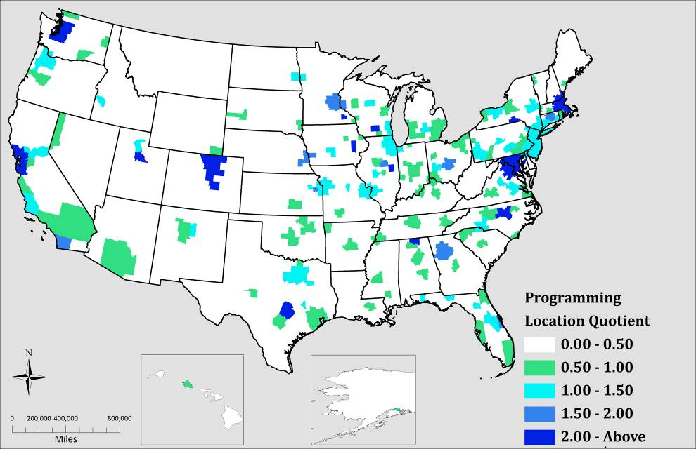
Source: American Community Survey, 2006-2008 Public Use Microdata
APPENDIX C

METROPOLITAN TABLES
Table 18: The Top 50 Overall Ratio of Video Game Occupations in U.S. Metropolitan Areas in 2006-2008
RANK | NAME | AUDIO | DESIGN | PRODUCTION | PROGRAMMING | OVERALL
1 | San Francisco-Oakland-San Jose, CA | 1.03 | 1.75 | 1.72 | 3.28 | 2.21
2 | Iowa City, IA | 1.83 | 2.01 | 1.56 | 2.13 | 1.90
3 | Santa Fe, NM | 1.58 | 3.19 | 1.31 | 1.36 | 1.88
4 | Austin-San Marcos, TX | 1.54 | 1.42 | 1.67 | 2.50 | 1.87
5 | Rochester, MN | 1.48 | 1.34 | 0.81 | 3.30 | 1.85
6 | Seattle-Tacoma-Bremerton, WA | 1.20 | 1.37 | 1.36 | 2.70 | 1.81
7 | Madison, WI | 0.96 | 1.46 | 1.69 | 2.31 | 1.79
8 | Lawrence, KS | 1.30 | 2.29 | 1.25 | 1.56 | 1.66
9 | Boston-Worcester- MA-NH-ME-CT | 0.89 | 1.17 | 1.53 | 2.31 | 1.65
10 | Raleigh-Durham-Chapel Hill, NC | 0.93 | 0.95 | 1.49 | 2.51 | 1.64
11 | Minneapolis-St. Paul, MN-WI | 1.19 | 1.40 | 1.65 | 1.84 | 1.61
12 | Denver-Boulder-Greeley, CO | 0.83 | 1.39 | 1.40 | 2.07 | 1.58
13 | Washington-Baltimore, DC-MD-VA-WV | 1.12 | 1.06 | 1.35 | 2.28 | 1.57
14 | Fort Collins-Loveland, CO | 0.99 | 1.34 | 1.14 | 2.19 | 1.54
15 | Champaign-Urbana, IL | 1.08 | 1.30 | 1.31 | 2.05 | 1.54
16 | Colorado Springs, CO | 0.95 | 1.36 | 1.00 | 2.19 | 1.50
17 | Fargo-Moorhead, ND-MN | 0.66 | 1.47 | 1.87 | 1.37 | 1.50
18 | State College, PA | 2.40 | 1.48 | 1.34 | 1.47 | 1.50
19 | New York-New Jersey NY-NJ-CT-PA | 1.56 | 1.56 | 1.53 | 1.18 | 1.42
20 | Atlanta, GA | 1.18 | 1.02 | 1.54 | 1.60 | 1.39
21 | Lincoln, NE | 0.80 | 1.38 | 1.18 | 1.63 | 1.36
22 | Huntsville, AL | 0.55 | 0.60 | 0.61 | 2.83 | 1.36
23 | Cedar Rapids, IA | 0.95 | 0.75 | 1.07 | 2.21 | 1.36
24 | Los Angeles-Orange County, CA | 2.62 | 1.50 | 1.47 | 0.84 | 1.34
25 | San Diego, CA | 0.95 | 1.28 | 1.20 | 1.58 | 1.33
26 | Portland-Salem, OR-WA | 1.14 | 1.47 | 1.26 | 1.30 | 1.32
27 | Provo-Orem, UT | 0.60 | 0.98 | 0.99 | 2.03 | 1.32
28 | Nashville, TN | 4.18 | 1.05 | 1.47 | 0.76 | 1.30
29 | Charlottesville, VA | 0.57 | 1.50 | 1.26 | 1.28 | 1.29
30 | Binghamton, NY | 0.41 | 1.26 | 0.58 | 2.12 | 1.29
31 | Columbus, OH | 0.60 | 1.13 | 1.20 | 1.63 | 1.28
32 | Dallas-Fort Worth, TX | 0.81 | 1.04 | 1.26 | 1.47 | 1.24
33 | Orlando, FL | 1.67 | 1.19 | 1.32 | 1.11 | 1.24
34 | Santa Barbara-Lompoc, CA | 1.66 | 1.61 | 0.98 | 1.02 | 1.22
35 | Omaha, NE--IA | 0.78 | 0.88 | 1.27 | 1.55 | 1.22
36 | Portland, ME | 0.73 | 1.20 | 1.68 | 0.86 | 1.20
37 | Burlington, VT | 0.94 | 1.15 | 1.51 | 1.00 | 1.20
38 | Hartford, CT | 0.85 | 0.85 | 1.18 | 1.50 | 1.17
39 | Rochester, NY | 1.00 | 1.04 | 1.07 | 1.41 | 1.17
40 | Kansas City, MO-KS | 0.75 | 1.07 | 1.10 | 1.38 | 1.16
41 | Salt Lake City-Ogden, UT | 0.57 | 1.14 | 1.20 | 1.25 | 1.15
42 | Chicago-Gary-Kenosha, IL-IN-WI | 1.04 | 1.12 | 1.27 | 1.07 | 1.14
43 | Bloomington-Normal, IL | 0.70 | 0.89 | 0.79 | 1.76 | 1.14
44 | San Luis Obispo-Paso Robles, CA | 0.82 | 1.42 | 1.01 | 1.08 | 1.14
45 | Des Moines, IA | 0.76 | 0.99 | 1.14 | 1.32 | 1.13
46 | Boise City, ID | 0.41 | 1.00 | 1.08 | 1.42 | 1.13
47 | Melbourne-Titusville-Palm Bay, FL | 0.98 | 0.76 | 0.76 | 1.75 | 1.11
48 | Philadelphia-Atlantic City, PA-NJ-DE-MD | 0.86 | 0.97 | 1.18 | 1.18 | 1.10
49 | St. Louis, MO-IL | 0.85 | 1.05 | 1.11 | 1.17 | 1.09
50 | Richmond--Petersburg, VA | 1.30 | 1.11 | 1.10 | 1.01 | 1.09
Source: American Community Survey, 2006-2008 Public Use Microdata
Table 19: Top 50 Overall Core Video Game Occupations in U.S. Metropolitan Regions, 2006-2008
NAME | Audio | Design | Production | Programming | Overall
New York-New Jersey NY-NJ-CT-PA | 33845 | 140489 | 148005 | 126234 | 448573
Los Angeles-Riverside-Orange County, CA | 45211 | 107055 | 113059 | 71143 | 336468
San Francisco-Oakland-San Jose, CA | 7237 | 51080 | 54118 | 113817 | 226252
Washington-Baltimore, DC-MD-VA-WV | 9398 | 36732 | 50577 | 94007 | 190714
Chicago-Gary-Kenosha, IL-IN-WI | 9768 | 43547 | 53265 | 49251 | 155831
Boston-Worcester MA-NH-ME-CT | 5317 | 28927 | 40695 | 67886 | 142825
Dallas-Fort Worth, TX | 5075 | 27054 | 35243 | 45474 | 112846
Seattle-Tacoma-Bremerton, WA | 4689 | 22184 | 23583 | 51802 | 102258
Atlanta, GA | 5909 | 21112 | 34338 | 39372 | 100731
Philadelphia-Wilmington PA-NJ-DE-MD | 5367 | 24931 | 32693 | 36272 | 99263
Minneapolis-St. Paul, MN-WI | 4085 | 19954 | 25254 | 31218 | 80511
Detroit-Ann Arbor-Flint, MI | 3905 | 23838 | 23333 | 24982 | 76058
Houston-Galveston-Brazoria, TX | 3916 | 20480 | 22398 | 22697 | 69491
Denver-Boulder-Greeley, CO | 2385 | 16581 | 17972 | 29350 | 66288
San Diego, CA | 2737 | 15350 | 15457 | 22557 | 56101
Miami-Fort Lauderdale, FL | 4435 | 17899 | 23125 | 10498 | 55957
Phoenix-Mesa, AZ | 2467 | 16138 | 17016 | 19642 | 55263
Portland-Salem, OR-WA | 2936 | 15747 | 14499 | 16519 | 49701
Austin-San Marcos, TX | 2494 | 9488 | 12051 | 19916 | 43949
St. Louis, MO-IL | 2251 | 11462 | 13069 | 15202 | 41984
Cleveland-Akron, OH | 2424 | 10666 | 13967 | 12153 | 39210
Tampa-St. Petersburg-Clearwater, FL | 2135 | 9982 | 12521 | 12764 | 37402
Orlando, FL | 3300 | 9759 | 11689 | 10798 | 35546
Raleigh-Durham-Chapel Hill, NC | 1348 | 5687 | 9648 | 17913 | 34596
Cincinnati-Hamilton, OH-KY-IN | 2281 | 9906 | 10882 | 9792 | 32861
Kansas City, MO-KS | 1445 | 8465 | 9442 | 13037 | 32389
Columbus, OH | 999 | 7851 | 8996 | 13459 | 31305
Pittsburgh, PA | 1810 | 7255 | 9259 | 11801 | 30125
Sacramento-Yolo, CA | 1353 | 7531 | 8029 | 13000 | 29913
Charlotte-Gastonia-Rock Hill, NC-SC | 1494 | 6497 | 10783 | 9396 | 28170
Milwaukee-Racine, WI | 1244 | 8258 | 8833 | 8463 | 26798
Nashville, TN | 5852 | 6068 | 9213 | 5226 | 26359
Indianapolis, IN | 1645 | 6952 | 8261 | 8076 | 24934
Salt Lake City-Ogden, UT | 837 | 6973 | 7907 | 9103 | 24820
Las Vegas, NV-AZ | 2828 | 7960 | 6897 | 4644 | 22329
San Antonio, TX | 1674 | 5722 | 6434 | 7015 | 20845
Norfolk-Newport News, VA-NC | 2668 | 6762 | 5469 | 5620 | 20519
Providence-Fall River-Warwick, RI-MA | 1415 | 6275 | 6103 | 5326 | 19119
Rochester, NY | 1103 | 4790 | 5280 | 7676 | 18849
West Palm Beach-Boca Raton, FL | 1206 | 5568 | 6378 | 4485 | 17637
Hartford, CT | 853 | 3508 | 5247 | 7409 | 17017
Richmond-Petersburg, VA | 1390 | 4916 | 5276 | 5328 | 16910
Omaha, NE--IA | 707 | 3300 | 5120 | 6885 | 16012
Greensboro-Winston-Salem- NC | 1327 | 5431 | 5600 | 3293 | 15651
Jacksonville, FL | 862 | 4262 | 4658 | 5619 | 15401
Oklahoma City, OK | 1235 | 3647 | 4731 | 5513 | 15126
Tucson, AZ | 1197 | 4431 | 3642 | 4738 | 14008
Grand Rapids-Muskegon-Holland, MI | 1188 | 4413 | 4796 | 3447 | 13844
Memphis, TN-AR-MS | 1422 | 2747 | 5264 | 4136 | 13569
Albany-Schenectady-Troy, NY | 861 | 3172 | 3197 | 6320 | 13550
Source: American Community Survey, 2006-2008 Public Use Microdata

BIBLIOGRAPHY

Association, E. S. (2010). Video Games In The 21st Century: The 2010 Report Economic Contributions of the US Entertainment Software Industry.

Barro, R. J. (1991). "Economic Growth in a Cross Section of Countries." The Quarterly Journal of Economics 106(2): 407-443.

Becker, G. S. (1965). "A Theory of the Allocation of Time." The Economic Journal 75(299): 493-517.

Beine, M., F. Docquier, et al. (2001). "Brain drain and economic growth: theory and evidence." Journal of Development Economics 64(1): 275-289.

BostInnovation (2010). MIT GAMBIT Game Lab Gearing Up to Find the Future of Gaming Again. K. Psaty, Pinyadda Media Network.

Bray, H. (2011). A move to help Boston level up. The Boston Globe. Boston.

Bresnahan, T. F. and A. Gambardella (2004). Building high-tech clusters : Silicon Valley and beyond. Cambridge; New York, Cambridge University Press.

Brown, R. H. (2010). "Game sector debates industry obstacles to growth in Massachusetts." Mass High Tech.

Brown, R. H. (2010). Harmonix confirms playable keyboard, guitars for Rock Band 3. Mass High Tech: The Voice of New England Innovation. Boston, MA, American City Business Journals.

Brown, R. H. (2010). "New England's video game cluster chipping away at challenges " Mass High Tech: The Voice of New England Innovation.

Brown, R. H. (2010). "PAX East to play in Boston longer, moving to BCEC." Mass High Tech: The Voice of New England Innovation.

Buss, T. F. (2001). "The Effect of State Tax Incentives on Economic Growth and Firm Location Decisions: An Overview of the Literature." Economic Development Quarterly 15(1): 90-105.

Caves, R. E. (2000). Creative industries : contracts between art and commerce. Cambridge, Mass.; London, Harvard University Press.

Chapple, K., A. Markusen, et al. (2004). "Gauging Metropolitan “High-Tech” and “I-Tech” Activity." Economic Development Quarterly 18(1): 10-29.

Cramer, M. (2007). "A little something to stick around." Boston Globe (Boston, MA).

Dayal, P. (2010). Video game pitch is win for Becker College may host new institute. Worcester Telegram & Gazette. Worcester, MA

Ducheneaut, N., N. Yee, et al. (2006). "Alone together?": exploring the social dynamics of massively multiplayer online games. Proceedings of the SIGCHI conference on Human Factors in computing systems. Montr\&\#233;al, Qu\&\#233;bec, Canada, ACM: 407-416.

Ellis, M., M. Reibel, et al. (1999). "Comparative Metropolitan Area Analysis: Matching the 1980 and 1990 Census Publis Use Microdata Samples for Metropolitan Areas." Urban Geography 20(1): 75-92.

Feser, E. J. (2003). "What Regions Do Rather than Make: A Proposed Set of Knowledge-based Occupation Clusters." Urban Studies 40(10): 1937-1958.

Florida, R. L. (2002). The rise of the creative class : and how it's transforming work, leisure, community and everyday life. New York, NY, Basic Books.

Florida, R. L. (2005). Cities and the creative class. New York, Routledge.

Gaudiosi, J. (2010). "Character traits: the current generation of CG game characters continue to push the state of the art.(Gaming)." Computer Graphics World 33(8-9): 8-9.

Glaeser, E. L. (1998). "Are Cities Dying?" The Journal of Economic Perspectives 12(2): 139-160.

Glasser, A. (2010). "8 Highest-Ranked Colleges for Game Design." Retrieved November 17, 2010, from http://www.gamepro.com/article/features/214164/8-highest-ranked-colleges-for-game-design/.

Gurley-Calvez, T., T. J. Gilbert, et al. (2009). "Do Tax Incentives Affect Investment?" Public Finance Review 37(4): 371-398.

Haddon, L. (1988). "Electronic and Computer Games: The History of an Interactive Medium."

Hall, P. (1998). Cities in civilization. New York, Pantheon Books.

Handel, M. J. (2009). The O*NET Content Model: Strengths And Limitations. Boston, Northeastern University. Submitted to the Review Panel of the Occupational Information Network (O*NET). National Academy of Science, Washington DC.

Hanson, A. and S. Rohlin (2011). "The Effect of Location-Based Tax Incentives on Establishment Location and Employment across Industry Sectors." Public Finance Review 39(2): 195-225.

Howkins, J. (2002). The creative economy : how people make money from ideas. London, Penguin.

Isard, W. (1960). Methods of regional analysis; an introduction to regional science. Cambridge, Published jointly by the Technology Press of the Massachusetts Institute of Technology and Wiley, New York.

Izushi, H. and Y. Aoyama (2006). "Industry evolution and cross-sectoral skill transfers: a comparative analysis of the video game industry in Japan, the United States, and the United Kingdom." Environment & Planning A 38(10): 1843-1861.

Jacobs, J. (1984). Cities and the wealth of nations : principles of economic life. New York, Random House.

Jaison, R. A. and M. G. Todd (2008). Human capital and economic activity in urban America, Federal Reserve Bank of New York.

Johns, J. (2006). "Video games production networks: value capture, power relations and embeddedness." Journal of Economic Geography 6(2): 151-180.

Kahn, J. P. (2010). Why Berklee is teaching its students to compose scores for video games. The Boston Globe. Cambridge, MA.

Kent, S. L. (2001). The ultimate history of video games : from Pong to Pokémon and beyond : the story behind the craze that touched our lives and changed the world. Roseville, Calif., Prima Pub.

Kerr, A. (2006). "The Business of Making Games." GameWork/Gameplay.

Koo, J. (2005). "How to Analyze the Regional Economy With Occupation Data." Economic Development Quarterly 19(4): 356-372.

LaViola Jr, J. J. (2008). "Bringing VR and spatial 3D interaction to the masses through video games." IEEE Comput Graphics Appl IEEE Computer Graphics and Applications 28(5): 10-15.

Lee, C. (2011). How to stop WMass "brain drain". 22News. Springfield, MA.

Lucas, R. E. (1988). "On the mechanics of economic development." Journal of Monetary Economics 22(1): 3-42.

Mankiw, N. G., D. Romer, et al. (1992). "A Contribution to the Empirics of Economic Growth." The Quarterly Journal of Economics 107(2): 407-437.

Markusen, A. (1996). "Sticky Places in Slippery Space: A Typology of Industrial Districts." Economic Geography 72(3): 293-313.

Markusen, A., D. King, et al. (2003). The artistic dividend : the arts' hidden contributions to regional development. Minneapolis, MN, Project on Regional and Industrial Economics, Humphrey Institute of Public Affairs, University of Minnesota.

Markusen, A. and G. Schrock (2006). "The Artistic Dividend: Urban Artistic Specialisation and Economic Development Implications." Urban Studies 43(10): 1661-1686.

Markusen, A., G. H. Wassall, et al. (2008). "Defining the creative economy: industry and occupational approaches.(Report)." Economic Development Quarterly 22(1): 24-45.

Mathur, V. K. (1999). "Human Capital-Based Strategy for Regional Economic Development." Economic Development Quarterly 13(3): 203-216.

Mattila, J. M. and W. R. Thompson (1955). "The Measurement of the Economic Base of the Metropolitan Area." Land Economics 31(3): 215-228.

Miyagiwa, K. (1991). "Scale Economies in Education and the Brain Drain Problem." International Economic Review 32(3): 743-759.

Mountford, A. (1997). "Can a brain drain be good for growth in the source economy?" Journal of Development Economics 53(2): 287-303.

Nolan, C., E. Morrison, et al. (2011). "Linking Industry and Occupation Clusters in Regional Economic Development." Economic Development Quarterly 25(1): 26-35.

Reed, K. (2006). "Plugging brain drain." Boston Globe (Boston, MA).

Reibel, M. (2007). "Geographic Information Systems and Spatial Data Processing in Demography: a Review." Population Research and Policy Review 26(5): 601-618.

Reibel, M. and A. Agrawal (2007). "Areal Interpolation of Population Counts Using Pre-classified Land Cover Data." Population Research and Policy Review 26(5): 619-633.

Reisinger, D. (2010) "Call of Duty: Black Ops hits $1 billion milestone." cnet news.

Saxenian, A. (1986). In search of power : the organization of business interests in Silicon Valley and Route 128. Cambridge, MA, Dept. of Political Science, Massachusetts Institute of Technology.

Saxenian, A. L. (2002). "Silicon Valley's new immigrant high-growth entrepreneurs." Economic Development Quarterly 16(1): 20-31.

Schultz, T. W. (1961). "Investment in Human Capital." The American Economic Review 51(1): 1-17.

Scott, A. J. and A. Mantegna (2009). "Human Capital Assets and Structures of Work in the US Metropolitan Hierarchy (An Analysis Based on the O*NET Information System)." International Regional Science Review 32(2): 173-194.

Simons, I. (2007). Inside Game Design. London, Laurence King Pub.

Siwek, S. (2010). Video Games in the 21st Century: The 2010 Report, Entertainment Software Association: 32.

Snider, M. (2010). A successful mission for ' Black Ops' ; Video game breaks records with $360 million in sales on first day. Usa Today. MONEY: 1B.

Soh, J. O. B. and B. C. Tan (2008). "Mobile Gaming." Communications of the ACM. 51(3): 35.

Stolarick, K., R. Florida, et al. (2005). "Montreal's Capacity for Creative Connectivity: Outlook & Opportunities." Working paper. Catalytix.

Thibodeau, P. (2011). "America's tech decline: A reading guide." Computerworld.

Thompson, W. R. and P. R. Thompson (1987). "National Industries and Local Occupational Strengths: The Cross-Hairs of Targeting." Urban Studies 24(6): 547-560.

Todd, M. G. (2009). "Knowledge And Earnings." Journal of Regional Science 49(3): 439-457.

Tschang, F. T. (2005). "Videogames As Interactive Experiential Products and Their manner of Development." International Journal of Innovation Management 09(01): 103-131.

Tschang, F. T. (2010). Hong Kong’s New Creative Industries: The Example of the Video Games Sector. Innovation Policy and the Limits of Laissez-faire: Hong Kong's Policy in Comparative Perspective. H. K. I. Project. Hong Kong.

Walker, R. A. (1985). "Is There a Service Economy? The Changing Capitalist Division of Labor." Science & Society 49(1): 42-83.

Wallace, R. (2010). Human Capital in the City: Exploring the Relationship Between Skill and Productivity in US Metropolitan Areas. Masters Theses. Paper 504.

Witkowski, T. (2005). "Outmigration 101: Can higher ed stem brain drain?" Boston Business Journal.

Wolf, M. J. P. and B. Perron (2003). The video game theory reader. New York; London, Routledge.

video game designers - 15-1099.13
See: http://www.onetonline.org/link/summary/15-1099.04
Refer to: http://www.census.gov/acs/www/data_documentation/public_use_microdata_sample
Refer to: http://www.census.gov/acs/www/data_documentation/public_use_microdata_sample
Taken from Steven Ruggles, J. Trent Alexander, Katie Genadek, Ronald Goeken, Matthew B. Schroeder, and Matthew Sobek. Integrated Public Use Microdata Series: Version 5.0 [Machine-readable database]. Minneapolis: University of Minnesota, 2010.
For more information see: http://www.census.gov/acs/www/guidance_for_data_users/comparing_data/
For a definition of statistical areas: http://www.census.gov/acs/www/data_documentation/custom_tabulation_request_form/msa_cmsa.html
A rule of thumb for location quotient is ratios above 1.25 or 1.50 reflect the potential for a strong workforce within that geographic region. Either ratio is at the discretion of the researcher. See the Massachusetts Department of Workforce Development Regional LMI Profile narrative http://lmi2.detma.org/lmi/pdf/profiles/Boston_Regional_Profile.pdf
The New York and Los Angeles metro areas ranked as the highest number of workers of video games, both regions were not listed because they did not have a high specialized workforce ratio.
See Milken Institute's Tech-Pole Index

