RECONNECTING TO LANDSCAPE:
AN EVALUATION OF THE POST HURRICANE COMMUNITIES OF BILOXI, MISSISSIPPI AND GALVESTON, TEXAS

A Thesis Presented
by
ELIZABETH ENGLEBRETSON

Submitted to the Graduate School of the
University of Massachusetts Amherst in partial fulfillment
of the requirements for the degree of

MASTER OF LANDSCAPE ARCHITECTURE

September 2013

Department of Landscape Architecture and Regional Planning

© Copyright Elizabeth Englebretson 2013

All Rights Reserved

RECONNECTING TO LANDSCAPE:
AN EVALUATION OF THE POST HURRICANE COMMUNITIES OF BILOXI, MISSISSIPPI AND GALVESTON, TEXAS

A Thesis Presented

by

ELIZABETH ENGLEBRETSON

Approved as to style and content by:

Flavia Montenegro-Menezes, Chair

Carey Clouse, Member

Mark Hamin, Member

Elisabeth Hamin, Department Head
Landscape Architecture and Regional Planning

DEDICATION

‘There is no such thing as a genuinely static human landscape,’ and because landscape is a reflection of society, if we wish to change the landscape for the better we will have to change the society which created it.
-J.B. Jackson, Southeast to Turkey, L7, Spring 1958.

ACKNOWLEDGMENTS

I would first like to extend my gratitude and thanks to my thesis committee for their support, guidance, and willingness to take the time to share their knowledge, and understanding, in order to make this thesis possible. I would like to acknowledge my thesis chair, Flavia Montenegro-Menezes, for introducing me to the ideas and theories that are the basis of this work. It is because of your teaching that I have discovered the importance of understanding and protecting living heritage and culture. A thank you goes to my committee member Mark Hamin for always making the time to listen and for supporting me in my effort to create change. And a thank you to committee member Carey Clouse for encouraging me and guiding me through the process by sharing her wealth of experience and creativity.
I would like to acknowledge my family for encouraging me to pursue my education and supporting me along the way. I am forever grateful to my Father for teaching me to appreciate the striking beauty of even the smallest details of this planet, and the importance working diligently to protect it. Thank you to my mother for teaching me the importance of fresh vegetables and family dinners. A thank you to my brother for always looking out for me. Without your unwavering support and encouragement I would not have made it this far, in thesis or in life. A thank you to all of my friends for sharing so many amazing experiences with me over the years, and for making it all worth it.
I would also like to acknowledge and extend my gratitude to the communities of Biloxi and Galveston for welcoming me with kindness and open arms. Thank you to Mr. Josey, Mr. Jackson, David Darrow and all the Galveston community gardeners, David
Perkes, Sarah Jones, and Britton Jones of GCCDS, Bill Stallworth, the wonderful women at Alice's cafe, Angie Molyneaux and all the artists of Art Can Change Everything, The owner of Prima Donna Vintage and Consignment Boutique, Brock and Lucas, The Biloxi History Train, and everyone that made my site visits such great experiences.

ABSTRACT
RECONNECTING TO LANDSCAPE:
AN EVALUATION OF THE POST HURRICANE COMMUNITIES OF BILOXI, MISSISSIPPI AND GALVESTON, TEXAS

SEPTEMBER 2013

ELIZABETH ENGLEBRETSON, B.F.A., UNIVERSITY OF NEW MEXICO

M.L.A., UNIVERSITY OF MASSACHUSETTS AMHERST

Chair: Professor Flavia Montenegro-Menezes

Cultural landscapes are built over time and reflect the direct interaction between political, economic, social, and environmental factors that affect communities on a daily basis. Many communities maintain a fragile daily balance within these landscapes as they are exposed to hazards and risks such as, lack of access to healthcare and affordable housing options, inadequate public health, and lack of fair wage employment and education. These daily hazards and risks create a fragile balance between sustainability and vulnerability within communities. The destructive power of an acute large scale disturbance, such as a hurricane, can shatter this balance and severe the communities connection to their landscape. Communities that lack the entitlement and access to resources necessary to recover and reconnect to their landscape post-disaster may become displaced from their cultural landscape temporarily or permanently. The void left by displacement post-disaster is often filled by different communities permanently altering the cultural landscape, removing an individual's sense of place.
This thesis evaluates the post-hurricane communities of Biloxi, Mississippi and Galveston, Texas, in order to understand the influence of internal and external organizations on the communities' abilities to reconnect to their landscape post-hurricane. The research was done using a mixed method approach that incorporated literature reviews and academic writing reviews, in order to set the framework for site visits to the cities of Biloxi, Mississippi and Galveston, Texas. During the site visits, qualitative data was collected through first-hand observation, photography, and interaction with the various communities and organizations in Biloxi and Galveston. Through this research I gained a better understanding of the paradigms applied to disaster recovery, and the influence of internal and external organizations on the process of reconnecting to the landscape.
The purpose of this research was to gain a better understanding of the factors affecting a community's ability to recover, rebuild, and reconnect to the landscape post-hurricane in order to enable a more holistic approach to preparedness and recovery from disaster in other communities in the future.
The research suggests that designers, policy makers, community members, and other internal and external organizations must take a pre-emptive approach to the destabilizing effect of hurricanes. By empowering communities to reduce daily risk, and by creating a stronger sense of place and connection to the landscape, communities can decrease vulnerability, increase sustainability, and adapt to the uncertain future brought about by the effects of climate change and coastal development on the destructive power of hurricanes.

TABLE OF CONTENTS
Page
DEDICATION....................................................................................................................iv
ACKNOWLEDGMENTS v
ABSTRACT .....vii
LIST OF TABLES xii
LIST OF FIGURES xiii
CHAPTER
1. INTRODUCTION and RESEARCH DESIGN 1
1.1 Introduction ..........1
1.2 Research Questions 5
1.3 Methodology 5

1. DEFINITIONS and RESEARCH FRAMEWORK 9
2.1 Research Framework 9
2.1.1 Cultural Landscape and Sense of Place 10
2.1.2 Climate Change/Resource Security/Sustainable Design 14
2.1.3 Vulnerability/Hazard/Risk 17
2.1.4 Resilience and Sustainability 18
2.15 Policy Reaction 25

1. PARADIGMS APPLIED TO DISASTER RECOVERY 28
3.1 Disaster Capitalism/Tabula Rasa 28
3.1.1 The East Biloxi 30
3.1.2 Galveston Public Housing 32
3.2 Loss of Density/Urban Fabric 33
3.2.1 St. Michaels Church, Biloxi 35
3.2.2 Public Transportation losses, Galveston 35
3.3 Disaster Capitalism/Tabula Rasa 35
3.3.1 Art Can Change Everything 37
3.3.2 The Galveston African American Museum 38

4. FOCUS AREA and HURRICANE BACKGROUND 43
4.1 Research Focus Area 43
4.1.1 Biloxi, Mississippi 43
4.1.1.1 Brief Biloxi History 44
4.1.1.2 Current Core Economic Drivers 46
4.1.2 Galveston, Texas 48
4.1.2.1 Brief Galveston History 49
4.1.2.2 Current Core Economic Drivers 52
4.2 Hurricane Basics 54
4.2.1 Biloxi and Katrina 56
4.2.2 Galveston and Ike 60

5. AID ORGANIZATIONS 69
5.1 External Aid Organizations 69
5.1.1 FEMA/NFIP 72
5.1.1.1 81st Texas Legislature 72
5.1.1.2 Mississippi Renewal Forum 73
5.2 Internal Aid Organizations 75
5.1.1 Biloxi, Mississippi 76
5.1.1.1 GCCDS 77
5.2.1 Galveston, Texas 80
5.2.2.1 St. Vincent's House 82
5.2.2.2 Wright Cuney WelFair 82

6. HERITAGE 87
6.1 Preservation and Restoration 87
6.1.1 Biloxi and the Loss of Architectural Heritage 88
6.1.2 Galveston and Architectural Heritage 89
6.2 The Loss of Trees 91
6.3 Memorializing the Landscape 92
6.3.1 Katrina Sculptures and Galveston Tree Sculptures 92
6.3.2 K-Lines and Ike Plaques 93
6.4 Large Scale Landscape Intervention 94
6.4.1 Bayou Auguste 94
6.4.2 Pleasure Pier 95
6.4.3 Ike Dike 95

7. CONCLUSIONS AND RECOMMENDATIONS 102

APPENDICES 109
A. THE TEN MELBOURNE PRINCIPLES FOR SUSTAINABLE CITIES.............................................................................................................109

B. LATIONAL REGISTER OF HISTORIC PLACES LISTING IN MISSISSIPPI AS OF DECEMBER 31, 2008 110

C. POST-KATRINA ACT(109TH CONGRESS) 112

D. ACRONYMS 113

BIBLIOGRAPHY 115

LIST OF TABLES
Table Page
1 Median Household Income 2006-2010................................... .................................... 8
2 Population Density Biloxi and Galveston 2000............................................................8
3 Population Density Biloxi and Galveston 2011............................................................8
4 Geographic Size Biloxi, Mississippi...........................................................................64
5 Geographic Size Galveston, Texas.............................................................................65
6 Hurricane strikes on the mainland United States (1851-2010)..................................67
7 Saffir/Simpson Hurricane Wind Scale..........................................................................67

LIST OF FIGURES
Figure Page

1 Born on Island, Galveston...........................................................................................27
2 East Biloxi Density Map.............................................................................................40
3 East Biloxi Streetscape 2013......................................................................................40
4 St. Michael's Church, East Biloxi...............................................................................41
5 Kress Building, Art Can Change Everything, Biloxi.................................................41
6 Galveston African American Museum, Galveston.....................................................42
7 Prayer Bench, Galveston African American Museum, Galveston.............................42
8 United States of America, Biloxi, Mississippi............................................................64
9 Biloxi, Mississippi......................................................................................................64
10 United States of America, Galveston, Texas..............................................................65
11 Galveston, Texas.........................................................................................................65
12 Shrimp Boat returning from a morning of work, Biloxi.............................................66
13 Cruise ship docked at the Texas Cruise Ship Terminal, Galveston............................66
14 Hurricane Katrina, 2005.............................................................................................68
15 Hurricane Ike, 2008....................................................................................................68
16 Updated FEMA Floodmap showing building height requirements for
rebuilding post-Katrina, East Biloxi..........................................................................85
17 St. Vincent's House, Galveston...................................................................................86
18 Wright-Cuney Community Garden Plan, Galveston ............................................. .86
19 Jefferson Davis Presidential Home post-Katrina, Biloxi .........................................97
20 Katrina Sculptures, Biloxi Artist: Marlin Miller ......................................................97
21 Ike Tree Sculpture, Galveston Artist: Earl Jones .....................................................98
22 K-lines, East Biloxi ..................................................................................................98
23 K-lines, East Biloxi ..................................................................................................99
24 Ike Plaque, Galveston ..............................................................................................99
25 Bayou-Auguste Plan, Biloxi ..................................................................................100
26 Pleasure Pier, Galveston ........................................................................................100
27 Proposed Ike Dike, Galveston ................................................................................101

CHAPTER 1

INTRODUCTION and RESEARCH DESIGN

1.1 Introduction

The post-hurricane recovery and rebuilding process is complex and influenced by many different factors. This thesis will evaluate the recovery and rebuilding process of Biloxi, Mississippi post-Hurricane Katrina (2005) and Galveston, Texas post-Hurricane Ike (2008), and the influence that external and internal organizations have had on policy, design, and community, within the process of reconnecting to their landscape.
The term landscape, as defined according to the European Landscape Convention, held in Florence Italy 2000, “means an area, as perceived by people, whose character is the result of the action and interaction of natural and/or human factors” (Council of Europe 2000 ,1). For this research, landscape is defined further as ‘cultural landscape’. The definition of cultural landscape provided by geographer Carl Sauer states that, “The cultural landscape is fashioned out of a natural landscape by a cultural group. Culture is the agent, the natural area is the medium, the cultural landscape the result” (Sauer 1968 ,103). Cultural landscapes are made up of a wide variety of political, economic, environmental, and social factors, and the destructive power of hurricanes can cause immediate and often drastic changes to the cultural landscape.
According to NASA, “A hurricane is one of the most destructive natural forces on Earth, often causing millions of dollars of damage and untold human suffering wherever one may hit” (NASA 2013). In 2005, Hurricane Katrina struck the Gulf Coast of the United States and proved to be a catastrophic storm; entire communities were destroyed or suffered significant damage and loss of life throughout the states of Florida, Georgia, Alabama, Mississippi, and Louisiana. (Knabb, Rhome and Brown 2006). Three years later, another powerful hurricane, Hurricane Ike, struck the Texas Gulf Coast, decimating the Bolivar peninsula and Galveston, causing significant damages over a 900- mile radius. (Berg 2009).
The unprecedented devastation caused by Hurricane Katrina in 2005 redirected United States government policy regarding preparedness, response, and rebuilding. In 2007, the Federal Emergency Management Agency (FEMA) and the National Flood Insurance Program (NFIP) released updated floodplain maps and building requirements in an effort to prevent Hurricane Katrina levels of destruction during future hurricane events. The FEMA and NFIP building requirements took effect two years into the recovery and rebuilding process post-Hurricane Katrina, and directed the recovery and rebuilding of Galveston, in 2008, post-Hurricane Ike.
The FEMA and NFIP policies focus on structural rebuilding through updated building heights, use of materials, and structural codes. However, the recovery and rebuilding process post-disaster is more than just building structures, or experimenting with the latest trends in architecture. Building more resilient communities requires building back the cultural landscape and empowering people through access to resources, such as fair-wage employment, affordable housing, education, public health, and access to participation in civil society. The level of destruction brought by Hurricane Katrina and Hurricane Ike, combined with the implementation of the more stringent and costly FEMA/NFIP policies, have brought about unprecedented opportunities and challenges for designers, builders, and communities working to rebuild post-disaster.
For this research I am choosing to focus on the cities of Biloxi, Mississippi post-Hurricane Katrina, and Galveston, Texas post-Hurricane Ike. These two cities are the focus of my research for many reasons:
- Similar core economic structures
- Similar population density and demographic base
- Biloxi and Galveston both have communities with strong cultural heritage and sense of place
These shared similarities have allowed me to look at the process of recovery and rebuilding in the cities of Biloxi and Galveston during different stages and periods of time spread out over multiple years. The core economies that the communities of Biloxi and Galveston depend on were severely impacted by the hurricanes. For example, the National Hurricane Center reported widespread damage to the Houston Shipping Channel and disruption of the petroleum industry after Hurricane Ike (2008):
“Damage to the Ports of Galveston and Houston, as well as debris in Galveston Bay and the Houston Ship Channel, kept those ports closed after the storm for several days, leaving almost 150 tankers, cargo vessels, and container ships waiting offshore. The U.S. Department of Energy said that 14 oil refineries were closed by the storm, as well as two Texas strategic petroleum reserve sites, causing rising gas prices and gas shortages across parts of the United States. In addition, the storm destroyed at least 10 offshore oil rigs and damaged several large pipelines” (Berg 2009 ,10)

In both cities, the tourist industry was crippled and could no longer employ as many people, if any at all, and many low wage service industry jobs were lost. The loss of jobs and destruction of housing effected the populations and demographics of both Biloxi and Galveston. According to the data provided by the 2010 U.S. Census, the populations of Biloxi and Galveston dropped by roughly 6,000 residents (Biloxi), and 9,000 residents (Galveston). The population density reflected in these numbers does not account for the shifts in the population demographics. As community members are being displaced, and recovery and rebuilding is proceeding, new populations of aid workers, organizers, business and corporate investors, and construction workers, are moving in. Even though the numbers in population may be rising again, the cultural landscape of the community is shifting. The cultural heritage of both Biloxi and Galveston has been influenced by many similar factors, including proximity to the ocean and a history of dealing locally with hurricanes. Although these two cities have a lot of similarities, they have taken different actions politically, economically, and socially during the recovery and rebuilding post-hurricane.
The National Ocean and Atmospheric Association (NOAA) is predicting a future increase in the level of destruction and monetary cost of hurricanes in the United States. “Since 2000, even after accounting for inflation, the United States has experienced 11 out of the 30 costliest tropical cyclones” (Blake et al. 2011 ,5). According to NOAA, the most recent hurricanes to strike the United States, as of the 2008 season, have not even been measured on the Saffir/Simpson Hurricane scale as major hurricanes (category 3 or higher), but have ranked among the deadliest and costliest since the records began in 1900 (Blake et al. 2011). This thesis evaluates the post-hurricane recovery and rebuilding efforts of Biloxi and Galveston, and looks at the wide variety and influence of internal as well as external organizations on the process of rebuilding and reconnecting communities to landscape.

1.2 Research Questions

- How have the different external and internal aid organizations influenced and affected the rebuilding process for the communities of Biloxi and Galveston?

- In what ways and to what extent are the cities of Biloxi and Galveston, and the communities within these cities, reconnecting to their landscapes? Through this process, have they become more resilient and sustainable?

- What place does/should community design and community engagement play in the rebuilding of communities post disaster? In what ways and to what extent can design professionals support this process?

1.3 Methodology

This research was done using a mixed-methods approach. The literature reviews and academic writing research set the framework for my site visits in late March, 2013. For the research done during my site visits to Biloxi and Galveston, I gathered qualitative data using the Interpretivist (or Naturalist) approach. “Naturalistic inquiry is a methodology that underscores the importance of firsthand observations to understand human action from the point of view of the actor in an uncontrived context” (Guba, 1978; Lincoln & Guba, 1985; Schwandt, 2001) (Alvermann and Mallozzi 2010 ,488). It is important to me, as a researcher, to engage directly with the community using a more flexibly structured approach, combining observation and experience. I conducted field research through a site visit to Biloxi March 17-21, 2013 and to Galveston March 23-27, 2013. The site visits included visual documentation through photography, as well as observation and informal conversations with organizations, business owners, and community members. I held informal conversations with directors of community organizations to discuss the structure and purpose of those organizations within the community, and the effects that Hurricanes Katrina and Ike have had on those local organizations and on the community’s connection to landscape in the respective cities. These site visits reinforced the secondary research that was gathered through review of academic and professional literature, including scholarship, policy documents, design and planning and journalism.
There are several limitations within this research.
- I had not been to Biloxi pre-Katrina and therefore was lacking an important reference point of Biloxi before Katrina. I had been to Galveston before Ike in 2001 and after Ike in 2009, which gave me a different understanding of the landscape changes, but during this most recent visit I also experienced parts of Galveston that I had never visited.

- This research is exploratory. The topics of political policy and procedure as applied to disaster recovery and mitigation, climate change, community resilience, and sense of place are complicated in nature. The theories and discussions presented within this research are used to provide a broad understanding and a framework for further discussion of these different topics and the effect they have on the community connection to landscape post- hurricane.

- With a very limited time period in each city, I was a tourist and observer, and I would assume that more time spent living or working in Biloxi and Galveston would give me a deeper understanding of the long term effects of the hurricane on the community connection to their landscapes.

Through a broad discussion and investigation of Biloxi and Galveston (two similar cities recovering from massive hurricane damage), I hope to put response, recovery, and rebuilding post-hurricane into a broad context. My research takes the position that we need to approach the process of rebuilding from a cultural landscape point of view, and "Build Back Better" in a way that emphasizes reconnecting, and reengaging, communities with their cultural landscape in order to reduce vulnerability, and increase resilience. Please see Tables 1-3 below for some basic background information on the demographic and socio-economic characteristics of Biloxi and Galveston, as a basis for comparing and contrasting their responses to Hurricanes Katrina and Ike, respectively.

Table 1: Median Household Income 2006-2010
(US Census Bureau Quickfacts Census 2010)

 | Median Household Income  2006-2010 | % Population Below Poverty Line
Biloxi | $47,772 | 12.9%
Galveston | $36,165 | 22.5%

Table 2: Population Density Biloxi and Galveston 2000
(US Census Bureau Quickfacts Census 2010)

 | 2000 Census  Population | Land area/ sq. mile | Population density  ( pop./sq. mile)
Biloxi | 50,644 | 38.22 sq./miles | 1,325/sq. mile
Galveston | 57,247 | 41.22 sq./miles. | 1,389/sq. mile

Table 3: Population Density Biloxi and Galveston 2011
(US Census Bureau Quickfacts Census 2010)
 | Estimated  Population 2011 | Land area/ sq. mile | Population density  ( pop./sq. mile)
Biloxi | 44,940 | 38.22 | 1,152.7
Galveston | 48,444 | 41.22 | 1,158.2

CHAPTER 2

DEFINITIONS AND RESEARCH FRAMEWORK

2.1 Research Framework

The definitions and disaster theory discussed in this chapter are used to build a framework under which to discuss the topics of recovery, rebuilding, and reconnecting the communities of Biloxi and Galveston to their landscape post hurricane. There are three main definitions discussed within this chapter:
- Defining cultural landscape, and sense of place, in order to approach disaster recovery and rebuilding from the more holistic cultural landscape definition.
- Defining climate change for the purpose of this research
- Defining and discussing vulnerability/risk and resilience/sustainability, from a socioeconomic, political and ecological viewpoint.
The research and analysis of Biloxi and Galveston looks at several factors affecting community recovery and rebuilding in both cities.
- The existing vulnerabilities and (lack of ) entitlements to resources of individuals and local communities
- The respective effects of federal, state, and city governmental policies and procedures
- The influence of non-profit and for-profit non-governmental agencies (including what is defined in this research as external and internal organizations).

2.1.1 Cultural Landscape and Sense of Place

Cultural landscapes are shaped over time, the work of many different communities who shape and define their place in the landscape. Destruction of cultural landscape can often erase a deeper connection to the past and a person’s sense of place in the present time. On a community level, landscape destruction can have a destabilizing effect on public health, education, social structure, and community resilience.
The study of cultural landscapes began with the work of Carl Sauer during his time as professor of geography at UC Berkley, from 1920-1950. For the first time, landscape was being discussed comprehensively with human populations as a part of the ecological system. Previous to the work of Sauer, human geography usually discussed human society separately from the landscape process. Sauer began discussing the roles that humans have in creating and modifying landscape. “The cultural landscape is fashioned out of a natural landscape by a cultural group. Culture is the agent, the natural area is the medium, the cultural landscape the result” (Sauer 1968 ,103). People were no longer seen as being separate from the landscape nor as simply being acted on by their surroundings, but were also influencing the landscape at the same time. “When Sauer talks about landscape, he is talking about a cultural entity, something human-crafted, a modification of nature rather than a natural environment. Landscape is cultural landscape. Geography is the science of cultural landscape” (Wylie 2007 ,20).
In the late 1960s, the field of ecology was similarly introduced to this perspective through the work of Ian McHarg. Design with Nature, published in 1969, represented McHarg’s new perspective, which revolutionized the study of ecology, provided a call for unity among professionals across many fields of study, and brought together many subfields of physical and social sciences in a new way. Ian McHarg wrote, “My most important objectives in this first encounter (with new graduate students) are to challenge professional myopia, exclusively man-centered views, to initiate consideration of basic values and to focus particularly on the place of nature in man’s world—the place of man in nature” (McHarg 1969 ,43).
Although McHarg’s work did not focus on the socio-cultural factors that form cultural landscapes, Design with Nature was the first time that human influence on the environment was studied as part of the ecological process. Design with Nature was part of an upsurge in environmental design theory and environmental protection policy during the 1970s in the United States. McHarg’s work encouraged researchers to take a site- specific, systems-based approach to ecology, environmental studies, and design. McHarg writes in Design with Nature about recognizing the need to apply data to knowledge and policy learning, but also seeming to pull away from the 1960s ‘counterculture’ aspect of the environmental movement.
“The arguments that are normally mobilized in plaintive bleedingheartism are clearly inadequate to arrest the spread of mindless destruction. Better arguments are necessary. The accumulation of some evidence of the ways of the working world produces an effective starting point. In the remarkably unsuccessful early years of my battles against the philistines I found that proffering my palpitating heart accomplished little remedy but that the diagnostic and prescriptive powers of a rudimentary ecology carried more weight, and had more value” (McHarg 1969 ,55).

The preceding work of Carl Sauer and Ian McHarg on human landscape set the stage for the subsequent work of J.B. Jackson. J.B Jackson built on the work of Sauer, and in the 1980s and 1990s inspired another evolution in cultural landscape studies by introducing the idea of the ‘vernacular’. John Wylie discusses Jackson’s theories and practices in his 2007 book, Landscape. Wylie explains Jackson’s use of the terms ‘landscape’ and ‘vernacular’; “The constant and dominant theme of his writing is that the term ‘landscape’ refers to the material world of ordinary everyday life -- the world of houses, cars, roads, sidewalks, backyards, the local, inhabited world of those who Jackson saw as ordinary Americans; people improvising and elaborating a life far removed from both metropolitan centres of power and abstract intellectual theorization” (Wylie 2007 ,43).
J.B. Jackson also took his interest in cultural landscape and expanded it to include urban landscapes. “His interests [Jackson’s] were in patterns in the landscape and the processes that shaped these, rather than individual buildings. Notably he also gives attention to the contemporary urban landscape rather than the rural. Current interest in the idea of Historic Urban Landscapes (HUL) at World Heritage level has antecedents here” (Taylor and Lennon 2012 ,33).
Through this research framework, I will investigate the fundamental human need to reconnect to the landscape post-disaster, and various factors influencing communities during this process. “Inextricably linked to this cultural concept of landscape is that one of our deepest needs is for a sense of identity and belonging, and a common denominator in this is human attachment to landscape and how we find identity in landscape and place” (Taylor and Lennon 2012 ,21). The cultural landscapes of the Cities of Biloxi and Galveston have historically been created and maintained through an involvement in, and direct understanding of, the unique ecological, historical and cultural characteristics of these areas. Cultural landscapes are organic and ever-shifting, within the balance of the communities that maintain them. J.B. Jackson describes his view of landscape, “not as a scenic or ecological entity but as a political or cultural entity, changing in the course of history” (Meinig and John Brinckerhoff 1979 ,153).
Cities and urban landscapes are constituted through a variety of communities with different definitions and ideas of what the city is and how it should function. The variety of communities comprises the wholes that serve to define the unique cultures of Biloxi and Galveston. Within these two cities, each community shares a variety of landscape experiences. Some of these experiences provide a larger sense of place, for example the Live Oak trees in both cities, and the heritage connection to Beauvoir in Biloxi or to the Historic District in Galveston. These larger ‘sense of place’ experiences are combined with more personal cultural landscape, for example a backyard garden or a neighborhood in which the person grew up. “Specific locations, like individual people sustain their significance and identity solely through reference to broader contexts. Webs of meaning that extend in all directions across a culturally saturated landscape” (Taylor and Lennon 2012 ,138).
A sense of place and connection to the landscape are individual as well as collective experiences, and each community will express this connection in unique ways. The people of Galveston call it Born on Island (B.O.I), and are proud to share the story of their roots on the island. Some East Biloxi community members could trace their family roots in Biloxi back to the later 1700s. According to the CASE Principles, “Place unites our social and ecological worlds. It is where real interaction occurs and stories unfold” (Newman and Jennings 2008 ,144). Sense of place facilitates resilience through a deeper connection to the ecology, heritage, and culture of the city.
2.1.2 Climate Change/Resource Security/Sustainable Design

It is assumed in this research that climate change is directly affected in various ways by human activity, and that the changes in global climate combined with coastal development have contributed to the increase in destruction caused by hurricanes. My research uses the definitions of Climate Change provided by the UNFCCC (The United Nations Framework Convention on Climate Change) Article 1. The first two definitions provide the framework for climate change within this thesis.
1. “Adverse effects of climate change” means changes in the physical environment or biota resulting from climate change which have significant deleterious effects on the composition, resilience or productivity of natural and managed ecosystems or on the operation of socio-economic systems or on human health and welfare.
2. “Climate change” means a change of climate which is attributed directly or indirectly to human activity that alters the composition of the global atmosphere and which is in addition to natural climate variability observed over comparable time periods.

The IPCC (Intergovernmental Panel on Climate Change) refers to climate change as “any change in climate over time, whether due to natural variability or as a result of human activity” (IPCC 2008 ,30). The IPCC has two branches; the executive branch is the WMO (World Meteorological Organization). The UNEP (United Nations Environment Program) as the governing branch of the WMO is responsible for organizing the global governments in policy and climate change goals. International policies developed by the IPCC, like the Kyoto Agreement (1997), have aimed to bring nations together to implement large-scale changes to the way that their peoples use resources and to mitigate the future destruction of the planet through climate change.
Even with the increased global awareness of climate change, individuals may often be unaware that changes on an individual level can help to mitigate climate change and create more resilient communities. This research recognizes the importance of resource security on the resilience and sustainability of communities. There have been efforts on a national and international level, e.g., in terms of regulations and policies controlling carbon emissions and pollution of our water systems, but until there is a better understanding of impacts from the overconsumption of resources and overproduction of wastes, recognized as individual action that creates a global effect, international climate change policies can only lead so far. IPCC makes the case that, by increasing the use of sustainable design, stronger climate change policies will be easier to address. “The phrasing of the linkage between sustainable development and climate change is very important: saying that the development path is more important than climate policies suggests that climate policies would be unimportant; rather the synergy has to be emphasized: climate policies are more effective, easier to implement, and possibly cheaper in a policy environment aiming at sustainable development” (IPCC 2000 ,7).
Sustainable design and development empowers communities and promotes resilience through site-specific use of renewable energy products, such as solar or wind, and also through locally-sourced materials (including food), and rehabilitating and incorporating the local ecosystem back into the local landscape. Providing urban communities with safe green space for outdoor activities and socializing, as well as other choices like reliable public transportation and safe bicycle lanes, empowers communities to make healthier choices socially, economically and physically. “Empowerment is about enabling people to take control of their day to day lives and to make their own decisions about their surroundings” (Lopes and Rakodi 2002, 122) (Newman and Jennings 2008 ,157).
Sustainable design moreover helps to alleviate some of the other daily risks and vulnerabilities that are present within communities, including improving public health and community engagement in the political system. Within this research, it is assumed that utilizing locally available resources and engaging the community to participate is one part of creating resilient sustainable communities. This research places significance on using site-specific energy sources, locally-sourced food, locally-sourced skilled labor and knowledge, and community participation in design processes and policy development. In the book Resilient Cities, Newman states: “Moving toward the resilient city can also be seen as a local community development exercise. All the efforts at localizing energy, food, materials and economic development remain dependent on the strength of local community” (Newman, Beatley and Boyer 2008 ,83).
Within the United States, greater understanding and acceptance of the impact of human activity and resource use on climate change is a slow process, and any real long- term redirection toward renewable energy and sustainable design has yet to be achieved on a broad scale. Based on the idea that we cannot fully predict exact effects of climate change, we must work to build communities that are more resilient to the underlying socioeconomic and environmental risks on a day-to-day basis, therefore strengthening communities against the effects of the unpredictable nature of hurricanes. According to Kelly and Adger, “Robustness stems from the shift of focus away from the speculative future” (Kelly and Adger 2000 ,329). The only certainty is that climate change in some form is happening, and will require a more long-term response.

2.1.3. Vulnerability/Hazard/Risk

This thesis argues that Hurricanes Katrina (Biloxi, 2005) and Ike (Galveston, 2008) are not the sole reasons for the level of destruction and the long-term disturbance occurring within the communities of Biloxi and Galveston. I see these hurricanes as the catalyst that finally ‘tipped the scales’ on the precarious socioeconomic, political and ecological stability of Biloxi and Galveston. The coastal, urbanized landscapes of Biloxi and Galveston function as part of the larger regional ecosystem, and every aspect of this ecosystem is interconnected and dependent on maintaining a level of balance. If one community or population within Biloxi or Galveston is at risk or vulnerable, then the whole system is left vulnerable to disturbance and can be destabilized by even minor political, ecological, and socioeconomic shifts. These three elements have an impact on a population’s hazard/ risk under the current politically devolved, economically capitalist structure of the United States. Included in the general framework of this research are four definitions below, which occur within communities at varying levels and can shift according to the influence of a small or large scale disturbance in the system.
- “Vulnerability denotes exposure to risk and an inability to avoid or absorb potential harm” (Pelling 2003 ,5).
- Hazard/Risk “The potential to harm individuals or human systems. In [The Vulnerability of Cities], hazard is ascribed to natural, physical or environmental elements. It can be everyday (scarcity of clean drinking water) or episodic (volcanic eruption)” (Pelling 2003 ,5).
- Adaptation refers to the ability of communities and individuals to reduce hazards/risks that create vulnerability through altering a behavior or interaction with one’s environment. “Adaptation is socially mediated and differentiated and takes place through mechanisms which can be characterized as social learning and policy learning” (Adger 2000 ,257).
- Resilience “is the capacity to adjust to threats and mitigate or avoid harm. Resilience can be found in hazard-resistant buildings or adaptive social systems” (Pelling 2003 ,5).

2.1.4 Resilience and Sustainability

For the purpose of this research, analyses of resilience and sustainability are being framed by definitions and research provided by: Cities as Sustainable Ecosystems (CASE) and the CASE use of the Ten Melbourne Principles for Sustainable Cities. The research framework also includes concepts of human ecology and design as discussed by Ian McHarg.
Ian McHarg brought the focus of ecology into the fields of urban planning and public health, and laid the groundwork for UNDEP (United Nations Environment Program) CASE principles. CASE builds on the idea of cities as ecosystems, “Cities as Sustainable Ecosystems (CASE) applies the processes by which natural ecosystems function to achieve environmentally healthy and sustainable cities.” (UNDEP 2002 ,4). The CASE (Cities as Sustainable Ecosystems) model emphasizes the importance of site- specific design and sense of place.
“Each city has a distinctive profile of human, cultural, historic and natural characteristics. This profile provides insights on pathways to sustainability that are both acceptable to the people and compatible with their values, traditions, institutions, and ecological realities. Building on existing characteristics helps motivate and mobilize the human and physical resources of cities to achieve sustainable development and regeneration” (Newman and Jennings 2008 ,144).

Resilience, like vulnerability and adaptation, works on many different levels. It is important to this thesis to discuss resilience both on the urban/city scale and on the individual scale. Communities cannot be adequately resilient to large-scale disturbance, including the impact of hurricanes, unless individuals’ (personal) resilience is addressed as well.
“Resilience in our personal lives is about lasting, about making it through crisis, about inner strength and physical constitution. Resilience is destroyed by fear, which causes us to panic, reduces our inner resolve, and eventually debilitates our bodies. Resilience is built on hope, which gives us confidence and strength. Hope is not blind to the possibility of everything getting worse, but it is a choice we make when faced with challenges. Hope brings health to our souls and bodies” (Newman, Beatley and Boyer 2008 ,1).

Fear and lack of hope (uncertainty) increases vulnerability, thereby reducing resilience in communities. Fear and lack of hope may be perpetuated by social exclusion. The idea of social exclusion speaks to the lack of access to resources and also the lack of participation within, or access to, the political and economic system. Social exclusion increases vulnerability of communities by not allowing for better adaptation to current hazards/risks. Social exclusion and inconsistent or out-of-date institutional (government) policy and planning can often create and maintain unequal levels of entitlement within communities. “The use of the term entitlements to define the material and social aspects of resource use is itself based on a premise that the institutions of the state are dominant in determining access to resources” (Adger 2000 ,257). Furthermore, “For the entitlements of the locally marginalized to be enhanced, attention needs to be paid to the cultural norms that lead to such marginalization within the local community” (Pelling 2003 ,51). Increased vulnerability after a hurricane, combined with lack of entitlement and lack of social and institutional support, can contribute to population displacement or to forced migration.
The reality in most communities is that daily risks and vulnerabilities leave not much room for climate change interventions on an individual level or larger municipal level. This is an important void that can potentially be filled by designers and planners. Communities, already in a situation of vulnerability to daily hazards/risks because of social exclusion including poverty, lack of access to healthcare and education, low-wage employment, classism, racism and many other factors, are more likely to suffer larger- scale disturbance and social upheaval during a major climate event (or any similar major disturbance). These communities are also less likely to recover fast from a large-scale disturbance and may long remain at a heightened state of vulnerability and risk to future disturbance. As presented by Hultman and Bozmoski, implementing sustainable design to increase resilience to daily hazards will therefore help make communities much more resilient to long-term climate changes. “Natural disasters, chronic natural hazards and climate change are geophysically interacting phenomena, as are social, economic and ecological vulnerability and resilience. In many cases, enhancing resilience or decreasing vulnerability to acute and chronic hazards concurrently builds adaptive capacity to climatic and hydrologic changes as well as mitigates future climate change” (Hultman and Bozmoski 2006 ,37).
The vulnerability of communities increases after hurricanes, as large population shifts often occur in an effort to gain access to resources such as, employment, housing, healthcare, and educational opportunities. When community members with entitlement and access to these resources and civil society institutions leave, remaining community is more vulnerable to collapse. “The vulnerability or security of any group is determined by the availability of resources and, crucially, by the entitlement of individuals and groups to call on these resources” (Adger 2000 ,254).
Creating and supporting civil society organization and community involvement is empowering, and leads to a reduction of vulnerability through public participation and cooperation among different community members: new voices are brought to the table. “Empowerment is important not just because it is a human right, but also because the issues of sustainability are far too complex and difficult to resolve without involving as many different views as possible in a creative strategic conversation. Aristotle called this ‘second-road thinking’, based on the insight that complex problems require voices of difference” (Newman, Beatley and Boyer 2008 ,157). Inclusion of the most vulnerable and at-risk community members in the political process and decision making process empowers the community, by giving individuals more control over the policy decisions that directly affect their lives. “To promote resilience, inclusive and consultative processes are needed that engage those most at risk. Often those most at risk are the most resourceful members of society, but also the least included in economic and political life” (UNDP 2004 ,83). Community participation in the decisions being made, within and about the community, also strengthens the connection to the landscape through a sense of belonging and caring for the community, a sense of place. “What Sirolli and Shuman have both found time and again is that place really matters. When people belong and have an identity in their town or city they want to put down their roots and create local enterprise” (Newman, Beatley and Boyer 2008 ,82).
This research aims to define vulnerability and resilience to hurricanes as it relates to urban populations and climate change from an ecological, political, and socioeconomic standpoint. It is not possible to effectively discuss vulnerability, adaptation, resilience, and sustainability without taking all of these different cultural, political, economic, and ecological variables into consideration. These variables operate at multiple levels, and relate to different types of vulnerability, adaptation, and resilience within communities.
Climate change and the discussion of resource security and entitlement must go together. Climate change affects humans on both an ecological and an socioeconomic level (e.g., access to clean water and energy, access to food, access to healthcare and education, and access to the political process), as well as impacting global-scale weather patterns and ecological processes.
The United Nation Development Program takes a multi-faceted approach when assessing vulnerability and risk. “In the DRI (Disaster Risk Index), vulnerability refers to the different variables that make people less able to absorb the impact of, and recover from, a hazard event. These may be economic (such as lack of reserves or low asset levels); social (such as the absence of social support mechanisms or weak social organization); technical (such as poorly constructed, unsafe housing); and environmental (such as the fragility of ecosystems)” (UNDP 2004 ,32). While it is important to adapt policy and planning focused on climate change to address future hurricane impacts, it is just a small part of creating resilience within communities. The concept of vulnerability presented by Kelly and Adger puts this into perspective.
“Vulnerabilis was the term used by the Romans to describe the state of a soldier lying wounded on the battlefield, i.e., already injured therefore at risk from further attack. The relevance to the present discussion is that vulnerability, in this classic sense, is defined primarily by the prior damage (the existing wound) and not by the future stress (any further attack). By analogy, then, the vulnerability of any individual or social grouping to some particular form of natural hazard is determined primarily by their existent state, that is, by their capacity to respond to that hazard, rather than by what may or may not happen in the future” (Kelly and Adger 2000 ,328)

There are many different types of vulnerability and risks associated with the varied populations within communities. Social exclusion and marginalization within communities often leaves certain individuals or groups more vulnerable to disturbance. This vulnerability is not based solely on poverty or lack of education, but based on a lack of access, and entitlement, to resources including healthcare, housing, education, fair wage employment, transportation, and political process. It is important to point out that, “Vulnerability, is not the same as poverty. It (vulnerability) means not lack or want, but defenselessness, insecurity, and exposure to risk, shocks and stress” (Chambers ,1). This idea is exemplified by the access to and use of financial credit in communities that are not considered ‘poor’ and can be seen in the rate of foreclosure during the housing collapse in the United States (Chambers). Poverty alone does not make one vulnerable, but poor communities are often disproportionately excluded from wider civil society, and through a lack of community empowerment, are left out of the process that creates access to resources that are necessary to adapt to disturbances. Lack of access to resources, on all socioeconomic levels, leaves communities less able to adapt to a newly-introduced stress or a larger-scale disturbance. “The vulnerability or security of any group is determined by the availability of resources and, crucially, by the entitlement of individuals and groups to call on these resources” (Adger 2000 ,254). In Biloxi, for example, a resident told me about the first few hours after Hurricane Katrina in which money became useless, and ‘rich’ and ‘poor’ became equally vulnerable and exposed for a time because Biloxi had been “cut off from the world” by the hurricane.
Wealth and access to resources does usually make a community less vulnerable, in most cases, but not necessarily more resilient or sustainable. Within the scope of this thesis, I would argue that wealth and access to resources in the United States does not necessarily make an individual more resilient to the effects of hurricanes and large-scale disturbance for two reasons.

- The first reason is based on the ecological statement that the destructive force of hurricanes are being influenced on a global scale because of climate change, and therefore the resilience of all communities must be determined in relation to the global (lack of) response to climate change.
- Secondly, the resilience and post-disaster recovery of communities is restricted by the long-term policies and inefficiencies of the current government structure on a local, state, and federal level.
2.1.5 Policy Reaction

Producing policy as a reaction to a specific hurricane event is in itself not enough to reduce vulnerability and risk to future events. Policy and design that is solely focused on mitigating current hurricane destruction will not create resilience within communities, for the sole reason that the long-term impact of climate change on frequency and severity of hurricanes is unpredictable. Planning and policy can make assumptions of hazard and risk, but there is no way to definitively predict the role of climate change relative to the future power of an extreme weather event. “The resilient city requires that we pay closer attention to people and community development in the process of change” (Newman, Beatley and Boyer 2008 ,83).
The socio-economic, ecological, and political approach to vulnerability and risk mitigation focuses on governmental (institutional) policy and policy implementation in order to create resilience through a process of policy learning. Adger states that “Any initiative taken at the individual level is ultimately constrained by the social hierarchies and institutions of society and is closely intertwined with the actions of the formal institutions which determine the nature of adaptation through the policy-learning process” (Adger 2000 ,258). Wealth and resource security allows for significant recovery due to entitlement and access to resources, but unless the ecological and political inequities are addressed, no part of the system can be more resilient. It is essential for the institutional (government) structure to be flexible and adaptive in response, throughout all the levels of policy and planning, to the fluctuating individual vulnerabilities within the community. If the institution (government), that in the end, controls the allocation of resources and the implementation of policy, is inefficient or disconnected from the community, then the population dependent on that institution is left vulnerable and at risk of disturbance. The groups or individuals within the communities of Biloxi and Galveston that have the best access (entitlement) to these resources will be the ones that can rebuild fast and therefore become seemingly less vulnerable to the next disruption (e.g., the casinos in Biloxi and the Historic District/Strand in Galveston).

Figure 1: Born on Island, Galveston
Image: (Elizabeth Englebretson 2013)

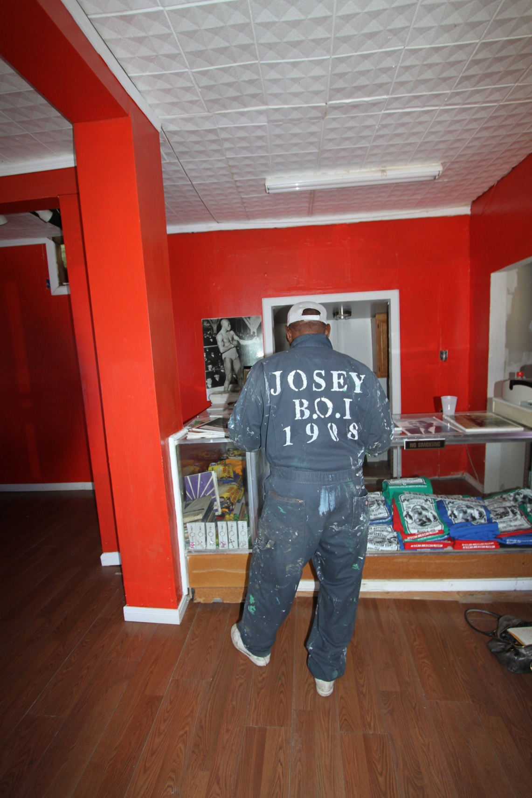

CHAPTER 3
PARADIGMS APPLIED TO DISASTER RECOVERY

3.1 ‘Disaster Capitalism’/‘Tabula Rasa’

In her book The Shock Doctrine: the rise of disaster capitalism, Naomi Klein introduces an analysis and theory of what she refers to as ‘Disaster Capitalism.’ “I call these orchestrated raids on the public sphere in the wake of catastrophic events, combined with the treatment of disasters as exciting market opportunities, ‘disaster capitalism.’” (Klein 2007 ,6). According to Klein, the principles behind Disaster Capitalism were developed by Milton Friedman in the 1950s through the Chicago School of Economics.
“To get governments back on the right track, Friedman, in his first popular book, Capitalism and Freedom, laid out what would become the global free-market rulebook and, in the U.S., would form the economic agenda of the neoconservative movement. First, governments must remove all rules and regulations standing in the way of the accumulation of profits. Second, they should sell off any assets they own that corporations could be running at a profit. And third, they should dramatically cut back funding of social programs” (Klein 2007 ,68).

The history of the Chicago School’s global influence can be traced through the bloody history of South and Central America after World War II. The ‘neoconservative’ or ‘neoliberal’ movement calls for a true free market economy, without regulation or government involvement. Friedman was an economic advisor for the Ronald Reagan administration and his protégés include Dick Cheney and Donald Rumsfeld. Friedman influenced decades of foreign and domestic policy, and redirected the United States Government’s approach to disaster recovery post-9/11 and post-Katrina. (Klein 2007)
According to Naomi Klein, ‘Disaster Capitalists’ regard the ‘creative destruction’ of communities, cities, and countries as an opportunity for economic growth. “By the time Hurricane Katrina hit New Orleans, and the nexus of Republican politicians, think tanks and land developers started talking about ‘clean sheets’ and exciting opportunities, it was clear that this was now the preferred method of advancing corporate goals: using moments of collective trauma to engage in radical social and economic engineering” (Klein 2007 ,9).
The opportunity for recovery and rebuilding is only accessible to groups within communities that have the entitlement and access to the resources necessary to rebuild. After Hurricane Katrina, East Biloxi was left bare. At the time, the real estate market was in full swing, and land speculators and development companies saw a great deal of profit opportunity in the destruction of the old neighborhoods. The North of Broadway neighborhood in Galveston similarly represented an opportunity to create infrastructure supporting the possible arrival of casinos. Many community members expressed to me the idea that the destruction caused by Ike to the North of Broadway neighborhood was an opportunity to redevelop and take over the neighborhood with parking and casinos. Klein discusses this from a more global perspective in Disaster Capitalism, in which she emphasizes that the people who follow the ideological direction of Friedman and the economic practice of disaster capitalism want to rebuild, they just have a different vision of how the social, economic, and political structure of a city, state, and country should function. As Naomi Klein suggests,

“.... disaster capitalists have no interest in repairing what was. In Iraq, Sri Lanka and New Orleans, the process deceptively called ‘reconstruction’ began with finishing the job of the original disaster by erasing what was left of the public sphere and rooted communities, then quickly moving to replace them with a kind of corporate New Jerusalem— all before the victims of war or natural disaster were able to regroup and stake their claims to what was theirs’ (Klein 2007 ,10).

3.1.1 The East Side of Biloxi

“The hurricane upended the tenuous balance, clearing whole tracts of old homes from valuable land in Biloxi neighborhoods that were rich in history but not much else. As in New Orleans, Katrina leveled the poorest part of town. The 2000 per capita income for one census tract in East Biloxi was about $12,000, according to the Census Bureau. That is the most ethnically diverse part of the city, home to nearly all of Biloxi's Asian immigrants and most of its African American residents” (Lunney 2006 ,31).

My introduction to Biloxi was on the Biloxi Tour Train. As we wound our way east on Howard Avenue, the mood changed from festive to somber as the tour guide lowered her voice and started telling the story of East Biloxi. This area East of Main had been hit hard. According to Architecture for Humanity (2009), “East Biloxi was one of the hardest hit areas of the Gulf Coast—over 90% of the neighborhood’s housing stock was damaged or destroyed” (Architecture for Humanity 2009 ,8).
The casinos and development speculators that purchased lots in East Biloxi after its destruction saw the opportunity to purchase valuable land for later development at a profit. According to Lunney, the dynamics of the hurricane and its aftermath “give the developers and casino operators the upper hand in what has become a rebuilding void in Biloxi” (Lunney 2006 ,30). The casinos and larger corporations seem to have legislative as well as in house support in place for rebuilding and even expanding operations. The casinos were supported by the Katrina Recovery Act, operated through the Mississippi Gaming Commission. The industry was further buoyed by the H.R. Bill 45, signed into law days after Katrina, allowing for the construction of onshore casinos. Land speculators were buoyed by this show of economic support and quickly scavenged for land on which to build accommodations for vacationers and casino staff. This was before the economic meltdown of 2008 and the BP oil spill of 2010. The housing market had not crashed yet, and developers were still looking to build. Ninety percent of the previously established neighborhoods in East Biloxi had been destroyed, and people were willing to sell without much prompting or legal fight. The development corporations regarded East Biloxi as a ‘tabula rasa’, a clean slate, that could be taken for a profit.
Seven years after Hurricane Katrina, the casinos are building larger parking garages in East Biloxi, but the old neighborhood sits empty, maintained by out-of-state corporations that purchased the land from residents within weeks of Hurricane Katrina. The economic collapse, and the complete implosion of the real estate market in 2008, followed by the BP oil spill in 2010, further weakened the fragile Gulf Coast economy. The developers never developed.
As a designer, it may be exciting in the abstract to look at a disaster area as a clean slate. The blank sheet of paper that can become whatever you want. But within cultural landscapes, and disaster landscapes, there is never truly a tabula rasa. In Fast Forward Urbanism, Dana Cuff and Roger Sherman discuss this further:
“The tabula rasa of disaster, compared to philosophical nothingness or the conceptual clean slate, is profoundly tainted. While it demands a fresh start and permits a physical response unfettered by historic context, the violent erasure of history never leaves behind a blank slate, but a highly polemic one. Politics, memory, economic interests, and opportunity vie for power in the process of recovery” (Cuff and Roger 2011 ,78).

During my research, I found it important to remind myself that there were many different visions for the recovery and rebuilding of Biloxi and Galveston. Whose vision of recovery was I observing during my site visits? Whose city are developers rebuilding?

3.1.2 Galveston Public Housing

The very political move to not replace the Galveston Public Housing that was demolished after Hurricane Ike (2008) is put into context by a passage in the Yates McKee article ‘Haunted Housing: Eco-Vanguardism, Eviction, and the Biopoitics of Sustainability in New Orleans’; “This unintentionally dystopian vision epitomizes the neoliberal dream of what the Center for Urban Pedagogy has called ‘The City without a Ghetto’; that is, a city in which it is not the dynamics of ghettoization that have been eliminated but ghetto residents themselves” (McKee 2008 ,97).
According to a 2011 PBS News Hour report, “The Galveston Housing Authority (GHA) wants to rebuild low-income homes through scattered site and mixed income development” (NewsHour 2011). While discussing the proposed use of ‘mixed income’ developments to replace public housing in New Orleans, McKee warns that the term ‘mixed use’ often provides ideological cover for gentrification.
“....., an ambiguous term that, left uninterrogated, has often served to justify programs of aggressive gentrification in the name of ‘de-concentration’ or ‘desegregating’ the urban poor, whether they be residents of public housing, private rentals, or privately owned homes (each which entails, it should be remembered, specific and differential levels of vulnerability to forces of displacement)” (McKee 2008 ,100).

The Galveston municipal government was finally forced by HUD to rebuild, or the entire state of Texas would have lost their Ike recovery funding. In May 2010, HUD approved an agreement that obligates Texas to rebuild all of the public housing lost in Galveston, $586 million to rebuild. (Wilder 2012). Magnolia Homes and Cedar Terrace, both in the North of Broadway neighborhood, still have not been rebuilt, and the empty lots (each the size of a neighborhood block), sit padlocked behind tall chain-link fences. The land is empty and flat, but for some reason still chained off from the public. This action of fencing off the empty public housing adds another layer of tension to an already brutalized landscape.

3.2 Loss of density/urban fabric

The loss of urban architectural density, combined with the complete loss of vegetation in some parts of Galveston and Biloxi, continues to leave a harsh physical and psychological impression of Hurricanes Katrina (2005) and Ike (2008) on the cities. For the purpose of this research, the ‘urban fabric’ is viewed as the same expression as the cultural landscape in an urban context. Over the centuries, the urban fabric of Biloxi and of Galveston formed around broader social contexts within the landscape. Dana Cuff and Roger Sherman discuss urban fabric as the ever-present cultural backdrop of civil society.
“Our habitual practices are codified in the built environment, through property and the claims we hold upon it, through regulation that has evolved to protect us from harm, through architectural form that absorbs daily life. Indeed, the space of the habitus is elaborated in architectural discourse, We refer to it as the urban ‘fabric’, the background buildings that comprise the city, or the generic city- the state of distraction, where we need not focus but can proceed in a routine manner” (Cuff and Roger 2011 ,80)

Large swaths of land in the North Broadway neighborhood of Galveston contain heavily damaged structures, some of these structures are abandoned, but many are still used by residents as housing. The areas where structures were destroyed by Hurricane Ike, or torn down shortly after, sit vacant. East Biloxi lost ninety percent of its housing stock to Hurricane Katrina, and only a small percentage has been rebuilt. The rest of the land remains vacant. Much the same is true for Galveston. Both Biloxi and Galveston have lost significant amounts of their pre-hurricane populations and the void left by the displacement of people has yet to be filled. The displacement of community members in Biloxi and Galveston is not only seen, but is also felt in the absence of the vibrancy and liveliness that defined a large extent of the cultural landscape in the pre-hurricane communities.
“The primary content of home, from what people say, is not material landscape but people. When one is absent, recollection of home is primarily of the human beings there. Without the continuing presence of the sustaining group, the place would no longer be home. It is one’s presence with this nurturing and sheltering group as they are associated with the landscape that give it meaning as the landscape of home” (Meinig and John Brinckerhoff 1979 ,136).

There are many factors that cause displacement. Some of them include:

- finding or following employment (Biloxi residents to Las Vegas with the Casino Corporations, and Galveston to Texas City).

- deciding housing too expensive to rebuild or continue renting (lack of entitlement to resources, increased flood insurance premiums).

- not wanting to rebuild; the experience was too traumatizing or just doesn't seem worth it.

3.2.1 St. Michael’s Church, Biloxi

St. Michael’s Catholic Church, in East Biloxi, is an example of the effects of displacement on community and the urban fabric. The entire neighborhood surrounding this church was completely destroyed by casino barges, debris, and storm surge. Few homes have rebuilt in this area, and St. Michael’s stands as a reminder of what once was. A community member talked about the stream of neighbors that would walk to and from church every Sunday through the streets of East Biloxi from surrounding neighborhoods. For me, this paints a vibrant picture of this community, walking in Sunday dress under the canopy of live oak trees.

3.2.2 Public transportation losses in Galveston

Loss of population and urban density affects every part of the infrastructure that supports the civic life of communities. The chain of command and amount of funding provided to Galveston for public transportation is based on the population of the city. After Hurricane Ike, the Galveston public transportation authority no longer had the population needed to qualify for federal funding. “Because of Ike displacements, Galveston slipped below 50,000 in the 2010 decennial census, making it ineligible for direct federal transit funds. Rather than receive its own transit money as a small urban area, the dip below 50,000 means Galveston is Texas’ biggest rural area and will compete for statewide transit funds” (Begley 2013).
3.3 Insurgent Citizenship

This research believes that communities practicing ‘insurgent citizenship’ are the partners of progressive designers and planners who are exploring new ways of connecting to landscape and building community. In his article ‘Cities and Citizenship’, James Holston discusses the influence that insurgent citizenship can have on urban planning and design; “It differs from the modernist objectives of planning because it aims to understand society as a continual reinvention of the social, the present, and the modern and their modes of narrative and communication. What planners need to look for are the emergent sources of citizenship, and their repression, that indicate this invention” (Holsten 1999 ,168). If you bring progressive artists to the area, the area can potentially be transformed. Art brings people, and people bring money, and ‘eyes on the street’ as Jane Jacobs described. Art brings restaurants and small local business and much more. Art is not perfect, but it can be a way to enliven neighborhoods, sometimes leading to gentrification, but it can also bring community together for a larger discussion about what they (residents) want to see in their neighborhoods. Through art, communities can begin again to participate more fully in civil society, and discourse. Art can lead to community empowerment, leading to a more resilient and sustainable community.

3.3.1 Art Can Change Everything, Biloxi
The Art Can Change Everything group of artists had gained access to the small empty house on Vieux Marche, in the Rue Magnolia Art District of Biloxi, for a month- long Pop-up Gallery showcasing the work of local artists from along the Gulf Coast. The group shows a wide range of work, including paintings, sculpture, murals, graphics, and large-scale installations. By organizing mural painting, pop-up galleries, and community events like the stoop parties, the Art Can Change Everything group is encouraging life to return to downtown Biloxi through art and music. Emphasizing local and neighborhood sourced products; art, food, beer, music, location. The small house on Vieux Marche, the group was currently occupying, was donated for the month by the Rue Vieux Investment Group. The Rue Vieux Investment Group is made up of local women that got tired of waiting for the Rue Magnolia Art District to come alive again after being destroyed by Hurricane Katrina. This group of women formed the Rue Vieux Investment Group and began purchasing and rehabbing the small homes as places for galleries and boutique shops. The Rue Magnolia Art District is directly across I-90 from the major casinos along the beach, and has the potential to attract a large amount of business.
The Art Can Change Everything group was just going to be temporary. The group of artists originally met at an event in which murals were added to the Kress Building in Downtown Biloxi, and decided to continue to make art together. During March, 2013, the group was loosely planning their next gallery occupation and seemed to be developing long-term projects.

3.3.2 African American Museum, Galveston

The building is painted green with larger-than-life portraits of Galveston BOI African American Men and Women who have gone on in life to achieve further great accomplishments in sports, medicine, politics and more. Barry White is on the front of the building, with Jack Johnson on the north side of the house. When I showed up (March 2013), at the Galveston African American Museum, Mr. Josey (the owner and operator) was finally finishing the remediation work he had started in 2008, after Hurricane Ike flooded his museum with at least 5' of water. The electrical work had been ruined by the saltwater storm surge, and the light pole out front had been completely washed away. Mr. Josey was planning to reopen in a couple days, and has been doing all the remediation and repair work by himself.
The Galveston African American Museum was the first museum in Galveston to highlight and celebrate the African American Heritage of the island. This bright green house sits in one of the most marginalized sections of Galveston, and serves as a constant reminder of success and celebration for African Americans in the community. Mr. Josey has created a gathering space for community members by installing a corner bench, which he labeled the Prayer bench. According to Mr. Josey, the bench is a place for community members to sit quietly and reflect. The bench is bolted down so well that it survived Ike with only losing the wooden back. Mr. Josey is also planning to open a small store attached to the museum building to sell snacks to neighborhood children so that they do not have to cross the busy streets to get a popsicle in the summer. He is planning to provide picnic benches or seats. The Galveston African American Museum promotes community and heritage through celebrating positive role models and helping to foster community gathering.

FIGURE 2: East Biloxi Density Map
Image: (GCCDS 2010)

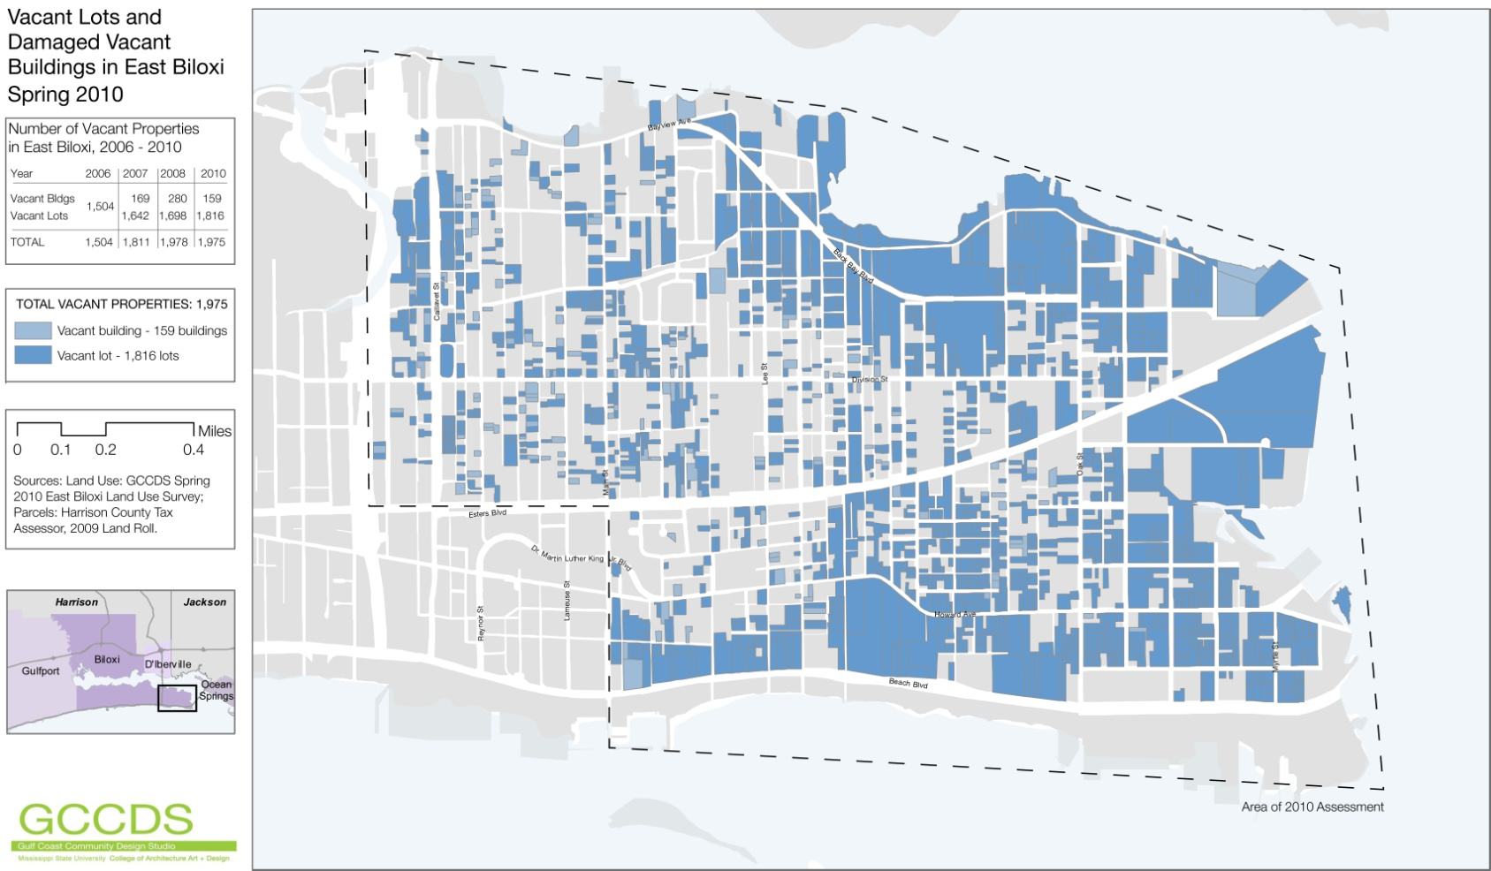

FIGURE 3: East Biloxi Streetscape 2013
Image: (Elizabeth Englebretson 2013)

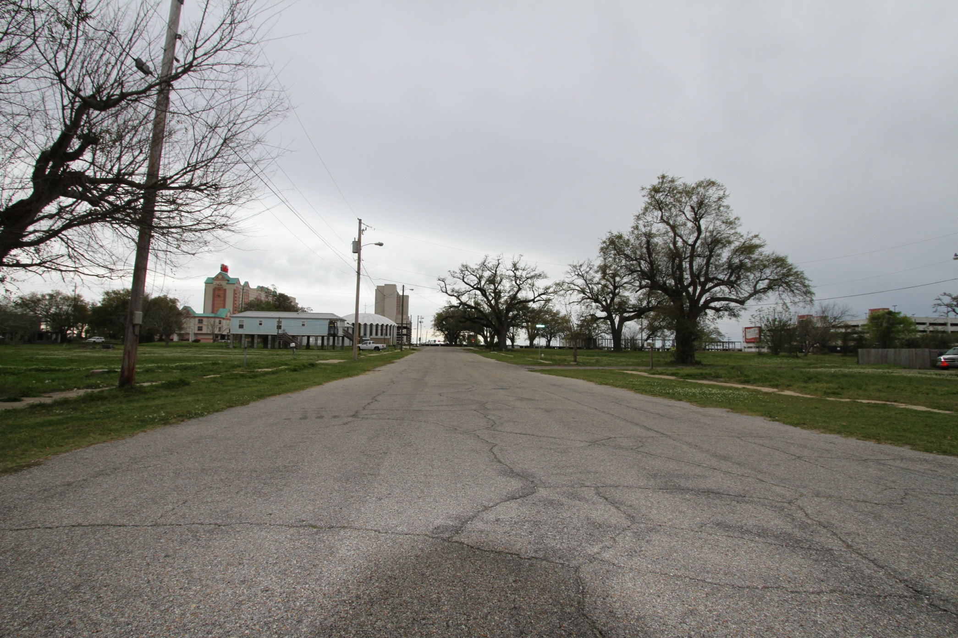

FIGURE 4: St. Michael's Church, Biloxi
Image: (Elizabeth Englebretson 2013)

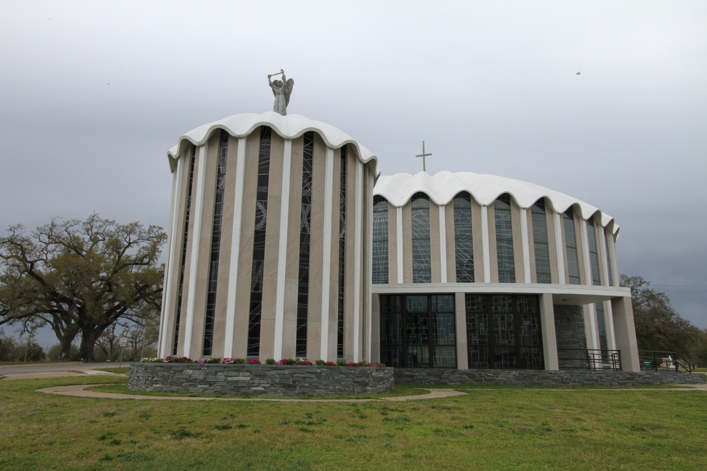

FIGURE 5: Kress Building, Art Can Change Everything, Biloxi
Image: Artist JoJo LaFargue (Elizabeth Englebretson 2013)

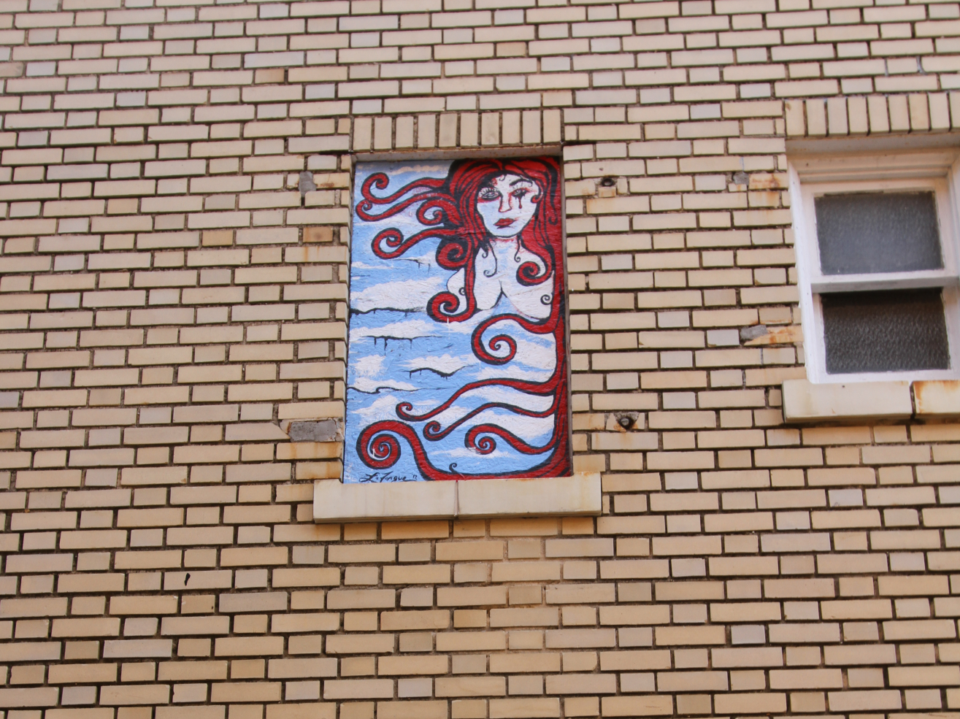

FIGURE 6: Galveston African American Museum, Galveston
Image: (Elizabeth Englebretson 2013)

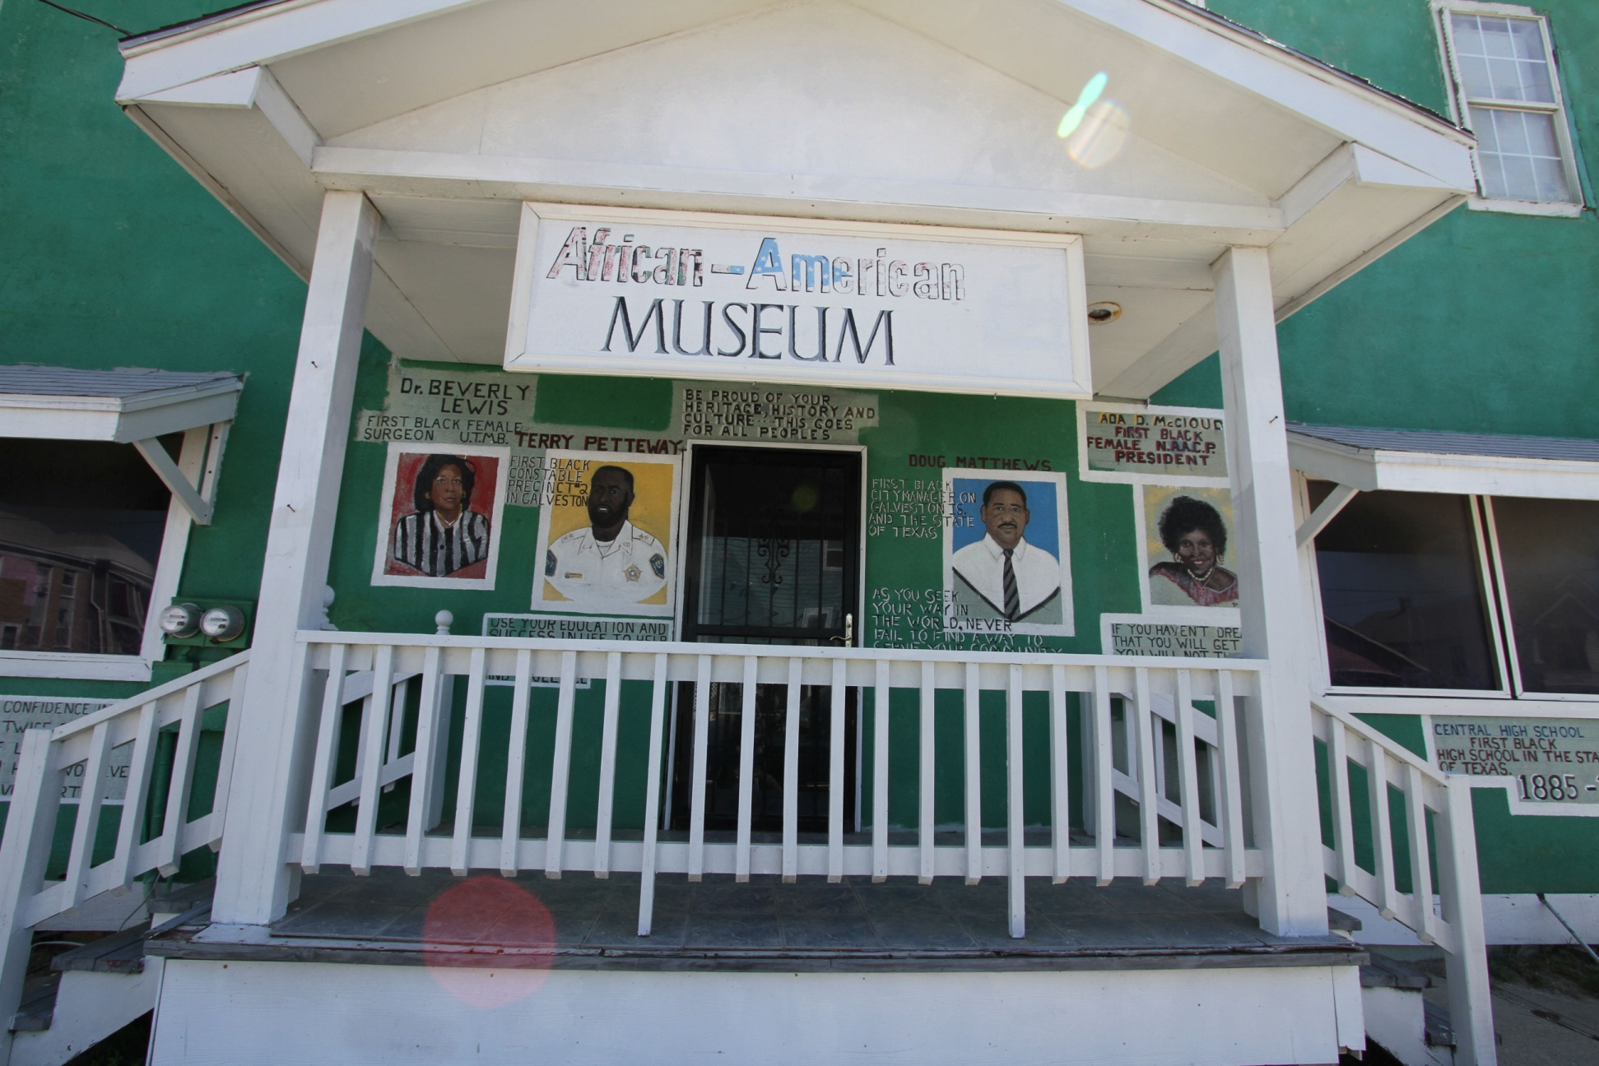

FIGURE 7: Prayer Bench, Galveston African American Museum, Galveston
Image: (Elizabeth Englebretson 2013)

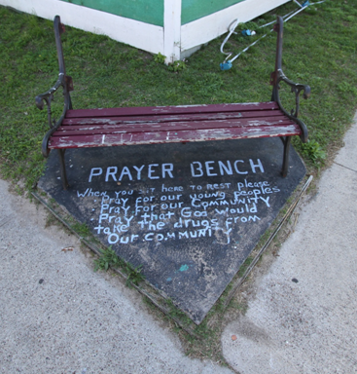

CHAPTER 4
FOCUS AREA and HURRICANE BACKGROUND

4.1 Research focus area

The focus of this research is the American Gulf Coast, specifically the cities of Biloxi, Mississippi and Galveston, Texas. Both cities are mid-sized, urbanized, densely populated, U.S. Gulf Coast cities. Biloxi and Galveston share similar demographic and economic structures. Although Biloxi and Galveston are similar in many ways, each of the cities maintains a unique site-specific sense of place.

4.1.1 Biloxi, Mississippi

At 38.22 square miles, Biloxi is located on the end of a peninsula between the Gulf of Biloxi and the Mississippi Sound in the Gulf of Mexico. The city is estimated to have a population of 44,940 people as of 2011 (US Census Bureau Quickfacts Census 2010). The southern coast of Biloxi is lined with white-sand beaches, and the peninsula is buffered by several small barrier islands that act as wave breaks. The northern coast sits on the Gulf of Biloxi and is part of the Historic Back Bay District.

4.1.1.1 Brief Biloxi History

The first group of Europeans to arrive in Biloxi was a group of French explorers led by Sieur d’Iberville. This group had been sent by France to find and secure the mouth of the Mississippi River. The historic account as written by Boudreaux observes, “On February 13, 1699, Iberville and 14 men landed on the mainland at present-day Biloxi. After several days the French became friends with the Biloxi Indians. There is some indication that they arrived along the Mississippi Coast a short time before the French” (Boudreaux Jr. City of Biloxi 2013).
The city of Biloxi was named after the Biloxi native tribe that was living in the area when Iberville arrived. “The Biloxi City (est. 1721) in Harrison County was named for the Biloxi tribe, which resided near the Mississippi coast during the late 1600s and early 1700s” (Baca 2007 ,8). Biloxi began developing into a vacation destination by the early 1800s especially after Mississippi became a state in 1817. Over the course of the next 50 years, Biloxi developed into a popular vacation destination for southerners (Boudreaux Jr. City of Biloxi 2013). The tourist industry was developing alongside the fishing industry in Biloxi, and both were booming by the late 1800s. The railroad (1870) influenced Biloxi by efficiently moving both tourists and fish along the Gulf Coast from New Orleans to Alabama. By the Early 1900s, Biloxi became fully established as a vacation destination as well as a booming fishing industry, and would soon be known as the Seafood Capital of the World. “In the 1920s there were more than 40 seafood factories occupying the two cannery districts” (City of Biloxi 2013).
In 1883, the artist George O’hr, referred to as the Mad Potter of Biloxi, moved into town. His legacy and impact on the heritage of Biloxi is still celebrated today in many ways, including a series of museums and working classrooms, designed by architect Frank Gehry, along Highway 90 in Biloxi. “While his work was not widely known during his lifetime, George O’hr (1857-1918) is now considered one of the United States’ finest artist-potters. The O’hr-O’Keefe Museum of Art in Biloxi is dedicated to promoting his work and legacy” (Mississippi Department of Archives and History 2013). Another unique landmark was established in 1877, when the first and only President of the Confederacy moved to Biloxi. In 1877, Jefferson Davis moved to the estate known as Beauvoir (French for Beautiful view). “Jefferson Davis was looking for a quiet retreat to write his books and papers” (Mississippi Division Sons of Confederate Veterans 2012). Beauvoir became the final home and future presidential library of Jefferson Davis.
One of the most iconic landmarks on the Gulf Coast is the Biloxi Lighthouse. According to the Biloxi Historical Society, the Lighthouse was built in 1848. The Lighthouse still stands today as a significant part of the cultural landscape. Another major part of the coastal cultural landscape in Biloxi is U.S. Highway 90. The highway opened in 1950 and connected Van Horn, Texas to Jacksonville, Florida and soon became a major part of the vacation experience for travelers, even to this day. “U.S. Highway 90, the first four-lane super highway, boosted travel along the Coast” (Nuwer 2013). Similar to the casino-lined landscape of present day Biloxi, Highway 90 was a major tourist destination. “In nightclubs lining Highway 90, entertainers such as Elvis Presley, Jayne Mansfield, Andy Griffin, and Hank Williams Sr., performed. Gambling and entertainment were everywhere along ‘The Strip’” (Nuwer 2013).
The Gulf Coast was booming until Hurricane Camille struck. Hurricane Camille hit the coast of Mississippi in 1969 as a Category 5 storm, sustained wind speeds of >150 mph. Camille is ranked as the 13th most destructive hurricane, with damages estimated at $ 9,282 million. (Blake et al. 2011). Camille disrupted the thriving tourist and gaming industry in Biloxi, and as the economy declined, the population of Biloxi also declined. The population of Biloxi was bolstered in the mid-1970s when a large influx of postwar Vietnamese refugees and immigrants moved to the city. According to the Boat People SOS Biloxi History, ‘(Biloxi) has become a ‘new home’ for thousands of Vietnamese refugees and immigrants who have resettled in the area since 1975. Its climate and geographical characteristics along with the local fishing industry comprise its main attractions” (Boat People SOS 2013). The Vietnamese cultural influence on the landscape of Biloxi can be seen today in the variety of restaurants, businesses, and churches within East Biloxi.
4.1.1.2 Current Core Economic Drivers

Much of the economic structure that has supported Biloxi since the early 1800s is still responsible for providing the modern economic base of Biloxi in 2013. The current economy of Biloxi is supported by the fishing industry, tourism/gaming, and Keesler Air Force Base.
The economic and social influence of the fishing industry in Biloxi has shaped the city over time and continues to do so today. “Biloxi’s seafood industry had experienced many transformations and labor struggles between fishermen and factory owners in the early 20th century, but regardless of its history, the seafood industry was a vital part of the Mississippi Gulf Coast economy and a powerful influence in the cultural fabric of the city of Biloxi” (Nuwer 2013). The fishing industry in Biloxi still harvests shrimp and oysters, as well as charter boat fishing operations that cater to tourists. This industry was severely affected by Katrina, then dealt another blow by the 2010 BP oil spill, but is now slowly recovering.
The second major industry driving the current economy in Biloxi, Mississippi is the casino and gambling industry. Biloxi is currently home to at least nine major casino establishments, including the BeauRivage, the IP Casino Resort Spa, and the Hard Rock Biloxi. Tour bus operators shuttle busloads of eager gamblers to the casinos of Biloxi each day and a local trolley shuttles visitors from casino to casino within the city. “The Biloxi area has traditionally been a destination for people seeking an affordable vacation. Over 14 million people visited casino-based establishments in the Biloxi-Gulfport region during 2008” (City of Biloxi 2009). Adjacent to the beachfront casinos on I-90 are the Biloxi Historic Downtown and the Rue Magnolia District. Biloxi city officials, business owners, designers, and community members are working to increase casino tourist traffic, by redeveloping the Downtown area and Rue Magnolia, to get visitors out of the casinos and in to the city of Biloxi.
The third major component to the Biloxi economy is Keesler Air Force Base. Keesler is a specialized military training facility for all branches of the armed forces located on the western edge of Biloxi, extending east with a VA hospital and military cemetery. This military base has a fluctuating population of roughly 27,000 active duty, civilian, family, and other personnel living and working on the base.
The long-term economic structure of Biloxi is a major part of the heritage of the city, but it also continues to be based on low-wage service casino industry jobs, the fishing/shrimping industry, and Keesler Air Force base.

4.1.2 Galveston, Texas

Galveston is a small barrier island on the Gulf of Mexico measuring 41.2 square miles. The Galveston beach runs along the east side of the island and is backed by a 17' high seawall that stretches along 10 miles of the Galveston Beachfront. The estimated population for 2011 was 48,444 people (US Census Bureau Quickfacts Census 2010). To the northwest sits the metropolis of Houston, TX and to the north is Galveston Bay. Driving from Houston to Galveston, on Interstate 45, provides a look at the diverse landscape of this area. Interstate 45 takes one through the Galveston Bay Estuary with the steaming smoke stacks of Texas City petrochemical refineries in the distance. “Galveston Bay is the largest and most biologically productive estuary in Texas, and sits adjacent to one of most heavily urban, industrialized areas in the nation” (Galveston Bay Geography 2013).

4.1.2.1 Brief Galveston History

The first Europeans on Galveston Island were a group of shipwrecked Spanish explorers who arrived in 1528. “The first Europeans arrived as early as 1528, when the survivors of a Spanish expedition led by Cabeza de Vaca washed up onto the beach and were met by the Karankawas on the island. Among the castaways was the first African to come to Texas—a Moroccan named Esteban” (Peché Runnel and Seriff 2009 ,vi). Galveston would be colonized and developed by the Spanish, French, Mexicans and Texans over the course of the next three hundred years. Galveston Island would establish itself as one of the largest and wealthiest cities in Texas. “Galveston was the wealthiest city in Texas for most of the nineteenth century—and most of its success was tied to its shipping, not passenger business. Cotton was king and Galveston was one of the largest cotton exporters in the country” (Peché Runnel and Seriff 2009 ,vi). The shipping industry moved products from Texas and around the world, driving and sustaining the economic growth of Galveston.
Galveston Island was home to several prominent Texas families in the 18th and 19th century, and their legacies have continued to influence the island landscape to this day, through various endowments and community organizations. Several prominent Galveston families became very rich from the opportunities in this city. The Moody family made their fortunes through a wide range of industry including banking, cotton, printing, hotels and many more. Everything in the region moved through the Port of Galveston, and the neighboring Strand District grew up quickly to support the commodities and shipping industry. “By the late 1800s, Galveston’s main commercial street—The Strand—was lined with Victorian buildings which housed commercial, financial, and legal businesses. Each of these businesses catered to Galveston’s thriving port economy. Galveston was one of the richest cities in the world, per capita, and the financial heart of much of the Southwest” (Peché Runnel and Seriff 2009 ,viii). The Port of Galveston also became a major immigration point of entry for the Southwestern and Southern United States, in the late 19th and early 20th century. “In one year, 1907, more people immigrated to the United States than ever before. Approximately 1.25 million were processed in Ellis Island. Galveston was projected to receive over 20,000 that same year” (Peché Runnel and Seriff 2009 ,x). Galveston was a port of entry for many people into the United States, both as slaves before the Civil War and as immigrants after.
After the Emancipation Proclamation, freed slaves established a rich African American heritage in Galveston. The Juneteenth holiday was started in Galveston on June 19, 1865, and marks the day that slaves of Galveston learned of the Emancipation Proclamation and their freedom. “Almost three years after Abraham Lincoln issued the Emancipation Proclamation—slaves in Galveston officially learned of their freedom when Union General Gordon Granger read the proclamation to a gathered crowd. Soon, the news spread to over 250,000 slaves throughout Texas” (Peché Runnel and Seriff 2009 ,viii). Juneteenth is still a much celebrated holiday among the communities of Galveston as well as African American communities elsewhere.
Galveston has a long history with hurricanes, and a significant aspect of Galveston’s heritage is the idea of ‘weathering the storm’, and recovering quickly, no matter the level of destruction. In 1900, Galveston suffered the worst recorded natural disaster in U.S. history. “The Galveston Hurricane of 1900 was responsible for at least 8,000 deaths and remains first on the list (of deadliest U.S Hurricanes)” (Blake et al. 2011 ,5). To prevent that level of destruction and loss of life in the future, Galveston was raised 17’ and a seawall was built. Galveston rebuilt and once again became a major vacation destination for wealthy Texans as well as working class families. “In the early 1900s, Galveston promoted itself as ‘The Coney Island of the South.’ Excursionists flocked to Electric Park to experience attractions including a roller coaster, carousel, theater, as well as the park’s prized possession, The Aerial Swing” (Galveston Island Historic Pleasure Pier 2013). The Electric Park was built and opened in 1906 on one of the beach piers along Seawall Boulevard, and was a major attraction for the beachfront. A wide variety of social activities happened along the Seawall in early 20th century Galveston. According to the Moody Mansion Galveston Historical Society tour guide, the Moody family enjoyed buying the most modern automobiles and would hold car races with other wealthy Texans on the hard-pack Galveston beaches.
In 1911, The Hotel Galvez was opened just down the beach from the Electric Park, and became one of the premier hotels on the Gulf. This Spanish Mission-style hotel provided high-end services to wealthy vacationers and businessmen. The Galvez is located on the Seawall Boulevard, and in the early 1900s would have been right in the middle of all the bustling beachfront activities. Although Galveston never returned to its previous status after ‘The Great Storm’ of 1900, the island did slowly recover, and once again became a thriving city. Even in the 21st century. the Port of Galveston, the Strand District, and Seawall Boulevard remain extremely vital modern economic and social supports to the City of Galveston.

4.1.2.2 Current Core Economic Drivers

Although Galveston is no longer promoted as the ‘Coney Island of the South’, much of the economic structure that helped to build the island remains virtually the same in the 21st century. The modern economy of Galveston is supported by the Port of Galveston, tourism, and the University of Texas Medical Branch.
The Port of Galveston is home to the Texas Cruise Ship Terminal. According to the Port of Galveston Authority, major cruise lines such as Carnival and Disney sail from Galveston. The Historic Strand District and the various hotels, restaurants and tourist activities benefit from the cruise ship passengers that are in town for a night or two before their cruise leaves. Galveston Island has a wide variety of tourism options and is a destination for weekend day trippers, conventions, and cruise ship passengers. Galveston Island is home to destinations like Moody Gardens, Schlitterbahn, and the Pleasure Pier. “In January 2012, Landry’s, Inc. revealed a monumental renovation plan for Galveston Island, transforming the Pleasure Pier into a world class amusement park for all ages. Landry’s vision recaptured the site’s original purpose as a pleasure pier, a preeminent destination venue for family fun” (Galveston Island Historic Pleasure Pier 2013).
There are also opportunities for camping at Galveston Island State Park or RV camping at locations on both the West and East Ends of the island. Families can take harbor tours from Pier 21 or tour the Historic Architecture of the Moody Mansion and Bishops Palace. Galveston is known for its historic architecture and well-preserved Victorian homes. The Strand District in Galveston is a registered National Historic Landmark District and caters to the tourists and locals. “The 26-square block district contains more than 100 restaurants and art galleries. Several tour companies offer guided tours. Some of the Strand’s historic buildings have also been documented by the Historic American Buildings Survey” (National Historic Landmark 2013).
The UTMB (University of Texas Medical Branch of Galveston) is the third major part of the Galveston economy. The campus was founded in 1881 and does specialized medical research in infectious disease, cancer, vaccines and other specialties. According to the UTMB 2010 Master Plan, the University has a 1.5 billion dollar budget (FY10) and employs over 11,600 people. UTMB is a very important part of the Galveston economy as well as part of the public health of Galveston. In 2010 UTMB had “2,460 students, 883 faculty, 499 residents” (Ford Powell and Carlson 2010 ,3). Many of the students and faculty live on the island and spend their spare time volunteering or participating in public health clinics like St. Vincent's House, the Greenhouse Foundation, as well as other events and programs around the island.

4.2 Hurricane Basics

The Atlantic Hurricane season runs from June 1 to November 30 with peak activity from mid-August to late October. “On average, close to seven hurricanes every four years (~1.8 per year) strike the United States, while about two major hurricanes strike the U.S. coast every three years” (Blake et al. 2011 ,20). Multiple storms form during every hurricane season, and some may make landfall, with little to no destruction. However, some Atlantic hurricane seasons produce severe storms like Andrew (1993), Camille (1969), Katrina (2005), and Ike (2008), which cause widespread devastation and loss of life.
Major Hurricanes are defined by the National Hurricane Center (NHC) as Category 3 or higher. The National Hurricane Center (NHC) category rating system only rates the power of a hurricane based on wind speed, and does not account for storm surge or inland flooding, which can be equally, if not more, destructive. Hurricanes that do not rate as major hurricanes according to the Saffir/Simpson Wind Scale are still a large threat due to storm surge and physical size of the storm. “The primary physical processes of interest are the wind field, storm surge, and wave climate. Not only does wind cause direct damage to structures along the coast, but it is ultimately responsible for much of the energy that is transferred to the ocean and expressed as storm surge, mean currents, and large waves” (Doran 2013 ,1). Massive storms can reach hundreds of miles in diameter, and the effects of the hurricane wind force can reach much farther than that, causing storm surge, severe rainfall, and inland flooding. According to the NOAA, “Typical hurricanes are about 300 miles wide although they can vary considerably in size. The storm’s outer rain bands (often with hurricane or tropical storm-force winds) are made up of dense bands of thunderstorms ranging from a few miles to tens of miles wide and 50 to 300 miles long” (NOAA 1999).

4.2.1. Biloxi and Hurricane Katrina

On August 29, 2005 Hurricane Katrina made landfall at Grand Isle, LA. Hurricane Katrina was a massive storm, and an unprecedented disaster for the United States. “Katrina was responsible for at least $108 billion of property damage and is by far the costliest hurricane to ever strike the United States. Katrina is also ranked the second deadliest Hurricane in U.S. history, with the loss of life estimated at over 1, 800 people” (Blake et al. 2011 ,5). Entire communities were wiped off the map along the U.S. Gulf Coast, and the Mississippi Gulf Coast in particular was devastated. The hardest-hit area in Mississippi was Harrison County, and within that county the City of Biloxi. The East End of Biloxi was destroyed. According to Architecture for Humanity, “East Biloxi was one of the hardest hit areas of the Gulf Coast—over 90% of the neighborhood’s housing stock was damaged or destroyed” (Architecture for Humanity 2009 ,8).
During Katrina, Biloxi experienced 17 hours of hurricane-force winds of up to 130 miles per hour. These wind speeds are Category 4 (131-155mph) according to the National Hurricane Center. Some areas along the Mississippi Coast estimated the storm surge to be between 17-22 ft. The storm surge from Katrina encircled the Biloxi peninsula, flooding the city of Biloxi from three sides, and reaching as far inland as 12 miles. (Knabb, Rhome and Brown 2006). “A precise measurement of the storm surge produced by Katrina along the northern Gulf coast has been complicated by many factors, including the widespread failures of tide gauges. Additionally, in many locations, most of the buildings along the coast were completely destroyed, leaving relatively few structures within which to identify still-water marks” (Knabb, Rhome and Brown 2006 2006, 8-9).
Many Biloxi homeowners lost everything and did not have the financial means, and also in some cases the desire, to rebuild. Many residents did not carry flood insurance, and many properties were not even categorized by FEMA maps as being in a flood zone. Hurricane Katrina proved to be especially destructive in East Biloxi, where a majority of the residents owned their homes outright and did not maintain flood insurance. Under federal law property owners with mortgages on their properties within flood zones are required to have flood insurance. In East Biloxi, many residents had owned their properties without mortgages for generations. “Because they did not hold a mortgage on the property, many did not carry flood insurance, a requirement of mortgages on properties in flood zones” (Architecture for Humanity 2009 ,20). This left many residents without any financial recourse after the storm.
After Hurricane Katrina, FEMA reconstructed their floodplain maps and so building requirements changed drastically for many property owners waiting to rebuild. Biloxi began rebuilding before the new FEMA/NFIP regulations took effect in 2007. Given the choice to rebuild before the 2007 deadline, some of the residents rebuilt under the previous regulations in order to save money and stop land grabs.
“Biloxi is one of a few cities along the Gulf Coast that rejected FEMA's advisory base flood elevations. Instead, in May, the local government opted for a lower threshold: Residents in the riskiest areas will have to rebuild their homes only about four feet higher to meet the city’s code. The federal government cannot force communities to adopt its new flood maps, but it’s a choice that comes with a price. Cities that don’t adhere to FEMA’s rules cannot participate in the flood insurance program, and their residents cannot benefit from other types of federal disaster-related assistance” (Lunney 2006 ,32).

Following the newly established FEMA height requirements proved to be a challenge for community members and design professionals financially, physically and culturally. In an effort to rebuild their homes, some community members rebuilt below the new FEMA elevations, therefore giving up their chance to have flood insurance, but at least being able to afford to rebuild.
The gaming industry was crippled after Katrina but was almost immediately bolstered by industry support and changes in State legislation. Hurricane Katrina’s storm surge slammed the floating casino barges ashore, causing massive destruction both to the barges as well as to onshore infrastructure, historic architecture, and local vegetation. According to the journal article, ‘A Tale of Two Cities, “August 2005, Hurricane Katrina zeros out revenue for three months. In 2006, with only five casinos open, revenues are the lowest since 1996” (Lunney 2006 ,36).
In order to speed the recovery of one of the largest economic drivers in Biloxi, the Mississippi Gaming Industry established the Hurricane Katrina Relief Fund (2006). The Hurricane Katrina Relief Fund helped to bolster the recovery of the Biloxi gaming industry by providing immediate, accessible, capital allowing casino corporations to continue rebuilding, instead of having to wait for government loans.
The rebuilding of the Biloxi gaming industry also included the transition of casinos from offshore only to land-based casinos. This move onshore was approved by the Mississippi legislature a little more than a year after Hurricane Katrina. Before House Bill 45 (2006), gambling casinos had only been allowed offshore on huge barges connected to hotels and resorts. In October 2006, the Mississippi legislature signed House Bill 45 into law. “House Bill 45 permits ‘shore-based’ gaming in permanent structures in Harrison and Hancock counties within 800 feet of the 19 yr. mean high-water line, or, with regard to Harrison County only, no farther north than Highway 90, whichever is greater” (Balch & Bingham LLP 2005 ,1).
By moving onshore, casinos have a greater impact on the local community landscape. The casinos’ high-rises are out of scale with the rest of Biloxi, and the complexes form a ring of massive structures enclosing the city from the sea on both the beachfront and the Back Bay. “While casinos bring employment, sales revenue, and tax income to the City of Biloxi, it directly influences the East Biloxi community in terms of land use, infrastructure, and general quality of life. The need for balance and compatibility exists between the desire for economic development and the preservation of the East Biloxi community” (Florida Planning and Development Lab 2008 ,i). Casinos are major economic engines in Biloxi, but they function as a form of second-tier tourism. Most visitors do not spend money outside of the casinos at local restaurants and local retailers. The majority of the money stays in house, and the direct influx of tourist dollars into local business is missing.
The tourism industry was further destabilized by the destruction of so much irreplaceable architectural, material and landscape heritage of Biloxi, which lost a significant amount of its architectural heritage during Katrina. The Tullis-Toledano Manor (1856) was completely destroyed during Katrina when the Grand Casino Biloxi barge was washed ashore by the 24-foot storm surge, crushing the historic brick home, and severely damaging the newly constructed O’hr-O’Keefe Museum of Art. The museum campus had been designed by Frank Gehry and the construction started in 2004, most of the campus was less than 18 months from completion when Katrina arrived in 2005.
Another significant landscape impact is the loss of the heritage trees and landscape. After Hurricane Katrina, the historic live oak trees that had provided canopy and shade in the hot summers were already gone or were waiting to be removed. Biloxi was shocked by the almost complete destruction that Hurricane Katrina brought to the peninsula. “Besides the loss of lives, homes, and personal property, hundreds of thousands of Katrina survivors in Mississippi have been experiencing a profound sense of loss, grief, and malaise over the destruction of places of employment, small and large businesses, churches, schools, neighborhoods, recreational facilities, historic sites, and even entire communities—the loss of so much about life that was familiar and cherished along the entire Mississippi Gulf Coast” (Scurfield 2006 ,105).

4.2.2 Galveston and Hurricane Ike

On September 13, 200,8 Ike struck Galveston as a Category 2 hurricane, with hurricane-force winds reaching 120 miles from the center (Ike does not rate as a major hurricane on the Saffir/Simpson Wind Scale). “Hurricane Ike struck the upper Texas Gulf Coast on Friday, September 13, 2008. As the third hurricane to hit Texas in 2008, it was the most devastating and destructive, spanning more than 900 miles wide and impacting more than 29 counties” (Texas Legislature 2008 ,1). According to the National Hurricane Center (NHC), “Ike became the second most costly hurricane in U.S. history, and third on the list of most deadly hurricanes in U.S. history. The estimated damages were $29.6 billion with a loss of life in the United States of 112 people and 23 missing” (Blake et al. 2011). In Galveston, Hurricane Ike pushed the storm surge up over the seawall and also up through the Houston Shipping channel, inundating the Historic Strand District, the North of Broadway Community, and the University of Texas Medical Branch (UTMB) on the back bay, areas that are normally protected from storm surge. After Ike, the possibility that there could be a storm surge of up to 25' with the right combination of factors redirected the Master Plan for the University of Texas Medical Branch of Galveston.
“Storm surge levels on Galveston Island and on the west side of Galveston Bay are estimated to be between 10 and 15 ft. Here, too, several NOS tide gauges failed, although the gauge at Eagle Point on the west side of Galveston Bay recorded a maximum surge of 11.48 ft. The highest inundation, of at least 10 ft, occurred on the bay side of Galveston Island, the coast of mainland Galveston County, as well as over Apffel Park at the northern tip of Galveston Island where Ike made landfall” (Berg 2009 ,7).

The University of Texas Medical Branch at Galveston is a research and teaching facility covering over 100 acres on a dense urban campus, with 80 major buildings and circulation needs of students, staff and patients. As part of the dense urban fabric of Galveston, the campus sits on the north side of the island surrounded by various residential neighborhoods, including the historic district.
The destruction brought about by Ike caused UTMB to make revisions to the 2000 Campus Master Plan. The new Master Plan 2010-2035 (Ford Powell and Carlson 2010) lists the three new issues and considerations for UTMB:
- Hurricane Ike and Mitigation response
- Acquiring 64 acres for Victory Lakes campus (off island)
- Reassessment of Galveston campus program size and land use
(Ford Powell and Carson 2010 ,2)

As an addition to this new Master Plan, the Walter P. Moore Campus Storm Mitigation Plan introduces new building requirements that move all “‘Mission critical functions’ 5' higher than the current regulation of 20'. All finished floor elevations are now required to be a minimum of 23.5' above flood level determined by FEMA. Mission critical functions are set no lower than 25' above FEMA flood level” (Ford Powell and Carson 2010 ,7).
Galveston suffered significant damage and loss to the architectural and landscape heritage of the island. Many of the historic piers and buildings along Seawall Boulevard were completely destroyed or damaged beyond repair. Most of the island sustained damage from the 15-foot storm surge that corroded wiring and flooded the city with sea water, mud, and oil from Galveston Bay. Residents were left to dig out knee deep sludge and replace walls, windows and rooftops. According to a member of the Galveston Art League, on Post Office road near the Historic Strand neighborhood, it took six months to remediate their building and get opened again. The neighborhoods, business owners, and property owners that had access to the necessary resources to rebuild were able to do so within 6-8 months according to most business owners in the area. The homes in the Historic District are rebuilt or being rebuilt with fresh paint and trees. This neighborhood is coming back to life with new restaurants, bakeries, and people back in their homes.
The North of Broadway Neighborhood sits directly to the west of the Historic District and Strand, and was almost completely destroyed by Hurricane Ike and the storm surge damage. This neighborhood was torn down after Ike, and many businesses, community organizations and residents were displaced and never returned. According to the director and owner of the Galveston African American Museum, he has spent the last four years and his own money rebuilding the museum to open in 2013.

Table 4: Geographic Size Biloxi, Mississippi
(US Census Bureau Quickfacts Census 2010)

Geographic Size | Square Miles
Biloxi | 38.22

Figure 8: United States of America, Biloxi, Mississippi
Google Earth

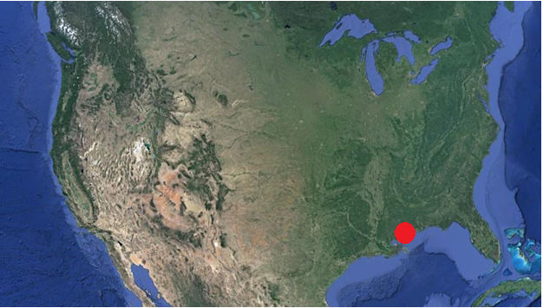

Figure 9: Biloxi, Mississippi
Google Earth
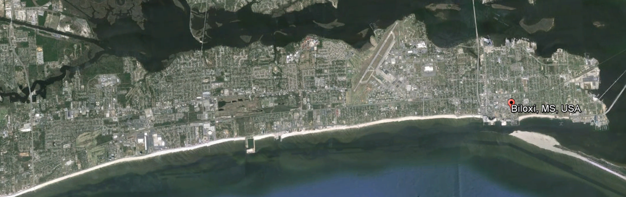

Table 5: Geographic Size Galveston, Texas
(US Census Bureau Quickfacts Census 2010)
Geographic Size | Square Miles
Galveston | 41.2

Figure 10: United States of America, Galveston, Texas
Google Earth

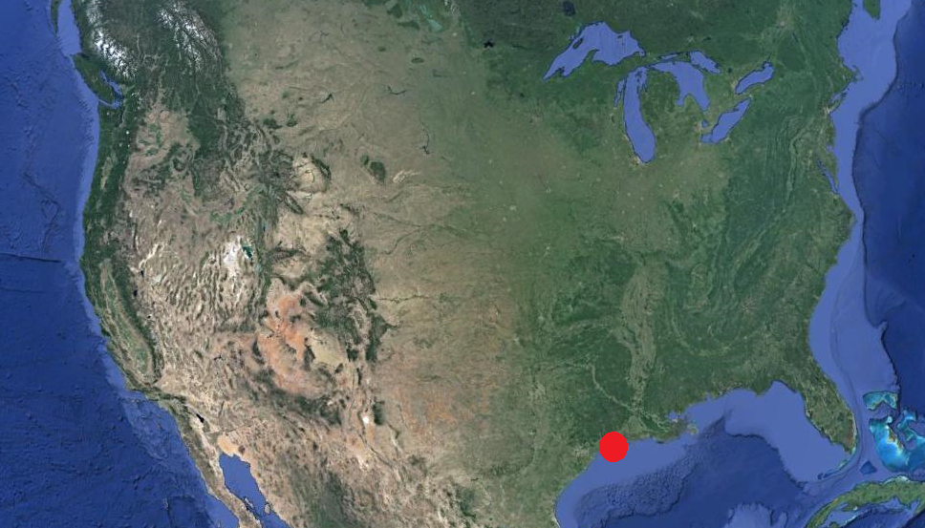

Figure 11: Galveston, Texas
Google Earth

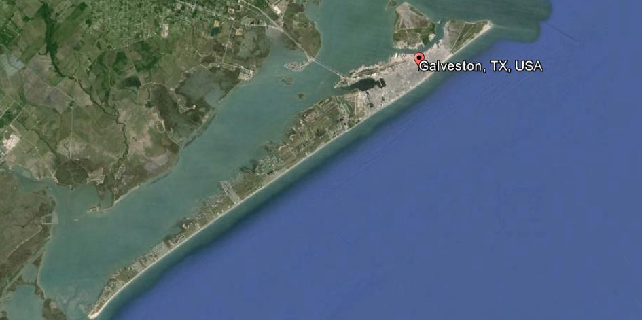

Figure 12: Shrimp Boat returning from a morning of work, Biloxi
Image: (Elizabeth Englebretson 2013)

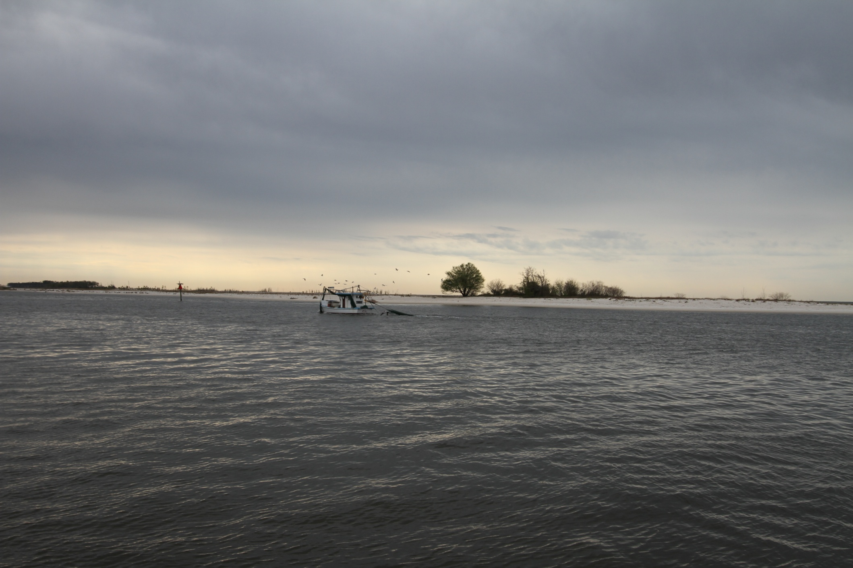

Figure 13: Cruise ship docked at the Texas Cruise Ship Terminal, Galveston
Image: (Elizabeth Englebretson 2013)
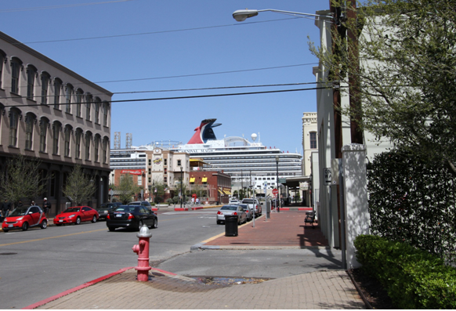

Table 6: Saffir/Simpson Hurricane Wind Scale
(Blake et al. 2011)

Category | Wind speed
1 | 74-95 mph
2 | 96-110 mph
3 | 111-130 mph
4 | 131-155 mph
5 | >150 mph

Table 7: Hurricane strikes on the mainland United States (1851-2010)
(Blake et al. 2011)
Category | Strikes
1 | 113
2 | 75
3 | 75
4 | 18
5 | 3
Total | 284
Major | 96

Figure 14: Hurricane Katrina, 2005
(Knabb, Rhome and Brown 2006 ,42)

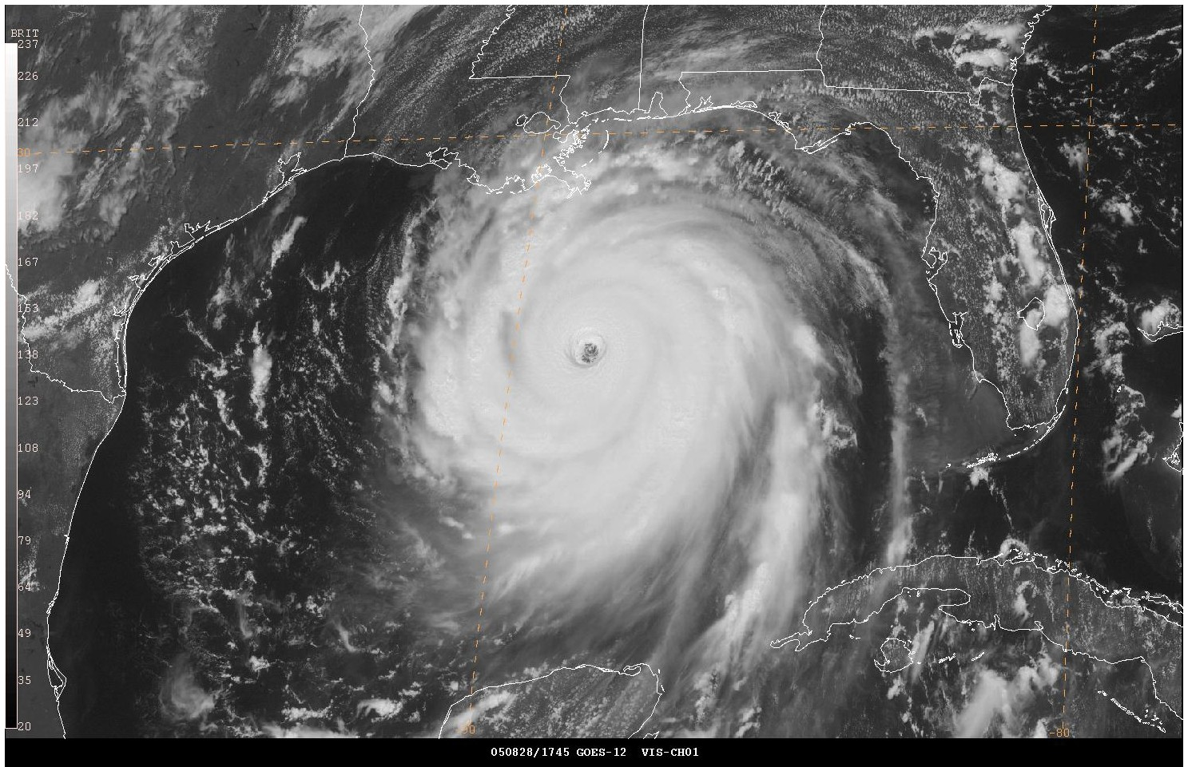
Figure 15: Hurricane Ike, 2008(http://loadstorm.com/files/Satellite_Image_of_Hurricane_Ike.jpg 2013)
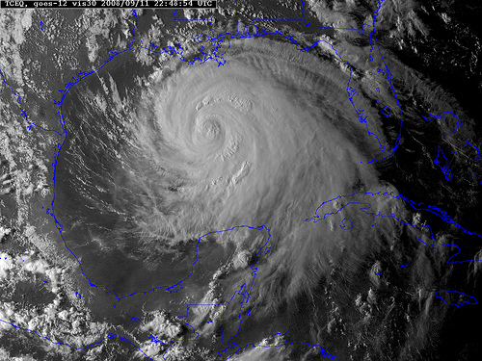

CHAPTER 5
AID ORGANIZATIONS

5.1 External Organizations

5.1.1 FEMA/NFIP

For the purpose of this research, ‘external organizations’ are defined as groups from outside the community that provide aid and assistance during post-disaster recovery and rebuilding (e.g., the US Federal Emergency Management Agency [FEMA] or The Congress for the New Urbanism [CNU]).
Hurricane Katrina caused such widespread destruction that the United States federal emergency response protocols and policies were questioned and re-evaluated. FEMA revised the floodplain maps for the first time since 1984.
The updated floodplain maps drastically changed the boundaries of the flood zones, increasing the number of homeowners required to follow the rebuilding guidelines set by FEMA and participate in the National Flood Insurance Program (NFIP). The new flood insurance rates for homeowners are often three times more than the homeowners’ mortgage. Rebuilding under the new regulations also increases labor and material costs. The revised FEMA/NFIP regulations that took effect in 2007 also drastically altered the social dynamic in neighborhoods by requiring homes to be raised, in some places by as much as 21 feet into the air.
Homeowners must also comply with the updated FEMA building guidelines in order to qualify for insurance. If homeowners do not follow these FEMA guidelines, they lose eligibility for FEMA aid.

“November 15, 2006: FEMA came out with provisional elevations [for rebuilding]. About two and a half square miles of land ( in Biloxi), which had once escaped FEMA regulation altogether, was now in the flood plain. The new maps set the base elevation (of constructions) at 21 feet, which meant that the vast majority of new construction would have to be raised well into the air” (Lewis 2006).

As mentioned earlier (1.1.4.1 Biloxi and Katrina), Hurricane Katrina was a major turning point in federal government policy toward hurricane preparedness, response, and rebuilding. Due to the widespread destruction Katrina left behind, as well as the governmental response that was criticized as being insufficient at best, the federal emergency management agency (FEMA) began to reevaluate their policies and regulations on everything from initial response to new building code requirements.
The 109th Congress, under the second George W. Bush administration, was tasked with producing a Congressional research report to study areas that needed reform. Investigators and their studies presented findings on major shortcomings, and most urged a reconsideration of existing policies and practices. This Congressional Research Service (CRS) report summarizes information on the emergency management modifications adopted by Congress in response to the widespread calls for change (Bea 2006). After receiving the results reported in the Congressional Research Service report, the 109th Congress enacted six new statutes to redirect future government response and recovery post disaster. These six statues directly address some of the inadequacies and failures in the response to Hurricane Katrina.
One of the six statutes enacted by the 109th Congress was the Post-Katrina Emergency Reform Act, also referred to as the Post-Katrina Act, November 15, 2006. “While expanding federal assistance authorities, the amendments seek to maintain state, local, and individual emergency management responsibility and accountability. In short, the Post-Katrina Act expands federal disaster assistance authority, but leaves the basic tenets of the Stafford Act (such as Presidential discretion, need for state requests, restrictions on eligibility) unchanged” (Bea 2006 ,40).
The governmental structure within the United States takes a multi-tiered approach to disaster response and recovery. The chain of command starts at the Mayoral level, up through the Governor, and then if necessary on to the President. Once the Governor declares a state of emergency, the state and local government can then ask the federal government for federal assistance. The President can declare a major disaster emergency and authorize federal assistance through the Robert T. Stafford Disaster Relief Act. The Stafford Act is written into the Post-Katrina Act passed by the 109th Congress, and offers another layer of federal assistance to support local disaster recovery from a federal level. According to the FEMA report the Stafford Act: “Authorizes federal assistance for state and local governments, certain nonprofit organizations, and families or individuals after state and local governments are overwhelmed by natural disasters and fires, floods, or explosions, regardless of cause. The statute gives the President the discretion to issue a major disaster or an emergency declaration in response to a gubernatorial request for assistance” (FEMA 2013 ,1).
The Stafford Act has a section that outlines the Hazard Mitigation Grant. This section provides the President with the authority to release additional funding in the form of grants to provide additional Federal funding for recovery and rebuilding. “The Hazard Mitigation Grant Program (HMGP), authorized by Section 404 of the Stafford Act, authorizes the President to provide grants to states in which major disasters have been declared. These funds must be used for activities that prevent future disasters or reduce their impact if they cannot be prevented” (FEMA 2013 ,17).

5.1.1.1 The 81st Texas Legislature

Frustrated by the delays in funding and support that the State of Texas was receiving from FEMA after a series of disasters in 2007, Governor Perry pushed support for the HB 2694 creating the Disaster Contingency Fund. According to the House Select Committee, some counties in Texas had been waiting three years for reimbursement from FEMA. “The DCF was created as an acknowledgement that Federal Emergency Management Agency (FEMA) assistance typically had long delays between the time the disaster occurs and when benefits are actually received. Although FEMA operations are out of the State’s control, that does not relieve the State from its duty to ensure that the residents of the affected area are not financially attended to” (House Select Committee On Hurricane Ike Devastation To The Texas Gulf Coast 2008 ,6) Texas Representative Mike Hamilton put the House Bill 2694, Disaster Contingency Fund, before the Texas Legislature for approval in 2007 (Hamilton 2007). HB 2694 allows for access to state funds, and flexibility with those funds, for disaster preparedness, response, and recovery . This bill gives the State government more flexibility to adjust quickly during times of emergency and disaster.
According to Governor Rick Perry (R, TX),
“Texas has seen an unprecedented level of emergencies and disasters in the last two years, and HB 2694 would aid those agencies and local governments whose resources and personnel have been stretched thin by these demands. Local governments typically have qualified for federal aid in fewer than 10 percent of major incidents, as categorized by the state, and the bill would provide a way for them to be reimbursed for unexpected response costs and repairs” (Hamilton 2007 ,2).

This legislation was successfully created, but according to the House Select Committee, the state failed to fund it, so this legislation was not available at the time of Hurricane Ike in 2008 (House Select Committee On Hurricane Ike Devastation To The Texas Gulf Coast 2008 ,6).

5.1.1.2 Mississippi Renewal Forum (Congress of the New Urbanism)

The Mississippi Gulf Coast was decimated by Hurricane Katrina on August 29, 2005. Three weeks after, the Congress of the New Urbanism was beginning their week-long design charette (October 11- 18, 2005) in the Capri Hotel in Biloxi. The New Urbanism designers had been invited by Governor Haley Barbour of Mississippi to propose the rebuilding and recovery designs for eleven cities that had been heavily damaged on the Gulf Coast of Mississippi. Funding for the Mississippi Renewal Forum came from the Knights Foundation. (Talen 2008) “The day arrived, three weeks after the handshake, and the several hundred ultimate participants showed up to their appointed rounds. The work schedule, which can be roughly summarized as days of meeting alternating with days of designing, took place for a total of one week” (Congress for the New Urbanism 2005 ,3).
Although the Mississippi Renewal Forum produced many innovative and progressive design and planning interventions, it did not addressed the reality of the cultural and social structure that is already in place in Biloxi and other Gulf Coast towns.
New Urbanism seems to take a utopian view of Biloxi, a look more from above than from within; a utopian view that sees Biloxi as a tabula rasa, or clean slate, to be redesigned to produce a city of the future, without really considering the Mississippi Gulf coast culture and social structure as it exists now. In his article, ‘The Gulf Coast Renaissance’,
Andrés Duany writes about the urban planning and lifestyle opportunities that can come from Katrina.
“What is so extraordinarily hopeful in Mississippi is that the devastation of Katrina will allow the Gulf Coast to arrive at this inevitable future faster — before anywhere else in the United States. Elsewhere the demolition must still be done, and it will take two or three generations. In Mississippi, it could take less than one. A blessing in disguise, if ever there was one” (Congress for the New Urbanism 2005 ,4).

While doing my site visit in Galveston, March 2013, I drove to the east end of Galveston Island to see the New Urbanism enclave of Beachtown. Beachtown is the long time vision of developer Mr. Shirazi. He fought for many years to gain the property and zoning rights to develop on the east end of Galveston. The entrance and exit road wind through the tidal marshes where Beachtown is built, within the dunes and adjacent to Stewart Beach Park, Appfel East Beach Park, and the Big Reef Nature Preserve. A few of the homes planned for the Beachtown community were built before Hurricane Ike and weathered the brunt of the hurricane as an example of resilient and sustainable design. Beachtown is not an attempt to rebuild Galveston and does not speak to the cultural landscape of Galveston, despite (or perhaps because) the homes are built in the Victorian home style represented in Galveston's Historic District. James Holston argues against modernist planning in his article Insurgent Citizenship,

“My criticism of modernist planning is not that it presupposes a nonexistent egalitarian society or that it dreams of one. To deny that dream is also to conceal or encourage a more totalitarian control of the present. It is rather that modernist planning does not admit or develop productively the paradoxes of its imagined future. Instead, it attempts to be a plan without contradiction, without conflict. It assumes a rational domination of the future in which its total and totalizing plan dissolves any conflict between the imagined and the existing society in the imposed coherence of its order. This assumption is both arrogant and false. It fails to include as constituent elements of planning the conflict, ambiguity, and indeterminacy characteristic of actual social life. More over it fails to consider the unintended and the unexpected as part of the model” (Holsten 1999 ,165).

5.2 INTERNAL AID ORGANIZATIONS

Internal Organizations are defined within this research as non-profit and for-profit aid and recovery groups that are formed by members of the affected communities or groups working directly within and with the community (e.g., the Hope Community Development Agency, St. Vincent’s House, etc.), to be discussed below.

5.2.1 Biloxi, Mississippi

5.2.1.1 Hope Community Development Agency

Bill Stallworth was the district representative for the hardest hit area of Biloxi, East Biloxi (Ward 2). I met Bill Stallworth while I was sitting on the wall outside the Salvation Army Kroc Community Center in Biloxi, MS during my site visit in March, 2013. Mr. Stallworth was across the street standing up a yard sign that had fallen down in someone's yard. The sign was promoting his recent run for reelection as Ward 2 Representative in Biloxi. The other end of the small front yard had a lazy looking grey pitbull that didn’t even stir. Mr. Stallworth was efficient and quick. He crossed the street to greet me, welcomed me to the neighborhood and gave me a business card, then continued on what seemed to be a ‘quick check’ of the neighborhood.
Almost immediately after Hurricane Katrina, Stallworth had started the Hope Community Development Agency, and began to organize the disaster response that was flooding East Biloxi post Katrina. At this time there were not even street signs to direct aid workers and organize response.
The Hope Community Development Agency was also working directly with community members to provide support during the process of filing claims, designing rebuilding, and securing financial resources to recover and rebuild. The Hope Center works to bridge the gap between the resources and the community. Bill Stallworth began to organize and include other organizations in the process in order to build a strong network of resources for the aid response and the community. The volunteer organizing group Hands Across The Gulf organized and installed temporary street signs to improve aid response, and provide way finding for aid workers.
The Hope Coordination Center (Hope Community Development Agency) has been set up in an old church on the more eastern end of Division Street in Biloxi, Mississippi. The Hope Center sits in a centralized location in the hardest-hit area of Biloxi, providing a stable location for meeting, organizing, and relief distribution. The Gulf Coast Community Design Studio (GCCDS), led by David Perkes and the Mississippi State University College of Architecture, Art + Design, moved in to old church and started working with the Hope Center to digitize maps and support the organization of the recovery and response, as well as working one on one with homeowners to provide professional architectural design at no cost to the homeowner.

5.2.1.2 GCCDS

Although The Gulf Coast Community Design Studio (GCCDS) and the Hope Community Development Agency share a building, they are separate agencies. The GCCDS was founded shortly after Katrina by David Perkes and functions as a professional outreach program of the Mississippi State University College of Architecture, Art + Design. David Perkes is an AIA architect and an associate professor at the Mississippi State University School of Architecture, Art, and Design. The Gulf Coast Community Design Studio began working with the Hope Community Development Agency during the initial stages of post-Katrina recovery. The very first project taken on by the GCCDS was to convert the paper maps of Biloxi that were being used by the Hope Center into higher-quality digital maps. After the maps were digitized, a grid system was developed to assign sections of the city to separate aid organizations. By assigning a grid system to Biloxi, the GCCDS and Hope Agency were able to monitor and organize the aid organizations working within the area to avoid confusion and wasteful overlap of services. “The ‘grid map’, as it came to be known, was a practical tool and the first of many maps produced by the GCCDS to provide useful information about complex issues such as flood zones, changing land uses, the impact of the devastation on Biloxi’s Vietnamese residents, the progress of rebuilding, and many other concerns” (Perkes 2009 ,66).
The GCCDS is a model for the positive role that design can play in disaster recovery and rebuilding. In the Journal of Architectural Education article ‘A Useful Practice’, David Perkes outlines the three main values needed to provide a successful, community-focused disaster response and recovery. (Perkes 2009)
- Service: “Service as a primary value is demonstrated in the activities of a practice, not in the compensation. In other words, service is not limited to volunteer work.”

- Proximity: “the Gulf Coast Community Design Studio’s most innovative move was to take the program a step closer to the needs of the community by not only creating an off-campus facility but by locating the design studio within a local non-profit organization in the community to which it would provide service.”

- Experience: “The degree to which a design practice works through experience, not the measure of expertise, is the primary condition that distinguishes community design from a standard architectural practice.”
Source: (Perkes 2009)
According to Perkes, the approach to design taken by GCCDS helped to keep the process of rebuilding from reducing down to just a couple of standard house plans. The GCCDS works one-on-one with homeowners during the design process in order to meet the needs of the family and to create a home that the homeowner will be invested in for the long term.
Another major difference from the traditional design approach is the payment structure. GCCDS does not get paid directly from the client. According to David Perkes, the GCCDS was able to set up a community loan system to provide money for individual rebuilds. These loans were paid back by the homeowner when FEMA funds, or other forms of financial reimbursement, were paid out to the homeowner. This allowed homeowners to begin rebuilding instead of having to wait three to four years for financial support to begin the process of rebuilding.
“Operating expenses for the services provided by the GCCDS to the Coordination Center and to the community of Biloxi are funded with federal grants from Housing and Urban Development, the National Small Business Administration, and the Department of Energy as well as private funds from the Knight Foundation and the Hearin Foundation. Thus, the relationship between the two organizations is a horizontal partnership and collaboration rather than the more vertical relationship between client and architect in which a client pays for professional services” (Perkes 2009 ,71).

The design-oriented, community-focused work that was done by the Hope Community Development Agency and The Gulf Coast Community Design Studio immediately after Katrina stabilized the emergent situation for many homeowners and community members in East Biloxi. This is a model of successful community-based response and recovery to disaster. This model bridges the gap between the federal aid response and the immediate as well as long-term needs of the communities affected by the disaster.

5.2.2 GALVESTON

5.2.2.1 St. Vincent’s House

St. Vincent’s House is a non-profit community center that provides education, emergency Services, and Social Aid to anyone needing these services. “The mission of St. Vincent’s House focuses on the needs of a forgotten people; the working poor and persons moving from welfare to work. St. Vincent’s House is situated in one of Galveston’s most impoverished neighborhoods where the average per-capita income is well below $10,000” (St. Vincent's House 2013).
The St. Vincent's House provides a community clinic, food pantry, preschool, a ‘hope mile’ walking route, basketball courts, and many services that support community empowerment and public health. Before Hurricane Ike, the St. Vincent’s House was situated among the houses, apartments, public housing, schools, and businesses of the North Broadway neighborhood, in Galveston. The storm surge from Hurricane Ike flooded the neighborhood with as much as 15ft. of water, and most of the buildings in the area were damaged beyond repair. A quote from Executive Director of St, Vincent’s House, Mr. Michael Jackson, tells the story of the North Broadway neighborhood.
“Jackson, presiding over the urban desert, has moved away from using the term ‘changed’ in describing his neighborhood. ‘It has been transformed,’ he says, and not for the better. ‘It’s not a thriving neighborhood: vacant lots, boarded-up buildings, a lot of people on the streets. It will follow the pattern of New Orleans: It will be smaller, and many people that were here will not be here.’” (Hamilton and Thevenot 2010).

When I visited Galveston during March 2013, it had been over two years since Michael Jackson had given that quotation. It has now been over four and a half years since hurricane Ike hit Galveston, Texas. During Hurricane Ike, St. Vincent’s House lost its bottom floor to flooding. The entire first story had flooded, destroying the day care/pre-school, the edible landscape, including the Mulberry tree, and heavily damaging the courtyard mural.
St. Vincent’s has been able to slowly rebuild, as have several of the houses around St. Vincent’s, but the rest of the neighborhood sits virtually empty. The largest open green space in the neighborhood is in the lot where the public housing used to stand. The lots are all maintained by the City of Galveston, which means they are mowed so that nothing grows there or is planted. These empty public housing lots are surrounded by chain link and are inaccessible to the public, creating a larger void in the urban landscape.
The St. Vincent’s building is like a beacon in this neighborhood, brightly painted and always playing music. One evening the outdoor speakers were playing Senegalese Hip Hop and the next afternoon it was Gospel. According to Michael Jackson, the Executive Director of St. Vincent’s House, art is also very important to St. Vincent's community engagement. Almost every surface on the property and the surrounding neighborhood block is painted with a mural. The Hope Mile community exercise loop is painted onto the sidewalk, with encouraging words and images marking the route.
Among many programs and services, St. Vincent's House runs a free community healthcare clinic, serving the public health needs of the surrounding community and beyond. The clinic is run as part of community health outreach and training by the UTMB (University of Texas Medical Branch).
“Our primary care clinic is administered by a full-time patient coordinator and staffed through the generosity of volunteer health professionals and students from UTMB Medical and Allied Health Schools, under the supervision of practicing doctors from the faculty. The UTMB affiliation affords the patients much needed access and referrals to University’s labs and resources that traditionally would have been unavailable. The clinic operates several days a week” (St. Vincent's House 2013).

According to Jackson, St. Vincent’s House was used for a year after Hurricane Ike (from 2008-2009) by the Red Cross as an outreach location. More recently (2012), Catholic Charities of Galveston has moved in to a space in the St. Vincent’s building after having to downsize their operations.

5.2.2.2 The Wellfair at Wright-Cuney, 2011

The North Broadway community outreach organizations hold an annual community wellness fair. This event is organized and held at St. Vincent's House in cooperation with Catholic Charities, Jesse Tree, and other outreach programs. In 2011, the Greenhouse Foundation was coordinating the implementation of a large scale community garden at the Wright-Cuney Community Center in Galveston. David Darrow, the founder of the Greenhouse Foundation, recognized an opportunity to open up a dialog with the community about healthy nutrition and public health. The groups involved in the 2011 Wellfair decided to join with the Greenhouse Foundation. The event was held at the Wright-Cuney Center and included the installation of the community garden by the Greenhouse Foundation volunteers and community members. (St. Vincent's House 2011 ,1) The organizations represented at the Wellfair in 2011 show the level of commitment these groups have to the people of the North Broadway neighborhood. The Jesse Tree, Catholic Charities, St. Vincent's House, Wright-Cuney Community Center, the City of Galveston, the Greenhouse Foundation, and many other groups made the day a success in the eyes of the organizers.
The Jesse Tree organization “brought a food fair and distributed over 30,000 pounds of food” (St. Vincent's House 2011 ,1). The Jesse Tree is a faith-based organization that works closely with the communities of Houston and the greater Houston area. The Jesse Tree has food distribution points around the metro area where community members can pick up food provided by the Houston Food bank. At these distribution sites, there are also mini clinics for blood pressure and diabetes checks, as well as workers to help people sign up for food assistance programs, subsidized housing, and other social services. The Jesse Tree used to have a location down the street from St. Vincent’s House but was unable to remediate the property and keep up with service demand, so the location closed. While touring the St. Vincent’s neighborhood, Michael Jackson pointed out the now shuttered and empty building that used to hold the Jesse Tree organization distribution center.
Many community members are not used to cooking with fresh vegetables, or are not sure how to prepare fresh vegetables. Galveston is a food desert with limited access to grocery stores and affordable fresh foods. According to Jackson, the edible landscape and community gardens provide some fresh produce for the community.
David Darrow, the founder of the Greenhouse Foundation, saw the need to provide how-to cooking classes. He organized cooking demonstrations, and nutrition education classes to help community members make healthy meals from the food they received from the Jesse Tree. “The Green House Foundation is a grass roots 501(c)(3) nonprofit organization with a mission to improve the health and the quality of life of all by encouraging community collaboration in creating green spaces, art, and education” (Greenhouse Foundation 2013).
During the Wellfair, The Greenhouse foundation organized the building and planting of twenty-one community garden beds, and the city ran irrigation to each of the beds.

Figure 16: Updated FEMA Floodmap showing building height requirements for rebuilding post-Katrina, East Biloxi
Image: (GCCDS 2008)

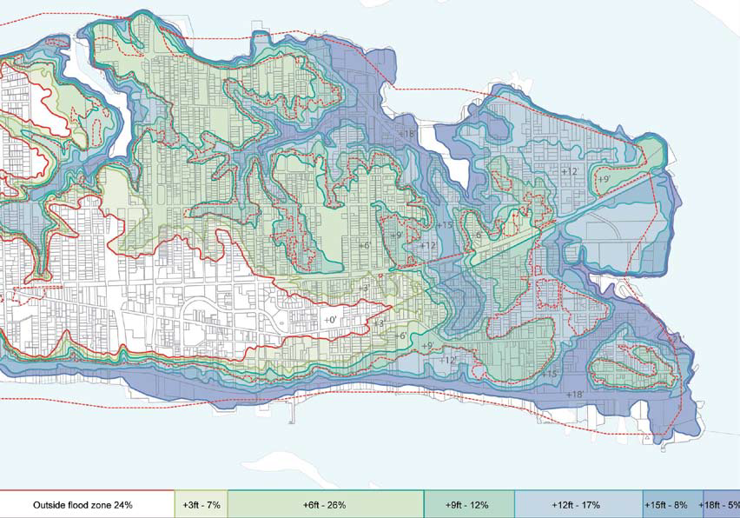

FIGURE 17: St. Vincent’s House, Galveston
Image: (Elizabeth Englebretson 2013)

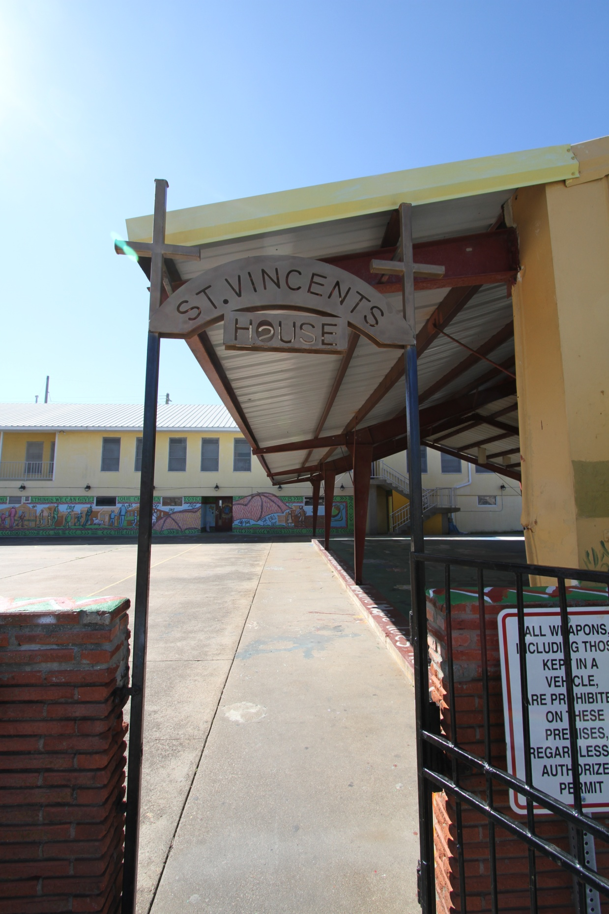

FIGURE 18: Wright-Cuney Community Garden Plan, Galveston
Image: (David Darrow 2010)

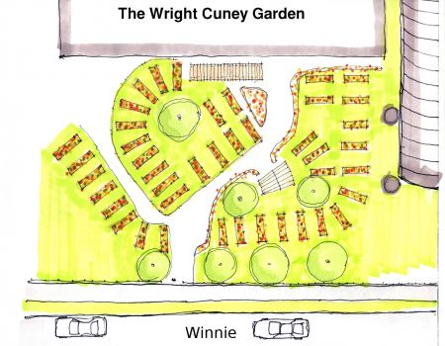
CHAPTER 6
HERITAGE

6.1 Preservation and Restoration

Architectural loss is not just about the loss of structure or dwelling. Historic architecture and vernacular architecture also serve to connect communities to the cultural landscape, to provide a sense of place; “The landmarks of home are the signs that one is welcome” (Meinig and John Brinckerhoff 1979 ,147). Without the architectural and cultural landscape, a community loses its connection to the history and often the present structure in the community.
In addition to a loss of sense of place, the architectural and cultural heritage of a community is a major driver in the modern tourism industry. The cities of Biloxi and Galveston have each incorporated their rich architectural and cultural heritage into their respective tourist economies. “In the United States conceptualizing heritage at the territorial level has led to the rapid growth of heritage areas and corridors as tools for both preservation and community development” (O'Donnell 2004 ,44).
Through the work of various local, state, and federal preservation programs and efforts, Biloxi and Galveston attempted to remediate and protect the remaining cultural landscapes after Hurricanes Katrina and Ike. There was significant destruction and damage in both communities, with Biloxi being devastated by Hurricane Katrina. “An estimated 350 buildings listed in the National Register of Historic Places were washed or blown away, along with most of the evidence of 300 years of Gulf Coast history. This makes Katrina the worst historic preservation disaster in our nation’s history” (Huffman, 2006) (Scurfield 2006 ,105).

6.1.1 Biloxi and the loss of Architectural Heritage

The architectural heritage of Biloxi was nearly wiped out during Hurricane Katrina (2005). Biloxi lost almost all of its heritage and ‘vernacular architecture.’ Many of the historic structures that were not completely destroyed were severely damaged, and some are still recovering.
“When Hurricane Katrina’s high winds and massive storm surge slammed into Mississippi’s Gulf Coast on August 29, 2005, many of the Coast’s most enduring landmarks disappeared. Gracious beachfront mansions, simple Creole cottages, bungalows, and shotgun houses—significant historic sites and private homes—the storm spared none of them. Demolition of the few remaining historic buildings has been a constant threat since FEMA began offering the unprecedented option of demolishing private residences at government expense” (Mississippi Heritage Trust 2007).

Many of these places cannot be rebuilt and are lost to history. A large majority of the historic artifacts (e.g., dishes, furnishings, paintings, documents, photos, etc.) were destroyed as well.
“Biloxi, Mississippi, was nearly washed off of the map, losing landmarks such as the Pleasant Reed Home, the house of a prominent African American in Biloxi during the late 1800s through early 1900s, and Beauvoir, the home of Confederate President Jefferson Davis, where more than half of the property was destroyed” (Joyner 2006 ,1).

The Historic Back Bay was also destroyed during Hurricane Katrina and has been replaced by the IP Resort and Spa and the Boomtown Casino. The piers are gone. The Old Brick house is still standing but had to undergo significant remediation and reconstruction.
People were not prepared for the intensity of Hurricane Katrina, and many museums and historic homes lost most, if not all, of their artifacts and antiques. The front door of Beauvoir was blown open, and the interior was destroyed by sea spray and the recorded 24' storm surge. “Beauvoir, last home of Jefferson Davis, the first and only President of the Confederacy, is outstanding among the many antebellum and fine Victorian homes that grace the Coast. Here, Davis wrote his memoirs and spent his final years. The home, library and grounds are beautifully preserved” (Mississippi Division Sons of Confederate Veterans 2012).

6.1.2 Galveston and Architectural Heritage

Galveston sustained heavy damage and losses to its architectural heritage due to the storm surge and flooding caused by Hurricane Ike (2008). Although most businesses, historic homes, and museums within Galveston sustained heavy damage, some community members were able to clean up and reopen within six months. Community business owners in the Historic Strand district were opening new galleries and restaurants, and historic homes such as the Bishops Palace and Moody Manor were reopening for tours, and the many restaurants and activities in the Historic Strand District were open for business and busy with customers.
There are over 43 registered properties on the National Register of Historic Places including 3 ships and the Galveston Causeway. Three of these properties were removed after their destruction during hurricane Ike, in 2008. Many of the historic piers along Seawall Blvd. were destroyed by Ike and most have not been rebuilt. One of the most significant reconstructions in this area of Galveston has been the Historic Pleasure Pier. The newly remodeled Pleasure Pier was in full swing during my visit in March 2013. In the Historic Strand District, it seemed that the vacant buildings were being filled by restaurants, art galleries, yoga studios, and boutique retail. The Texas Cruise Ship Terminal is now launching Disney cruises, which you can watch launch from the remodeled Tremont Hotel rooftop patio bar. This area of Galveston was in the process of developing for both the tourist market, as well as the upper middle class. The density of the Historic Strand area seemed to have returned and was expanding.
Most of the significant redevelopment in Galveston is due to the CEO of Landry’s Corporation, Tilman Fertitta Jr. The Landry’s corporation is responsible for the redevelopment of three historic hotel properties in Galveston. Through the Mitchell Historic Properties Group, Tillman redeveloped the Tremont Hotel, The Harbor House on Pier 21, and the historic Galvez. These three hotels are managed by the Wyndham Hotel Corporation. Tillman is also responsible for redeveloping the historic Pier 21, on the harbor side of Galveston, and redeveloping the Pleasure Pier, once known as the Electric Park.
The National Register of Historic Places is the official list of the Nation’s historic places worthy of preservation. Authorized by the National Historic Preservation Act of 1966, the National Park Service’s National Register of Historic Places is part of a national program to coordinate and support public and private efforts to identify, evaluate, and protect America's historic and archeological resources (National Historic Landmark 2013).

6.2 Loss Of Trees

“The storm(Ike) created a stark landscape that greatly reduced the morale of our citizens. It also denied residents of the infrastructural benefits that urban forests provide: reduced storm runoff, cleaner air, improved water quality, shade and lower energy consumption” (Galveston Island Tree Conservancy 2013). One of the significant losses expressed in casual conversation by community members, and observed through site visits was the loss of the iconic Live Oak in Biloxi and Galveston. “One senior US official described it (Hurricane Ike) as the worst loss of urban tree canopy in the nation’s history” (Galveston Island Tree Conservancy 2013).
What vegetation was not immediately killed by Katrina or Ike died slowly from salt poisoning and had to be removed a year or two later. According to the Galveston Island Tree Conservancy, “In 2008, Hurricane Ike’s storm surge flooded much of Galveston and destroyed 80 percent of the island’s tree canopy. Over 40,000 trees, many planted in the aftermath of the Great Storm of 1900, were destroyed” (Galveston Island Tree Conservancy 2013).
The landscape is still being built back and repaired after the losses of Hurricanes Katrina and Ike. The cities have small trees, and the yards have minimal vegetation, and were mostly just maintained by mowing. All of the vegetation and trees that had been growing and maintained for generations were wiped out. Landscape, like the urban cultural fabric, is formed over generations and takes time and interaction of many different factors to develop.

6.3 Memorializing the Landscape

6.3.1 Katrina Sculptures and Galveston Tree Sculptures

According to a community member in Biloxi, the tree sculptures help to “save the few remaining trees.” Reuse of dead trees as public art sculpture in both Biloxi and Galveston has created new opportunities to memorialize the landscape, as well as to promote a new beginning (physically and psychologically) for the community.
Marlin Miller sculptures line the Beach Boulevard in Biloxi. Carved into sea birds, fish, and many other representations of the Gulf Coast Culture in Biloxi, these larger than life sculptures gleam in the sunlight.
The tree carving done post-Katrina in Biloxi, by artist Martin Miller, inspired the community of Galveston after their tree population was decimated by Ike. According to a Texas Monthly writing by Sonia Smith, the Tree Sculpture movement in Galveston was inspired by the work done in Biloxi. “This seaside town’s [Galveston's] art project was set in motion by Donna Leibbert, who was inspired by the sculptures carved from trees killed by Hurricane Katrina in the Biloxi, Miss., area” (Smith 2012). Galveston has many different artists working on tree sculptures. One of those artists is Earl Jones, who used the tree trunk at Wright-Cuney Community Center in Galveston to promote self -empowerment through education.
Both Biloxi and Galveston promote tree sculptures as part of the tourist economy. Galveston has a Tree Sculpture tour, and Martin Miller sells his book and sculptures at the Biloxi Visitor Center.

6.3.2 K-Lines and Ike Plaques

Hurricane Katrina had produced a new cultural marker on the landscape referred to by community members as ‘K-lines’. K-Lines are the blue lines painted on light poles to indicate the post-Katrina water levels. The K-lines in the hardest hit parts of East Biloxi reflected the 24-foot storm surge that wiped the neighborhood out.
In the Historic Strand District of Galveston, bronzed plaques indicate the storm surge levels. Many businesses that I visited within the UTMB and Historic District had such plaques. The storm surge level in the North of Broadway Neighborhood is marked by the loss of urban density. Everyone can know how deep the water was, even if there are no bronzed plaques to mark it.

6.4 Larger-Scale Landscape Interventions

6.4.1 Bayou Auguste

“Before the Army Corps of Engineers petrified the bayou, its ecology was an astonishing compression of flora and fauna. Thick greenery along the banks quenched its thirst and sheltered a rich compendium of prairie life. When left intact, bayous are the most beguiling and graphic expressions of the moist prairie. The sources of the bayous are the watersheds hidden in the grounds of the delta. The management of the vast complex of prairie, bayous, and delta watersheds, now peppered by suburbanization, is as complex as the management of life itself.” (Cuff and Roger 2011 ,95)

The GCCDS design restores the landscape and ecological function of the bayou, and makes the daily ecological cycles of the bayou a part of the community. This project is being implemented in sections, and runs parallel to the Hope VI neighborhood. The Hope VI Project neighborhood was built to represent a new design direction for more affordable housing, and to provide local homeownership opportunities for lower-income residents in Biloxi. “The Biloxi Housing Authority’s Hope VI Project lost 62 percent of its units to Hurricane Katrina. The Project was implemented to meet affordable housing needs and it was hoped that it would serve as a national model” (Bounds 2006 ,18).

6.4.2 Pleasure Pier, Galveston

The newly redeveloped Pleasure Pier on the Seawall has returned the pier to one of its earlier cultural landscapes. In the early 1900s, the Pleasure Pier was called the Electric City. It was destroyed by hurricane Carla (1961); the Flagship Hotel was built in its place and stayed open for 40 years. According to community members, the Flagship Hotel had been in need of repair for a while before Hurricane Ike, and Ike was the final blow. After the damages caused by Hurricane Ike, the Flagship Hotel was torn down, and the Pleasure Pier was redeveloped by Landry’s Corporation and opened in 2012.
The redevelopment drastically changes the viewshed in this area of the island. At night, wedding photos are taken on the beach with the neon Ferris wheel reflecting off the surface of the Gulf in the background. The Pleasure Pier is $10 to enter (rides and food are extra), and seems prohibitively expensive for many of the island’s residents and some of the less-affluent weekend visitors.

6.4.3 Ike Dike

In 2008, post-hurricane Ike, the SSPEED Center, based out of Rice University in Houston, Texas, began exploring options to mitigate future storm surge damage to the Houston Shipping Channel and Galveston. “There are areas of the coast we shouldn’t settle on. But we have — and we’re not going anywhere,” he says. “We’re just a shooting gallery. They are going to keep hitting us. The two options are to retreat or to build structural solutions” (Hamilton and Thevenot 2010).
Before Hurricane Ike, a 25' storm surge on the island was unheard of. After the destruction of Galveston and the serious disruption to the Houston shipping channel, various engineers, scientists, designers, and researchers began to seek ways to adapt to the increased risk associated with hurricanes.
"”Before Ike rolled ashore and splintered much of Galveston’s housing stock, such scenarios had been ‘completely off the radar,’ says Bill Merrill, a professor of marine sciences at Texas A&M Galveston. Merrill’s radar tuned in vividly while he rode out Ike on the second floor of his historic building on The Strand in Galveston, watching 8 feet of surge hollow out the first floor. He’s been advocating ever since for the Ike Dike — a proposed 17-foot-high wall stretching 60 miles, with a two-mile floodgate between Galveston Island and the Ike-flattened Bolivar Peninsula” (Hamilton and Thevenot 2010)

Research on the Ike Dike is funded by a Houston Endowment looking for solutions to the vulnerabilities faced by the Galveston/Houston region.

FIGURE 19: Jefferson Davis Presidential Home post-Katrina, Biloxi
Image: Albert and Associates Architects
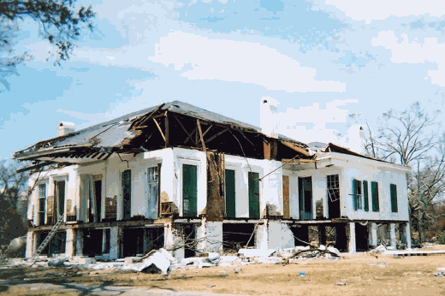

Figure 20: Katrina Sculptures, Biloxi Artist: Marlin Miller
Image: (Elizabeth Englebretson 2013)

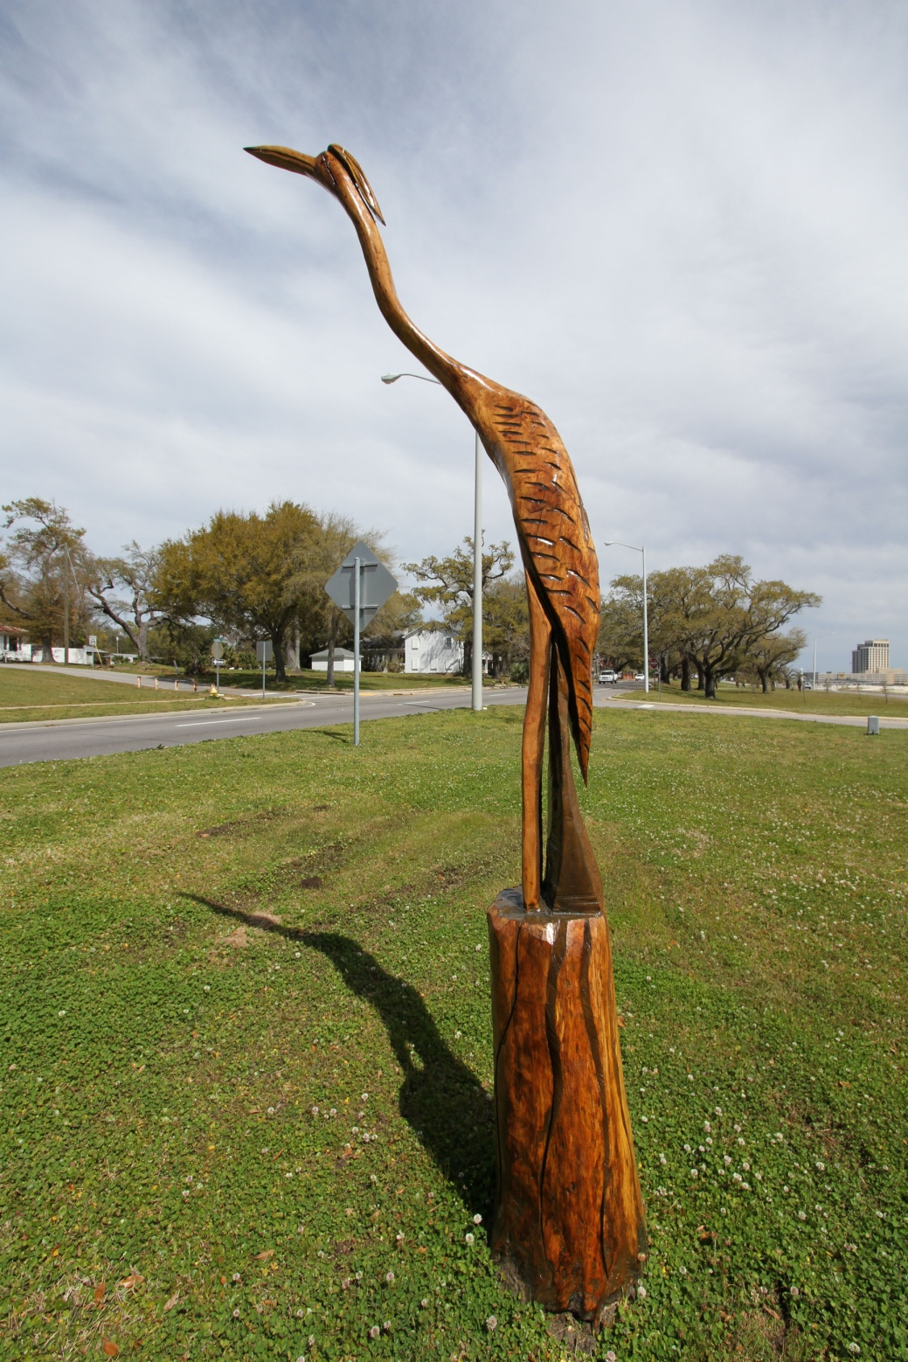
Figure 21: Ike Tree Sculpture, Galveston Artist: Earl Jones
Image: (farm6.staticflickr.com/5305/5560564749_eb40190178_z.jpg 2013)

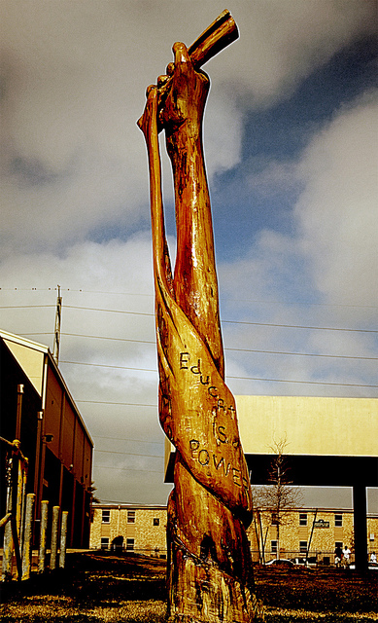

Figure 22: K-lines, East Biloxi
Image: (Elizabeth Englebretson 2013)

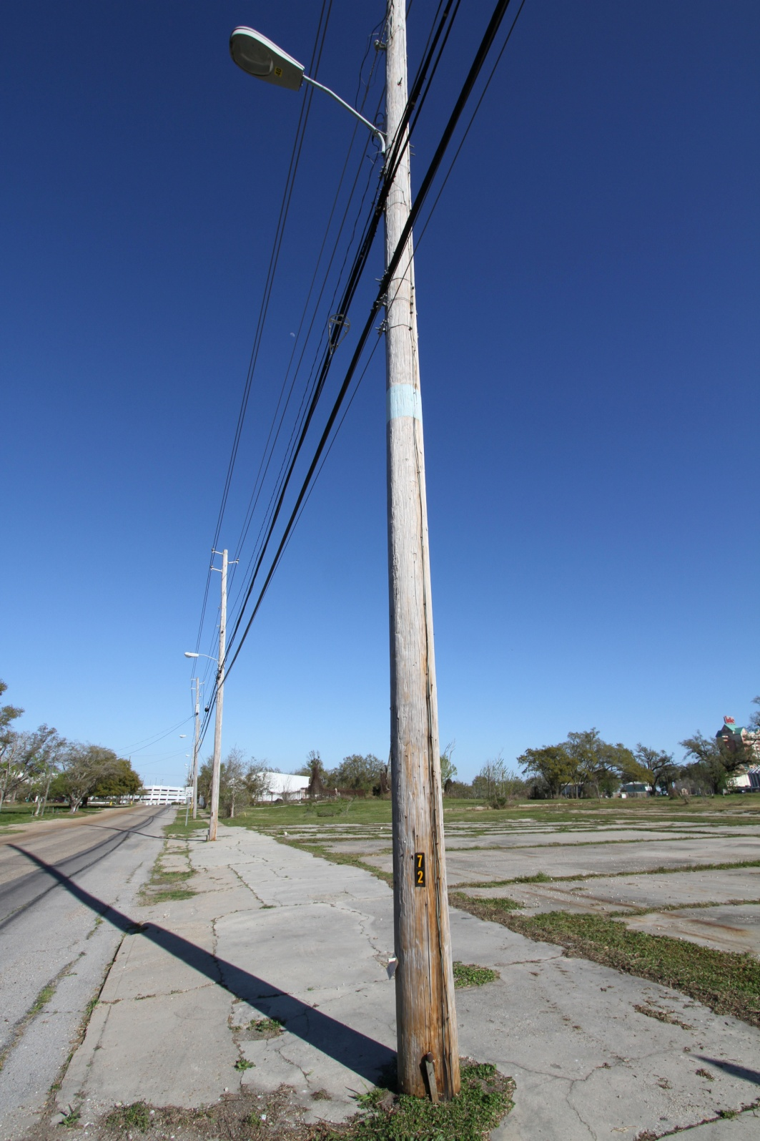

Figure 23: K-lines, East Biloxi
Image: (Elizabeth Englebretson 2013)

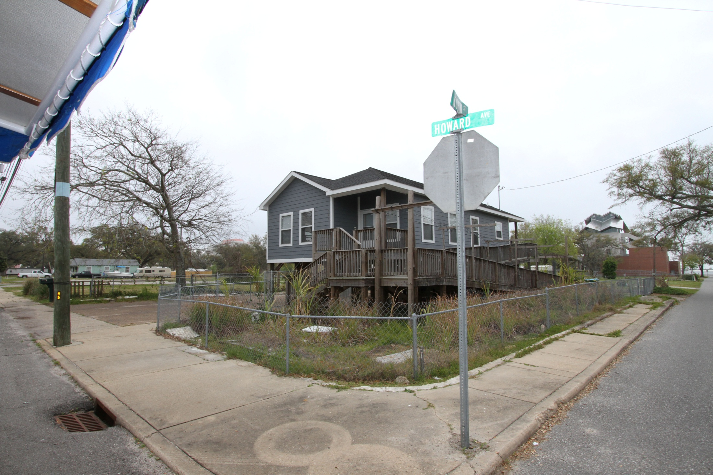

Figure 24: Ike Plaque, Galveston
Image: (Elizabeth Englebretson 2013)

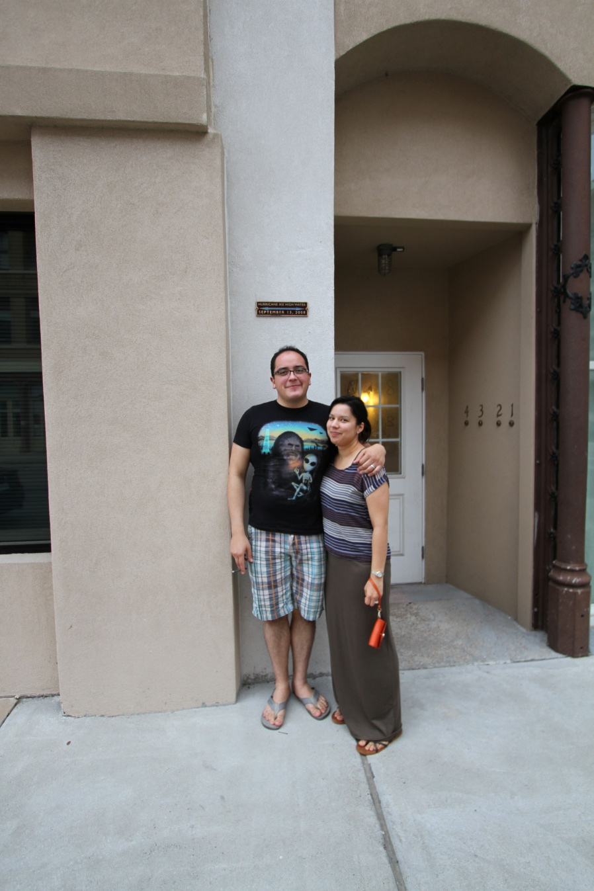

Figure 25: Bayou-Auguste Plan, Biloxi
Image: (GCCDS 2011)

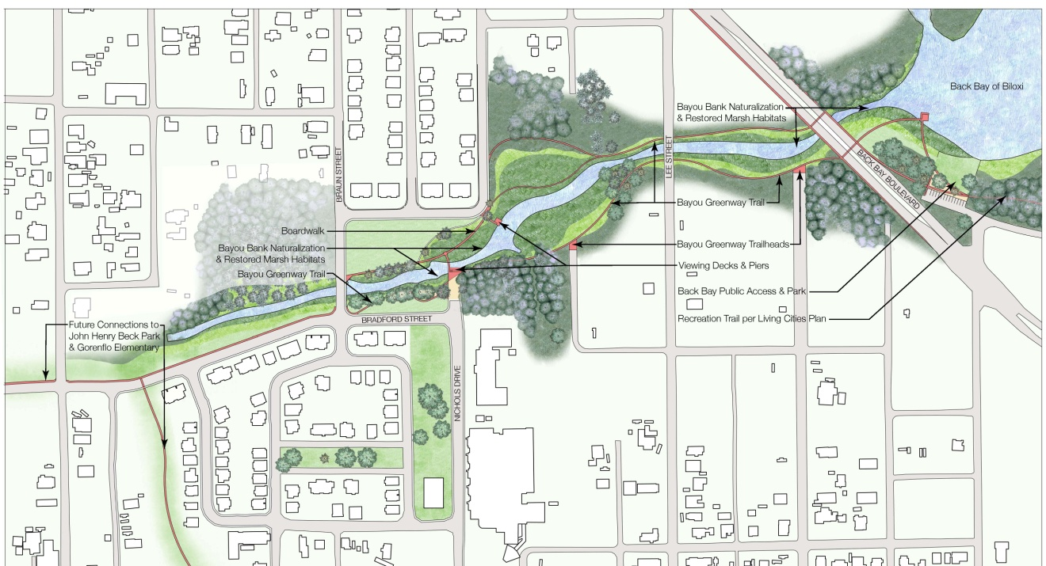

Figure 26: Pleasure Pier, Galveston
Image: (www.pleasurepier.com 2013)

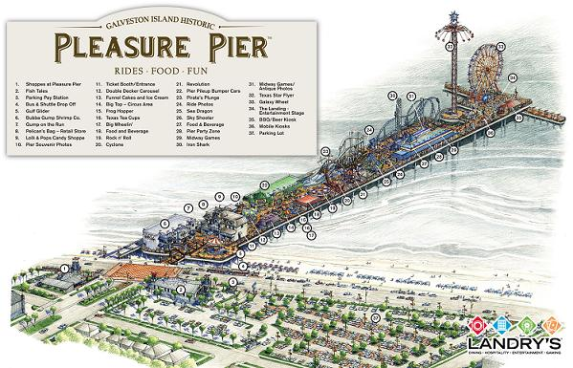 .
FIGURE 27: Proposed Ike Dike, Galveston
Image: (Hamilton and Thevenot 2010)
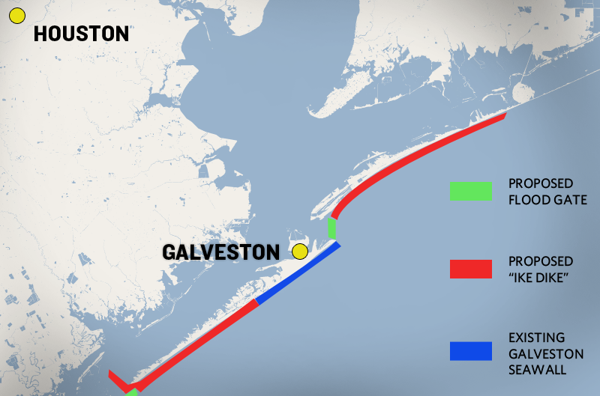

CHAPTER 7

CONCLUSIONS and RECOMMENDATIONS
7.1 Summary
According to the NOAA, the United States is affected by an average of 1.8 hurricanes a year, with two major hurricanes striking the United States coast every three years (Blake et al. 2011). Hurricane Katrina was rated by the NHC as a category 3 storm, and caused the destruction of ninety percent of the housing in East Biloxi, and the storm surge from Hurricane Katrina was documented at twenty-four feet in parts of the city (Architecture for Humanity 2009) (Blake et al. 2011). Hurricane Ike came ashore as a Category 2 hurricane, and was labeled by the NHC as the 2nd costliest and 3rd deadliest hurricane in United States history (Blake et al. 2011). According to the NHC, Hurricane Ike was not even rated on the Saffir/Simpson scale as a major hurricane when it struck the Texas coast. Even with a Category 2 storm, the storm surge that was produced by Hurricane Ike inundated the harbor side of Galveston and was measured in some parts of town at fourteen feet. The cultural landscape and heritage that had grown over generations in Biloxi and Galveston was disrupted, leaving decaying structures, dying trees, or gaping holes, in the urban landscape. In these cities the changed landscape is a constant reminder of the unpredictable, unstoppable, destructive nature of hurricanes.

The effects of climate change and increased coastal development, combined with outdated preparedness, recovery, and rebuilding policies, have left many communities vulnerable to the destructive power of hurricanes. These vulnerabilities are reflected in the loss of life, property, economic stability, and the disintegration of social fabric in communities post-disaster. However, hurricanes are only one of the many risks that create ecological and socioeconomic vulnerability and instability within communities. By lowering the chronic hazards and daily risks a community has to face, we improve the overall resilience of that community to hurricanes and other large-scale disturbances. By approaching the process of hurricane preparedness, recovery, and rebuilding from a more holistic, cultural landscape point of view, communities can address the daily risks such as; lack of access and entitlement to resources, lack of healthy and safe affordable housing, and lack of involvement in civil society, in order to increase the communities’ sustainability and resilience therefore making them less vulnerable to major storm events.
Through the centuries, residents of urban landscapes have become dependent on government-supported civic infrastructure to secure the necessary resources for daily life; clean water, waste removal, electricity, petroleum, and food. The government should be responsible for creating viable infrastructure systems that are safe to fail, and resilient enough to rebound quickly and efficiently post-hurricane or other disaster. Statistically we know that the next major hurricane will happen. What we cannot predict is where it will strike, or with what level of intensity and destruction. In order to become resilient to the next major storm event, all potentially affected communities must plan and design to become more resilient on a daily basis.
Reconnecting communities to their landscape in Biloxi and Galveston has proved to be a complex process for both cities. External and internal organizations involved in the process of response, recovery, and rebuilding are faced with complex community dynamics. Despite perhaps the best intentions, many external aid organizations have been unable to work efficiently, or closely enough with the communities to provide for the immediate as well as long-term needs of reconnecting the community to landscape. Federal and state reimbursements have been applied slowly and erratically in Biloxi and Galveston. Some communities in Biloxi waited four or more years for FEMA financial aid to arrive to start rebuilding. Communities in Galveston are still waiting. In Biloxi some residents no longer felt they could depend on FEMA for long-term preparedness and post-disaster responsiveness. Community members have been questioning whether it is worth paying for flood insurance, when the monthly cost of insurance tripled for some homeowners after Hurricane Katrina. If another such hurricane impacts their community, many people will not try to rebuild again. In Galveston, many residents of the North of Broadway Neighborhood expressed distrust in the intentions of government rebuilding programs, and were left wondering why their community has not been rebuilt in the five years since Hurricane Ike.
Rebuilding after a disaster of any magnitude takes time, may often be blocked or detoured, and requires great patience. But in some cases there is no rebuilding at all, just stagnation. There needs to be hope that through these slower recovery times will come more participatory, resilient and sustainable communities. There needs to be movement forward. I would argue that communities are often willing to change if there is a hope for a better future. There were several times during my informal conversations in Biloxi and Galveston when people said major changes(good or bad) would not have been possible without the storm. Historically, disasters and other large-scale disturbances have been a catalyst for urban change. Through the complete destruction of landscape, a large-scale redevelopment of the urban environment becomes possible. But even after FEMA went through an overhaul post- hurricane Katrina, their policies still remain not very forward- thinking. The money that FEMA allocates to cities to help rebuild infrastructure is very controlled, and is only allocated to rebuild ‘as was’, i.e., to pre-disaster specifications. Additional funding from the city government, grants, donations, and private investments are required for communities to upgrade current infrastructure and building techniques. State governments are left to supplement the cost for any additional improvements. The same system is in place for homeowners who are often left to find funding and support to update and rebuild their properties. There is often very little budget for improvements, and redesign attempts may be misguided because of a lack of funding, as well as the use of volunteers who may not be held accountable for their work.
The current vulnerability, and lack of preparedness, of many communities to hurricane events leaves them dependent on the effectiveness of the external and internal organizations responding during recovery, and rebuilding. If the nation is committed to moving toward a more sustainable future, we need to have policies and procedures that support sustainable design included in our disaster recovery and rebuilding policies on a federal, state, and local level. There are two major actions that could be taken to further streamline the FEMA response to hurricane events and make recovery and response more efficient and effective:
- FEMA needs to have more direct response. Through a community-based local organization FEMA could provide an emergency lump sum loan, and the money could then be allocated directly to the community in the form of micro loans. This would put money where it is needed most without having to wait for a Federal response to each individual community member’s level of need during recovery and rebuilding. Appropriate safeguards against fraud and mismanagement would still be required, however.

- Redevelop funding structure so that cities can upgrade while rebuilding and are not bound by FEMA to just replace ‘as was’ if they have a definite plan in place.

As part of FEMA’s community preparedness agenda, the agency should be restructured again to include groups of planners, designers, engineers and scientists who can investigate possible alternative design interventions that can readily be implemented to improve community sustainability and resilience before the next major storm event. Proactively incorporating landscape architects, engineers, and planners into a federal program licensing program , much like the system set up by the USGBC LEED program, could establish a group of qualified design firms that can be certified, or licensed by FEMA, as ‘disaster ready’, and able to accept and direct revolving community loans to jump-start the recovery process. The partnership between the Hope Center and the GCCDS, which worked together to produce maps and a grid system post Katrina, serves as a model for organizing the recovery and response to hurricanes. The partnership that was set up immediately following Hurricane Katrina helped to prevent system waste, and provide accountability for organizations working in the grid map system laid out by Hope Center and GCCDS.
The Hope Center and the GCCDS focuses on rebuilding resilient communities by keeping community residents directly involved in the design the process. The GCCDS also emphasizes the importance of keeping quality design in the rebuilding process, and encourages the use of quality materials. Building homes back using the GCCDS system of individualized, thoughtful, and well-executed design, maintains an organic form of neighborhood that does not just repeat the same three or four cookie-cutter designs over and over. During the GCCDS design and rebuilding process, homeowners met with the individual architects to discuss the homeowners’ particular design needs, and areas for improvement, enabling homeowners to create unique architecture to meet their individual needs. The model set up by the GCCDS empowers community members in their daily as well as future choices, and offers options for their community, reinforcing their sense of place and connection to the landscape. Sense of place and cultural landscape are vital, often overlooked pieces of design. These site-specific political, social, economic, and design responses from Biloxi and Galveston exemplify the importance of approaching each city, and even each specific community within the city, as culturally unique in their process of recovery and rebuilding. Community members need to be empowered as part of the planning, designing, and rebuilding process, in order to reconnect or maintain their connection with the landscape. It is also important for community members to have a stake, some ‘sweat equity’, in the rebuilding of their homes and communities, reinforcing a sense of place and responsibility to their landscape during the long, difficult process of rebuilding.
Disaster recovery and rebuilding, is a challenging process, often taking years, if not decades. Some parts of cities are destroyed and never rebuilt, altering the cultural landscape permanently. Because at this period in time scientists and engineers cannot control nor prevent the destructive forces of hurricanes, we need to focus on reducing daily risk to communities, streamlining the governmental recovery effort, and advocating for innovation in design to bring urban infrastructures up to date. Landscape architects, architects, engineers, and urban planners must implement and advocate for the use of alternative energy, intensive stormwater management systems, designs that increase public health, and designs focused on strengthening the community connection to the landscape, to decrease daily risks and increase resilience to small-scale disturbances as well as the unpredictable large-scale future effects of hurricanes.

APPENDIX A

The Ten Melbourne Principles for Sustainable Cities
(UNDEP 2002)

1. Provide a long-term vision for cities based on sustainability.
2. Empower people and foster participation and inter-generational equity.
3. Recognize and build on the characteristics of cities including their human, cultural, historic and natural systems.
4. Build on the characteristics of ecosystems
5. Achieve long term economic and social security.
6. Expand and enable cooperative networks to work towards a common sustainable future.
7. Enable communities to minimize their ecological footprint through the redevelopment and operation of their urban metabolism.
8. Enable continual improvement, accountability and transparency.
9. Require effective demand management and appropriate use of environmentally sound technologies for cities
10. Recognize the intrinsic value of biodiversity and natural ecosystems and their protection and restoration.

APPENDIX B

National Register Of Historic Places
Listings in Mississippi as of December 31, 2008
(Mississippi Heritage Trust 2007)

Harrison County
** Bailey House (Holy Angels Nursery) (Biloxi MRA) (Removed 5 Nov 2008) Biloxi 18 May 1984
Barq, E., Pop Factory (Biloxi MRA) Biloxi 18 May 1984
Bass, Raymond Site (22-Hr-636) (A) Biloxi 26 Feb 1987
Beauvoir (NHL) Biloxi 3 Sep 1971
Benton, Thomas & Melinda, House Gulfport 9 Aug 2002
Biloxi Downtown Historic District Biloxi 3 Sep 1998
Biloxi Garden Center (See Old Brick House)
Biloxi Lighthouse Biloxi 3 Oct 1973
** Biloxi’s Tivoli Hotel (Trade Winds) (Biloxi MRA) (Removed 5 Nov 2008) Biloxi 18 May 1984
Bixoxi Veterans Administration Medical Center (F) Biloxi 14 Feb 2002
Bond House (Biloxi MRA) Biloxi 18 May 1984
**Brielmaier House (Biloxi MRA) (Removed 16 Jul 2008) Biloxi 18 May 1984
Brunet-Fourchy House (Mary Mahoney’s) (Biloxi MRA) Biloxi 18 May 1984
**Church Of The Redeemer (Biloxi MRA) (Removed 5 Nov 2008) Biloxi 18 May 1984
Clemens House (Biloxi MRA) Biloxi 18 May 1984
Dantzler, G. B., House Gulfport 1 Dec 1989
**Fisherman’s Cottage (Biloxi MRA) (Removed 16 Jul 2008) Biloxi 9 Mar 1990
Fort Massachusetts (Ship Island) (F) Gulfport Vicinity 21 Jun 1971
French Warehouse (Gulf Islands NTL SS) (22-Hr-638) (A) (F) Biloxi 13 Dec 1991
**Gillis House [Relisted - 1978] (Removed 16 Jul 2008) Biloxi 7 Jul 1978
Grass Lawn (See Milner House)
Gulf Coast Ctr. For The Arts (Old Library) (Biloxi MRA) Biloxi 8 May 1984
Harbor Square Historic District Gulfport 13 Aug 1985
**Hermann House (Biloxi MRA) (Removed 5 Nov 2008) Biloxi 18 May 1984
Hewes Building Gulfport 7 Oct 1982
**Hewes, Finley B., House (Removed 16 Jul 2008) Gulfport 15 Aug 2002
Holy Angels Nursery (See Bailey House)
**House At 121 West Water Street (Biloxi MRA) (Removed 16 Jul 2008)
Biloxi 18 May 1984
House At 407 E Howard Ave Biloxi 17 Jul 1986
Josephine (Shipwreck) (22-Hr-843) Biloxi Vicinity 22 Nov 2000
Magnolia Hotel Biloxi 14 Mar 1973
** Margaret Emilie (Schooner) (Delisted 1989) Biloxi 1973
Mary Mahoney's (See Brunet-Fourchy House)
**Milner House (Grass Lawn) (Removed 16 Jul 2008) Gulfport 31 Jul 1972
Nativity B.V.M. Cathedral (Biloxi MRA) Biloxi 18 May 1984
Old Brick House (Biloxi Garden Center) Biloxi 3 Oct 1973
Peoples Bank Of Biloxi (Biloxi MRA) Biloxi 18 May 1984
Quarles, W. J., House Long Beach 16 Oct 1980
Redding House (Biloxi MRA) Biloxi 18 May 1984
**Reed, Pleasant, House (Reed House) (Removed 16 Jul 2008) Biloxi 11 Jan 1979
Saenger Theater (Biloxi MRA) Biloxi 18 May 1984
Scenic Drive Historic District Pass Christian 7 May 1979
Scherer House (Spanish House) (Biloxi MRA) Biloxi 18 May 1984
Seashore Campground School (Biloxi MRA) Biloxi 18 May 1984
Spanish House (See Scherer House)
Suter House (Biloxi MRA) Biloxi 18 May 1984
Swetman, Glenn, House (Biloxi MRA) Biloxi 18 May 1984
Tivoli Hotel (See Biloxi's Tivoli Hotel)
**Toledano/Philbrick/Tullis House (Removed 16 Jul 2008) Biloxi 5 Nov 1976
Trade Winds (See Biloxi's Tivoli Hotel)
Turkey Creek Community Historic District Gulfport 21 Mar 2007
U.S. Post Office & Customhouse (F) Gulfport 19 Mar 1984
U.S. Post Office, Courthse & Customhse/Biloxi City Hall Biloxi 30 Jan 1978
West Beach Historic District (Biloxi Mra) Biloxi 18 May 1984
West Central Historic District (Biloxi Mra) Biloxi 18 May 1984
West Central Historic District (Addl Documentation)

APPENDIX C
Six statutes enacted by the 109th Congress
(Bea 2006)

November 15, 2006
“Six statutes enacted by the 109th Congress are notable in that they contain changes that apply to future federal emergency management actions. These public laws include the following:

- Title VI of P.L. 109-295 (H.R. 5441), the Post-Katrina Emergency Management Reform Act of 2006, referred to in this report as the Post-Katrina Act;
- Sections of P.L. 109-347 (H.R. 4954), the Security and Accountability for Every Port Act of 2005, known as the SAFE Port Act;
- P.L. 109-308 (H.R. 3858), the Pets Evacuation and Transportation
Standards Act of 2006;
- P.L. 109-63 (H.R. 3650), the Federal Judiciary Emergency Special
Sessions Act of 2005;
- P.L. 109-67 (H.R. 3668), the Student Grant Hurricane and Disaster
Relief Act; and
- Sections of P.L. 109-364 (H.R. 5122), the John Warner National
Defense Authorization Act for Fiscal Year 2007.

Most of these statutes contain relatively few changes to federal authorities related to emergencies and disasters. The Post-Katrina Act, however, contains many changes that will have long-term consequences for FEMA and other federal entities. That statute reorganizes FEMA, expands its statutory authority, and imposes new conditions and requirements on the operations of the agency.”

APPENDIX D

Acronyms
ABFE -Advisory Base Flood Elevations

BHA- Biloxi Housing Authority

CATS- Center for Applied Transect Studies

CNU- Congress for the New Urbanism

DCF- Disaster Contingency Fund

FEMA- Federal Emergency Management Agency

FIRM- Flood Insurance Rate Maps

GCCDS- Gulf Coast Community Design Studio

GCRR- Galveston County Restore and Rebuild

GHA-Galveston Housing Authority

GHF- Galveston Historic Foundation

HMGP- The Hazard Mitigation Grant Program

HUD- Housing and Urban Development

HUL-Historic Urban Landscapes

IPCC- United Nations International Panel on Climate Change

LEED- Leadership in Energy and Environmental Design

MCOA-Mississippi Casino Operators Association

MDAH- Mississippi Department of Archives & History

MEMA - Mississippi Emergency Management Agency

MHT- The Mississippi Heritage Trust

NFIP- National Flood Insurance Program

NHC- National Hurricane Center

NOAA- National Oceanic and Atmospheric Administration

NPS- The National Park Service

NWS- National Weather Service

SOI- The Secretary of the Interior

SFHA- Special Flood Hazard Area (the 100-year base flood plain).
SSPEED- Severe Storm Prediction, Education and Evacuation from Disasters Center
TEMA- Texas Emergency Management Agency

ULI- Urban Land Institute

UNDP- United Nations Development Programme

UNEP- United Nations Environment Program, Governing Counsel IPCC

UNFCCC- United Nations Framework Convention on Climate Change

USGBC- United States Green Building Council

WMO- World Meteorological Organization, Executive Counsel IPCC

BIBLIOGRAPHY

Adger, W. N. "Social and Ecological Resilience: Are they Related?" Progress in Human Geography 24.3 (2000): 347-64. Print.
Adger, W. Neil, and P. Mick Kelly. "Social Vulnerability to Climate Change and the Architecture of Entitlements." Mitigation and Adaptation Strategies for Global Change 4.3/4 (1999): 253-66. Print.
Alvermann, D. E., & Mallozzi, C. A.Interpretive research. In A. McGill-Franzen & R. L. Allington (Eds.), Handbook of Reading Disability Research.(2010): 488-498. New York: Routledge. Print.
Architecture for Humanity. Biloxi Model Home Program. Biloxi, MS: Architecture for Humanity.(2009). Print.
Architects For Humanity. (2013). Web. http://architectureforhumanity.org/.
Art Can Change Everything.( 2013). Web. http://artcanchangeeverything.com/press- releases.html.
Associated Press. "Galveston agrees on plan for rebuilding Ike-damaged public housing." (Tuesday, August 28 2012). Web. http://www.abclocal.go.com/ktrk/.
Baca, Keith A. Native American Place Names in Mississippi. Jackson, MS, University Press of Mississippi. (2007). Print
Balch & Bingham LLP. B&B Review The Mississippi Gaming Update Commission Meetings of September 29, October 27, and November 17, 2005. Sept., Oct., Nov. 2005 ed. Mississippi: Balch & Bingham LLP.(2005). Print.
Bea, Keith., United States. Federal Emergency Management Agency, Library of Congress ,Congressional Research Service. Federal Stafford Act Disaster Assistance Presidential Declarations, Eligible Activities, and Funding. [Washington, D.C.]: Congressional Research Service, Library of Congress.(2006). Print.
Bearden, Tom. "Rebuilding A Community Health Center Following A Natural Disaster: Interview in Biloxi, Mississippi." Health affairs 26.5 (2007)Print.
Bedient, Dr Philip B.; J. D. Blackburn Jim; Antonia Sebastian. SSPEED (Severe Storm Prediction, Education and Evacuation from Disasters Center )Center Phase I Report Learning the Lessons of Hurricane Ike: Preparing for the Next Big One. Houston, TX: Rice University.(November, 2011). Print.

Begley, Dug . Funding loss threatens Isle bus service. Transportation section .Houston Chronicle.(March 18, 2013).Web. http://www.houstonchronicle.com/news/houston-texas/houston/article/Funding-loss-threatens-Isle-bus-service-4362198.php.
Berg, Robbie. "Tropical Cyclone Report Hurricane Ike,1-14 September 2008." AL0929008.National Hurricane Center.(2009).Print.
Bernstein, Lenny; R. K., Pachauri; Andy, Reisinger. Intergovernmental Panel on Climate Change. Climate Change 2007 : Synthesis Report. Geneva, Switzerland: IPCC. (2008). Print.
Bernstein, Mark. Rand Gulf States Policy Institute. "Rebuilding housing along the Mississippi Coast ideas for ensuring an adequate supply of affordable housing." (2006). Web.
Birch, Eugenie Ladner; Susan M. Wachter. Growing Greener Cities : Urban Sustainability in the Twenty-First Century. Philadelphia: University of Pennsylvania Press. (2008). Print.
Blackwell, Marlon. "Architecture in a Landscape of Unholy Unions." Journal of Architectural Education 63.1. (2009).Print.
Blake, Eric S.; et al. " NOAA Technical Memorandum NWS NHC-6 the Deadliest, Costliest, and most Intense United States Tropical Cyclones from 1851 to 2010 (and Other Frequently Requested Hurricane Facts)." National Weather Service , National Hurricane Center, Miami, Florida. (2011).Print.
Blasingame Custer, Janna. "New Urbanism and Euclidian Zoning: Can they Co-Exist?" . Paper 17 Vol. University of Georgia, Georgia Law: Land Use Clinic.(2007). Print.
Boat People SOS. Community Profile Biloxi, Mississippi. BPSOS .(2011). Web. http://www.bpsos.org/mainsite/where-we-work/us-branches/gulf- coast/community-profile.html.
Boudreaux Jr., Edmond. History of Biloxi. City of Biloxi.(2013).Web. http://biloxi.ms.us/history/.
Butler III, Patrick H. "Moody, William Lewis, Jr.," Handbook of Texas Online. Texas State Historical Association. (2013). Web. http://www.tshaonline.org/handbook/online/articles/fmo22.
Chambers, Robert. "Editorial Introduction: Vulnerability, Coping and Policy." IDS Bulletin 20.2: 1-7.(1989).Print.
City of Biloxi. "Comprehensive Plan." (December, 2009).Web. http://www.biloxi.ms.us/CompPlanDraft.htm.
City of Biloxi. Biloxi History.(2013).Web. http://www.biloxi.ms.us. .
City of Galveston Tree Committee, Galveston Island Tree Conservancy, Texas Forest Service. "Galveston Releaf: A Strategic Plan for Replanting." (November 2010).Web.
Clancy, Goody and Living Cities. "Moving Forward: Recommendations for Rebuilding East Biloxi.".( 2006). Print.
Comerio, Mary C. "Housing Issues After Disasters." Journal of Contingencies and Crisis Management 5.3 (1997):166-78. Print.
Council of Europe. European Landscape Convention Explanatory Report. 20.X.2000 Vol. Florence: Council of Europe, 2000. Print.
Cressey, Daniel. Faculty Cut at Hurricane-Hit Texas University. Nature News Blog: Nature Publishing Group, a division of Macmillan Publishers, December 2, 2008. Print.
Cuff, Dana; Roger, Sherman. "Fast-forward urbanism rethinking architecture's engagement with the city." 2011.Print.
Delurey, Michael; David, Sulek; Lawrence, Frascella. "S+B CASE STUDY - Convenors of Capability - the Hope Community Center in Biloxi, Mississippi" Strategy & business.50 (2008): 90. Print.
Diamond, Jared M. Collapse : How Societies Choose to Fail Or Succeed. New York: Viking, 2005. Print.
Doran, Kara S. Hurricane Ike : Observations and Analysis of Coastal Change. [S.l.]: Bibliogov, 2013. Print.
Dorney, Diane. The Mississippi Renewal Forum - Summary Report. Congress for the New Urbanism. November 2005. Print
Ellis, Sue; Sultan Barakat. "From Relief to Development: The Long-Term Effects of Temporary Accommodation on Refugees and Displaced Persons in the Republic of Croatia." Disasters 20.2 (1996):111-24. Print.
FEMA. Hurricane Katrina in the Gulf Coast: Mitigation Assessment Team Report, Building Performance Observations, Recommendations, and Technical Guidance. FEMA 549. July,2006. Print.
FEMA.2013.Web. http://www.fema.gov/.
FEMA."The Stafford Act: Robert T. Stafford Disaster Relief and Emergency Assistance Act, as Amended". Located in United States Code, Title 42. The Public Health and Welfare, Chapter 68. Disaster Relief. FEMA. (April 2013). Print.
Florida Planning and Development Lab Department of Urban & Regional Planning Florida State University. East Biloxi Community Benefits Report. Florida State University. (October 2008). Print.
Ford;Powell;Carson. University of Texas Medical Branch UTMB Master Facilities Plan 2010-2035. University of Texas Medical Branch, Galveston. (2010). Print
Freiberg, Noga; Victoria, Zhugalo Luda. Environment Protection Authority. UNEP International Environmental Technology Centre., United Nations Environment Program, Division of Technology, Industry and Economics, Melbourne (Vic.). Council, Melbourne Principles for Sustainable Cities : [Developed at an International Charrette Held in Melbourne (Australia) between 3 and 5 April. Melbourne, Vic.: United Nations Environment Program, Division of Technology, Industry and Economics. (2002). Print.
Galveston Art League.Galveston Texas.(2013).Web. www.galvestonartleague.com

Galveston Bay Geography.(2013). Web.
http://www.gbep.state.tx.us/about-galveston-bay/geography.asp.
Galveston Island Convention & Visitors Bureau. Tree Sculpture Tour. Galveston Island, Texas: Galveston Island Convention & Visitors Bureau.(2013). Print.
Galveston Island Tree Conservancy.(2013).Web. http://galvestonislandtreeconservancy.org/
Galveston Island Historic Pleasure Pier. (2013). Web. http://www.pleasurepier.com/history.html
Galveston Seawall Cam.(2013).Web.http://www.galveston.com/seawallcam/.
Garfí, Marianna, et al. "Evaluating Benefits of Low-Cost Household Digesters for Rural Andean Communities." Renewable & Sustainable Energy Reviews 16.1 (2012):575-81. Print.
Gerber, Brian J.; Scott E. Robinson. "Local Government Performance and the Challenges of Regional Preparedness for Disasters."Public Performance & Management Review 32.3.(2009): 345-71. Print.
Gray, David E. Doing Research in the Real World. London: Sage Publications.(2004). Print.

Gulf Coast Community Design Studio (GCCDS). Bayou-Auguste Master Plan. (2011).Print.

Hamilton, Mike. HB 2694: Bill Analysis. House Research Organization. (5/2/2007). Print.

Hamilton, Reeve; Thevenot, Brian. "Hurricane Ike Awakened Region to Dire Flooding Threats" Texas Tribune.(September 14, 2010). Print
Hanley, Ted. "The Sprout: The Jesse Tree's Newsletter." The Sprout. (February 2012). Print.
Harrison County History. (2013). Web. http://www.ms1stop.com/customers/harrisonco/history.htm
Hayden, Dolores. The Power of Place : Urban Landscapes as Public History. Cambridge, Mass.: MIT Press.(1995). Print.
Holloway, AJ; Lt Gen Clark Griffith. "Building Our Future Embracing Our Past." Reviving the Renaissance; the City of Biloxi.(July 20, 2006).Web. http://biloxi.ms.us/pdf/RTR07202006.pdf.
Holsten, James. "Cities and Citizenship." TLS, the Times literary supplement.5037.(1999): 37. Print.
Hope Community Development Agency. Rebuilding Biloxi: Lessons Learned From Katrina. Gulf Coast Community Design Studio.(2013).Web.
http://www.mitigationleadership.com/pdf/Stallworth_Panel2.pdf.
Hultman, Nathan E.; Alexander S. Bozmoski. "The Changing Face of Normal Disaster: Risk, Resilience and Natural Security in a Changing Climate." Journal of International Affairs 59.2 (2006): 25-41. Print.
IPCC. Intergovernmental Panel on Climate Change., Working Group II, Intergovernmental Panel on Climate Change. Climate Change 2007 : Impacts, Adaptation and Vulnerability : Working Group II Contribution to the Fourth Assessment Report of the IPCC Intergovernmental Panel on Climate Change. Geneva: IPCC Secretariat.(2008). Print.
IPCC. "Intergovernmental Panel On Climate Change development, Sustainability And Equity proceedings Of The Second IPCC Expert Meeting On Des
Supporting Material Prepared for Consideration by the Intergovernmental Panel on Climate Change. this Supporting Material has Not been Subject to the Formal IPCC Review Processes .Edited by Ramon Pichs, Rob Swart, Neil Leary and Flo Ormond Compiled by Ramon Pichs the Activity was Held in Support of the Development of IPCC's Third Assessment Report, Pursuant to a Decision of the Relevant Working Groups II and III of the Panel but such Decision does Not Imply Working Group Or Panel Endorsement Or Approval of the Proceedings Or any Recommendations Or Conclusions Contained Therein." (Havana, Cuba 23-25 February 2000).Print.
IPCC. Report of the Joint IPCC WG II & III Expert Meeting on the Integration of Adaptation, Mitigation and Sustainable Development into the 4th IPCC Assessment Report . St Denis, Reunion Island, France: IPPCC.(February 16–18, 2005). Print.
Jordan, Andrew; John Greenaway. "Shifting Agendas, Changing Regulatory Structures and the 'New' Politics of Environmental Pollution: British Coastal Water Policy, 1955-1995." Public Administration 76.4 (1998):669. Print.
Joyner, Brian D. "Historic Preservation in the Aftermath of Katrina." Heritage Matters (March, 1, 2006):1.Print.
Kelly, P. M.; W. N. Adger. "Theory and Practice Assessing Vulnerability to Climate Change and Facilitating Adaptation." Climatic Change 47.4.(2000)Print.
Klein, Naomi. The Shock Doctrine : The Rise of Disaster Capitalism. New York: Metropolitan Books/Henry Holt.(2007). Print.
Knabb, Richard D.; Rhome, Jamie R.; Brown, Daniel P. "Tropical Cyclone Report: Hurricane Katrina, August 23-30, 2005." Fire Engineering.(2006).Print.
Krauss, Clifford; James C., McKinley Jr. "Damage Extensive as Storm Batters Texas.(National Desk)." The New York Times 157.54433.(2008).Print.
Kwon, Miwon. One Place After another : Site-Specific Art and Locational Identity. Cambridge, Mass.: MIT Press.(2002). Print.
Lau, Joseph. "Helter Shelter: Housing Disaster Survivors, the Vancouver Model." M.Arch. DalTech - Dalhousie University (Canada). (1998). Print.
Lewis, Jim. "Battle for Biloxi.(Magazine; Rebuilding Urban Areas Post Hurricane Katrina)." The New York times magazine. (2006): 100(L). Print.
Lefebvre, Henri. Urban Landscape History: The Sense of Place and the Politics of Space. The Production of Space, Chapter 2. Victoria, Australia. Blackwell.(1991). Print.
Longstreth, Richard W. Cultural Landscapes : Balancing Nature and Heritage in Preservation Practice. Minneapolis: University of Minnesota Press.( 2008). Print.
Lopez, Russ. Building American Public Health : Urban Planning, Architecture, and the Quest for Better Health in the United States. New York, NY: Palgrave Macmillan.(2012). Print.
Lord, Jerry Joseph. "The charging of the flood a cultural analysis of the impact and recovery from Hurricane Ike in Galveston, Texas." Dissertation University of Texas at Austin. (2011).Print.
Lunney, Kellie. "A Tale of Two Cities.(Post Disaster Reconstruction)." National journal 38.30. (2006).Print.
McLeod, Douglas E. The Moody Family. Texas Heritage Magazine. Issue 4. (2012). :9-15. Print
McHarg, Ian L. American Museum of Natural History. Design with Nature. Garden City, N.Y.: Published for the American Museum of Natural History [by] the Natural History Press. (1969). Print.
McKee, Yates. "Haunted Housing: Eco-Vanguardism, Eviction, and the Biopolitics of Sustainability in New Orleans." Grey Room 30, Grey Room Inc. and the University of Massachusetts Institute of Technology Winter. (2008): 84-113. Print.
MDAH. Mississippi Department of Archives and History.(2013). Web. http://mdah.state.ms.us/index.html.
Meinig, D. W.; John Brinckerhoff, Jackson. The Interpretation of Ordinary Landscapes : Geographical Essays. New York: Oxford University Press. (1979). Print.
Meyers, Rhiannon. "Groups give views on rebuilding Galveston public housing."(January 14, 2010).Web. http://www.khou.com/news/Groups-give-views-on-GHA- rebuilding.
Mississippi Department of Archives and History. Mississippi History Timeline. Mississippi Department of Archives and History. (2013). Web. http://mdah.state.ms.us/
Mississippi Division Sons of Confederate Veterans,. Beauvoir. Biloxi, MS 2012. Web. http://www.beauvoir.org/about/index.html
Mississippi Renewal Forum, Congress for the New Urbanism. Mississippi Governor's Commission on Recovery, Rebuilding, and Renewal. "Mississippi Renewal Forum, Summary Report : Recommendations for Rebuilding the Gulf Coast". Gaithersburg, MD: The Town Paper.(2005). Print.
Mississippi Heritage Trust. 10 Most Endangered List 2007. (2013).Web. http://www.mississippiheritage.com/list07.html.
Mitchell, W. J. T. Landscape and Power. Chicago: University of Chicago Press, (1994). Print.
NASA. (2013).Web. www.nasa.gov
National Hurricane Center. (2013). Web. http://www.nhc.noaa.gov/
National Historic Landmark. National Park Service. (2013). Web. http://www.nps.gov/nhl/
Newman, Peter; Timothy Beatley; Heather Boyer. Resilient Cities : Responding to Peak Oil and Climate Change. Washington, DC: Island Press.(2009). Print.
Newman, Peter; Isabella Jennings. Cities as Sustainable Ecosystems : Principles and Practices. Washington, D.C.: Island Press.(2008). Print.
NOAA. Hurricane Ike Synopsis. National Weather Service.(2009). Web. http://www.srh.noaa.gov
NOAA. Hurricane Basics. The COMET Program, University Corporation for Atmospheric Research. (May,1999). Print
Nuwer, Deanne Stephens. The Seafood Industry in Biloxi: Its Early History, 1848-1930. Mississippi History Now. Mississippi Historical Society.(2000–2013). Web. http://mshistory.k12.ms.us/articles/209/the-seafood-industry-in-biloxi-its-early- history-1848-1930.
----------Gambling in Mississippi: Its Early History Mississippi History Now. Mississippi Historical Society. (2005). Web. http://mshistory.k12.ms.us/articles/209/the- seafood-industry-in-biloxi-its-early-history-1848-1930
O'Donnell, Patricia M. "Learning from World Heritage: Lessons from 'International Preservation & Stewardship of Cultural & Ecological Landscapes of Global Significance,' the 7th US/ICOMOS International Symposium." The George Wright Forum 21.2 (2004):41-61. Print.

Pachauri, R. K.; A. Reisinger; Eds. "Contribution of Working Groups I, II and III to the Fourth Assessment Report of the Intergovernmental Panel on Climate Change." Climate Change 2007: Synthesis Report IPCC, Geneva, Switzerland.(2007):104.Print.
PBS NewsHour. Galveston Aims to Build a Healthier City after Ike's Wave of Destruction.(September 22, 2011). Web

Peché, Linda Ho; Amalia. Runnel; Suzanne, Seriff. The Forgotten Gateway: Coming To America Through Galveston Island. Bob Bullock Texas State History Museum. (2009). Print
Pelling, Mark. The Vulnerability of Cities : Natural Disasters and Social Resilience. London; Sterling, VA: Earthscan Publications.(2003). Print.
Perkes, David. "A Useful Practice." Journal of Architectural Education 62.4.(2009)Print.
Planning Services, Inc. New Orleans. Biloxi (Miss.),City Planning Commission. Comprehensive Plan, City of Biloxi, Mississippi. Public Improvements Program. Prepared for Mayor and Commissioners and City Planning Commission, through the Mississippi Research and Development Center and the Gulf Regional Planning Commission. New Orleans: [n.p.].(1971). Print.
Redlener, Irwin. "Americans at risk why we are not prepared for megadisasters and what we can do now."(2006).Web.
Redlener, Irwin, and David A. Berman. "National Preparedness Planning: The Historical Context and Current State of the U.S. Public's Readiness, 1940-2005." Journal of International Affairs 59.2. (2006): 87-103.Print.
Richardson, Todd; Robert Renner. "Staff Studies in Housing and Community Development." Cityscape, Department of Housing and Urban Development 9.1 (2007): 189-215.Print.
Ricklis, Robert A. The Karankawa Indians of Texas: An Ecological Study of Cultural Tradition and Change. Austin: University of Texas Press.(1996).Print.
Sauer, Carl Ortwin. The Morphology of Landscape. New York: Johnson Reprint Corp. (1968).Print.
Scurfield, Raymond. "Post-Katrina Aftermath and Helpful Interventions on the Mississippi Gulf Coast." Traumatology. 12.2 (2006): 104-120.Print.

Select Committee on Hurricane Ike Devastation to the Texas Gulf Coast . House Select Committee On Hurricane Ike Devastation To The Texas Gulf Coast Texas House Of Representatives Interim Report 2008. A Report To The House Of Representatives 81st Texas Legislature.(February 11, 2009). Print
Sigo, Shelly. "Biloxi GOs Get S&P Upgrade Thanks to Post-Katrina Rebuilding." The Bond Buyer, sec. The Regions: 6. (Tuesday, November 14, 2006).Print.
SmartCode Version 9.2. [Ithaca, NY]: The Town Paper. (2009). Print.
Smith, Sonia."What Ike Hath Done, Artists Shall Transform". Texas Monthly.
(February 4, 2012). Print.

St. Vincent's House. Pamphlet.(2013). Print
St. Vincent's House. "Hope Journal." A Newsletter for the Friends of St. Vincent's House 10.1 (2012). Print.
---"Hope Journal." A Newsletter for the Friends of St. Vincent's House 9.1.(2011). Print.
Talen, Emily. "New Urbanism, Social Equity, and the Challenge of Post-Katrina Rebuilding in Mississippi." Journal of Planning Education and Research 27.3 (2008): 277-93.Print.
Taylor, Ken; Jane Lennon. Managing Cultural Landscapes. London; New York: Routledge. (2012).Print.
Texas Legislature, House of Representatives, Select Committee on Hurricane Ike Devastation to the Texas Gulf Coast. House Select Committee on Hurricane Ike Devastation to the Texas Gulf Coast, Texas House of Representatives Interim Report, 2008 : A Report to the House of Representatives, 81st Texas Legislature. [Austin, Tex.]: House Select Committee on Hurricane Ike Devastation to the Texas Gulf Coast.(2009). Print.
UNESCO. Florence Declaration on Landscape. Florence: UNESCO; International Traditional Knowledge Institute.( 2012). Print.
United Nations Development Program. Bureau for Crisis Prevention and Recovery. Reducing Disaster Risk a Challenge for Development : A Global Report. New York, NY: United Nations Development Program, Bureau for Crisis Prevention and Recovery.(2004). Print.
UNDEP. Draft Melbourne Principles United Nations Environment Program. Melbourne, Victoria Australia. United Nations Environment Program. 3 – 5.(April 2002). Print.
United States., Department of the Interior. Charles A., Birnbaum; Christine, Capella Peters. Historic Landscape Initiative (Project). The Secretary of the Interior's Standards for the Treatment of Historic Properties : With Guidelines for the Treatment of Cultural Landscapes. Washington, D.C.: U.S. Dept. of Interior, National Park Service, Cultural Resource Stewardship and Partnerships, Heritage Preservation Services, Historic Landscape Initiative. (1996). Print.
Urbina, Ian. "After Surviving Storm, Fleeing A Fetid, Devastated Galveston.(National Desk)(Galveston Island in Texas After Hurricane Ike)." The New York Times 157.54434. (2008).Print.
US Census Bureau.(2013).Web. http://www.quickfacts.census.gov.
US Highways. US90/Alt US90/Track US90.(2001).Web. http://www.us- highways.com/flus090.htm.
UTMB. The University of Texas Medical Branch. UTMB Master Facilities Plan 2010- 2035. Ford, Powell, and Carlson.(2010). Print.
W. Bartley, Hildreth. "The Financial Logistics of Disaster: The Case of Hurricane Katrina." Public Performance & Management Review 32.3.(2009): 400-36. Print.
Walter, E. V. Placeways : A Theory of the Human Environment. Chapel Hill: University of North Carolina Press.(1988). Print.
Williams, Maggie. Galveston's African American Historic Places and Pioneers; A Guidebook. Ed. Old Central Cultural Center and Galveston Historical Foundation's African American Heritage Committee.(October, 2010). Print.
Wilder, Forrest. Galveston's Nasty Public Housing Debate. The Observer. http://www.texasobserver.org/galvestons-nasty-public-housing-fight/.(April 15, 2012).Web.
Woodhams, Susie. "After Ike, a Deluge of Reinvention." Boston Globe, sec. Travel.( June 5, 2011). Print.
World Meteorological Organization.(2013).Web. http://www.wmo.int/.
World Meteorological Organization. Weather, Climate, Water, Natural Hazards. (2013).Web.http://www.wmo.int/showcase/documents/hazards_wmd.pdf.
Wright, Brian; Mark Zonarich. "Disaster Response Planning and Rebuilding Toolkit." Town Planning and Urban Design Collaborative 1.1. (2011).Print.
Wylie, John. Landscape. London; New York: Routledge.(2007). Print.

See Table 1
See Tables 2 and 3
See Figure 1
“This usage differs from that in the United Nations Framework Convention on Climate Change (UNFCCC), where climate change refers to a change of climate that is attributed directly or indirectly to human activity that alters the composition of the global atmosphere and that is in addition to natural climate variability observed over comparable time periods” (IPCC 2008 ,30).
For the purpose of this research, the terms ‘hazard’ and ‘risk’ will be interchangeable.
For the purpose of this research, the terms ‘resilience’ and ‘sustainability’ will be interchangeable.
For CASE principles, See Appendix A
Biloxi Tour Train is a group-led city tour that involves being towed around by a Jeep Wrangler while seated in a shaded bench seat open air ‘train car’, much like the driving tours at botanical gardens and zoos.
See Figures 2 and 3
See Tables 1 and 2
See Figure 4
See Figure 5
See Figure 6
See Figure 7
See Table 4
See Figures 8 and 9
See Figure 12
See Table 5
According to historian Robert Ricklis, the Karankawas people were a small band of a larger group that occupied the land from the mouth of the Colorado River to northeastern Mexico. The history of this people was mostly lost over time and is largely incomplete. (Ricklis)
See Figure 13
Moody Gardens® is a public, non-profit educational destination utilizing nature in the advancement of rehabilitation, conservation, recreation, and research.
Schlitterbahn Galveston Island Waterpark is also the world's first convertible waterpark and is the third waterpark in the Schlitterbahn family of Texas parks. The summer season offer more than 32 family-friendly attractions.
Hurricane as defined by the WMO “Tropical cyclones are areas of very low atmospheric pressure over tropical and sub-tropical waters which build up into a huge, circulating mass of wind and thunderstorms up to hundreds of kilometers across. Surface winds can reach speeds of 200 km/h or more. About 80 tropical cyclones form every year. Their names depend on where they form: typhoons in the western North Pacific and South China Sea; hurricanes in the Atlantic, Caribbean and Gulf of Mexico, and in the eastern North and central Pacific Ocean; and tropical cyclones in the Indian Ocean and South Pacific region” (World Meteorological Organization 2013).
See Table 6
See Table 7
See Figure 14
See Figure 15
See Appendix C
Director of the CNU (Congress of the New Urbanism)
See Figure 17
See Figure 18
See Appendix C
See Figure 19
See Figure 20
See Figure 21
See Figure 22 and 23
See Figure 24
See Figure 25
See Figure 26
See Figure 27
See Table 7
See Table 7

