IDENTIFYING THE SPATIAL PATTERN OF OFF-ROAD VEHICLE ACCIDENTS IN MICHIGAN’S SILVER LAKE STATE PARK

I-Chun “Nicky” Wu
Department of Community, Agriculture, Recreation, and Resource Studies
Michigan State University
nicky186881@gmail.com

Kimberley Borland
Department of Geography
Michigan State University

Charles Nelson
Department of Community, Agriculture, Recreation, and Resource Studies
Michigan State University

Abstract
A spatial point pattern analysis was performed to examine Off-Road Vehicle (ORV) accident patterns in Silver Lake State Park, Michigan, to assist in accident prevention. The K function was used to identify accident clusters, the kernel intensity function was used to detect accident hotspots, and the independent t-test was used to assess if percent slope was the underlying environmental factor that affects the occurrence of accidents. The results indicated that accidents were significantly clustered. The hotspots were where riders crested hills in the directional zone and encountered an abrupt slope on the back side. Another high-risk area was in directionally unrestricted areas. The t-test confirmed that accidents occurred in the steeper slope areas more frequently than flat areas. Park managers should consider adding unidirectional traffic patterns in areas of poor visibility and requiring reduced speeds near beach areas through an enforced speed limit.

1.0 Introduction
Silver Lake State Park is located in Oceana County, Michigan, along the Lake Michigan shoreline. The state park is famous for its 2,000-acre Silver Lake Sand Dunes that are available for exploration and hiking from April 1st to October 31st each year. In the northern part of the park, a 450-acre area is designated for ORV (off-road vehicle) use where recreationists can ride their ORVs through the sand dunes. The sand dunes, which are visited by 300,000 riders and passengers annually, are appealing to ORV riders because of the steep slopes and constantly changing topography (see Figure 1 for managerial map, Nelson et al. 2010).

<Insert Figure 1 about here>

Based on the results of the 2010 Silver Lake State Park ORV Accident Assessment Report, a total of 880 ORV accidents occurred in the designated ORV area between 2002 and 2009 (Nelson et al. 2010). Of the 880 accidents, 748 (85%) had one or more reported or possible injuries, and five accidents (< 1%) resulted in fatalities. Due to the high injury rate, identifying spatial clusters and where the clusters occurred (hotspots) has become an important task for accident prevention. Additionally, the 450-acre sand dune area contains ridges, steep slopes, and hollows. The Accident Assessment Report (Nelson et al. 2010) shows that eighty-four percent of accidents were caused by riders losing control of their ORV vehicles after cresting the hills. Therefore, we wanted to know if the percent slope affects the occurrence of the ORV accidents in the sand dunes so that proper managerial strategies could be performed to reduce or eliminate accidents.

1.1 Objectives
ORVs were grouped into four types for further analysis: motorcycles/dirt bikes (hereafter motorcycles); ATVs (both three and four wheelers); dune buggies/sand rails (hereafter dune buggies); and trucks/jeeps/SUVs (hereafter trucks). Based on where accidents occurred, there are four objectives of this study:
- Identify the spatial pattern of ORV accidents for each type of vehicle.
- Detect accident hotspots for each type of vehicle.
- Determine if percent slope is the first order property affecting the occurrence of accidents.
- Provide management strategies for accident prevention at Silver Lake State Park.

2.0 METHODS
Original accident data were obtained from the Silver Lake State Park management office. Raw data were recorded in a park-developed accident report and Michigan’s UD-10 accident reporting form by the responding park officers and County Sheriff’s deputy. Accidents did not include Global Positioning System (GPS) coordinates when the responding officer filed the report. Instead, the spatial distribution of accidents was determined based on their marked location on the area map that is part of each park accident report. Accidents that were recorded using a UD-10 form did not provide such location information. A total of 656 accidents that occurred during the seven-year study period had sufficient location information and were placed using Geographic Information System (GIS), ESRI’s ArcGIS 9.3.1. Of the 773 vehicles involved, 389 were ATVs (50.3%), 168 were trucks (21.7%), 113 were motorcycles (14.6%) and 103 were dune buggies (13.3%). Latitude and longitude coordinates for accidents were later projected to Michigan GeoRef coordinates, which uses meters as the measurement unit, to avoid the distortion of using longitude and latitude for statistical analysis.

A 10-meter resolution digital elevation model (DEM) was downloaded from the USGS National Elevation Dataset (NED; USGS National Elevation Dataset 2010) and then imported into GIS to capture the topography of the Silver Lake State Park area. The spatial analyst tool “slope” was used to create the percent slope surface. The percent slope for each accident point was extracted and stored in the attribute table of the accident point shapefile. The attribute table containing vehicle types, x coordinates, y coordinates, and percent slopes were later imported into R software for statistical analysis.

K function and kernel intensity function are two well-established and published statistical methods in geographical epidemiology for detecting prominent disease clusters (see Gatrell et al. 1996 and Wheeler 2007). Given that ORV accidents occur arbitrarily within the park boundary, statistical methods targeted to identify clusters and hotspots were appropriate to achieve our research objectives.

K function describes the spatial pattern of a set of observed point data against a theoretical model called complete spatial randomness (CSR). CSR is when the probability of an occurrence of an observed case is independent of what other data points have occurred and is equally likely over the study region. The outcome of a K function thus displays whether the point pattern departs from randomness in the direction of clustering or regularity (Gatrell et al. 1996, pp. 258-262). To ensure the K function, a statistical assessment (a Monte Carlo simulation process) can be used to generate confidence envelopes along the CSR line for each K function result to test the statistical significance (O’Sullivan & Unwin 2010, p. 148). This study performed both K function and Monte Carlo simulation to examine whether ORV accidents were spatially clustered or regularly distributed.

After determining if accidents are clustered, we need to know where the clusters are located in the study area. A kernel intensity function was used to identify high intensity accident hotspots (see Gatrell et al. 1996, pp. 259-260). Kernel intensity function utilizes a fixed size of bell-shape “kernel” with a reasonable radius. It centers every observed case in the study area to weight the cases within the kernel boundary, and eventually forms an illustration of high intensity hotspots. In addition, to determine if percent slope was affecting the occurrence of accidents, we generated a heterogeneous Poisson model containing 150 randomly distributed points within the study area to compare with the accident points. The percent slope for each heterogeneous Poisson point was derived using the “extract” GIS function from the percent slope surface. An independent t-test was used to compare the mean percent slope of the heterogeneous Poisson points to that of the accident site percent slope.

3.0 Results
The results contain spatial patterns for four types of vehicle accidents and the independent t-test for accident points and heterogeneous Poisson random points.

3.1 Motorcycle Accidents
The graph of the K function for motorcycle accidents (Figure 2) shows statistically significant clustering. The line of small circles rises abruptly within 150 units of h (distance unit), which indicates an excess of motorcycle accidents within short distances; this represents the pattern of spatial clustering. The line of small circles also lies well outside of the Monte Carlo confidence envelope (dotted line) along the theoretical line of zero for CSR. This confirms that the motorcycle accidents are significantly clustered.

<Insert Figure 2 about here>

Contrasted with the managerial map (Figure 1), the kernel intensity function illustration (Figure 3) shows several areas in the northwest and center of the ORV area where motorcycle accident intensity is high. One accident hotspot appears in the south unidirectional zone where motorcycle riders cross the first hill. Another apparent hotspot emerges from a directionally unrestricted area where riders cross the dunes from all directions. Accidents also occur along the shoreline of Lake Michigan and in the last hill of the south directional zone.

<Insert Figure 3 about here>

3.2 Dune Buggy Accidents
The graph of the K function for dune buggy accidents (Figure 4) shows statistically significant clustering. The line of small circles ascends quickly within 100 distance units and is well above the CSR envelope, which indicates a large number of dune buggy accidents occur in a small region. The statistical test proves that the dune buggy accidents are significantly clustered.

<Insert Figure 4 about here>

The kernel intensity function illustration (Figure 5) shows high accident intensity in a number of areas across the unidirectional zone and the northwest side of sand dunes. The most obvious accident hotspot appears in the middle of the directionally unrestricted area where many dune buggies collide with other vehicles. Another noticeable hotspot occurs along the shoreline of Lake Michigan where the path surface is relatively smooth compared to the hilly sand dunes. Dune buggy accidents were less likely to happen between the hills except for the area behind the last hill in the south directional zone.

<Insert Figure 5 about here>

3.3 Truck Accidents
Figure 6 of the K function displays the statistically significant clustering for truck accidents. Again the line of small circles is outside of the CSR envelope and moves up dramatically within 100 distance units. From Figure 6 we expect to see a more aggregative point pattern for truck accidents. The statistical test demonstrates that the truck accidents are significantly clustered.
<Insert Figure 6 about here>

The kernel intensity function illustration (Figure 7) verifies the aggregation and reveals that a large hotspot occurs in the south directional zone. Trucks are powerful enough to travel from the bottom to the top of the highest hill in the Silver Lake Sand Dunes, and most of the truck drivers lost control of their vehicles and flipped over. Another unobvious hotspot is located near the south edge of the south directional zone in the back side of the second highest hill among the sand dunes.

<Insert Figure 7 about here>

3.4 ATV Accidents
The graph of the K function for ATV accidents (Figure 8) shows statistically significant clustering. The line of small small circles rises steeply within 100 distance units and exceeds the boundary of the CSR envelope. The graph statistically proves that ATV accidents are significantly clustered within short distances.

<Insert Figure 8 about here>

Figure 9 is the kernel intensity function illustration that identifies several areas in the south directional zone, two minor regions in the directionally unrestricted area, and a large linear area along the shoreline of Lake Michigan where ATV accident intensity is high. The highest accident intensity for ATVs is located at the back side of the first hill in the south directional zone. From the figure we find that many ATV accidents occur after crossing the peak, becoming airborne and tumbling into the dune valley after losing control. Similar patterns are presented in the third and last hill within the south directional zone. It is noticeable that the flat area along the shoreline is an accident hotspot, possibly because of the high rate of speed due to the lack of topographic undulation.

<Insert Figure 9 about here>

3.5 Independent t-test
Independent t-tests were conducted to compare mean percent slope between ORV accident points and heterogeneous Poisson points. Table 1 below shows the detailed results. The mean percent slope for ORV accident points was 10.9 and the mean percent slope for heterogeneous Poisson points was 7.5. A Levene's test for equality of variances was performed before the t-test to evaluate the basic assumption of variance homogeneity. An F of 2.524 (p = 0.112) shows that the assumption was not violated. We obtained a value t of 5.758 (p < 0.001) for equal variance outcome with 921 degrees of freedom for the significance test. The independent t-test result showed the percent slope of ORV accidents was significantly higher than the percent slope of heterogeneous Poisson points. We can therefore conclude that ORV accidents tend to happen on steeper slopes.

<Insert Table 1 about here>

4.0 Discussion and Conclusion

4.1 Point Pattern Analysis
The K function statistic is a spatial exploratory method that describes the external pattern of a set of data points without considering the underlying environmental factors. For example, it is possible that ORV accidents clustered simply because there were more vehicles traveling within the area. A K function extension named K₁₁-K₂₂ offers a solution which takes into account the underlying factors and is able to generate more accurate outcomes from a point pattern analysis (see Gatrell et al. 1996 and Wheeler 2007), yet this method is beyond the scope of our study. Nevertheless, the exploratory K function still provides a decent examination to achieve the research objective of identifying spatial clusters and it is sufficient for this study given that the main purpose is to locate accident hotspots and provide management strategies.

The kernel intensity function is also a spatial exploratory method that was used in the study to find areas where accidents occurred at higher intensities. The result of different vehicle type interestingly presents different hotspot patterns which reflect the characters of different vehicle types/rider behaviors and the diverse hazards in the dunes (blind spots, water holes, steep slopes). Hotspots detection is useful for park managers to tailor appropriate management strategies or rules for each vehicle type and within different zones, especially when enforcement patrols are limited.

4.2 Conclusion
The spatial cluster detection methods used to examine the pattern of ORV accidents at Silver Lake State Park provided substantial evidence of high-risk areas for different vehicle riders. The K function statistics for each vehicle type showed that accidents for motorcycles, dune buggies, trucks, and ATVs occurred in a clustered pattern. Each vehicle type had its own unique behavior when the kernel intensity function was performed to detect accident hotspots. Overall, ORV accidents most commonly occurred when riders crossed peaks, became airborne, and tumbled down the back side of the hill due to the topographic features of the sand dunes and riders’ lack of skill in controlling their vehicles. This is often the case on the first hill and the last hill of the south directional zone. Further, a large number of motorcycle, buggy, and ATV accidents occurred in the directionally unrestricted area where vehicles traveled from all directions and collided due to reduced visibility and the unanticipated appearance of other vehicles. Another high-risk area existed near the Lake Michigan shoreline where ORV riders travel from various directions at a higher speed in the relatively flat area. Accidents often occured either because the vehicle encountered water holes and lost control or collided with other vehicles appearing suddenly from the nearby vegetated area. Finally, the independent t-test showed that ORV accidents tend to happen on steeper slopes, which reflects the fact that most accidents occur when vehicles are cresting a dune.

4.3 ORV Park Management Implications
Based on the results, park managers should consider adding unidirectional traffic patterns in areas of poor visibility. Another strategy would be to reduce speeds near the shoreline through an enforced speed limit. They could also control the number of vehicles that are allowed to access the ORV area at a given time, although this could be more challenging to enforce if it resulted in longer lines to enter the area, especially during the peak season and on long weekends. Physical carrying capacity has already been accounted for through the existing defined staging/parking area, entrance requirements, and other procedures that limit the number of vehicles in the ORV area to some extent.

As ORV use continues to increase in popularity, safety at regulated ORV scramble areas will likely become an increasingly important management issue. The combination of point pattern analysis and management techniques described here for Silver Lake State Park will be a useful tool for identifying and managing ORV safety in these settings.

4.4 Future Research
ORV accident data collection and analysis could be improved by requiring that responding management personnel record coordinates using a GPS unit to increase accident location accuracy. Further research could include advanced spatial pattern analysis such as K₁₁-K₂₂ function to better describe underlying environmental factors and generate more accurate estimations. Other accident variables such as the reported cause of accidents or number of vehicles involved can provide additional data to better define accident circumstances and suggest ways to prevent or minimize them. Point pattern analysis could also be applied to analyze, understand, and develop management responses to other site-specific incidents such as drownings or crimes in recreation areas if coordinates are recorded using a GPS unit by initial responding management personnel.

5.0 References
Gatrell, A. C., Bailey, T. C., Diggle, P. J., & Rowlingson, B. S. (1996). Spatial point pattern analysis and its application in geographical epidemiology. Transactions of the Institute of British Geographers, 21(1), 256-274.
National Elevation Dataset (2010). Download source: http://cumulus.cr.usgs.gov/webappcontent/neddownloadtool/NEDDownloadToolDMS.html.
Nelson, C. and Wu, I. (2010). Silver Lake State Park Off-Road Vehicle (ORV) Accident Assessment: 2002-2009. Report to the Michigan Department of Natural. Department of Community, Agriculture, Recreation and Resource Studies, Michigan State University, East Lansing, MI.
O’Sullivan, D. & Unwin, D. J. (2010). Geographic Information Analysis (2nd Ed.). John Wiley & Son, NJ: Hoboken.USGS
Wheeler, D. C. (2007). A comparison of spatial clustering and cluster detection techniques for childhood leukemia incidence in Ohio, 1996-2003. International Journal of Health Geographics 6(13).

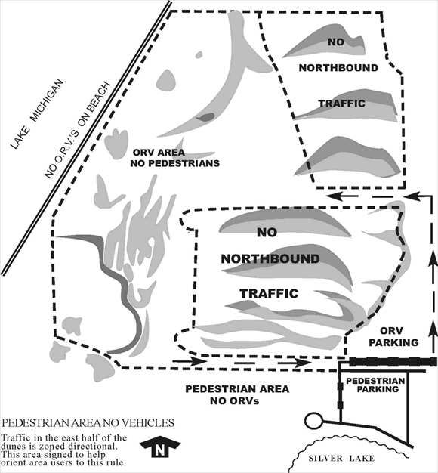
Figure 1. Silver Lake Sand Dune Managerial Map
Source: Michigan Department of Nature Resource
http://www.michigan.gov/dnr/0,1607,7-153-10365_15070-34760--,00.html

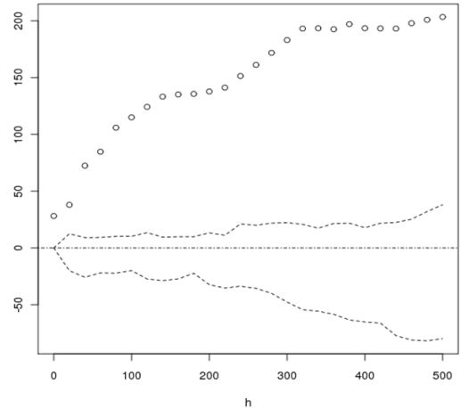
Figure 2. K function for Motorcycle Accidents

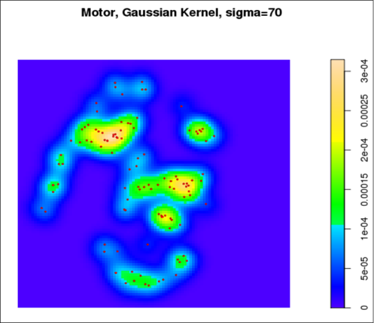
Figure 3. Motorcycle Accident Hotspots

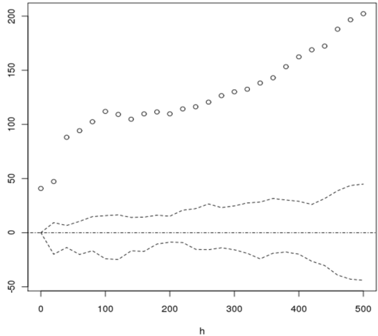
Figure 4. K function for Dune Buggy Accidents

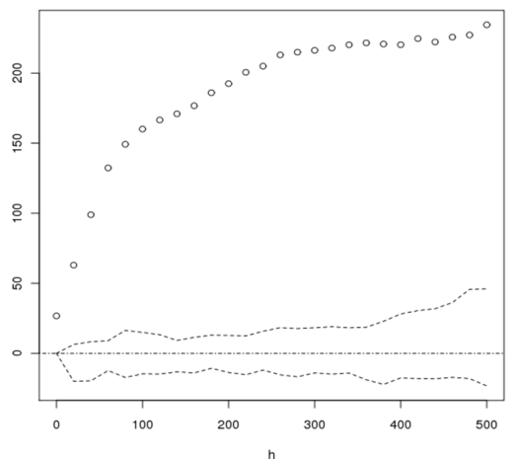
Figure 6. K function for Truck Accidents

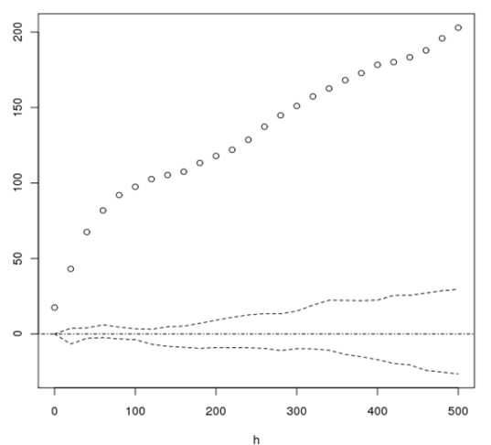
Figure 8. K function for ATV Accidents

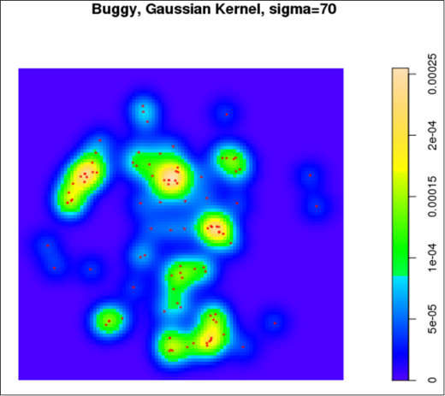
Figure 5. Dune Buggy Accident Hotspots

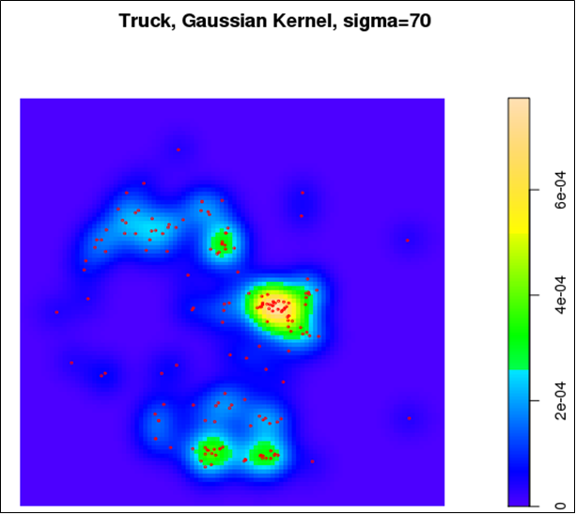
Figure 7. Truck Accident Hotspots

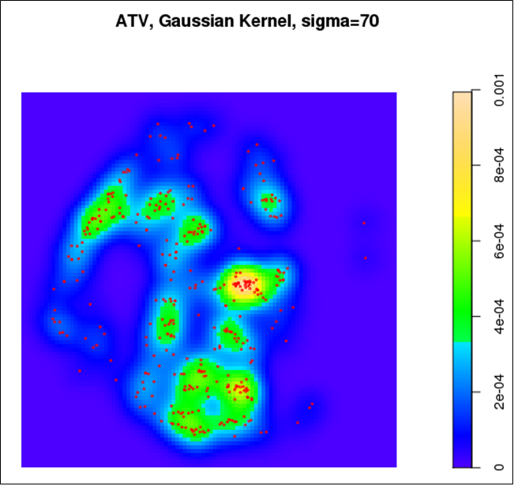
Figure 9. ATV Accident Hotspots

Table 1. T-test for ORV accident points and heterogeneous Poisson points

 | N | Mean | Std. Deviation | Levene’s F | Sig. | t | df | Sig.  (2-tailed)
ORV Accidents | 773 | 10.899 | 6.654 | 2.524 | .112 | 5.758 | 921 | 0.000**
Hetero Poisson Points | 150 | 7.527 | 6.083
** p < .001

