RETHINKING SCHOOL DESIGN TO PROMOTE SAFETY AND POSITIVITY

A Thesis Presented

by

EMILY A. MOREAU

Submitted to the Graduate School of the
University of Massachusetts Amherst in partial fulfillment
of the requirements for the degree of

MASTER OF ARCHITECTURE

May 2020

Architecture

© Copyright by Emily A. Moreau 2020

All Rights Reserved

RETHINKING SCHOOL DESIGN TO PROMOTE SAFETY AND POSITIVITY

A Thesis Presented

by

EMILY A. MOREAU

Approved as to style and content by:

Sandy Litchfield, Chair

Ray K. Mann, Member

Stephen D. Schreiber, Chair
Department of Architecture

ACKNOWLEDGEMENTS

For everyone who has been affected by mass violence, bullying, or has felt unsafe, unhappy, or uninspired at school.
Thank you to everyone who has supported me along the way.

ABSTRACT

RETHINKING SCHOOL DESIGN TO PROMOTE SAFETY AND POSITIVITY

MAY 2020

EMILY ANNE MOREAU

B.F.A., UNIVERSITY OF MASSACHUSETTS DARTMOUTH
M.ARCH., UNIVERSITY OF MASSACHUSETTS AMHERST

Directed by: Professors Sandy Litchfield and Ray K. Mann

Since the 1999 massacre at Columbine High School in Colorado, there have been two-hundred and thirty more school shootings in the United States, not including those that have happened at colleges or universities. This has been a major change that American school systems have been struggling to adapt to, especially since many of the schools were built in the 1950s and 1960s. In the wake of these recurring tragedies, there are strategies that can be followed to not only provide safer schools that will protect students, but also design with empathy in mind. This thesis will examine how architecture can inspire empathy in a school, while also providing a safe learning environment. Specifically, the generator for these design strategies will be a new design for Chelmsford High School, serving grades nine through twelve. This age range is particularly important to serve and inspire, as the average age of a school shooter is sixteen. High schools that inspire empathy will make students more excited to be at school and more interested in taking care of their community and building.
The program of this new design will provide and support the education and safety of students, faculty, and staff. It will also act as a beacon where people in the surrounding community can participate in activities outside of school hours. This will foster a connection, and provide a second home for more than just employees and students who use the school on a daily basis.

TABLE OF CONTENTS
Page
ACKNOWLEDGEMENTS iv
ABSTRACT v
LIST OF TABLES ix
LIST OF FIGURES x

CHAPTER

1. INTRODUCTION 1

2. DESIGN FOR MEANING 2
The Architecture of Happiness 2
Environmental Stoicism and Place Machismo and How Buildings Learn: What Happens After They’re Built 4

3. RESEARCH ON SCHOOLS 8
Community-Oriented Architecture in Schools: How ‘Extroverted’ Design Can Impact Learning and Change the World 8
Schools’ Design Can Play Role in Safety, Student Engagement 11

4. PRE-DESIGN RESEARCH 15
Crime Prevention Through Environmental Design 15
Empathy in Architecture 18
Placemaking 22

5. PRECEDENT STUDIES 27
Sandy Hook Elementary School 27
Crime Prevention Through Environmental Design (CPTED) Strategies in Sandy Hook Elementary School 30
Indian Community School 33
Embassy Design 36

6. SITE SELECTION 40
Context 40
Town History 41
Demographics 43
Site History 44

7. SITE ANALYSIS 47
2020 Chelmsford Open Space Master Plan 47
Land and Water on the Site 48
History of Chelmsford Schools 52
Chelmsford Public Schools 54

8. PROGRAM 56
Town Assessments and New Standards for Schools 56
Current Chelmsford High School Program 57
Proposed New Program 58
Designing for Empathy 60

9. REGULATION 66
Building Code and Accessibility 66

10. DESIGN PROCESS 67
Site Planning 67
Building Design 69
Designing for Safety 72

11. CONCLUSION 75

APPENDICES

A: COLLAGES AND MODELS 76
B: ORAL THESIS DEFENSE PRESENTATION 82

BIBLIOGRAPHY 91

LIST OF TABLES
Table Page

Table 1: Standard Program According to MSBA 68
Table 2: Types of Construction 75

LIST OF FIGURES
Figure Page

Figure 1: Sandy Hook Elementary School – Duck Mural 35
Figure 2: Sandy Hook Elementary School 38
Figure 3: Crime Prevention Strategies in Sandy Hook Elementary School 41
Figure 4: Indian Community School 44
Figure 5: Crime Prevention Strategies in the Indian Community School 45
Figure 6: US Embassy in Beirut, Lebanon Site Plan 48
Figure 7: Beirut, Lebanon Campus Rendering 49
Figure 8: 255 Prineton Street, North Chelmsford, MA 01863 50
Figure 9: Locus Map of Chelmsford, MA 51
Figure 10: Existing buildings on the site to be demolished 55
Figure 11: Site Analysis 57
Figure 12: Water Resources in Chelmsford, MA 59
Figure 13: Soils in Chelmsford, MA 61
Figure 14: Student survey results from final documentation 70
Figure 15: Pre-Design Diagram 76
Figure 16: Site Plan 77
Figure 17: Collages 78
Figure 18: Wire Models 79
Figure 19: Program Layout Process 79
Figure 20: Program Diagram 79
Figure 21: Drawing Process 80
Figure 22: Crystal Parti Diagram 81
Figure 23: Painting by Wenzel Hablik 81

CHAPTER 1

INTRODUCTION

In 2015 Malcolm Gladwell, author for The New Yorker, theorized that new school shootings are more likely to occur based on how many shootings had happened prior, suggesting that killers draw inspiration from previous incidents in what he described as “a slow-motion, ever-evolving riot.” The 1999 massacre at Columbine High School was one of those that have subsequently inspired killers. There have been two-hundred and thirty more school shootings in the United States since. Much like that massacre, the average school shooter is 16-years old, and has a connection to the school, generally a current student or alumni.
How can a school be designed to minimize the potential for threats and create a more positive atmosphere for the primary users and the surrounding community through environmental design and crime prevention strategies?
My thesis is going to explore schools and other building types such as embassies that must address both place and safety concerns. I will be looking at questions about what creates a sense of place and belonging in architecture and the built environment, and why it so often falls short. De Botton’s The Architecture of Happiness will address peoples’ relationships with the built environment, while Benedikt’s Environmental Stoicism and Place Machismo and Brand’s How Building Learn will discuss why architecture and the built environment are not often able to address that concern.

CHAPTER 2

DESIGN FOR MEANING

The Architecture of Happiness
Alain de Botton’s The Architecture of Happiness is a “journey through the philosophy and psychology of architecture and the indelible connection between our identities and our locations.” I was interested in reading The Architecture of Happiness because of the question of what makes architecture truly matter to people, and the question of how can architecture truly matter to people. This book is very optimistic when dealing with the conversation about what architecture can do for us, its inhabitants. It is hard to tell if this story is meant for architects, or if it is trying to bring architecture to a level that everyone can understand, but it seemed relevant to my thesis because it addresses the key question of how architecture can make its end users happy. A main goal of mine is to be able to inspire empathy in the students, and shape the way they feel when in the school.
De Botton is a philosopher by trade with a lot of education in his background. When he was young, he went to a few privately funded boarding schools. Raised in an elite environment he went to the University of Cambridge, and went on to pursue his master’s degree in philosophy at King’s College in London. Finally, he began a PhD in French philosophy at Harvard University, but did not complete the degree and instead began writing books.
The main question that de Botton is asking in The Architecture of Happiness is what architecture can do for you, the regular person who inhabits buildings. In an NPR interview with Neal Conan, the host of “Talk of the Nation”, Conan suggests that, “One of the first things you address in your book are some suspicions, some doubts about the nature of architecture and its ability to change our world. You question its seriousness and its moral worth.”
De Botton’s arguments are organized very clearly. The first chapter of his book introduces his argument. With the general observation that architecture can “change [and] affect moods and explain something about ourselves.” It is hard to say that he has observed a problem or a failure. Throughout the rest of the chapters, de Botton introduces concepts through a variety of clear examples.
In the second chapter, de Botton goes on to explain some of the history of architecture. He starts with classicism and moves into the overall “trend” of essentially creating whatever kind of architecture you want.
In chapter three the book becomes more philosophical and, for me, interesting. De Botton speaks about the meaning of abstract shape. He starts by talking about Adrian Stoke’s ideas about the sculpture of Barbara Hepworth, and moves into the language of typefaces. He then talks about how it does not really matter what something is, as long as it means something to the person interacting with it. This is easily translated into art and architecture. I see it most when considering abstract art, such as pieces by Jackson Pollock or Mark Rothko. They do not tell an obvious story the way that many classical pieces or illustrations do, but they evoke feeling in the viewer, and in so doing they mean something to the viewer. It is the same with architecture. When you consider schools that are built in the 1950s and 1960s, which I explore further in the next section, and in Chapter 3, they do not evoke much in the user. Generally, they were designed for efficiency and constructed as quickly as possible, but without creating meaning for the user. In my design I am trying to evoke happiness in my end users – the students - and to create a more meaningful experience for them in the school.
De Botton has developed his overall argument up until the third chapter, but here it where you start to really understand that he is not just talking about architectural things like plans, space, and design, but more about the emotion that architecture can evoke in the user. Reviewer Charles Smith explains in his review in the Gaurdian that de Botton’s message is simple. De Botton is encouraging society to pay attention to the consequences of design, specifically in architecture. Overall, architecture should not be solely left to the architects, it affects every one, and everyone should have a language to understand and judge the buildings they are using.
De Botton takes a naturalistic stance because he has a strong interest in phenomenology. Naturalistic study is a type of study where the researcher observes and records behavior and phenomenon in its natural setting. De Botton is clearly observing how people interact with their homes and other buildings that they use every day.
When designing a space, ideas from de Botton are important to think about. The designer should consider the building’s occupants in every aspect, and be able to evoke positive feelings in them. For my project, I am aiming to inspire empathy in the students that will occupy the building, creating an appreciation and respect for the space that will provide fond memories for them as they move into the next phases of their lives, and in turn empathy and respect for the fellow inhabitants.

Environmental Stoicism and Place Machismo and How Buildings Learn: What Happens After They’re Built
“Environmental Stoicism and Place Machismo”, by Michael Benedikt, is a polemic, or a strong written attack on something. Benedikt is the director for both the Center for American Architecture and Design and the Graduate Program in Interdisciplinary Studies at the University of Texas at Austin. Although Benedikt has worked in practice, he is most known for his writing and has published over one-hundred articles and book chapters. His focus on schools toward the end of the article inspired my interest in the topic.
This polemic is broken down into five parts. The first introduces the ideas of “environmental stoicism” and “place machismo”. Benedikt defines environmental stoicism as “the ability to endure places that are cheap or neglected, depressing or demanding, banal, uncomfortable, or controlling – places to which people would normally react with despair.” He goes on to explain his definition of place machismo, saying “stoicism advises calm acceptance of what cannot be improved, machismo recommends pride in the grim embrace of harsh realities.” It is Benedikt’s opinion that this phenomenon has particularly impacted the built environment in the United States.
In the second section Benedikt discusses “interiorism” and “exteriorism” and the fact that interior design is an underappreciated field, mainly by architects. Benedikt say that peoples’ mindsets are “masculine.” Buildings are more statements than something to engage with. Thirdly, Benedikt relates the ideas of “interiorism” and “exteriorism” back to environmental stoicism and place machismo, and the idea of “interiorism” as feminine, and “exteriorism” as masculine. The fourth section is where his argument really takes shape through a real-life case study of high schools in the United States, where environmental stoicism and place machismo are very present and damaging to the student environment.
Benedikt argues that during the 1960s that environmental stoicism and place machismo took hold of architects, and buildings often started becoming plain and separate from both their landscape and their interior. Being separated from the landscape and interior suggests that the building is also separate from its occupants. This contradicts everything that de Botton states in The Architecture of Happiness, that buildings should mean something to the users. Buildings that act as monuments and are separate from everything around it by nature will not mean as much to a person as a building that is more connected to its surroundings.
In his fifth section, Benedikt proposes a specific effort he believes “would lessen the need for place stoicism and insensitivity.” This effort is in the design of schools, namely high schools. Benedikt believes that by allowing architects to have freedom in design where they can “reinforce rather than undercut education”, place machismo will no longer be a problem because young adults would be shaped by a more positive environment.
Benedikt introduces the ideas and concepts in a captivating way using the phrases environmental stoicism and place machismo. Benedikt also references the work of Robert Venturi, Denise Scott Brown, Steven Izenour, and Rem Koolhaas. Which are very useful examples for visualizing the type of work we are supposed to be thinking of when reading his article.
How Buildings Learn: What happens after they’re built, by Stewart Brand, broaches a similar topic to that of “Environmental Stoicism and Place Machismo”. How Buildings Learn is a polemic that questions the way buildings are used and constructed. Brand is an American writer who created The Whole Earth Catalog.
Brand’s argument in this section of How Buildings Learn is set up in different chapters entitled “Flow”, “Shearing Layers”, “The Scenario-buffered Building”, and the appendix “The Study of Buildings in Time”. He begins by introducing his main argument that few buildings adapt well to time:
“The old church is torn down, lovely as it is, because the parishioners have gone, and no other use can be found for it. The old factory, the plainest of buildings, keeps being revived: first for a collection of light industries, then for artists’ studios, then for offices (with boutiques and a restaurant on the ground floor), and something else is bound to follow. From the first drawings to the final demolition, buildings are shaped and reshaped by changing cultural currents, changing real-estate value, and changing usage.”
Brand’s approach is to examine buildings as a whole and over time looks at everything from the initial design, to the construction, and to the way we use buildings.
A review by Daniel Bluestone in the Journal of the Society of Architectural Historians, states that “Brand’s analysis is framed by history. His interest in the ways in which buildings are changed and adapted by residents and owners is precisely what puts him into a debate with the practice of architectural history.” Bluestone goes on to explain that Brand is critical of architectural historians because they focus solely on the original use of a building. He says, “This approach slights the manner in which the meanings and forms of buildings and places are changed and reinterpreted through time.” What Brand is looking at is the idea of buildings being able to ebb and flow with new uses.
Why is it that some buildings end up being demolished when there are so many others that change and evolve often with the different users? I feel that when designing a new school, it should be beautiful and able to evoke something in its users, but also it should be able to evoke something in the entire community and anyone that may use it. Perhaps it does not need to be what someone typically thinks of as a “school” building, but generally a beautiful place that makes its occupants feel something.

Each of these authors, de Botton, Benedikt, and Brand, address topics that I am exploring in my thesis. They offer insight to the forces that shape meaningful relationships to architecture and the built environment in both positive and negative ways. It is important to research the ways in which people interact with architecture currently in order to design something more successful for the future.

CHAPTER 3

RESEARCH ON SCHOOLS

Community-Oriented Architecture in Schools: How ‘Extroverted’ Design Can Impact Learning and Change the World
In the ArchDaily article, by Vanessa Quirk, “Community-Oriented Architecture in Schools: How ‘Extroverted’ Design Can Impact Learning and Change the World”, Quirk discusses how schools that struggle with simple things like unhappy teachers, angry students, disconnected administration, can greatly benefit from a new type of school design. Quirk begins by explaining that architects must inhabit the shoes of the people they are designing for. She notes that architects consider every detail, thinking about the configurations of classrooms and offices, addressed the acoustical needs of a classroom, and potentially even included furnishing apt for the students’ size. She is introducing the fact that architects really do try to account for everything. Architects may also consider the administration who may not go into the school building on a daily basis, the teachers, and how they’ll communicate to their class without outside distractions occurring, and of course students, as their learning is the most important thing happening in the school.
Quirk begins by pulling in the reader with the aforementioned statements, but then goes on to state that physical conditions should be primary especially in a school. Quirk mentions studies that prove that a positive environment is capable of improving student engagement and well-being. She is supporting the idea that if you approach design in a way that focuses on society, and creating a school that is open to the community will be symbolic simply in the sense that it is so positive.

This is the most important statement in the whole article. Aside from just how the school looks and how that affects the behavior of the end users, there is something more, Quirk introduces the idea that architects normally “take an introverted approach to designing schools” in a way that creates a sense community for students. Quirk says that an extroverted approach is one that is open to the community, and encourages members of the community to interact with the school as much as it encourages the students to interact with the community.

This idea prompted me to consider the question of how a school can be designed not only a fortress for students and teachers, but also somewhere that people really enjoy going to, where the community can be integrated to enhance the end user’s time in the building. It would be very important to allow the community into the school, by way of evening classes, events, etc. Although, as Quirk mentions, schools are generally some of the largest buildings in towns with a major presence in the community – even serving as important landmarks – they still aren’t generally the most used buildings in the town.
Allowing, and really welcoming more than just faculty, staff, and students to use a school makes the school potentially a place that the community loves and wants to take care of. This idea is somewhat related to the “broken window theory”. According to the Center for Evidence-Based Crime Policy (a sector of the Department of Criminology, Law, and Society)
“The broken windows model of policing was first described in 1982 in a seminal article by Wilson and Kelling. Briefly, the model focuses on the importance of disorder (e.g., broken windows) in generating and sustaining more serious crime. Disorder is not directly linked to serious crime, instead, disorder leads to increased fear and withdrawal from residents, which then allows more serious crime to move in because of decreased levels of informal social control.”

In other words, if something is already broke, people are not going to care as much about it, so they will not take as good care of it and crime and negligence will continue to occur.
Although Quirk is not talking about crime in her article, she IS talking about something that is loosely a “community-use” version. If the community feels welcomed into a place, more people will come to utilize it, and the more people in the community who use the space, the more likely they are to take care of it because it now holds more meaning to more people. More people feel a connection to the space.
Quirks introduces a few case studies. First, she mentions and describes the Marysville Getchell High School in Marysville, Washington. Quirk explains that in 2004, the school district was dealing with many issues ranging from hostility between the community and the school board, to teachers strikes. To fix all these problems, the district decided they wanted to start fresh. Quirk suggests that involving the community in the new design would encourage their investment in the success of the new schoool. The district embarked on a four-month planning process that included workshops of architects, students, parents, teachers, and administration.
The process of studying what people want in the place where they send their children, work, learn, or even just drive by, is an interesting and enticing idea. Quirk says that the design ended up displaying the “communal inception” of the school, providing a space that did not focus solely on the students and teachers, but also the community. She goes on to explain how the Guiding Principles for the Design of the School discusses that with the use of transparency and collaboration, the boundaries between the students, faculty, and staff and the community are blurred.
This article was very helpful in considering the design of a school relative to the question of safety. While focusing on the safety of students, faculty, and staff, and the creation of an enjoyable, positive learning environment for them, it is important to consider the broader community, and how everyone can get something from a school without compromising safety. Quirk makes it clear in her argument that schools that engage the entirety of the community might in a greater sense be safer.
Many of the ideas Quirk mentions, such as the permeability of a school, fall in line with the most recent thoughts for designing a safe school. Obviously, it is not best to design a glass box that can easily be broken into, but it is important to have clear sightlines, and a sense of openness that connects the school to the community beyond. Many of Quirk’s ideas seem to be very important guiding factors in the design of a safe school and clearly in the design of a school everyone would love.

Schools’ Design Can Play Role in Safety, Student Engagement
In “Schools’ Design Can Play Role in Safety, Student Engagement”, from Education Week written by Jaclyn Zubrzycki in 2013, Zubrzycki argues that the it is not the building that creates a schools culture. This is the first sentence in the article, setting the mood off the bat. This message means that, the culture of the school is made primarily by the students, faculty, and staff who occupy the school. However, Zubrzycki explains that there has been research that demonstrates that the buildings can affect engagement and morale in students. Because of this research, many school officials are attempting to move past that typical design of long hallways crowded with lockers, and dark classrooms with no windows, like those mentioned in Benedikt’s polemic.
Zubrzycki sets up her argument into three basic sections that each address ways to invest students in their school communities, which would in turn reduce the amount of discipline problems. Zubrzycki mentions architect Irene Nigaglioni, from the Houston-based firm PBK saying that design firms are aiming to include students in the design process. Making an important connection between educators and architects. An architect cannot design an excellent school building without understanding the intimate relationship the educators and students have with the building and how they need to use it.
Zubrzycki’s first point is “fostering connections.” Surprisingly, this section is heavily building-focused, and not extremely human-focused, or student-focused. Zubrzycki describes some examples of new schools that have different types of design that foster a new way of learning in comparison to the typical school buildings that most of us are familiar with. Quoting Craig Mason, an architect from the DLR Group in Kansas, Zubrzycki says that buildings are now learning-focused, whereas they used to be more teaching-focused. Learning-focused implies that the students are going to school to learn. Teaching-focused implied that teachers are there to teach. Schools should aim to be more learning-focused because it is truly about the students learning, not about the teachers teaching.
Zubrzycki also talks about cafeterias that are being set up like cafes, where students can work while eating, larger windows to improve both daylighting and indoor air-quality, and the removal of lockers from the hallways to reduce chaos. Some of the case studies Zubrzycki discusses are The Holt Elementary School in Eugene, Oregon; the Center for Advanced Professional Studies in Blue Valley, Kansas; and the Marysville Getchell School Campus, in Marysville, Washington.
At the Holt Elementary School, there are glass walls between connected classrooms. This changes both the teaching culture and student behavior issues, by making both aspects become public. By making both these aspect public, both teachers and students will be more likely to be on their best behavior. This is a form of surveillance, just by their peers. Students are less likely to act out when they know their peers and other teachers in the school can see them, and teachers will work harder knowing that their coworkers can see them. The Center for Advanced Professional Studies, which has a specialized high school program, uses meeting rooms for part of the day rather than classrooms. This allows students to spend a piece of their day in a “business-inspired world.” At the Marysville Getchell School Campus is a complex of four smaller schools in the town that was renovated to achieve a “small-school focus.” The superintendent of this school system credits the change to an increase in the graduation rate.
The next section Zubrzycki discusses is “Addressing Perceptions.” She begins this section by talking about architect Amy Yurko, who explains that there is sometimes tension that occurs between traditional ideas about safety and a newfound openness that is seen in many new buildings. Yurko defends open buildings, saying that they can be safe, too. She does not support the design of school with thick concrete walls, saying that schools that are designed in that way create “a culture and environment where kids don’t feel known.”
At the Perspectives Charter Schools in Chicago, found Kimberlie Day, decided to exclude metal detectors, which was resisted by the community. Day defended her decision explaining that students being more invested in the school community is more impactful to individual safety than a metal detector. Zubrzycki introduces Crime Prevention Through Environmental Design, or CPTED. CPTED was a set of design strategies developed in the 1970s by C. Ray Jeffery, a criminologist (to be discussed in the next section). Some of their strategies include tracking building access, including borders naturally, offering clear surveillance, and clear sightlines within the building.
These ideas can be seen in newer buildings with the addition of technology. Zubrzycki uses lockers as an example explaining that they are no longer necessary, with their original use being to hold textbooks even though students are typically using tablets or laptops in class now. With that change in education, lockers are now just a place for students to hide things. Lastly, Zubrzycki brings up the idea of “Extending the Honeymoon.” There is typically a “honeymoon phase” that exists with a new building or renovation. Two educators Zubrzycki interviewed for this article say that doing simple things like continuing to hang up students work and making sure the building is well maintained can change the climate of the school. Speaking about their newly built school after a natural disaster, Angie Besendorf, the assistant superintendent at the Joplin, Montana school district explains how students now take pride in their school because they felt like the educators and administrators cared about them and their education.

As an educator who writes articles like this for other educators and school professionals, Zubrzycki’s arguments seem very credible. She leads from one idea to the next seamlessly. Each new idea is introduced with real-life examples created by professionals in the field of architecture, so as someone looking at this article through that lens it’s nice to see someone from outside the field look at it in a new way. While this did not exactly relate to the idea of how to keep schools safe from an active shooter or other terrorist event, it does relate to the idea of creating a positive school environment that will not harbor such extremely negative emotions.
There are connections between this article and many of the others I have looked at so far for my topic. I see many obvious connections between Zubrzycki’s ideas and those demonstrated by Katherine Flynn in her article for the American Institute of Architects written in 2018, called “Architects prioritize design as a school security option.” Clearly, from the title, Flynn’s article discusses the ideas of student safety as related to chaos and violence, while Zubrzycki’s discusses general safety through design. However, both authors discuss similar ideas, and set up their arguments and ideas similarly. It has been interesting to read these in tandem, seeing one written from an educator’s point-of-view, and the other written from an architect’s point-of-view.
Based on these two articles, one can easily visualize the outcome of what would happen if an architect spoke with the students, educators, and staff that use a school. It is clear to see the importance of engaging the community that will be the overall end-users of the building.

CHAPTER 4

PRE-DESIGN RESEARCH

Crime Prevention Through Environmental Design
Crime Prevention Through Environmental Design (CPTED) is a collection of guidelines to follow when designing a building or urban area to create safer places. In the United States, it was felt that the social framework for self-policing was being destroyed by urban renewal strategies around the 1960s, which is when the concept of CPTED was introduced by C. Ray Jeffery, a criminologist. Jeffery developed upon the ideas of American Architect Oscar Newman, author of Defensible Space, which was a new concept at the time Newman was conducting his research. Jeffery’s research led to the study of the four main principles of CPTED, which are Natural Surveillance, Access Control, Territoriality, and Maintenance, and a fifth which is sometimes included: Activity Support. Research has shown that application of the CPTED measures drastically reduce criminal activity.
The first principle of CPTED is Territoriality. Territoriality is defined by Cozens, Saville, and Hillier as: “A design concept directed at reinforcing notions of proprietary concern and a ‘sense of ownership’ in legitimate users of space thereby reducing opportunities for offending by discouraging illegitimate users.” It is explained that territoriality acts as the primary principle that each other principle can fall under. Different types of territoriality include symbolic barriers, such as signage, and real barriers, such as fences. Real barriers can be any design aspect that delineates between public, semi-private, and private spaces. Natural surveillance and access control also contribute towards the territoriality principle by promoting legitimate users’ informal social control. This means that the primary users of a space will have more control over their space if signage tells others they do not belong there, or if a fence stops them. For instance signage denoting a “private way” deters outside people from entering a space that is not theirs. Although people are entirely capable of driving up these streets, they are much less likely to enter because it feels as if the residents on that street are in control and that it is not appropriate to enter.
In the review of CPTED by Paul Michael Cozens, Greg Saville, and David Hillier titled “Crime prevention through environmental design (CPTED): a review and modern bibliography” the authors explain that “if offenders perceive that they can be observed (even if they are not), they may be less likely to offend, given the increased potential for intervention, apprehension, and prosecution.” They go on to discuss different types of natural, formal, or organized and mechanical strategies. These can include residents’ or building occupants self-surveillance opportunities, police patrols, street lighting, and CCTV.
These ideas of “natural surveillance” are directly linked to the idea of the panopticon, which was a type of institutional building, and system of control, designed by Jeremy Bentham, an English designer in the 18th century. Bentham’s concept was to allow all inmates of a prison be observed by a single security guard, but the inmates would not be able to tell that they are being watched. Bentham’s panopticon prison was designed as a round building with a guard in the center, surrounded by the inmates’ cells. Because the inmates could not tell if they were being actively watched or not, they were more likely to be well-behaved for fear the guard was watching. More than two-hundred years later, the idea of the panopticon is being executed as closed-circuit television and police presence.
The principle of Access Control focuses on reducing opportunities for crime by denying access to potential targets and creating more of a sense of risk in offenders. Cozens, Saville, and Hillier explain that access control can, like natural surveillance, include informal or natural, formal, or organized, and mechanical strategies. Informal and natural strategies include spatial definition, formal and organized strategies include security personnel, and mechanical strategies include locks and bolts. These strategies are obviously very connected to the ideas in natural surveillance. Also, according to Cozens, Saville, and Hillier, in urban conditions, studies have found that both increased pedestrian movement and decreased pedestrian movement through spaces can lead to reduced levels of crime depending on the circumstance.. A study conducted by Barry Poyner in 1992 looked at the impact of widening aisles at an outdoor farmers market, which found there were significant drops in recorded robberies over a two-year period. This finding supports the idea that it is not necessarily the number of people walking through a site that will increase the risk of crime, but rather the setup of the space that will affect it.
Maintenance and management of the site is the idea of “promoting a positive image and routinely maintaining the built environment.” According to Cozens, Saville, and Hillier “Vacant premises have been found to represent crime ‘magnets’ and smaller buildings were a preferred site for drug dealing since they had less management and financial resources to regulate such criminal activity.” Cozens, Saville, and Hillier reference a study done by Sloan-Howitt and Kelling in 1990 about a cleanup program to remove graffiti from all train cars and stations on the New York subway system. With the introduction of this cleanup program, graffiti was reduces, and arrests for graffitiing also declined, despite the fact that there was an increased police attention. The concept of maintenance as a crime prevention design principle relates to the idea of the Broken Window Theory, mentioned earlier.
Crime prevention through environmental design is by nature a subset of standard environmental design. Environmental design is generally taught as passive design strategies that increase the sustainability of a building without making expensive changes or decisions. They are decisions that can be made such as the orientation of the building on the site to increase or decrease sun exposure, using trees for natural shading, angling the roof for ideal sun exposure, and more. The principles of crime prevention through environmental design follow the same ideas as general environmental design principles. Implementing CPTED principles is done in a similar way, where they are implemented early in design of the site and are overarching decisions that will end up guiding the overall design.

Empathy in Architecture
An important aspect of dealing with something so negative as mass violence in a school is considering empathy and how that can change the views of students and people in the school. The median age of school shooters in the United States is 16, insinuating that a lot of the violence that occurs is done by students at their own school. An obvious fix for this problem is to make school somewhere that students want to be for most of the day. As Benedikt points out in his case study at the end of his polemic “Environmental Stoicism and Place Machismo”, high schools in the United States are bland, hardened, and uninspiring. School should be the last place where students are uninspired. Benedikt goes on to ask questions about this saying: Benedikt questions this, asking why the design doesn’t respect youthfulness or learning, if it appears to sympathize with the students occupying the space, if there are areas for the students to get away, so to say. He concludes that the answer to all these questions is no.
As per de Botton, architecture cannot solve all students’ issues, including those of school shooters. However, by creating a more thoughtful design the chances are increased for more empathy and inspiration in the students.
Benedikt explains that city administrators always have reasons for the “soullessness of school design.” He explains further that during the postwar baby boom, architects understood that there was a sort of need to churn out plans for schools that were efficient in every way – programming, construction, space planning, etc. Benedikt says “The goal, then and now, was efficiency.” Benedikt blames the book Toward Better School Design by William Wayne Caudill. Caudill wrote this book with all good intentions, saying that natural lighting was necessary, plans should be open and easily navigated, and there should be a visual openness to the outdoors, which all stand true. However, his main point was the value of efficiency, saying that the organization of people, building layout, and construction could all be shown on simple charts. These were the factors that dominated school design by the 1970s. This idea of efficiency in all areas of school design was brought too far when it became thoughts of “ if teenagers are to learn from books and blackboards and teachers’ faces, they shouldn’t need to look out windows,” Benedikt explains.
It was these thoughts that led classrooms to have little to no windows, or very high windows. Similarly, designers thought about teenagers being messy; if they are messy, then the materials used should be easily cleaned, i.e. the use of linoleum tiles. If there is a certain illumination that is ideal for a classroom, then set the lights everywhere at that number of foot-candles without shadow. Benedikt ponders every area that was addressed for efficiency in construction and design. He addresses energy problems leading to an incredibly tight building, theft leading to locks everywhere, abused furniture leading to uncomfortable steel desks bolted down, and misbehavior leading to closed-circuit television everywhere. This is the school most people know in the United States, most everyone can picture their high school and it fits this dim profile. Benedikt says it is “barely better than a minimum-security prison.” Benedikt sympathizes with the students, explaining that being a teenager is already hard and they are not receiving a positive message at these dated schools. He explains that students who are in these environments are learning that they are delinquents who have no individuality, and their sensitivity should be disregarded.
So how can schools be designed to oppose these negative feelings? Students should not go to school and feel such a strong discomfort during their most formative years. An article by Jill Berkowicz and Ann Myers, titled “How Architecture Affects Learning”, tackles this subject through case studies. They begin their article by noting that elementary through high school is so formative for children. They acknowledge that studies have been done on how architecture can affect our well-being, like that done by de Botton, and wonder what architecture’s effect is on learning. They explain that both educators and architects are beginning to look at this question. A great example is the Khan Lab School where there is thoughtful design of education spaces, and teachers are already seeing the benefits. Berkowicz and Myers explain that the Khan Lab School offers non-traditional spaces for classroom learning. They are set up as zones that have a different mode of learning. These spaces do not need to be specific to a subject, but are rather flexible for the students to learn in a way that best suits them.
Myers and Berkowicz further explain that there are interactive walls and displays, including a “passion project gallery”. This specifically relates to placemaking, an important piece of community involvement and end-users caring about the space in which they live and work. In addition to the “passion project gallery”, there are writable walls, something used in newly constructed college dormitories to help make it feel like home, public question boards, and a welcome wall. There are flexible seating areas and smaller café style seating arrangements meant to encourage collaboration. There are also library nooks, and “phone booths” to encourage communication with experts and mentors through video calls.
Myers and Berkowicz explain that because of the fluidity of the space, students must address different aspects of community. There are two main advantages of the learning dpace design: multi-use spaces, and open workspaces. They go on to compare this transitional nature to schools in the United States that were built 50-60 years ago, the same schools that Benedikt discussed in his case study in “Environmental Stoicism and Place Machismo”. They note how these buildings are not designed for change, and that they are extremely static. They believe that schools should continue to evolve with education, and new ways that educators are teaching. The Khan Lab School is not a design template, but rather a design process template. They note that not everything needs to be the most hi-tech, but it must be adaptable. “Every school designed in this way will look different, but underlining each will be a shared understanding of how space can enhance learning.”
This is a unique process because of how it is committed to including teachers and students in the planning process. Community involvement in the design of any community-centered building can, and usually is, the most important piece of design. At the new Sandy Hook Elementary School in Newtown, Connecticut, the community was integral in getting exactly the school they wanted for their needs. Myers and Berkowicz end their article stating that environments start to reflect the values of those who occupy the space when the ideas of each occupant are considered collaboratively.

Placemaking
One way of creating a more community-oriented space that people love is through placemaking. Creating a sense of place can capitalize on a “local community’s assets, inspiration, and potential, with the intention of creating public spaces that promote people’s health, happiness, and well-being.” The Project for Public Spaces (PPS) is a nonprofit organization that aims to help people create and sustain public spaces that build strong communities.
In an article on the PPS website titled “Architecture of Place: Buildings That Work for People” the author references Louis Sullivan’s famous quote “form ever follows function.” They claim that it is important to remember what that phrase is about. When the phrase was coined, it was seen as “humanist” meaning that the building should animated by the human. They further explain that, Jane Jacobs later noted that “the idea of function underwent a ‘drift from humanism to gimmicky.’”
The authors opinion on the matter of placemaking in buildings is that architects and planners need to closer attend to local and specific preferences, considering ways that their efforts and designs can create authentic, meaningful places for people to use and enjoy. They explain that good design can achieve many of today’s urban problems, including environmental issues to social issues. Their stance on this matter of good design is that architects and planners are falling short because of their focus on creating an artistic statement that is less likely to engage people. They go on to give great examples that show how architecture of place is possible. They offer examples of architects in the 1960s and 1970s like William H. Whyte, Jan Gehl, and Christopher Alexander who “led the early rebellion against the neglect of function.” Louis Kahn’s Yale Center for British Art is a good example of a building that works as well as somewhere so humane as a gallery as it does a piece of the urban fabric. They also use Renzo Piano’s addition to the Isabella Stewart Gardner Museum, which highlights the ability to carefully collaborate the design process with the building users. Examples of aspects of this addition that encapsulate the ideas behind placemaking are the pure program, a greenhouse, living room feel, café, store, galleries, and an auditorium, which are all seamlessly placed in glass common areas.
The author ends their article discussing Jane Jacobs further. Jacobs believes that design ideas and movements can have a big impact on the built environment, where most individual designers cannot have as large an impact. Jacobs once said, “First comes the image of what we want, then the machinery is adapted to turn out that image.”
In another article on their site, titled “Toward an Architecture of Place: Moving Beyond Iconic to Extraordinary,” written by Fred Kent four years prior to the aforementioned article, similar topics are discussed. He opens his article speaking about how people realize having a sense of place is important to everyone everywhere. Kent argues that this sense of place is a fundamental reality that is missing too often from the discussion of architecture and design. He uses the Cooper Union Building designed by architecture firm Morphosis, completed in 2009, as an example. Nicolai Ouroussoff, an architecture critic from The New York Times discusses the building saying that it is not perfect, but he believes there should be more architecture like it in New York because it’s such a bold statement. He comments on it’s “lively public spaces” where there is opportunity for interaction between people. Kent goes on to discuss specific moments of the building that create that sense of place that is so desired, yet unobtained in so many influential buildings. He talks about how architecture critics need to more often talk about the human aspect of architecture. Kent explains how these places do not successfully engage with peoples’ intuitive sense of place.
How can this sense of place, that the PPS has been exploring for 35 years, better a community such as a high school, and help it defend itself against violence? It seems somewhat backwards to consider taking a place that is supposed to be something of a fortress and open it up to the community, but allowing people from the surrounding neighborhoods and the town to come and interact with a beautiful space is a way to get them to care about it. The more a group of people care about a space, the more they are likely to defend it. The idea of opening a space is not one that has been explored in response to mass violence, but it does hold merit in cities and at the urban design scale.
However, in response to mass violence the design team for the new Sandy Hook Elementary School directly involved the community. They had a committee of parents, teachers, staff, and in general townspeople, who were invited to give their input when the team at Svigals + Partners was working on the design. This led to some beautiful decisions being made, and although this building is not often used by people outside the direct community of the school, it holds a lot of meaning to them. When interviewing members of the community, the architects at Svigals + Partners were told a story about ducks who would come every year through the Sandy Hook site to lay their eggs. When the ducklings hatched, teachers, students, and staff would line the halls to walk the ducklings through their school before the ducklings moved on. A sense of place was created in the lobby using this tradition and memory. The architects integrated a mural of ducks flying that is repeated through the lobby, cafeteria, and the central hallway (see figure 1).
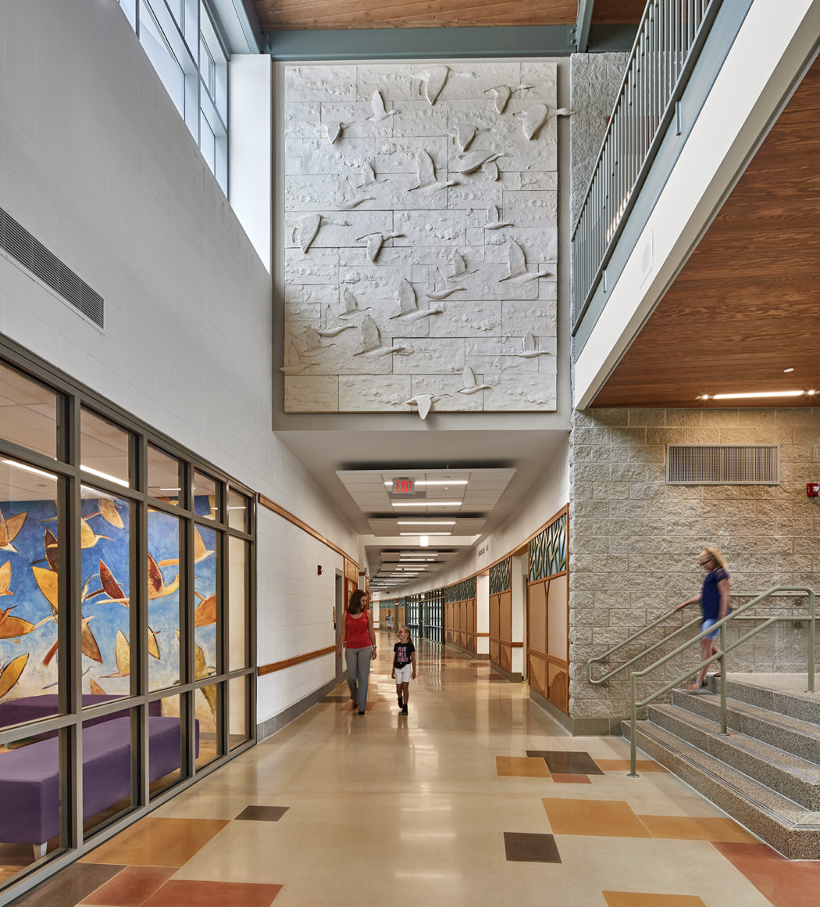
Figure 1: Sandy Hook Elementary School – Duck Mural
(Svigals + Partners)
It is through this type of placemaking, and the opening of the space to the community, that people will begin to care about their places and take the best care of them. Obviously this doesn’t defend a place against every threat, but it can help deter the pressing feeling of a dim school, like the example given in Benedikt’s “Environmental Stoicism and Place Machismo” of a school that feels more like a prison than a place students are going to learn and live through their most formative years of life. My project is going to accomplish this by offering the students a colorful place that is full of light. It is a building that will celebrate what the students are most passionate about. When you enter the building, you will be able to see what the students at the school care about.

CHAPTER 5

PRECEDENT STUDIES

Sandy Hook Elementary School
One case study is the new Sandy Hook Elementary School in Newtown, CT, completed in 2016. Designed by Svigals + Partners, there were two main strategies they focused on: collaboration and art integration. Speaking towards the idea of collaboration on their website, Svigals + Partners says,
“Key to the success was the need for the establishment of a strong trust among participants, designers and the community. This allowed expectations to fall away and the design of a new school to emerge unique to this site and this community.”

Karrie Jacobs, a contributing editor for Architect Magazine says, “The workhorse of Svigals + Partners’ architectural tool kit is something called a School Based Building Advisory Committee (SBBAC)”, which Jacobs describes as a “simple strategy of gathering as many interested parties as possible to talk about a school as it’s being designed.” This committee works together to determine what the building and place signifies to the community, how it should work, and how they think it should look. It consists of everyone from students and teachers, to people within the community and designers. Jacobs explains that “this approach to making the community a collaborator is what gave Svigals an edge in Newtown.”
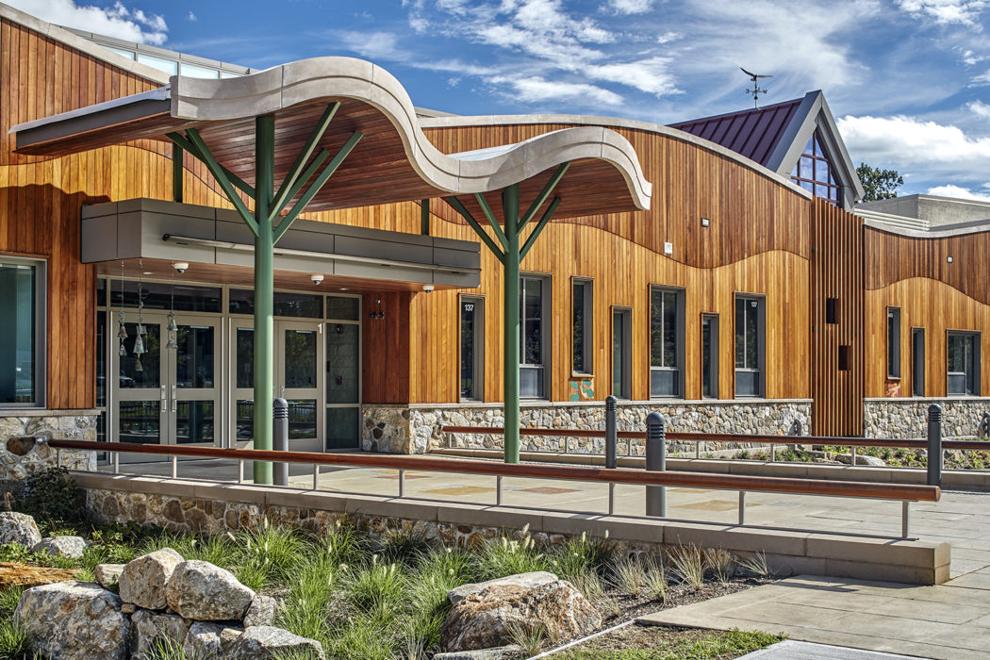
Figure 2: Sandy Hook Elementary School
(Svigals + Partners)
The second main strategy Svigals focuses on is Art Integration. Their website states “with security a deep concern, the town realized that the design would only succeed if the educational mission remained the primary goal. In this way, all design decisions around security were also serving this essential mission.” The idea of art integration was important to the designers again because of collaboration and the community’s thoughts and feelings. When the architects met with their committee, and even prior when they met with the school board who was commissioning the project, Barry Svigals, founder of Svigals + Partners, says “We had to admit we didn’t know what was needed, and neither did they.”
Svigals took the ideas that the community offered them in addition to their knowledge of school design and created an entire building that acts like a piece of art. There are notes of the old school in every corner of this new one. The concept of working with the community is one that I am aiming to accomplish in my project. Through a student survey, I learned more about what is important to them, and what would make it a place that they love.
In response to the story about the ducks from the community (mentioned in Chapter 4) , the new building, there are elegant duck motifs in accent walls by the main lobby. And throughout the school there are tree motifs. There is a grand two-story tall glass window at the rear of the main lobby that has a tree sculpture going up the height of it. In other hallways, there are trees made from wood planks on the walls. At the end of the corridors on the second floor, there are what they call “treehouses” where students can work on projects with friends while overlooking the forest to the rear of the building. Svigals should be considered carefully for focusing on what the community wanted and needed in this school.
Aside from being a gorgeous school that in a way can help heal some of the wounds left behind from the old school, the new building is a fortress. Although it is highly unlikely that there would be a repeat attack on this school, it was important that the students, faculty, and staff feel a sense of safety. In the event something were to happen again, they would be kept safe, or be able to escape.
The shooting that occurred in 2012 was the deadliest mass shooting at a school in the US history, and the fourth deadliest mass shooting by an individual in US history. In an article in the online magazine Dezeen by Gunseli Yalcinkaya, Jay Brotman, managing partner of Svigals + Partners says, “Good buildings should prevent unwanted intrusions of any kind.” Yalcinkaya focuses on the design strategies used to achieve this goal. The first strategy mentioned is the maximization of escape routes. Yalcinkaya says, “the inside of the school is made to maximize escape routes – classrooms are situated far away from likely points of entry, and face towards a woodland, granting easy access to alternative exits.” He goes on to explain that the classrooms are all also equipped with locks and security doors. Yalcinkaya also explains that these strategies were decided upon through the workshops with the SBBAC, which is an important aspect of the community collaboration that Svigals utilized. Many of the articles written about this design do not focus on the harder parts of the design process for a building such as this one. Most of the articles are focusing on the fact that Svigals wanted to hear about all the things that the community remembered and wanted to see in the new building, like the art integration, and colorful spaces. It’s important to remember that the designers of this project also had to hear about the firsthand accounts of the tragedies, and then had to take the information and turn it into something that was beautiful but also made everyone who uses the facility feel extremely safe. Brotman says “building prosperous, compassionate communities cannot happen with a bunker mentality.” Yalcinkaya explains that this was when Brotman brought up the idea of using landscaping tactics, such as bioswales, or larger trees and planters, as protection against terror attacks. Brotman says,
“Buildings and public spaces must be designed for many goals, and the most important are to encourage compassion, prosperity, collaboration and joy. Nature, art and accessibility are just as important as security features.”

I find it really inspiring that this is the viewpoint that the designer at Svigals + Partners maintained throughout their process. The school really became a beautiful place where students can feel like they’re at home, and safe, despite the horrific events that occurred just years ago.

Crime Prevention Through Environmental Design (CPTED) Strategies in Sandy Hook Elementary School

The apparent use of the Crime Prevention Through Environmental Design (CPTED) principles are very successful in this school (figure 3). The four principles of CPTED are natural surveillance, natural access control, territorial reinforcement, and maintenance. According to the CPTED website
“[CPTED] theories contend that law enforcement officers, architects, city planners, landscape and interior designers, and resident volunteers can create a climate of safety in a community right from the start. [and] CPTED’s goal is to prevent crime by designing a physical environment that positively influences human behavior.”

They also lay out the benefits of CPTED training for each party on the website. Community residents will get opportunities to play meaningful roles in community crime prevention, an improved sense of security and quality of life, fewer crimes committed in neighborhoods, and new crime prevention skills. Municipal leadership will see less crime committed in their towns and an improved sense of safety. Police officers will gain support from and with planning and development agencies, and clarification on neighborhood priorities related to crime and quality of life. And, planners and architects will have a greater role in the design of the environment, and a holistic approach to the development and planning process. CPTED is also recognized as an acceptable component of LEED.
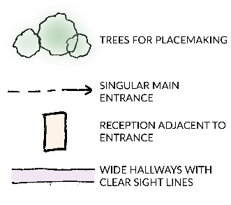
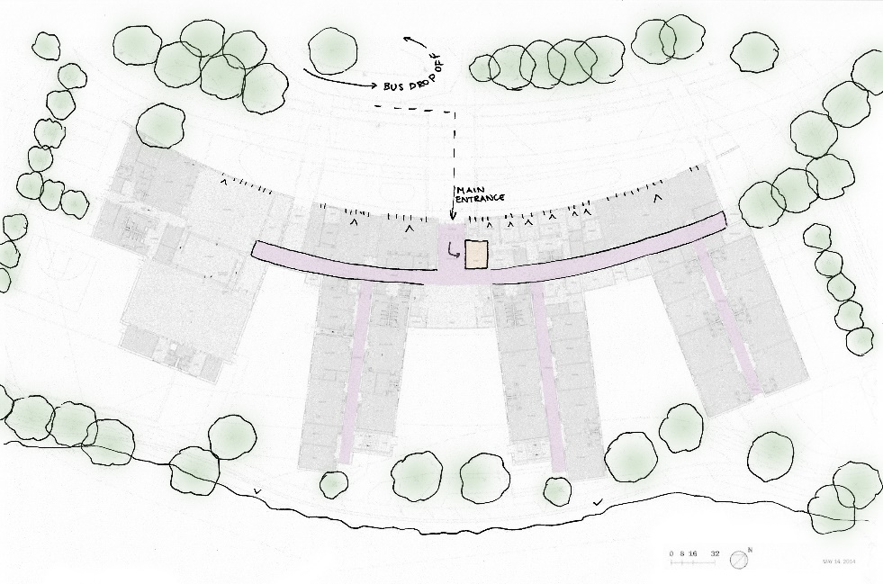
Figure 3: Crime Prevention Strategies in Sandy Hook Elementary School
(by author)
Of the four principles of CPTED, Sandy Hook Elementary School focuses mainly on natural surveillance, which is likely the most pertinent principle. Natural surveillance of a building entails keeping areas well lit, particularly building entrances; eliminating hiding spots, meaning to removes hedges and trees, and other things that could be used for hiding; using closed circuit television to keep an eye on areas that don’t have natural sight lines, and putting monitors up in public areas so that visitors are aware that they’re being watched. They also suggest landscaping options such as low, thorny bushes below windows because they do not obstruct the view, and do not provide a comfortable place to hide.
The next principle is natural access control. They suggest using maze-like entries in main lobbies. “The goal is to cut off straight-line access to a potential target… we’re not talking about barbed wire – even tension barriers that have to be jumped or navigated around can discourage the bad guys.” Also, curbing and landscaping can direct both vehicle and foot traffic into a controlled and visible area.
This third principle is territoriality, which aims to create a clear distinction between public and private property. You want to make sure that receptionists have a clear sightline to all entrances, in addition to the ability to quickly and discretely call for help. Signage should be visible at all entrances. And, especially at schools, a visitor badging system should be put in place, and visitors should be escorted properly.
Lastly, the CPTED looks at maintenance. They state that maintenance is related to territoriality and focuses on the idea of the “Broken Windows Theory”, discussed previously, that “A well-maintained area sends the message that people notice and care about what happens in the area.”
Almost all these practices and strategies can be found in the new Sandy Hook Elementary School, which I find to be a very important aspect of designing any public building. Obviously at Sandy Hook, they have an incredible reason to require the feeling of safety, but any school should feel this safe. The original Sandy Hook Elementary School is described as a “brick donut” built in 1959. This sounds exactly like my elementary school in Chelmsford, which I expect is how a lot of schools look like throughout the United States. Of course it is not the appearance of a school that causes someone to decide to attack it, but it is easy to see areas of these schools that need to be improved upon in the case that something were to happen. It is important to be aware of the problems present in many schools throughout both the United States and the world, and I find the new Sandy Hook Elementary School to be an exemplary building.

Indian Community School
The Indian Community School is in Franklin, Wisconsin, just south of Milwaukee. Completed between 2003 and 2007, the school sits on 190-acres of land, at 150,000 square feet. Chris T. Cornelius, from studio:indigenous was a consulting architect to the project, in collaboration with Antoine Predock. According to the studio:indigenous website, the main initiative of the school is to integrate cultural values into educating young people,. The building was awarded the 2009 Design Excellence Award from the AIA Committee on Architecture for Education.
Since entering graduate school, Cornelius knew that he wanted to develop architecture that is based in the “timeless worldviews of Native Americans.” Cornelius is a member of the Oneida Nation, and the stories and traditions of native peoples are a key part of his identity. The Indian Community School is not only a school building, but also acts as the Center of Community for the American Indian population of Milwaukee. This is a very important aspect of the school for my studies. The building is set up in such a way that it adheres to select crime prevention strategies, not necessarily on purpose (figure 5), but it also acts seamlessly as the center for community. 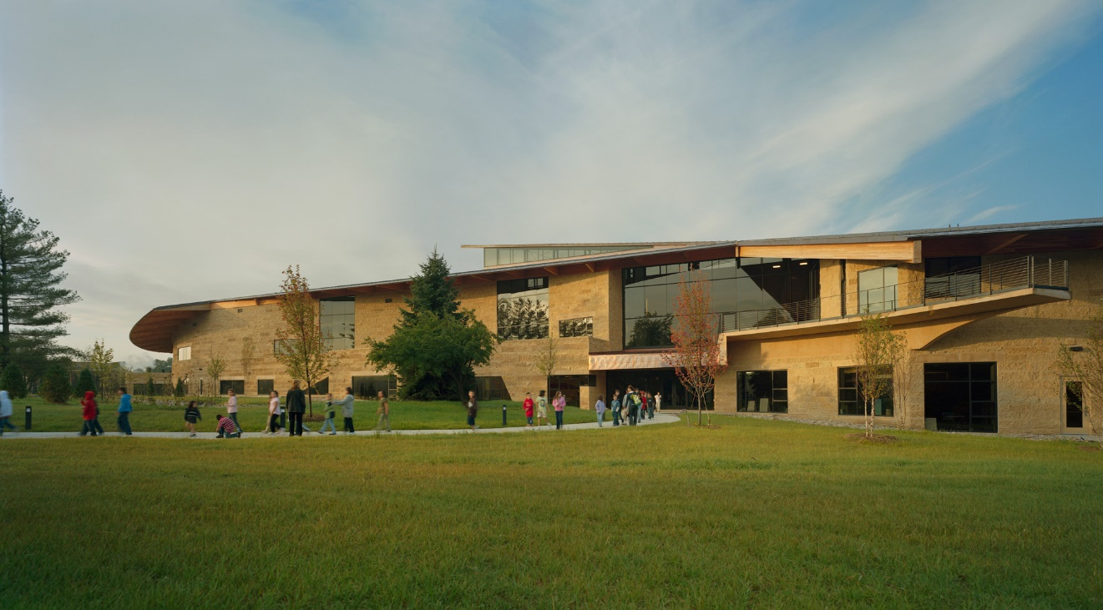
Figure 4: Indian Community School
(studio:indigenous)
This is something I aim to achieve in my school as well. While I know it needs to primarily function as a high school, I want it to be able to function as a community center for anyone to be able to enjoy. By accomplishing this, it gives the school more opportunity to mean something to more people. Inspiring empathy in the students is the primary goal, but inspiring empathy in the entire community is ideal.
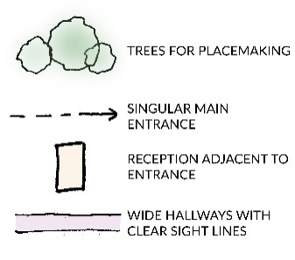
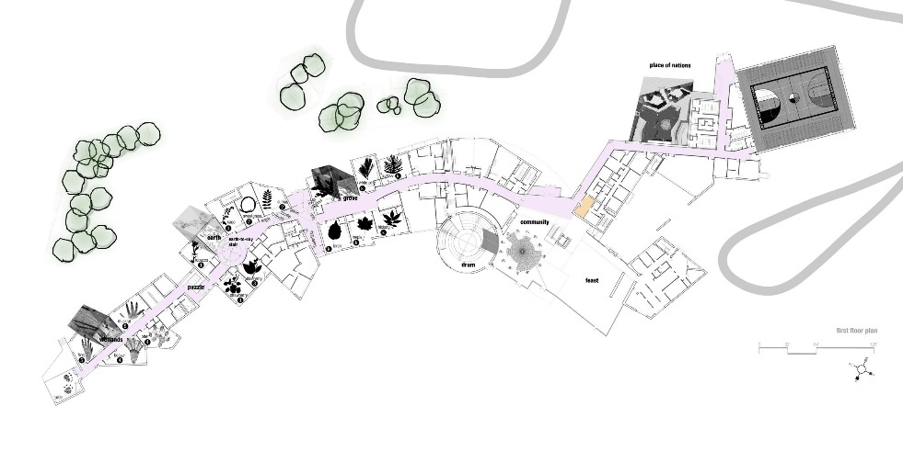
Figure 5: Crime Prevention Strategies in the Indian Community School
(by author)
Many clients have found value in studio:indigenous’s design approach, which resonates with many groups who have strong cultural identities, and could be used when designing post-tragedy. In every case of his design, “Cornelius sees the work not only as an embodiment of stories and traditions of the past, but also as the development of a contemporary story.” This approach is very valuable when considering places to rebuild after a horrific event. Considering schools such as Sandy Hook Elementary School and Columbine High School, as well as places such as Pulse Nightclub, there are so many challenges that they face. Maintaining a similar mindset to that of Cornelius would allow these places to be rebuilt without forgetting the events of the past and the people killed or injured.
Cornelius explains that “the architecture is part of the current story. What is it that we want to make or achieve? The stories haven’t necessarily changed, but the characters have.” When thinking about this in the setting of Columbine, for example, it is understandable that the current students have a different perspective of the school than students who attended 20 years ago when the massacre occurred. Teachers must constantly worry about their and the students’ safety, rather than be able to focus only on education. Constructing a new building doesn’t mean that the past is being forgotten or left behind, but will rather open up new opportunities to honor the past within the new construction and create a place for new stories to be made without fear of the past being repeated.

Embassy Design
United States Embassies are a valuable resource when thinking about designing any safe, beautiful structure. In 2013, author Tanya Ballard Brown wrote an article for National Public Radio where she considered the question of whether U.S. Embassies can be safe without being unsightly. She explains how several embassies are critiqued because of their lifeless, bunker appearance. She goes on to explain that the design quality and overall look of embassies isn’t just something that diplomats and civilians alike want to see, but it’s actually something that affects the way that diplomats work. They say that the distance and isolation from the city centers and a lack of accessibility complicates their jobs.
Ballard Brown explains how lately there has been an increase in interest to improve the design of embassies within the American Foreign Service Association. Susan Johnson, president of the American Foreign Service Association says that after Worl War II, there was a desire to use modern architecture to display the values of the United States, using architecture as a tool. Between the use of modern architecture and the need for safety, embassies became more like prisons and fortresses than beautiful spaces to promote openness and optimism. The Design Excellence Guiding Principles include a series of topics to be considered when designing an embassy. Some of these topics are predictable, such as purpose and function, site, operations and maintenance, and safety and security. Some of the topics are less obvious, such as historically, architecturally, or culturally significant properties and collections, art, and holistic approach to project development and delivery. Johnson says “I think what we’re aiming to do now is find a balance that combines security and beauty, and use technology and innovation to do it. If we’re going to do it, let’s make that building say something positive about America.”
I find these design guidelines and principles an extremely important set of topics that should probably be considered when designing any building, regardless if it’s showcasing the entire country, or just a family in a small town who is constructing a new house. It most certainly should be considered when building any public building that could be at risk of attack, because when the possibility of violence is there, why not plan for the worst, and get an incredible building out of it? For my analysis of Embassy design I will focus most closely on the approach to the building, both vehicular and pedestrian, and the concept of specifically local placemaking on the site.
The United Stated Embassy in Beirut, Lebanon offers complex problems for Morphosis, the architect on the project, to address. With the initial bombing of the U.S. Embassy in Beirut in 1983, and the one following a year later, embassy design was drastically altered. Americans quickly developed a bunker mentality which is still seen in the current design that is under construction. U.S. Embassies are less-likely to be found in city centers in order for them to be in “suburban exile”, where they can implement heavy fortification.
In the new design by Morphosis they are implementing several crime prevention strategies while still maintaining a beautiful look for the campus from both outside and inside. By situating the embassy on a hill, the vast concrete wall will not completely hide the beautiful architecture behind for the people of Beirut. Also, the design of the site plan is very maze-like. When someone enters the embassy, they cannot immediately approach the buildings (see figure 6).
The architect also opted to sink the buildings partially into the landscape, which works well in both the design sense with the style of buildings they design, but also does create a safer portion of the buildings under ground. According to the Architectural Review the United States Department of State chose the design by Morphosis because “it didn’t look like a fortress”. This implies that the United States is aware of the issue of embassies, in general, looking like fortresses when they should be expressing the ideals of American democracy.
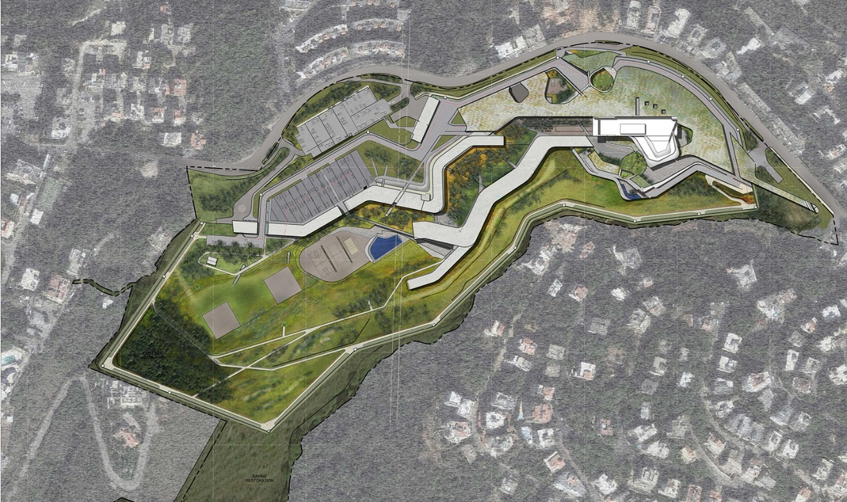
Figure 6: US Embassy in Beirut, Lebanon Site Plan
(Morphosis)
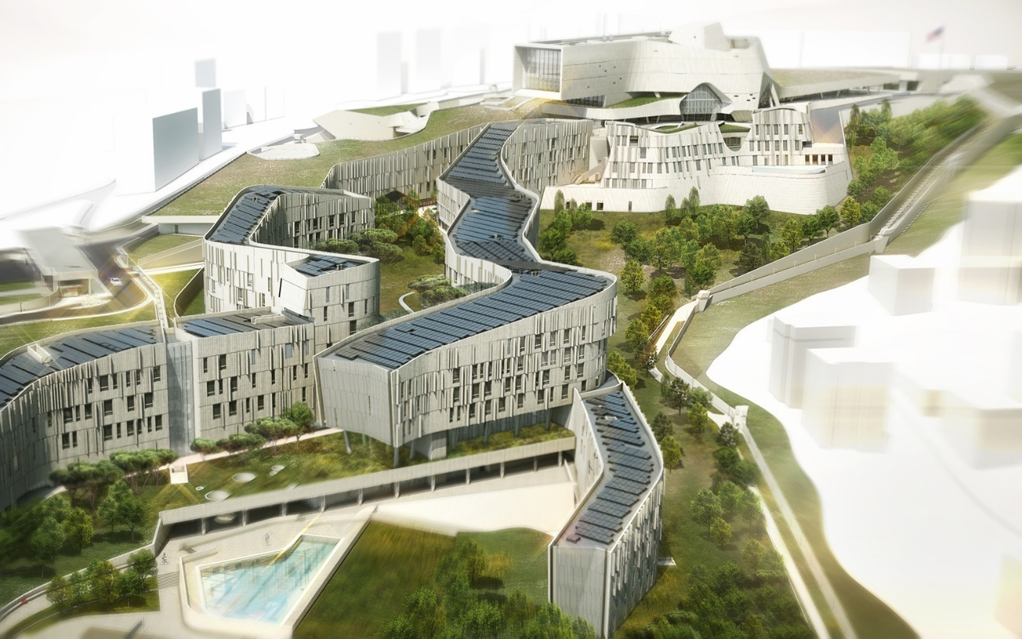
Figure 7: Beirut, Lebanon Campus Rendering
(Morphosis)

CHAPTER 6

SITE SELECTION

Context
The proposed site for a new Chelmsford High School is located at 255 Princeton Street in North Chelmsford, MA just south of the Merrimack River (figure 8). 255 Princeton Street has historically been owned by UMass Lowell and is known as their West Campus. Chelmsford, MA is in Middlesex County, bordering Lowell on its East Side, 30 miles from Boston, and 38 miles from Worcester. US Route 3 intersects Interstate 495 on the Northeastern border by Lowell. In 2018 the Town of Chelmsford had a population of 35,313 people across 23.2 square miles, according to the United States Census.
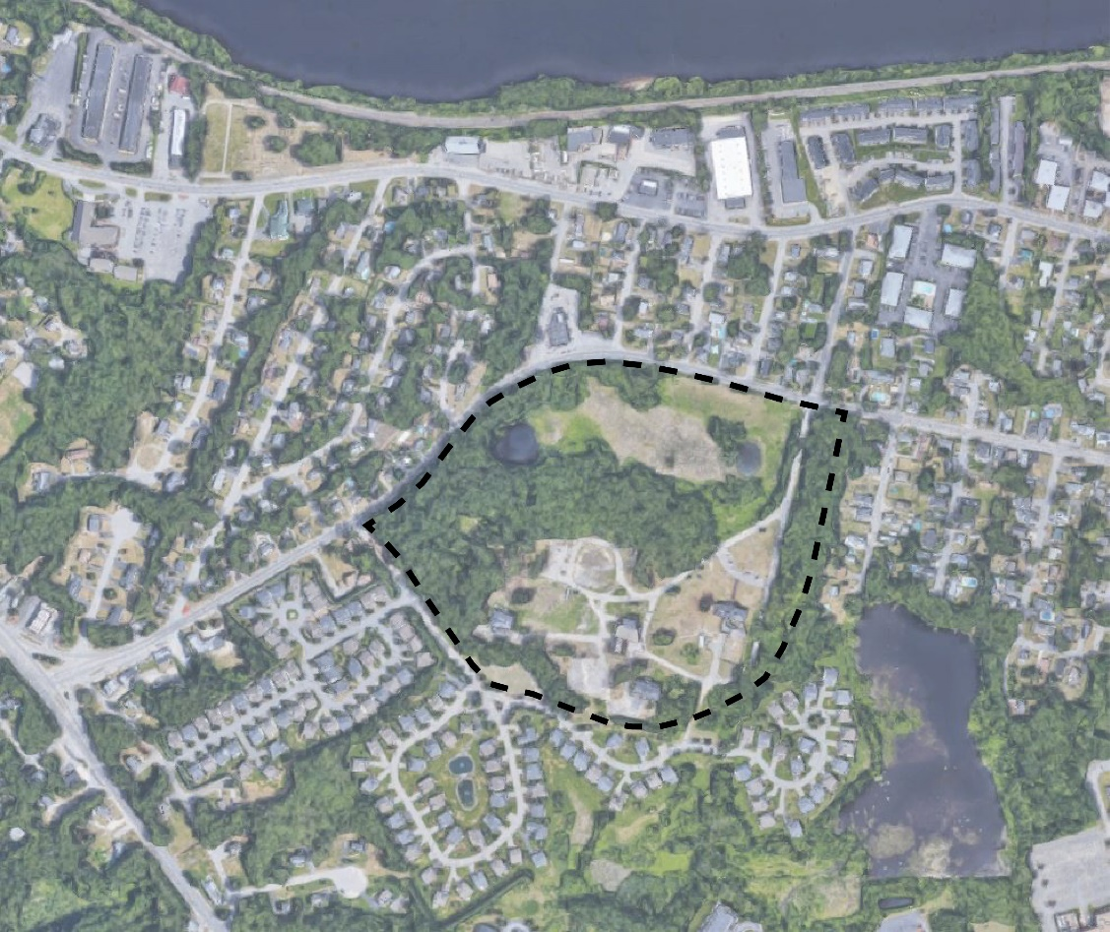
Figure 8: 255 Prineton Street, North Chelmsford, MA 01863
(by author)

Town History
The Town of Chelmsford (figure 9) has a thriving historic core, and is home to several historic preservation and cultural organizations. According to the 2020 Chelmsford Master Plan, during their sessions to outline the master plan they worked with residents and found that many people were looking for an engaged arts community, a form of placemaking in town. The committee involved in the master plan suggests that promoting the town’s historic resources could encourage tourism which in turn would stimulate the town’s economy.
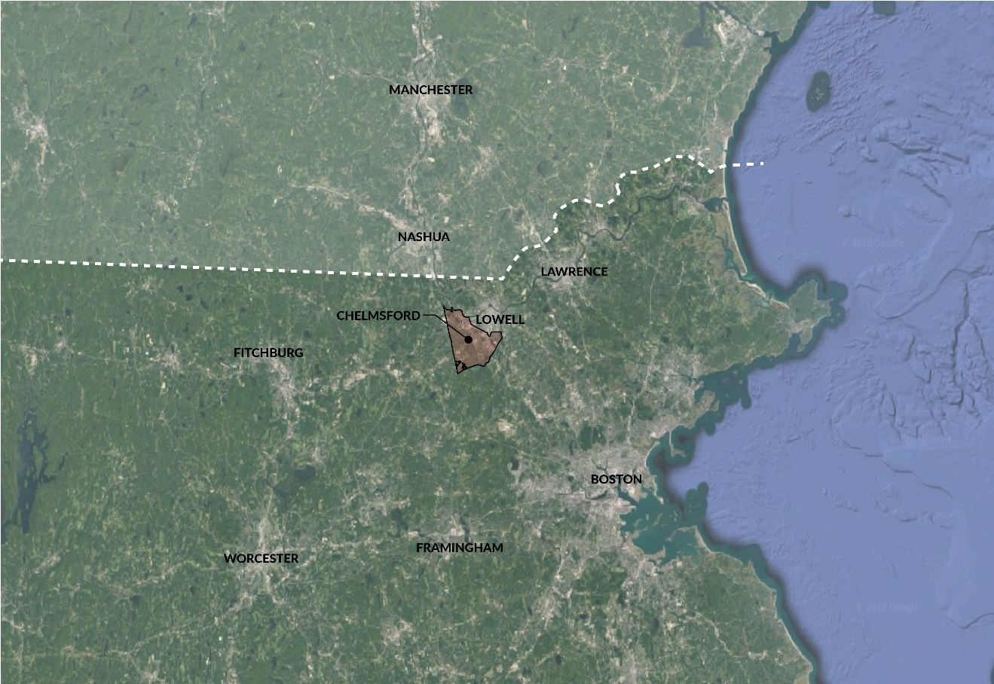
Figure 9: Locus Map of Chelmsford, MA
(by author)
Among the multiple books published about Chelmsford’s history a primary resource is the book History of Chelmsford, by Rev. Wilson Waters from 1917. The nearly 1000-page book covers the town’s history from before its settlement in 1655 through about 1910. This book looks into everything that happened in and around Chelmsford during this time including the Native Americans; Province Wars; the Battle of Bunker Hill; records of Chelmsford men in the Revolution; Shays’ Rebellion; roads, bridges, canals, and railroads; slaves, witches, and small pox; the School for the Deaf; religious organizations and burial grounds; and the early schools of Chelmsford. A Part Two detailing some more specific stories of people’s lives was published after, and a third installment History of Chelmsford 1910-1970, by Eleanor Parkhurst was published in 2011.
The Wamesit tribe originally occupied the land that Chelmsford is situated on. Residents from Concord and Woburn settled the area in 1652, and in May 1655 the town was granted general charter. It was named Chelmsford after the town in Essex, England, where many of the original settlers were from. When the town was settled it was almost entirely forested aside from areas by waterways, and areas that had been massacred by burning by Native Americans. Many of the settlers made their homes around what is now the Town Center, which is the main historic core in town. In 1672 the population was only sixty-seven, based on the tax list. The first school in the town was completed in 1713, with little growth happening during the 18th century with the Revolutionary War occurring.
According to the US Census, the population of the town increased to 1,341 in 1776. However, the growth of the community remained slow until the start of the Industrial Revolution. The railroad came to town in 1838, and the Merrimack River provided power for the mills. During this time most of the town’s population growth occurred in North Chelmsford because of the mills. In the early 1900s the population grew significantly and streetcar routes from Lowell were introduced to The Center of Chelmsford. Trolley routes around the center of town were abandoned in the early 1900s, and the roads were improved for the automobile. By then there was no significant industrial development, most development was suburban and focused in the eastern portion of Chelmsford near Lowell. The development of the regional highway system during the 1960s and 70s was the reason for rapid development. Today, the town is nearly fully developed.
The Town of Chelmsford has a high number of historic buildings, beginning with settlement of the community in the 17th century, through its industrial development in the 19th century. Historic buildings in town include homes, mill buildings, religious and school buildings, and barns. Many of the historic buildings are owned by the Town and exist in the Town Center or Vinal Square in North Chelmsford. According to the 2020 Chelmsford Master Plan architectural styles in the town include those which were popular in the 18th through 20th centuries. These include styles from the Federal style of the 18th century to the Colonial Revival in the 20th century. Many of the historic buildings in the town are well-preserved and maintained, lending to the character of the town, and it’s sense of place.

Demographics
The Town of Chelmsford was incorporated into the state of Massachusetts in 1655 by citizens from Concord and Woburn. Located in Middlesex County in the North Eastern part of Massachusetts, the Town of Chelmsford covers a 22.54 square mile land area. As of 2016, the population was 32,171 people, with an average household income is $107,493, compared to the state average of $77,385, and $63,179 nationally. The budget for the town was $118,944,700 in 2016, and the town government consists of a board of selectmen, a town manager, and a representative town meeting.
The existing Chelmsford High School is currently located on Richardson Road in North Chelmsford, minutes away from Drum Hill Rotary, the intersection of Route 3 and North Road, leading towards Lowell, MA, about a five-minute drive from the proposed site. The high school houses grades nine through twelve, with a total of 1484 students during the 2018-2019 school year. The student to teacher ratio is 13.22:1. Grade nine had a total of 372 student, ten had 347 students, eleven had 391 students, and twelve had 373 students. The school has a predominantly white population, with 1185 students throughout the four grades. There are 177 students of Asian descent, 57 of Hispanic descent, 38 African American students, and 27 students of other races. There ratio of male to female students, is nearly a fifty-fifty with 725 being male, and 759 female.

Site History
The Princeton Street site is approximately 0.5 miles south of the Merrimack River in a largely residential area directly at the border of Lowell.
The Middlesex Council Truancy School, a reform school for boys, occupied the site from 1898 until 1973 when it was shut down after a series of investigations of the treatment of the students. The buildings were abandoned for a few years until Wang Laboratories purchased and occupied it until 1984. Wang Laboratories then sold the site to UMass Lowell (Lowell State College at the time) for 1 dollar. In 1985 Lowell State College moved into three of the five buildings (Upham Hall, Read Hall, and Gould Hall, shown in figure 10) and housed the Graduate School of Education. The other two buildings Richardson Hall and Bigelow Hall were being used by the Robert F. Kennedy school that housed juvenile girls until 2015.
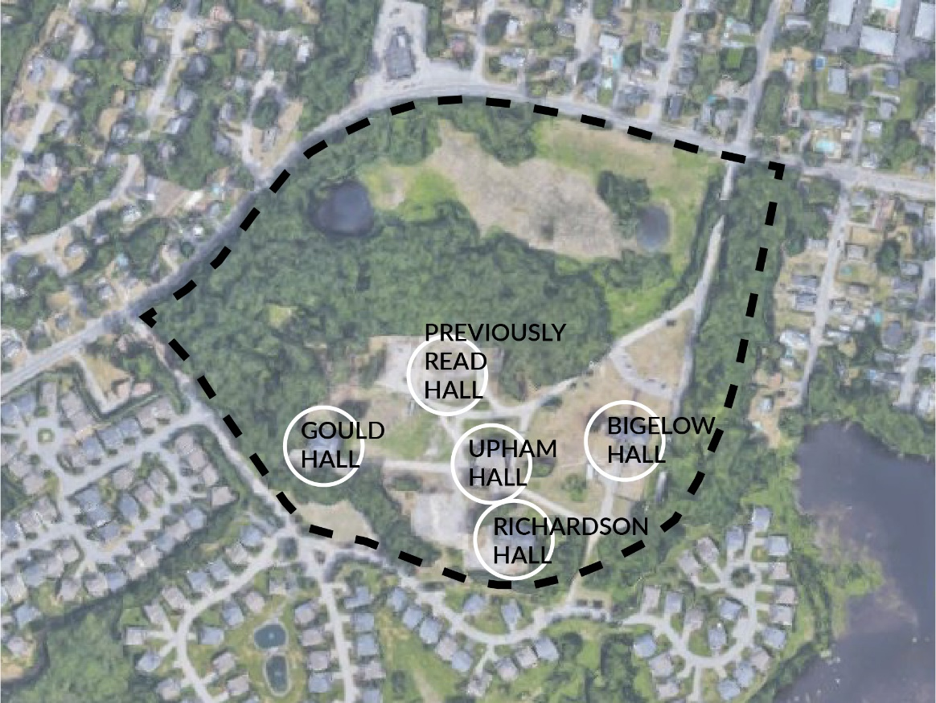
Figure 10: Existing buildings on the site to be demolished
(by author)
The UMass Lowell West Campus had to deal with the building conditions which ranged from extensive deterioration to needing cosmetic repair. One of the buildings, Richardson Hall, had been in a fire while it was in use by the Robert F. Kennedy School. There was also a feeling of isolation between the West Campus and the other three campuses. Around 2000 the chancellor deemed the buildings unsuitable to hold the Graduate School of Education or to host classes.
In 2015 the Robert F. Kennedy School left the West Campus Location and the buildings have been left vacant since. In 2013 Read Hall caught fire and as a result the building was demolished. In 2014 Massachusetts Senator Michael Barrett drafted a bond, which became a bill in 2014 to fund the demolition of Upham, Gould, and Richardson Halls. Bigelow was left undetermined. In 2017 Governor Charlie Baker signed off on the bond bill with a demolition date yet to be determined.
At the same time that the decisions were being made to demolish the remaining buildings, Chelmsford Town Manager Paul Cohen established the West Campus Planning Committee, with the goal of brainstorming ways the property could be utilized when it is acquired from UMass Lowell. In August 2018, the property was sold back to Chelmsford. As of April 2019, the property was sold to Alice Cui, a developer from Lexington, MA, for $3.245 million, with plans for residential development on the land.

CHAPTER 7

SITE ANALYSIS

2020 Chelmsford Open Space Master Plan
In 2010 the Town of Chelmsford developed a Master Plan for 2020 that looked at many various components including Land Use and Zoning, Economic Development, Transportation and Circulation, Housing, Open Space and Recreation, Natural, Historical and Cultural Resources, Facilities and Services, and a Plan for Implementation. According the Master Plan there are 2,620.42 acres of open space, and “approximately 991.16 acres … are considered permanently protected.” Of the 2,620.42 acres “there are 230.46 acres of school property in Chelmsford that are not permanently protected, including school athletic fields and playgrounds.” A series of recommendations were stated to identify and prioritize open space and potential recreation parcels to be targeted for future use and/or protection. The last of these recommendations was to “develop a Master Plan for the UMass Lowell West Campus … that has an open space component.” Using the information found in these various components by the town, I developed a diagram to show the site analysis that most affects this site (figure 11).
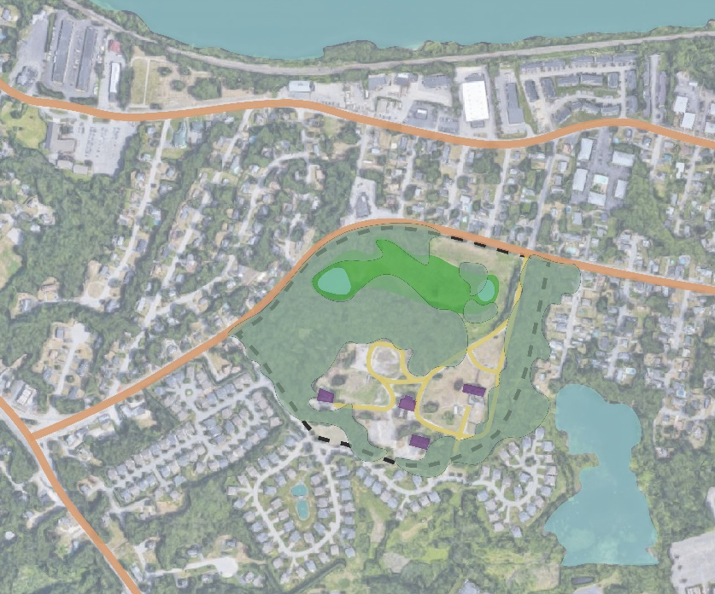
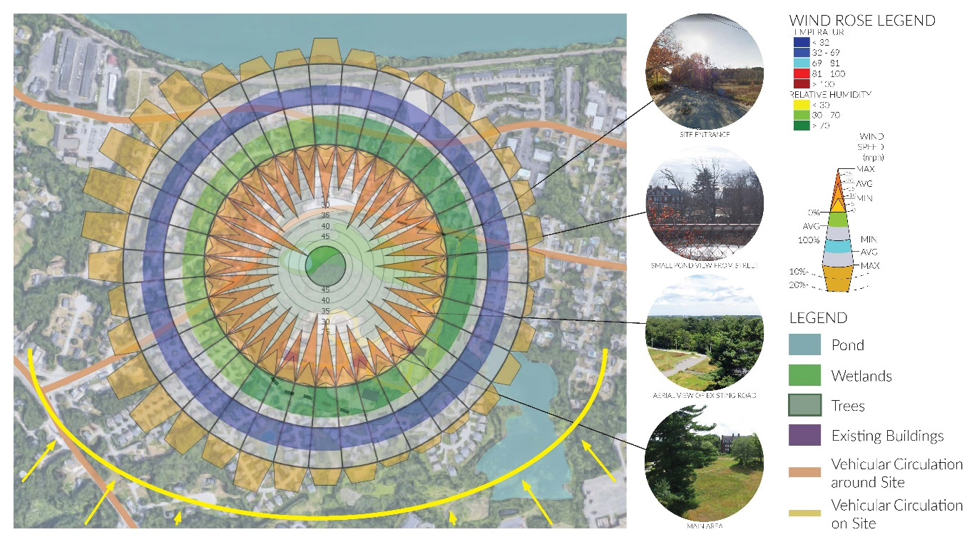
Figure 11: Site Analysis
(by author)

Land and Water on the Site
The Merrimack River is a 180-mile river which goes through northeastern Massachusetts, and up into southern New Hampshire. According to the 2020 Chelmsford Master Plan the river provides the second more surface drinking water in New England. The river is also an important route for waterfowls and songbirds’ migration.
The river forms Chelmsford’s border with Lowell and Tyngsboro, and the Merrimack River and the Concord River are both Class B waterways, meaning they are to be used for recreation, fish and wildlife habitat, agricultural and industrial use, and navigation. Chelmsford has actively been improving access to the Merrimack River, most recently improving the only public boat launch between Lowell and New Hampshire at Southwell Field.
The Merrimack River and the eleven named streams that run through town, impact the 100-year flood plain (figure 12). Given the proposed site’s proximity to the river, it’s surprising to see that it is not affected by the 100-year flood plain. According to the Hazard Classification of Chelmsford Dams in the 2020 Chelmsford Master Plan the Stony Brook Stream Dam, located to the west of the proposed site, is classified as “Significant” in the Hazard Class. While the Merrimack River is also expected to change dramatically by the Swains Pond Dam, neither of these conditions will affect the proposed site, however they are of the closest proximity to the site.
The site also sits on an aquifer and there are two small bodies of water on the site closest to Princeton Street, which will require any development to be pushed further back on the site, but allowing for natural landscaping.
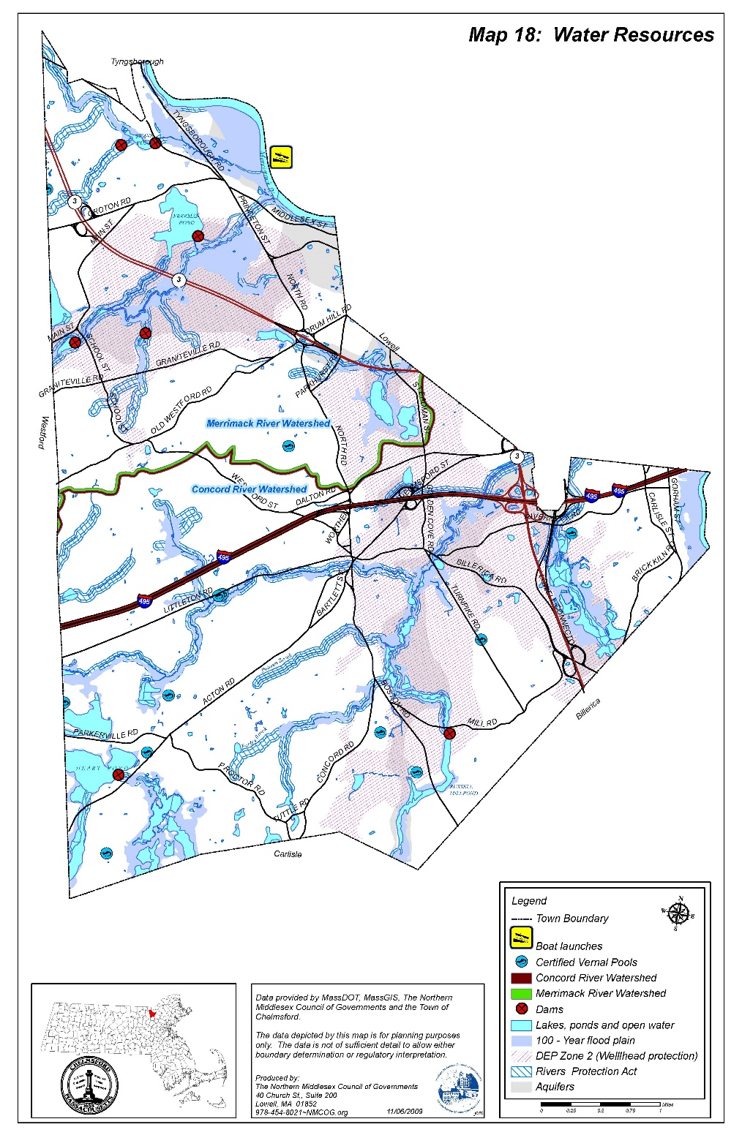
Figure 12: Water Resources in Chelmsford, MA
(Chelmsford Master Plan 2010)
According to the Master Plan all the drinking water in Chelmsford originates from aquifers. The Town’s water districts indicate that there is capacity to increase water production by 20% to accommodate growth in the future. The superficial geology of the site is mainly course soil (figure 13), but with the addition of the minimal open water space at the street-side of the site. The soil on site is primarily Urban Land, and Windsor and Hinckley. According to the United States Department of Agriculture (USDA), Urban Soil is found in areas that provide drinking water and other natural resources. They are typically found in cities and recreation areas. The other two soil types, Windsor and Hinckley are geographically associated soils to each other. According to the USDA Windsor soil is nearly level, and excessively drained. In the case of this site, there are areas of also excessively drained Hinckley soils, which include soils that all drain relatively well such as Merrimac soils, Agawam soils, and Deerfield soils. All these soils generally do not have slopes of more than three percent. The soils all have rapid permeability, and the water capacity is low. They are acidic soils through each layer from the surface through the substratum. The USDA explains that these kinds of soil are good for community development, and that when excavated they can become unstable.
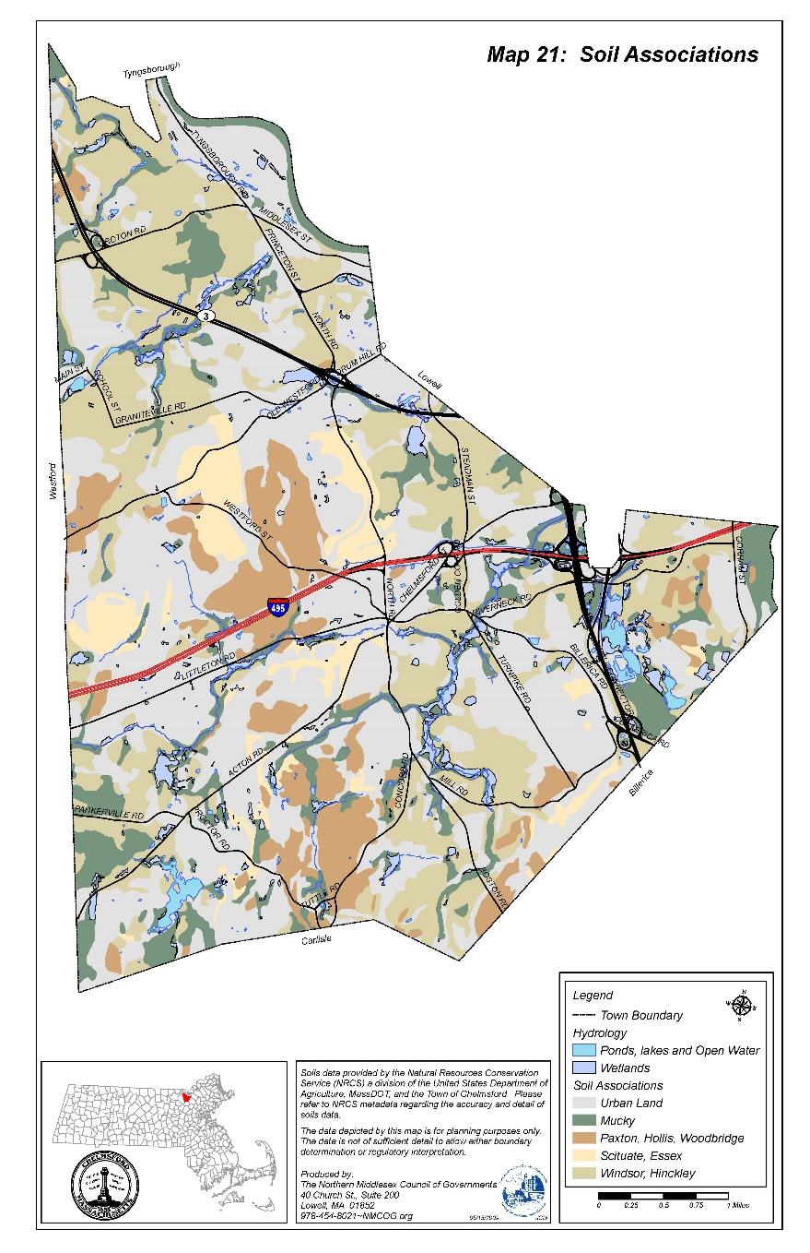
Figure 13: Soils in Chelmsford, MA
(Chelmsford Master Plan, 2010)

History of Chelmsford Schools
The Town of Chelmsford has a rich history of schools, and historic properties that schools previously existed at. The first schoolhouse in town was the 1802 Schoolhouse at Forefathers Cemetery in the center of town. According to the Massachusetts Historical Commission Building Survey, the original grant for this schoolhouse was dated November 28, 1718. In 1802, the original structure was replaced with a new brick structure, which still stands on the same site to this day. It is, of course, no longer used as a schoolhouse, but the town holds historical events there, as well as opening it during town-wide events.
In 1866, the first school for the deaf was opened down the road from the 1802 schoolhouse. It was opened in a room of a historic home owned by Deacon Adam Otis, a very influential person in the Town of Chelmsford. Miss Harriet B. Rogers was the first principal of the Chelmsford School for the Deaf, which had great success in its practice of the pure oral method to teach the deaf. The students were taught to speak and to read from lips.
In 1851 the 1802 Schoolhouse was abandoned and a new one was built on North Road, across the street from the Chelmsford School for the Deaf. This new “yellow schoolhouse” was first used as a primary and grammar school, and later used as a high school.
Down the road on Academy Street, another school was opened in 1825, named the Chelmsford Classical School. The Chelmsford Classical School was a private enterprise organized to provide more advanced studies than those offered by the public schools. Ralph Waldo Emerson was the teacher of the students enrolled at the Classical School, and its pupils later gained distinction throughout the world. In 1862 during the Civil War, some of its pupils joined the army and the school closed.
In 1896 a school, called the Golden Cove School, was built in the Westlands section of Chelmsford. By 1919 the school became very crowded, and grades 1 and 2 needed to be taught in the morning and 3 and 4 in the afternoon. By 1921 only grades 1 and 2 were able to be taught here, and a new school was built on Dalton Road, also in the Westlands section of town. After students were moved from the building into the new one, a Catholic church held classes there. In 1940, when the Westlands school was being renovated, classes were held in the Golden Cove School for one last year.
In the North side of town was the Middlesex Truancy School. Located on the proposed site, this controversial school was erected as a campus of five buildings where boys from all over New England were sent if accused of poor behavior. According to an essay written by George Cormier, titled “Triumph Over Truancy … How Middlesex County Truant School Changed My Life” there was no reason given for why he was taken away from his family to go to this school. Cormier wrote this essay at the age of 81 in 2010, and he recalled very violent punishments against the boys who misbehaved at the school saying they would be slapped across the face, forced to have their heads shaved, and hit with a large shillelagh.
There have been many other schools built between these and the current schools in town, but none that were as influential, or that lasted long before the current schools needed to be built to accommodate the number of students in the growing town.

Chelmsford Public Schools
There are currently seven schools in the Town of Chelmsford: four elementary schools throughout the town, two middle schools surrounding the high school, and one central high school. Additionally, there is a community education building in the existing Westlands elementary school which was closed in 2008 due to budgetary reasons, and a preschool, named Chelmsford High Integrated Pre-School (CHIPS) inside the high school.
Chelmsford high school was founded in 1917. The first building dedicated solely to grades nine through twelve was in the center of town in the building of the current town hall. When Chelmsford High School outgrew that location, they moved to what is now McCarthy Middle School, about a 5-minute walk from the current high school building which was built in 1974. Today, the current high school, McCarthy Middle School, Parker Middle School, and Harrington Elementary School make up the central campus.
In 2007 Chelmsford High School underwent extensive renovations. There was a complete renovation of all the existing science classrooms where they constructed a second wing dedicated for the sciences where there used to be school district administration offices. There were also upgrades to the ceilings, floor tiles, electrical, and HVAC. A new 1000-seat performing arts center was constructed, which was the first time in its 33-year history that the high school had its own auditorium. Previously exposed stairwells were enclosed to improve circulation at the ends of the academic wings. In 2008 the library was renovated into a learning common, and new lockers were installed. And in 2018 there was a renovation to the wrestling room and weight room.
Despite such an overhaul of renovations to the school there are still complaints about the building. Because of the layout, there is a central core of rooms that do not have windows or any access to the outside. Because of this there have been complaints by teachers and staff who work every day in that section of the building. Although no one has diagnosed this, there seem to have been cases of sick building syndrome for some staff in this area. Specifically, a school nurse transferred positions to Parker Middle School because every day in work she suffered from allergy and cold-like symptoms, as well as difficulty in concentration, and fatigue, all of which are symptoms of sick building syndrome as described by the National Institutes of Health. There are other problems within this school, including issues of plan and section which will be discussed in later sections.

CHAPTER 8

PROGRAM

Town Assessments and New Standards for Schools
In 2016 and 2017 the Town of Chelmsford and the Chelmsford School Committee conducted a review of the current facilities to assess their condition and identify deficiencies that were to be included into a master plan for both the short- and long-term. In addition to assessing the condition of the current buildings, the Town was also identifying the potential of new building construction, addition, or renovation for the long-term.
During the process of the facilities assessments, it was found that Chelmsford High School has both spaces that are undersized and oversized, according to the Massachusetts School Building Authority (MSBA). Specifically, almost all classrooms in the building (aside from some of the science labs that were renovated in 2008) are undersized. Spaces that are oversized for the school population include the performing arts center, the cafeterias, the learning commons, the locker rooms, and the art classrooms. There are only a few spaces in the school that are the correct size. All of these spaces are in the basement and include the recently renovated science labs, and the gymnasium. The MSBA noted that the high school also needs space to move the currently windowless classrooms, and to incorporate additional special education spaces.
In considering master plan options for moving forward in the coming years, the plan to build a new high school was widely accepted as the preferred option. Choosing to construct a new high school has many advantages including: being a source of pride for the town, providing up to date resources for students, and adding new amenities that can benefit the town.
According to the MSBA, there are specific educational program requirements that must be met. On the Massachusetts School Building Authority’s website, they state
“To ensure that school projects are responsive to the educational needs of a District, the MSBA requires the district to document its educational program and define proposed educational activities. … Establishing a comprehensive and thoughtful educational program also helps to provide for future flexibility to adapt to changes in programming or teaching methodologies over the useful life of the school.”
The sample educational program for high schools that the MSBA uses is Sharon High School, in Sharon, Massachusetts. For the purposes of this thesis, I am studying the Sharon High School program and the Newton North High School program.

Current Chelmsford High School Program
As noted in the previous section, Chelmsford High School is outgrowing its current building, as seen in a study by Dore & Whittier Architects. There are around 28 general programming areas including areas such as the gym, science labs, the auditorium, classrooms for each subject (math, sciences, English, foreign language, social studies, and art), music, main offices, and cafeterias. Of these programming areas, ten are not large enough for the current size of the student body.
Areas in the lowest level that are no longer large enough include the wrestling room, weight room, and the science labs. On the first floor, areas that are undersized include twenty classrooms, the dual-purpose orchestra and chorus room, the main office, one of five art classrooms, and the Chelmsford Television room. On the second and top floor there are twenty more classrooms that are undersized. This concludes that every useable classroom in the building is undersized. There are about six additional classrooms which are the correct size, but were not included in this part of the study because they don’t have windows, so they technically aren’t up to code.
In addition to having many spaces that are undersized, Chelmsford High School also has an equal number of spaces that are oversized. On the lowest level these include the athletics locker rooms (locker rooms for students in gym class are the correct size), the wood shop, and the auditorium. On the first floor the band and theater rooms, two cafeterias, kitchen, two house offices, and three art classrooms, are oversized. On the second floor the learning commons and two house offices. This leaves only six areas of program that are the size they should be for the student and staff populations. The gym, computer labs, locker rooms, two lecture halls, one art room, and the nurse’s office are the proper size.

Proposed New Program
In my new Chelmsford High School building, I do not intend on altering the program aside from resizing what needs to be resized to adhere to the standards set by the Massachusetts School Board Association for a high school with an approximate enrollment of 1500 students (table 1). Note that this will be adjusted in the design and layout of the building.
On the lower level there will be thirteen classrooms dedicated to the sciences, eleven classes dedicated to math, two computer labs that can be shared between math and sciences, and two lecture halls, as well as the mechanical spaces.
On the first floor will be the four largest areas of program, the gym, auditorium, cafeteria, and library. There will be the theater, chorus, orchestra, and band rooms, as well as five large classrooms for the arts. The other classroom wing will hold ten classrooms for foreign languages. There will also be the main office suite including the nurse’s office, and a conference room that can be shared by faculty, staff, and by the community if scheduled.
The second floor will hold the additional classroom spaces for English and social studies. There will be a second level to the library between the classroom wings, and a small area for a roof garden above the main office area on the first floor. There will also be additional program from the gym, cafeteria, and seating for the auditorium.
Table 1: Standard Program According to MSBA
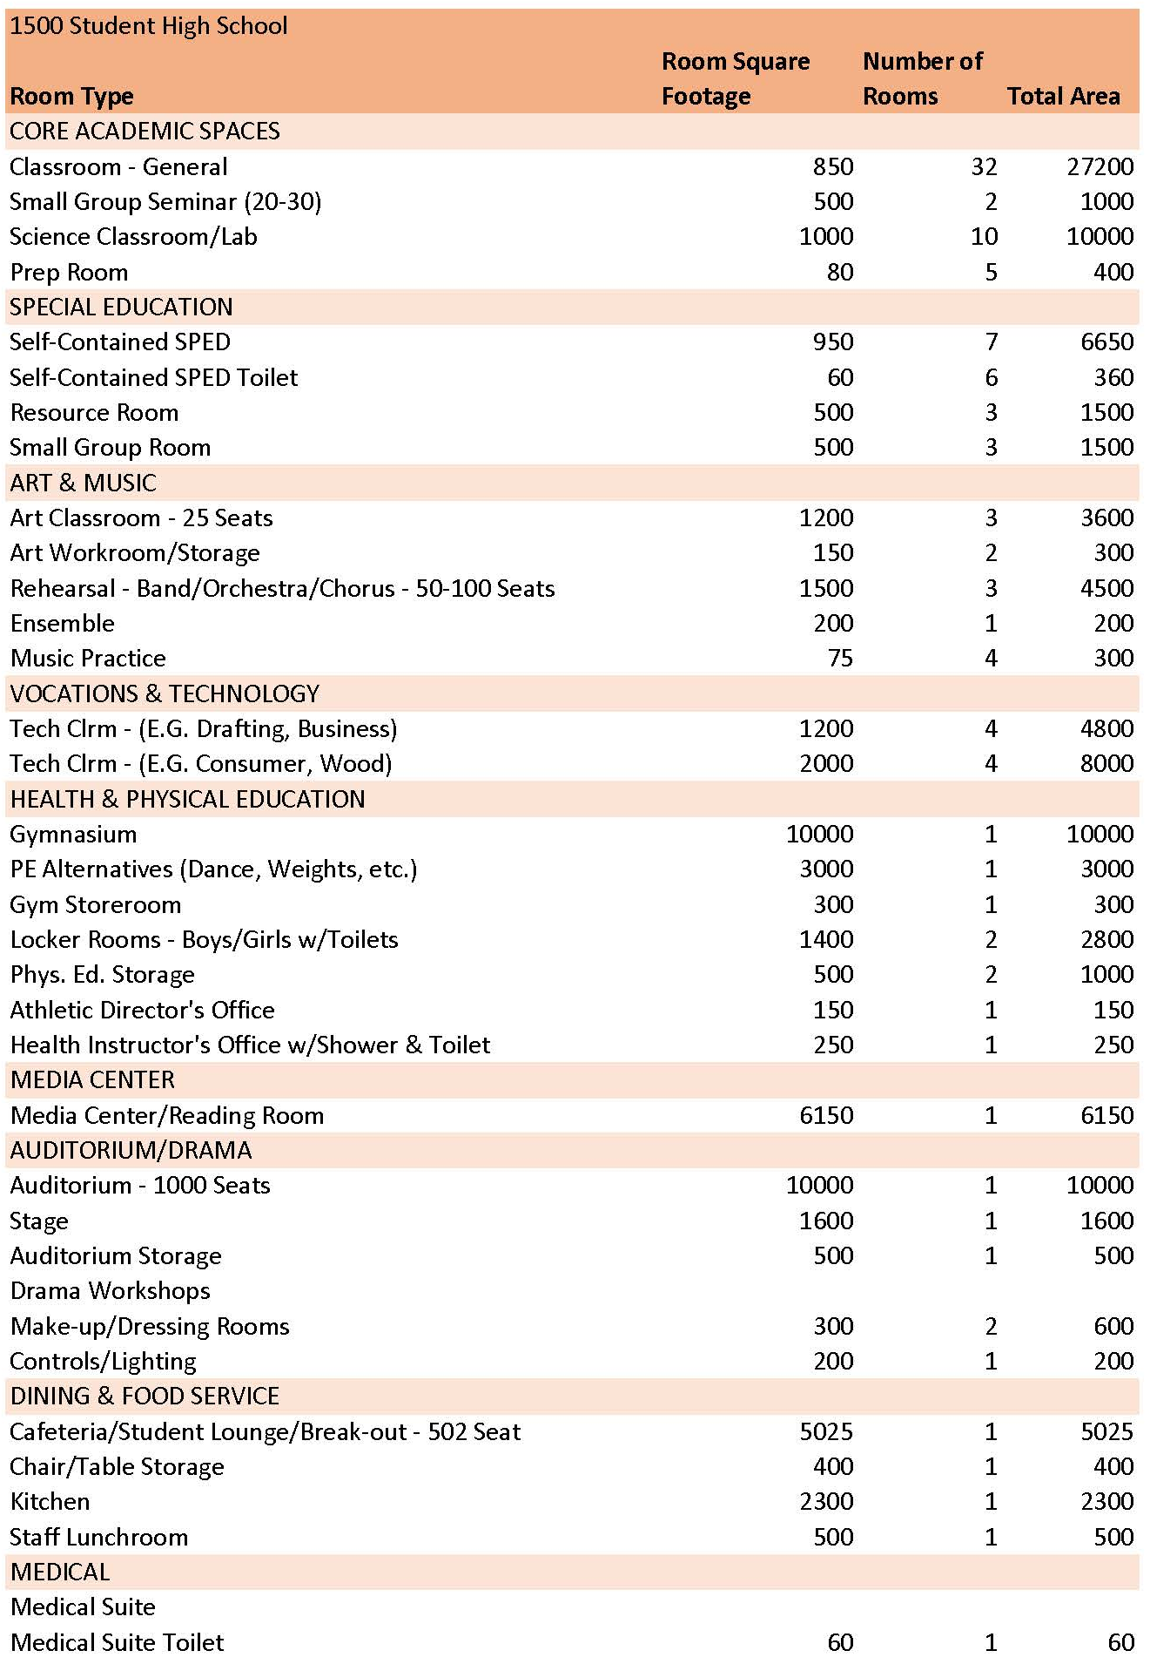
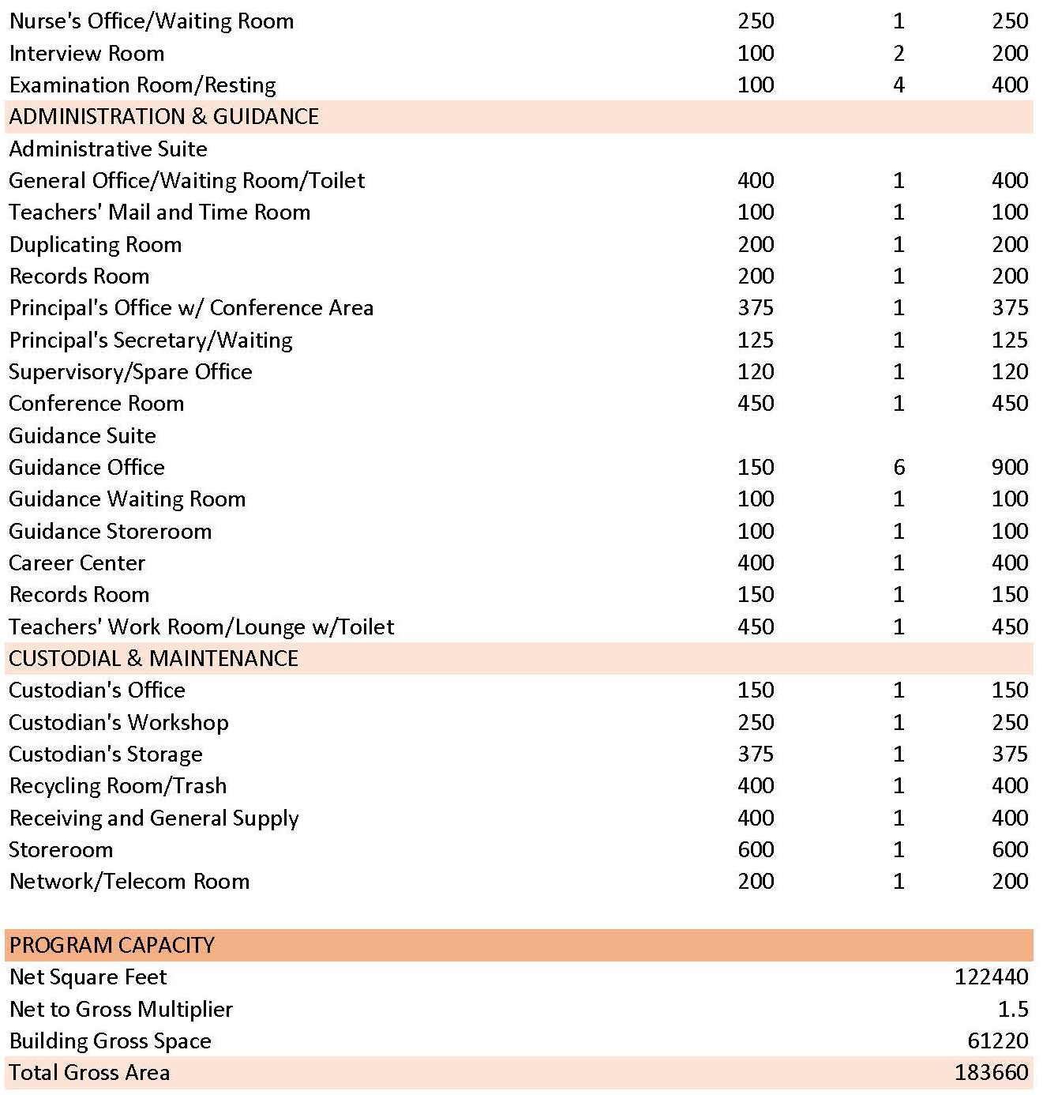

Designing for Empathy
Entering the design phase of a new Chelmsford High School focuses primarily on empathy and inspiration in architecture. In Chapter Four I discuss the topic of empathy in architecture and how it can change the views of students and people in the school.
To begin more detailed designing, I surveyed a group of students currently attending Chelmsford High School about things they like in their school, would possibly like to see in a new school, and in general things that they are interested in. The twelve questions I asked stem from Michael Benedikt’s polemic “Environmental Stoicism and Place Machismo”. See figure 14 for a selection of charts documenting the results.
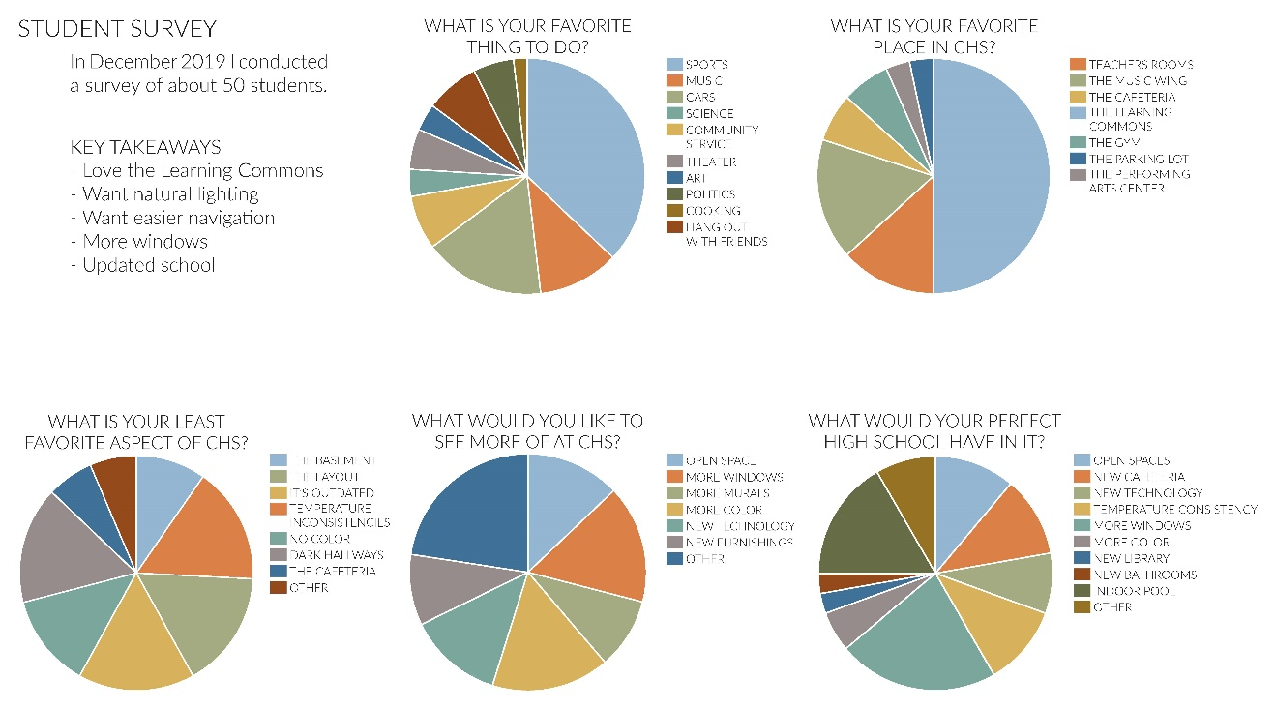
Figure 14: Student survey results from final documentation
(by author)
In Chapter Four I quote Benedikt on a list of areas in North American high schools that closely follow the factors laid out by Caudill. Benedikt mentions energy consumption leading to too-tight buildings; the most efficient size of a school being large and at full capacity; theft leading to locks and bars; misbehavior leading to video scanning throughout the school; and so on. Many of these factors were specifically called out by Chelmsford High School students as being things they would like to see changed. Having been a student there in the past, I understand where a lot of these students are coming from in their responses.
The most common response when asked what their favorite aspect of the Chelmsford High School Building was that it is easy to navigate. The layout of the school is a square with two wings, creating an “L” in plan. Almost everyone was a fan of the symmetry, the classroom wings, and the second floor the Learning Commons, that was added in 2008.
After the students identified their favorite aspect of the school, I asked about their least favorite aspect is. Many students said that everything looks the same, and that it is “old and dirty.” Some people called out the walls as being dirty, some mentioned the desks and other furnishings, and most just said the whole school is dirty. Some complained that the school is “devoid of life” because “so many parts of it are a dank grey or pallid white.” While the first and second floors were called out as many people’s favorite aspect because of the layout, some people called out the basement level as their least favorite aspect. One student said,
“My least favorite part about the building is the science area [in the basement], it’s very confusing and I still don’t understand the set up. I never really know how to get anywhere down there, and it’s cramped and cold.”
More students called out the basement floor saying that the lecture halls are distant and closed off from everything, leading to them not being used very often despite being recently renovated. And someone else mentioned that “sometimes the setup of it makes it feel like a prison.” A recent change to the setup of the school was to rearrange classrooms so that they were no longer organized by subject in the wings. This was called out by a few as their least favorite aspect of the school because it makes it feel more confusing to navigate.
When asked what students would like to see more of at Chelmsford High School, many students asked for more murals. Chelmsford has always had a wonderful mural program where an Advanced Placement art student would be chosen each spring semester to paint a new mural in the school. This is an incredible placemaking strategy that I will be bringing into a new design.
Other students commented that they would like more open common spaces for students to work, more natural daylighting in the hallway areas (where there is currently no natural daylight), and more color. Students were interested in seeing more “homey architecture” which based on some of those responses seemed to mean wood or carpeted floors, color, and more common spaces.
One student specifically called out security as something they would like to see in the main office, reflecting the issue previously mentioned about its location. The main hallway you need to cross that is often filled with students, as it is one of the places students gather during off-times of the day (something that could be remedied by new common spaces). In addition there was a concern about there being too many entrances to the school. In addition to the main entrance, there are entrances at the end of each wing on both the first and basement levels, a rear parking lot entrance, two entrances by the gym, and two entrances by the Performing Arts Center. In total there are ten entrances that can be accessed by anyone throughout the day, with only the main office entrance being as secure as the main secretaries are able to keep it.
I next asked the students what their favorite place in the high school is. Most people said that the Learning Commons are their favorite because it is “cozy, warm, and different from the rest of the school.” A few other students commented that the Performing Arts Center (PAC), and as an extension of that the music classrooms, is their favorite place. One student said about the PAC that “it’s so new and open… it’s also easy to hear people and walk around, and the temperature is always good.” It seems clear that students gravitate towards the newer areas in the school, which is unsurprising. They were renovated and added very recently and nicely.
One student’s response was particularly frank, and I feel as if there would be several other students who feel this way. They say “I honestly don’t have [a favorite place], most if not all of the rooms don’t feel homey and make me feel uncomfortable mostly. Except for specific [classrooms] because the teachers are really kind.” When I was a student at Chelmsford High, this was a common feeling among many of my friends. They did not care for any specific “place” in the school, but they could always be found in a classroom of a teacher they loved. This school is special because of the people in it, not because of the building.
I then asked, “If you were going to design your ideal high school what would it have in it?” A lot of students took this as an opportunity to rehash some of the items they listed in their least favorite aspects of the school. A few answered saying they would have more carpeted rooms and consistent temperature control. Many wanted more windows, or a better connection to the outdoors. Many students specifically asked for more/better technology and Wi-Fi. And a few wanted to include nicer and larger gymnasium features including an indoor pool because the swim teams need to travel for every practice, and a bigger gym that includes an indoor track.
I followed this question by asking students what they love to do, whether it be in or out of school. Having read about their favorite aspects of the school and what they’d like to see in their ideal school it was clear that this group has many interests, and that the school doesn’t do a bad job of providing spaces for a lot of their interests. Many people love playing music, theater, marching band, and listening to music. Others play sports including swimming, cycling, basketball, soccer, running both indoor track and cross-country track, football, tennis, and badminton. A handful enjoyed other activities such as working on cars or driving, history and politics, Model United Nations, baking, and community service. Almost everyone said that they like to hang out with friends.
Next, I asked how Chelmsford High School can be a place that they love to be and makes them happy. The students had great answers for this question. Some students kept their responses at the surface level, saying it would be nice if the school offered a “flexible block” in the schedule where they can go anywhere they need to for help, or just have downtime; or having warm, natural light; offering more classes in different areas of study such as engineering or technology; or just updating the school in general.
Other students dug a little bit deeper into the reasons why the school is not somewhere that makes them feel happy. Someone called out the attitude of the students, saying that “[they would] change the attitude that students have towards their education. I like learning and going to school, but that’s not the case for most students and teachers, and that is really upsetting.” For a high school student, between the age of 14 and 18, I find this to be a very profound and well thought out response.
Another student called out the drug problem that is not spoken about or really addressed in general. The Chelmsford teenage population has had drug problems for many years. With the town’s median income being slightly above average, it has always been said that the drug problem comes from the fact that there’s money to be spent on drugs, and obtaining drugs from the neighboring city of Lowell is easy for students in Chelmsford and other surrounding towns. This student’s problem with being happy at school “has to do with the people’s attitudes and problems with drugs. If people were less rowdy and nicer, and if they did not do drugs, I would be happier.”
I then asked a series of questions about their physical surroundings at the school. I asked if they would like to have more open gathering spaces, where they can hang out with friends, or sit quietly before or in between class times, to which 93% of students said they would like to see. When asked if they would like more natural daylighting, 100% of students said yes. And when asked if they would like more colors in their classrooms and common areas, 83% of students responded yes, and most students wanted to see more blue in the school because they find it more calming.
Considering the students’ opinions and feelings about a new school is an important step and giving them something they will love. Also, in turn, it is an important step in creating something that the community will love. Everyone who meets the primary users of the space are going to be better off because these children and young adults are better off. While not everything can be solved by painting the walls nicer colors than white, or adding more windows in common spaces, it’s a big step in the direction of designing a space that will inspire empathy in young people, and will make it a place that people love to be.

CHAPTER 9

REGULATION

Building Code and Accessibility
Given the size of the building, with the gross floor area for the basement being roughly 75,000 square feet, the first floor being roughly 150,000 square feet, and the second floor being roughly 100,000 square feet, the building can be construction with heavy timber. This site is a great option for heavy timber because of the location being wooded. Heavy timber construction will allow the building to situate in its space and feel more like a part of the site rather than take away from the nature surrounding it.
The primary use and occupancy classification for the building will be A-1 and A-4 Assembly, and E Educational.
The allowable building height for a heavy timber with these classifications is 85 feet above the grade plane, and there can be four stories above the grade plane (table 2).
Table 2: Types of Construction
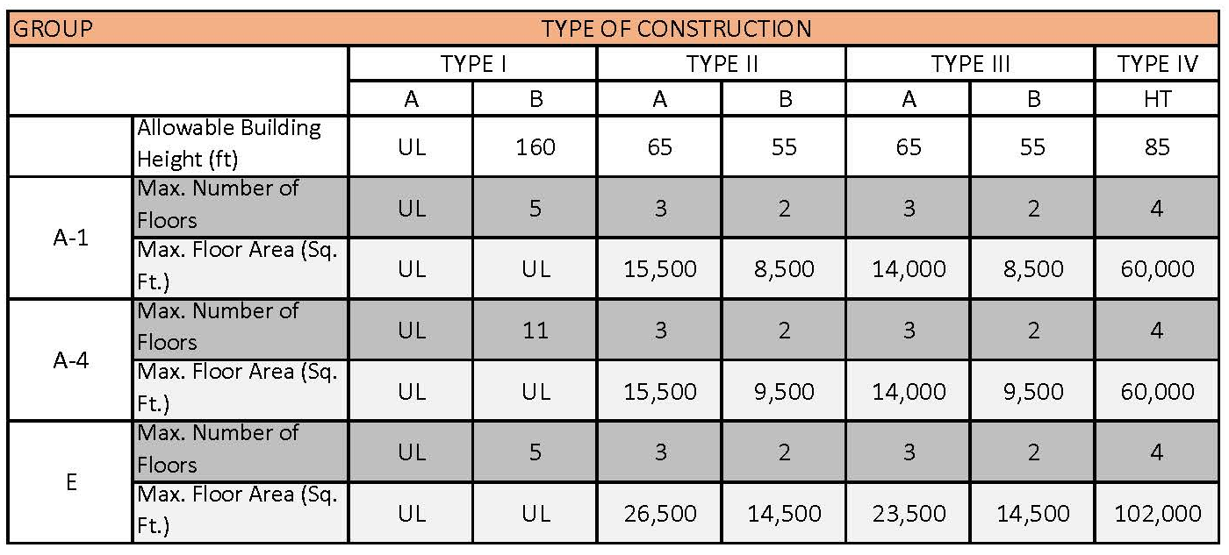

CHAPTER 10

DESIGN PROCESS

Site Planning
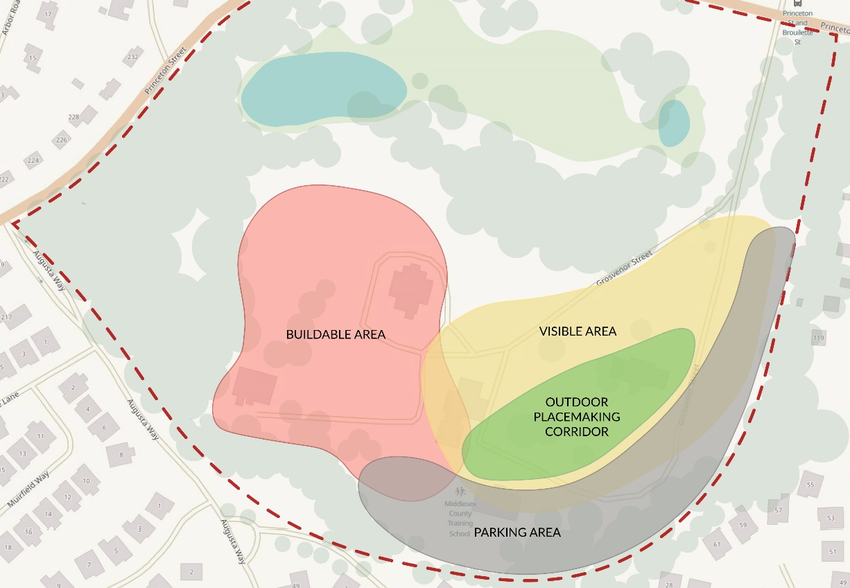
The site plan arose from the desire to apply crime prevention strategies. My pre-design diagram, you can see the various crime prevention strategies (figure 15). In the red is the buildable area of the site. I designated this the buildable area based on the topography of the site and the proximity of trees which allows for a more hidden escape option. The yellow area is the visible area from the buildable area. The gray is a good option for the parking, it is partially in the visible area where people will be walking to the building from their car, and partially outside of the visible area. Within the visible area and the parking area is the opportunity for an outdoor placemaking corridor. This will allow for the site to welcome the students coming from the parking lot or approaching by bus to be welcomed before even entering the building with something positive that will calm them down and make them feel happier.
Figure 15: Pre-Design Diagram
(by author)
These decisions all led to the site plan (figure 16). On this plan you can see there is a single driveway entrance onto the site that brings each visitor into the visible area before people can move into different areas on the site. Pedestrians have a specific path to walk on that brings them through the central placemaking area in the middle of the site, and parking is situated out of the way along the outer edge of the site. 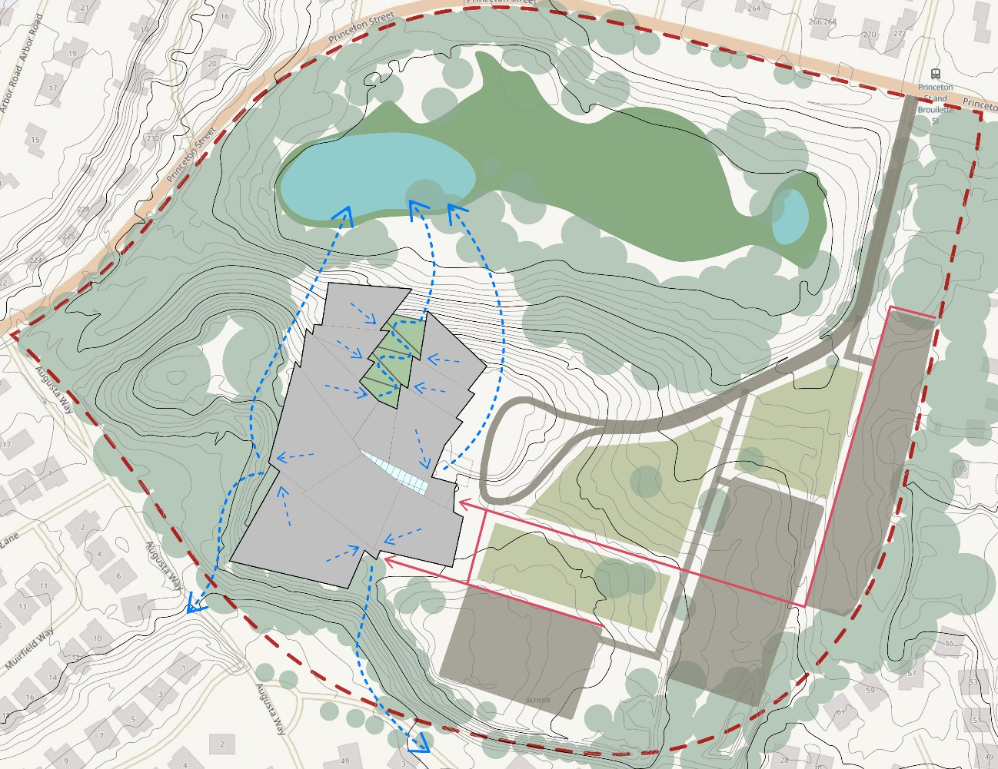
Figure 16: Site Plan
(by author)
The building is set inside the buildable area at the top of the hill, allowing for better sight for the receptionist to be able to see who is approaching. The roof of my building allows for rainwater to flow down either side of the hill, moving north into the pond that is in the wetland area, and south to pre-existing drainage areas.

Building Design
The design for my building began with artistic explorations of the history of Chelmsford through collage (figure 17). After my collages, I translated them into simplified thumbnails focusing solely on shapes and forms within the compositions. From these thumbnail drawings I then made abstract wire models (figure 18) that I explored in plan and elevation and related to each other. See Appendix A for larger images.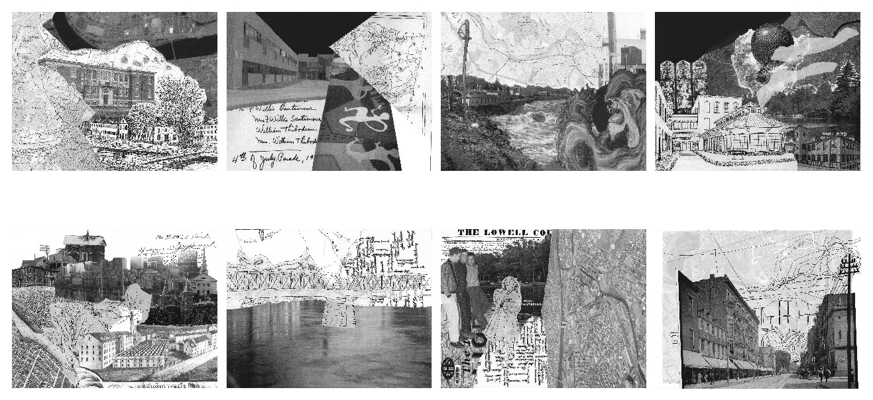
Figure 17: Collages
(by author)

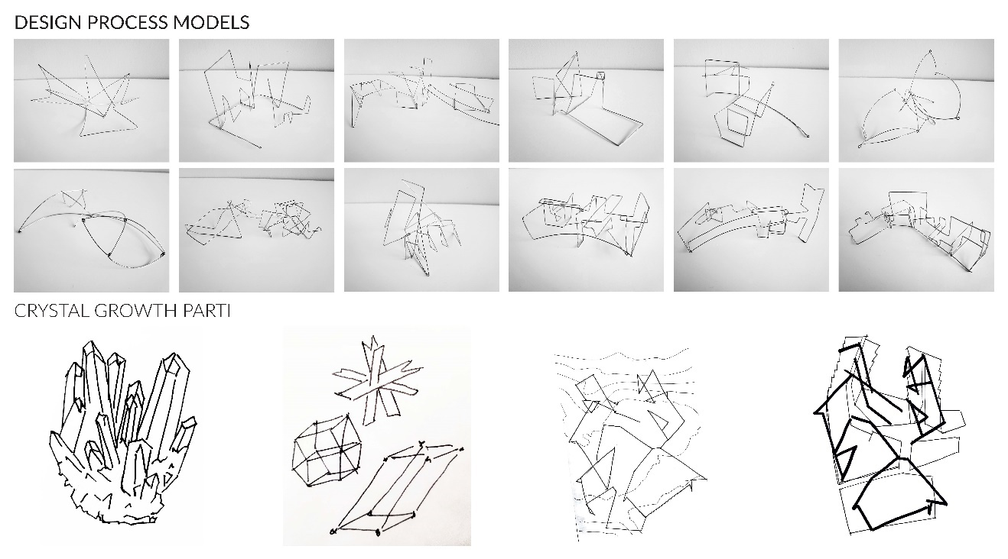
Figure 18: Wire Models
(by author)

I then followed this exercise with a series of larger wire models that fit on my site model at a 1/16” scale. With these models situated on the site plan, I worked to fit the program into the shapes formed in the wire models and explored different options for the building layout (figure 19). This ultimately led to my program layout (figure 20). 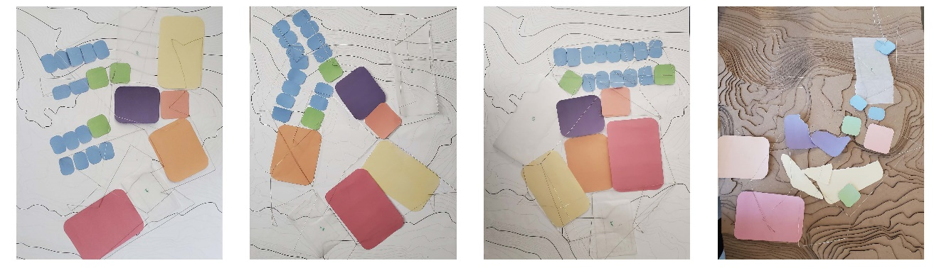
Figure 19: Program Layout Process
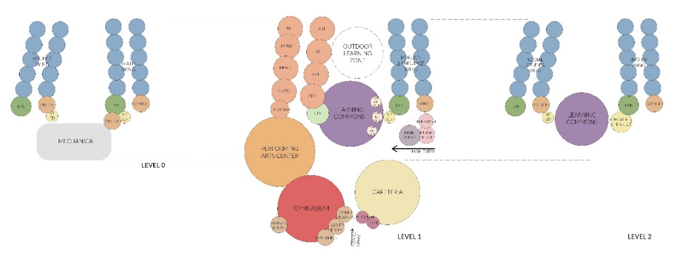
(by author)
Figure 20: Program Diagram
(by author)
I did a series of tracings over the site with the larger wire models and program layout over the top (figure 21). It was during this phase that the idea of crystal growth as a parti diagram for inspiration came (figure 22). Using crystals as inspiration for each step of design led to specifics in the thought of placemaking ideas. One important way I implemented placemaking was through art walls and murals. Murals have always been an important part of Chelmsford High School, and a tradition that many students love. As an example for an art wall to include in my final documentation, I was looked at the work of Wenzel Hablik, a German Expressionist painter and architect who did a series of paintings of crystal cities (example of his painting below in figure 23). Hablik’s paintings further inspired forms and colors within both the interior space and exterior space of my building. The elevations in my building were designed from both forms in my wire models, as well as from forms in Hablik’s paintings. I also used colors from his paintings as accent walls in certain spaces, and included furniture in spaces that had similar forms to those in his paintings.
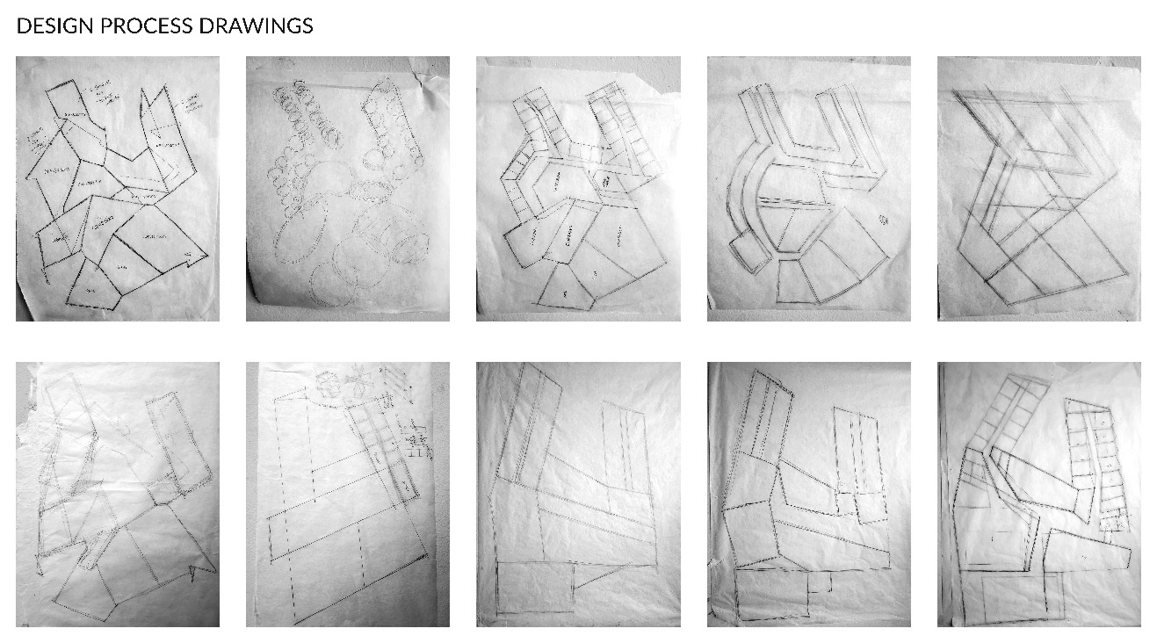
Figure 21: Drawing Process
(by author)
Figure 22: Crystal Parti Diagram
(by author)

Figure 23: Painting by Wenzel Hablik
(arthistoryproject.com)

Designing for Safety
When designing this high school, I considered Crime Prevention Through Environmental Design strategies (see Chapter 4). These strategies manifest differently in school buildings than in C. Ray Jeffrey’s original research when he coined the term “Crime Prevention Through Environmental Design”. I still followed the four main principles of Natural Surveillance, Access Control, Territoriality, and Maintenance, but did choose to include the sometimes-excluded Activity Support, and my own addition of Placemaking. In studying my two main precedents, Sandy Hook Elementary School in Newtown, Connecticut, and Newton North High School, in Newton, Massachusetts, I found that the four main principles, and placemaking showed themselves in the same way for each building.
Having a main, wide hallway in the school acts as a form of natural surveillance. In both of my precedents, the user can stand in a minimum of three spots along the hallway and see down each part of the corridor. In my building, you can stand in three spots and see down each corridor, the two classroom corridors, and the corridor leading to the gymnasium.
Having the main office directly adjacent to the main entrance is key to having successful access control. While most high schools I have studied have the reception area directly by the main entrance, in Chelmsford High School, the main office, with a big glass window, is directly across the hall from the entrance, but visitors still often bypass it even while knowing they are supposed to go to the office to sign in. This leaves the receptionists calling to security to try to find the person who entered, and not knowing if the situation is safe. In my new Chelmsford High School, I have created a sign-in location in the entry vestibule so that a visitor must sign in at the front desk before entering.
Having one main entrance in and out is another successful way to accomplish access control. One of the main reasons why the shooters at Columbine High School were so deadly is because there were so many entrances in and out of the school, and on multiple levels. Students present the day of the attack had varying reports of where they saw the shooters even if they were reporting right around the same time. Having one main entrance is important because reception can keep track of visitors more closely. All schools require a secondary entrance, even if it’s just for service, but it’s important for a school to keep these doors locked throughout the day and only unlock them when they’re going to be in use for an event, or install a card reader for staff and faculty. Fire exits can be locked from the outside so that it is safe for students to exit the building according to code, but people outside the school are unable to enter.
Territoriality is a simpler principle. As I explained in Chapter 4, territoriality is “the primary umbrella concept upon which all the others are based.” Symbolic barriers are the most effective type of territoriality. Signage and fences go a long way in stopping intruders.
Placemaking on my site, and the sites of my two main precedents exists in the form of trees. Trees are a way to make a site feel homier and comforting for its users. Trees and nature are the most straightforward way to execute placemaking. In an article by Amanda Morrell, a landscape architect at Stantec, she explains the value of trees, specifically in an urban setting. Morrell explains that “[trees] bring cultural, environmental, psychological, economic, and physical value to our communities.” She also makes the point that
“the landscape should not be seen as an appendage tagged on after the construction of a building or block. No… the landscape, trees particularly, need to be viewed as a key public investment by our cities and towns, which will help ensure trees reach their potential as placemakers. As designers, it is our responsibility to ensure that trees are essential components of urban design.”
This goes for smaller scale urban design as well. It is easy to forget about the landscape when designing a building, but it is a key component in creating a place where people feel calm and happy.
Inside the building, placemaking is accomplished by creating pause points for students, and allowing for natural daylighting in spaces that would not normally be reached. Using color throughout the school in comfortable furniture and accent walls helps the students and visitors engage in their spaces. By executing each of these strategies, the school will be a safer place without the need for extreme measures such as metal detectors or a constant police presence.

CHAPTER 11

CONCLUSION
In conclusion placemaking can act to minimize the potential for threats and create a more positive atmosphere. The main goal of this project was to explore crime prevention strategies in a new way, looking primarily at placemaking initiatives.
This was determined through the research of other schools which have designed both with integration of the community and as a direct response to a tragedy, as well as through the research of embassies which are designed with safety in mind as well as beauty. Through a survey with the current student body it was determined that what would make school a more positive atmosphere are all aspects of placemaking. Students want to see more windows, more color, and more murals. During the design process each of these aspects was included, as well as findings from research based on de Botton, Benedikt, and Brand, and other sources that focus specifically on placemaking.
The next stage of this project will focus on the landscape and how further integration can create more areas for placemaking. While there is a good connection with the site from a crime prevention stand point, there are more opportunities for placemaking. This would affect the entry sequence into the building, which would offer the opportunity to enhance a student’s mood as soon as they set foot on the property. It will also consider a more in-depth entry sequence to the site, looking further into embassy design strategies, and placemaking strategies for the community’s use.

APPENDIX A

COLLAGES AND MODELS




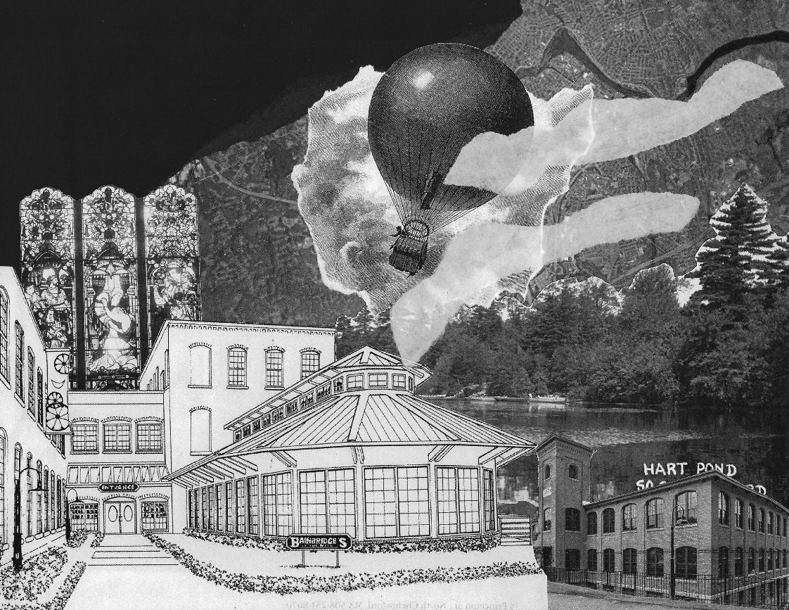
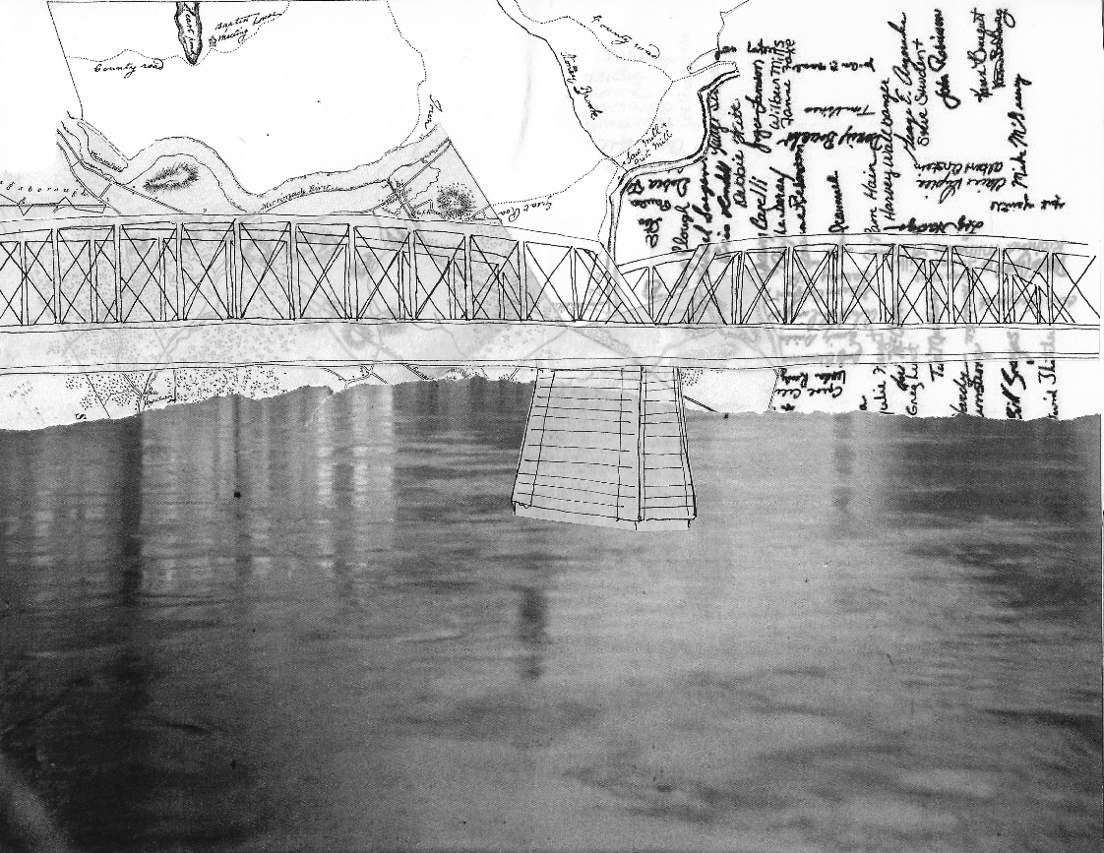
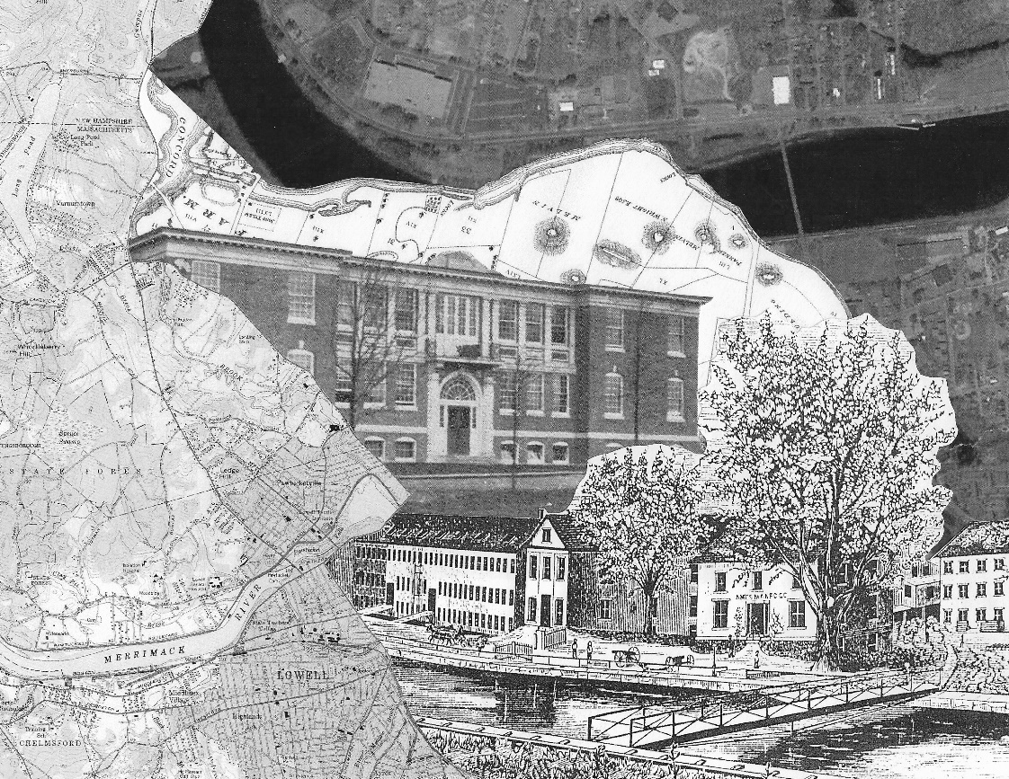
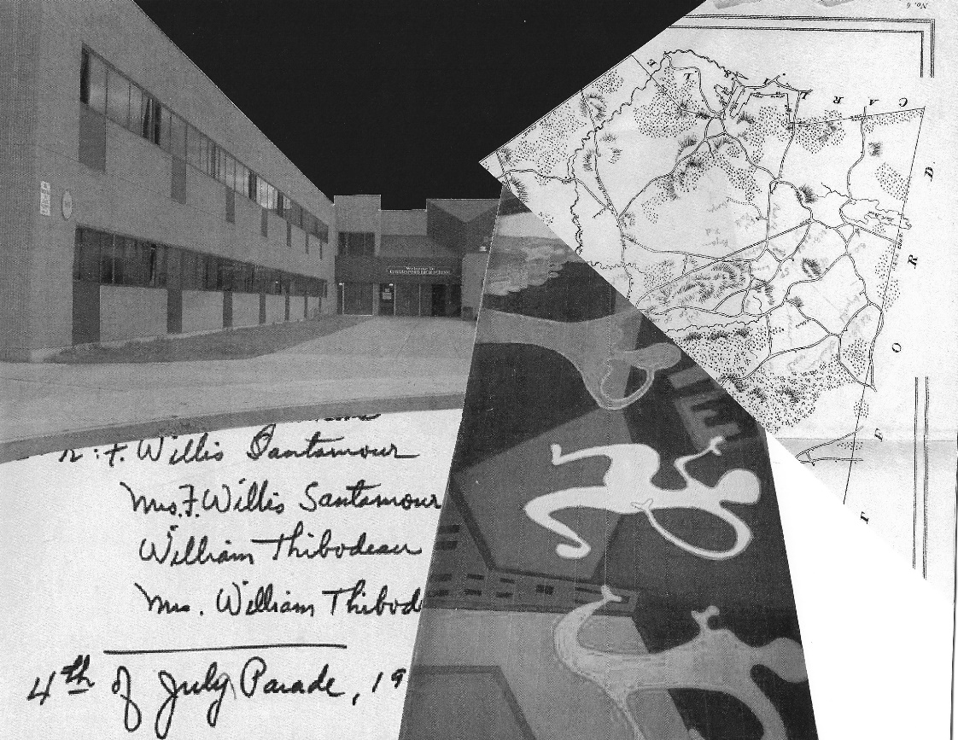
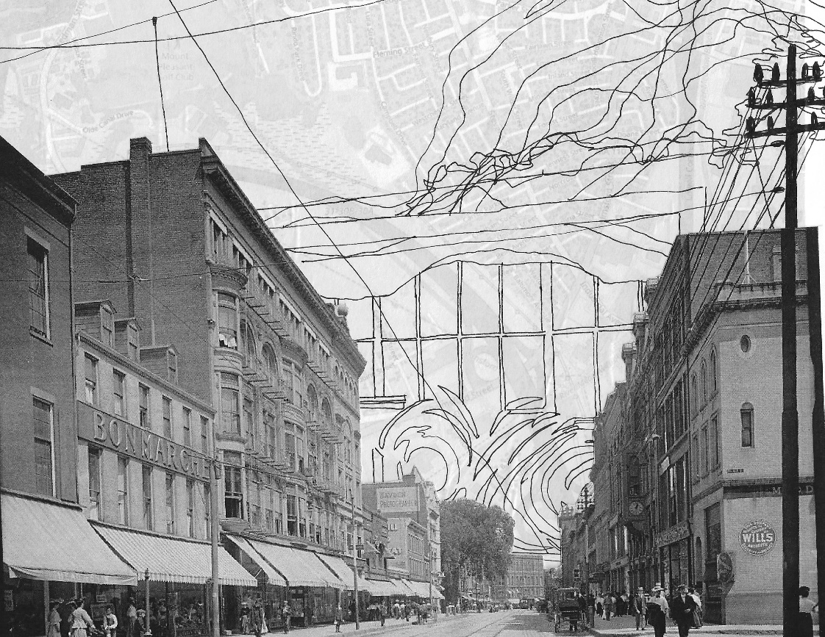

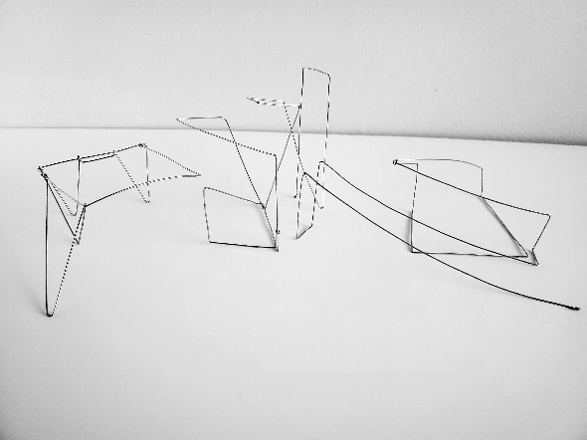

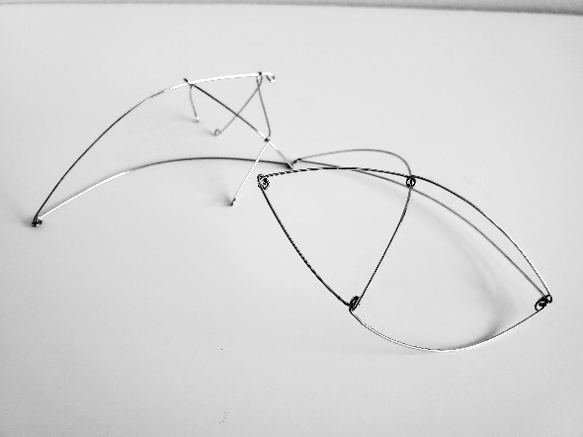
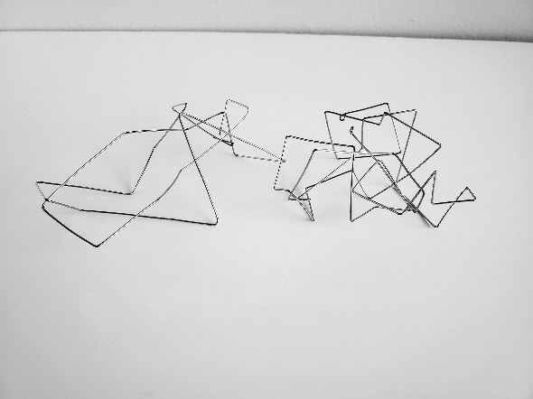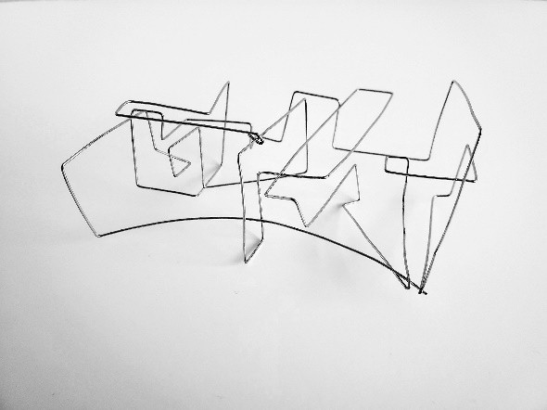
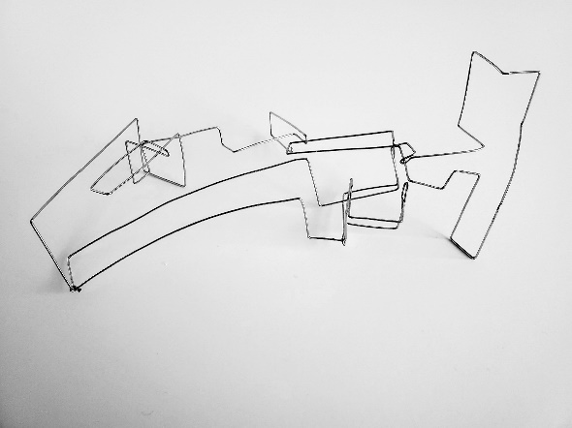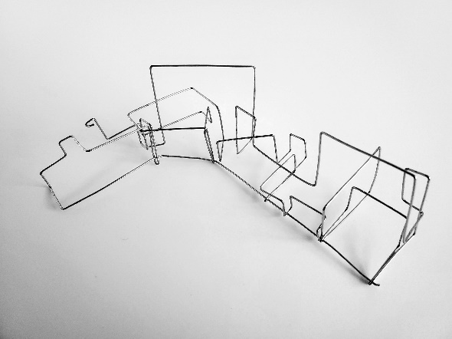

APPENDIX B

ORAL THESIS DEFENSE PRESENTATION

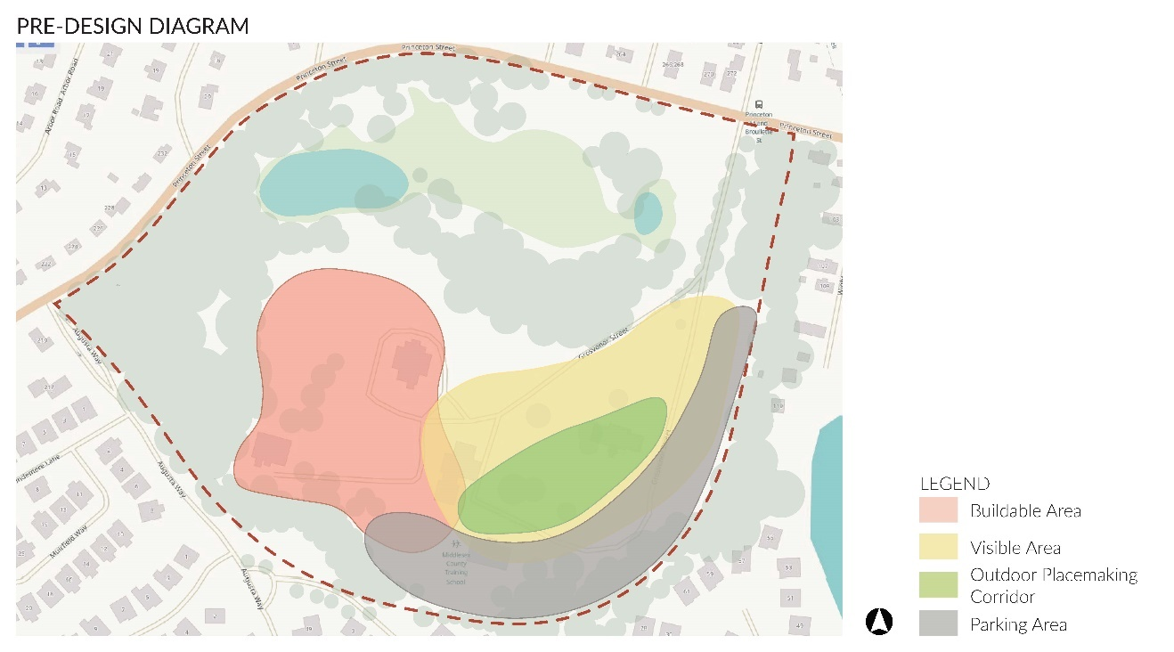
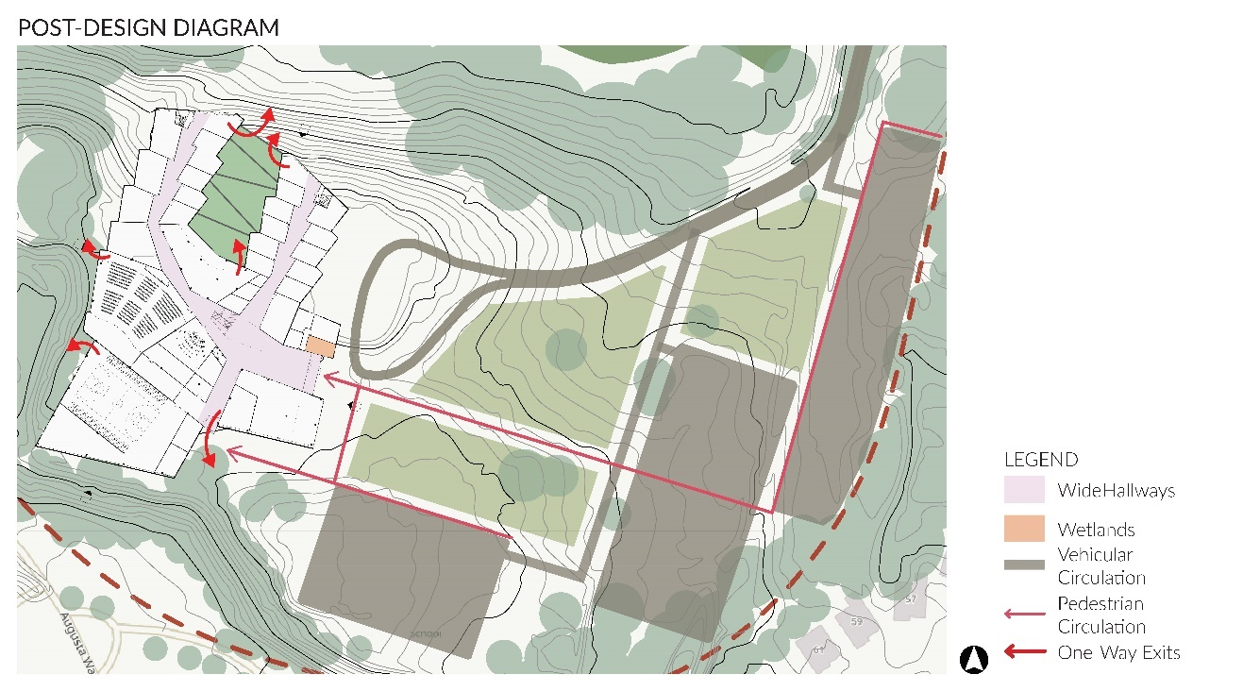

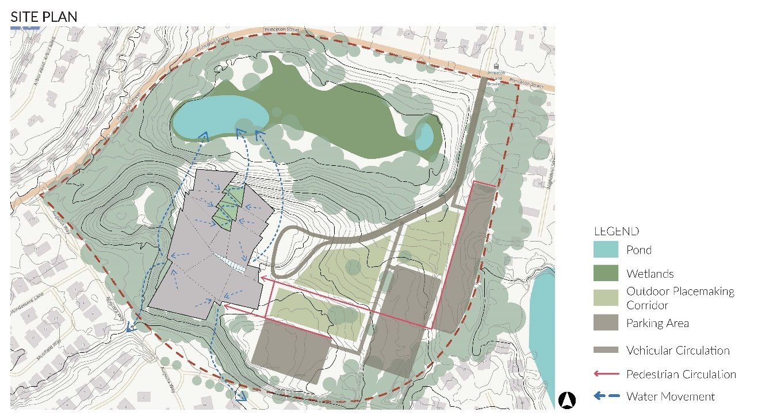
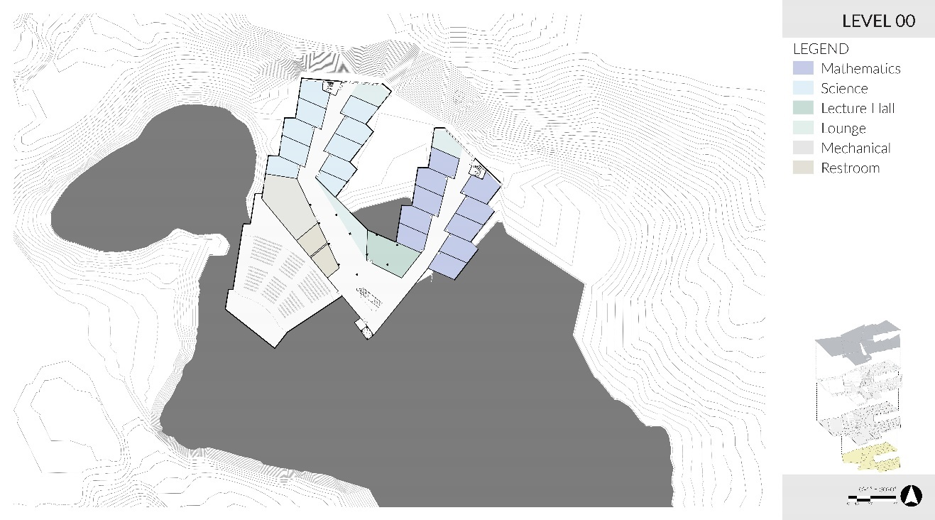
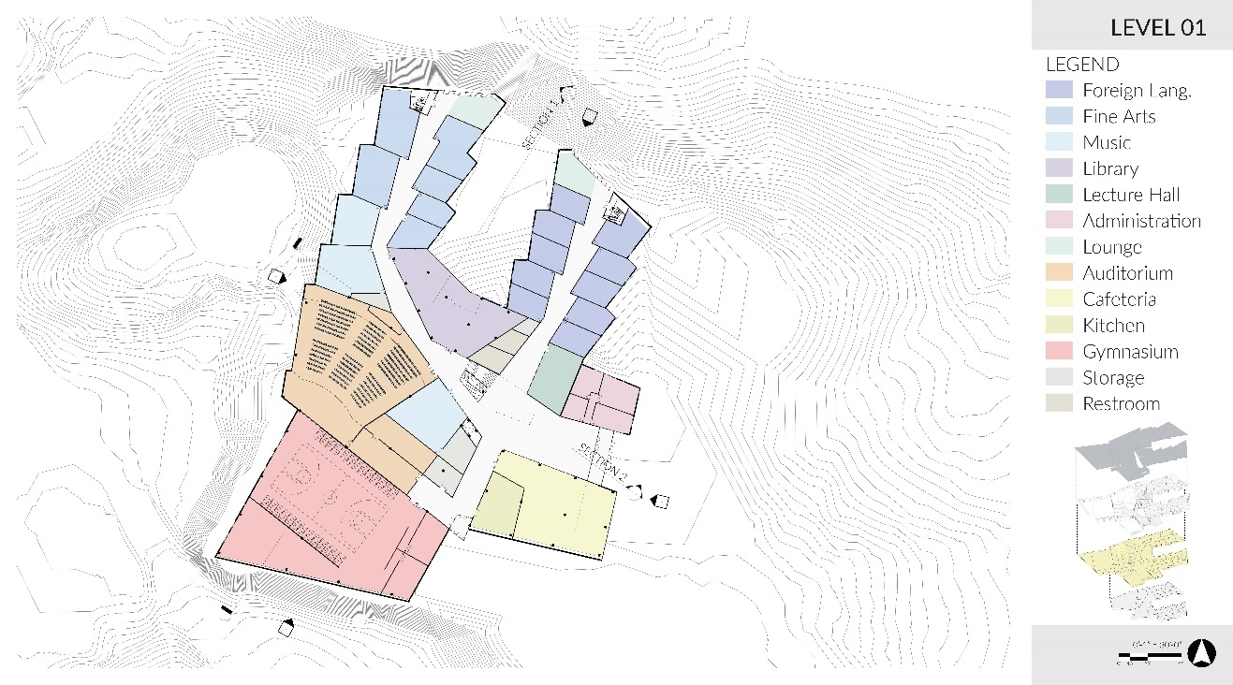
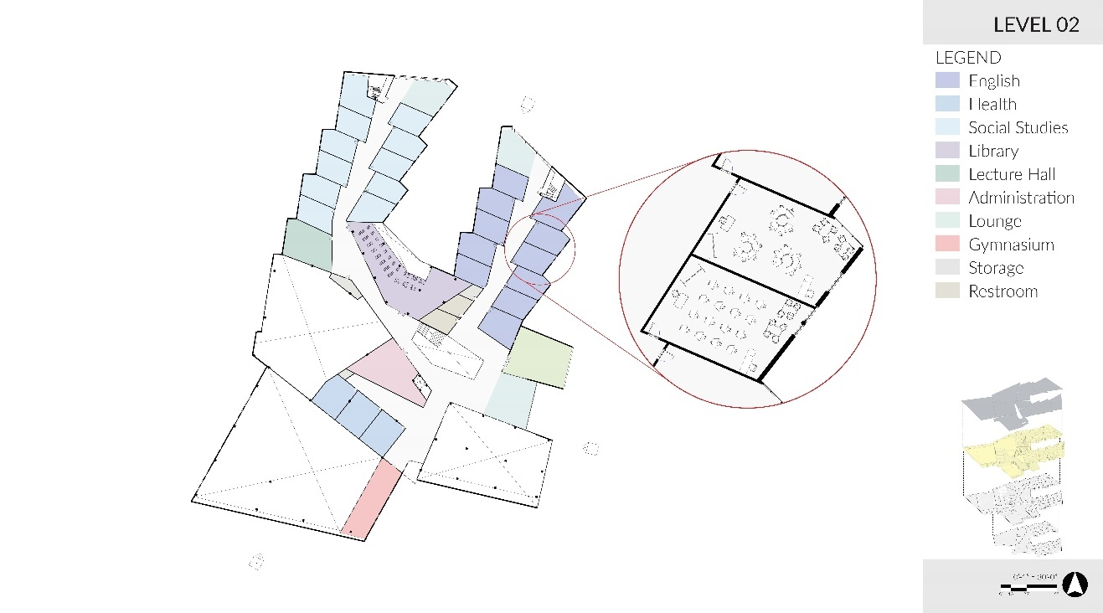
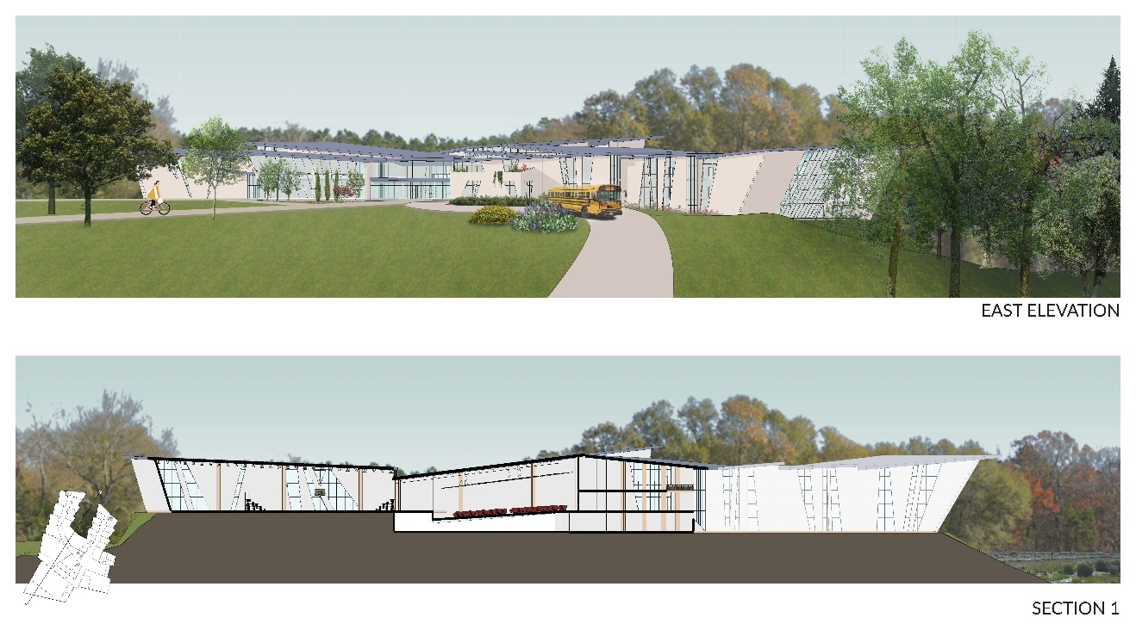
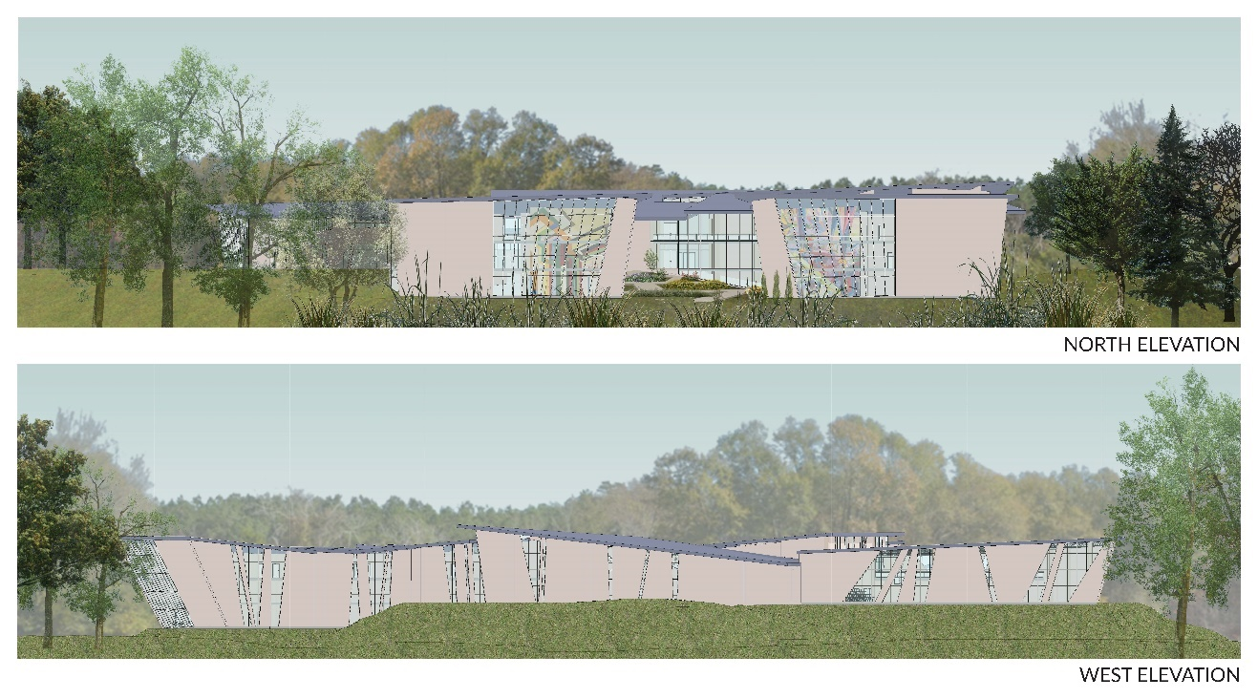
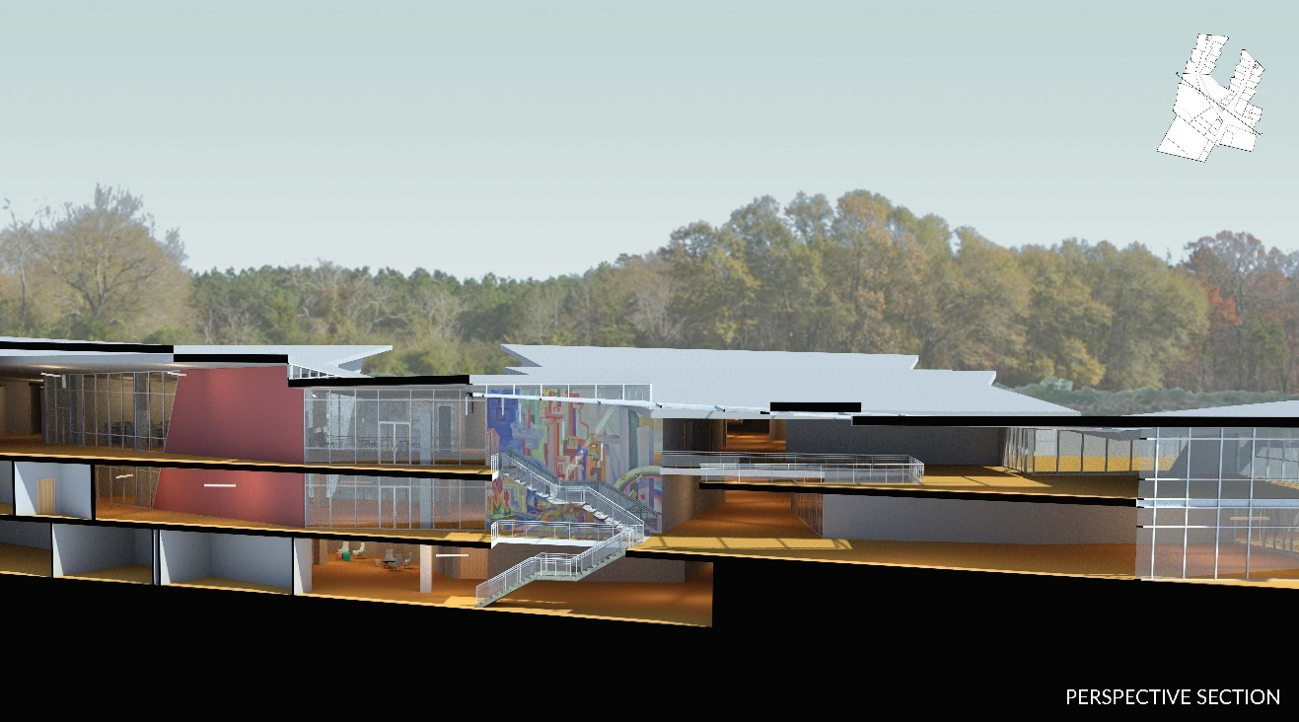
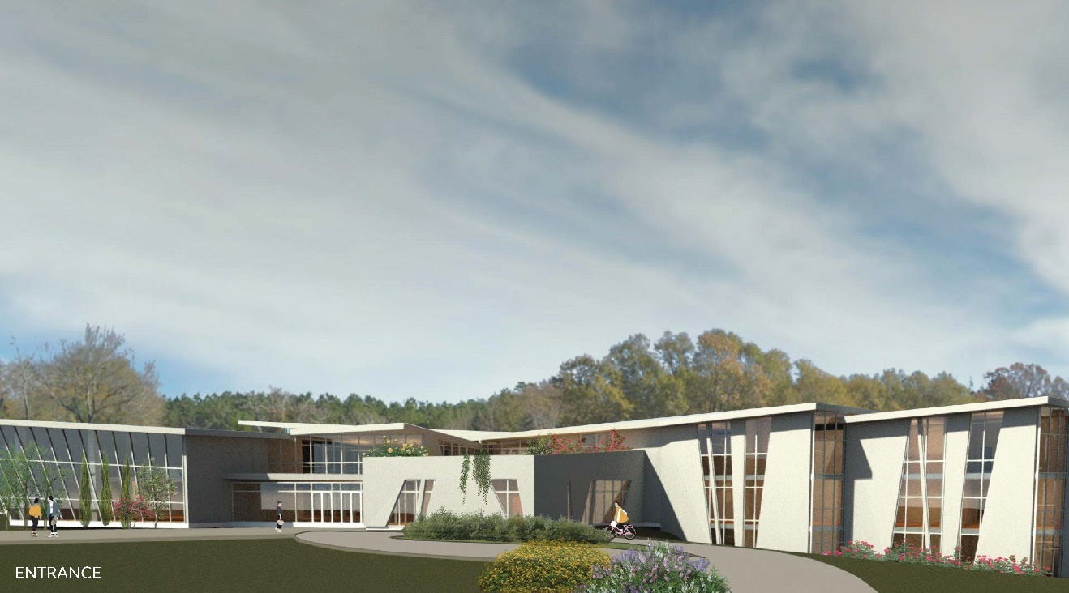
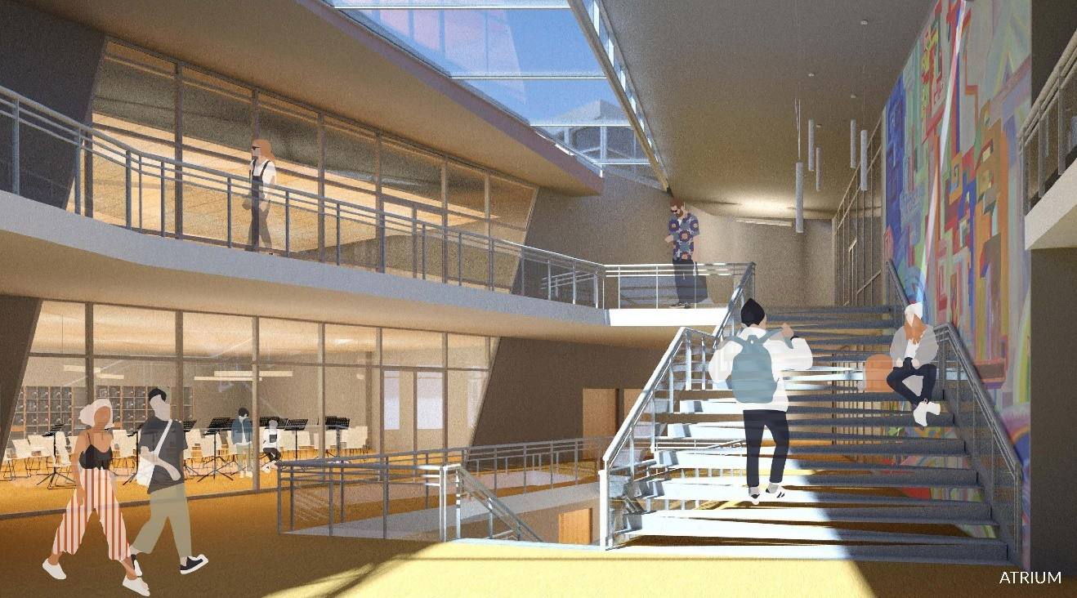
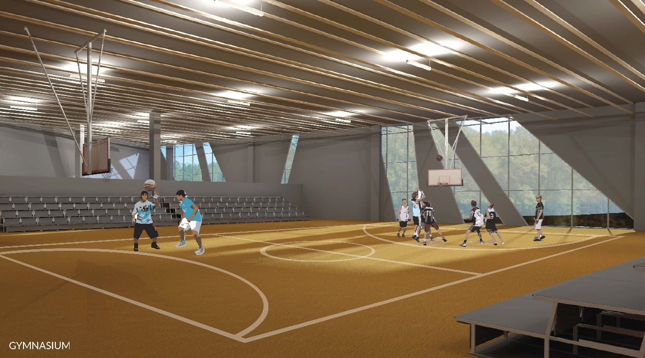
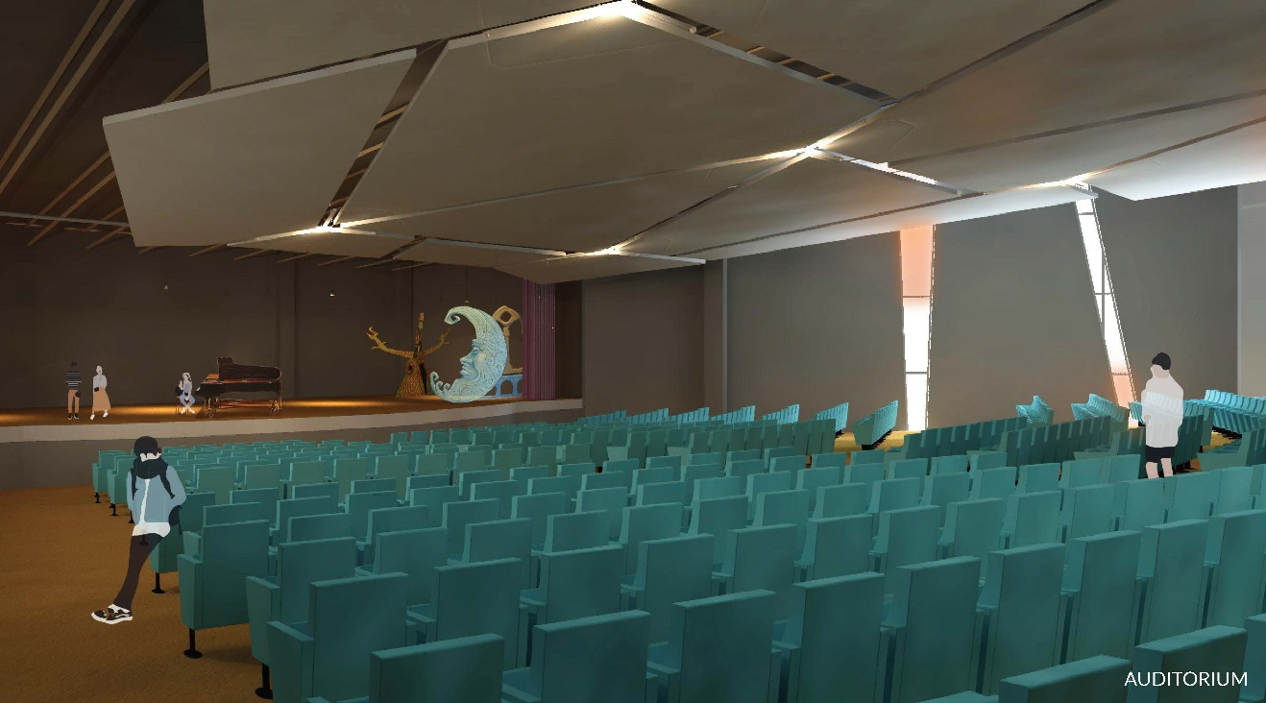
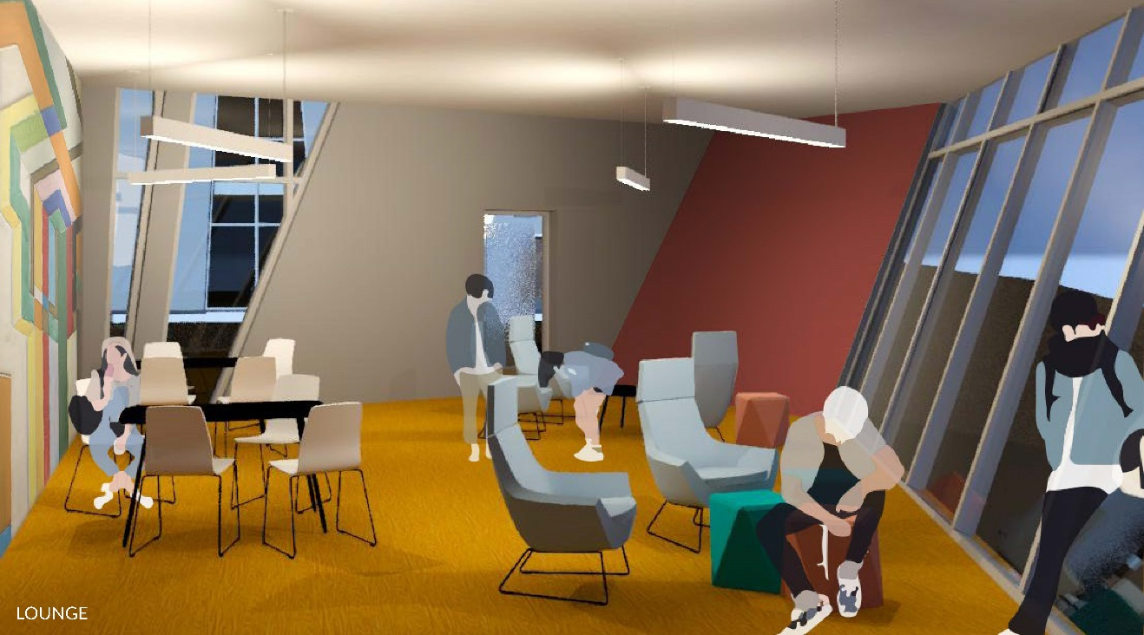
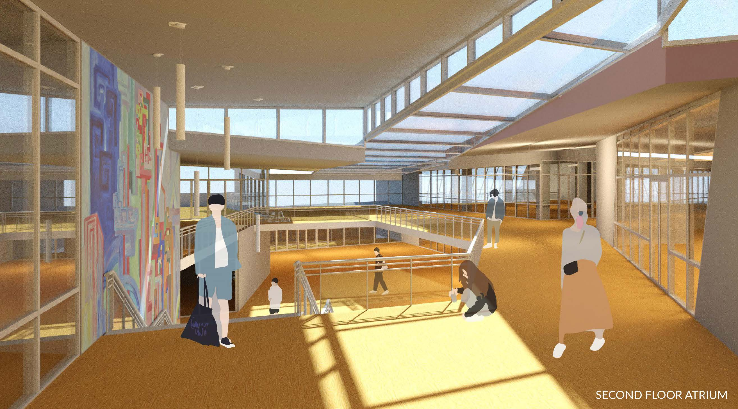
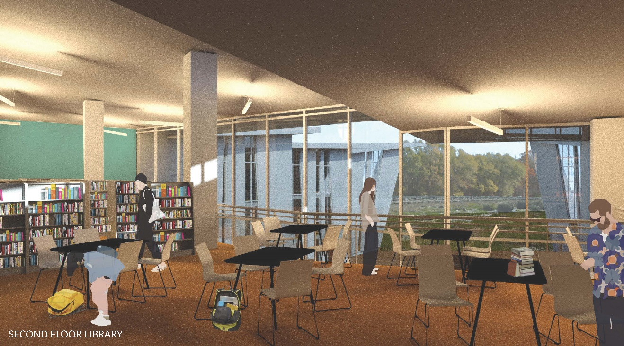
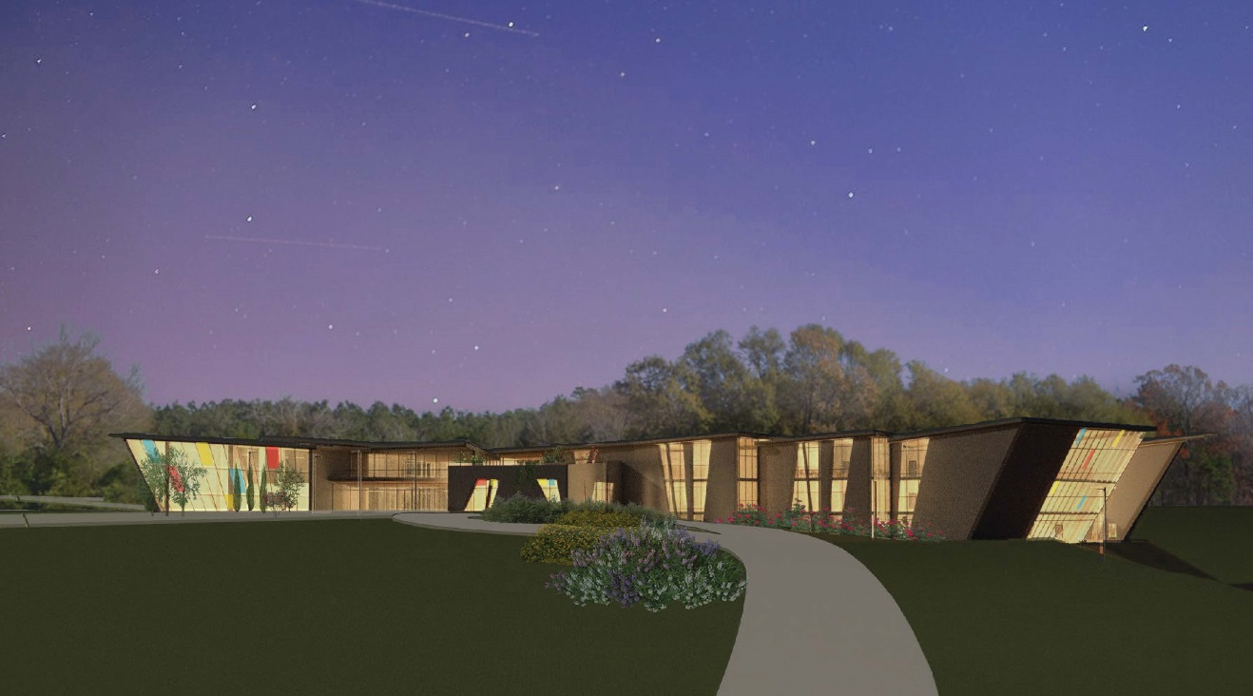

BIBLIOGRAPHY
"Architecture of Place: Buildings that Work for People." www.pps.org., last modified August 15, accessed Oct 5, 2019, https://www.pps.org/article/architecture-of-place-a-call-for-buildings-that-work-for-people.
"Indian Community School." studio:indigenous., accessed Sep 1, 2019, https://www.studioindigenous.com/indian-community-school.
"International CPTED Association.", accessed April 20, 2020, www.cpted.net.
"Massachusetts School Building Authority.", accessed April 20, 2020, massschoolbuildings.org.
"Chelmsford Historical Commission.", chelmsfordgov.com.
"Massachusetts Department of Education School and District Profiles.", http://profiles.doe.mass.edu/.
"Massachusetts Department of Environmental Protection." Mass.gov., accessed Apr 23, 2020, https://www.mass.gov/orgs/massachusetts-department-of-environmental-protection.
"Massachusetts Historical Commission.", sec.state.ma.us/mhc/.
"The Town of Chelmsford Demographics.", townofchelmsford.us.
"Town of Chelmsford Master Plan 2010." Northern Middlesex Council of Governments., accessed Apr 23, 2020, http://www.nmcog.org.
"Principles and Standards for Designing Teaching and Learning Spaces." Teaching and Learning Services (TLS)., accessed Apr 20, 2020, https://www.mcgill.ca/tls/spaces/principles.
"Sandy Hook School.", accessed Apr 28, 2019, https://www.svigals.com/work/sandy-hook-school.
Abdullah, Aldrin, Massoomeh Hedayati Marzbali, Azizi Bahauddin, and Mohammad Javad Maghsoodi Tilaki. 2015. "Broken Windows and Collective Efficacy." SAGE Open 5 (1): 215824401456436. doi:10.1177/2158244014564361. https://journals.sagepub.com/doi/full/10.1177/2158244014564361.
Ballard Brown, Tanya. "Can U.S. Embassies be Safe without being Unsightly?" NPR.org., last modified February, 26, accessed Oct 6, 2019, https://www.npr.org/sections/thetwo-way/2013/02/26/172978571/can-u-s-embassies-be-safe-without-being-unsightly.
Benedikt, Michael. 2002. "Environmental Stoicism and Place Machismo." Harvard Design Magazine.
Berkowics, Jill and Myers, Ann. "How Architecture Affects Learning." Education Week - Leadership 360., last modified April 5, accessed Mar 18, 2019, http://blogs.edweek.org/edweek/leadership_360/2018/04/how_architecture_affects_learning.html?cmp=SOC-SHR-FB.
Bluestone, Daniel. 1995. "Review: How Buildings Learn: What Happens After they'Re Built by Stewart Brand." Journal of the Society of Architectural Historians 54 (2). https://jsah.ucpress.edu/content/54/2/235.
Bond, Michael. "The Hidden Ways that Architecture Affects how You Feel.", last modified June 6, accessed Mar 18, 2019, http://www.bbc.com/future/story/20170605-the-psychology-behind-your-citys-design.
Brand, Stewart. 1995. How Buildings Learn: What Happens After they'Re Built. London, England: Penguin Books.
Chenoweth, Hannah. "Sandy Hook Architect Shares Insights into Design Process.", accessed Apr 28, 2019, https://info.k12facilitiesforum.com/blog/sandy-hook-architect-shares-insights-into-design-process.
Conan, Neal. 2006. "'The Architecture of Happiness'." NPR.Org. https://www.npr.org/templates/story/story.php?storyId=6247700.
Cornell, Dewey, Peter Sheras, Anne Gregory, and Xitao Fan. 2009. "A Retrospective Study of School Safety Conditions in High Schools using the Virginia Threat Assessment Guidelines Versus Alternative Approaches." School Psychology Quarterly 24 (2): 119-129. doi:10.1037/a0016182. http://silk.library.umass.edu/login?url=http://search.ebscohost.com/login.aspx?direct=true&db=pdh&AN=2009-08555-003&site=ehost-live&scope=site.
Cox, John W., Rich, Steven, Chiu, Allyson, Muyskens, John and Ulmanu, Monica. "Analysis | More than 228,000 Students have Experienced Gun Violence at School since Columbine." Washington Post., last modified May 8, accessed Oct 6, 2019, https://www.washingtonpost.com/graphics/2018/local/school-shootings-database/.
Cozens, Paul Michael, Greg Saville, and David Hillier. 2005. "Crime Prevention through Environmental Design (CPTED): A Review and Modern Bibliography." Emerald Insight. https://www.emerald.com/insight/content.
Deutsch, William. "Environmental Design and the Impact on Crime Prevention." The Balance Small Business., accessed Apr 28, 2019, https://www.thebalancesmb.com/crime-prevention-through-environmental-design-394571.
Dore & Whittier Architects, Inc. 2017. Chelmsford Facilities Assessment.
Flynn, Katherine. 2018. "Architects Prioritize Design as a School Security Solution." American Institute of Architects.
Gladwell, Malcolm. 2015. "How School Shootings Spread." The New Yorker. https://www.newyorker.com/magazine/2015/10/19/thresholds-of-violence.
Golembiewski, Jan. "Building a Better World: Can Architecture Shape Behaviour?" The Conversation., last modified January 6, accessed Mar 18, 2019, http://theconversation.com/building-a-better-world-can-architecture-shape-behaviour-21541.
Goode, Erica. 2018. "Opinion | the Things we Know about School Shooters." The New York Times, February 15,. https://www.nytimes.com/2018/02/15/opinion/school-shooters-florida-guns.html.
Jacobs, Karrie. "Sandy Hook Rebuilds." Architect., last modified -08-23T13:25:00.000Z, accessed Apr 28, 2019, https://www.architectmagazine.com/Design/sandy-hook-rebuilds_o.
Joshi, Sumedha M. 2008. "The Sick Building Syndrome." Indian Journal of Occupational and Environmental Medicine 12 (2): 61-64. doi:10.4103/0019-5278.43262. https://www.ncbi.nlm.nih.gov/pmc/articles/PMC2796751/.
Kelling, George L. and William J. Bratton. 1998. "Declining Crime Rates: Insiders' Views of the New York City Story." Journal of Criminal Law and Criminology 88 (4). https://scholarlycommons.law.northwestern.edu.
Kent, Fred. "Toward an Architecture of Place: Moving Beyond Iconic to Extraordinary." www.pps.org., last modified March 12, accessed Oct 5, 2019, https://www.pps.org/article/toward-an-architecture-of-place-moving-beyond-iconic-to-extraordinary.
Melanson, Alana. 2018. "UML Cleared to Sell West Campus in Chelmsford." Lowell Sun, August 17,. https://www.lowellsun.com/ci_32076875/uml-cleared-sell-west-campus-chelmsford.
Messner, Matthew. 2017. Studio:Indigenous, the Firm Rooted in the Worldviews of Native Americans. Archpaper.Com.
Morrell, Amanda. "Why Planting Urban Trees is Important to Communities." ideas.stantec.com/blog/the-value-of-urban-trees-in-placemaking., last modified August 10, accessed Apr 20, 2020, https://ideas.stantec.com/blog/the-value-of-urban-trees-in-placemaking.
Myers, Ann and Berkowicz, Jill. "How Architecture Affects Learning." Education Week - Leadership 360., last modified April 5, accessed Oct 5, 2019, http://blogs.edweek.org/edweek/leadership_360/2018/04/how_architecture_affects_learning.html?cmp=SOC-SHR-FB.
Nast, Condé. "How Architecture and Design can Help Prevent School Shootings." Architectural Digest., last modified June 26, accessed Mar 18, 2019, https://www.architecturaldigest.com/story/school-shooting-prevention-design.
Passy, Jacob. "Schools Rethink Building Design to Protect Students from Mass Shooters." MarketWatch., last modified February 25, accessed Mar 20, 2019, https://www.marketwatch.com/story/how-schools-are-being-designed-to-protect-students-and-teachers-from-mass-shooters-2018-02-16.
Pastore, Doris R., Martin Fisher, and Stanford B. Friedman. 1996. "Violence and Mental Health Problems among Urban High School Students." Journal of Adolescent Health 18 (5): 320-324. doi:10.1016/1054-139X(95)00063-X. https://www.sciencedirect.com/science/article/pii/1054139X9500063X.
Quirk, Vanessa. "Community-Oriented Architecture in Schools: How 'Extroverted' Design can Impact Learning and Change the World." ArchDaily., last modified March 5, accessed Mar 18, 2019, http://www.archdaily.com/213438/community-oriented-architecture-in-schools-how-extroverted-design-can-impact-learning-and-change-the-world/.
Robinson, Aaron. 2018. The Turbulent History of UMass Lowell’s Forgotten Campus. Umlconnector.Com. http://umlconnector.com/2018/10/the-turbulent-history-of-umass-lowells-forgotten-campus/.
Sampas, Tony. "LibGuides: UMass Lowell - West Campus - Student Project: History." libguides.uml.edu., accessed Apr 23, 2020, //libguides.uml.edu/c.php?g=829274&p=5955161.
Sisson, Patrick. "Sandy Hook Elementary School Design Finds Safety, Security in Openness." Curbed., last modified -02-22T15:42:54-05:00, accessed Apr 28, 2019, https://www.curbed.com/2018/2/22/17042004/sandy-hook-elementary-school-design-security-safety.
Smith, Charles Saumarez. 2006. "Observer Review: The Architecture of Happiness by Alain De Botton." The Observer, May 6,. https://www.theguardian.com/theobserver/2006/may/07/art.
Town of Chelmsford Master Plan Committee and The Northern Middlesex Council of Governments. "Chelmsford Master Plan VIsion Quest 2020."Chelmsford, MA.
Welsh, Brandon and David Farrington. 2004. "Evidence-Based Crime Prevention: The Effectiveness of CCTV." Crime Prevention and Community Safety 6 (2): 21-33. doi:10.1057%2Fpalgrave.cpcs.8140184.
Wilkinson, Tom. "Typology: Embassy." Architectural Review., last modified Deecember 9, accessed Apr 23, 2020, https://www.architectural-review.com/essays/typology/typology-embassy/10045511.article.
Wilkinson, Tom. "United States Embassy in Beirut, Lebanon by Morphosis." Architectural Review., last modified December 9, accessed Apr 23, 2020, https://www.architectural-review.com/essays/typology/united-states-embassy-in-beirut-lebanon-by-morphosis/10045515.article.
Yalcinkaya, Gunseli. "New Sandy Hook School Designed to "Prevent Unwanted Intrusions"." Dezeen., last modified -10-26T00:00:31+01:00, accessed Apr 28, 2019, https://www.dezeen.com/2017/10/26/new-sandy-hook-school-designed-prevent-unwanted-intrusions-kind-news-architecture/.
Zubrzycki, Jaclyn. 2013a. "Building Toward a Positive Climate." Education Week 32 (16): 32. https://www.edweek.org/ew/articles/2013/01/10/16physical.h32.html.
Zubrzycki, Jaclyn. 2013b. "Schools' Design can Play Role in Safety, Student Engagement - Education Week." Quality Counts, January 4,. https://www.edweek.org/ew/articles/2013/01/10/16physical.h32.html.

(Goode, 2018)
(Gladwell, 2015)
(Goode, 2018)
(De Botton, 2006)
(Conan, 2006)
(Conan, 2006)
(Saumarez Smith, 2006)
(Benedikt, 2002: 1)
(Benedikt, 2002: 1)
(Benedikt, 2002: 4).
(Benedikt, 2002: 5).
(Brand, 1994: 2).
(Bluestone, 1995: 235).
(Bluestone, 1995: 235).
(Quirk, 2012)
(Quirk, 2012)
(Quirk, 2012)
(Quirk, 2012)
(CEBCP, 2018)
(Quirk, 2012)
(Quirk, 2012)
(McGill University, 2017)
(Zubrzycki, 2013)
(Zubrzycki, 2013)
(Zubrzycki, 2013)
(Zubrzycki, 2013)
(Zubrzycki, 2013)
(Zubrzycki, 2013)
(Zubrzycki, 2013)
(Zubrzycki, 2013)
(Cozens, Saville, Hillier, 2005)
(Cozens, Saville, Hillier, 2005)
(Cozens, Saville, Hillier, 2005)
(Poyner, 1993)
(Cozens, Saville, Hillier, 2005)
(Kelling, Bratton, 1998)
(Cox, 2019)
(Benedikt, 2002: 5)
(Benedikt, 2002: 5)
(Benedikt, 2002: 5)
(Benedikt, 2002: 5)
(Benedikt, 2002: 5-6)
(Myers, Berkowicz, 2018)
(Myers, Berkowicz, 2018)
(Myers, Berkowicz, 2018)
(Myers, Berkowicz, 2018)
(Myers, Berkowicz, 2018)
(Myers, Berkowicz, 2018)
(PPS, 2019)
(PPS, 2016)
(PPS, 2016)
(PPS, 2016)
(Kent, 2012)
(Kent, 2012)
(Kent, 2012)
(Svigals + Partners, 2016)
(Jacobs, 2016)
(Svigals + Partners, 2016)
(Jacobs, 2016)
(Jacobs, 2016)
(Svigals + Partners, 2016)
(Svigals + Partners, 2016)
(Svigals + Partners, 2016)
(Yalcinkaya, 2017)
(Yalcinkaya, 2017)
(Svigals + Partners, 2016)
(Yalcinkaya, 2017)
(CPTED, 2017)
(Deutsch, 2018)
(Deutsch, 2018)
(Messner, 2017)
(Messner, 2017)
(Cornelius, 2007)
(Ballard Brown, 2013)
(Ballard Brown, 2013)
(Ballard Brown, 2013)
(Ballard Brown, 2013)
(Ballard Brown, 2013)
(Wilkinson, 2019)
(Wilkinson, 2019)
(CMP, 2010)
(NMCOG, 2010)
(Waters, 1917)
(Waters, 1917)
(Waters, 1917)
(US Census, 2010)
(CMP, 2010)
(NMCOG, 2010)
(CMP, 2010)
(NMCOG, 2010)
(CMP, 2010)
(Waters, 1917)
(US Census, 2010)
(MA DOE, 2019
(Robinson, 2018)
(Robinson, 2018)
(Sampas, 2018)
(Melanson, 2018)
(CMP, 2010)
(CMP, 2010)
(CMP, 2010)
(MA DEP, 2019)
(CMP, 2010)
(NMCOG, 2010)
(USDA, 2019)
(USDA, 2019)
(USDA, 2019)
(USDA, 2019)
(USDA, 2019)
(MHC, 2017)
(CHC, 2012)
(CHC, 2012)
(CHC, 2012)
(CHC, 2012)
(Cormier, 2010)
(CHC, 2012)
(Dore & Whittier, 2017)
(Dore & Whittier, 2017)
(Joshi, 2008)
(Dore & Whittier, 2017)
(Dore & Whittier, 2017)
(MSBA, 2019)
(Dore & Whittier, 2017)
(Dore & Whittier, 2017)
(MSBA, 2019)
(Morrell, 2016)
(Morrell, 2016)

