Profiling the Emotional Peaks and Valleys in Stories of Cross-border Shopping

The stories that travellers tell provide valuable insight to tourism managers responsible for shaping travel experiences. Access to consumer stories has never been greater due to the rise of online forums, reviews, and blogs (Gretzel, Fesenmaier, Lee, & Tussyadiah, 2010). Yet, researchers’ ability to make sense of these stories is limited by current theoretical and methodological approaches. We contend that there is an opportunity to develop new approaches to measure customer experience using advanced text analysis and sentiment indices. Specifically, we use narrative theory to explain the importance of emotional peaks and valleys in stories and propose a natural language processing (NLP) approach to identify and profile the issues that greatly impact on travellers’ experiences. Our narrative text-analytic approach is demonstrated using interview data describing 428 cross-border shopping experiences.
RELEVANT LITERATURE
Storytelling is ubiquitous, and marketers have studied the content, structure, and impact of word-of-mouth conversations and service experiences (Richins, 1983; Stern, 1998). Tales of customer journeys, like other stories, usually follow a narrative arc that rises to a climax – the emotional peak or most exciting part of the story. Traditional stories are full of regularities, and people incorporate such regularities into a story schema in memory that serve as templates for sense making and story telling (Mandler, 2014; Padgett & Allen, 1997).
Kahneman, Fredrickson, Schreiber, and Redelmeier (1993) argue that the peak (or most extreme) experience and the end of the experience have a disproportionate impact on overall evaluations. People tend to summarize and evaluate experiences by focusing on only a few features (Ariely & Carmon, 2000). A travel experience can be considered as a sequence of events and the peak points are comparable to critical incidents in service research (Dalakas, 2006; Verhoef et al., 2009). Peak experiences matter – they weigh more heavily than the other moments that constitute an overall experience. The “peak experience” heuristic has been found in travel experiences, for example riding the train (van Hagen & Bron, 2014) and river rafting trips (Arnould & Price, 1993).
Positive and negative emotions are present at every step of the customer journey, not only are they prevalent but they can be powerful, especially if consequential decisions are at stake (Andrade, 2015; Zaltman, Olson, & Forr, 2015). The affective charge of consumer emotions can be characterized by valence and arousal. Further, the ability to report the specific emotions activated over the course of a travel experience presents a great opportunity to tourism researchers – especially when the emotions are integrated into the appraisal structure of valenced reactions to events, agents, and objects (Ortony, Clore, & Collins, 1990; Richins, 1997).
RESEARCH QUESTION
Current methods of measuring the affective and emotional character of consumers’ experiences suffer from two major drawbacks: (1) Self-administered questionnaires are intrusive, and can raise concerns about social desirability and hindsight bias, and (2) Human coding of emotions and/or sentiment is beset by reliability issues and is expensive to scale. The purpose of this paper is to explore the viability of using natural language processing (NLP) techniques to reveal the emotional aspects of consumer travel experiences. NLP promises to automate the process, to speed results, to reduce costs, and to improve the quality and consistency of measurement (Pitt, Mulvey, & Kietzmann, 2018). Accordingly, we investigate how NLP sentiment analysis can be used to detect peak and valley experiences and specific emotions in consumers’ stories.
METHOD
The dataset consists of 428 1- 2-page briefs that summarize the key findings of semi-structured interviews with adult cross-border shoppers. Most interviewees were Canadians shopping in the United States; however, the dataset also includes dozens of episodes of international shoppers visiting other nations. The textual was analyzed in two steps: Step 1: Sentiment Analysis and Peak Detection: The textual briefs were analyzed using the VADER sentiment analyzer (Hutto & Gilbert, 2014). For the present work, we used the “compound score”, a measure of sentiment polarity which ranges from -1 (negative) to 1 (positive), with 0 being neutral. Over 11,700 sentences were analyzed, logging the peak (maximum) and valley (minimum) values for each interview. Sentences classified as neutral (-0.5 < compound score < 0.5) were purged resulting in a subset of 387 “peak” sentences and 140 “valley” sentences. Step 2: Emotional Tone Analysis: The 527 sentences were input into IBM Watson Tone Analyzer (version 3.4.1), a service that uses linguistic analysis to detect joy, fear, sadness, anger, analytical, confident and tentative tones found in text. Tone scores exceeding the 0.5 threshold were logged into a database.
RESULTS
The Sentiment Profile Graphs illustrate the natural ebbs and flows of the cross-border shopping experience, as told to the interviewer. The story’s emotional peak and valley are highlighted in red. Beyond these exemplars, we found evidence of joy (trip planning, discovery of novel goods, getting deals, collaborative shopping), anger (indecisive, frugal, or otherwise annoying shopping companions), sadness (poor exchange rates, limited spending money, stock outs, shopping alone, doubts about taxes and duties, border-crossing wait times, risk of vehicle search or interrogation), and fear (travelling alone and feeling insecure, losing your passport). Of greatest interest are emotion triggers under marketers’ control.
Sentiment Profile Graph | Shopping Occasion  (Destination) | Emotional Peak | Emotional Valley
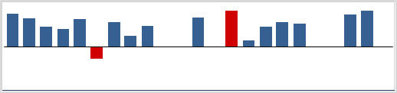 | Outlet shopping  (Seattle, WA) | Shopping with friends | None
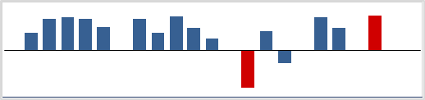 | Back-to-school shopping  (Syracuse, NY) | Great deals | Poor driving conditions
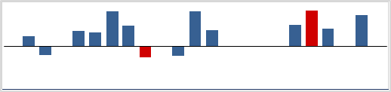 | Flight layover  (109 Shibuya Mall, Japan) | Unique purchases | Restricted time
 | Wedding trip  (Dubai) | Function and fun | Currency exchange fluctuations
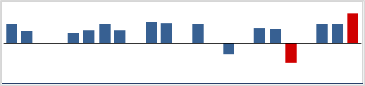 | Shopping excursion  (Walden Galleria, NY) | Quick, much variety, and cheap | Cutting tags & wearing clothes to avoid taxes
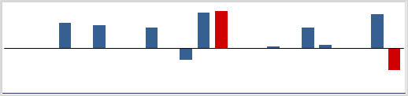 | Outlet shopping  (Destiny USA mall, NY) | Luxury brands add emotional gratification | Hotel quality (not clean)

CONCLUSION
This paper demonstrated a way to study the emotional peaks, valleys, and transitions found in cross-border shopping experiences. We found that NLP text analytic methods hold great promise to contribute to the measurement and management of traveller experience in tourism. The next step in our research program is to dig more deeply into travellers’ reasoning structures and to explore whether emotional profiles can distinguish different types of cross-border shopping occasions. Understanding these key touch points in the consumer experience offers an opportunity for better targeting of services and information needed to maximize satisfaction and greater overall efficiency in expenditures.
REFERENCES
Andrade, E. B. (2015). Consumer emotions. In C. Lamberton, D. D. Rucker, & M. I. Norton (Eds.), The Cambridge Handbook of Consumer Psychology (pp. 90-121). Cambridge: Cambridge University Press.
Ariely, D., & Carmon, Z. (2000). Gestalt characteristics of experiences: The defining features of summarized events. Journal of Behavioral Decision Making, 13(2), 191-201.
Arnould, E. J., & Price, L. L. (1993). River magic: Extraordinary experience and the extended service encounter. Journal of Consumer Research, 20(1), 24-45.
Dalakas, V. (2006). The importance of a good ending in a service encounter. Services Marketing Quarterly, 28(1), 35-53.
Gretzel, U., Fesenmaier, D. R., Lee, Y. J., & Tussyadiah, I. (2010). Narrating travel experiences: the role of new media. In R. Sharpley & P. R. Stone (Eds.), Tourist experience: Contemporary perspectives (pp. 171-182). New York: Routledge.
Hutto, C. J., & Gilbert, E. (2014). Vader: A parsimonious rule-based model for sentiment analysis of social media text. Paper presented at the Eighth International Conference on Weblogs and Social Media (ICWSM-14). .
Kahneman, D., Fredrickson, B. L., Schreiber, C. A., & Redelmeier, D. A. (1993). When more pain is preferred to less: Adding a better end. Psychological Science, 4(6), 401-405.
Mandler, J. M. (2014). Stories, Scripts, and Scenes: Aspects of Schema Theory: Psychology Press.
Ortony, A., Clore, G. L., & Collins, A. (1990). The Cognitive Structure of Emotions. Cambridge UK: Cambridge University Press.
Padgett, D., & Allen, D. (1997). Communicating experiences: A narrative approach to creating service brand image. Journal of Advertising, 26(4), 49-62.
Pitt, C., Mulvey, M., & Kietzmann, J. (2018). Quantitative insights from online qualitative data: An example from the health care sector. Psychology & Marketing, 35(12), 1010-1017.
Richins, M. L. (1983). Negative word-of-mouth by dissatisfied consumers: A pilot study. Journal of Marketing, 47(1), 68-78.
Richins, M. L. (1997). Measuring emotions in the consumption esxperience. Journal of Consumer Research, 24(2), 127-146.
Stern, B. B. (1998). Representing Consumers: Voices, Views, and Visions. New York: Routledge.
van Hagen, M., & Bron, P. (2014). Enhancing the experience of the train journey: Changing the focus from satisfaction to emotional experience of customers. Transportation Research Procedia, 1(1), 253-263.
Verhoef, P. C., Lemon, K. N., Parasuraman, A., Roggeveen, A., Tsiros, M., & Schlesinger, L. A. (2009). Customer experience creation: Determinants, dynamics and management strategies. Journal of Retailing, 85(1), 31-41.
Zaltman, G., Olson, J., & Forr, J. (2015). Toward a new marketing science for hospitality managers. Cornell Hospitality Quarterly, 56(4), 337-344.

