The Effects of Offering Menu Information on Perceived Waiting Time:
The Case of a Casual Dining Restaurant in Korea

Gumkwang Bae
Hotel and Restaurant Management
University of Missouri-Columbia

And

Dae-Young Kim
Hotel and Restaurant Management
University of Missouri-Columbia

ABSTRACT
With the assumption that waiting time is an important factor that directly influences customer satisfaction, this study employs an experimental design in a real restaurant setting to measure the effect of directs stimuli (i.e., offering menu information) on perceived waiting time. Specifically, the purpose of this study is to examine the effects of menu information as a method of distracting customers and reducing perceived waiting time. The test was conducted for three weeks under three manipulated conditions (i.e., music, no distraction, and offering menu information). The result of this study shows that there are significant mean differences between the conditions in terms of the gap score between perceived and actual waiting time. The research findings are anticipated to provide restaurant managers with some meaningful operational marketing strategies.
Key words: waiting time, perceived waiting time, satisfaction, menu information.

INTRODUCTION
It has been noted that waiting time is an important factor in quality of service, which strongly influences customer satisfaction. For this reason, managers are constantly looking for ways to reduce waiting time and waiting lines (Taylor, 1994). However, it is difficult to manage waiting time because the nature of waits is not an article of commerce but customers’ experience. Though many articles have dealt with the psychology of waiting time (e.g. Jones & Peppiatt, 1996; Maister, 1985) and types of waits (e.g. Dube-Rioux, Schmitt, & Leclerc 1988; Taylor, 1994; Cameron, Baker, Peterson, & Braunsberger, 2003; Hornik, 1984; Hwang & Lambert, 2005), there are few practical methods to control waiting time in restaurant management. The existing research has examined consumers’ reactions to waiting for service by focusing on indirect methods such as the use of mirrors or the use of music as research stimuli in managing waiting time (Sasser, Olsen, & Wyckoff, 1978; Hui, Dube, & Chebat, 1997). Survey methods are also often employed to assess customers’ memories and perception in previous studies.
In terms of the types of waits, several kinds of waiting time have been examined in previous research: pre-process waits, in-process waits, and post-process waits (Dube-Rioux, Schmitt, & Leclerc, 1988); pre-schedule waits, post-schedule waits, and queue waits (Taylor, 1994); high-cost waits and low-cost waits (Michaelle, Laurette, & Jean, 2003); subjective waits and objective waits (Hornik, 1984); and acceptable waiting time and unacceptable waiting time (Hwang & Lambert, 2005), (See Figure 1). Sometimes different types of waiting time occur simultaneously, and consequently researchers combine these waits to describe various types of wait time. For instance, a delay in an airplane’s departure is an example of a pre-process, post-schedule, high-cost waiting time, while arriving early for a doctor’s appointment is an example of a pre-process, pre-schedule, low-cost waiting time (Taylor, 1994).
It has also been noted that descriptive menu, a type of menu information, improve positive attitudes toward the food and restaurant and intentions toward re-patronage (Wansink, Painter & Ittersum, 2001; Harnack & French, 2008). In the sense, it is reasonably assumed that if managers give customers an opportunity to read menus, customers’ perceived waiting time would decease because they are more likely to focus on the choices on the menu rather than on the length of the wait. In addition, offering menu information will give customers a sense of responsibility because they already have menus in hand, which suggests an obligation to purchase. As a result, the manager can reduce the rate of customers’ willingness to leave the waiting area. That is, offering menu information in the waiting area may also be a tool to increase the likelihood of purchase.
With the understanding of the types of waits and the effects of offering menu information on perceived waiting time, this study proposes an experimental method for describing customers’ reactions in a real restaurant setting to a direct stimulus (i.e. offering menu information) and its effect on waiting time. Specifically, the purpose of this study is to identify the effects of menu information as a method to distract customers and reduce perceived waiting time. Based on the research findings, this study also suggests practical methods for improving customer satisfaction in the competitive restaurant industry. Consequently, it is anticipated that restaurant managers will be able to apply offering menu information in the waiting area as one of their operational marketing strategies.

LITERITURE REVIEW
Types of waits in terms of process and scheduling
In a food service setting, the fundamental division of waiting time is based on when the wait takes place in the serving process. A pre-process wait occurs before the customer is seated; an in-process wait occurs during order taking and during the meal; and a post-process wait occurs prior to receiving and paying the check (Taylor, 1994). Previous studies have suggested that most customers feel pre-process waits to be more unpleasant than waits during other points in the process. Thus, pre-process waits should be considered as a primary focus of restaurant management (Dube-Rioux, Schmitt, & Leclerc, 1988; Venkateson & Anderson, 1985).
In addition, a pre-process wait may be divided into three types of waits based on the customer’s scheduled appointment time: pre-schedule waits, post-schedule waits (that is, delays), and queue waits. Pre-schedule waits and post-schedule waits differ in “the timing of the wait with respect to a scheduled commencement time” (Taylor, 1994). Thus, pre-schedule waits are waits which occur prior to the scheduled time due to the customer’s early arrival. On the other hand, post-schedule waits are waits which occur after the scheduled time due to operational delays. In a service situation without scheduled appointments, a queue wait, in which customers wait in line, may be employed (Taylor, 1994). Research on waiting time points out that customers consider waiting time in service queues to be a gauge of service (McDonnell, 2007), and, in fact, waiting time is more important than service quality in determining customer satisfaction (Davis & Vollmann, 1990). Thus, this study focuses on pre-process waits and queue waits because complaints may increase exponentially at this point and the manager can improve the efficiency of food service operations by managing waiting time in service queues.
High-cost waits and low-cost waits
Another factor which may affect customer satisfaction is the cost of waits (Cameron et al., 2003). Prior research has found that the cost of a wait is based on the perceived opportunity cost (Houston et al., 1998). In most waiting situations, the waiting cost may be either a low-cost wait or a high-cost wait. An airplane delay may be an example of a high-cost wait and the waiting lines in a restaurant may be an example of a low-cost wait. This study examines low-cost waits in waiting lines in a food service setting because in the competitive restaurant industry, even low-cost waits negatively influence customer satisfaction, and compared to high-cost waits, customers may be more easily distracted during their wait by external stimuli in low-cost waits (Cameron et al., 2003).
Objective waits and subjective waits
Though time is a continuous process, each person perceives it differently according to the situation. Three minutes in a boxing ring may seem like three hours, while three hours in a casino may seem like thirty minutes. An objective wait is the actual waiting time measured by the clock, whereas a subjective wait is the perceived waiting time estimated by each person. Many studies have found that perceived waiting time is related to the evaluation of service (Taylor, 1994; Houston, et al., 1998) and customer satisfaction (Lee & Lambert, 2000; Pruyn & Smidts, 1998). Since perceived waiting time is connected to the mood of the customer (McDonnell, 2007; Hui, et al., 1997), customer satisfaction is influenced not by actual waiting time, but by perceived waiting time. In addition, compared to reducing actual waiting time, the cost of reducing perceived waiting time by stimuli is less than reducing actual waiting time, which requires the manipulation of human resources and of the operational layout of the restaurant. Though this study mainly focuses on subjective waiting time, it can be expected that offering menu information will reduce actual waiting time as well.
Acceptable waiting time and unacceptable waiting time
Acceptable waiting time is defined as “the maximum number of minutes tolerated in a specific waiting situation” (Pruyn and Smidts, 1998). Hwang and Lambert (2005) identified acceptable waiting times in a multi-stage restaurant system. According to the study, acceptable waiting times vary depending on the stage in the service process (i.e. greet, seat, order, serve, check, and pay), and respondents’ expectation levels (i.e. satisfactory, unsatisfactory, very unsatisfactory). Though this study is based on the concept of acceptable waiting time as described by Hwang and Lambert (2005), this study adjusts the definition of waiting time to measure perceived waiting time as the waiting time for seating after entering a restaurant identifying that the mean value of unsatisfactory waiting time for seating is 33.30 minutes (5.28+28.02) and the mean value of very unsatisfactory waiting time for seating is 47.91 minutes (8.52+39.39).
The proposed research framework
Based upon this understanding of types of waiting time, this study focuses on pre-process, queue, low-cost, subjective waits, which may have either acceptable or unacceptable perceived waiting time, in order to measure the effects of offering menu in a restaurant service setting. This study posits that offering menu information reduces the gap between perceived waiting time and actual waiting time, and increases customer satisfaction compared to standard waits without offering menu information. The research framework and research variables are shown in Figure 1.

Note: The marked areas are research variables.

RESEARCH METHOD
Sample: An experimental design was employed in order to examine the effects of offering menu information in the waiting area within the context of the hospitality industry. A total of 16 graduate students were recruited from a university in the north-west area of South Korea to serve as experimental subjects. This study, conducted during lunch time at an Italian restaurant which is located near the university, posited that the operational definition of waiting time is time spent waiting for seating after entering a restaurant.
Conditions of experiment: Three conditions (waiting time with music, waiting time with no distraction, and waiting time with offering menu information) were conducted for three weeks with the same persons. For each condition, the participants were asked to push a portable buzzer (see Figure 2) at two points: first, when they perceived uncomfortable feelings (e.g., annoyance, boredom, anxiety, and so on) due to the length of the wait, and second, when they were willing to leave the restaurant due to the length of the wait. When the participants pushed the buzzer, they were asked to estimate their perceived waiting time on the memo sheet without anyone knowing. The experimenter checked the actual time of participants through a receiver connected with the buzzers.
After the last two experiments, the participants were asked to fill in a survey about waiting time, customer behavior in the restaurant, and demographic information. The experimenter compared the gap between actual waiting time and perceived waiting time as estimated by the subjects, and identified the relationship between several variables: frequency of eating in the area near the university, meal duration, party size, information friendliness, quality of waiting facilities, fairness of waiting time, and plans after meal, as well as participants’ attitude toward waiting time.
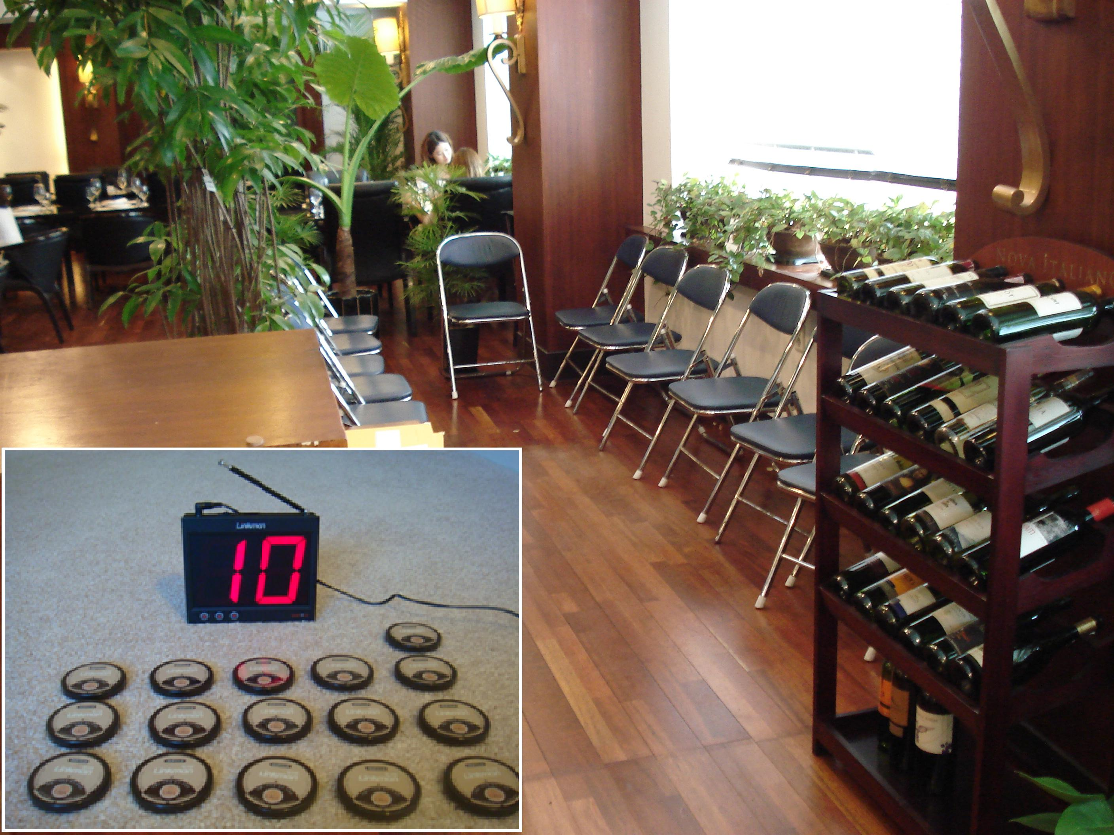

Figure 2. Layout of waiting area and the image of buzzer and receiver

Procedure: The participants gathered in a classroom and listened to an explanation of the experiment. They read a short introduction, but were not informed about specific research purposes or hypotheses. After viewing the short introduction of the study, the participants went to the restaurant to begin the experiment. In order to prevent the participants from checking the actual waiting time, the experimenter took away any items which could measure time, such as watches and cell phones. The experimenter gave each participant a buzzer for measuring actual waiting time and a memo sheet for measuring perceived waiting time. The participants were informed that the restaurant was experiencing a wait and took seats in the waiting area.
Research instrument: The questionnaire was developed based on a review of related research studies including perceived waiting time, willingness to leave the waiting area, and customer satisfaction. Respondents were asked to rate each item on a dimension (i.e., customer satisfaction) on a scale from 1 “strongly dissatisfied” to 5 “strongly satisfied.” The survey instrument also included questions on demographic information, individual customer behaviors (i.e., meal duration, waiting attitude, and party size), and number of visits to restaurants per month.
RESULTS
Figure. 4 and 5 describe the gap between perceived and actual waiting time under three different conditions: waiting time with offering music, waiting time without distraction, and waiting time with offering menu information. The findings in this study are that 1) unlike the previous study which which posited a positive impact of music on perceived waiting time (Hui, Dube, & Chebat, 1997), there were no effects of music in this study, and 2) compared to other the two conditions, there are significant differences in the gap between perceived and actual waiting time with offering menu information. Specifically, the sections labeled GAP record perceived waiting time subtracted from actual waiting time. According to each respondent, while 31% of respondents’ perceived waiting time without distraction is shorter than the actual time, 81% of respondents’ perceived waiting time when offered menu information is shorter than the actual time that they have spent in the waiting area at the point of uncomfortable feeling. Thus, this study identified that customers are more tolerant of waiting when offered menu information at waiting area.

Figure 4. PWT, AWT, and Gap scores at the point of uncomfortable feeling

PWT: Perceived waiting time. AWT: Actual waiting time. GAP = PWT - AWT

Figure 5. PWT, AWT, and Gap scores at the point of willingness to leave

PWT: Perceived waiting time. AWT: Actual waiting time. GAP = PWT - AWT
Using ANOVA, significant mean differences were found in the gap between perceived and actual waiting time in both at the point of the customer’s experiencing uncomfortable feelings with the wait (F: 5.161, P< 0.01) and at the point of the customer’s willingness to leave (F: 3.385, P< 0.043), under three different conditions: waiting time with menu information, waiting time with no distraction, and waiting time with music. While the gap shows a negative mean for the condition of offering menu information, the gap is positive for the other conditions (see Table 1). Negative gaps (-190.63, -141.69) mean that customers’ perceived waiting time is shorter than the actual time that they have spent in the waiting area. Thus, the results indicated that customers were more tolerant of waiting with menu information (see Table 1, 2).

TABLE 1. The gap of between PWT and AWT at the point of uncomfortable feeling
 | Group | N | Mean  (Second) | F-value
Uncomfortable feeling | Menu Information | 16 | -190.63ª | 5.161**
Uncomfortable feeling | No distraction | 16 | 39.13^{b} | 5.161**
Uncomfortable feeling | Music | 16 | 125.50^{b} | 5.161**
Uncomfortable feeling | Total | 48 | -8.67 | 5.161**
- PWT: Perceived waiting time. AWT: Actual waiting time.
- The value is mean (**p< .01)
- Means with letters within a column are significantly different from each other by Duncan's multiple range test (a < b < c)

TABLE 2. The gap between PWT and AWT at the point of willingness to leave
 | Group | N | Mean  (Second) | F-value
Willingness to leave | Menu Information | 16 | -141.69ª | 3.385*
Willingness to leave | No distraction | 16 | 96.12^{ab} | 3.385*
Willingness to leave | Music | 16 | 228.56^{b} | 3.385*
Willingness to leave | Total | 48 | -8.67 | 3.385*
- PWT: Perceived waiting time. AWT: Actual waiting time.
- The value is mean (**p< .05)
- Means with letters within a column are significantly different from each other by Duncan's multiple range test (a < b < c)

IMPLICATIONS
The results of the study show that offering menu information has positive effects on reducing perceived waiting time as compared to regular waits and waits with the use of music in a waiting area. One implication of this research is that though the genre of music played in the restaurant matched the respondents’ preferences, the use of music was not able to positively affect perceived waiting time in this study. For this reason, this study assumes that the effects of music on perceived waiting time depend on the type of restaurant, customers’ music preferences, the customer’s mood at the time, and so on. In other words, though the use of music might distract customers from perceived waiting time with proper music, the effects of music are complex and it is difficult to identify other variables in the use of music which cannot be controlled.
Another implication of this study is that offering menu information is an effective tool for a manager to communicate with customers in the waiting area, because it is difficult for managers to interact with customers during the meal. If managers use waiting time as a tool to deliver messages about their product, the intention to revisit or satisfaction with products will increase.

LIMITATION AND FUTURE STUDY
This study could not identity differences in age and gender due to the limitation of data characteristics, so the results may not be generalizable to all customers of other food service settings. In addition, though compared to other methods of data collection, such as an e-mail questionnaire, this method has the advantage of measuring customers’ reaction on the real time, there may be technical and operational problems. For example, the technical problem may be that the receiver cannot present several numbers at the exactly same time and operational problem may be that respondents can be influenced by other respondents’ reaction.
In order to solve these potential problems, future requests will employ a more advanced receiver to present several numbers at the exactly same time, and will add physiological equipment to measure customers’ physiological reactions such as changes in heartbeat. Furthermore, in order to reduce actual waiting time, which can increase the rate of turnover related to the revenue of restaurant as well as perceived waiting time, future studies should examine methods reducing actual waiting time in a real food service setting. Scheduling, forecasting, and process design are frequently-used methodologies to reduce actual waiting time. Thus, a pre-ordering system including menu information in the waiting areas or lines, which can reduce cooking time as well as delivery time will be employed in a future study.

REFERENCES
Cameron, M.A., Baker, J., Peterson, M., & Braunsberger, K. (2003). The effects of music, wait-length evaluation, and mood on a low-cost wait experience. Journal of Business Research, 53, 421-430.
Davis, M.M. & Vollmann, T.E. (1990). A framework for relating waiting time and consumer satisfaction in a service operation. Journal of Services Marketing, 4(1), 61-70.
Dube-Rioux, L., Schmitt, B. H., & Leclerc, F. (1988). Consumer’s reactions to waiting: When delays affect the perception of service quality. Advances in Consumer Research, 16, T. Srull, ed. Provo, UT: Association for Consumer Research, 59-63.
Harnack, L. J., & French, S. M. (2008). Effect of point-of purchase calorie labeling on restaurant and cafeteria food choices: A review of the literature. International Journal of Behavioral Nutrition and Physical Activity, 5, 51.
Hornik, J. (1984). Subjective vs. Objective time measures: A note on the perception of time in consumer behavior. Journal of Consumer Research, 11(1), 615-618.
Houston, M.B., Bettencourt, L.A., Wenger, S. (1998). The relationship between waiting in a service queue and evaluations of service quality: a field theory perspective. Psychology and Marketing, 15(8), 735-753.
Hui, M.K., Dube, L., & Chebat, J.C. (1997). The impact of music on consumers’ reaction to waiting for services. Journal of Retailing, 73(1), 87-104.
Hwang, J., & Lambert, C. U. (2005). Customers’ identification of acceptable waiting times in a muti-stage restaurant system. Journal of Foodservice Business Research, 8(1), 3-16.
Jones, P., & Peppiatt, E. (1996). Managing perception of waiting times in service queues. International Journal of Service Industry Management, 7(5), 47-61.
Katz, K.L., Larson, B.M., & Larson, R.C. (1991). Prescription for waiting-in-line blues: entertain,
enlighten, and engage. Sloan Management Review, Winter, pp. 44-53.
Lee, W., & Lambert, C. U. (2000). Impact of waiting time on evaluation of service quality and customer satisfaction in foodservice operations. Foodservice Research International, 12, 241-254.
Maister, D. (1985). The psychology of waiting lines. in Czepiel J.A., Solomon M. and Surprenant
C.S. (Eds), The Service Encounter, Lexington Books, MA.
McDonnell, J. (2007). Music, scent and time preferences for waiting lines. International Journal of Bank Marketing, 25(4), 223-237.
Pruyn, A. & Smidts, A. (1998). Effects of waiting on the satisfaction with the service: Beyond objective time measures. International Journal of Research in Marketing, 15, 321-334.
Sasser, W.E., Olsen, M., & Wyckoff, D.D. (1978). The Management of Service Operations. Allyn
& Bacon, Boston, MA.
Taylor, S. (1994). Waiting for service: The relationship between delays and evaluations of service. Journal of Marketing, 58, 56-69.
Venkatesan, M., & Beverlee B.A. (1985). Time Budgets and Consumer Services, in services Marketing in a Changing Environment, Thomas M. Bloch, Gregory D. Upah, and Valerie Zeithaml, eds. Chicago: American Marketing Association, 52-55.
Wansink, B., Painter, J., & Ittersum, K. V. (2001). Descriptive menu labels’ effect on sales. Cornell Hotel and restaurant Administration Quarterly, 42(4), 68-72.

