TEACHER’S DISCIPLINE PRACTICES AND RACE: THE EFFECT OF “FAIR” AND “UNFAIR” DISCIPLINE ON BLACK AND WHITE STUDENT’S PERCEPTIONS AND BEHAVIORS

A Thesis Presented
by
ADRIAN RIVERA-RODRIGUEZ

Submitted to the Graduate School of the
University of Massachusetts Amherst in partial fulfillment
of the requirements for the degree of

MASTER OF SCIENCE

May 2021

Psychological and Brain Sciences

TEACHER’S DISCIPLINE PRACTICES AND RACE: THE EFFECT OF “FAIR” AND “UNFAIR” DISCIPILNE ON BLACK AND WHITE STUDENT’S PERCEPTIONS AND BEHAVIORS

A Thesis Presented
by
ADRIAN RIVERA-RODRIGUEZ

Approved as to style and content by:

Nilanjana Dasgupta, Chair

Kirby Deater-Deckard, Member

Linda R. Tropp, Member

Caren M. Rotello, Department Chair
Psychological and Brain Sciences

ABSTRACT
TEACHER’S DISCIPLINE PRACTICES AND RACE: THE EFFECT OF “FAIR” AND “UNFAIR” DISCIPLINE ON BLACK AND WHITE STUDENT’S PERCEPTIONS AND BEHAVIORS
May 2021
ADRIAN RIVERA-RODRIGUEZ, B.S., UNIVERSITY OF KANSAS
M.S., UNIVERSITY OF MASSACHUSETTS AMHERST
Directed by: Professor Nilanjana Dasgupta
Negative stereotypes characterizing Black males as prone to causing trouble can lead teachers to punish misbehaving Black boys more harshly than their White peers. Awareness of unfair discipline practices has been linked to future disciplinary infractions among Black males, hinting that some Black males may engage in defiant behavior in response to unfair discipline. Despite the documented links between awareness of unfair discipline and future disciplinary infractions among Black males, questions remain as to (1) the types of disciplinary practices from teachers that students perceive as fair and unfair; (2) the psychological processes that motivate Black male behavior after experiencing unfair discipline; and (3) whether these psychological processes differ from those that motivate White male behavior. Across three studies, the present research explores these questions by asking Black and White men to recall the type of treatment from teachers that they perceived as fair and unfair (Study 2), as well as how they would have perceived and responded to different scenarios describing instances of either fair and unfair discipline from teachers in middle and high school (Studies 1 and 3). Qualitative results from Study 2 highlights negotiable (i.e., a collaborative effort between a teacher and their pupil to discuss and analyze how and why a particular situation arose from all perspectives) and non-negotiable (i.e., teacher ignores the pupil’s explanation for the infraction) discipline as two contrasting practices that men viewed as fair and unfair, respectively. Quantitative results from Study 3 indicated that unfair (non-negotiable), compared to fair (negotiable) discipline from teachers triggered negative emotions associated with reputation threat (i.e., embarrassment, shame, anger, and sadness), which in turn predicted future defiant behavior among both Black and White men. Furthermore, the extent to which unfair discipline from teachers was attributed to racial bias also predicted greater negative emotions and defiant behavior for Black, but not White, men. Together, these findings shed light on a process through which unfair disciplinary practices may motivate defiance from students via negative emotions among both Black and White students; as well as the unique role that race bias attributions have on Black students’ perceptions of unfair discipline.
Keywords: school, discipline, race, bias, reputation threat, behavior

TABLE OF CONTENTS
Page
ABSTRACT iii
LIST OF TABLES ix
LIST OF FIGURES x

CHAPTER
1. INTRODUCTION 1
1.1 Teacher Racial Bias and Disciplinary Outcomes 1
1.2 Student Perceptions of Racial Bias and Disciplinary Outcomes 3
1.3 Theory of Precarious Manhood: Reputation Threat Motivates Defiant Behavior 4
1.4 Is Unfair Discipline More Threatening to Black Boys? 6
1.5 Goals of the Proposed Research 8
2. STUDY 1 11
2.1 Method 11
2.1.1 Participants 11
2.1.2 Measures and Procedure 12
2.1.2.1 Independent Variable 12
2.1.3 Dependent variables 13
2.1.3.1 Attributions of disciplinary action 13
2.1.3.2 Reputation threat 13
2.1.3.3 Defiant behavior 13
2.2 Results 16
2.2.1 Effect of discipline condition and race on attributions of disciplinary action 16
2.2.2 Effects of discipline condition and race on reputation threat 17
2.2.3 Effects of discipline condition and race on defiant behavior 17
2.2.4 Effects of discipline condition and race on compliant behavior 17
2.2.5 Attributions to racial bias mediate the effect of race on defiant behavior 18
2.3 Discussion 19
2.3.1 Attributions to racial bias. 19
2.3.2 Attributions to racial bias mediates the effect of race on defiant behavior 20
2.3.3 Reputation threat 21
3. STUDY 2 22
3.1 Method 23
3.1.1 Participants 23
3.1.2 Materials and procedure 23
3.1.2.1 Independent variable (fair and unfair treatment from teachers) 23
3.1.2.2 Dependent variables 24
3.1.2.2.1 Attributions of (un)fair treatment from teachers to race bias 24
3.1.2.2.2 Reputation 24
3.1.2.2.2.1 Reputation threat 25
3.1.2.2.2.2 Reputation affirmation 25
3.1.2.2.3 Behavioral responses 25
3.1.2.2.3.1 Defiant behavior 26
3.1.2.2.3.2 Classroom engagement 26
3.2 Results 26
3.2.1 Effect of fair and unfair treatment and race on attributions to racial bias 27
3.2.2 Effect of fair and unfair treatment on reputation threat 27
3.2.3 Effect of fair and unfair treatment on reputation affirmation 27
3.2.4 Effect of fair and unfair treatment on behavior 28
3.2.5 Mediational analysis 29
3.2.5.1 Model 1: Mediation predicting defiant behavior for both Black and White men through reputation threat 30
3.2.5.2 Model 2: Moderated mediation predicting defiant behavior for Black men through attribution to racial bias and reputation threat 30
3.2.5.3 Model 3: Moderated mediation predicting defiant behavior for Black men with controls 31
3.2.5.4 Model 4: Mediation predicting engaged behavior for both Black and White men through reputation affirmation 32
3.2.6 Qualitative analyses 32
3.2.6.1 Content analysis of narratives from the unfair vs. fair condition 32
3.2.6.2 Qualitative analysis of narratives in the fair and unfair condition 33
3.2.6.3 Content analysis indicating vs. not indicating teacher racial bias 35
3.2.6.4 Content analysis racial bias 36
3.7 Discussion 36
3.7.1 Black and White perceptions of fair and unfair treatment from teacher, and racial bias 36
3.7.2 Reputation threat and attributions to racial bias as mediators of behavior 38
3.7.3 Fair treatment from teachers leads to greater classroom engagement through reputation affirmation 38
4. STUDY 3 41
4.1 Method 41
4.1.1 Participants 41
4.1.2 Materials and procedure 42
4.1.2.1 Independent variables. 42
4.1.2.1.1 Classroom demographics manipulation 42
4.1.2.1.2 Discipline manipulation 43
4.1.2.2 Dependent variables 44
4.1.2.2.1 Perceived fairness 44
4.1.2.2.2 Attributions of disciplinary action 44
4.1.2.2.3 Reputation threat and negative emotions 45
4.1.2.2.3.1 Reputation threat/affirmation 45
4.1.2.2.3.2 Negative emotions 46
4.1.2.2.4 Behavioral Response 46
4.1.2.2.4.1 Defiant behavior 46
4.1.2.2.4.2 Classroom engagement 47
4.2 Results 47
4.2.1 Effect of fair and unfair discipline on perceived fairness 47
4.2.2 Effect of discipline and race on discipline attributions 48
4.2.2.1 Attributions to racial bias 48
4.2.2.2 Exploring alternative discipline attributions 48
4.2.3 Effect of discipline and race on reputation threat or affirmation. 49
4.2.4 Effect of discipline and race on negative emotion. 49
4.2.5 The effect of discipline and race on classroom behavior 50
4.2.5.1 Classroom engagement 50
4.2.5.2 Defiant behavior 50
4.2.6 Attributions that predict defiant behavior 51
4.2.7 Mediational analysis 51
4.2.7.1 Mediational analysis plan 51
4.2.7.2 Model 1: Testing the race bias pathway 52
4.2.7.3 Model 2: Testing the bad reputation pathway 52
4.2.7.4 Model 3: Testing if each pathway is significant controlling for the other 53
4.2.7.5 Model 4: The mediating role of reputation affirmation on Classroom engagement 53
4.3 Discussion 54
5. GENERAL DISCUSSION 56
5.1 What do students perceive as fair and unfair discipline? 56
5.2 Reputation threat and related negative emotions explains why some students engage in defiant behavior in response to unfair discipline 58
5.3 Fair (negotiable) discipline, practices have positive effects on student behavior 59
5.4 Black and White participants are equally likely to feel threatened by, and engage in, defiant behavior in response to unfair (non-negotiable) discipline practices 60
5.5 Limitations 62
5.6 Future directions 63

APPENDICES
A. STUDY 1 MANIPULATION MATERIALS AND BEHAVIORAL MEASURES 94
B. STUDY 2 MANIPULATION MATERIALS AND BEHAVIORAL MEASURES 97
BIBLIOGRAPHY 100

LIST OF TABLES
Tables |  | Page
1. | Factor loading for Reputation Threat and Reputation Affirmation 68
2. | Factor loadings for Defiant Behavior and Classroom Engagement 69
3. | Descriptive Statistics and Bivariate Correlations for Study 2  Constructs 70
4. | Frequency of Themes in Participant Narratives Describing Fair Teacher Treatment 80
5. | Frequency of Themes in Participant Narratives Describing Unfair  Teacher Treatment 81
6. | Frequency of Themes in Attributions of Unfair Treatment to Racial Bias Among Black Participants 82
7. | Factor loadings for Reputation Threat/Affirmation and Negative  Emotion 83
8. | Factor loadings for Defiant Behavior and Classroom Engagement 84
9. | Descriptive Statistics and Bivariate Correlations for Study 3  Constructs 85
10. | Effect of Fair and Unfair Discipline on Participant Attributions 88
11. | Regression Coefficients: Alternative Attributions that Predict Defiant Behavior 89

LIST OF FIGURES
Figures |  | Page
1. | Attributions of Discipline to Racial Bias 65
2. | Defiance in Response to Discipline 66
3. | Effect of Participant Race on Defiant Behavior, Mediated by  Attributions to Race Bias 67
4. | Attributions of Teacher Treatment to Racial Bias 71
5. | Effect of Teacher Treatment on Reputation Threat Effect of Teacher Treatment on Reputation Threat 72
6. | Effect of Teacher Treatment on Reputation Affirmation 73
7. | Effect of Teacher Treatment on Defiant Behavior 74
8. | Effect of Teacher Treatment on Classroom Engagement 75
9. | Model 1 76
10. | Model 2 77
11. | Model 3 78
12. | Model 4 79
13. | Effect of Fair and Unfair Discipline on Perceived Fairness 86
14. | Effect of Fair and Unfair Discipline on Race Bias Attributions 87
15. | Model 1 90
16. | Model 2 91
17. | Model 3 92
18. | Model 4 93

CHAPTER 1

INTRODUCTION
National reports indicate widespread race disparities in disciplinary rates between Black compared to White students in K-12 schools (Government Accountability Office, 2018), with suspension rates for Black students more than doubled from 11% to 24% from 1970 to 2010 (Losen & Martinez, 2013; Losen, Hodson, Keith, Morrison & Belway, 2015). In 2018, the Government Accountability Office estimated that Black students were about four times as likely to be disciplined than their White peers, often for the same misbehavior. This is especially concerning for Black boys, because boys are overrepresented across a range of disciplinary actions, from detention to suspension to expulsion (Skibba, Michael, Nardo, & Peterson, 2002; Government Accountability Office, 2018). While one might expect that race disparities in suspension and expulsion rates occur at the level of extreme misbehavior (e.g., acts of violence), studies show that this is not the case. Surprisingly, the largest gaps in suspension and expulsion rates between Black and White boys occur for minor infractions, such as being defiant or disrespectful towards a school authority (Gregory, & Weinstein, 2008; Skibba, Michail, Nardo, & Peterson 2002). What’s more, these race differences in disciplinary rates persist even after controlling for students’ social class (Skibba et al, 2002; Wallace, et al., 2008), the type of school they attend (Government Accountability Office, 2018), and teacher experience (McCarthy, & Hoge, 1987).

1.1 Teacher Racial Bias and Disciplinary Outcomes
So why are Black boys punished more harshly for minor infractions compared to their White peers? Much of the research aimed at explaining the racial gap in student disciplinary rates broadly focuses on the attributions that teachers make about misbehaving students. Social psychological research has shown that racial stereotypes often influence the attributions teachers make about misbehaving students (Giliam et al., 2016; Okonοfua & Eberhardt, 2015; for a review, see Okonofua, Walton & Eberhardt, 2016). When it comes to school performance and behavior, stereotypes often characterize Black boys as lazy, unmotivated to learn, and prone to causing trouble (Gaertner & Mclaughlin, 1983). The consequences of these socially ingrained stereotypes are reflected in the classroom where these stereotypes might influence teachers to expect Black boys to misbehave; a phenomenon which has been empirically tested by Gilliam and colleagues (2016) who used eye tracking technology to monitor the amount of time teachers spent monitoring Black and White students while anticipating students to misbehave. On average, teachers spent significantly more time looking at Black boys compared to White boys and girls as well as Black girls, suggesting that teachers expected Black boys to misbehave (Gilliam et al., 2016).
These stereotypes can also bias teacher’ perceptions of the severity of misbehavior from Black students, particularly Black boys. For Black boys specifically, one study found that 10-year old Black boys are perceived to be significantly less innocent and more culpable for their actions, than their 10-year old White peers (Goff, Jackson, Di Leone, Culotta, DiTomasso, 2014). These racially biased perceptions of misbehaving Black boys can cause harsher disciplinary action from teachers in response to misbehaving Black compared to White students. Indeed, research by Okonofua and Eberhardt (2015) empirically demonstrated that teachers were less tolerant and advised harsher disciplinary action in response to the same misbehavior when made to believe that the student was Black compared to White.
These findings illustrate a process where negative stereotypes lead teachers to (1) anticipate misbehavior from Black students, and (2) be less tolerant and harsher in their disciplinary response to misbehavior from Black students compared to their White peers. What is less known is how Black students perceive discipline from teachers.

1.2 Student Perceptions of Racial Bias and Disciplinary Outcomes
By the time Black students reach adolescence, they are more aware of, and are more likely to have experienced, racial discrimination from their teachers, compared to their White peers (McKown, & Weinstein, 2003; Fisher, Wallace, & Fenton, 2000; Sellers, Copeland-Linder, Martin, & Lewis, 2006). It is well documented that students’ awareness of the racial gap in school discipline correlates with institutional mistrust in the education system (Yeager, Purdie-Vaughns, Hooper, & Cohen, 2017; Yeager, Bosson, Cohen, Burnaford, & Weaver, 2008), academic disengagement among Black students (Mendoza-Denton, Downey, Purdie, Davis, & Pietrzak, 2002; Yeager et al., 2017), lower feelings of connectedness with peers and adults at school (Anyon, Zhang & Hazel, 2016; Gregory, Cornell & Fan, 2011; Yeager, Bosson, Cohen, Burnaford, & Weaver, 2008), and future disciplinary infractions during early adolescence (Copeland-Linder, Lambert, Chen & Ialongo, 2006; Simons, Chen, Stewart, & Brody, 2003; Yeager et al., 2017). These studies, which consistently link perceptions of disproportionate discipline at the school-level to negative academic and disciplinary outcomes at the student-level, have led some researchers to speculate that Black students perceive the race-discipline gap in schools as racially biased which can negatively affect interpersonal relationships between students and their teachers (Bradshaw, Mitchel, O'Brennan & Leaf, 2010).
Okonofua and colleagues (2016) further hypothesize about the impacts of disproportionate discipline on the relationship between teachers and students of color. In their theorized cyclical model of escalation that exacerbates the racial disciplinary gap, they suggest that racial stereotypes lead teachers to give harsher punishments to misbehaving Black students, compared to misbehaving White students, which in turn causes Black students to react in an aggressive or defiant manner. These behavioral responses may then serve to validate the negative stereotypes that teachers hold about Black students, and thus the cycle continues (Okonofua, Walton & Eberhardt, 2016). As previously mentioned, multiple studies have found evidence in support of the link between racial stereotypes and disproportionate discipline from teachers in response to misbehaving Black students, compared to their White peers; however, no studies to my knowledge have empirically tested the second half of the model (how students perceive and react to teachers’ behavior) in controlled experimental studies that speak to causal relations between student perception and their intended behavior. Thus, whether Black students attribute disproportionate discipline to racial bias, and whether attributions to racial bias motivate students to defy their teachers remains an empirical question that I explored in the current research.

1.3 Theory of Precarious Manhood: Reputation Threat Motivates Defiant Behavior
If unfair discipline from teachers does increase the likelihood that boys will engage in defiant behavior, then further questions arise about the underlying processes that motivate this link among male students. The Theory of Precarious Manhood (TPM) provides a theoretical framework that may explain why some male students engage in defiant behavior in response to unfair discipline. According to TPM, manhood is a status that must be actively maintained, and one’s reputation as a man is gained and lost as a function of social status (O’Dea, Chalman, Castro Bueno, Saucier, 2018). As such, men are conditioned to develop extra-sensitivity to social status threats, such as insults, and are motivated to act against the source that threatens their social status (Bosson & Vandello, 2011). Studies have shown that this compensatory action is often aggressive in nature (Nisbett, 1993; Cohen & Nisbett, 1994; Cohen, Nisbett, Bowdle, & Schwarz, 1996; Saucier, Stanford, Milller, Martens, Miller, Jones, McManus & Burns, 2016; DeWall, Bushman, Giancola & Webster, 2010) and stems from the activation of negative emotions and cognitions (Vandello, Bosson, Cohen, Burnaford & Weaver, 2008).
Negative emotions of shame, embarrassment and anger in particular have been shown to be the driving emotions linking social status threat and aggressive behavior (Tangney, Wagner, Fletcher & Gramzow, 1992; Anderson & Bushman, 2002; Felson, 1993). Shame (and related feelings of embarrassment and humiliation) are negative self-evaluative emotions that arises when individuals see themselves as inferior to others and reflects instability in their social standing (Felson, 1993). Experiencing shame and related emotions like embarrassment can cause individuals to simultaneously want to hide and punish others (Wicker, Payne & Morgan, 1983), and is strongly correlated with anger (Averill, 1982), hostility (Tangney, 1990), and shifting blame for one’s loss of social standing to external factors (Tangney, 1990).
Within the broader framework of TPM, researchers have found that men who perceive disrespect as a threat to their social status are likely to feel shame, embarrassment and anger, in turn motivating them to reaffirm their social status as a man through aggressive behavior (Tangney, Wagner, Fletcher & Gramzow, 1992; Anderson & Bushman, 2002). In the current research, I apply this framework to the context of school discipline. Given that the concept of masculinity and social reputation are intertwined for many men (Saucier et al., 2016); and that gaining and maintaining social status as a young man is key to the formation of masculine identity among adolescent males (Adler, Kless & Adler, 1992; Allen, 2013), I propose the following. Within the context of school discipline, it is possible that unfair discipline from teachers is perceived by male students as disrespectful, which in turn is likely to threaten their reputation, and motivate male students to act defiantly towards the source of the threat, in this case the teacher who unfairly disciplined them. While this process likely occurs among both Black and White male students, I hypothesize that Black males may feel extra threatened by unfair discipline, compared to their white peers, for reasons outlined below.

1.4 Is Unfair Discipline More Threatening to Black Boys?
Decades of institutional racism within schools may cause many Black students to mistrust the educational system (Yeager et al., 2017, Yeager et al., 2014). In turn, research has shown race based institutional mistrust to predict negative academic and disciplinary outcomes for Black students (Mendoza-Denton, Downey, Purdie, Davis, & Pietrzak, 2002, Yeager et al., 2017). Because of this long history of institutional discrimination within the education system, I hypothesize that Black and White students may subjectively perceive unfair discipline from teachers very differently, even if the discipline objectively looks the same. Specifically, I expect Black students will be more likely to attribute unfair discipline from teachers to racial bias, compared to White students.
Should Black students be more likely to attribute unfair discipline from teachers to racial bias, then they may feel more threatened by unfair discipline compared to their White peers. Consistent with this prediction, one laboratory study made both Black and White men the targets of explicit racial discrimination and found that racial discrimination induced greater masculinity threat among Black compared to White men, and motivated Black men to reaffirm their masculinity through a physical display of strength (Goff, Di Leone & Kahn, 2012). If Black students are more likely to attribute unfair discipline to racial bias, then they may be more likely to feel that their reputation as a man is threatened by unfair discipline, which in turn may elicit more defiant behavior to reaffirm their social status, compared to their White peers.
Further correlational evidence emphasizing the link between racial/ethnic discrimination and defiant behavior at school was found among a sample of 500 Black youths in a longitudinal study tracking the association between a host of environmental stressors, including racial discrimination, and several health risk behaviors, including aggressive behavior (Copeland-Linder, Lambert, Chen & Ialongo, 2011). Frequency of self-reported experiences with discrimination was shown to account for a significant amount of variability in contextual stress among 8th grade boys, which in turn predicted teacher- reported aggressive behavior in 10th grade.
These, and similar correlational studies (Martin, McCarthy, Conger, Gibbons, Simons, Curtana & Brody, 2011; Simons, Chen, Stewart, & Brody, 2003; Wong, Eccles & Sameroff, 2003) elucidate an important link between racial discrimination and aggressive/defiant behavior among Black adolescents. Furthermore, research by Goff and colleagues (2012) show that Black men are more threatened by racial discrimination, and more likely to engage in a physical display of toughness to reaffirm their threatened status, compared to White men. These findings led me to hypothesize that Black men who attribute unfair discipline from teachers to racial bias would also perceive unfair discipline as a greater threat to their reputation and would therefore be more likely to engage in defiant behavior to reaffirm their reputation, compared to White men.

1.5 Goals of the Proposed Research
Across three studies I sought to test the following primary hypothesis regarding racial differences in how Black and White men respond to retrospective accounts of how they would have perceived and reacted to unfair discipline from teachers. First, I hypothesize that Black men will be more likely to attribute unfair (vs. fair) treatment from teachers to racial bias, compared to White men. Second, I hypothesize that unfair (vs. fair) discipline will elicit greater emotional responses related to reputation threat (i.e. feeling disrespected, dishonored, less like a man, ashamed, embarrassed, angry and sad) among Black men compared to White men. Third, I hypothesize that Black men will be more likely to report that they would have engaged in defiant behavior (e.g., ignoring the teacher, skipping class, cursing at the teacher) in response to unfair (vs. fair) discipline, compared to White men.
Fourth, the current studies also explores two mediational processes through which reputation threat might mediate the effect of unfair (vs. fair) discipline from teachers on defiant behavior from students. Using the TPM theoretical framework, the first model explores whether the effect of unfair (vs. fair) discipline on defiant behavior was mediated by reputation threat, equally for both Black and White students. Specifically, I hypothesize that unfair discipline would induce greater perceived threat to both Black and White students’ reputations, which would, in turn, predict increased likelihood that students would engage in defiant behavior. The second model built on the first by testing a sequential mediational process moderated by race. Specifically, this model explored whether Black participants would be more likely to attribute unfair discipline to racial bias, compared to White participants, and whether attributions to racial bias induced reputation threat, in turn predicting a greater likelihood of engaging in defiant behavior.
Finally, it is important to note that Fair and Unfair discipline was operationalized in two different ways. In Study 1, fair and unfair discipline was operationalized in terms of equal or unequal discipline to two students. Specifically, fair discipline was described as receiving equal discipline for the same misbehavior as another student whereas unfair discipline was described as receiving unequal discipline compared to another student. In Study 3 the operationalization of fair and unfair discipline was changed based on qualitative data collected in Study 2. This operationalization of discipline describes fair discipline as negotiable (i.e. a collaborative effort between a teacher and their pupil to discuss and analyze how and why a particular situation arose from all perspectives) and private, and unfair discipline as non-negotiable (i.e. teacher ignores the pupils explanation for the infraction) and public. In the current research, I have purposefully placed a heavy focus on the negative impacts of unfair discipline, as this type of discipline has been shown to disproportionately target Black male students and contribute to the school-to-prison pipeline (Mukasey., Sedgwick., & Flores, 2007; Wald and Losen, 2003; Snyder and Sickmund, 2006). Nonetheless, research has shown that negotiable discipline practices, synonymous with our operationalization of “fair” discipline in Study 3, effectively reduce future disciplinary infractions among student with socioemotional and behavioral issues and improve teacher student relationships (Greene, Ablon, & Goring, 2003; Greene, 2011; Schaubman, Stetson, & Plog, 2011). So, while it is not central to my hypothesis, I nonetheless explore the potential positive effects that fair (i.e., negotiable) discipline can have on student behavior in studies 2 and 3.
CHAPTER 2

STUDY 1
In Study 1 young Black or White American men read vignettes of fictitious student teacher interactions in high school classrooms in which the teacher disciplined two students’ infractions for the same misbehavior equally (equal discipline) or disciplined one student’s infractions but not the other (unequal discipline). I examined the effect of equal vs. unequal discipline and participant race (Black and White) to test the following hypotheses. First, Black men will be more likely to attribute unequal (vs. equal) discipline from teachers to racial bias, compared to White men (Hypothesis 1). Second, Black men will be more likely to feel that unequal (vs. equal) discipline from teachers threatens their reputation, compared to White men (Hypothesis 2). Third, Black men will be more likely to engage in defiant behavior in response to unequal, (vs. equal) discipline from teachers, compared to White men (Hypothesis 3). Fourth, that unequal (vs. equal) discipline would be attributed to racial bias, more so among Black compared to White men, in turn predicting greater reputation threat, and subsequent defiant behavior (a moderated serial mediational model).

2.1 Method

2.1.1 Participants
Data was initially collected from 587 Black and White male participants between the age of 18-35 via Cloud Research TurkPrime Panels to prescreen participants prior to the study. During this initial data collection process, participants were assigned an anonymized participation ID and asked to complete a demographic questionnaire indicating their age, gender identity, and racial/ethnic group. From this original sample, a combined total of 280 Black and White, male participants, between the age of 18-35 were invited and consented to participate in the experimental portion of the study via TurkPrime.
Three a priori exclusion criteria were used to trim the data. First, participants were excluded if they took less than 500 seconds (8 minutes 20 seconds) to complete the study. By design participants were locked into a particular task in the experiment for 5 minutes; thus a participant who completed the entire study in 500 seconds or less would have dedicated 3 minutes or less (200 seconds) for the rest of the experiment, indicating a lack of attention to experimental tasks. Second, participants who gave the same response for multiple items within a scale (response bias) were also eliminated. Third, participants were excluded for having duplicate participation codes suggesting they were erroneously invited to participate in the study twice. In total, 18 participants were excluded for the above three exclusion criteria, leaving 272 participants (131 Black, 141 White) for analysis.

2.1.2 Measures and Procedure

2.1.2.1 Independent Variable
We manipulated equal and unequal discipline with two vignettes (Vignette Task 1). Before reading the vignettes, participants were asked to imagine themselves in the shoes of their high school selves. The vignettes described the participant and another high school student who was of another race (Black classmate for White participants; White classmate for Black) engaging in the same misbehavior in a high school class. Depending on condition, the vignettes described either both the participant and the classmate of another race being disciplined in the same way for misbehaving (equal discipline condition), or only the participant being disciplined (unequal discipline condition). Vignettes used in the discipline manipulation can be found in Appendix A.

2.1.3 Dependent variables

2.1.3.1 Attributions of disciplinary action
We assessed attributions of the disciplinary action as equal vs. unequal and racially biased with 2 items: “Was the teacher’s disciplinary response fair or unfair to you?”, “Was the teacher’s disciplinary response to your behavior racially biased or not?”. Participants indicated their attributions on a scale from 1 (extremely unfair/not at all biased) to 7 (extremely fair/extremely biased).

2.1.3.2 Reputation threat
We assessed reputation threat via a word search task (Goff et al., 2012). The word search task consisted of 6 insults to masculinity (crybaby, girly, pansy, sissy, weakling, wuss) and 6 neutral words (bird, chalk, cloud, house, legs, tree). Participants were given 5 minutes to find as many words as possible. Based on Goff et al.’s work, identifying a greater number of insults indicates a higher level of reputation threat. The word search task can be found in Appendix A.

2.1.3.3 Defiant behavior
We assessed the likelihood that participants would engage in defiant behavior with three scenarios that all described interactions with the teacher from the discipline manipulation vignettes. Participants rated how likely they would have been to behave in the manner described in each scenario on a scale of 1 (not at all likely) to 7 (extremely likely).
The first scenario describes a situation where the teacher asks the participant why they didn’t turn in their homework assignment. The participant is asked how likely they would be to: (1) “Apologize for not having done the homework and tell the teacher it won’t happen again.”, (2) “Shrug your shoulders and give Mrs. Smith a blank look”, (3) “tell the teacher that you didn’t do the homework because you think the class is stupid and a waste of time.”.
The second scenario described a situation where the teacher is looking for any excuse to pick on the participant in front of the class, reprimanding the participant for trivial things like slouching and not being prepared to take notes during the lecture. The participant is asked how likely they would be to (1) “Call the teacher an ‘asshole’ in front of the entire class.”, (2) Withdraw from the lesson and quit caring about Mrs. Smith, your grades, and your performance in the class.”, (3) “Apologize to Mrs. Smith and try to be on your best behavior to avoid getting in further trouble.”.
The third scenario described a situation where the participant asks the teacher for permission to use the bathroom. The teacher then instructs the participant to hurry back. The participant is asked how likely they would be to (1) “Walk directly to the bathroom and come straight back to class.”, (2) “Take the longest route to the bathroom, stopping outside various classes that are in free period to talk to friends before eventually going to the bathroom, finally returning 15 minutes later.”, (3) “Meet up with friends and wander the halls together until the bell rings, signifying the end of class”.
All 9 behaviors across the three scenarios were subject to a principal component analysis using an oblimin rotation. This analysis revealed the presence of three components with eigenvalues exceeding 1, explaining 42.96%, 15.46% and 12.43% of the variance, respectively. An inspection of the scree plot revealed a clear break between the second and third components. Many of the items that loaded onto the third component also cross-loaded onto the other components (i.e., factor loading was above .4 across multiple components). For these reasons, I re-ran the analysis forcing a 2-factor solution. This 2-factor solution explained a total of 58.42% of the variance, with Factor 1 contributing to 42.96% and Factor 2 contributing to 15.46%.
Factor 1 was labeled as Defiant Behavior (Cronbach’s alpha = .83) and consisted of the following 6 items: (1) “Call the teacher an ‘asshole’ in front of the entire class.”, (2) Withdraw from the lesson and quit caring about Mrs. Smith, your grades, and your performance in the class.”, (4) “Shrug your shoulders and give Mrs. Smith a blank look”, (5) “Take the longest route to the bathroom, stopping outside various classes that are in free period to talk to friends before eventually going to the bathroom, finally returning 15 minutes later”, (6) “Meet up with friends and wander the halls together until the bell rings, signifying the end of class”. Responses to these 6 items were averaged together to create a single composite labeled “Defiant Behavior” measuring how likely participants would have been to act defiantly on a scale of 1 (not at all likely) to 7 (extremely likely).
Factor 2 was labeled Compliant Behavior (Cronbach’s alpha = .58) and consisted of 3 behaviors: (1) “Apologize for not having done the homework and tell the teacher it won’t happen again.”, (2) “Apologize to Mrs. Smith and try to be on your best behavior to avoid getting in further trouble.”. (3) “Walk directly to the bathroom and come straight back to class.”. But because the reliability was low for Compliant Behavior, I examined the effect of discipline condition, race, and their interaction individually for each of the 3 items instead of analyzing this as a composite factor.

2.2 Results

2.2.1 Effect of discipline condition and race on attributions of disciplinary action
As a manipulation check, I tested whether the vignette condition would influence the perceived fairness of the teacher’s discipline. A Condition (Equal, Unequal) x Race (White, Black) Analysis of Variance (ANOVA) revealed a main effect of condition (F(1, 270) = 185.17, p < .001; d = 1.66) on the perceived fairness of the discipline described in the vignettes. As expected, participants in the equal discipline condition rated the disciplinary action as fairer (M = 5.50, SE = .12) than participants in the Unequal discipline condition (M = 3.27, SE = .11).
To test whether discipline condition and participant race influenced participants’ attributions of the disciplinary action as racially biased, I conducted a Condition (Equal, Unequal) x Race (White, Black) ANOVA. This analysis revealed a main effect of Race (F(1, 270) = 18.41, p < .001; d = .51) and Condition (F(1, 270) = 87.71, p < .001; d = 1.12) on participants’ attribution of racial bias. Specifically, a main effect of race indicated that Black participants were more likely to attribute discipline (both Equal and Unequal) to race bias (M = 3.32, SE= .14), compared to White participants (M = 2.52, SE = .13). And, participants in the Unequal condition were more likely to attribute the disciplinary action to race bias (M = 3.80, SE = .13) compared to participants in the Equal discipline condition (M = 2.04, SE = .14). The Condition x Participant Race interaction, however, was not significant (F(1,270) = .750, p = .387) (see Figure 1).

2.2.2 Effects of discipline condition and race on reputation threat
On average, participants generated 12.02 words in the allocated 5 minutes, some of which were neutral words (e.g. bird, chalk, cloud), and some of which were reputation threat words (e.g. crybaby, girly, sissy). A proportion of reputation threat words out of the total number of words generated by a person was used as the dependent variable to capture activation of masculinity threat. A Condition x Race ANOVA on the proportion of threat words generated by each participant during the word search task revealed no significant effects of Condition (F(1, 267) = .76, p = .759), Race (F(1, 267) = 2.37, p = .125), or a Condition x Race interaction (F(1, 267) = 1.25, p = .229).

2.2.3 Effects of discipline condition and race on defiant behavior
To test whether discipline condition or participant race influenced participant’s reports of engaging in defiant behavior, I conducted a Condition x Race ANOVA. These analyses yielded a significant main effect of race on defiant behavior (F(1, 270) = 7.88, p = .005; d = .32), such that Black participants were more likely to engage in defiant behavior (M = 2.84, SE = .12) compared to White participants (M = 2.39, SE = .12). There was, however, no main effect of Condition (F(1,270) = 1.11, p = .294) or Condition x Race interaction (F(1, 270) = 1.55, p = .213) on Defiant Behavior (see Figure 2) .

2.2.4 Effects of discipline condition and race on compliant behavior
I conducted a Condition x Race ANOVA to test whether discipline condition or participant race influenced participant’s reports of engaging in each of the following compliant behaviors. (1) “Apologize for not having done the homework and tell the teacher it won’t happen again.”. (2) “Apologize to Mrs. Smith and try to be on your best behavior to avoid getting in further trouble.” (3) “Walk directly to the bathroom and come straight back to class.”. Results show no significant effect of Condition, Race, or a Condition x Race interaction for any of these three behaviors.

2.2.5 Attributions to racial bias mediate the effect of race on defiant behavior
I originally hypothesized that unfair (vs. fair) discipline would be attributed to racial bias for Black more than White participants, which in turn would predict greater masculinity threat, and subsequent defiant behavior (a moderated mediational process with two sequential mediators: attributions of race bias and masculinity threat; and participant race as the moderator). However, I could not justify testing this model for two reasons. First, there was no Condition x Race interaction on race bias attributions or defiant behavior. Second, the masculinity threat measure did not reveal any differences as a function of condition or participant race. There was, however, a main effect of race on both attributions and behavior, such that Black participants were more likely to attribute discipline to racial bias and were more likely to engage in defiant behavior compared to White participants. Based on these results, I tested an exploratory mediational model where participant race predicted defiance through attributions of the discipline as racially biased using Hayes (2013) process model 4.
Results from this analysis yielded a significant main effect of Race on Attributions to Racial Bias, a = .79, SE = .22, p < .001, 95% CI [.36, 1.22]; such that Black participants were more likely to engage in defiant behavior compared to White participants. The effect of Attributions to Racial Bias on Defiant Behavior was also significant, b = .13, SE = .05, p = .004, 95% CI [.04, .22], such that greater attributions to race bias was associated with a greater likelihood of engaging in defiant behavior. The direct effect of Race on Defiant Behavior was significant, c’ = .34, SE = .16, p = .038, 95% CI [.02, .66], such that Black participants were more likely to engage in Defiant Behavior compared to White participants. Finally, the indirect effect (I.E.) of Race on Defiant behavior was significantly mediated by attributions to race bias, I.E. = .10, SE = .05, 95% CI [.02, .20] (partially standardized effect = .07) indicating that Black participants were more likely to attribute discipline to race bias, which was in turn associated with a greater likelihood of engaging in defiant behavior, compared to White participants (see Figure 3).

2.3 Discussion

2.3.1 Attributions to racial bias.
I originally hypothesized that Black participants would be more likely to attribute unequal (but not equal) discipline to racial bias, compared to White participants. Results did not support this hypothesis; instead results indicated that Black participants were more likely to attribute discipline from teachers to racial bias regardless of whether the discipline was equal or not, compared to White participants. This unexpected result suggests that Black men’s perception of race bias is influenced by other, as-yet-unidentified, cues in disciplinary vignettes, and was not simply determined by strict equality of punishment in comparison to White peers.
Study 1 results also indicated that all participants, regardless of race, perceived unequal treatment from the teacher as more racially biased than equal treatment whereas I had predicted that Black men would perceive greater race bias than White men in the unequal punishment condition. This does not fit previous studies indicating that racial minorities show greater sensitivity to racial bias, compared to majority group members (McKown, & Weinstein, 2003; Fisher, Wallace, & Rose, 2000; Sellers, Copeland-Linder, Martin, & Lewis, 2006). One possibility for the failure to replicate a race specific effect for unequal punishment is that the unequal discipline manipulation signaled potential racial bias to both Black and White participants because the vignette described the participant being disciplined while a classmate of a different race was not. Thus, the salience of race in the scenarios may have elicited attributions of race bias from all participants regardless of race. To better understand the reasons that influence men’s attributions of race bias in school contexts, the manipulation of discipline was changed in Study 2.

2.3.2 Attributions to racial bias mediates the effect of race on defiant behavior
Originally, I hypothesized that unequal (more so than equal) discipline would be attributed to racial bias for Black but not White participants; and that attributions to racial bias would predict greater masculinity threat, which in turn would lead to greater engagement in defiant behavior. However, a series of ANOVAs did not justify running this model. Instead, I found that Black participants were more likely to attribute any discipline from teachers to racial bias than White participants, and that greater attributions to racial bias predicted greater defiant behavior among Black (compared to White) participants. While not a priori hypothesized, this simple mediational process is generally consistent with the reasoning that inspired this line of research (although it should be noted that this model is purely correlational). That is, Black participants are more likely to attribute teacher discipline (regardless of condition) to racial bias, compared to White participants, which is associated with greater engagement in defiant classroom behavior. While these findings are not without their limitations (discussed below), they nonetheless point in a direction that provides preliminary support for the general hypothesis about an underlying process unique to Black students, where attributions of discipline to racial bias is associated with students’ defiant response to teachers.

2.3.3 Reputation threat
Study 1 failed to detect any effect of discipline condition or participant race on reputation threat. There are two possible explanation why this might have occurred. First, the discipline manipulation may not have been potent enough to induce masculinity threat. Previous studies that have found racial bias effects on masculinity threat for Black more so than White men manipulated strong explicit racial bias, not an ambiguous form of race bias used in Study 1. It is possible that this ambiguity was not enough to induce masculinity threat. Alternatively, and more likely, the word search task used to measure reputation threat may not be a reliable measure, especially when administered online, because participants may have been inattentive. For these reasons Study 2 takes a different approach to measure reputation threat.

CHAPTER 3

STUDY 2
Study 2 followed a similar method as Study 1, but with two noticeable changes in study design. First, because our operationalization of fair and unfair discipline in terms of objective equality did not predict differences in defiant behavior, Study 2 used an autobiographical recall task to manipulate fair an unfair discipline. Participants’ written responses on the autobiographical recall task were also content coded to identify common themes related to (un)fair treatment from teachers, beyond objective equality, that were most likely perceived as fair, unfair, and racially biased by Black and White men. Second, because the word search task used in Study 1 to measure reputation threat did not reveal any differences in threat as a function of discipline condition or participant race, Study 2 replaced the word search task with self-report measures designed to capture the effect of fair and unfair treatment from teachers on reputation threat.
Using this mix of quantitative and qualitative methods, Study 2 aimed to test the same 4 hypotheses from Study 1. Hypothesis 1, that Black men will be more likely to attribute unfair (vs. fair) treatment from teachers to racial bias, compared to White men. Hypothesis 2, that Black men will be more likely to feel that unfair (vs. fair) treatment from teachers threatens their reputation, compared to White men. Hypothesis 3, that Black men will be more likely to engage in defiant behavior in response to unfair (vs. fair) treatment from teachers, compared to White students. Hypothesis 4, that unfair treatment (more so than fair treatment) would be attributed to racial bias, more so among Black compared to White participants, in turn predicting greater reputation threat, and subsequent defiant behavior (a moderated serial mediational model). Finally, while not central to our hypothesis, Study 2 also explored a simple mediational model where fair treatment from teachers predicts greater classroom engagement through reputation affirmation, equally for men of both races.

3.1 Method

3.1.1 Participants
Data was initially collected from 414 participants via CloudResearch TurkPrime Panels. Of these 414 participants, 46 were excluded for not meeting the participation criteria (male identifying, Black or White, 35 years old or younger). Of the remaining 367 participants 72 were excluded because they did not complete the prompt asking participants to write about a time when they were treated either fairly or unfairly by a teacher, which served as the independent variable. This left us with 295 participants (153 Black, 142 White) between the age 18-35.

3.1.2 Materials and procedure

3.1.2.1 Independent variable (fair and unfair treatment from teachers)
Participants were randomly assigned to either a fair or unfair treatment condition, which determined the writing prompt they received for an autobiographical recall task. Participants in the fair treatment condition were asked to write about a time when they were treated fairly by a teacher in either middle school or high school with the following prompt: “Please take a moment to think back on your experiences in middle school and/or high school. Think about a specific teacher who you felt treated you fairly. What was your experience with that teacher? Please reflect on those experiences and write in detail about any instances where they treated you fairly.”. Participants in the unfair treatment condition received the same prompt but were asked to write about a time when they were treated unfairly by a teacher.

3.1.2.2 Dependent variables

3.1.2.2.1 Attributions of (un)fair treatment from teachers to race bias
We assessed the extent to which participants attributed the (un)fair treatment they wrote about in the writing prompt to racial bias with the following question: “Do you think the teacher’s (un)fair treatment of you was due to your race?” Participants indicated the extent to which they attributed the (un)fair treatment to their race on a scale of 0 (Not at all) to 100 (Very Much). Participants were then prompted to describe why they did or did not attribute the treatment from their teacher to race in an open-ended response.

3.1.2.2.2 Reputation
We assessed the extent to which participants felt that the (un)fair treatment they wrote about affected their reputation and influenced the emotions they experienced with 18 items that started with the following prompt: “Think back to how you felt when you were treated (un)fairly by your teacher. Then indicate the extent to which each of the following words describes your feelings at the time. ‘When I was treated (un)fairly by my teacher, I felt _______.’” This sentence stem was followed by 6 reputation related items: dishonored, honored, disrespected, respected, less like a man, more like a man; and 12 emotions they may have felt at the time: proud, humiliated, embarrassed, ashamed, happy, excited, angry, sad, threatened, supported, powerful, and victimized on a scale of 0 (not at all) to 100 (very much). A principal component analysis (PCA) using an orthogonal rotation forced an uncorrelated factor solution and yielded a 2-factor solution (i.e. 2 factors with eigenvalues exceeding 1). These 2 factors explained a total of 76.56% of the variance and were characterized as “Reputation Affirmation” (factor 1) and “Reputation Threat” (factor 2). The factor loadings can be found in table 1.

3.1.2.2.2.1 Reputation threat
Reputation Threat (Cronbach’s alpha = .96) explained 11.00% of the variance, and consisted of the following 10 items: dishonored, disrespected, less like a man, humiliated, embarrassed, ashamed, angry, sad, threatened, and victimized. All 10 items were averaged together to create a single reputation threat composite score ranging from 0 (not at all threatened) to 100 (very threatened).

3.1.2.2.2.2 Reputation affirmation
Reputation affirmation (Cronbach’s alpha = .96) explained 65.60% of the variance, and consisted of the following 8 items: honored, respected, more like a man, proud, happy, excited, supported, and powerful. All 8 items were averaged together to create a single reputation affirmation composite score ranging from 0 (not at all boosted) to 100 (very boosted).

3.1.2.2.3 Behavioral responses
Participants were also asked to indicate how often they engaged in a number of behaviors with the following prompt: “In reflecting on the behaviors you described above, indicate how often you would engage in each of the following behaviors. After the teacher treated me fairly, I would _______.” Participants indicated how often they engaged in each of 12 behaviors on a scale of 0 (Never) to 100 (All the time). A PCA using an orthogonal rotation forced an uncorrelated factor solution and yielded a 2-factor solution. These 2 factors explained a total of 66.00% of the variance and were characterized as “Defiant Behavior” (factor 1) and “Classroom Engagement” (factor 2). The factor loadings can be found in table 2.

3.1.2.2.3.1 Defiant behavior
Defiant behavior (Cronbach’s alpha = .90) explained 46.51% of the variance and consisted of the following 7 items: verbally aggressive, curse at teacher, distract other students, argue with the teacher, become physically aggressive, sleep during class, skip class. All 7 items were averaged together to create a single defiant behavior score indicating how often participant engaged in defiant behavior on a scale of 0 (never) to 100 (all the time).

3.1.2.2.3.2 Classroom engagement
Engaged behavior (Cronbach’s alpha = .88) explained another 19.47% of the variance and consisted of the following 5 items: participate in class discussion, seek help from teacher, pay attention to teacher, take notes during lecture, complete homework. All 5 items were averaged together to create a single classroom engagement score indicating how often participant were positively engaged in class on a scale of 0 (never) to 100 (all the time).

3.2 Results
Descriptive statistics for all constructs analyzed (i.e. Reputation Threat, Reputation Affirmation, Defiant Behavior, and Classroom Engagement), as well as bivariate correlations between all constructs can be found in table 3.

3.2.1 Effect of fair and unfair treatment and race on attributions to racial bias
I conducted a Condition (Fair, Unfair) x Race (White, Black) ANOVA to test whether treatment condition and participant race influenced participants’ attribution of the treatment from teachers as racially biased. This analysis revealed a significant Race x Condition interaction, F(1, 291) = 24.46, p < .001. Breaking this interaction down revealed a significant race difference among participants in the Unfair (t(148) = -7.54, p < .001, d = 1.25) but not the Fair condition (t(143) = -1.84, p = .070). Specifically, Black participants in the unfair condition were significantly more likely to attribute unfair treatment from teachers to racial bias (M = 42.59, SE = 4.07), compared to White participants (M = 6.61, SE = 2.21), whereas in the fair condition there was no difference in attributions of bias by Black and White participants (see Figure 4).

3.2.2 Effect of fair and unfair treatment on reputation threat
I conducted a Condition (Fair, Unfair) x Race (White, Black) ANOVA to test whether treatment condition and participant race influenced perceived threats to participants’ reputation. This analysis yielded a main effect of Condition, F(1, 295) = 570.46, p < .001, d = 2.78, such that participants in the unfair treatment condition felt their reputation was significantly more threatened (M = 56.73, SE = 1.50) than participants in the fair treatment condition (M = 5.84, SE = 1.52). The main effect of Race was not significant, F(1, 295) = .95, p = .334. The Condition x Race interaction was also not significant, F(1, 295) = 1.72, p = .191 (see Figure 5).

3.2.3 Effect of fair and unfair treatment on reputation affirmation
I conducted a Condition (Fair, Unfair) x Race (White, Black) ANOVA to test whether treatment condition and participant race affirmed participants’ reputation. This analysis yielded a main effect of condition (F(1, 294) = 916.857, p < .001; d = 3.52), such that participants in the fair condition felt their reputation was affirmed (M = 65.03, SE = 1.34), compared to participants in the unfair condition (M = 8.08, SE = 1.32). This analysis also yielded a significant effect of race (F(1, 294) = 11.43, p = .001, d = .43), such that Black participants reported greater affirmation of their reputation (M = 40.00, SE = 1.30) compared to White participants (M = 33.10, SE = 1.36). The Race x Condition interaction was not significant (see Figure 6).

3.2.4 Effect of fair and unfair treatment on behavior
I conducted a Condition (Fair, Unfair) x Race (White, Black) ANOVAs to test whether treatment condition and participant race affected participants’ behavioral engagement and defiance in separate analyses. For defiant behaviors, results indicated a main effect of Condition (F(1, 294) = 55.67, p < .001, d = .87), such that participants reported more frequent defiant behavior in the unfair treatment condition (M = 19.93, SE = 1.41), compared to the fair treatment condition (M = 4.91, SE = 1.44). The main effect of Race (F(1, 294) = 1.18, p = .278) and the Condition x Race interaction (F(1 , 294) = .59, p = .441) were not significant (see Figure 7).
For classroom engagement, results indicate a main effect of Condition, F(1, 294) = 240.04, p < .001, d = 1.80, such that participants reported more frequent classroom engagement in the fair treatment condition (M = 75.12, SE = 1.86) compared to the unfair treatment condition (M = 34.61, SE = 1.84). The main effect of Race (F(1, 294) = 1.72, p = .190) and the Condition x Race interaction (F(1, 294) = .12, p = .734) were not significant (see Figure 8).

3.2.5 Mediational analysis
All mediational analyses were run with the Process v3.4 Macro for SPSS (Hayes, 2017). Significant mediation was determined through the interpret of the indirect effect using a bootstrap approach (5000 iterations) to obtain 95% CIs. To test my primary hypothesis that unfair treatment from teachers would be attributed to racial bias, more so among Black compared to White students, which would in turn lead to greater reputation threat and subsequent defiant behavior, I tested a moderated sequential mediational model in three steps. First, I tested a simple mediational model (Model 1) to test whether treatment condition predicted defiant behavior mediated through reputation threat. Second, I expanded on model 1 by testing the hypothesized moderated sequential mediational model (Model 2) to determine whether treatment condition predicted greater attributions to racial bias for Black compared to White participants (race moderation); and whether attributions to race would in turn predict greater reputation threat, resulting in greater defiant behavior. Finally, I tested a third model (Model 3) to see whether the moderated sequential mediational process (Model 2) remained significant after controlling for the simple mediational process (Model 1).
I also aimed to explore the potential positive effects of fair treatment on classroom engagement, through reputation affirmation. Specifically, I aimed to test a model where fair treatment from teachers leads to reputation affirmation among both Black and White students, in turn leading to greater classroom engagement. This was done with a single mediational model (Model 4) to test whether treatment condition predicted classroom engagement through reputation affirmation.

3.2.5.1 Model 1: Mediation predicting defiant behavior for both Black and White men through reputation threat
The first mediational model (Model 1) tested the hypothesis that reputation threat would mediate the relationship between treatment condition (fair vs. unfair) and defiant behavior. The total effect of treatment condition on defiant behavior was significant, c = 15.16 95% CI [11.21, 19.11], such that participants who wrote about a teacher who treated them unfairly were more likely to report engaging in defiant behavior, compared to participants who wrote about a teacher who treated them fairly. The effect of treatment condition on reputation threat was also significant, a = 50.31 95% CI [46.04, 54.57], such that participants who wrote about unfair treatment reported greater reputation threat compared to participants who wrote about fair treatment. The association between reputation threat and defiant behavior was also significant, b = .34 CI [.24, .44], such that greater feelings of reputation threat predicted a greater likelihood of engaging in Defiant Behavior. Finally, the indirect effect was significant (I.E. = 16.86 CI [9.78, 23.99]; partially standardized effect = .90), as hypothesized, reputation threat mediated the effect of treatment condition on defiant behavior, such that unfair treatment (compared to fair treatment) predicted greater reputation threat, which was in turn associated with increases in defiant behavior (see Figure 9).

3.2.5.2 Model 2: Moderated mediation predicting defiant behavior for Black men through attribution to racial bias and reputation threat
The second model (Model 2) tested a sequential mediational process moderated by race, where unfair treatment from teachers is more likely to be attributed to racial bias among Black, compared to White participants, in turn predicting greater perceived reputation threat and increased defiant behavior. The effect of treatment condition on attributions to racial bias was significantly moderated by race (a*w = 30.02, [18.32, 31.72]), such that unfair treatment was more likely attributed to racial bias by Black participants (a_{black} = 30.02 [18.32, 41.72]), but not White participants (a_{white} = .42 [-8.00, 8.85]). The association between racial bias attributions and reputation threat was also significant, d = .32 [.21, .44], such that greater attributions of unfair treatment to racial bias was associated with greater feelings of reputation threat. The association between reputation threat and defiant behavior was also significant, b = .34 [.24, .44], such that the greater feelings of reputation threat were associated with greater defiant behavior. Finally, model 2 showed the sequential mediational process to be moderated by race. Specifically, the sequential mediational process was significant for Black (I.E. = 3.28 [1.37, 5.89]; partially standardized effect = .18), but not White (I.E. = .05 [-.52, .84]) participants (index of moderated mediation = 3.23 [1.35, 5.74]) (see Figure 10).

3.2.5.3 Model 3: Moderated mediation predicting defiant behavior for Black men with controls
To test whether the moderated sequential mediational process (Model 2) was significant after controlling for the effect of the simple mediational process (Model 1), a third model was tested. Results of Model 3 once again showed the moderated sequential mediational process to be significant for Black (I.E. = .99, [.04, 2.18]; partially standardized effect = .05), but not White (I.E. = .01, [-.18, .30]) participants (Index of Moderated Mediation = .98, [.04, 2.10]), even after controlling for the simple indirect effect of treatment condition on defiant behavior through reputation threat (see Figure 11).

3.2.5.4 Model 4: Mediation predicting engaged behavior for both Black and White men through reputation affirmation
Model 4 tested a simple mediational model where fair treatment from teachers lead to greater reputation affirmation, which in turn predicted greater classroom engagement. The total effect of teacher treatment on classroom engagement was significant (c = -40.84, [-45.93, -35.75]), such that participants who wrote about fair treatment from teachers also reported greater classroom engagement, compared to participants who wrote about unfair treatment. The effect of teacher treatment on reputation affirmation was also significant (a = -56.80, [-60.57, -53.03]), such that participants who wrote about fair treatment from teachers also reported greater reputation affirmation, compared to participants who wrote about unfair treatment. The association between reputation affirmation and classroom engagement was also significant (b = .56, [.41, .70]), such that increases in reputation affirmation were associated with increases in classroom engagement. Finally, the indirect effect was significant (I.E. = -31.63, [-38.07, -24.73]; partially standardized effect = -1.04), and was not moderated by race (Index of moderated mediation = -1.94, [-5.56, .85]). As hypothesized, fair treatment predicted greater classroom engagement through reputation affirmation among both Black and White students (see figure 12).

3.2.6 Qualitative analyses

3.2.6.1 Content analysis of narratives from the unfair vs. fair condition
To better understand the types of situations and interactions with teachers that students considered to be fair and unfair, I conducted a content analysis on the narratives that participants wrote about, separately by manipulated condition (fair and unfair treatment from teachers). This content analysis resulted in the creation of 13 themes (6 in the Unfair Condition and 7 in the Fair Condition) that were common across participants’ narratives. Two research assistants then coded each narrative for these themes with either 0 (theme not present), or 1 (theme present). Narratives that differed in code between the two research assistants were then reexamined with both coders and myself, and a consensus was reached through discussion. Finally, I summed the number of times each theme appeared across participant narratives and divided it by the total number of participants in each condition to create a proportion representing how often a theme was mentioned, separately by condition.

3.2.6.2 Qualitative analysis of narratives in the fair and unfair condition
Narratives from participants who were asked to write about a time when they were treated fairly by a teacher were coded by the following themes: Academic (was the fair treatment related to academic performance), Discipline (was the fair treatment related to discipline), Supportive (did the teacher provide support to the participant), Encouraging (did the teacher encourage the participant to do their best), Understanding (did the teacher acknowledge situations that may have influenced student behavior or performance), Respect (did the teacher show the student respect), Equality (did the teacher treat all students the same). Table 4 shows the proportion of participants in the fair condition whose narratives reflected these themes.
Narratives from participants who were asked to write about a time when they were treated unfairly by a teacher were coded for the following themes: Academic (was the unfair treatment related to academic performance), Discipline (was the unfair treatment related to discipline), Falsely Accused (did the teacher accuse the student of doing something they didn’t do), Inequality (did the teacher treat the participant differently compared to other students), Public (was the treatment from the teacher public, in front of other students), Disrespectful (was the treatment from the teacher disrespectful). Table 5 shows the proportion of participants in the unfair condition whose narratives reflect each of these themes.
This analysis shed light on themes that men perceived as important in distinguishing between fair and unfair treatment from teachers. While the these themes were present in the narratives of both Black and White participants, it is important to note that some themes were mentioned more often by on race compared to the other. For unfair treatment specifically, White participants were more likely to mentioned themes of inequality (62% of narratives), and of being falsely accused for something they didn’t do (38% of unfair narratives) compared to Black participants (inequality was mentioned in 41% of narrative and falsely accused was present in 25% of narratives). Conversely, narratives of unfair treatment from Black participants were often public in nature (65% of Black narratives), and described situations where the teacher acted disrespectfully towards them (53% of Black narratives). These themes were less common among White participants with about 48% of narratives describing public unfair treatment and 40% of them describing situation where the teacher was disrespectful. Narratives describing fair treatment from teachers were thematically similar across race. In fact, the only noticeable difference in thematic content between Black and White participants was that White participants were more likely to mention receiving some type of support from their teacher (present in about 49% of White narratives) compared to Black participants (present in only 27% of narratives). These difference in narrative content are discussed in further detail in the discussion section.

3.2.6.3 Content analysis indicating vs. not indicating teacher racial bias
To better understand the types of situations that participants attributed to racial bias, I examined participants’ open-ended responses explaining why they did or did not attribute their teacher’s treatment to be racially biased. First, I coded each response as 0 (if participants did not believe racial bias played a role) or 1 (if participants did believe racial bias may have played a role). Next, I conducted a content analysis on narratives from the subsample of participants who believed racial bias may have played a role in how they were treated. Two research assistants then coded each narrative for these themes with either a 0 (theme not present), or 1 (theme present). Narratives that differed in code between the two research assistants were then discussed as a group, and a consensus was reached. Finally, I summed the number of times each theme appeared in narratives in this subsample and divided it by the total number of participants in the subsample to create a proportion representing how often a theme was mentioned in narratives where participants believed racial bias may have played a role. This content analysis revealed 4 themes common across this subsample of narratives where participant believed racial bias may have played a role. These were: (a) their status as a racial minority, either at their school or in their classroom (Racial Minority), (b) their perception of racial inequality at the school (Racial Inequality), (c) their perception that the teacher was racist (Teacher Racist), and (d) their perception that racism exists in society at a systemic level (Systemic Racism).

3.2.6.4 Content analysis racial bias
Only 2 (out of 71) White participants (2.8%) attributed unfair treatment to racial bias. In both cases, participants suggested that racial bias may have played a role because they were a racial minority at the school. Black participants on the other hand were much more likely to attribute unfair treatment to racial bias. Of the 76 open ended responses from Black participants explaining why they did or did not attribute unfair treatment to racial bias, 40 of them (52.6%) suspected that they were treated unfairly due to their race. These 40 responses were coded for each of the 4 themes outlined above (i.e., Racial Minority, Racial Inequality, Teacher Racist, Systemic Racism). Table 6 shows how often each of these themes appeared in narratives within the unfair condition that were attributed to racial bias.

3.7 Discussion

3.7.1 Black and White perceptions of fair and unfair treatment from teacher, and racial bias
Qualitative analyses revealed several different themes as influential to participants perceptions of teacher treatment as either fair or unfair. For the most part, Black and White participants gave equal importance to themes of understanding, encouragement, equal treatment, and respect from teachers as pivotal to their perceptions of treatment from teachers as fair. White participants were, however, more likely to mention support from teachers as influential to their perceptions of teacher treatment as fair, compared to Black participants. It is entirely possible that White participants on average received greater support from their teacher’s compared to the Black participants in our sample, reflecting what prior research has already shown in regards to the well documented preferential treatment that White students receive, relative to their Black peers, within the education system (Goff et al. 2014; Okonofua et al. 2015; Okonofua, et al. 2016; McKown & Weinstein, 2003; Fisher et al., 2000; Sellers et al., 2006; Mendoza-Denton et al. 2017; Yeager et al. 2017).
Interestingly, racial differences emerged in the frequency of certain themes that influenced participants’ perceptions of unfair treatment from teachers. Black participants were more likely to write narratives of unfair treatment that were public in nature, and that involved disrespectful treatment from their teacher, compared to White participants. It is interesting that these themes were more common in narratives from Black participants, and may reflect the importance of maintaining respect, especially in public, for Black adolescents (Christerson, Edwards, & Flory, 2010). In comparison, White participants were more likely to mention themes of inequality and being falsely accused for something they didn’t do, compared to Black participants. This is interesting given previous research showing that Black participants are disproportionately punished compared to their White peers (Okonofua et al., 2015; Okonofua et al., 2016). It is possible then, that this difference in thematic frequency within Black and White narratives of unfair treatment is driven by an expectation from White participants that they should receive equal treatment, and should not be falsely accused by their teachers. These expectations may have made White participants hypersensitive to perceived inequality and false accusations from teachers, leading to a greater frequency of these themes in unfair narratives from White compared to Black participants.

3.7.2 Reputation threat and attributions to racial bias as mediators of behavior
Both Black and White participants who wrote about unfair treatment felt equal levels of reputation threat and were equally likely to engage in defiant behavior. Mediational analyses linked these findings together and found that unfair treatment from teachers induced reputation threat, which in turn predicted defiant behavior equally for Black and White men. Attributions to racial bias mediated the link between unfair discipline and reputation threat for Black but not White men. I had hypothesized that recalling stories of past unfair treatment from middle or high school teachers would lead Black more than White men to attribute teachers’ behaviors to racial bias, which in turn would predict greater reputation threat and defiant behavior. Results from Study 2 supported this hypothesis. Black men were more likely to attribute unfair treatment from teachers to racial bias than White men, and attributions to racial bias predicted greater reputation threat and subsequent defiant behavior among Black, but not White men. Furthermore, this process remained significant, even after controlling for the reputation threat as a mediator. Thus, Study 2 found evidence in support of a process unique to Black men, were their perceptions that unfair treatment from teachers was due to racial bias predicted greater reputation threat, in turn influencing defiant behavior.

3.7.3 Fair treatment from teachers leads to greater classroom engagement through reputation affirmation
Study 2 also aimed to test the hypothesis that fair treatment from teachers would predict classroom engagement through reputation affirmation. Results supported this hypothesis and found that fair treatment predicted greater reputation affirmation among students, which in turn predicted classroom engagement. Importantly, this process was not moderated by race indicating that both Black and White students equally benefit from fair treatment from teachers.
Altogether, these findings are promising in helping us understand how Black and White students differ in the way they interpret, process, and respond to unfair discipline, and highlight the positives effects of fair treatment on student behavior. Furthermore, these findings show that students’ perceptions of fair and unfair discipline are not as clear-cut as I originally thought. While Study 1 operationalized fair and unfair discipline in terms of objectively equal treatment across race, Study 2 showed that students had subjective expectations about teachers’ behaviors, and these expectations were the lens through which students perceived teacher behaviors to be fair or unfair.
While these findings are promising, they are not without their shortcomings. One limitation with the current model is that it focuses narrowly on attributions to racial bias as the precursor for why Black and White men experience school discipline differently and overlooks alternative attributions that might also predict reputation threat and subsequent defiant behavior for both Black and White men.
A second limitation of Study 2 has to do with the measurement of reputation threat, which was operationalized to include threats to honor, respect, and masculinity, as well as negative emotions related to such threats, such as embarrassment, shame, anger and sadness. As a result, it is difficult to pinpoint which of these components mediates the effect of unfair treatment on defiant behavior. Because the (un)fair treatment manipulation was based on autobiographical recall, it was difficult to discern whether these individualized situations elicited threats to reputation, an emotional response, or both. To address this issue, Study 3 used a standardized vignette informed by qualitative findings from the Study 2.

CHAPTER 4

STUDY 3
The goal of Study 3 was to use standardized classroom vignette describing interactions between a teacher and student, informed by the results of the previous study, to conceptually replicate the results from Study 2. Specifically, Study 3 aimed to replicate Study 2 findings which show that Black men were more likely to attribute unfair (vs. fair) treatment from teachers to racial bias, compared to White men (in support of Hypothesis 1); and that attributing unfair discipline to racial bias was associated with greater feelings of reputation threat and a greater likelihood of engaging in defiant behavior (in support of Hypothesis 4). Study 3 also aimed to reexamine whether Black men were more likely to feel reputation threat (Hypothesis 2), or whether they were more likely to engage in defiant behavior (Hypothesis 3), in response to unfair treatment from teachers compared to White men (two hypothesis that were not supported in Study 2). Furthermore Study 3 aimed to expand on Hypothesis 4 by exploring alternative attributions that might also mediate the link between unfair discipline and defiant behavior, equally for Black and White participants, in parallel with the race bias attribution pathway found in Study 2. Finally, Study 3 aims to conceptually replicate the mediational link between fair discipline and classroom engagement, through reputation affirmation, that was found in Study 2.

4.1 Method

4.1.1 Participants
Data was initially collected from 415 participants who identified as male, and either Black or White, between the ages of 18-35 (consistent with Studies 1 and 2). Of these 415 participants, 71 were excluded for missing one of two attention check questions, leaving 344 participants (136 Black, 208 White).

4.1.2 Materials and procedure

4.1.2.1 Independent variables.

4.1.2.1.1 Classroom demographics manipulation
A content analysis of the narratives that participants attributed to racial bias in Study 2 revealed that students’ status as a racial minority at the school was the most common explanation given as to why participants attributed perceived unfair treatment to racial bias (~35%). Having failed to control for this in previous studies which attempted to use standardized vignettes (Study 1), I included racial composition of the classroom in the current vignettes and held it constant across conditions. This was done subtly by asking participants to look at a picture of a “typical” high school classroom and imagine they were a student in the classroom, and that the photo was taken from their point of view. The picture showed a lecture style classroom taken from the back of the room, with the teacher in front, and can be found in Study 3 Appendix B. All the students and the teacher shown in the picture were White. Thus, all participants were subtly led to envision a predominantly White classroom. To help participants engage with the picture, we asked them to report the ratio of male to female students, and the gender of the teacher in the picture. These questions were used to ensure that the participant would notice the demographics of the classroom without explicitly mentioning race. They were then told to read a short scenario (which functioned as the discipline manipulation), imagine that they were the student in the scenario, and that the events described took place in the classroom they saw in the picture.

4.1.2.1.2 Discipline manipulation
I operationalized fair discipline as negotiable (i.e. a collaborative effort between a teacher and their pupil to discuss and analyze how and why a particular situation arose from all perspectives), and unfair discipline as non-negotiable (i.e. teacher ignores the pupil’s explanation for the infraction), based on the qualitative analysis from Study 2. Discipline was manipulated with a vignette that had a fair and unfair version (vignettes can be found in Study 3 Appendix B). These vignettes described an exam-taking situation in a classroom where the teacher mistakenly suspects a student of passing notes with a classmate with the intention of cheating on the exam. Based on the qualitative analysis in Study 2, fair (negotiable) discipline was operationalized as having four key elements. First, the teacher was described as confronting the student privately to ask about the observed behavior, not publicly in front of their peers. Second, the teacher in the vignette did not jump to conclusions and accuse the participant of cheating, but instead explained what she saw and why she thought cheating may have occurred. Third, the teacher in the vignette gave the student an opportunity to explain the situation. Fourth, the teacher in the vignette gave the student the benefit of the doubt but warned that should a similar incident occur in the future she will not be as lenient.
Unfair (non-negotiable) discipline was also operationalized as having 4 key elements based on the qualitative analysis from Study 2. First, the teacher was described as yelling at the student publicly about passing notes in the middle of the exam in front of the entire class. Second, the teacher in the vignette accuses the student of cheating. Third, the teacher does not give the student an opportunity to explain the situation. Fourth, the teacher fails the students on the exam and refers them to the principle for further disciplinary action.

4.1.2.2 Dependent variables

4.1.2.2.1 Perceived fairness
To ensure that participants perceived the scenario described in the fair and unfair conditions as fair and unfair respectively, participants rated the teacher’s disciplinary action on 6 items related to fairness: how fair, just, reasonable, biased and proportionate was the discipline. Each item was responded to on a bipolar scale from -5 (unfair, unjust, unreasonable, biased, disproportionate) to 5 (fair, just, reasonable, unbiased, proportionate), with midpoint 0 indicating neither. Responses were averaged across all 6 items to create a composite (un)fair score (Cronbach’s alpha = .72).

4.1.2.2.2 Attributions of disciplinary action
I assessed the extent to which participants attributed the disciplinary action described in the vignette to several factors including race, with the following prompt: “If this [the disciplinary action described in the scenario] had happened to you in high school, to what extent would you say the teacher’s reaction was due to your ___?” Participants indicated the extent to which they perceived the teacher’s reaction was due to their intelligence, academic record, disciplinary record, gender, race, good reputation, and bad reputation on a scale of 0 (not at all) to 10 (very much).

4.1.2.2.3 Reputation threat and negative emotions
Study 3 used two self-report measures to distinguish between reputation threat and related negative emotions. The first measure assessed the extent to which participants felt that the discipline affirmed or threatened their reputation by impacting their sense of honor, respect, and masculinity. These three items were measured on a bipolar scale from -5 (very dishonored, very disrespected, less like a man) to 5 (very honored, very respected, more like a man). To assess the extent to which discipline elicited negative emotions associated with reputation threat, we asked participants to rate the extent to which they would feel embarrassed, ashamed, angry, and sad if a similar situation as the one described in the scenario happened to them when they were in high school, on a scale of 0 (not at all) to 10 (very much). Responses to these items were standardized and subject to a PCA using an orthogonal rotation forcing an uncorrelated factor solution and yielded a 2-factor solution. These 2 factors explained a total of 77.60% of the variance and were characterized as “Reputation Threat/Affirmation” (factor 1) and “Negative Emotions” (factor 2). The factor loadings can be found in table 7.

4.1.2.2.3.1 Reputation threat/affirmation
Reputation Threat/Affirmation (Cronbach’s alpha = .88) explained 62.70% of the variance and consisted of the following bipolar scale items: disrespected/respected, dishonored/honored, less/more like a man. These items were averaged together to create a reputation threat/affirmatio score, where more negative numbers indicate greater reputation threat, and more positive numbers indicate reputation affirmation.

4.1.2.2.3.2 Negative emotions
Negative emotions (Cronbach’s alpha = .86) predicted 14.86% of the variance and consisted of the following 4 emotion items: embarrassment, shame, anger, and sadness. These items were average together to create a negative emotion score, where a greater score indicates greater felt negative emotions. Importantly, anger, showed evidence of cross loading (i.e. . However, because existing theories and research treats anger as an emotional response to a perceived threat to one’s reputation (Cohen, Nisbett, Bodle, & Shwarz, 1996; Averill, 1982; Tangney, 1990), I decided to include anger within the construct of “Negative Emotions”.

4.1.2.2.4 Behavioral Response
We asked participants to indicate how likely they would be to engage in a number of predetermined behaviors with the following prompt: “If this [the disciplinary action described in the scenario] had happened to you in high school, how likely would you be to ___?” The likelihood of engaging in 14 different behaviors was measured on scales ranging from 0 (not at all) to 10 (very much). A PCA using an oblique rotation allowed for a correlated factor solution and yielded a 2-factor solution. These 2 factors explained a total of 65.96% of the variance and were characterized as “Defiant Behavior” (factor 1) and “Classroom Engagement” (factor 2). The factor loadings can be found in table 8.

4.1.2.2.4.1 Defiant behavior
Defiant Behavior (Cronbach’s alpha = .92) explained 54.08% of the variance and consisted of the following 8 behaviors: ignore the teacher; lose interest in course material; curse at the teacher; behave disrespectfully; act coldly towards the teacher; cause trouble for the teacher; skip class; stop trying in class. Composite scores for defiant behavior were created by averaging across the respective items. Higher scores indicate a greater likelihood of engaging in these behaviors.

4.1.2.2.4.2 Classroom engagement
Classroom engagement (Cronbach’s alpha = .89) predicted 11.88% of the variance and consisted of the following 6 behaviors: Behave the same as I always do; be on my best behavior; behave respectfully towards the teacher; act in a friendly way towards the teacher; try and avoid further trouble; try my best to get a good grade in her class. Composite scores for compliant behavior were created by averaging across the respective items. Higher scores indicate a greater likelihood of engaging in these behaviors.

4.2 Results
Descriptive statistics for all constructs analyzed, as well as bivariate correlations between all constructs can be found in table 9.

4.2.1 Effect of fair and unfair discipline on perceived fairness
To test whether perceptions of the discipline manipulation as fair and unfair differed as a function of participant race and/or discipline condition, I conducted a Race (Black, White) x Condition (Fair, Unfair) ANOVA (see Figure 13). This analysis revealed a significant effect of Condition, F(1, 342) = 609.08, p < .001, d = 2.67, such that participants in the fair condition perceived the discipline to be more fair than unfair (M = 2.54, SE = .16), while participants in the unfair condition perceived the discipline to be more unfair than fair (M = -3.01, SE = .16). There was also a marginal effect of Race, F(1, 342) = 3.41, p = .066, d = .20, such that discipline was perceived to be more unfair by White participants (M = -.44, SE = .14) than Black participants (M = -.02, SE = .18). A Condition x Race interaction was not significant, F(1, 342) = .05, p = .82.

4.2.2 Effect of discipline and race on discipline attributions

4.2.2.1 Attributions to racial bias
To test the hypothesis that discipline condition and participant race would influence participants’ attributions of discipline as racially biased, I conducted a Race (White, Black) x Condition (Fair, Unfair) ANOVA (see Figure 14). This analysis revealed a significant main effect of Race (F(1, 338) = 75.92, p < .001) and Condition (F(1, 338) = 42.71, p < .001). These effect were qualified by a significant Race x Condition interaction, F(1, 338) = 37.90, p < .001. Simple t-tests revealed a bigger race difference in the unfair discipline condition (t(167) = -9.71, p < .001, d = 1.47) than the fair discipline condition (t(168) = -1.982, p = .049, d = .34), such that Black participants were more likely than White participants to attribute discipline to racial bias in the unfair condition (ΔM_{Black-White} = 4.56) compared to the Fair Condition (ΔM_{Black-White} = .79).

4.2.2.2 Exploring alternative discipline attributions
To explore alternative attributions participants might have made to explain the teacher’s disciplinary action described in the scenario, I conducted a series of Race (White, Black) x Condition (Fair, Unfair) ANOVAs for each attribution (see Table 10). Both Black and White participants were significantly more likely to attribute fair (vs. unfair) discipline to their intelligence, academic record, disciplinary record, and their good reputation. Conversely, participants were more likely to attribute unfair discipline (vs. fair discipline) to their gender and their bad reputation. Furthermore, a Race x Condition interaction approached significance, F(1, 338) = 3.78, p = .056, for participants’ attributions to their bad reputation. Examining the main effect of race separately for fair and unfair discipline revealed a trend showing that White participants were more likely to attribute discipline to their bad reputation (M = 4.83, SE = .34) than Black participants (M = 3.89, SE = .46) in the unfair (t(165) = 1.66, p = .099), but not fair (t(170) = -1.01, p = .314) discipline condition.

4.2.3 Effect of discipline and race on reputation threat or affirmation.
A Race (White, Black) x Condition (Fair, Unfair) ANOVA was conducted to test whether participant experienced differences in reputation threat as a function of race, discipline condition, or their interaction. This analysis revealed a main effect of Condition, F(1, 340) = 238.83, p <.001, d =1.69, such that participants in the unfair discipline condition felt significantly greater reputation threat (M = -2.66, SE = .16), than participants in the fair discipline condition (M = .879, SE = .16). A main effect of Race was also significant, F(1, 340) = 7.50, p = .007, d = .31; such that White participants reported greater reputation threat (M = -1.21, SE .14) than Black participants (M = -.58, SE = .18). The Race x Condition interaction was not significant, F(1, 340) = 1.39, p = .239.

4.2.4 Effect of discipline and race on negative emotion.
A Race (White, Black) x Condition (Fair, Unfair) ANOVA tested whether participants experienced different negative emotion as a function of their race, discipline condition, or the interaction. This analysis revealed a main effect of Condition, F(1, 341) = 194.78, p < .001, d = 1.50, such that participants in the unfair discipline condition experienced stronger negative emotion (M = 6.32, SE = .19) compared to participants in the fair discipline condition (M = 2.68, SE = .18). The main effect of Race (F(1, 341) = 1.11, p =.293) and the Race x Condition interaction (F(1, 341) = 1.60, p = .207) were not significant.

4.2.5 The effect of discipline and race on classroom behavior

4.2.5.1 Classroom engagement
A Condition (Fair, Unfair) x Race (White, Black) ANOVA was conducted to test whether the likelihood of being positively engaged in class differed as a function of race, discipline condition, or its interaction. This analysis revealed a main effect of condition, F(1, 341) = 77.16, p < .001, d = .95; such that participants in the fair discipline condition were more likely to be positively engaged in class in their behavior (M = 6.78, SE = .19) compared to participants in the unfair discipline condition (M = 4.35, SE = .20). The main effect of Race (F(1, 341) = .52, p =.471) and the Race x Condition interaction (F(1, 341) =1.62, p = .204) were not significant.

4.2.5.2 Defiant behavior
A Condition (Fair, Unfair) x Race (White, Black) ANOVA was conducted to test whether the likelihood of engaging in defiant behavior differed as a function of race, discipline, or its interaction. This analysis revealed a main effect of Condition, F(1, 342) = 175.98, p < .001, d = 1.44; such that participants in the unfair discipline condition were more likely to act defiantly (M = 4.52, SE = .17) compared to participants in the fair discipline condition (M = 1.32, SE = .17). The main effect of Race (F(1, 342) = .28, p =.599) and the Race x Condition interaction (F(1, 342) = 2.08, p = .150) were not significant.

4.2.6 Attributions that predict defiant behavior
Hierarchical multiple regression was used to assess which attributions of the many that were tested (i.e. intelligence, disciplinary record, academic record, gender, good reputation and bad reputation) significantly predict defiant behavior, while controlling for discipline condition, race, and the condition x race interaction. Discipline condition, race and the Condition x Race interaction were entered in Step 1, explaining 35.0% of the variance in defiant behavior. Attributions to race bias, intelligence, disciplinary record, academic record, gender, good reputation and bad reputation were in included at Step 2 and explained 46.9% of the variability in defiant behavior. Including these attributions accounted for a significant increase in variability (ΔR² = 11.9%, F(6,309) = 7.67, p < .001). Examination of the standardized coefficients revealed that of the 7 attributions added in Step 2, only 2 attributions—race bias and bad reputation—significantly predicted defiant behavior (β_{RaceBias} = .13, p = .030; β_{BadReputation} = .29, p < .001). Standardized coefficients for all attributions can be found in table 11.

4.2.7 Mediational analysis

4.2.7.1 Mediational analysis plan
I tested 2 mediational pathways in Study 3. The first pathway (i.e., the race bias pathway) examined whether race bias attributions and negative emotions mediate the effect of discipline condition on defiant behavior, for Black but not White participants (replication of Study 2). The second pathway (i.e., the bad reputation pathway) examines whether attributions to one’s bad reputation and negative emotions mediate the effect of discipline condition on defiant behavior, for both Black and White participants. In the following section we examine each of these mediational pathways independently, and then test whether each pathway remains significant while controlling for one another. Finally, I also tested whether reputation affirmation mediates the effect of fair discipline on classroom engagement.

4.2.7.2 Model 1: Testing the race bias pathway
The race bias pathway was tested using a moderated sequential mediation model (Model 1, see Figure 15). Specifically, this model tested the effect of discipline condition (X) on defiant behavior (Y) through race bias attributions (M₁) and negative emotion (M₂), with Race moderating the effect of X on M₁. This mediation model found evidence to suggest that the effect of discipline condition on defiant behavior was sequentially mediated through race bias and negative emotion for Black (I.E. = .12, [.04, .23]; partially standardized effect = .05) but not White (I.E = .00, [-.02, .03]) participants (Index of Moderated Mediation = .12, [.03, .23]). Specifically, Model 1 found unfair discipline to predict greater race bias attributions for Black, but not White participants, which was in turn associated with greater negative emotions, and more defiant behavior. A similar model was run with reputation threat as the second mediator (M₂) instead of negative emotion, however, this moderated mediation model was non-significant for both Black (I.E = -.02, [-.07, .01]) and White (I.E. = -.00, [-.01, .00]) participants (Index of Moderated Mediation = -.02, [-.07, .01]).

4.2.7.3 Model 2: Testing the bad reputation pathway
The bad reputation pathway was tested using a moderated sequential mediation model (Model 2, see figure 16). Specifically, this model tested the effect of discipline condition (X) on defiant behavior (Y) through attributional concerns about one’s bad reputation (M₁) and negative emotion (M₂), with race moderating the effect of X on M₁. This mediation model found evidence to suggest that the effect of discipline condition on defiant behavior was sequentially mediated through attributions to one’s bad reputation and negative emotion for both Black (I.E. = .03, [.00, .09]; partially standardized effect = .01) and White (I.E = .06, [.01, .15]; partially standardized effect = .02) participants (Index of Moderated Mediation = -.03, [-.10, .00]). Specifically, both Black and White participants attributed unfair discipline to teacher’s perceptions of their bad reputation, which was in turn associated with greater negative emotions, and more defiant behavior.

4.2.7.4 Model 3: Testing if each pathway is significant controlling for the other
We examined whether the race bias pathway and the bad reputation pathway significantly mediated the link between discipline condition on defiant behavior while controlling the other (Model 3, see Figure 17). The indirect effect of the race bias pathway remained significant, after controlling for the indirect effect of the bad reputation pathway, for Black (I.E._{Black} = .36, CI [.03, .71]; partially standardized effect = .14) but not White (I.E._{White} = .01, CI [-.05, .09]) participants (Index of Moderated Mediation = .35, CI[.03, .71]). Conversely, the indirect effect of the bad reputation pathway also remained significant (I.E. = .04, CI [.003, .089]; partially standardized effect = .02), after controlling for the indirect effect of racial bias pathway, and was not moderated by race (Index of Moderated Mediation = -.02, CI [-.07, .003]). All path coefficients can be found in Figure 17.

4.2.7.5 Model 4: The mediating role of reputation affirmation on Classroom engagement
A simple mediational model (Model 4) examined the effect of discipline condition (X) on classroom engagement (Y) through reputation affirmation (M). As hypothesized, reputation affirmation significantly mediated the effect of discipline condition on classroom engagement, conceptually replicating findings from Study 2 (I.E. = -1.45, [-2.13, -.78]; partially standardized effect = -.52). Specifically, participants in the fair discipline condition were more likely to feel that their reputation was affirmed by their teacher, which in turn predicted greater classroom engagement (see Figure 18).

4.3 Discussion
In Study 3, I hypothesized that unfair discipline (compared to fair discipline) would trigger race bias attribution, among Black, but not White, participants, and that these attributions would lead to greater reputation threat and/or related negative emotions, in turn predicting defiant behavior. Results from Study 3 supported this hypothesis and for the first time show that attributions of unfair discipline from teachers as racially biased uniquely impact the behavior of Black male students, above and beyond alternative attributions.
I examined 6 different alternative attributions other than race bias that might also predict defiant behavior in responses to fair and unfair discipline from teachers, including attributions to intelligence, academic record, disciplinary record, gender, good reputation, and bad reputation. Of these 6 attributions, only bad reputation significantly predicted defiant behavior in response to unfair discipline. In other words, both Black and White men who attributed unfair treatment to their bad reputation were likely to feel greater negative emotions, in turn predicting a greater likelihood of acting defiantly.
Recall that Study 3 also aimed to distinguish between reputation threat and related negative emotions as the driving force that motivates students to engage in defiant behavior in response to unfair discipline. Study 3 found negative emotions related to reputation threat (i.e. shame, embarrassment, anger, and sadness), but not reputation threat (i.e. feeling disrespected, dishonored, and less like a man) per se, to mediate the association between participants’ attributions (both race bias and bad reputation) of unfair discipline and defiant behavior. While this finding is interesting, it is not enough to suggest that reputation threat does not play a role in influencing male student behavior in response to discipline. It is possible that reputation threat, or the loss of reputation, honor and status as a man are the antecedents that cause men to feel ashamed, embarrassed, angry, or sad, as previous research suggests (Tangney, Wagner, Fletcher & Gramzow, 1992; Anderson & Bushman, 2002; Felson, 1993). This was not examined in the current study, however, as it is likely not sufficiently powered to detect an indirect effect between unfair discipline and defiant behavior that passes sequentially through 3 mediators, and is a limitation of the study. Nonetheless, the process modeled here sparks an interesting discussion about the role of negative emotions that result from the attributions students make in response to unfair discipline from teachers, and its implications on students’ behavior.
Study 3 also found evidence to suggest that fair discipline influences positive classroom engagement for both Black and White students, both in terms of academic achievement (e.g. “trying to get a good grade in class”), and the relationship they have with their teacher (e.g. “behave respectfully towards the teacher”). Furthermore, the effect discipline has on classroom engagement was shown to be mediated by reputation affirmation. Specifically, fair (compared to unfair) discipline from teachers predicted greater reputation affirmation, which in turn predicted greater positive classroom engagement for both Black and White students.
CHAPTER 5

GENERAL DISCUSSION
I examined the ways in which Black and White students perceive, process, and react to discipline from teachers across three studies, and revealed four findings with important implications regarding our understanding of the race discipline gap. The first involves our understanding of what Black and White students perceive as fair and unfair discipline from teachers. The second sheds light on two mechanisms that explain why students may engage in defiant behavior after receiving unfair discipline from teachers, one that occurs equally among both Black and White students, and one that is unique to Black students. The third shows the positive effects that “fair” (i.e. negotiable) discipline practices can have on both Black and White students. The fourth shows that Black and White participants were equally likely to feel threatened by, and engage in defiant behavior in response to, unfair discipline; despite previous research that led me to hypothesize that Black participants might be more sensitive and reactive to unfair discipline compared to their White peers.

5.1 What do students perceive as fair and unfair discipline?
The first involves our understanding of what Black and White students perceive as fair and unfair discipline from teachers. In Study 1, I operationalized fair and unfair discipline in terms of objective equal treatment of a Black and White student. I defined fair discipline as receiving equal disciplinary outcomes for the same misbehavior compared to one’s peers and unfair discipline as receiving unequal disciplinary outcomes for the same misbehavior, compared to one’s peers. This focus on equal treatment regarding discipline was guided by previous research on the race discipline gap which focused on disparate treatment for the same misbehavior based on race (Okonofua & Eberhardt (2015). While qualitative results from Study 2 show that equal treatment compared to other students does influence men’s perceptions of fair and unfair discipline, it was not the only cue that students use to determine whether a teacher is fair or unfair.
The content analysis of participants written responses describing fair vs. unfair treatment from teachers revealed that several other factors are central to Black and White men’s perceptions of fair and unfair discipline beyond equal treatment with their peers. Particularly relevant to disciplinary contexts were themes of understanding, respect, false accusations, and discipline meted out publicly or privately. This was evident in Study 3, where I described two separate scenarios where a student’s behavior during an exam was mistaken for cheating. In one scenario, the teacher respectfully allowed the students to explain their behavior in private and let the student off with a warning that similar behavior in the future would result in harsher discipline. In the other scenario the teacher publicly accuses the student of cheating on the exam, did not give the student a chance to explain their behavior, and harshly disciplined the student. Both Black and White students equally perceived the teacher in the first scenario as fair, and the teacher in the second scenario as unfair.
These findings show the nuances that influence students’ perceptions of discipline as either fair or unfair. The implications of these nuances highlight the important role that teachers play when disciplining students. In order for teachers and administrators to correct student behavior in a way that is perceived as fair by the student, they must ensure that they engage with the student in a respectful manner in private without public humiliation, providing the student with the opportunity to explain their behavior, while considering the specific circumstances that lead the student to be disciplined in the first place. It is not enough to simply focus only on equal discipline of all students for the same misbehavior. These considerations are especially relevant in conversations about the effectiveness of zero-tolerance policies in school, which aim to discipline all students equally by mandating predetermined disciplinary action in response to specific misbehaviors, regardless of the unique situational factors surrounding the misbehavior. If teachers fail to allow students to explain themselves and consider the circumstances that may have caused the student to misbehave in the first place, they risk being perceived by the student as unfair, which can have very serious repercussions on student behavior.

5.2 Reputation threat and related negative emotions explains why some students engage in defiant behavior in response to unfair discipline
This brings us to my second finding regarding racial differences in how Black and White students process unfair discipline from teacher, and their implications on behavior. In both Study 2 and Study 3, I found both Black and White students to be more likely to engage in defiant behavior in response to equal (vs. unequal) discipline (Study 1) and fair (vs. unfair) discipline (Study 3) from teachers. Furthermore, these reputation threat (Study 2) and negative emotions related to status loss (Study 3) were identified as mechanisms through which unfair discipline from teachers motivates students’ defiant responses. These findings are in line with previous work by Bosson and Bandello (2011) who assert that negative emotions like embarrassment, shame and anger, evoked by threats to one’s social reputation as a man, elicit aggressive reactions (see also Tangney, Wagner, Fletcher & Gramzow, 1992; Anderson & Bushman, 2002; Felson, 1993).
While both Black and White men were equally likely to feel threatened by unfair discipline from teachers, the reasons why Black and White students felt threatened were markedly different. Both Black and White men who attributed unfair discipline from teacher to their bad reputation were more likely to feel ashamed, embarrassed, angry, and sad, which in turn predicted defiant behavior. This suggests that students, regardless of race, who already have a reputation as being a troublesome student were at greater risk of feeling negative emotions that motivated defiant behavior as a result of unfair treatment. However, even after controlling for students’ preexisting reputation as a bad student, attributing unfair treatment to racial bias remained a significant source of negative emotions for Black but not White students. Given that Black participants were significantly more likely to attribute unfair (vs. fair) discipline to racial bias in both Study 1 and Study 2, this finding has serious implications on our understanding of discipline and its impact on Black students, particularly for first time offenders. For example, consider a Black student who does not perceive themselves to have a reputation as a bad student. If a situation were to arise where he was disciplined by their teacher, but the teacher disciplined him in a manner that he perceived to be unfair, then he would be significantly more likely to attribute the disciplinary action as racially biased. These attributions to race bias, in turn, puts the student at greater risk of feeling negative emotions that might motivate him to act defiantly in response.

5.3 Fair (negotiable) discipline, practices have positive effects on student behavior
The results highlighted above show the important role that teachers play when disciplining students, particularly students of color. But negative student behavioral outcomes are not the only reason teachers and administrators should work to ensure that they discipline students fairly. While unfair discipline increases the likelihood that students will act defiantly, fair discipline was found to increase positive classroom engagement among both Black and White students. Furthermore, both Studies 2 and 3 found reputation affirmation to mediate this effect. Specifically, fair treatment made participants feel respected, honored, and more like a man, which in turn predicted greater academic engagement (e.g. “try and get a good grade in the class”) and more positive relationships with the teacher (e.g. “act friendly towards the teacher”).
These findings are important as positive relationships between a student and their teacher are correlated with better academic performance, greater sense of belonging at school, and lower disciplinary infractions over the course of a student’s academic journey (Yeager et al., 2014). Unfortunately, students belonging to racial and ethnic minority groups are less likely to perceive themselves as having a close, positive, relationship with their teachers, compared to their White peers (Christerson, Edwards & Flory, 2010). While there are multiple reasons as to why this is the case that are beyond the scope of this paper, findings from this research suggest that teachers who listen to, support, and treat their students with respect stand the best chance of fostering positive relationships with their students, regardless of race.

5.4 Black and White participants are equally likely to feel threatened by, and engage in, defiant behavior in response to unfair (non-negotiable) discipline practices
Part of my hypothesis was that Black participants would be more likely to feel reputation threat/negative emotions, and be more likely to engage in defiant behavior, in response to unfair discipline, compared to White participants. The reasoning behind these hypotheses were twofold. First, research has shown that Black men as more likely to feel masculinity threat, and more likely to affirm themselves through stereotypically masculine behavior, after experiencing racial discrimination, compared to White men (Goff, et al., 2012). Second, research has found strong associations between perceived racial/ethnic discrimination and behavioral problems (including aggressive behavior) at school, among students of color (Copeland-Linder, Lambert, Chen & Ialongo, 2011, Martin, McCarthy, Conger, Gibbons, Simons, Curtana & Brody, 2011; Simons, Chen, Stewart, & Brody, 2003; Wong, Eccles & Sameroff, 2003). These findings suggest that Black men, who were more likely to attribute unfair discipline to racial bias compared to White men, would then be more likely to feel reputation threat, and more likely to engage in defiant behavior.
This hypothesis was not supported in any of the three studies presented here. One explanation as to why we did not find this predicted racial difference in reputation threat and defiant behavior in response to unfair discipline has to do with the subtlety of the manipulation. Previous experiments which found Black men to be more threatened by racial discrimination and more likely to engage in a display of physical toughness to reaffirm themselves compared to White me, used blatant instances of racial discrimination, such as a race-based insult to intelligence (Goff et al., 2012). The scenarios in my studies were subtle and ambiguous regarding racial discrimination. Because we did not specifically indicate racial discrimination as the reason for the teacher’s discipline, White participants may have been able to attribute the unfair discipline to other explanations that were more relevant to their experiences in middle or high school. These alternative attributions (i.e. one’s bad reputation) were enough to elicit similar levels of reputation threat and subsequent defiant behavior among both White and Black participants.
Qualitative research suggests that Black youth may value respect from others to a greater extent than their White peers (Christerson, Edwards & Flory, 2010). Indeed, we found Black men to more frequently mention themes of disrespect as vital to their perceptions of unfair treatment from teachers compared to White men in Study 2. Despite this, Black and White men were equally likely to feel reputation threat as a result of unfair discipline from teachers in Study 3. I interpret these findings to show both Black and White men desire respect equally. It is not a big leap to assume that all human beings desire respect. Thus, both Black and White participants should feel equally threatened when exposed to the same type of unfair discipline and should be equally motivated to affirm their reputation through defiant behavior. These differences in frequency of thematic content surrounding respect between Black and White participants, both in this study and in previous qualitative studies is likely not a reflection of a difference in values, but instead a reflection of a need for respect that may not be fulfilled in the lives of Black men given the everyday racism and systemic racism they deal with.

5.5 Limitations
These studies are not without their limitations. First and foremost, our sample consisted of adults who were asked to simulate their experiences in middle and high school, and to indicate how they would have perceived, processed, and behaved in response to fair and unfair treatment as if they were still adolescents. Some participants may have struggled to simulate how fair and unfair discipline would have affected them in their adolescence. Future studies should work to conceptually replicate these findings with an adolescent population.
The current study was further limited in its broad operationalization of negative emotion and defiant behavior. To keep the survey length manageable, I avoided long scales like the PANAS to measure emotion and instead focused on a select few emotions (mainly embarrassment, shame, anger, and sadness) related to reputation threat. Future studies should measure a broader array of emotions with validated scales to examine whether attributions to race bias and bad reputation elicit different emotions or not, and whether these emotions predict different behaviors.
On a similar note, the operationalization of defiant behavior captured a range of different behaviors, some of which were overly aggressive (e.g. cursing at the teacher), while others involved withdrawal or avoidance (e.g. ignoring the teacher or skipping classes). It is likely that different emotional responses triggered by unfair discipline predict differences in overtly aggressive, avoidant, and withdrawal behaviors. Teasing apart these behavioral differences is important, given previous research showing that Black students receive harsher discipline compared to their White peers, especially in response to subtle acts of defiance like ignoring teacher instructions.

5.6 Future directions
While the findings from these three studies are not without limitations, they are nonetheless promising and valuable in advancing our understanding of how Black and White student differ in their interpretations, and subsequent reactions to unfair discipline. By having identified these racial differences, future studies can work to uncover factors that predict whether a student is likely to attribute unfair discipline to race bias or not. Furthermore, questions remain as to how unfair discipline attributed to racial bias might influence student’s perceptions and behaviors in other school contexts unrelated to discipline. For example, students who attribute unfair discipline to race bias may question whether they can trust the education system or whether they belong in school, which can negatively impact academic engagement. Finally, future research should work towards testing the generalizability of this model to other racial and ethnic minority groups that are disproportionately disciplined or underrepresented in the academia.

Figure 1
Attributions of Discipline to Racial Bias
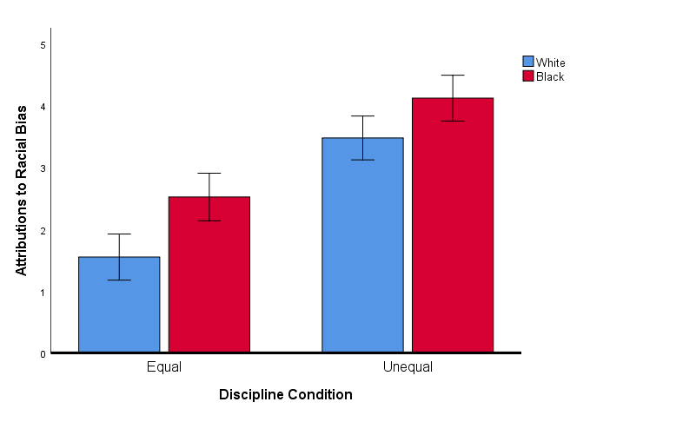
Mean attributions of discipline to racial bias, as a function of race and condition. Error bars represent 95% confidence intervals.
Figure 2
Defiance in Response to Discipline
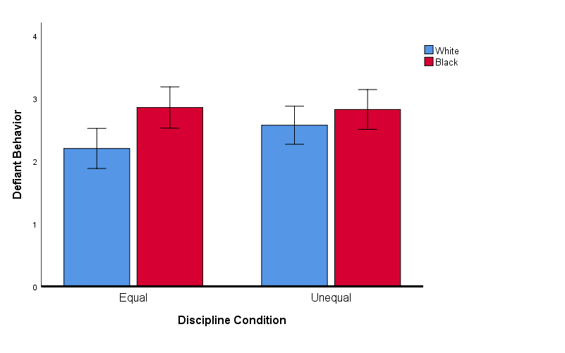
Participants' mean likelihoods of engaging in blatant defiance in response to discipline from teachers, as a function of discipline condition. Error bars represent 95% confidence intervals.

Figure 3
Effect of Participant Race on Defiant Behavior, Mediated by Attributions to Race Bias

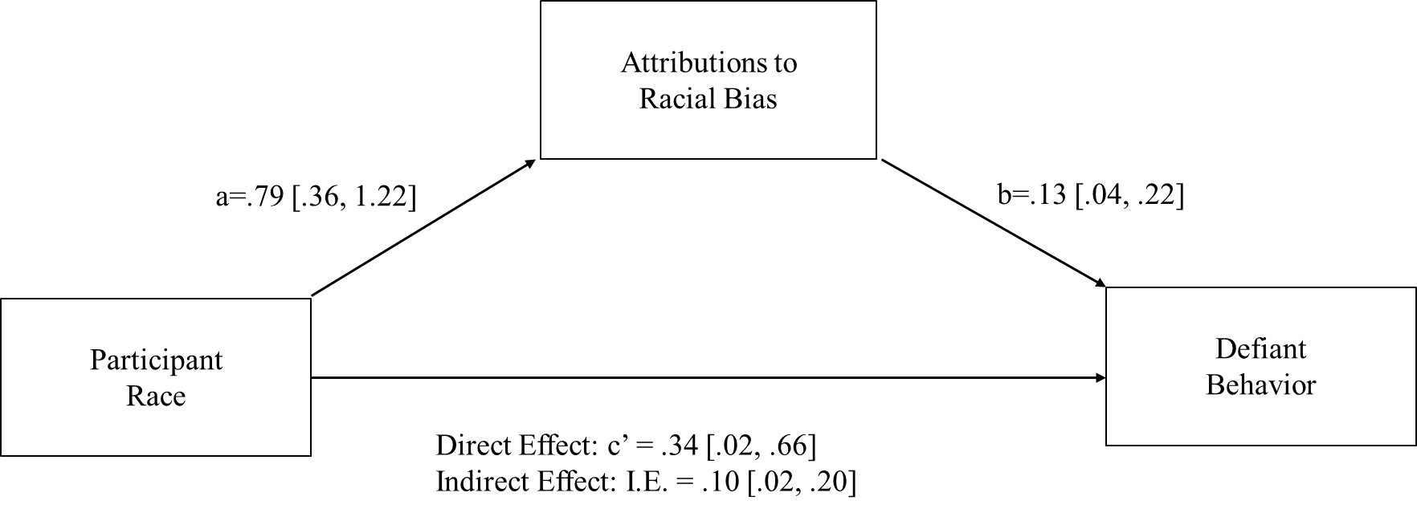

Mediational model illustrating the indirect effect of Participant Race on Defiant Behavior through Attributions to Race Bias. Note: Participant race was dummy coded with White participants as the reference group.

Table 1
Factor loading for Reputation Threat and Reputation Affirmation
 | Factors
Item | Reputation Affirmation | Reputation Threat
Happy | .878 | -.398
Supported | .862 | -.398
Respected | .855 | -.456
Honored | .846 | -.397
Proud | .811 | -.375
Excited | .761
Powerful | .643
More like a man | .553
Humiliated | -.388 | .869
Embarrassed | -.345 | .854
Ashamed |  | .846
Less like a man |  | .744
Sad | -.356 | .718
Victimized | -.430 | .696
Threatened |  | .696
Disrespected | -.642 | .668
Dishonored | -.518 | .639
Angry | -.593 | .621
Factor loadings shown from a principal component analysis using an orthogonal rotation.

Table 2
Factor loadings for Defiant Behavior and Classroom Engagement
 | Factors
Item | Defiant Behavior | Classroom Engagement
Verbally aggressive | .852
Curse at teacher | .821
Distract other students | .769
Argue with the teacher | .636 | -.328
Become physically aggressive | .717
Sleep during class | .690
Skip class | .611 | -.350
Participate in class discussion |  | .829
Seek help from teacher |  | .821
Pay attention to teacher |  | .813
Take notes during lecture |  | .670
Complete homework |  | .600
Factor loadings shown from a principle component analysis using an orthogonal rotation.

Table 3
Descriptive Statistics and Bivariate Correlations for Study 2 Constructs
 | Fair | Unfair | Correlations
Construct | M(SE) | M(SE) | 1 | 2 | 3
1. Reputation Threat | 5.84(1.52) | 56.73(1.50)
2. Reputation Affirmation | 65.03(1.34) | 8.08(1.32) | -.75**
3. Defiant Behavior | 33.10(1.36) | 40.00(1.30) | .52** | -.31**
4. Classroom Engagement | 75.12(1.86) | 34.61(1.84) | -.61** | .74** | -.43**
** Correlation significant at .01 level (2-tailed)
* Correlation significant at .05 level (2-tailed)

Figure 4
Attributions of Teacher Treatment to Racial Bias
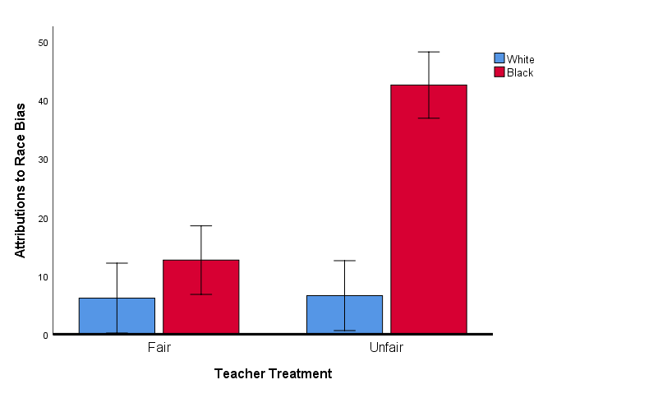
Mean attributions of teacher treatment to racial bias as a function of treatment condition and participant race. Error bars represent 95% confidence intervals.

Figure 5
Effect of Teacher Treatment on Reputation Threat
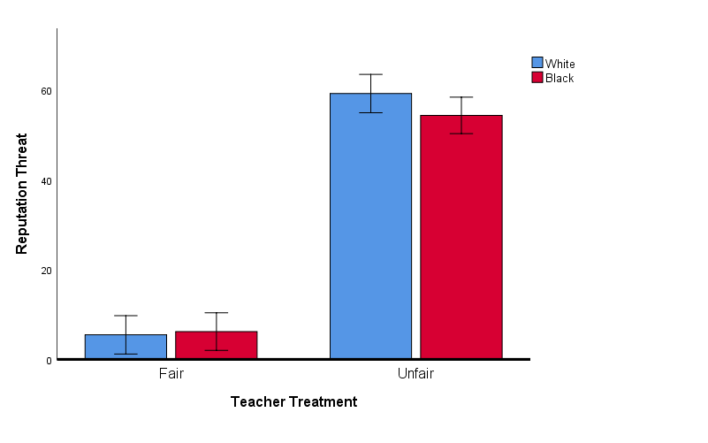
Mean feelings of reputation threat as a function of teacher treatment and participant race. Error bars represent 95% confidence intervals

Figure 6
Effect of Teacher Treatment on Reputation Affirmation
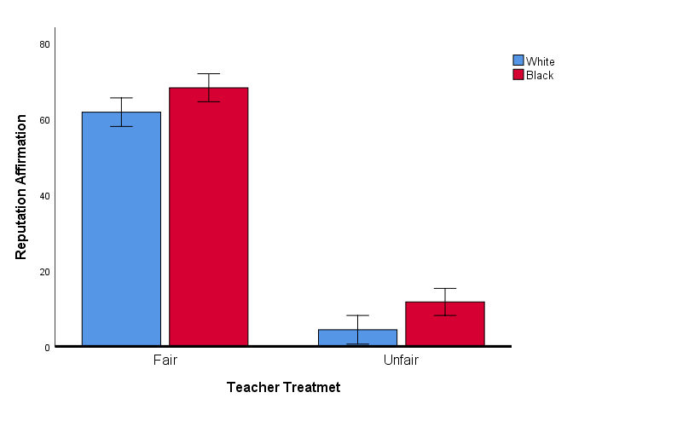
Mean feelings of reputation affirmation as a function of teacher treatment and participant race. Error bars represent 95% confidence intervals

Figure 7
Effect of Teacher Treatment on Defiant Behavior
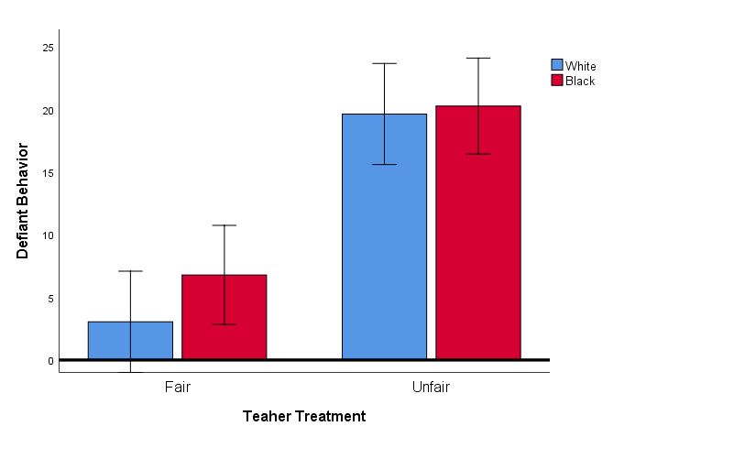
Mean defiant behavior scores as a function of Teacher treatment and participant race. Error Bars represent 95% confidence intervals.

Figure 8
Effect of Teacher Treatment on Classroom Engagement
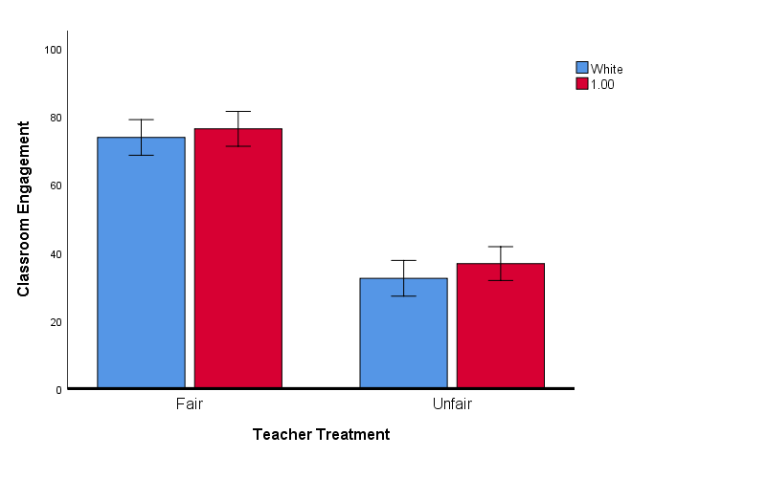
Mean classroom engagement scores as a function of Teacher treatment and participant race. Error Bars represent 95% confidence intervals.

Figure 9

Model 1
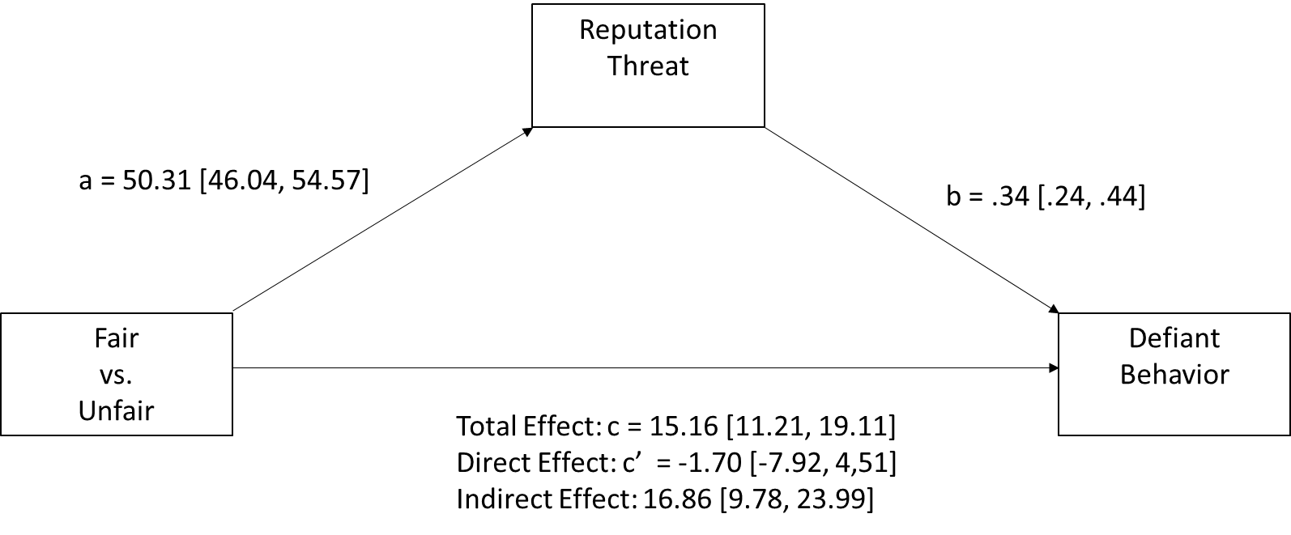
Model 1 illustrates a mediational process were unfair (compared to fair) treatment predicts increases in reputation threat, in turn predicting increases in defiant behavior.

Figure 10
Model 2
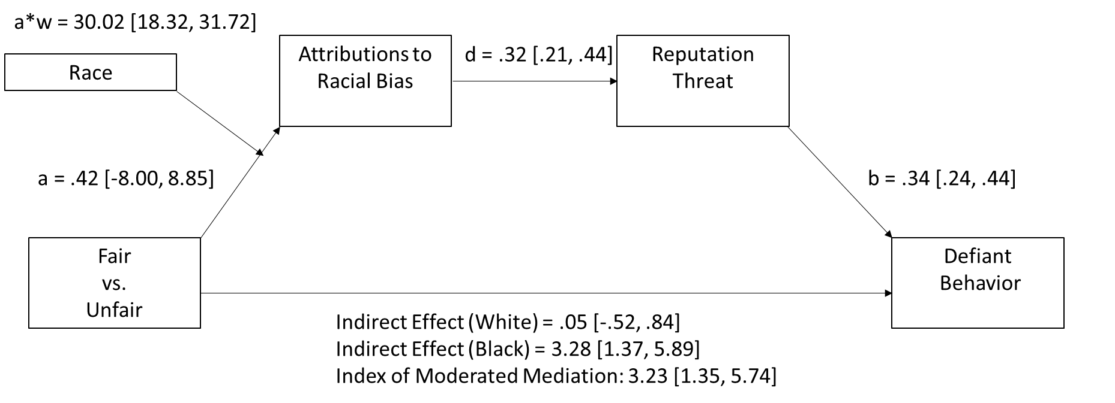
Model 2 illustrates a mediational process were unfair treatment (compared to fair treatment) predicts greater attributions to racial bias for Black but not White participants, which in turn predicts greater reputation threat and subsequent defiant behavior. Note: Participant race was dummy coded with White participants as the reference group.

Figure 11
Model 3
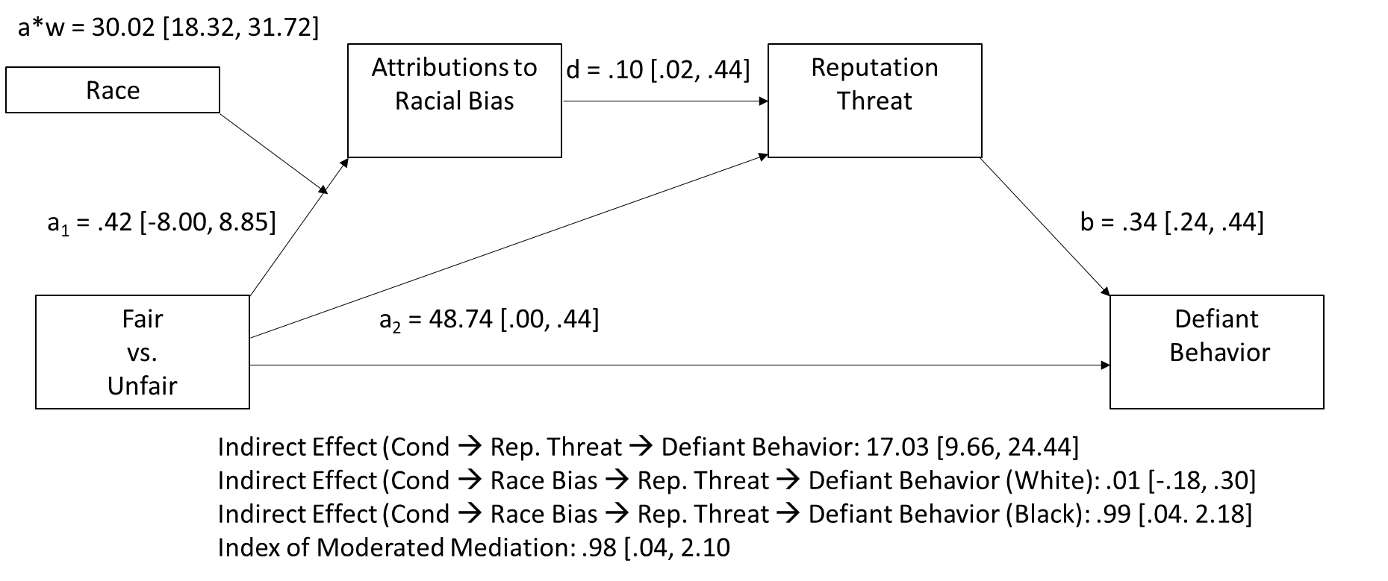
Model 3 illustrates the same mediational process illustrated Model 2 (unfair treatment leads to greater attributions to racial bias, in turn predicting reputation threat and subsequent defiant behavior for Black, but not White, participants), while controlling for the simple mediational process illustrated in Model 1 (unfair treatment leading to greater defiant behavior through reputation threat). Note: Participant race was dummy coded with White participants as the reference group.

Figure 12
Model 4
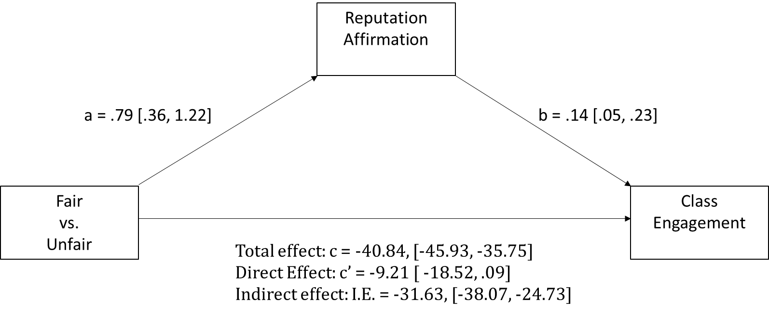
Model 4 illustrates a simple mediational model where fair (compared to unfair) treatment from teachers predicts greater class engagement through reputation affirmation.

Table 4

Frequency of Themes in Participant Narratives Describing Fair Teacher Treatment
Theme | Frequency | Proportion
Academic | 81 | 55.1%
Supportive | 36 | 24.5%
Understanding | 34 | 23.1%
Encouraging | 33 | 22.5%
Equality | 29 | 19.7%
Respect | 25 | 17.0%
Discipline | 11 | 7.5%
Note. Frequency refers the number of narratives about fair treatment from teachers that were coded as having a specific theme present. Proportion refers to the number of narratives that were coded as having a specific theme present out of the total number of narratives about fair treatment from teachers.

Table 5
Frequency of Themes in Participant Narratives Describing Unfair Teacher Treatment
Theme | Frequency | Proportion
Public | 85 | 56%
Inequality | 77 | 50.3%
Disrespect | 71 | 46.4%
Academic | 59 | 38.6%
Discipline | 55 | 36.0%
Falsely Accused | 47 | 30.7%
Note. Frequency refers the number of narratives about unfair treatment from teachers that were coded as having a specific theme present. Proportion refers to the number of narratives that were coded as having a specific theme present out of the total number of narratives about unfair treatment from teachers.

Table 6
Frequency of Themes in Attributions of Unfair Treatment to Racial Bias Among Black Participants
Theme | Frequency | Proportion
Racial Minority | 14 | 35.0%
Racial Inequality | 11 | 27.5%
Teacher Racist | 9 | 22.5%
Institutional Racism | 7 | 17.5%
Note. Frequency refers the number of narratives that attributed unfair treatment from teachers to racial bias that were coded as having a specific theme present. Proportion refers to the number of narratives that were coded as having a specific theme present out of the total number of narratives about unfair treatment from teachers that were attributed to racial bias.

Table 7
Factor loadings for Reputation Threat/Affirmation and Negative Emotions
 | Factors
Item | Threat/Affirmation | Negative Emotions
Disrespected/Respected | .906 | -.286
Dishonored/Honored | .895 | -.280
More/less like a man | .779 | -.200
Embarrassed | -.354 | .828
Ashamed | -.189 | .886
Angry | -.631 | .503
Sad | -.278 | .800
Factor loadings shown from a principal component analysis using an orthogonal rotation.

Table 8
Factor loadings for Defiant Behavior and Classroom Engagement
 | Factors
Item | Defiant Behavior | Classroom Engagement
Behave the same as always | .031 | .653
Behave respectfully | -.200 | .782
Be on best behavior | -.033 | .884
Act friendly towards teacher | .055 | .875
Try and avoid trouble | -.137 | .604
Try to get a good grade | -.088 | .743
Ignore the teacher | .653 | -.012
Lose interest in course material | .606 | -.240
Curse at the teacher | .869 | .130
Behave disrespectfully | .789 | -.157
Act coldly towards teacher | .573 | -.323
Cause trouble for the teacher | .887 | .079
Skip Class | .790 | -.038
Stop trying in class | .744 | -.167
Factor loadings shown from a principal component analysis using an oblique rotation.

Table 9
Descriptive Statistics and Bivariate Correlations for Study 3 Constructs
 | Fair | Unfair | Correlations
Construct | M (SE) | M (SE) | 1 | 2 | 3
1. Reputation  (Threat/Affirmation) | .88 (.16) | -2.66 (.16)
2. Negative Emotion | 2.68 (.18) | 6.32 (.19) | -.57**
3. Defiant Behavior | 1.32 (.17) | 4.52 (.17) | -.41** | .42**
4. Classroom Engagement | 6.78 (.19) | 4.35 (.20) | .47** | -.13* | -.61**
** Correlation significant at .01 level (2-tailed)
* Correlation significant at .05 level (2-tailed)

Figure 13
Effect of Fair and Unfair Discipline on Perceived Fairness
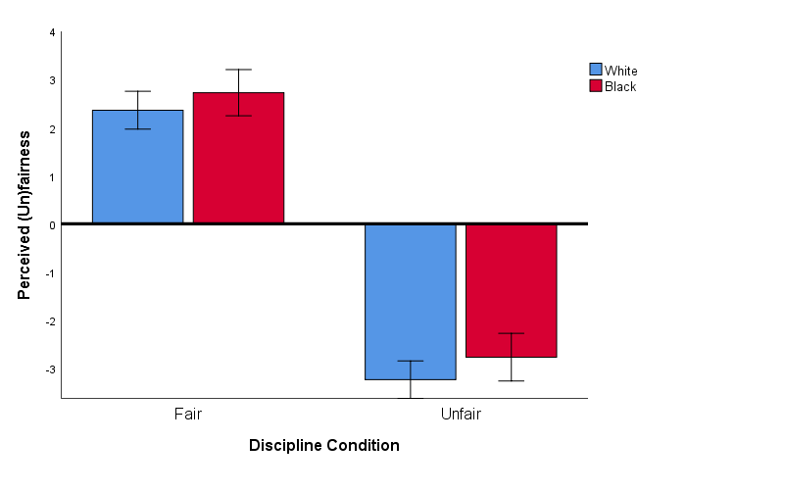
Mean scores of perceived fairness and unfairness as a function of discipline condition and participant race. Scale from -5 (very unfair) to 5 (very fair) with midpoint 0 (neither fair or unfair).

Figure 14
Effect of Fair and Unfair Discipline on Race Bias Attributions
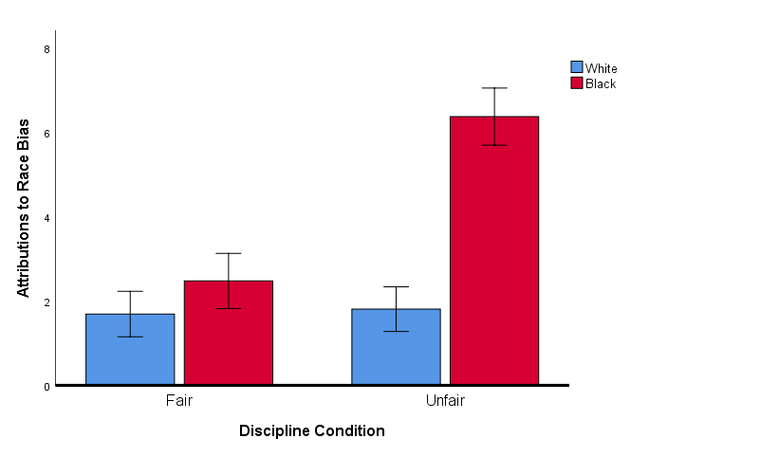
Mean attributions of discipline to racial bias, as a function of discipline condition and participant race.
Table 10
Effect of Fair and Unfair Discipline on Participant Attributions
 | Fair | Unfair |  |  | Race |  | Cond. |  | Race x Cond
 | M(SD) | M(SD) | Df_{Between} | Df_{Within} | F | p | F | p | F | p
Intelligence | 4.41(.23) | 2.49(.24) | 1 | 341 | 1.52 | .218 | 33.60 | <.001 | .52 | .470
Academic Record | 5.06(.24) | 3.07(.25) | 1 | 340 | .01 | .92 | 34.26 | <.001 | .413 | .521
Disciplinary Record | 5.54(.27) | 3.88(.27) | 1 | 342 | .00 | .99 | 19.08 | <.001 | .00 | .99
Gender | 2.56(.25) | 4.20(.25) | 1 | 341 | 2.06 | .153 | 21.92 | <.001 | .002 | .966
Good Reputation | 5.61(.24) | 2.08(.25) | 1 | 336 | 1.18 | .279 | 104.92 | <.001 | .686 | .408
Bad Reputation | 2.16(.25) | 4.36(.25) | 1 | 338 | .52 | .471 | 39.09 | <.001 | 3.78 | .053

Table 11
Regression Coefficients: Alternative Attributions that Predict Defiant Behavior
Variables | β | P
Control
Condition (0 = Fair, 1 = Unfair) | .53 | <.001
Race (0 = White, 1 = Black) | -.04 | .49
Condition x Race | .11 | .11
Attributions
Race Bias | .13 | .03
Intelligence | .00 | .99
Academic Record | -.02 | .77
Disciplinary Record | .04 | .55
Gender | .01 | .89
Good Reputation | -.09 | .15
Bad Reputation | .29 | <.001

Figure 15
Model 1
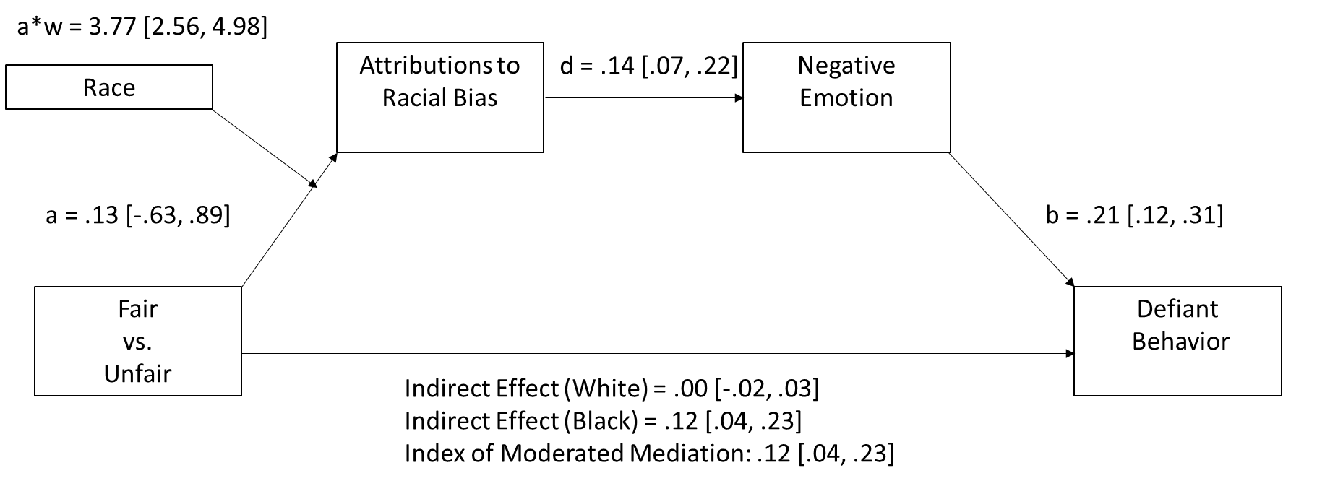
Figure 15. Sequential mediation model illustrating the indirect effect of discipline condition on defiant behavior through attributions to racial bias (M₁) and negative emotions (M₂). Note: Participant race was dummy coded with White participants as the reference group.

Figure 16
Model 2
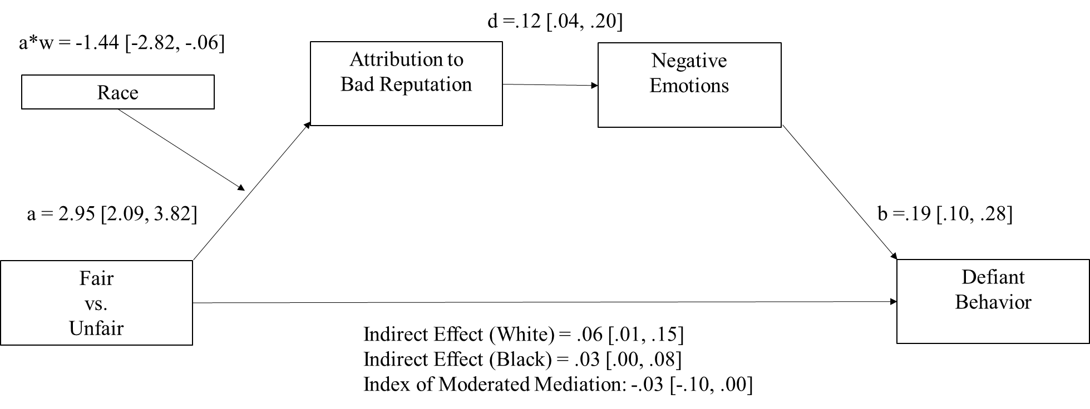
Figure 16. Sequential mediation model illustrating the indirect effect of discipline condition on defiant behavior through attributions to bad reputation (M₁) and negative emotions (M₂). Note: Participant race was dummy coded with White participants as the reference group.

Figure 17
Model 3
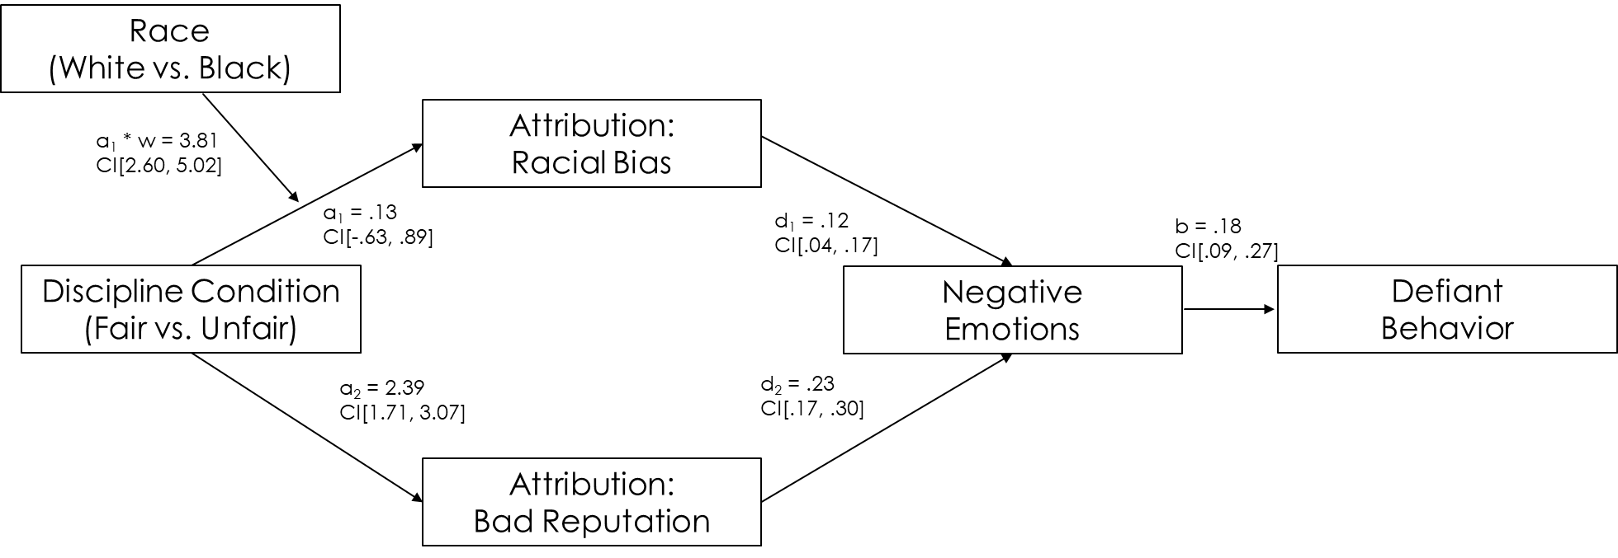
Figure 17. Sequential parallel mediation illustrating two indirect effects (1) through attributions to racial bias, (2) through attributions to bad reputation. Indirect effect 1 was significantly moderated by Race via the a₁ path. Indirect effect 2 was not significantly moderated by Race. Note: Participant race was dummy coded with White participants as the reference group.

Figure 18
Model 4
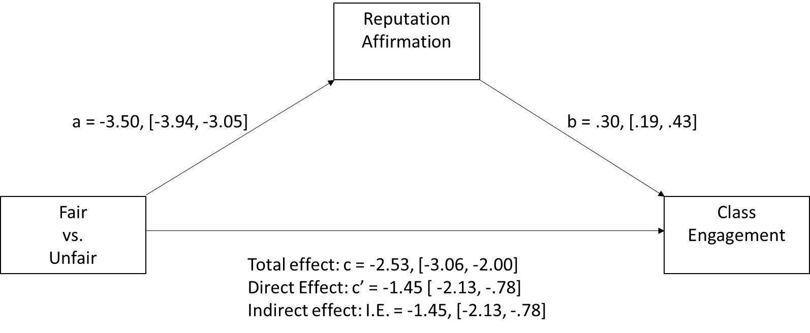
Figure 17. Simple mediational model illustrating the effect of discipline condition on classroom engagement through reputation affirmation.

APPENDIX A
STUDY 1 MANIPULATION MATERIALS AND BEHAVIORAL MEASURES
Unequal discipline manipulation (Vignette task 1)
Vignette 1 - You and your classmate, Devonte (Jake), are talking in class while your teacher, Mrs. Smith, is giving a lesson. The teacher tells the two of you to stop talking in class. You comply for a short while, but then the two of you start the conversation back up again. The teacher notices and gives you detention, however, Devonte (Jake) does not get in trouble.
Vignette 2 – You are sitting in class while the teacher, Mrs. Smith, is lecturing. You notice your classmate, Devonte (Jake), on his phone, even though your school has a strict no phone policy. Class has been in session for about 10 minutes when the teacher notices Jake on his phone. The teacher tells Devonte (Jake) to put the phone away. Devonte (Jake) puts his phone in his pocket, but you notice that he is still texting on it whenever the teacher isn't looking. Later, towards the end of class, you feel your phone vibrate in your pocket. You quickly look at the text and see it's from your friend. You decide to respond to the text, but the teacher sees you texting. The teacher confiscates your phone and gives you detention.
Equal discipline manipulation (Vignette task 1)
Vignette 1 - You and your classmate, Devonte (Jake), are talking in class while your teacher, Mrs. Smith, is giving a lesson. The teacher tells the two of you to stop talking in class. You comply for a short while, but then the two of you start the conversation back up again. The teacher notices and gives the both of you detention.
Vignette 2 - You are sitting in class while the teacher, Mrs. Smith, is lecturing. You notice your classmate, Devonte (Jake), on his phone, even though your school has a strict no phone policy. Class has been in session for about 10 minutes when the teacher notices Jake on his phone. The teacher confiscates Jake’s phone and gives him detention. Later, towards the end of class, you feel your phone vibrate in your pocket. You quickly look at the text and see it’s from your friend. You decide to respond to the text, but the teacher sees you texting. The teacher confiscates your phone and gives you detention.

Masculinity Threat Word search Task
Instructions: Find and circle as many words as you can in the time allotted, even if the words you find are slang.

D | F | R | E | J | E | C | A | G | Q | R | W | A | Z | Q
B | F | A | I | R | Y | W | S | U | R | Y | S | F | G | L
U | U | D | F | X | G | T | R | E | E | J | K | D | H | K
P | A | N | S | Y | Q | R | D | F | W | C | N | Q | I | P
M | K | E | S | T | P | O | F | L | H | M | P | V | I | U
P | F | B | I | R | D | U | I | O | O | L | P | I | O | W
E | R | T | S | D | C | F | V | W | U | S | S | K | O | Q
C | E | S | S | A | E | C | U | E | S | P | Y | N | J | E
D | X | A | Y | I | N | D | O | R | E | M | T | B | P | E
A | I | U | C | R | B | C | Q | B | V | E | R | F | B | E
O | S | D | E | S | M | H | R | U | T | D | F | T | V | S
W | E | R | J | U | E | A | E | L | G | I | R | L | Y | A
I | P | W | E | A | K | L | I | N | G | R | A | R | C | T
Y | I | L | A | G | S | K | K | G | S | T | L | W | E | K
W | T | U | R | Y | K | W | C | E | W | C | A | Y | U | G

APPENDIX B
STUDY 2 MANIPULATION MATERIALS AND BEHAVIORAL MEASURES
Classroom Demographics Manipulation Picture
Instructions: In a moment you will read a short scenario describing a situation that might arise in a typical high school class. To help you imagine the classroom where the scenario takes place, take a look at the picture below. Imagine you are a student in this classroom, and that the picture is taken from your point of view. Observe your classmates, the teacher, and the different objects in the classroom.
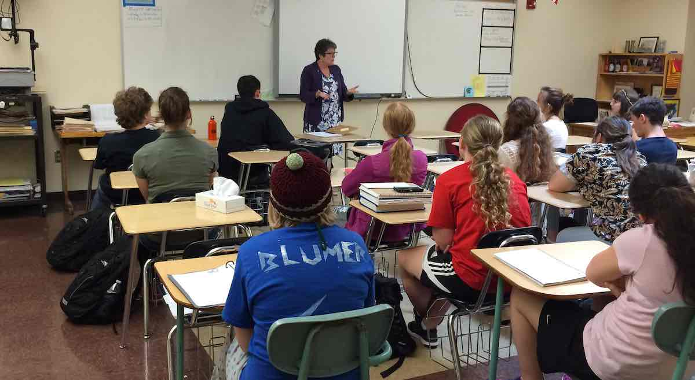
From the perspective of the picture, where in this classroom are you seated?
_Front
_Back
Are the students in this classroom mostly male or female?
_Female
_Male
Is the teacher male or female?
_Male
_Female
Classroom Scenario – Fair
You are in class taking a big exam that is worth a large portion of your final grade. The teacher, Mrs. Smith, informs the class that she will not tolerate any cheating during the exam and that talking is strictly prohibited. During the exam, Mrs. Smith walks around the classroom to make sure no one is talking or cheating. She seems to be watching everyone and makes a point to walk by everyone's desk and look over their shoulder.
Towards the end of the exam, a classmate asks you if they can borrow your eraser. You reach over to hand them your eraser. After the exam, when everyone is packing up their backpacks and getting ready to leave the classroom, Mrs. Smith comes over and asks to speak to you and your classmate in private.
When all the other students have left the room, Mrs. Smith tells you and your classmate that she heard the two of you whispering to one another during the exam, and that she saw you pass something to your classmate. Mrs. Smith asks you both whether you were passing notes about the exam.
You both try your best to explain the situation: that your classmate was asking to borrow an eraser, and that you had handed your eraser to them.
Mrs. Smith gives you both the benefit of the doubt, but tells the two of you that in the future, should any issues arise during an exam you both should raise your hands and inform her of the situation. She also says that if something like this happens again, she will not be so lenient.
Classroom Scenario – Unfair
You are in class taking a big exam that is worth a large portion of your final grade. The teacher, Mrs. Smith, informs the class that she will not tolerate any cheating during the exam and that any form of talking is strictly prohibited. During the exam, Mrs. Smith walks around the classroom to make sure no one is talking or cheating. You notice that she is spending a lot of time looking in your direction. She also seems to walk by your desk and look over your shoulder multiple times throughout the exam.
Towards the end of the exam, a classmate asks you if they can borrow your eraser. You oblige and reach over to hand them your eraser. As soon as you do, Mrs. Smith yells at you from across the room in front of the entire class and accuses you of cheating, saying that she heard you whispering to your classmate and saw you hand something to them.
You try your best to explain the situation: that your classmate was asking to borrow an eraser, and that you had handed your eraser to them.
Mrs. Smith won't listen. In front of the entire class, she tells you that you will receive a 0 on the exam, and that she will be referring you to the Principal for further disciplinary action.

BIBLIOGRAPHY

Adler, P. A., Kless, S. J., & Adler, P. (1992). Socialization to gender roles: Popularity
among elementary school boys and girls. Sociology of education, 169-187.

Allen, Q. (2013). Balancing school and cool: tactics of resistance and accommodation
among black middle-class males. Race Ethnicity and Education, 16(2), 203-224.

Anderson, C. A., & Bushman, B. J. (2002). The effects of media violence on
society. Science, 295(5564), 2377-2379.

Anyon, Y., Zhang, D., & Hazel, C. (2016). Race, exclusionary discipline, and
connectedness to adults in secondary schools. American Journal of Community Psychology, 57(3-4), 342-352.

Averill, J. R. (1983). Studies on anger and aggression: implications for theories of
emotion. American psychologist, 38(11), 1145.

Bosson, J. K., & Vandello, J. A. (2011). Precarious manhood and its links to action and
aggression. Current Directions in Psychological Science, 20(2), 82-86.

Bradshaw, C. P., Mitchell, M. M., O'Brennan, L. M., & Leaf, P. J. (2010). Multilevel
exploration of factors contributing to the overrepresentation of black students in office disciplinary referrals. Journal of Educational Psychology, 102(2), 508.

Christerson, B., Edwards, K. L., & Flory, R. W. (2010). Growing up in America: The
power of race in the lives of teens. Stanford University Press.

Cohen, D., & Nisbett, R. E. (1994). Self-protection and the culture of honor: Explaining
southern violence. Personality and Social Psychology Bulletin, 20(5), 551-567.

Cohen, D., Nisbett, R. E., Bowdle, B. F., & Schwarz, N. (1996). Insult, aggression, and
the southern culture of honor: An" experimental ethnography.". Journal of personality and social psychology, 70(5), 945.

Copeland-Linder, N., Lambert, S. F., Chen, Y. F., & Ialongo, N. S. (2011). Contextual
stress and health risk behaviors among African American adolescents. Journal of youth and adolescence, 40(2), 158-173.

DeWall, C. N., Bushman, B. J., Giancola, P. R., & Webster, G. D. (2010). The big, the
bad, and the boozed-up: Weight moderates the effect of alcohol on aggression. Journal of Experimental Social Psychology, 46(4), 619-623.

Felson, R. J. (1993). Review essay: Shame, anger, and aggression.

Fisher, C. B., Wallace, S. A., & Fenton, R. E. (2000). Discrimination distress during
adolescence. Journal of youth and adolescence, 29(6), 679-695.

Gaertner, S., & McLaughlin, J. (1983). Racial Stereotypes: Associations and Ascriptions
of Positive and Negative Characteristics. Social Psychology Quarterly, 46(1), 23-30.

Gilliam, W. S., Maupin, A. N., Reyes, C. R., Accavitti, M., & Shic, F. (2016). Do early
educators’ implicit biases regarding sex and race relate to behavior expectations and recommendations of preschool expulsions and suspensions. Research Study Brief. Yale University, Yale Child Study Center, New Haven, CT.

Goff, P. A., Di Leone, B. A. L., & Kahn, K. B. (2012). Racism leads to pushups: How
racial discrimination threatens subordinate men's masculinity. Journal of Experimental Social Psychology, 48(5), 1111-1116.

Goff, P. A., Jackson, M. C., Leone, D., Lewis, B. A., Culotta, C. M., & DiTomasso, N.
A. (2014). The essence of innocence: Consequences of dehumanizing Black children. Journal of personality and social psychology, 106(4), 526.

Government Accountability Office (2018). Discipline Disparities for Black Students,
Boys, and Students with Disabilities

Greene, R. W., Ablon, J. S., & Goring, J. C. (2003). A transactional model of
oppositional behavior: Underpinnings of the Collaborative Problem Solving approach. Journal of Psychosomatic Research, 55(1), 67-75.

Greene, R. W. (2011). Collaborative problem solving can transform school
discipline. Phi Delta Kappan, 93(2), 25-29.

Gregory, A., & Weinstein, R. S. (2008). The discipline gap and African Americans:
Defiance or cooperation in the high school classroom. Journal of School Psychology, 46(4), 455-475.

Hayes, Andrew F.(2013). Introduction to Mediation, Moderation, and Conditional
Process Analysis: A Regression‐Based Approach. New York, NY: The Guilford
Press. Journal of Educational Measurement, 51(3), 335-337.

Losen, D. J., & Martinez, T. E. (2013). Out of school and off track: The overuse of
suspensions in American middle and high schools.

Losen, D. J., Hodson, C. L., Keith, I. I., Michael, A., Morrison, K., & Belway, S. (2015).
Are we closing the school discipline gap?

Martin, M. J., McCarthy, B., Conger, R. D., Gibbons, F. X., Simons, R. L., Cutrona, C.
E., & Brody, G. H. (2011). The enduring significance of racism: Discrimination and delinquency among Black American youth. Journal of Research on Adolescence, 21(3), 662-676.
McCarthy, J. D., & Hoge, D. R. (1987). The social construction of school punishment:
Racial disadvantage out of universalistic process. Social Forces, 65(4), 1101-1120.

McKown, C., & Weinstein, R. S. (2003). The development and consequences of
stereotype consciousness in middle childhood. Child development, 74(2), 498-515.

Mendoza-Denton, R., Downey, G., Purdie, V. J., Davis, A., & Pietrzak, J. (2002).
Sensitivity to status-based rejection: implications for African American students' college experience. Journal of personality and social psychology, 83(4), 896.

Nisbett, R. E. (1993). Violence and US regional culture. American psychologist, 48(4),
441.

O'Dea, C. J., Chalman, S. T., Bueno, A. M. C., & Saucier, D. A. (2018). Conditional
aggression: Perceptions of male violence in response to threat and provocation. Personality and Individual Differences, 131, 132-141.

Okonofua, J. A., & Eberhardt, J. L. (2015). Two strikes: Race and the disciplining of
young students. Psychological science, 26(5), 617-624.

Okonofua, J. A., Walton, G. M., & Eberhardt, J. L. (2016). A vicious cycle: A social–
psychological account of extreme racial disparities in school discipline. Perspectives on psychological science, 11(3), 381-398.
discipline. Sociology of Education, 88(3), 181-201.

Mukasey, M. B., Sedgwick, J. L., & Flores, J. R. Office of Juvenile Justice and
Delinquency Prevention.

Saucier, D. A., Stanford, A. J., Miller, S. S., Martens, A. L., Miller, A. K., Jones, T. L., ...
& Burns, M. D. (2016). Masculine honor beliefs: Measurement and correlates. Personality and Individual Differences, 94, 7-15.

Schaubman, A., Stetson, E., & Plog, A. (2011). Reducing teacher stress by implementing
collaborative problem solving in a school setting. School Social Work
Journal, 35(2), 72-93.

Sellers, R. M., Copeland‐Linder, N., Martin, P. P., & Lewis, R. L. H. (2006). Racial
identity matters: The relationship between racial discrimination and psychological functioning in African American adolescents. Journal of research on Adolescence, 16(2), 187-216.

Simons, R. L., Chen, Y. F., Stewart, E. A., & Brody, G. H. (2003). Incidents of
discrimination and risk for delinquency: A longitudinal test of strain theory with an African American sample. Justice Quarterly, 20(4), 827-854.

Snyder, H. N., & Sickmund, M. (2006). Juvenile offenders and victims: 2006 national
report. Office of juvenile justice and delinquency prevention.

Skiba, R. J., Michael, R. S., Nardo, A. C., & Peterson, R. L. (2002). The color of
discipline: Sources of racial and gender disproportionality in school punishment. The urban review, 34(4), 317-342.

Tangney, J. P. (1990). Assessing individual differences in proneness to shame and guilt:
Development of the Self-Conscious Affect and Attribution Inventory. Journal of personality and social psychology, 59(1), 102.

Tangney, J. P., Wagner, P., Fletcher, C., & Gramzow, R. (1992). Shamed into anger? The
relation of shame and guilt to anger and self-reported aggression. Journal of personality and social psychology, 62(4), 669.

Vandello, J. A., Bosson, J. K., Cohen, D., Burnaford, R. M., & Weaver, J. R. (2008).
Precarious manhood. Journal of personality and social psychology, 95(6), 1325.

Yeager, D. S., Purdie-Vaughns, V., Garcia, J., Apfel, N., Brzustoski, P., Master, A., ... &
Cohen, G. L. (2014). Breaking the cycle of mistrust: Wise interventions to provide critical feedback across the racial divide. Journal of Experimental Psychology: General, 143(2), 804.

Yeager, D. S., Purdie-Vaughns, V., Hooper, S. Y., & Cohen, G. L. (2017). Race Gaps in
School Trust: Where They Come from and How to Resolve Them. PRC Research Brief Series.

Wald, J., & Losen, D. J. (2003). Defining and redirecting a school‐to‐prison
pipeline. New directions for youth development, 2003(99), 9-15.

Wallace Jr, J. M., Goodkind, S., Wallace, C. M., & Bachman, J. G. (2008). Racial, ethnic,
and gender differences in school discipline among US high school students: 1991-2005. The Negro educational review, 59(1-2), 47.

Wicker, F. W., Payne, G. C., & Morgan, R. D. (1983). Participant descriptions of guilt
and shame. Motivation and emotion, 7(1), 25-39.

Wong, C. A., Eccles, J. S., & Sameroff, A. (2003). The influence of ethnic discrimination
and ethnic identification on African American adolescents' school and socioemotional adjustment. Journal of personality, 71(6), 1197-1232.

To ensure that participants would be able to recollect their high school experiences, I restricted participant’s age between 18 and 35.
Partially standardized effects were calculated for all significant indirect effects to help interpret the indirect effects in terms of variability in the outcome variable (i.e. standard deviations of Y), and are one type of effect size metric recommended by Hayes (2013) for mediation models. The partially standardized effect indicates changes in Y in standard deviations as a function of a one-unit change in the predictor variable (X) through mediator (M).
While not all public schools have predominantly White student bodies or a majority White teaching staff, statistics from the Condition of Education 2020 report (a congressionally mandated annual report) show that the student body in public schools across the U.S. are a majority white (61% White in 2000) and are projected to remain majority White over the course of the next decade (estimated 41% White in 2029). Black students on the other hand made up only 17% of the student body in 2000 and are projected to make up 15% of the student body in 2029. Teachers were also overwhelmingly White in the early 2000s (83% of teachers were White in 2003) with little change in these demographics over recent years (80% in 2015). For these reasons, I decided to use pictures of classrooms with an all-White student body and a White teacher to control for classroom demographics in the current study.

