Senior Tourism with sustainable marketing perspective in Mazatlan and Los Cabos, Mexico.
Abstract
Tourism is a multidimensional activity that has standed out over the last years, experimenting a constant increase and a profound diversification with important implication in the destination’s ecosystems. Combined with that, as an unprecedented demographic phenomenon, new consumers’ profiles in the tourist activity are emerging, the ageing of the world’s population has caused the emergence of recent markets as the senior tourism.
The tourist activity in the senior context is associated with the exploration of new ways to improve this collective’s quality of life and to help senior citizens in the ageing process. Marketing, for its part, seeks the consumer’s satisfaction contributing on their well being and affects on the persuasion to influence on their behavior (demand) and the decision making related with the target (supply).
In this proposal, the tourism activity has its own meeting point with sustainability, in an effort to face the complexity that the environment care mainly poses, in contrast tourism that is evidenced as a predator facing this monumental challenge. Nevertheless, marketing, up to this moment, has shown a passive attitude and reactive facing the sustainable development, fostering the creation and commercialization of products and services such as alternate ways that satisfy not only to certain consumers that sympathize with this line. However the challenge is enormous and demands a structural check of the axes that have driven it traditionally.
This work objective is to analyze a possible correlation between the sustainable tourist offer and the tourism in regards of the segment of senior citizens between 55 and 74 years in two study cases: Mazatlan and Los Cabos in Mexico, from the theoretical perspective of Gunn Model (Gunn & Var, 2002), the Tourism Area Life Cycle Theory (Butler, 1980) and the Generational Theory (Strauss & Howe, 1997), linking the methodology of Indicators of Sustainable Development for Tourism Destinations (World Tourism Organization [UNWTO], 2005).
Introduction
United Nations projections on population point out that the ageing of the world’s population is the most profound change in history (United Nations [UN, 2010). It is projected that the senior citizen segment will continue growing until 2080, with a maximum of 241 million individuals (UN, 2015). The growing participation from senior citizens in the tourism activity, combined with the demographic event, have led the governments and activity suppliers to identify the senior market as imperative.
In this sense, international tourism grew 5% in 2018 reaching the number of 1.4 billion tourists, with a prediction of 4.4% in increase of international arrivals annual rate in developing countries, double the rate of developed countries (UNWTO, 2019). Nonetheless, this demand´s constant development thoroughly challenges the ecosystems in the destinations, such as CO2 gas emissions that are referred to international tourism transport, forecasted with an increase of 103% for the term of 2005 to 2030 (UNWTO & International Transport Forum, 2019), and the contribution of tourism estimated in 8% over the greenhouse effect gas emissions in the world, which influences in a crucial way on the global warming (Lenzen et al., 2018). Therefore, several authors conjecture the lack of frameworks of reference in marketing that promote and motivate the transformation of the different types of tourism toward sustainability (Chin, Chin & Wong, 2018, Danilova-Volkovskaya, Koval, Babchenko & Volkovskiy, 2018, Font & McCabe, 2017; Maugeri, Gullo, Romano, Spedalieri & Licciardello, 2017).
On this matter, Mexico’s position within the tourism world ranking points out its location as number 7 in the most visited countries category in 2018, while, in the rubric of revenue capture, took up number 16 place in the same year with 22.5 US billion dollars (Mexico’s Tourism Secretariat [SECTUR, 2019, pp. 6-7). In this way, the pre-eminence of a type of visitors whose expense positions Mexico in an unequal situation of tourists acquisition is profiled, which is desirable to revert. This first stroke of the problem, leads to the reflection about the sustainability of tourism, since these figures reflect a massification of the activity.
Presumably, sustainable tourism in Mexico is a pending task, which translates into a challenge for Management disciplines in general, and more specifically marketing. In a way that, tourism marketing used for the creation and satisfaction of needs and commercialization of the destinations that drive the economy of a country, has built a death and no life model, penetrating in the massive consumption of tourist products as revenue generators and sources of employment, without seeking a balance in sustainability, life promoter, natural resources conservation and a flagrant stimulus of the human species’ continuity.
In this context, in terms of tourist destinations, two types under the concept of sun and beach in Mexico prevail, the traditional ones, such as Mazatlan in Sinaloa, and the Integrally Planned Centers (IPC), which is the case of Los Cabos in Baja California Sur (Brito and Cànoves, 2019). The research focuses on these two destinations as case studies, which dictates the Tourism Area Life Cycle Theory, that classifies in rejuvenation and consolidation, respectively (Butler, 1980). Mazatlan and Los Cabos show a positive inclination in the attendance of foreign visitors in the last decade (from 2009 to 2019) for both destinations, which averages a +9% in Los Cabos and a +17% in Mazatlan, being the United States and Canada their main origin markets (SECTUR, 2020).
In such way, this work leads to outline about the main elements that tourist marketing may hold in terms of sustainability as a competitive advantage of a destination that takes care of International senior segment, set out from the perspective of two sun and beach tourist destinations study cases in the northern of Mexico.
Crisis because of Covid-19
Mexico, as a country, is facing an economic setback derived from the importance that tourist activity has in economic terms, since it is estimated that tourism will drop between 50%and 80% which will negatively impact the national PIB (Gross Domestic Product) causing a decrease from 3.5% to 5% (Deutsche Welle, 2020).
Due to all of the above, there is room to add that the field research will completely reflect the pandemic context, in this way, it will have consequences on the supply and demand mechanisms, and the positioning of the destination units. This being so, an extraordinary event especially for the target population of this study, which are considered the most vulnerable, during this emergency.
Theoretical background and literature
Sustainable marketing from the tourism perspective
From the focus of marketing, tourism is commonly conceived as a desire and not as a need, a luxury, an aspirational consumption activity, that favors consumerism, when being considered non-essential (McCabe, 2014). In such a way that, identifying tourism as a development agent and at the same time, as a constant aggressor of the destinations’ ecological balance, allows to show the need to transform the focus of tourist marketing, which is considered responsible of contributing in a disproportionate way to a “successful” model in short term economistic terms.
The challenge facing this reality, is precisely centered on how a set of criteria that run the opposite to sustainability and has guided marketing activities for more than half a century is rebuilt. Consumption economy has created excess, waste and side effects. In this regard, it is observed that marketing in tourism not only seeks profitability, but also the social and environmental aspect that flags up the sustainable development can not be postponed.
In this scenario, the imperative for sustainable marketing could be characterized by two types of capacity: market capacity and the resource capacity or ecological burden. The first one refers to the current consumption in society, which is very high for this to make it possible for the next generation reach the same level of consumption, and the second one, emphasizes the consumption capacity that is related with the capacity of the resources from which makes use of to produce goods and services.
Along the same line, Font and McCabe (2017, p. 869), deepen around sustainable marketing and point out that “the sustainable marketing can use the skills and techniques of marketing for a good purpose, knowing about the market needs, designing more sustainable products and identifying more persuasive methods to achieve a change on behavior.”
In fact, sustainable tourist marketing is based at least on two important criteria, sustainability as the governing center on the destination offer and the rationality on the consumption from visitors, which stimulates a new modality in tourism where a harmonic relationship with the ecosystems in the destinations is privileged, the recipient communities and the economic benefits the activity sustains, promoting tourist destinations among market segments that are identified with this proposal.
Namely, Dolnicar (2006), Dolnicar and Leisch (2008) show evidence in their researches based on Kotler criteria (1997), which state that senior represent a viable segment to apply sustainable marketing techniques, consequently they are more susceptible to perform this type of behavior. In the same way, other researchers corroborate by pointing out in the studies on senior people as the most conscious in regards to the sustainable behavior; giving great weight to the appraisal of the environment as a key attribute, influencing on the products and brands election (Borden, Coles & Shaw, 2017; Li, Li & Hudson, 2013).
Indicators of Sustainable Development for Tourism Destinations
Meanwhile, UNWTO (2005) segregates the three sustainable development dimensions (environmental, sociocultural and economic) in a series of components and indices for the tourist destinations, of which they are considered relevant for these analyses which are described in the following lines: well-being of the recipient communities, exploitation of the economic benefits from tourism, valuable natural resources protection, ordinance and control of the destination place (tourism related transportation), the sustainability of the operations and tourist services, the design of products and services (marketing activities, destination’s image protection and an offer of a variety of experiences).
Tourist Area Life Cycle Theory (TALCT)
Tourist destinations that are mentioned as study cases in the present document are described according to the stage of the life cycle that are going through, therefore, offering sustainable tourist products, can determine the destination’s level of evolution, in compliance with TALCT, Such concept follows the development process of the tourist area from the field of marketing, according to which, the sales of a product behave slowly at the beginning, subsequently they experiment a rapid growth rate, they stabilize and then decrease, that is to say, the follow a basic asymptotic curve (Butler, 1980).
Gunn Tourism System Model
Within the margins of this investigation the Gunn Model is mentioned, which theoretical approximation addresses the planning of the tourist system seen from the market perspective, this is demand and supply, where the stewardship of marketing in the commercialization of the tourist destinations is argued (Gunn & Var, 2002).
The Gunn model reefers to the tourist’s experience such as the purpose of the entire tourist system and presents the relationships among the different that integrate both main elements and point out the offer is made of attractions, services, transport, information and promotion.

Tourism senior from the viewpoint of the Generational Theory.
According to Alen, Losada and De Carlos (2017, p. 1339): “Senior tourism covers the wide spectrum of activities carried out by senior, retired, non-retired, older than 55 years people, with different income levels, education, etc. In addition, this group, can be identified as baby boomers (Frye, 2015, Patterson & Pegg, 2009), which is a term given by marketing, that classifies the several generations based on their similarities to delimit individuals that, according to their years of birth, belong to one or another generational group.
Therefore, when tackling a group from the population that belongs to a range of age, evokes the idea of a generation, which derive from the generational theory that has been popularized in the United States by Strauss and Howe (1997, p.61) which define a generation as an “addition of the people born in the lapse of time in a period of life that share a common location in history, and hence, a common collective person”
Consequently, through the generational lens, the dissimilarities, that prevail among the cohorts with the hypothesis that assumes that the senior person from the same generation shows consistency in his behavioral development and trip characteristics, typical of this collective, are emphasized (Alén et al., 2017); moreover is a particularly relevant variable for the high level tourist investigation (Chen & Shoemaker, 2014, Jang & Ham, 2009, You & O’Leary, 1999).
For the purposes of the investigation a proposed theoretical representation is referred to (annexed 1), in which it is determined the sustainable tourist offer as the independent variable and it is planned to build, as shown in the annexed 2, through the components and factors already mentioned from Gunn Model that coincide with the proposed indices by UNWTO (2005). In addition, the dependent variable which is the senior tourist demand is confirmed, with which the generational theory would be applied. Equally, it is estimated to analyze the structural differences of the sustainable tourist offer in the destination according to the according to the stage of the life cycle that is going through as a tourist product.
Position of sustainable tourism in the senior segment facing COVID-19.
The COVID-19 pandemic poses complex challenges, by considering the mechanisms that historically have defined the success of tourism through the growth in the number of visitors and income reception, since it is stated that: “tourism exacerbate the risk of outbreaks from pathogens derived from the climate change, and therefore, a factor that increases the risk of pandemics as much as directly or indirectly” (Gossling, Scott & Hall, 2020, p. 13). Consequently, this activity is immersed in a challenge facing a global model based in the number of consumers that interrelate with the risks and affectation to the environment.
Gossling et al. (2020, p. 14) point at some initiatives from the sustainable order in the destinations: “certain positive ongoing changes may be perceived as precursors of a transformation at a wider level, which will lead the tourist global system redirecting it to the Sustainable Development Goals form United Nations”, which influences in a substitution of the success model from tourism measured in terms of surmountable figures every year as an abstract notion.
Hypothesis
Hypothesis 1: The effects of the demand of TSe in Mazatlan and Los Cabos are determined by a greater level of sustainability of the supply, favored by product strategies in the context of sustainable tourist marketing.
Method
The contextual conditions of this work are presented in a multilevel conceptual framework, causing a mixed methodology. Then, in the cuantitative approach, it is proposed the collection of data related to the sustainability of the tourist supply from the destination through the documentary analysis and semistructured interviews in depth with tourism, while in the quantitative field it is distinguished the application of statistical tools through an exit questionnaire aimed at the senior market that falls in the category of the study.
The information and data that will be investigated, will have an exploratory reach, to determine, define and assess the associated variables, with the objective of obtaining a general view in relation to its reality in the sustainable tourism framework. Moreover, it is pointed, as descriptive, to portrait the reality of this collective (senior) and the analysis of their interactions with the environment that involve the destination. Moreover, it is described as explanatory to answer the research questions, broadening the knowledge limits on the topic.
The type of investigation is non-experimental and cross sectional and the correlational type is consider, since is projected that the demand of TSe has significative correlation with the sustainability of the tourist supply of the destination, based on the sustainable tourist market. Therefore, the investigation method adopted is descriptive and explanatory.
The proposal for the exit questionnaire to the senior, includes airports at the passengers’ exit section, as well as hotels, because the information will be obtained from the own experience. In order to carry out the survey the sampling by conglomerates technique according to the places proposed to contact the subject of study. Once obtained the lists from the population sample, a simple random sampling will be conducted, therefore we would be talking about a biphase sampling. Similarly, it is proposed to use descriptive statistics and inferences with univariate and multivariate techniques for the data analysis.

Expected results
It can be inferred that, sustainable marketing could build a solid relationship between the senior person and tourism, open the way to new spheres in research that contribute to responding to a more balanced consumption, preserving the economic aspect, but without functioning as a detractor of the ecosystem and the community. Concurrently, the advantages of tourism activity provides the senior are translated in an important social contribution, under the lines of this document.
Possible Implications
The investigation project intends to establish lines that allow define the marketing strategies that enable the assessment of the tourist activity in the senior citizen from the sustainable perspective, where a comparative study serves to extrapolate the case as an example for tourist destinations in similar conditions in Mexico as well as other countries.

References
Alén, M. E., Losada, N. & Domínguez, T. (2015). The Impact of Ageing on the Tourism Industry: An Approach to the Senior Tourist Profile. Social Indicators Research, 127, 303–322. doi:10.1007/s11205-015-0966-x
Borden, D. S., Coles, T. & Shaw, G. (2017). Social marketing, sustainable tourism, and small/medium size tourism enterprises: Challenges and opportunities for changing guest behaviour, Journal of Sustainable Tourism, 25(7), 903–920. doi: 10.1080/09669582.2016.1270952
Brito, R. M. y Cànoves V. G. (2019). El Desarrollo Turístico en Mazatlán, México: Un análisis de las condiciones de la sostenibilidad. Cuadernos de Turismo, 43(2019), 187–213. doi:10.6018/turismo.43.08
Butler, R. (1980). The Concept of a Tourism Area Cycle of Evolution: Implication of Management of Resources. The Canadian Geographer 24(1), 5–12. doi:10.1111/j.1541-0064.1980.tb00970.x
Chen, S. C. & Shoemaker, S. (2014). Age and cohort effects: The American senior tourism market. Annals of Tourism Research, 48, 58–75.
Chin, C. H., Chin, C. L., & Wong, W. P. M. (2018). The implementation of green marketing tools in rural tourism: the readiness of tourists? Journal of Hospitality Marketing & Management, 27(3), 261–280. doi: 10.1080/19368623.2017.1359723
Danilova-Volkovskaya, G. M; Koval L. N., Babchenko, A. P. & Volkovskiy, N. N. (2018). The Tourist Directions Resources and Sustainable Development Competitive Advantage Marketing Model in the North Caucasus. Materials Science Forum, 931, 1182–1186. doi:10.4028/www.scientific.net/MSF.931.1182
Deutsche Welle. El impacto al turismo arrastrará a la economía mexicana (2020, abril 15). Consulted 13-04-2021 en: https://www.dw.com/es/el-impacto-al-turismo-arrastra-a-la-econom%C3%ADa-mexicana/a-53137428.
Dolnicar, S. (2006). Nature-conserving tourists: The need for a broader perspective. Anatolia, 17(2), 235–256.
Dolnicar, S. & Liesch, F. (2008). Selective marketing for environmentally sustainable tourism. Tourism Management, 29, 672–680.
Font, X. & McCabe, S. (2017). Sustainability and marketing in tourism: its contexts, paradoxes, approahes, challenges and potential. Journal of Sustainable Tourism, 25(7), 869–883. doi:10.1080/09669582.2017.1301721
Frye, A. (2015). Capitalising on the Grey-haired Globetrotters. Discussion Paper, Organización y Cooperación para el Desarrollo Económico. International Transport Forum.
Gössling, S., Scott, D., & Hall, C. M. (2020). Pandemics, tourism and global change: a rapid assessment of COVID-19. Journal of Sustainable Tourism, 1–20.
Gunn, C. A., & Var, T. (2002). Tourism planning: Basics, concepts, cases. Psychology Press.
Jang, S. S. & Ham, S. (2009). A double-hurdle analysis of travel expenditure: Baby boomers seniors versus older seniors. Tourism Management, 30(3), 372–380
Kotler, P. (1997). Marketing Management: Analysis, Planning, Implementation, and Control (9a ed.). Upper Saddle River: Prentice Hall.
Lenzen, M., Sun, Y. Y., Faturay, F., Ting, Y. P., Geschke, A. & Malik, A. (2018). The carbon footprint of global tourism. Nature Climate Change, 8, 522–528.
Li, X., Li, X. R., & Hudson, S. (2013). The application of generational theory to tourism consumer behavior: An American perspective. Tourism Management, 37, 147–164.
Maugeri E., Gullo E., Romano P., Spedalieri F. y Licciardello A. (2017). The Bioeconomy in Sicily: New Green Marketing Strategies Applied to the Sustainable Tourism Sector. Procedia Environmental Science, Engineering and Management, 4(3) 135–142
McCabe, S. (2014). Introduction. En S. McCabe, The Routledge handbook of tourism marketing (pp. 1-12). Oxford, UK: Routledge
Mexico’s Tourism Secretariat SECTUR. (2019). Cuenta Satélite del Turismo de México 2018. Consulted 12-03-2019 en https://www.datatur.sectur.gob.mx/RAT/RAT-2018-12(ES).pdf
Mexico’s Tourism Secretariat SECTUR. (2020). Compendio Estadístico del Turismo en México 2019. [Base de Datos]. Consulted 14-04-2021 en https://datatur.sectur.gob.mx/SitePages/CompendioEstadistico.aspx
Patterson, I. & Pegg, S. (2009). Marketing the leisure experience to baby boomers and older tourists. Journal of Hospitality, Marketing and Management, 18, 254–272. doi:10.1080/19368620802594136
Strauss, W. & Howe, N. (1997). The fourth turning: An American prophecy. New York: Broadway Books.
United Nations UN (2010). Ageing. ONU. Consulted 06-02-2019 en https://www.un.org/en/sections/issues-depth/ageing/
United Nations UN. (2015). Conferencias clave sobre envejecimiento poblacional. ONU. Consulted 06-02-2019 en http://www.un.org/es/sections/issuesdepth/ageing/index.html
World Tourism Organization UNWTO. (2005). Indicadores de desarrollo sostenible para los destinos turísticos – Guía práctica. OMT. Consulted 22-02-2019 en http://www.ucipfg.com/Repositorio/MGTS/MGTS14/MGTSV07/tema2/OMTIndicadores_de_desarrollo_de_turismo_sostenible_para_los_destinos_turisticos.pdf
World Tourism Organization UNWTO. (2019). Aspectos destacados del turismo internacional 2019. Madrid: Autor.
World Tourism Organization UNWTO & International Transport Forum. (2019). Transport-related CO2 Emissions of the Tourism Sector – Modelling Results. Madrid: Autor. doi:10.18111/9789284416660
You, X. & O’Leary, J. T. (1999). Tourism recreation research destination behavior of older UK travelers. Tour Recreation Research, 24, 23–34.

Annexes

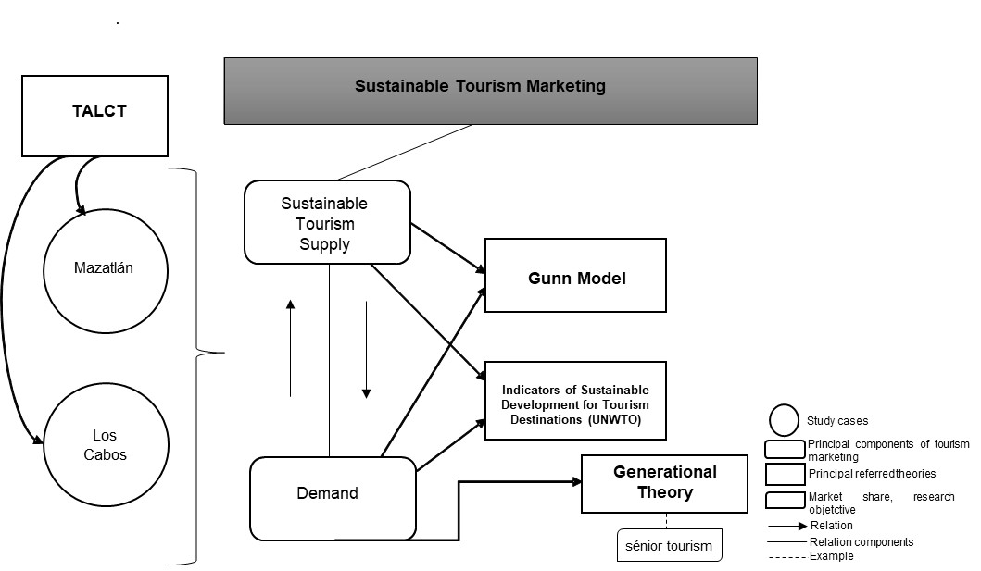
Annexed 1: Theoretical representation of the Sustainable Tourism Marketing perspective in terms of the supply from the TALCT scope in the study cases, focus on senior market (demand), framed in the Gunn Model, UNWTO indicators and Generational Theory.
Source: Author (2021), based on Butler (1980), Gunn and Var (2002), UNWTO (2005) and Strauss y Howe (1997).

Annexed 2: Gunn Model related to Indicators of Sustainable Development for Tourism Destinations (UNWTO).
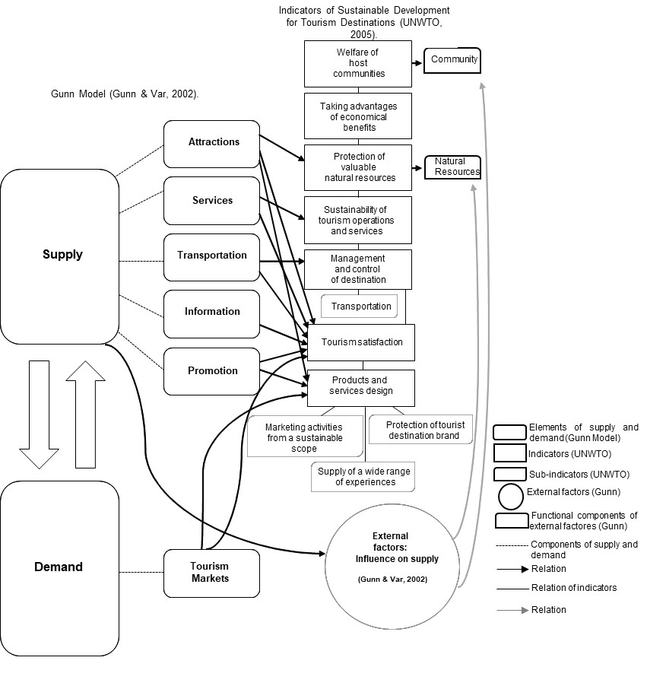Source: Author (2021), based on Gunn and Var (2002) and UNWTO (2005).

