DETROIT: REVITALIZING URBAN COMMUNITIES

A Master’s Thesis

by

DAVID N. FITE

Submitted to the Graduate School of the
University of Massachusetts Amherst in partial fulfillment
of the requirements for the degree of

MASTER OF ARCHITECTURE

May 2020

Master of Architecture I

© Copyright by David N. Fite 2020

All Rights Reserved

DETROIT: REVITALIZING URBAN COMMUNITIES

A Master’s Thesis Presented

by

DAVID N. FITE

Approved as to style and content by:

Eldra Dominique-Walker

Stephen Scheiber, Department Head
Architecture

DEDICATION

This thesis is first and foremost dedicated to my fiancé Alexis. Without you, I never could have completed this project. It is also dedicated to the people of Detroit who have experienced undue economic hardship due to globalization, racism, and the lack of strong social safety net in the United States. Your struggles should never be forgotten. Finally, it is dedicated to my father, and his father, both of whom were blue collar Detroiters. The skills they learned, and their infamous work ethics, have provided me a stable upbringing and the opportunity to pursue my dreams.

ABSTRACT
DETROIT: REVITALIZING URBAN COMMUNITIES

MAY 2020

DAVID N. FITE, B.S., EASTERN CONNECTICUT STATE UNIVERSITY

M.ARCH., UNIVERSITY OF MASSACHUSETTS AMHERST

Directed by: Professor Eldra Dominque-Walker

This thesis examines the relationship between architecture and planning in Detroit. The relationship between these two disciplines has reinforced gross inequality in socioeconomic status over many decades. It has been compounded by racism which planning policy and Architecture exploited during the 20th Century for private interests. This impacts the built environment at all scales. Today division is reinforced through small details such as how handrails are placed on benches, but it extends to planning metropolitan areas, and how they are divided up into city and suburb. At the scales between, both architecture and planning reinforce the segregation within their own disciplines, but the stage is set at this intersection. The scale of 1”=100’ has a history of being a scale at which both architectural form, and planning, can be expressed simultaneously. This is famously seen in the scale model of San Francisco which was commissioned by the City during the Great Depression.

Architecturally, the prevalence of skywalks between major buildings in urban areas has greatly increased. These networks grow organically, responding to a market demand for division, a city within a city. In Detroit, neighborhoods have edges, and within a few blocks, there is emptiness and abandonment. It is one of these edges that is explored in the intervention. The edges are oftentimes reinforced by the built environment with walls, traffic regulations, and pedestrian access carefully controlled at the scale of the neighborhood. Therefore, the thesis proposes a new form of development and is interested in this scale where architecture and planning are supposed to meet. Through this interdisciplinary approach, more problems are addressed simultaneously. The intervention identifies an educational district just outside of downtown Detroit and greatly expands it over several decades. 3 focus buildings were developed in more detail to sketch possible formal outcomes of the exercise in the built environment. The intervention proposes greater community input which informs this reimagining of neighborhood. The idea also draws on the concept of a “15-minute neighborhood,” which has been proposed by the mayor of Detroit as a solution to urban blight in Detroit.

TABLE OF CONTENTS

Page

ABSTRACT v
LIST OF FIGURES vii
1. A NEW KIND OF DETROIT 1
Introduction 1
“Why Detroit?” 2

2. HISTORY OF DETROIT 4
Early Development 4
The Ford Model, and its Post WWII Outcome 5
Modern Detroit, a Trajectory of Decline 11

3. DETROIT DIVIDED 13
Dividing Detroit at the Municipal Boundary 13
Disenfranchising Detroit 15
Detroit and the Automobile 22

4. PLANNING FOR THE 21st CENTURY 24
Detroit and the Future 24
Efforts to Revitalize Downtown and other Areas 26
Improving Public Transit in Detroit 28

5. THEORETICAL APPROACHES, PROFESSIONAL RESPONSES 33
The Regional City 33
The Parallel City: Minneapolis Skyway System 39
Parrallel Building: The Hartford Civic Center 43

PROPOSED SITE AND INTERVENTIONS 48

Proposed Site 48
Land Use and Demographics Analysis 52
Voices from the Community 54
Picking Focus Buildings 65
The Scale at Which Planning and Architecture Meet 67
Conclusions 69

APPENDICES 72
BIBLIOGRAPHY 82

LIST OF FIGURES

1. A proposed park in downtown Detroit. 3
2/3. The automobile facilitated movement across class and race during the Great Migration 4
4. Today, Fordlandia is mostly abandoned 8

5. A protester is arrested during the riots of 1967 10

6. Aerial view of the destruction during the 1967 Detroit riots. 11

7. Many lots around Detroit have been abandoned. 13

8. Diagram illustrating the border of Detroit at Grosse Point. 15

9. Michigan’s 14th Congressional district 15

10. Maptitude for Redistricting software screenshot – provided by Caliper 21

11. Current Congressional District map of the State of Michigan 21

12. An original Ford Model T, still operating in 2019 24

13. Proposed redevelopment of Northwest Detroit, along Grand River Ave 28

14. There is no centralized location of job opportunities in the metro area 29

15. A heat map of who is most likely to use the existing transit system. Provided by
Regional Transit Planning Group 30
16. Existing public transit system map. Provided by the Detroit DOT 31
17. The proposed regional transit plan reconnects city and suburb 33
18. Regional cities rely on a series of several nodes that network together 36
19. Canton, Michigan was once home to prestine land and a rural way of life 37
20. The consequence of prioritizing the fringe is a degrading urban core 38

21. Diagramming growth of the Minneapolis Skyway System (1970’s – 2016) 40
22. The monolithic architecture of the skyways disorients users 41

23. After public outcry, wayfinding signage was added to the Skyway system 42
24. The Renaissance Center is separated from the rest of downtown 43
25. The Hartford Civic Center, in the late 1970’s shortly after its opening 44
26. The NCAA tournament was enjoyed by sellout crowds for every session 45

27. Early rendering of Dunkin’ Donuts Park, a new minor league baseball stadium in
downtown Hartford. The park’s popularity has exceeded expectations. 47
28. The Core City area and its surrounding neighborhood 50

29. Abandoned Buildings in Core City 50
30-34. Schematic Plan Phasing Drawings 61-63
35. Axonometric views of conditions help humanize the planning process 64

CHAPTER 1

A NEW KIND OF DETROIT

Introduction
While every city has ups and downs over the course of its existence, no major city in the United States has experienced a more prolific downturn in recent years than the City of Detroit. Detroit’s problems festered and exacerbated themselves in particularly destructive ways which ultimately led to violence and uncontrolled decline. Exclusive suburban municipalities were formed due to white flight, sucking revenue from the City government, and eventually, bankrupting of the city. By the end, the state government appointed emergency management to combat the problem. Because the scope of Detroit’s problems is so far reaching, and because problems are so deeply ingrained, they are manifested and reinforced by the built environment. Therefore, resolving Detroit’s issues involves resolving issues in the built environment and rebuilding in a way that reinforces keeping communities together instead of breaking them apart. In a city where inequality has manifested itself in the built environment, what would a more community-oriented approach to development look like? While Detroit’s problems are well known and far reaching, some observers feel the city is on a path to revitalization.
A revitalized downtown is championed as evidence that Detroit is again on the upswing. But who is this downtown for, who works there, enjoys its amenities, and lives there? Outside of the bubble, large swaths of land continue in a semi abandoned state. Collapsing houses dot the streets. Entire blocks lay empty. Many of these neighborhoods have no streetlamps, and in some, the police do not respond to emergency calls. Architecturally, this state of abandonment in Detroit can raise critical questions about how urban renewal can be leveraged to rebuild a city in the image of those who it has left behind. Much of the architecture downtown feels uninspired, and many of the jobs are for people who live in the suburbs. For Detroit to avoid falling into the same pitfalls it has in the past, the built environment needs to reinforce connections between downtown and the working-class communities that live within the city limits. Targeted reuse of buildings in areas which were once significant to the urban fabric, for public good, could be one piece of redeveloping the city in these areas at the fringes. Detroit’s current state offers developers an opportunity to rebuild in ways that accomplish many goals simultaneously: sustainability, densifying the urban core, and social responsibility. Central to sustainability is the concept of reusing what we have already built. Is there an opportunity to restore Detroit’s abandoned neighborhoods? In order to contextualize the city and respond to its current state effectively, it is vitally important to understand its history, relevant urban theory, possible paths forward for the city, theoretical approaches to a more community oriented urbanism, and precedent projects that have advanced the goal of creating a city that serves its residents.

“Why Detroit?”
During the research and writing of this thesis, the question “Why Detroit?” was asked many times by faculty and peers who were reviewing the work. Detroit represents a particularly metastasized form of urban degradation. Ideas about suburbanization were born and used here in particularly effective manners to achieve goals of racial and socioeconomic division, with the affluent leaving the city behind for the suburbs. These ideas were exported all over the United States, including Boston and New York, where most UMass Architecture students will eventually practice. Therefore, it is important to research and understand the underpinnings of the suburban sprawl that surrounds these cities. Sprawl eventually leaves the city to fend for itself in favor of lower taxes for those who can afford to leave, or live independently of the city but within it.
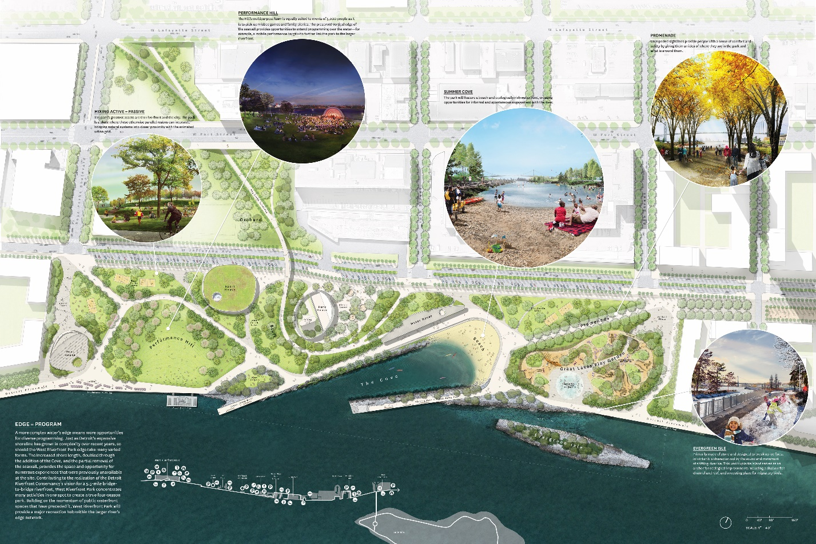

Figure 1: A proposed park in downtown Detroit.

CHAPTER 2

History of detroit

Early Development
Detroit was first settled by the French and Americans over 300 years ago. It served as a vital trading post at the Canadian border, interfacing both with each other and the Native population. Detroit traded in a variety of goods at that time, but one of them was slaves. Race as an indication of social standing was therefore deeply embedded into the culture of Detroit from the get-go. While they would ultimately fall on the northern coalition during the Civil War, the seeds had been laid for a form of racism to persist up through today.
The emergence of Henry Ford made Detroit a magnate for migrant workers seeking a middle-class life. Detroit was a major destination during The Great Migration, a period when African Americans migrated from the South to avoid Jim Crow era segregation. The automobile also introduced suburbia to White Americans. Ads glorified taking drives through the country and living away from the city, closer to nature. 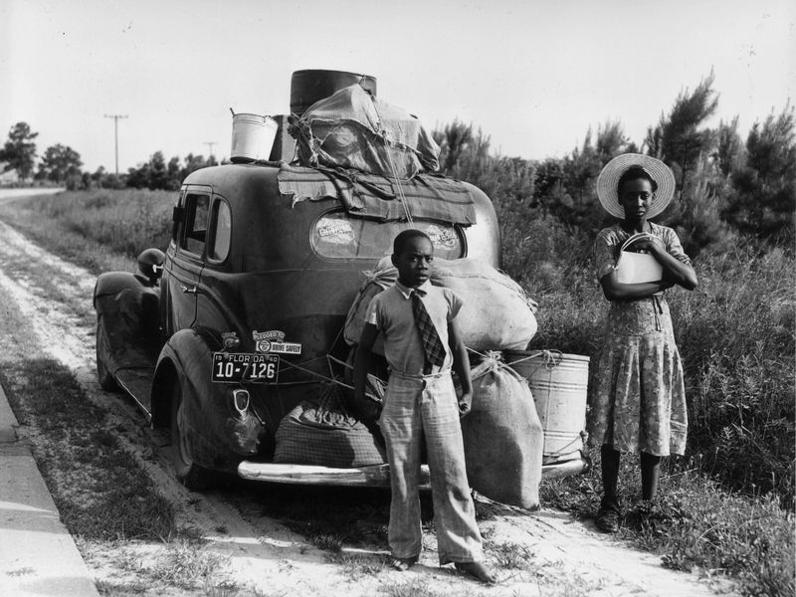 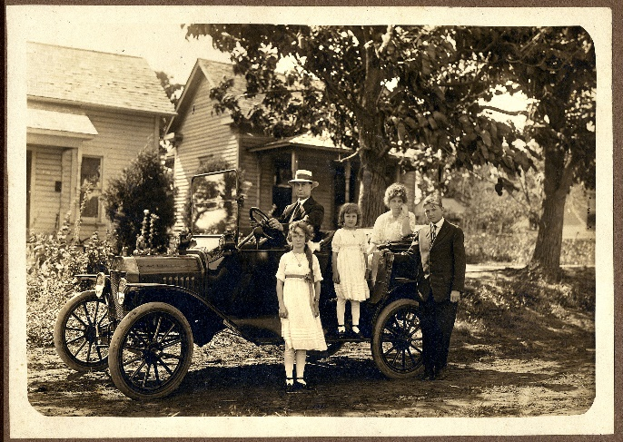
Figures 2 & 3:The automobile facilitated movement across class and race.
Detroit brewed its own Jim Crow, with de facto segregation both in the job market and in the private property markets. The unions struggled to straddle an impossible line between White workers and African Americans, many times leaving African Americans behind. Henry Ford was a notable exception; in that he went out of his way to hire African Americans and give them at least some access to the middle-class dream. Henry Ford is often celebrated for doing this, but the reality of his benevolence is also somewhat controlling. Ford required his workers to live up to certain moral standards in private, in order to receive the full “$5 a day” compensation he is famous for. Still, many auto companies were not willing to hire African Americans in the first place, making Ford’s efforts notable given the historical context.

The Ford Model, and its Post WWII Outcome
By the mid-20th Century, Detroit found itself voting segregationists into local office. Slum neighborhoods for African Americans dotted the city. In these communities, “bootleg landlords” would take single family homes and convert them into railroad style living conditions or worse. With properties consistently packed out, it comes as no surprise that a disproportionate number of house fires started in Detroit’s black neighborhoods. The real estate market has reinforced it. In the middle part of the 20th Century, a real estate agent who sold a home to an African American family in a white neighborhood would be blacklisted from the White community. Even though explicit forms of these racial covenants were deemed unconstitutional years prior, spoken agreements between residents remained, as did the ability to exert this social pressure, reaching beyond the scope of the ruling. Racial covenants played out in other cities besides Detroit, including Minneapolis, where extensive research has been done to document the process and the effects that live on to this day.
Henry Ford realized he could control a suburb’s government more easily than the city, and that in the suburb he could have lower taxes. He used backhanded tactics to effectively convince three different municipalities to join under the suburb of Dearborn, which to this day remains one of the more important suburbs in Detroit’s economy and culture. In Dearborn, Ford was able to consolidate power and as the largest taxpayer, he was able to significantly lower his obligations to the public. Although he preached inclusion in the workplace, his African American employees could not live in Dearborn, and therefore, they commuted from the city. When the Great Depression hit, he laid off about 1/3 of that workforce. Many of those laid off were minorities and residents of the city. At that time, municipalities administered and distributed unemployment. The City of Detroit protested that Ford should be contributing, but ultimately, they were left on the hook for providing unemployment to the city’s workers without any money provided from Ford himself. All of this led to Ford promoting his model as a new way for people to get away from the “grip” of the city and live a cleaner, happier, healthier, and cheaper life in the suburbs, where everyone’s dollar went further because tax rates were lower. The reality was that responsibility was simply being transferred onto the urban center. This kind of exploitative and combative relationship between municipalities played out many times in Detroit, and with Ford himself all over the world, in places as far flung as the middle of the Amazon rainforest in Fordlandia, Brazil. In this way, Ford pioneered the idea of the exclusive suburb that cuts itself off from its surrounding neighbors to advance itself.
Fordlandia is an interesting case study in Ford’s ideas of suburbanization. Here, we can see how his mentality fares in harsher conditions where they are unable to leech off the economy of a neighboring municipality. Ford also refused help on planning Fordlandia, and similarly, there is no evidence that he consulted any of the leading texts on urban planning that were being written at that time. Ford basically believed that he was a smart guy, that experts were overrated, and that “history is bunk.” While his folksy way may have flown in the US, and the relative strengths of the urban cores may have been able to support an exploitative suburban model to a degree, in Fordlandia, his refusal to collaborate and consult was an immediate disaster. His socially conservative views on how his workers should behave completely backfired. He also had no idea how to actually grow rubber, which was the entire premise of the community. Ultimately, many died of disease, and there was mutiny. Workers went on strike and ransacked the settlement. Ford only allowed his workers to eat a few different varieties of food. He insisted on a dry campus. There were no women, but a brothel existed just outside the town line. He refused to speak with botanists who could have advised on him on how to plant the rubber he was trying to export at a reduced cost. In the end, Fordlandia was abandoned. Today, it is a dying ghost town with only a few residents remaining, mainly descendants of those who worked there. There is a lone inn for those adventurous enough to visit the remote settlement.

Figure 4: Today, Fordlandia is mostly abandoned.
Central to Ford’s ideas were his “ideal worker.” Much has been written about Ford’s noteworthy goal of paying his workers $5 a day, kicking off the American middle class, and allowing his workers to make enough to buy the product they were producing. The reality however was that Ford’s $5 a day came with a lot of catches. Ford was extremely interested in his worker’s personal lives and expected them to be living a lifestyle that he approved of. Workers who did not want to do this would not be eligible for the bonuses that made up the meat of the $5 per day agreement. And so again, Ford left urban African American workers at his mercy, both at the municipal level and in the workplace. Although Ford had a different relationship with his workers than other employers at the time, and was far more willing to hire African Americans, he didn’t fundamentally change the relationship between workers and owners. He sought to control every aspect of his worker’s lives and rewarded those who were at least willing to pretend that they were following along. Ultimately, this would result in efforts to get Ford’s workers to unionize. When that happened, Ford had the organizers beat up, and then he passed legislation making it illegal for unions to hand out pamphlets to workers in Dearborn.
Race relations reached a boiling point in 1967, which hadn’t been the first-time race riots took over the city. Still, it became a national touchstone in the conversation on race relations, and equality. By the end, significant damage had been done to the city. By the 1970’s Detroit’s economy was already showing signs of collapse and being referred to as a dying city. Technology was advancing to a point where manufacturing could be exported overseas. While this would eventually affect all races to some degree, it affected African Americans first and by far the hardest. Those who had been kept down by the relentless system of racism in the city were the first to lose their jobs. Few of these jobs appear to have been replaced. Today, there are more workers in the city of Detroit than there are available jobs, and many of those jobs are white collar jobs Downtown. Service sector jobs may have filled some void, but the earning power of the former factory workers was reduced. White flight metastasized, leaving an urban core that was disproportionately African American, losing jobs and losing a tax base.
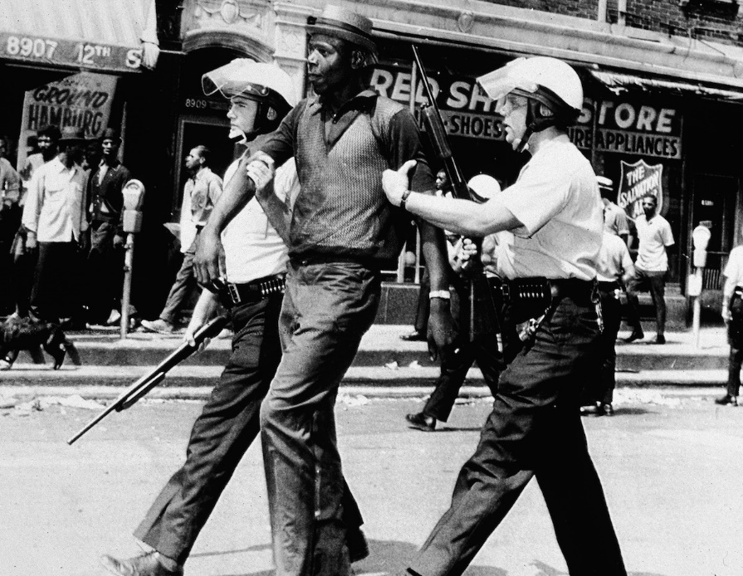
Figure 5: A protester is arrested during the riots of 1967. 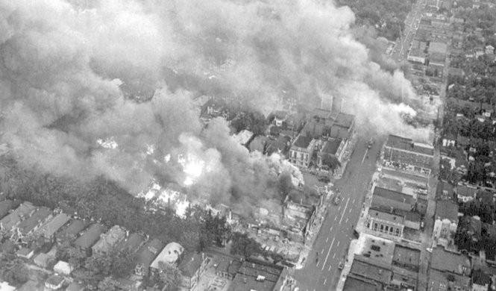
Figure 6: Aerial view of the destruction during the 1967 Detroit riots.

Modern Detroit, a Trajectory of Decline
The factors that led to Detroit’s decline were much more complex than the economic impacts. Detroit was home to ruthless redlining and segregation practices for the bulk of the 20th Century. The effect is largely intact today. Racial fractures formed and were exploited repeatedly by real estate agents, white citizens, and politicians. African Americans effectively had no other choice but to submit to this kind of segregation and the predatory market. There was simply not enough housing stock for them in the city. The city had forced them into a few neighborhoods through redlining. Single family homes were converted into multi family, often in a non-code compliant manner, to pack as many people in as possible. “Railroad style” living (or worse) was not uncommon. As a result, a disproportionate majority of the fires in Detroit occurred in these African American neighborhoods. When it came time to build highways, the city decided to route them through these neighborhoods, causing property value to drop even further. Those who were not displaced by the highway corridor were now tethered to the land they had invested in.
By the 1990’s, automation and globalization were wreaking havoc on Detroit. One could be forgiven if they thought some of the writings in Sugrue’s book were about the 2010’s. The language for describing Detroit in the 1990’s was already so dire that much of the same language was used to describe the bankruptcy of the city. As the city deteriorated, a series of emergency mangers were appointed by the state to manage the crisis. Emergency managers took over multiple cities in the region, and the public schools. Many schools were closed, and most municipal pay was cut. The people of Detroit did not vote for any of the people who were appointed to these positions, they were directly appointed by the Governor of Michigan – Republican Rick Snyder. In this way, municipal authority was usurped by the state government.
The problem kept getting worse. By the mid 2000’s foreclosures and evictions are raising, and by 2008 they are peaking. The population is on a decades-long decline and therefore, a significant amount of property has been abandoned. As the abandoned properties deteriorated. Neighboring property became worthless, causing it to also be abandoned, spreading blight across the City like a cancer. People got behind on their taxes, and abandoned property. Wayne County is notorious for “accidentally” overvaluing properties, and then foreclosing on those who cannot pay (often African Americans) within a few years for their ridiculous tax bills. Today, many such properties can be bought for $1-3000 from the Detroit Land Bank. Some efforts are made by non-profits to buy foreclosed homes and work with the existing owner to catch up on the bill, but these efforts are a band aid on an enormous wound.

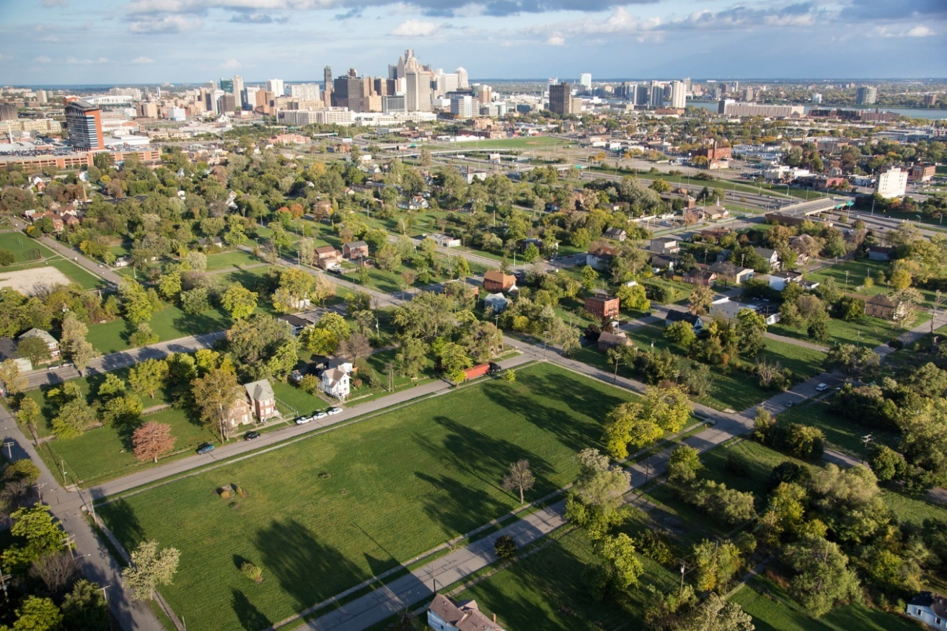
Figure 7: Many lots around Detroit have been abandoned.

chapter 3

detroit divided

Dividing Detroit at the Municipal Boundary

Detroit has a notoriously combative relationship with the surrounding suburbs. These walls come in many forms. In Detroit one barrier came in the form of a Farmer’s Market, discussed on pages 151 – 152 of the book Arsenal of Exclusion and Inclusion. Alter Road is an area where multiple barriers have been put up to keep motor traffic in a city out of the neighboring, more affluent suburb. Detroit pushed back on what would have been the sixth barrier between them and the suburbs at this location. The Farmer’s Market, stereotypically a location associated with progressive culture, was being used as a physical barrier to keep communities segregated. The original proposal had the Farmers Market obstructing a critical throughway between the communities, with its back-facing Detroit. The revised proposal and subsequent projects have choked the throughway still, but not to the extent it would have if the activists hadn’t gotten involved. Activists eventually discovered that the project was annexing city land into the suburbs. This legal foothold for the activists allowed them to force the design to be reworked under more scrutiny. Detroit justifiably feels they cannot trust this town’s government, and although the final project does look beautiful from the Detroit side, the effort to integrate it into the city appears minimal when looked at on the ground.
The index provides several sources documenting this fight. The articles range in scope from contemporaneous reporting to in depth retrospective investigations. What is clear even from this brief passage, is that the municipal boundary is a particularly powerful force in exclusion and inclusion. The effect it has on the built environment is clearly shown in the diagram below. In the case of Detroit, the built environment is being manipulated to reinforce this relationship using walls, traffic regulations, and buildings. This effectively creates a condition in which a Detroiter cannot easily enter the suburb.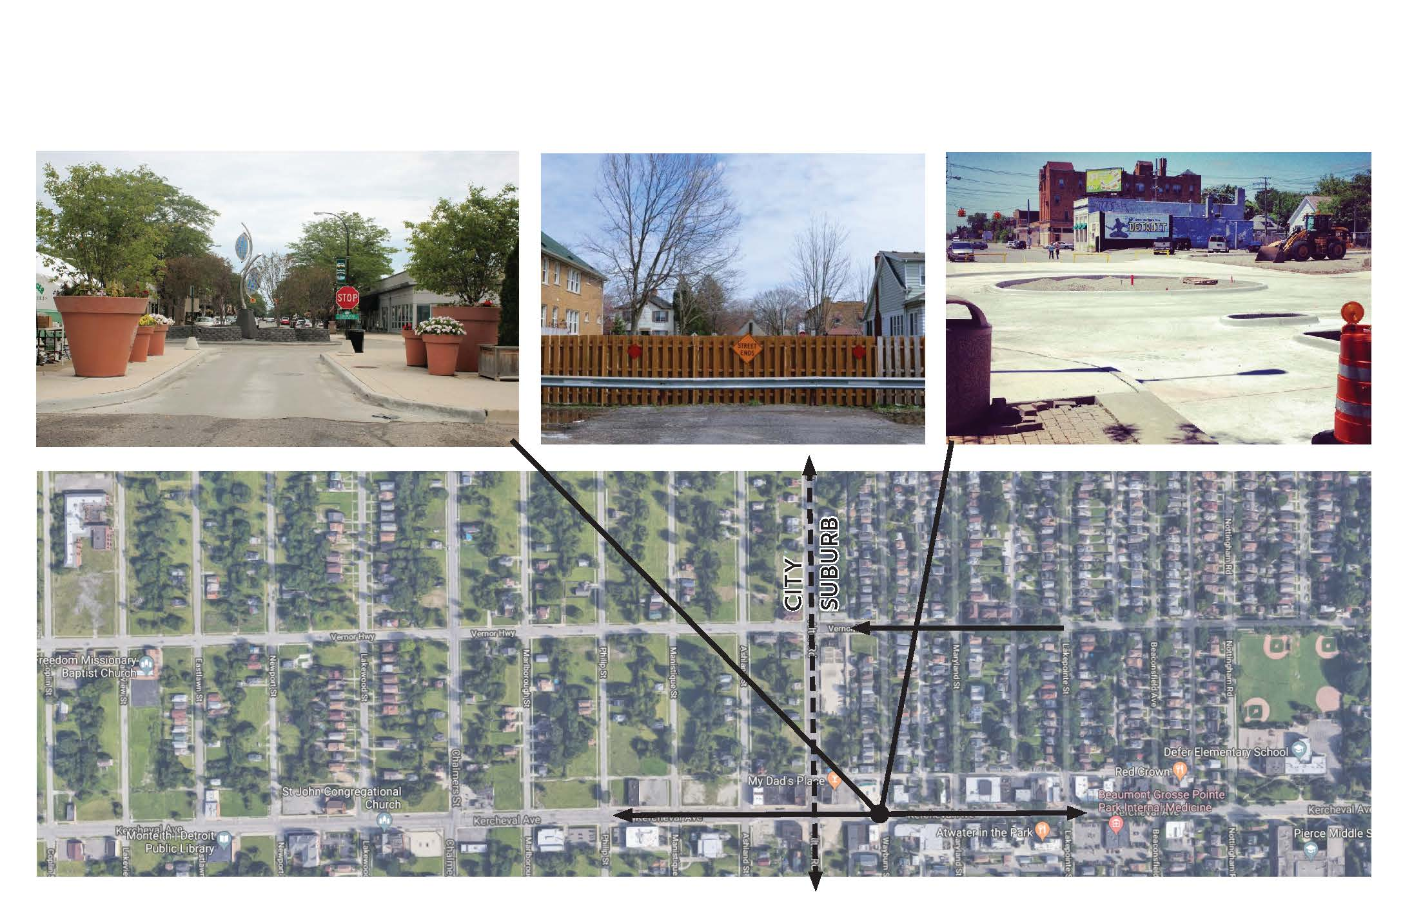
Figure 8: Diagram illustrating the border of Detroit at Grosse Point.

Disenfranchising Detroit

Figure 9: Michigan’s 14th Congressional district
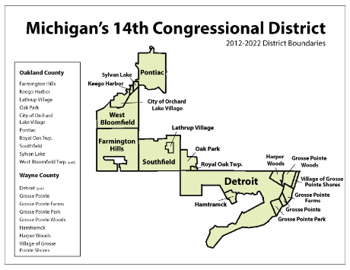
In the past several years Detroit has been victimized by partisan political gerrymandering. The effort has been led by the Republican Party and aided by national party officials. “Now that we had a spectacular election outcome, it’s time to make sure the Democrats cannot take it away from us in 2011 and 2012.” This was an opening point on a plan to subvert the Democratic process in the state of Michigan. State Republicans, having just enjoyed a wave election fueled by dislike for President Obama, and the Tea Party movement, were now aiming to make sure they stayed in office for many years to come. Office holders were instructed to immediately incorporate precinct level data they had compiled over the course of the campaign by national party officials.
Newly elected Republican officials in the state of Michigan, and presumably elsewhere, were invited to come to Washington DC by the national party for a workshop on using GIS software to gerrymander districts for political gain. Gerrymandering is a practice that can loosely be defined as manipulating boundaries of electoral constituencies, typically at the congressional level, to favor a group. Recently, the Republican Party have been especially heinous and discriminatory in their use of the tactic. The result is districts like the 14th Congressional district (Figure 9). Incidentally this district is home to the Grosse Pointe suburbs.
In Washington DC, the newly minted state level Republicans were taught how to use a GIS software known as Maptitude for Redistricting. Maptitude is privately developed by Caliper and can be used for a variety of purposes in private and public sectors. Caliper has also decided to dip into the political process by releasing this particular software, which is specifically geared for political parties to use in analyzing redistricting. Caliper uses the logos of both major parties on their website to advertise the tool. This introduces a whole new layer of planning into the mix. In day to day coverage of gerrymandering in the media, what remains unclear is how it is happening. It should also be noted that independent of the issue of gerrymandering, it is deeply problematic that a private company is designing and releasing software that is widely used in drawing up political districts. The tool was also recently used by Democrats in California. In a press release, Caliper lauded the results, stating:
“A 2013 report, commissioned by the League of Women Voters of California in partnership with The James Irvine Foundation, found that the commission made a concerted effort to make the process more democratic and nonpartisan. The report, "When the People Draw the Lines," finds that California's first citizen-led redistricting commission successfully democratized redistricting in the state… Designed with the help of redistricting professionals and other stakeholders, Maptitude for Redistricting has a comprehensive set of the features that redistricters need. In addition to equalizing the population of districts and complying with Federal requirements, criteria may include attempting to create compact districts, trying to keep political units and communities within a single district, and avoiding the drawing of boundaries for purposes of partisan advantage or incumbent protection.” (emphasis mine)
This last sentence is interesting, because it exposes that Caliper is aware their software can be used to test partisan advantage. The software does not make a value judgement on what you do with that information. If you wish to exploit the information to consolidate political power, Caliper’s program clearly will not stop you from doing it. There are no limits, but for a private company to set limits might also be problematic. In this way, the very existence of the software, coming out of the private market, seems ethically grey. That said, it is not a question as to whether Republicans attempted to commit political gerrymandering. It is only a question of whether the court system will find that it is unconstitutional to do so. Later in the chain of emails, political bartering takes place explicitly. For example: “We would like to keep the strip between Mound and Van Dyke all the way to 16 miles so that we can continue to represent General Dynamics, the Chrysler Plant, and the Ford Transmission plant.” These are explicitly not people or communities, but corporations. The reply is just as troubling in that it illustrates this was an iterative and collaborative process that took place across the party, and based on other recent court rulings, across multiple states:“Take a look. Don’t get hung up… the lines can be moved to accommodate.” The natural question arises. Accommodate who?
“The chart below shows the election data of this plan compared to the 2001 / current districts. All GOP seats improve except CD02 and CD03 (both still the most GOP though). McCotter’s district cannot get better unless we put Ottawa County in it.”
All of this is being done in Caliper’s GIS software. There were lawsuits of course, as the Republican Party had planned for in the leaked emails. The lawsuit eventually reached federal court. An expert witness was called to testify on the districts. Christopher Warshaw, who describes himself as an Assistant Professor of Political Science at George Washington University on his personal webpage, came to the stand. His work has been published in many academic journals related to the field, and he attended graduate school at Stanford University. Warshaw stated, “The Michigan Senate maps have more pro-Republican bias than 99.7 percent of all state Legislature maps across the country in the last 45 years.” Warshaw had shown himself to be an effective witness in the past. He testified in a similar court case against the Pennsylvania State Republican Party, and the State Supreme Court ruled the maps would have to be redrawn. The GOP’s response was an attempt to impeach the entire bench of that court. They were unsuccessful in their legislative efforts to do so; despite the unconstitutional advantage they were still enjoying when that vote was cast.
While this paper was being written, the Supreme Court ruled on a 5-4 partisan line that the gerrymandering in North Carolina was a state issue and so the federal government would not get involved in the state district drawing process. “The drafters of the Constitution, Chief Justice John G. Roberts Jr. wrote for the majority, understood that politics would play a role in drawing election districts when they gave the task to state legislatures. Judges, the chief justice said, are not entitled to second-guess lawmakers’ judgments.”
This level of compromised Democracy, and the problems that come with it, is beyond something any architect or even a city’s regional planner can resolve. While efforts can be made to mitigate the effects on a human or neighborhood scale, for the architect it is ultimately executing a philosophy on a project by project basis. This is simply not the kind of systemic change that is truly needed. The problem is complex, and the symptoms come from all angles. For example, when a building in Detroit becomes abandoned, especially a large one, it is almost immediately broken in to and stripped of all its metals so they can be sold at salvage shops. There are no resources available to stop this from happening, but that same lack of resources is also what allows squatting to occur, which at times leads to people in Detroit reclaiming abandoned homes, gaining ownership, and refurbishing them, with the assistance of a public-private cooperation effort between the Detroit Land bank, Home Depot, and a lender. On the other side of the coin, when one or a few homes become abandoned, there is a clear tendency for the blight to spread across large areas.
One ray of hope may come from those who use Caliper’s software in good faith. Jowei Chen was able to simulate over 1,000 theoretical maps that could be “fairly” drawn over the state of Michigan for districting. His simulation therefore illustrated that in order to achieve the maps in use in Michigan, partisan motivations had to be underlying. While the Supreme Court of the United States won’t hear these cases, it appears at this writing that state courts still can. In Pennsylvania, the State Supreme Court ruled that it violated the state constitution, and thereby shielded the ruling from being taken up by federal court. These other gerrymandering cases have not had that dynamic, and so now, national interests have an opportunity to get their hands on this issue and establish precedent one way or another. While political strategy is not the goal of this thesis, all of this marks important context for how Michigan functions and the clear parallels that can be drawn to other states around the nation which also experience these stressors.
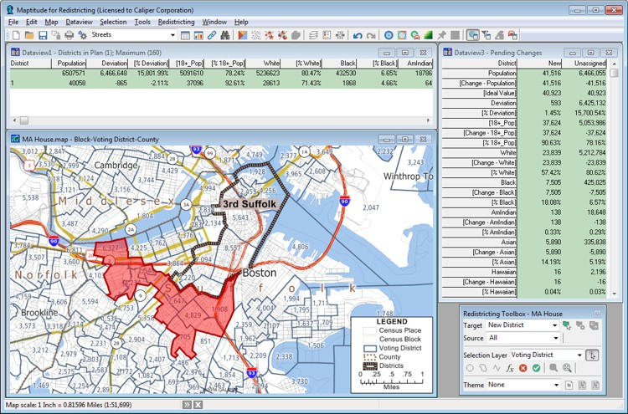
Figure 10: Maptitude for Redistricting software screenshot – provided by Caliper.|
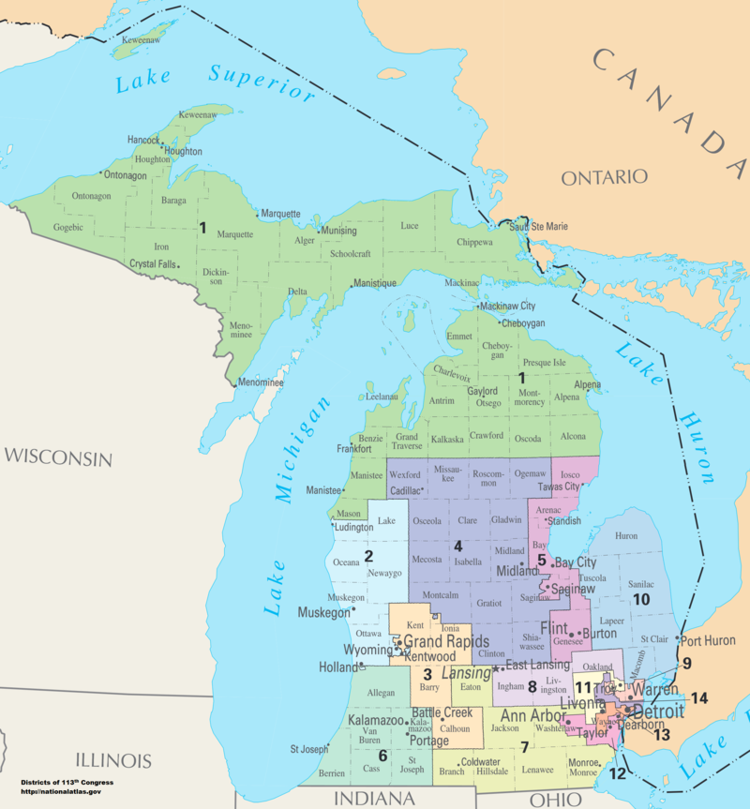
Figure 11: Current Congressional District map of the State of Michigan.
If the state legislature is drawn so that the needs of the urban core are not represented, that core will not be fairly considered in the political process. It also means that any effort on the neighborhood scale will be incremental, and that a larger community effort will need to take place simultaneously. Designing to withstand the extreme forces of poverty and racism, both the day to day and systemic factors, is extremely difficult and could easily overwhelm even the best-intentioned interventions.

Detroit and the Automobile
Detroit cannot rely on the automotive industry to revitalize its city in a sustainable fashion. The industry itself historically excluded African Americans. Today, most automotive jobs are in the suburbs and many of these suburban jobs are out of reach for city residents, particularly those who rely on public transit. There is little doubt that the automobile will remain a significant part of Detroit’s cultural identity, and a significant part of the workforce, but changes to the economy must be made. These factory jobs used to employ millions in the city. Today they have moved overseas or to the suburbs and it is unlikely they will ever return. 25% of Detroiters do not own a car, even though public transit is sub-par, making it difficult or impossible to access these suburban automotive jobs in the first place. This dynamic reinforces the racial divide. GM opened the Renaissance Center downtown in the 1970’s, but that is a corporate headquarters, not a factory for semi-skilled blue-collar workers. People of means can also live in the Rennaisance Center complex, eat there, exercise there, they never have to leave. In this way, General Motors reinforces segregation of a mostly white economic elite.
In his essay, Towards Sustainable Consumption of Automobility, Paul Nieuwenhaus takes the automotive industry to task for wasteful practices that decrease the lifespan of the automobile. He argues that even as vehicles become more fuel efficient, or electric, there is a less obvious footprint beneath the surface that needs to be examined. Vehicles today are overproduced and overconsumed, straining natural resources. Automakers have introduced software into the vehicle that makes tinkering more difficult for the owner. Nieuwenhaus argues that tinkering increases sentimental value of the car, encouraging the consumer to keep it longer. It also fills a practical role – the tinkerer does not need to pay for routine maintenance work.
If an owner develops an emotional relationship with the car, and does keep it up, the car can last for decades. The car can be retrofitted with a cleaner, or electric engine. The longer the user has the car, the more of an emotional bond they form. A more modular approach to car construction might allow a higher degree of personalization and longer lifespan, which Nieuwenhaus argued in 2008. We need to not only consume less oil, but to buy new cars less often. For Detroit this means significantly fewer jobs in the industry. But at the same time, it cuts to a hallmark principle of sustainability: using what we already have to its fullest. If these changes are not made, the planet will continue the unsustainable path we are on now, with massive climate impact that will overwhelm any short-term economic benefits this status quo may bring to the region. Therefore, this thesis chooses to be optimistic, and assumes American’s relationship to the automobile is going to fundamentally change. This was reflected programmatically in the schematic planning exercise, which phases out the automotive industry, and the final program of the eneighborhood.

Figure 12: An original Ford Model T, still operational in 2019.
CHAPTER 4

Planning for the 21st Century

Detroit and the Future

By the mid-21st Century, the above-mentioned strategies should have been implemented by the major manufacturers to stave off the worst effects of climate change. A wholistic approach will be required. In the documentary film A People’s History of Detroit, dozens of Detroit residents are interviewed to express their memories on the city, opinions on its current state, and what they hope to see in the future. People in Detroit seem to remain optimistic about the ability of their community to recover. The ability to recover is deeply embedded into the city, which burned to the ground in 1805 and then was rebuilt. This achievement is commemorated on the flag in Latin, which loosely translates to ‘from the ashes we will rebuild.’ Reinvention is at the core of Detroit’s identity.
At the same time, many people have become desperate as opportunity dried up and the city went bankrupt. Many of them expressed that the feeling of community they once had was taken away from them. African American residents expressed missing their old neighborhoods, the “main street” feeling they got from walking into black owned businesses in their community. Several others expressed the need for a library in their communities, some said they never had this even when things were going well in Detroit. Schools were consistently identified as a community need. In Detroit, around a dozen schools have been closed this century. While a few were closed because they had been replaced, the majority were not. Some of these schools have sat abandoned for several years and been looted for scrap metal by the residents. In the documentary it is indicated that this looting process took place very quickly, leaving the building damaged and devoid of critical components such as piping and wire. In order for Detroit to thrive in the future, these programmatic elements need to be brought back. The people in Detroit who do not drive need to have reasonable access to a central area where their basic needs can be met. While providing access to the central core of Detroit is important, historically Detroit was a city of many neighborhoods, with each neighborhood being anchored by a localized “downtown” of small businesses and professionals who served that community. A successful Detroit of the 21st Century would find a way to balance that past while still looking forward to the future and tackling the challenges of the 21st Century.

Efforts to Revitalize Downtown and other Areas
There have been some encouraging signs downtown economically, but they remain tied to White Detroiters and the suburbs. The Renaissance Center sets the tone of a high-end program that caters to corporate workers who commute into the city from the suburbs, remaining separate from the city at large. Recently, some residential development has been done to encourage these people to live and work downtown, and one would hope this might strengthen the tax base for the city. Efforts have also been made to revitalize the waterfront through a series of park projects connected by a river walk that would extend over five miles once complete. On the west side of downtown, a beach has been proposed that would be isolated by a man-made cove, so the river could freeze in this area during the winter and be used for ice skating and hockey. These efforts to increase quality and quantity of public space are noble, and the city needs to start somewhere, but ultimately these new downtown amenities don’t serve the poorer residents. Those who do not own cars would find it very time consuming to ever reach these destinations. Therefore public redevelopment of the city must expand.
The city of Detroit built a new baseball park downtown several years ago. They also added a new football stadium, and a new hockey arena. The baseball stadium had previously sat in Corktown, while the football stadium was relocated from Pontiac. In this way, the city core has begun to densify and provide more amenities. There is a streetcar that runs down Woodward Avenue, a main thoroughfare in the city. It ties into the Amtrak station “Wolverine” line that runs out through Dearborn, onto Ann Arbor, and eventually Chicago. The people mover provides additional elevated circulation in this core area and loosely ties into the Antrack line as well. The downtown core is the most walkable portion of Detroit at this time, but the walkability could easily be extended out further with mindful development.
Belle Isle was redeveloped by auto racing mogul Roger Penske several years ago. The public park had been all but abandoned following Detroit’s bankruptcy. Penske proposed that he would invest substantial money into redeveloping the park if he could put a motorsports course on the island. The decision has been divisive among Detroiters. Penske and his supporters say the race set up and take down takes only a few weeks a year, and that the total amount of time it takes them to construct the temporary grandstands and course barriers is the quickest of any temporary course in North America. Opponents say that Penske takes too much time, that the asphalt footprint is too great on what was supposed to be a nature preserve, and that the loud race cars disturb the animals. It should be noted that before Penske renovated the park, it was unusable, even the toilets were broken. Now, the park can be enjoyed for many months out of the year when the race is not being held.
There is some awareness from the major players in Detroit’s redevelopment that development outside of the central core needs to take place. Banking giant JP Morgan Chase has invested over $150 million into the redevelopment of Detroit. In June of 2019 they committed another $50 million to the cause, this time earmarking it for “affordable housing, job training, and entrepreneurship.” The bankers claim they hope to focus on helping African American residents and try new approaches to increase affordable housing in the city. It is worth noting that in 2013 JP Morgan was fined $13 billion for their role in facilitating the 2009 mortgage crisis and subsequent economic collapse. This collapsed devastated Detroit, especially northwest Detroit. According to Senator and 2020 Presidential candidate Elizabeth Warren, Jamie Dimon told her during her investigation to go ahead and fine them for their behavior, because he “could afford it.” While it is good to see major private donors saying the right thing, given the track record of JP Morgan Chase in recent years, one must wonder if they have other motives.
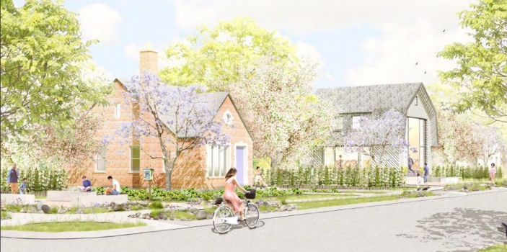
Figure 13: Proposed redevelopment of Northwest Detroit, along Grand River Ave.

Improving Public Transit in Detroit

In considering public transit, it bears repeating that 25% of Detroiters do not own a car. Those who rely on public transit can often face devastating commute times to some of the city’s largest employers. Because the city has been so divided for so long, the commute pattern of Detroiters is highly atypical. It is more difficult to plan transit than it would be in a city like New York or Boston where the transit paths are highly regular and can exist around one or a few central nodes. New York and Boston also feature a mixed system of commuter rail, Amtrak, subways, and buses, while Detroit only has buses, one Amtrak rail line that is not connected to the rest of the continental US, and extremely limited rail in the central core. Each of these systems is self-serving, they make little effort to communicate with one another and miss critical opportunities to provide connection.
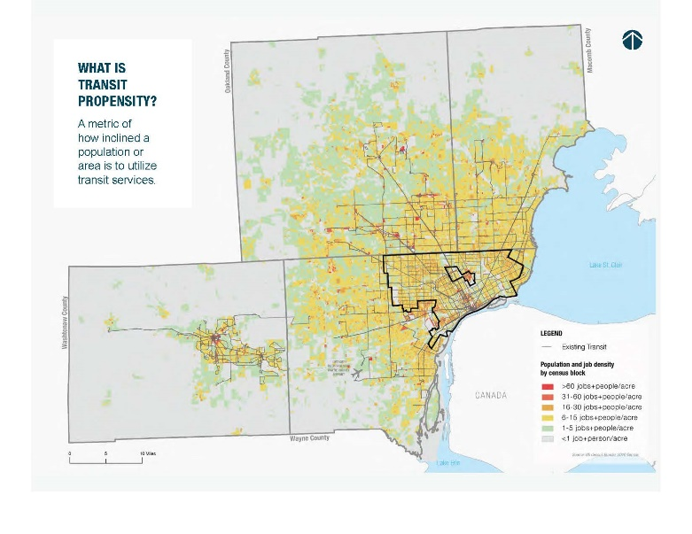
Figure 14: There is no centralized location of job opportunities in the metro area
For example, in Core City, the Amtrak line passes right over a major intersection but does not stop there. This kind of dysconnectivity can cause a city to stagnate, and then decay if left unchecked. Some of the disconnection is by design. Suburbanites remain skeptical of people who live in Detroit proper, and racism is still persisting in Michigan. In Detroit, it is difficult to take a bus into the suburbs, even though most of the jobs are in these areas.
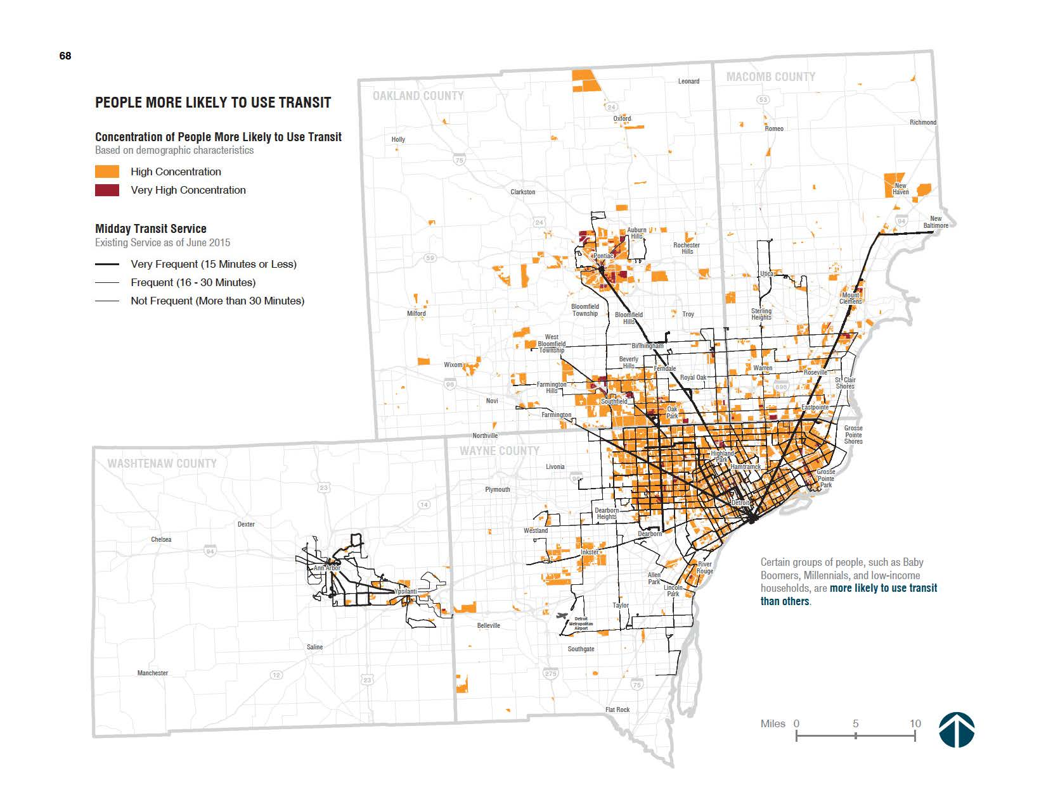
Figure 15: A heat map of who is most likely to use the existing transit system. Provided by Regional Transit Planning Group.
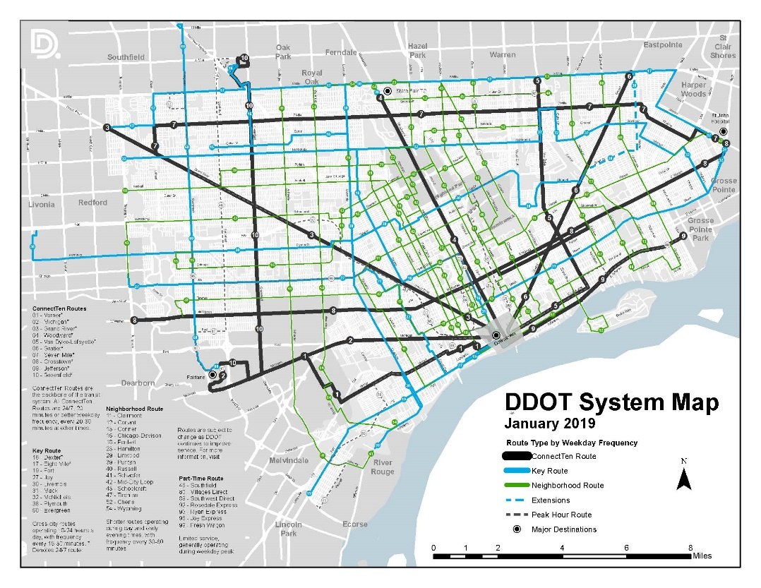
Figure 16: Existing public transit system map. Provided by the Detroit DOT.
The bus lines don’t connect well enough to form a good grid, and they don’t come often enough to keep commuting times low. With no regional rail, Detroit is forced to rely on Amtrak for long distance public transit. Trains bound for Chicago leave a few times a day, and it is $32 to buy a discounted ticket through to Chicago in advance. This is the only rail corridor connecting Detroit to the region.
The current public transit network does not meet the needs of its users. Therefore, a working group has been formed to propose a regional transit master plan for 2045. The committee met in the summer of 2019 and provided updates on current efforts to master plan the area’s transit network. The master plan focuses on improving connectivity in the central core and providing regional rail connection to Detroit’s outlying suburbs. This kind of regional connection hits the central themes of Peter Calthorpe’s Regional Cities book. Calthorpe notes that Regional Cities will have many central nodes, but that these nodes are best if they are well connected. Different nodes would also serve different purposes. One can easily imagine this in a regional network that includes the urban core, Dearborn, Ann Arbor, East Lansing, and Pontiac, for example. Theoretically, the urban core could be connected to each of these cities, creating a region that is able to take better advantage of the rich public resources that are available. At University of Michigan, automated vehicles are being tested. How does this tie in with Ford’s proposed innovation center in downtown Detroit, for example? What possibilities could exist if Wayne State were connected to the University of Michigan, and/or Michigan State, with regional rail connections? And conversely, what can these institutions learn from the city, and how can access to the city better prepare today’s students for a future that is looking increasingly urban and globalized? A robust regional rail connection in Detroit would allow public education institutions to explore these ideas further. The final intervention assumed the regional rail initiative would materialize in some form.
In conjunction with decreased reliance on cars, the Detroit Regional transit plan proposes an expansive new network that, if fully adopted, would reconnect the Detroit Metro area and outlying edge cities such as Flint and Ann Arbor. Efforts also exist to revitalize Detroit’s public education system, and to retrain its workers. In totality, there exists a robust framework for redevelopment that can be best leveraged by investing in the community members themselves. This could provide incentive for a private developer to redevelop this area in a way that is ethical in terms of its carbon footprint and its obligations to the community. 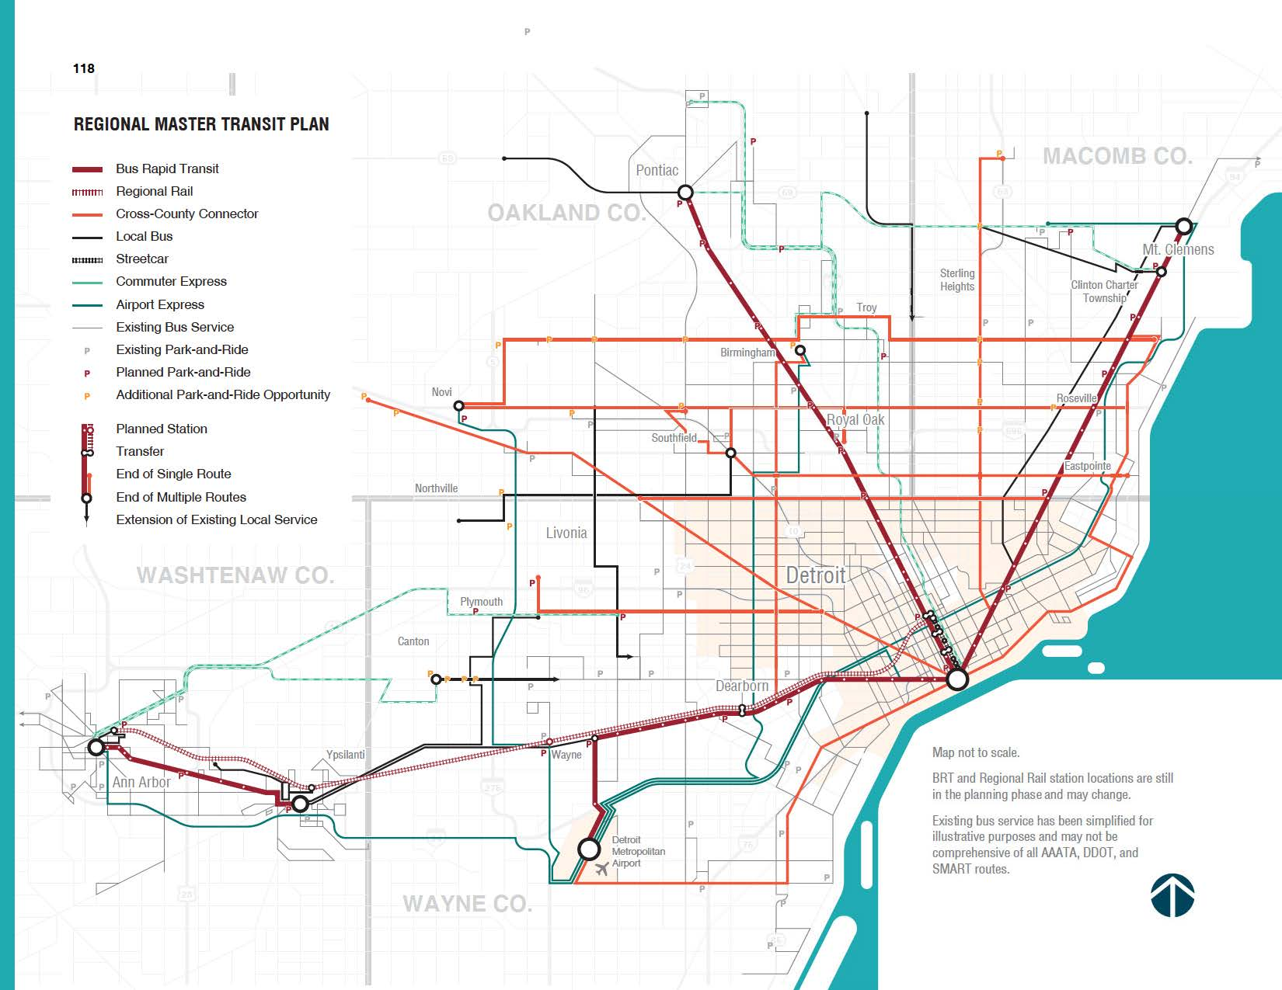
Figure 17: The proposed regional transit plan reconnects city and suburb.

chapter 5

theoretical approaches, professional responses

The Regional City
Peter Calthorpe focuses on urban design, planning, and architecture. His firm is award winning. His book Regional Cities: Planning for the End of Sprawl was published in 2001 and he hoped to explain “how regional-scale planning can integrate urban revitalization and suburban renewal into a coherent vision of metropolitan growth.”
Chapter 3 starts on page 43 by setting the context of what regional design is.
“Regional Design is an act that integrates multiple facets at once: the demands of the region’s ecology, its economy, its history, its politics, its regulations, its culture, and its social structure. Its results are specific physical forms as well as abstract goals and policies – regional maps and neighborhood urban design standards as well as implementation strategies, governmental policies, and financing mechanisms.”
Civil Engineers don’t consider the outside context of where they are designing. The argument is built on page 44 by considering the historical context of the Broadacre plan, and Clarence Stein, who’s thought was instrumental in FDR’s New Deal. One of the key solutions emphasized in this chapter by Calthorpe is diversity. On page 45 he discusses how efficiency is correlated with smaller working groups, not hierarchal organizations. He also notes another factor, the idealization of “Main Street” and quaint historic districts by general public. Diversity calls for a return of the mixed-use neighborhood. It implies a neighborhood that has widely varying household types, incomes, races etc. We are a long way off from this at societal scale, but as architects the ideal can be advanced on many projects. Therefore, diversity can be a way to guide preservation. It implies a neighborhood that has widely varying household types, incomes, races etc. The Green Building in Louisville may serve as a template for private engagement with the public that is constructive for all parties. The building mixes some art and cultural spaces in with office space to support the building’s financial needs. In this way the building becomes a destination and adds value to the business by giving it exposure. It effectively targets a building for reuse to retain character in the urban core.
Calthrope then raises a critical question:“What happens to regions or neighborhoods if they are “designed” according to these principles? An interesting set of parallel design strategies emerges at both the regional and the neighborhood levels. First and foremost, the region and its elements-the city. Suburbs, and the natural environment-should be conceived as a unit, just as the neighborhood and its elements-housing, shops, open space, civic institutions, and businesses-should be designed as a unit. Treating each element separately is endemic to many of the problems that we now face. Just as a neighborhood needs to be developed as a whole system, the region must be neared as a human ecosystem, not a mechanical assembly.”
This is a point that is expanded upon in the many chapters that follow and the beautiful drawings that accompany his work. It is about creating major open space corridors in the city to resemble the “village green” concept. Pages 53 – 59 are all about implementing these ideas and the passage above, with a number of case studies drawn that illustrate how the concepts take root at the scale of the neighborhood to the scale of the region. The approach is incremental, but still he seeks to transform the city over time through the collective implementation of the ideas. The book is therefore always from this pragmatic standpoint in the design standard. The large corporation is dealt with by rising vertically. Certain cultural norms like industry and big box mass distribution aren’t going away. Therefore, the mega cities will have several central districts. Civic buildings are integrated into these communities. The concept of the regional city, and the characteristics of successful nodes, was integral in developing the final intervention.
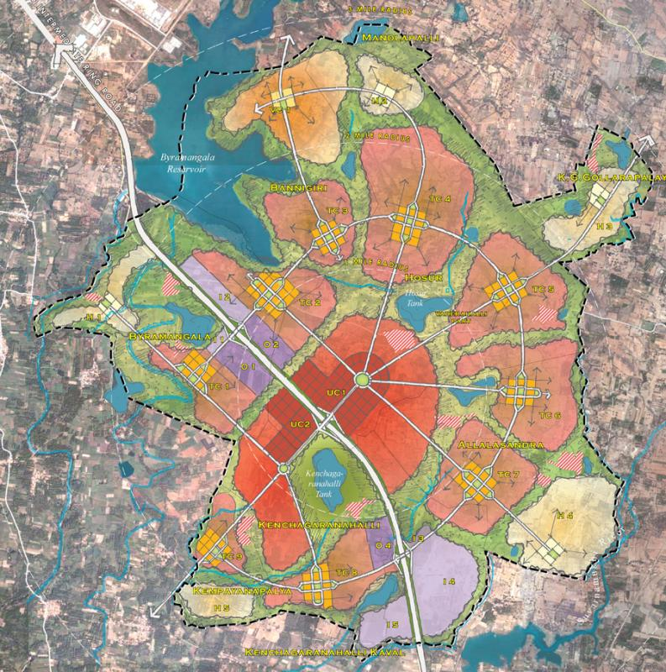
Figure 18: Regional cities rely on a series of several nodes that network together.
Nature preserves are noted as a political issue and it is acknowledged that beyond what is already protected, it will be difficult to integrate more open space. In this way, the opportunity to reorganize open space in Detroit is truly an exceptional one. Calthorpe notes however that when open space preserves are at the edge of the regional city, that is more universally desirable. Again, the pragmatic approach is desired. Two different kinds of preserves exist: regional boundaries, and community separators. Community separators are preserved for habitat and recreation. Preserving farmland as a regional boundary is a different matter. The land value isn’t high and there are many justifications for preserving the land. However, as cities grow, the value of farmland rises and farmers are tempted to sell out to developers. Today, there is desire in the US to protect rural culture close to urban areas.. There is interest in financing open space acquisition publicly. “A complete regional design must integrate protected habitat with significant farmland preservation and scenic corridors.”
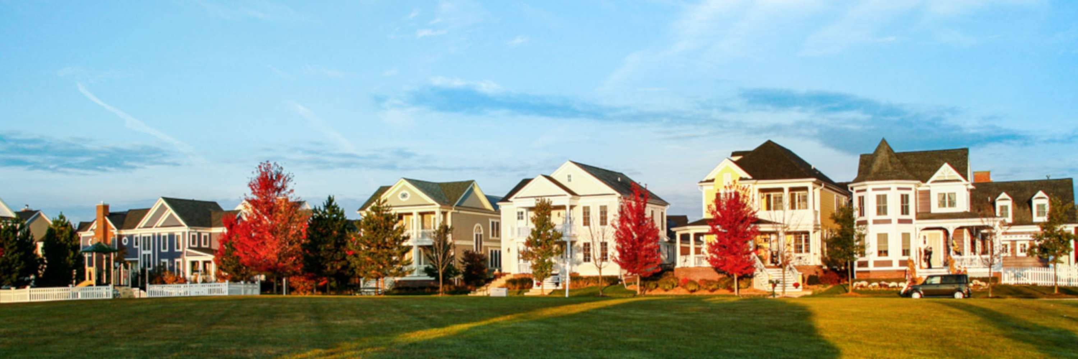
Figure 19: Canton, Michigan was once home to prestine land and a rural way of life.
The last category to an integrated regional design are corridors: water ways, traffic flows, habitat movements. Each region has a fundamental watershed structure. It’s important to understand the overall drainage path from the mountaintop down to the river and into the ocean. Continuity is more important than quantity. These systems can become assets within neighborhoods and then the larger watershed elements create open space elements at a regional level naturally – the water must go somewhere, and that where becomes your public preserve. The Emerald Necklace in Boston comes to mind as an example here. “Ecology and development become inseparable (58).” Corridors can also refer to rail lines, commuter, freight, metro, busways, streetcar lines, historic boulevards, main streets, each essential to the region. A balance between them achieves optimal flow. Land use must fit with the corridor type or it will fail. 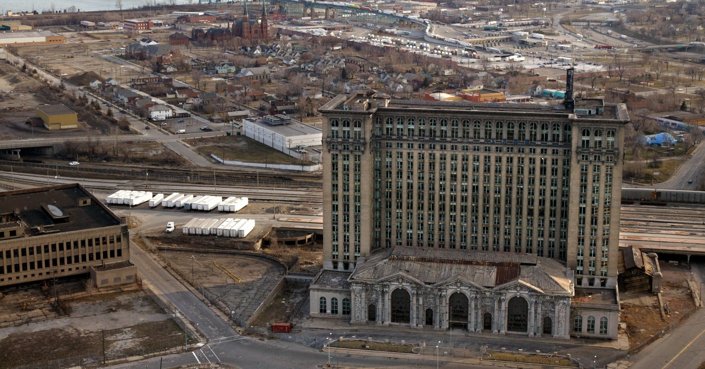
Figure 20: The consequence of overprioritizing suburbs is a degrading urban core.
To coordinate utility corridors with land use policy, they must be expanded in areas targeted for development and constricted in areas targeted for preservation. By doing this you will force the hand on future development you might not control. “The bias of the past forty years has been to subsidize infrastructure at the suburban fringe.” If we are going to revitalize a region it’s imperative that we repair their infrastructure. “The greatest opportunity for corridor reuse is in our unused railroad right of ways.” A sustainable form needs to be shaped out of the best traditions combined with the complexity of the modern world. Any future will be a wave of local, regional, and global characteristics. It is a balance between these scales and forces that must be attended to. Mass production will not go away, the government won’t collapse, globalization will not implode.

The Parallel City: Minneapolis Skyway System
The new book Parallel Cities:The Multilevel Metropolis explores how cities function on different planar axis. This can be done to organize program and traffic corridors in major cities. It is also done to restrict access for some while making it easier for others. The ground plane is the only plane that all humans can share. All other planes are restricted by ownership and privilege. This is even the case for public subway systems, as you must first be able to get there, in order to use it. The book therefore focuses on analyzing the city in section and how these relationships have developed over time. Analyzing the city in section is not a new idea, indeed it was a central component of both Haussmanization and the modernist movement. Planners often spend a lot of time looking at organizational structure in plan, so the vertical plane can be easily overlooked. Buildings that become interconnected by skyways are also exempt from some of the access requirements of public throughways like roads and sidewalks. These elevated horizontal networks grow slowly over time. Since they are often less regulated, can become like mazes that are impossible to navigate if you do not already know how to use them.
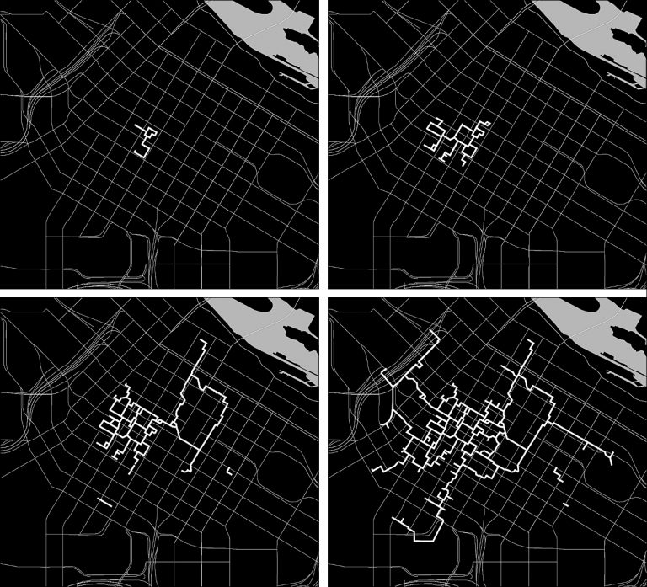
Figure 21: Diagramming growth of the Minneapolis Skyway System (1970’s – 2016).
In Minneapolis the experiment with elevated horizontal pedestrian access began innocently enough. These “skyways” are technically public, but they are built on private property, and are like easements. Opponents of the skyway system claim it has sucked life out of downtown, while supporters counter that it saved downtown decades ago, and that Minneapolis may not have survived without them due to the long cold winters. Some activists have tried to organize movements to stop using the skyways altogether and thereby force street level development back into the city. Eventually, a tipping point was reached where a developer building on an adjacent lot has to connect to the skyway system or his property value will drop significantly. There is no master plan in place for these kinds of networks, which is exactly what early proponents of the idea wanted. When the idea was first pitched in major cities, at times, there were no drawings accompanying it, and the major proponents of the idea were more interested in creating policy space for the proposal than drawing out what it would look like in practice. As a result, the Minneapolis Skyway is not user friendly.
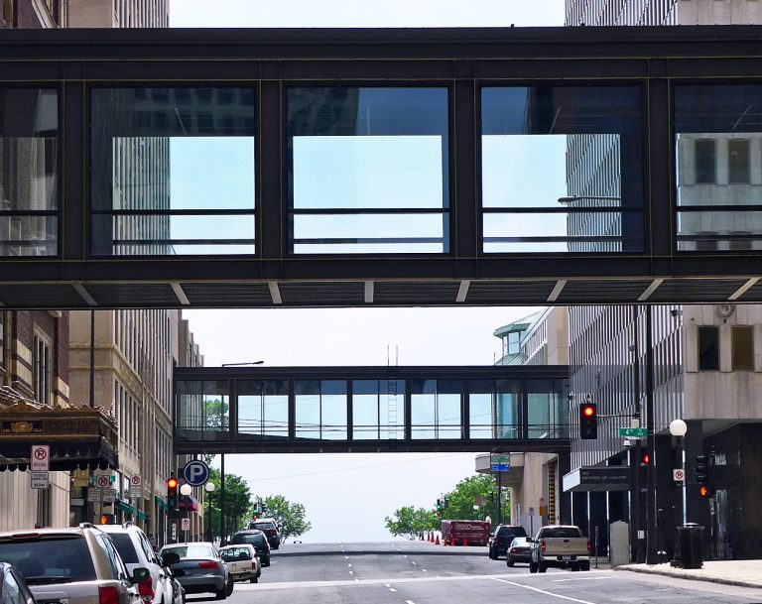
Figure 22: The monolithic architecture of the skyways disorients users.
There is very little wayfinding in the network, although in recent years some effort has been made to change that by installing map kiosks at central nodes following community concerns over wayfinding in the labyrinthian network. In reviewing this network, it became clear that Detroit has a network like this taking over downtown. It is dubbed “surreptitious architecture” by the authors because the takeover can be slow and difficult to read until the effects are very clearly being felt on the ground plane. 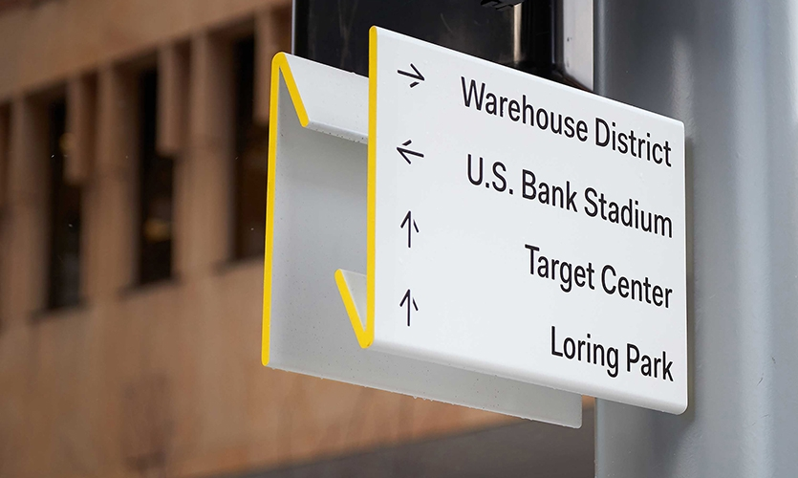
Figure 23: After public outcry, wayfinding signage was added to the Skyway system.
In Detroit, the Renaissance Center acts as a city within a city. It is advertised as a place to live, eat, play, and work, you never have to leave. The Renaissance Center even has its own zip code. If you want to go out for a ball game, the “Detroit People Mover” will take you, on an elevated track. People who live in the Renaissance Center could theoretically enjoy a high quality of life for years at a time without ever touching the true public ground plane. This is the “parallel city,” a second, privatized city, existing within the downtown core yet ultimately entirely separate from it. It could survive entirely on its own as a township with the addition of just a few emergency services, which its residents, in theory, could easily afford. With Detroit’s long history of racism influencing politics, and segregation, the development of the Renaissance Center and the people mover is deeply concerning to any urban theorist who wants to promote a city that is inclusive.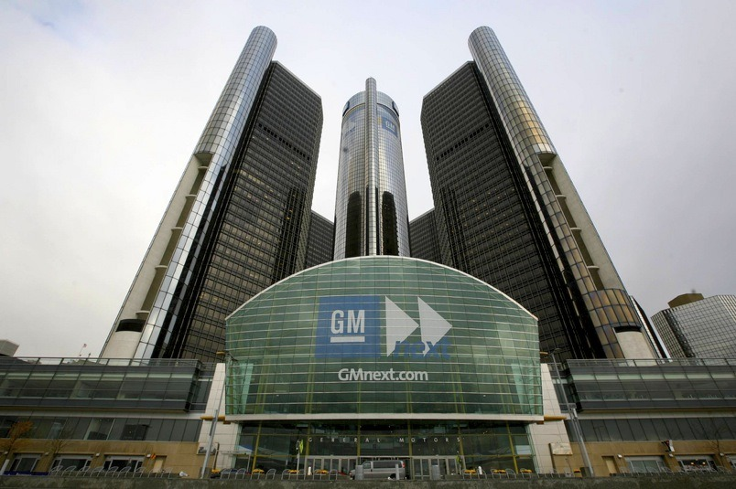
Figure 24: The Renaissance Center is separated from the rest of downtown.

Parrallel Building: The Hartford Civic Center
The Hartford Civic Center is a public entertainment complex that opened in Downtown Hartford during the mid 1970’s. Infamously, the roof collapsed under heavy snow loads in the 1980’s, forcing a major renovation. The Hartford Civic Center was home to the Hartford Whalers, a former National Hockey League franchise that later moved to North Carolina. It is also home to UConn Basketball, concerts, figure skating, conventions, and many other events. When the Civic Center was built the goal was to revitalize the downtown area. The Civic Center was separated from the downtown however, operating as a self-contained entity. 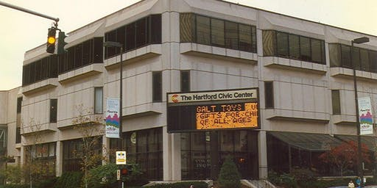
Figure 25: The Hartford Civic Center, in the late 1970’s shortly after its opening.
Guests would arrive from the suburbs and park in the garage underneath the building, providing direct access without ever engaging the street level. Once inside, patrons had the option to head directly to their event or do some shopping and dining in the upscale mall that was attached. Access from the outside to this day is heavily restricted to a few critical points. The Civic Center therefore became a piece of infrastructure that primarily served the middle class and above, not the actual residents of Hartford proper. Separation is reinforced again in the cityscape by the nearby I-84 highway corridor, which chokes off downtown from the rest of the city and allows cars to get on or off at key points of commerce without having to engage the rest of the city. Hartford to this day is a commuter city, many people who work there live in the surrounding suburbs.
The Civic Center’s mall is closed these days, and the venue struggles to continue providing its patrons with top tier talent. Uconn basketball continues to be the biggest reliable draw, but attendance is down on the Men’s side as the team has struggled to keep up with major powerhouses the last several years. However last year, the Civic Center hosted the NCAA Men’s basketball tournament, an event that aptly demonstrated the changing nature of downtown Hartford. Without the mall, today’s Hartford Civic Center leads far more of its patrons out onto the street level, theoretically increasing a footprint of inclusion into the building’s vicinity. Hartford Courant sports columnists noted that the NCAA Tournament, combined with other newly redeveloped areas adjacent to the building, created one of the liveliest atmospheres the city had seen since the 1980’s, an era regarded by locals as a heyday for the city.
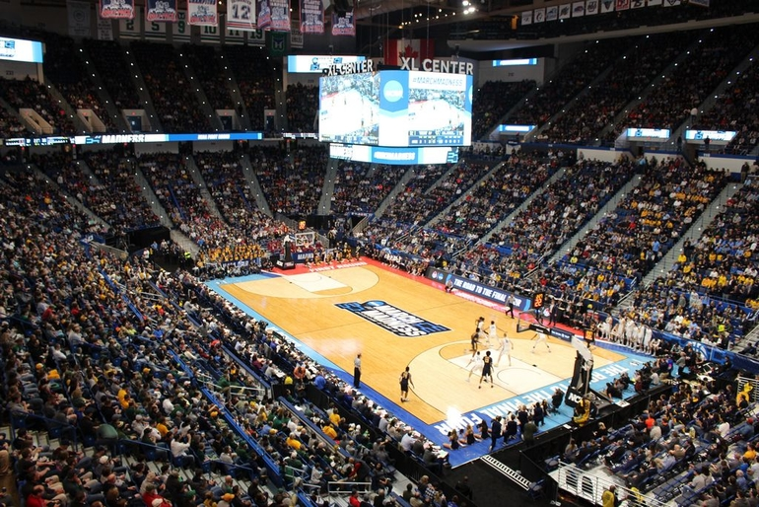
Figure 26: The NCAA tournament was enjoyed by sellout crowds for every session.
Still, questions remain. The NCAA Tournament tickets were expensive, the very nature of the event caters to a certain class of college educated people rooting for their alma maters. While this is not always true, anecdotally, the event appears to have been mostly enjoyed by people who do not live in the city. Hartford has made tremendous strides in correcting a poorly planned downtown, with proposals to reroute the highway corridor, redevelopment of abandoned buildings, and a new minor league baseball park on the other side of the interstate which is an architectural gem. Most in the city are aware the old Civic Center will need to be replaced soon, and perhaps it is the exclusive nature that contributes to its demise. Ironically, the Hartford Civic Center exists on an “island” surrounded by four streets. The venue is too small by today’s standards to be home to a professional sports team, but desire remains in Hartford to bring professional hockey back to the city. For years, architects and engineers have studied the site trying to come up with a way to retrofit the building to accommodate more people. The proposals typically find there is no good way to do it without tearing down and rebuilding on a new lot. The infrastructure that once protected event goers from their downtown neighbors is now choking off their ability to provide world class entertainment in the 21st Century. The City and State are in financial trouble, and so the building has seen a series of piecemeal renovations, each designed to extend the life of the building a few more years at a time. Still, its final days are coming, and at the time of this writing, the city had once again retained an architect to study the future of the complex.
The Hartford Civic Center serves therefore as a useful metaphor for the Renaissance Center. The Renaissance Center is entirely separated from the downtown, even though it is right in the center. It advertises itself as a place where you can live a full life and never leave. It has its own zip code. The Renaissance Center allows an elite few who a life of complete luxury, completely out of sight from the rest of society. Unlike the Hartford Civic Center, it continues to be successful, and appears to have no signs of slowing down. Instead, it has extended its influence surreptitiously into the landscape, a manifestation of the mentality of those who hide behind it. At the most basic level, they keep the surrounding context entirely out. Connection to the ground plane is purposely limited, seclusion and exclusion are encouraged by the program and its manifestation in the built environment. There is hope, however. The Civic Center’s story illustrates the changing effect buildings like this have on their surrounding areas, and that they can be retrofitted to address the problem. 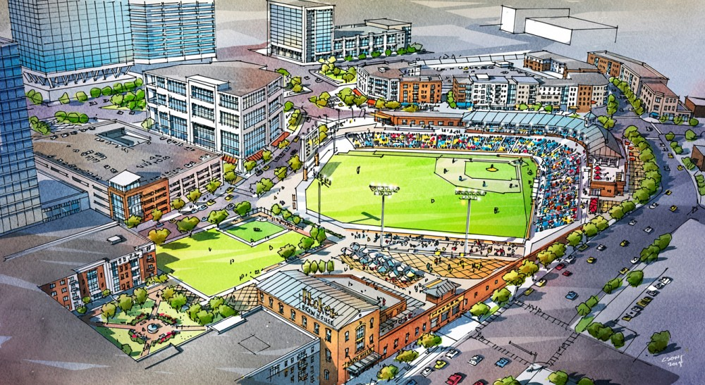
Figure 27: Early rendering of Dunkin’ Donuts Park, a new minor league baseball stadium in downtown Hartford. The park’s popularity has exceeded expectations.

chAPTER 6

PROPOSED SITE AND INTERVENTIONS
Proposed Site
One unique feature of Detroit is its geographic size. Although there has been rampant suburbanization, the municipal boundary extends far beyond the city center. However, because of suburbanization, an interesting phenomenon has occurred where the areas at the edge of the municipality are less dense than the suburbs surrounding them. Ironically, in the suburbs, there are complaints that pristine natural land is being lost to development, even as nature reclaims Detroit proper at the edges. Therefore, the proposed site looks to situate itself near downtown, but outside of it, to promote densification of the urban core. The proposed site takes advantage of Detroit’s current assets and a hopeful vision for the future. The intervention assumes that the 2045 regional transit goals will be generally met, with some flexibility. By positioning the timeframe of the intervention into the middle part of the century, the regional transit plan can be taken advantage of. It allows us to more realistically assume that Detroiters become less reliant on the automobile, given that millennials in the city are interested in using public transit more frequently. It is assumed that when the regional rail connection is made that the state’s universities will want to take full advantage of the increased connectivity and invest their assets in community outreach programs, fully taking advantage of the educational district which already exists in this location. The site is uniquely positioned to tackle the issues which were explored in the literature review.
In Core City and Woodbridge, there is an intersection of three major throughways, West Warren Avenue, Grand River Avenue, and the Amtrak rail line. The Amtrak rail line precedes through the neighborhood without stopping. However, it could be converted into a regional rail line, with a stop being added for this neighborhood on that line. Within walking distance from the intersection right now are a supermarket, a Boy Scout facility, an athletics complex for youth, a prep school, and housing. Buses in two directions provide access to Wayne State University and downtown Detroit. There is ample housing stock and several abandoned buildings which have potential for restorations, making this an exciting and dynamic place to explore a more community-oriented redevelopment project. Central to the redevelopment is the idea of providing connectivity from the ground plane, onto the elevated level of the regional rail line. The proposed transit station also reuses part of an old building which is adjacent to the site.
Central to the neighborhood is the idea of expanding the educational district. For this reason, the other two buildings which are explored in a bit more detail in the final intervention are the elementary school and library. Both of these buildings are placed on the Core City side of the neighborhood in hopes of revitalizing this area. The diagrams below begin to illustrate the relationship between the neighborhoods, and how West Grand River has come to represent a barrier in quality of life that is reflected in the built environment. In order to overcome that barrier, the intervention proposes two important public works projects on that side of the dividing line: an elementary school and a library. The train station sits on the other side of West Grand River, at the intersection of the Amtrack line. By creating these three pieces, West Grand River is activated into a throughway instead of being an attribute which reinforces division.

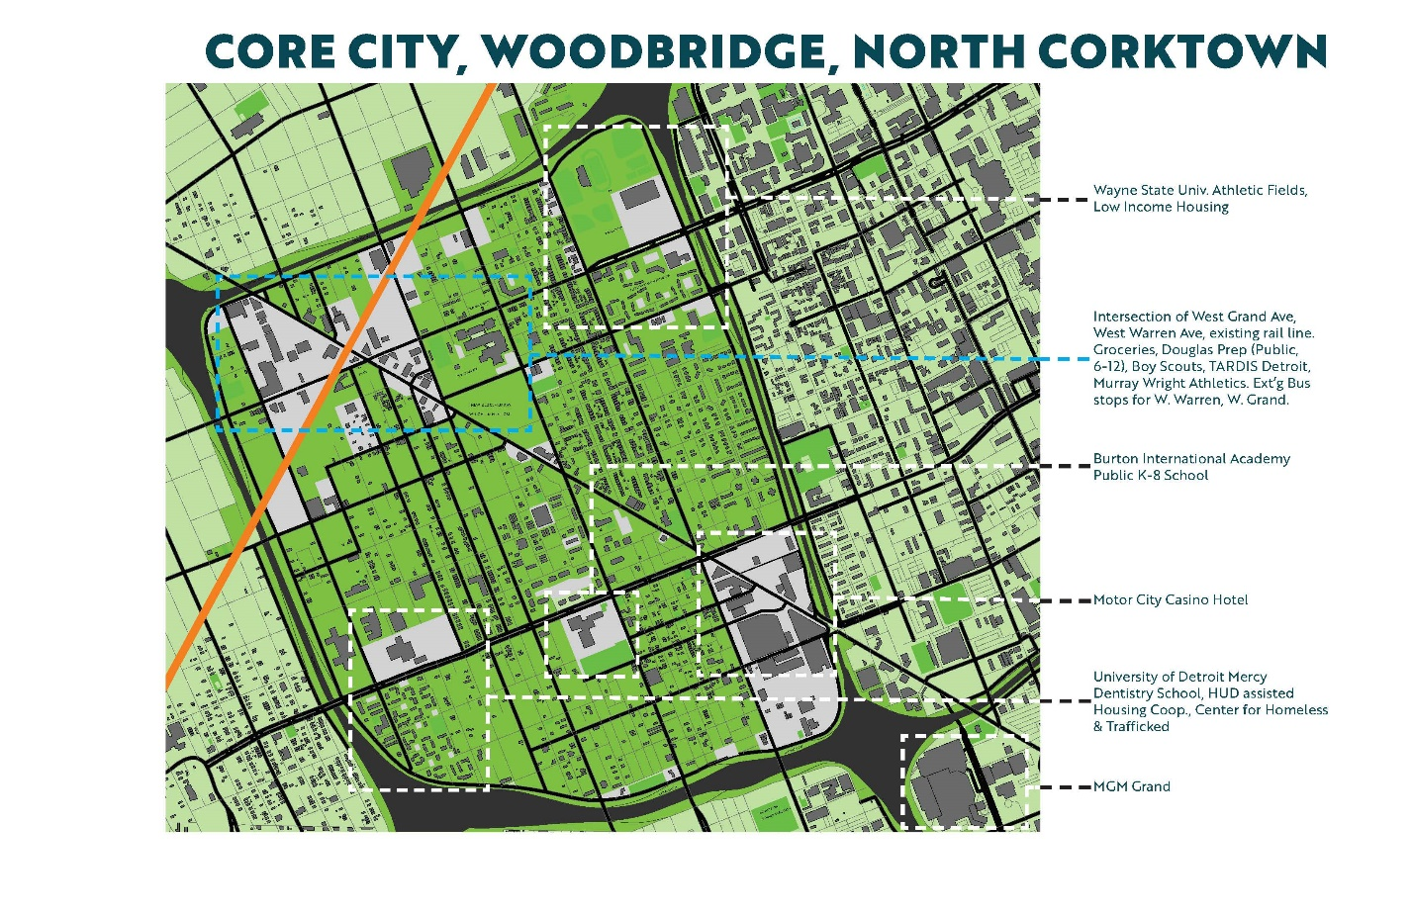Figure 28: The Core City area and its surrounding neighborhood
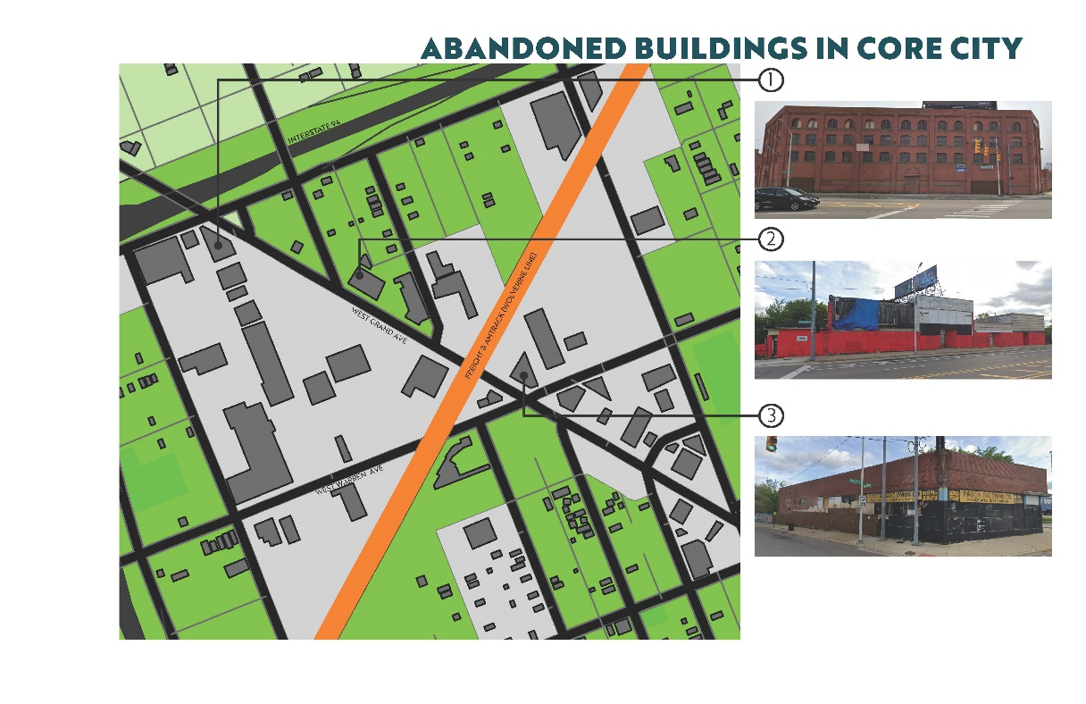
Figure 29: Abandoned Buildings in Core City
The distance between the proposed interventions allows an opportunity to explore how the ground plane between them can be used to reconnect a community and create a sense of place at what could clearly be a walkable downtown node for a large community. This is most fully realized in the new park that connects all the buildings and forms a common space in the center of this public educational district.
There is historical precedent for these kinds of downtown nodes all over the city, but as it decayed many of them were lost. This is the culture of walkability which existed underneath the Motor City, the 25% who do not drive to this day. For this population the project becomes about reactivating their own independence by providing access to the region, investing in them, their children, and their potential. With the regional transit network being implemented, making this connection is easier and public incentive is provided for revitalization in this area. In tandem with that, such revitalization would indicate that Detroit is less reliant on the automotive industry for its job base than it is today. Understanding that this site is a node which could serve as a gateway to the region for a community, with a walkable downtown that encourages alternate forms of transportation, the goal of creating and reinvigorating community becomes clear. It serves as a model for smaller scale urban renewal. The model could be applied throughout the city by reinventing and reusing assets that are already in place in these former downtown nodes. These nodes used to serve as epicenters for culture and locally owned businesses, including many African American businesses. Considering all of this offers an opportunity to envision the implementation of Calthorpe’s principles architecturally, reinforces the mayor’s own calls for “15-minute neighborhoods,” and proposes a way to resolve parallel cities.

Land Use and Demographics Analysis
West Grand River Avenue is the border between two neighborhoods: Woodbridge and Core City. Woodbridge has a greater share of the amenities in the area, with access to Wayne State University, and other educational opportunities occurring on their side of the divider. The Motor City Casino is on their side of the avenue and they have relatively stronger access to downtown. The Boy Scout troop and the youth athletics facility are on their side of the divide also. There are no critical public resources on the Core City side. Clustered around Wayne State University are several nicely maintained homes. Overall the people in the Woodbridge neighborhood are enjoying a noticeably higher quality of life. Woodbridge is also home to TARDIS Detroit, a small outdoor library that is fashioned after the telephone booth in the Doctor Who television series. This indicates that education and youth are of importance to this neighborhood. The Core City side has a lot more vacant lots and a lower percentage of occupiable buildings. The general condition of the building is of a lower quality. More information on this can be found in Appendix A. Motor City Mapping is an online repository of mapping data for Detroit. Their neighborhood by neighborhood reports allow for these comparisons to be made on either side of the Avenue. The Core City’s most notable amenities surrounding the site are a grocery store, and a small museum that is currently under renovation. There is also the University of Detroit Mercy, Corktown Campus, at the southern boundary of the neighborhood, which as the name indicates is affiliated with the next neighborhood to the south. Core City has 4 times as many lots with illegal dumping as Woodbridge, and it has far less than average density compared to the rest of the city. Opportunity is quite clearly concentrated in Woodbridge at this time, particularly for youths.
Under these conditions, it becomes clear that there is a “Core City” community which is not engaged in the amenities offered in Woodbridge. This is reaffirmed when analyzing demographic data. There is a divide here, but it is more subtle than the municipal and congressional boundaries that were explored earlier in this paper. It is a sort of boundary that is softer, and could perhaps be overcome with thoughtful architecture and planning. Sensitive implementation, in a university community, with access to public transit, would motivate Woodbridge to engage with their neighbors in Core City. For Core City, a community would be created with upward mobility in the strong educational district. Appendix A provides a full breakdown of land use in this focus area.
According to evictionlab.org, the largest database of eviction information in the United States, the foreclosure crisis spared both Core City and Woodbridge relatively speaking. It is possible one reason for this is the relative affluence of Woodbridge, and the low density of people in Core City means there were fewer to lose their homes in the first place. However, when looking at the data on a per capita basis, the numbers remain low. Density and racial census data shows Core City is predominately African American. In Woodbridge, Whites and African Americans mix throughout the neighborhood. South of Wayne State University, there is a housing project that is a high density African American population. Racial division does exist in this area, but we see again there is a softer border than what is seen in the city at large and at municipal boundaries.
Aside from the regional transit plan, Detroit also has a master plan. Martin Luther King Boulevard, conceptually, could become a non-motorized route. This would be at the southern boundary of the neighborhoods. The streets that form the main intersection of the proposed downtown area will remain critical motorized arteries. In the master plan, Core City and Woodbridge are also grouped as one entity, referred to as “Jeffries.” Neighborhoods are then clustered into larger groups, and in the case of Jeffries they are forming part of the “downtown” neighborhood group. The area surrounding the main intersection is generally zoned for “Institutional,” “Light Industrial,” and “Medium Density Residential” use. The proposed intervention effectively upends the existing zoning requirements. While they were taken into consideration, they were not a driving factor in the final outcome, which sought to fundamentally reorganize the space in a way that would override zoning requirements in the area.
Voices from the Community
In Detroit, developers are now required by law to coordinate with community leaders, so their concerns are heard, and their needs are better served. According to the city of Detroit’s website, the community benefits ordinance “requires developers to proactively engage with the community to identify community benefits and address potential negative impacts of certain development projects. The ordinance was approved by Detroit voters in 2016. When projects trigger the CBO process, a Neighborhood Advisory Council is established, with nine representatives from the project’s impact area to work directly with the developer and establish community benefits, which are included in the final development agreement approved by the Detroit City Council.”
Since this is a larger scale intervention, and since it is a community oriented project, we are assuming this project would trigger the CBO process. In Detroit Documentary: A Story of the People, dozens of residents are interviewed, many of whom are community organizers, the kinds of people who would be on boards like this. In considering their opinions, it is best to read their quotes directly and let them stand on their own in terms of speaking for what the community needs. The following quotes are some of the most notable excerpts from the documentary and were closely tied to the schematic planning effort:
“I would say to anyone you know, protect your spirit. Protect your spirit. Because you’re in the place where spirits get eaten.”
“Develop with the people that’s already here. Don’t force us out.”
“When you go downtown and you… see that statue out there called the Spirit of Detroit, but, it’s likeness does not represent the people who live here. In that aspect it marginalizes a lot of people and their stories.”
“There are so many points in time where I feel like community comes together and creates wealth… and resilience where people don’t think they exist.”
“I think of Detroit as like a furnace and if you can survive in Detroit it makes you into this… kind of… hard substance, that can survive anywhere in the world.
“It’s a movement city and, for that reason, it has a lot of resilience and vitality and life, even under attack.”
“If I were defining my neighborhood I would define it as a third world neighborhood… but within those conditions you have hope, you have people who have a desire to… love others, to experience peace, to raise their kids, to be great.”
“We had everything we needed in the community from… the liquor store… the pawn shop, the laundromat, you had clothing stores… right in your community. And that began to change when they decided that they wanted to take the land.”
“You name it and we had it, with the exception, I say this as a teacher, with the exception of a library. There was not one empty building on Jefferson.”
“The thing I remember most coming up through there was how full the neighborhood was… how a train ran right down the tracks there across the boulevard and there were warehouses there.”
“We don’t have no fire station, we don’t have no police station, how does the economy allow a live community to just die?”
“We were a community of block clubs, there were 300 across the city… it was a way that people felt connected to their communities and felt power in their communities.
“Basically they’re saying the people of Detroit can’t do anything about the problem so we need to bring in people who are more educated, maybe college educated, more affluent, whiter.”
“I love how I was trained by black professionals in Detroit. When I came here I was young… the people I worked for were African Americans, very well trained… they had a love for Detroit and inspired me to do my best for Detroit.”
“You look at midtown, you look at Corktown… how the hell they get support and we don’t? How do they get resources and we don’t?... that white privilege, automatically put you at the table, puts you in the conversation, to get those resources.”
“What we don’t wanna do is we don’t want to abandon government because that creates a huge vacuum, and leaves power there for the taking. It looks like who’s stepping in to that vacuum is big business and corporations… citizens are pushed to the edge.”
“Understand that there is a hidden hand. We are on very valuable property, we are situated by a very strategic location… and I know it is more than our officials not being competent because many of them are.”
“This has been going on for generations, people stealing, now they need to be held accountable and people don’t like change.”
“Go walk through any neighborhood in the city and ask how it is that the people in power care about the people of this city. When the government puts up Christmas lights downtown but can’t put up streetlights in our neighborhoods, how messed up is that?”
“Communities feel powerless to those that have money. Communities are doing the work of foundations, and ultimately all foundations can do is dish out money… and that’s not bad, but ultimately who does the work is those on the ground. It’s time for the foundations to recognize that this should be a very equal relationship considering what you’re getting out of the deal.”
“I don’t think we really see the beauty in ourselves because we don’t see the resiliency that in the face of all odds, having a job or not having a job, in the face of this racialized neighborhood it’s like, we still here, and some of us are even thriving, but the majority of us are in survival mode, we living paycheck to paycheck, hand to mouth, robbing Peter to pay Paul… you know, all the chatter, and it builds a sense of anxiety, high blood pressure, and frustration, and still we move through.”
“I envision a Detroit of producers and consumers being the same. So one of the things we think about is that work, with the new technologies that have unemployed us, are now the new technologies that we can employ to create a more craftsmanlike existence, where we are not just consuming things from China but actually produce the things we want, our own clothing, our own furniture, our own food.”
“We have a lot of talented people in this community but you’ll never know them… you have a lot of talent in the city and it’s an untapped resource, you have unemployed teachers, unemployed masons, you have all walks of life, all kinds of talents and nobody is using it… everyone isn’t a derelict, they just come into some unfortunate times in their life.”
“How do we utilize the buildings we have?... How do we utilize… the people? The brain power, the know how?”
“Need a better infrastructure to do organizing and progressive work in Detroit… Could we create some synergies by learning from all foots what’s going on, the vision of the kind of work they would like to see happen… we are in the midst of a reworking of Detroit, and in many ways citizens are on the outside of that… What are the tools community folks could use in order to be more successful in defining what their own communities could look like, engaging in their own mapping strategies, looking at the way the community looks and identifying injustices through spatial analysis… and how that becomes… an advocacy tool… to contribute to a broader mission.”
The people of Detroit need development that invests in the people who are already there. They need someone who can see the value in the people that live there. They do not want to be something standing in the way of progress and revitalization, but rather an integral piece of that process. They are an untapped resource with many talents and interests. The people of Detroit deserve a lot more than the current trajectory of the revitalization efforts, which has been overly focused on bringing affluent people into the city center. The proposed intervention will serve the people quoted above and attempt to address their needs architecturally in a way that is sensitive while boldly responding to the many issues they have faced over their lives at the scale which is required: the neighborhood. The proposed intervention will be about providing people with the tools they need to survive, but also to lift themselves up, and especially their children. The proposed intervention will provide opportunity to an underserved population and understands that providing them this opportunity is an investment that will pay society back many times over. It may leverage both public and private assets to accomplish this goal, and thereby demonstrate the power of unity over division.

Proposed Intervention: Planning Studies
It became clear early in the intervention that a planning phase would be required to understand how the neighborhood at large could be revitalized. Because the space around Woodbridge and Core City is so disorganized around the central arterial roads that cross here, it was important to both fundamentally reimagine the space, and create a realistic plan showing how the neighborhood could reorganize itself between now and the target date of 2045. It quickly became clear that the intervention was functioning in a space where architecture meets planning. To design a neighborhood, a top down approach can quickly take over from the planning side, which designs almost exclusively in plan view. However, on the community side, this “top down” approach is not trusted. In Detroit, the local governments are not trusted to do what is best for communities. Therefore, a more architectural approach is also required which can help the community move beyond the feeling that solutions are being imposed on them.
One strategy we found enormously helpful as we came close to the end of the planning phase was to take some of the planning proposals and consider them from an isometric view. This immediately gave the plans a feeling of being “lived in” to the reviewers and helped dispel the notion that a utopian city was being imposed in a top down way. And, while this project could be said to fall under the long tradition of reimagining the city, it is notably different because it seeks to include the community rather than act as though it knows better than the community. For this reason, reviews were consistently held with professors, community input from the city was considered through the documentary, and the chair of this thesis was selected due to being born and raised in Detroit. The final intervention represents the outcome of this process.
The drawings below illustrate a densification of Detroit which could take place over several decades. In Phase 1, all the abandoned buildings are removed. In Phase 2, the existing program is desndified to better organize and identify open space assets. Phase 3 shows several major public assets being added to the community, and a private build out in phases 4 and 5. Open space is infilled with a public-centric program and reorganized to the edges of the neighborhood over time. In this way, its use becomes more beneficial to the community and the environment. The reorganization allows for larger scale rewilding, and the densification creates a walkable neighborhood with many public transit options.
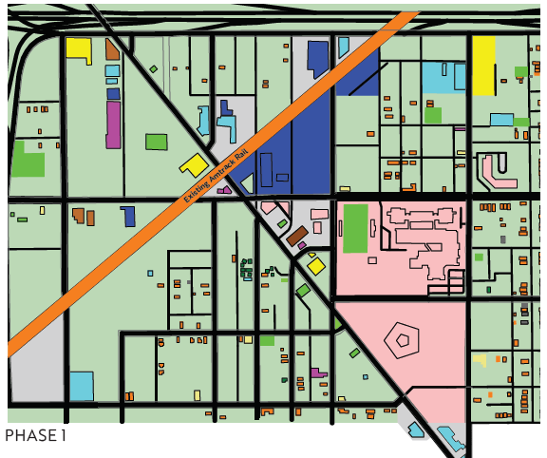
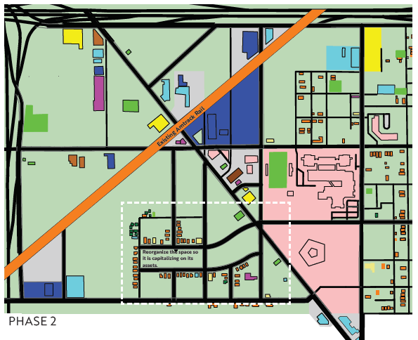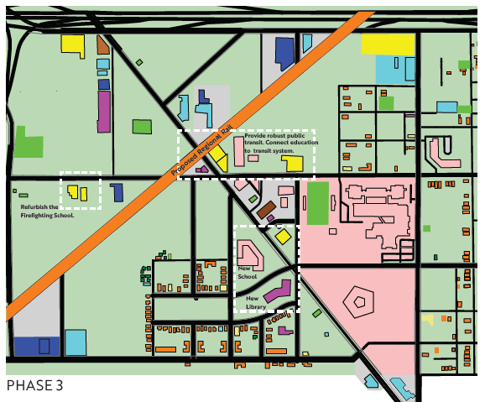

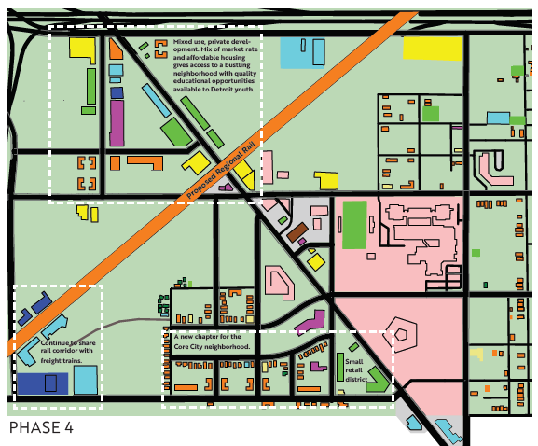
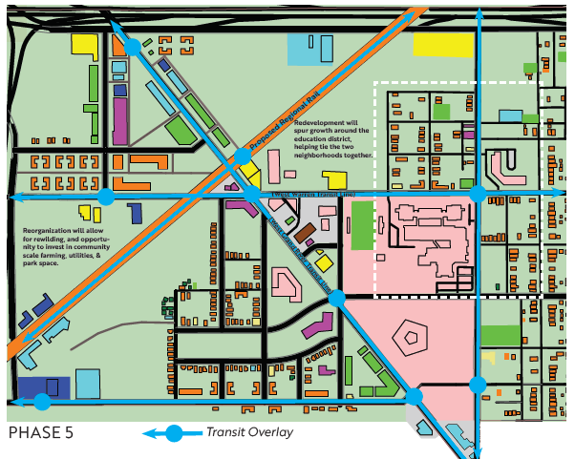

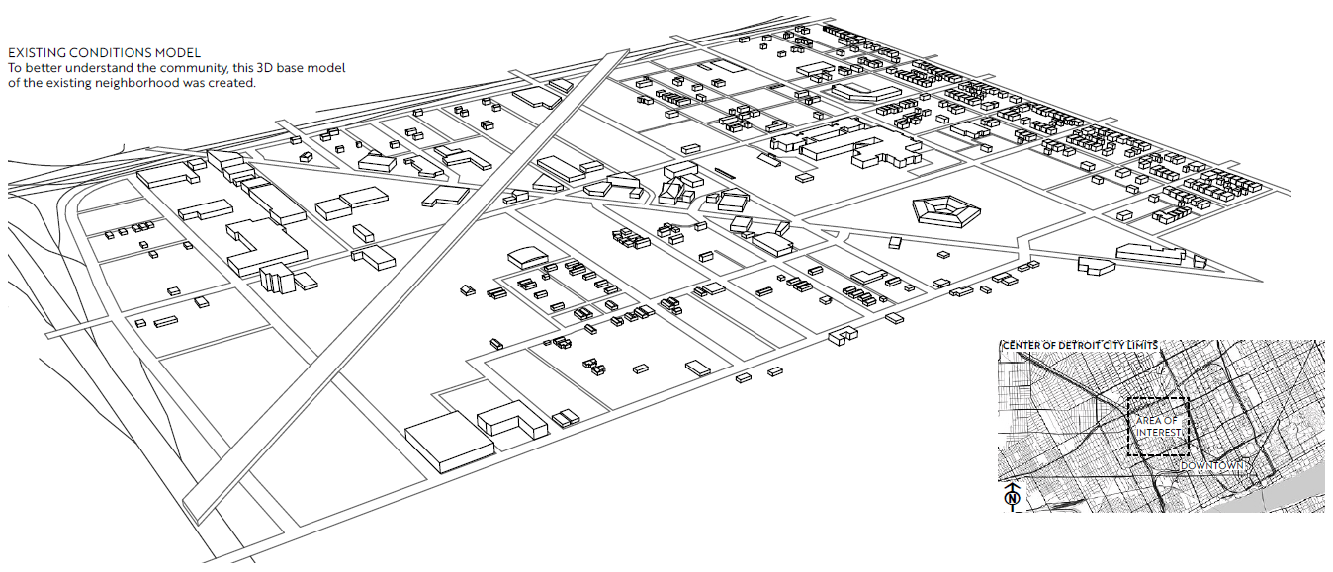

Figures 30- 35: This phasing plan was presented after considering input from community stakeholders. The proposal works across several decades to reorganize the space by eliminating blight, and reorganizing the neighborhood to better use built and open space assets. The master plan for this neighborhood is schematic, and additional changes were made in creating the final intervention. Axonometric views of conditions, such as the existing conditions directly above, helped humanize the planning process.

It was noted that the above drawing was particularly effective in humanizing the site and creating a sense of scale within the neighborhood. When the planning phase was presented early on, all drawings were shown in plan, and this dynamic reinforced the feeling that the planning phase was being imposed on the community. Providing drawings in an axonometric view for the following presentation helped humanize the large-scale planning exercise. It allows the plan to be inhabited in the mind of the client. The building heights shown here are not exact. It is a diagrammatic representation of rough building heights and road widths. Even just at this conceptual level, providing the drawing was enormously helpful for those reviewing on behalf of the community. It provided a higher level of legibility and understanding of scale that could not be fully conveyed in the “top down” planning phase diagrams.

Picking Focus Buildings

During the planning phase it became clear that programmatic requirements were the driving force in the project. Although this is an architectural thesis, it is also a large-scale social intervention that seeks to help undo decades of systemic economic and racial injustice. The question quickly became, what programmatic elements are missing from this neighborhood, and of those, what are the most critical to add, and where is their impact maximized? The biggest missing link that was identified, both in review sessions and through a review of the comments gathered during the “community input” phase, was education. There was widespread desire expressed for libraries and schools. This community had the advantage of already having an educational district to build off, but it had still lost its elementary school during Detroit’s bankruptcy. Therefore, the new elementary school became a top priority for this project.
Throughout the planning phase, we continued to revisit the idea of transitioning away from the automobile and what that may look like in Midwestern cities which were explicitly developed for heavy reliance on the automobile in the 20th Century. Detroit, being home to the automobile, was particularly affected by this planning mentality. However out of this came an opportunity to reorganize a large amount of space, and densify an area that previously had been underutilized, since suburbanites could quite easily drive right past it.
To change the culture of transportation in Detroit, a robust public transit system would have to be put into place. We believe this transit system would include increased Amtrak connectivity, regional rail, increased bus service, and streetcars. There is precedent for each of these interventions in the history of Detroit and there are advocacy groups working to make this a reality today, as was previously discussed. The train station was therefore chosen as the second focus building for the project. The train station is also attached to a market which would sell local goods and food produced in the neighborhood, and it would provide counter serve restaurant service in the basement underneath the train tracks. This market is an existing building, and is currently under renovation. Therefore, it was clear this could be the target for integrating adaptive reuse into the renewal. In this way, the train station became a point of arrival, not just a utilitarian service. This is a critical component in encouraging a move to reliance on public transit. By providing the train station as an amenity, decreasing surface parking coverage, densifying the neighborhood, and incorporating an already shifting culture into our vision of the future, we believe this is a realistic proposal for changing the future of transportation in Detroit.
The third intervention, the library, is less developed architecturally than the first two. Nevertheless, it was still important in the programmatic concept of the neighborhood as a center for learning. Today, the neighborhood’s library is a converted phone booth. Residents may take and leave books on the honor system. This small structure speaks to the desire for a library and the lack of one. Therefore, a new library was identified as a third critical component in the project. The conceptual rendering of the library therefore seeks to represent the core programmatic elements that may come into play at a library in this neighborhood such as adult learning, public common space, and access to technology. The library is situated deeper into the neighborhood, in an effort to make it more accessible to adult residents who live in the neighborhood. Its positioning also connects into the educational district and extends it into the Core City neighborhood, along with the park and elementary school.
Another important goal of the project was to reorganize the open space. As can be seen in the existing conditions, there is ample open space but it is poorly organized. By prioritizing the organization of built and unbuilt spaces over several decades the neighborhood reclaims itself from open space while simultaneously reclaiming the open space for itself. This is best manifested through the addition of park space on the triangular lot south of the train station, the addition of a solar field to the east, and the reforestation that occurs north of the solar field. While not shown, community water collection was also discussed as a likely outcome for some of the open space. When people live in a city that cannot provide utilities reliably, where the infrastructure is degrading beyond repair, providing utilities at the scale of the community would help residents reclaim their neighborhoods and stabilize quality of life. This is critical for improving the built environment and the social outcomes for residents. Full documentation of the final proposed intervention can be seen in Appendix B.

The Scale at Which Planning and Architecture Meet
“But how is this architecture?” That was the question that was risen several times during the final review of this work. To answer that question, I turned to the famous scale model of San Francisco, which was commissioned by the Planning Department during the Great Depression. A lesser known fact about the model is that it was an architect who first dreamt up the idea. Incidentally, the model is at the scale of 1” = 100’, the same scale the site plan in Appendix B was presented at. 1” = 100’ was more than enough scale in the San Francisco model to express base architectural features, and it also expresses important planning features like redlining. It is true that details cannot be expressed at this scale but detail is not the only scale at which architects work. To reject the basis of architectural work because the scale large is to undercut the value architecture can provide community at this scale. The edge which forms on the property line, is just as architectural as the edge between two materials.
Therefore, I propose that the scale at which urban planning and architecture meet is the scale of 1” = 100’. At this scale, we can begin to articulate the major features of buildings, while still being zoomed out far enough to overlay the elements an urban planner is interested in, such as zoning. At the scale of 1” = 100’, the architect can have a full and proper context of a neighborhood on one sheet and the planner can see that the neighborhood is being taken into consideration. For an architect to adequately respond to Detroit, and other underserved communities, this broader understanding of the neighborhood is required. Architecture extends beyond the individual site and into the realm of how sites are interfacing and organized in relation to critical pieces of infrastructure, from the highway and regional rail to sewer lines and electricity. The interfacing of these elements requires an interfacing of disciplines, an exercise which is architectural in and of itself. Examining this intersection is therefore not of lesser importance, but of the upmost importance, and should be of greater focus in architectural education in my opinion. It is my hope that this work will push this understanding of architecture operating at a larger scale than the building. The point of the work is for us to stop and ask as professionals, what we have done to examine this scale. The organization of programmatic requirements into a formal expression does not begin and end with the particulars of the site, it extends to the neighborhood, the city, the state, and the nation. For this reason, it is critical to examine the scales at which due consideration may fall through the cracks and to understand the implication of this on architecture. For this reason, the proposed interventions should be understood as schematic sketch models that were drawn in response to this examination. These sketch models illustrate a possible formal outcome which is architectural, but it is to be understood that the formal outcome depicted is schematic. What is most important is understanding how the planning process and neighborhood development informed these decisions and ultimately created the circumstances under which these formal sketch expressions can take place. For any of this to occur, fundamentally, planning had to be involved. For the plan to succeed, fundamentally, architecture had to be involved, and for the thesis to succeed, the scale at which these two met had to be most fully understood.

Conclusions
The question of “who gets to be where” is a question that far surpasses the scope of architecture. However, the formal implications of the question, and answers to it, affect all disciplines that work on the built environment. “Who gets to be where,” informs the programmatic requirements of each individual project. The collective outcomes of those projects, even over the course of decades, comes to inform and reform the conditions under which the question is answered going forward further. A city is an organism that sheds its skin and regenerates. The regeneration is continuous and not necessarily for the better. When a city fundamentally fails to address this reality for many decades, or literally runs away from the problem, the results will be expressed in the built environment over time. Eventually, the build environment will come to fully embody this underlying social condition. This is what has happened in Detroit. This expression of division happens at the experiential level of the end user, all the way up to the scale of the urban and regional plan, and, at each point in between. It is fundamentally both a question for a small landowner, and the most powerful politician. It is of critical importance and informs architectural outcomes to a great degree. By rethinking the scale at which we are responsible to ask this question at as architects, we can arrive at an architecture which seeks to fully communicate with and build up the neighborhoods around us.
Building healthy neighborhoods is not done by keeping people separated or elevated on paths between “important” buildings. It is done through full integration on the ground plane. In this case, public education is used to bring two neighboring communities together. There is a significant investment on the part of the public, but one that we believe would pay off many times over down the line. It would improve quality of life, provide enormous job opportunity, reinvigorate the city, and provide upward mobility for the next generation. The city currently has an initiative to create many of these so called “15 minute neighborhoods.”. These are neighborhoods where you can walk to meet your essential needs without passing urban blight. This is an essential outcome for a city that needs to reclaim urban character from abandonment, while simultaneously becoming more sustainable and resilient to meet 21st Century needs. Architects must meet each community where it already is and seek to find ways to build the community up for the people who are already there. This may involve meeting with neighborhood interest groups, participating in master planning activities, getting public funding, working with urban planners, and potentially come to involve 2 or 3 separate projects on multiple sites to coordinate community development over time, much like this project depicts. The key becomes two-fold: first, the needs of the community must be acknowledged. Second, the needs of the community must be met. The built environment has traditionally answered this question for communities in a definitive, concrete way. Many times, the concreteness and finality of the decision, has been made without community input. There was, and still is, a school of thought that the architect knows best. However, we now see this 20th Century method of top-down development has failed. It failed in Detroit because the plan was implemented by private interests. It will continue fail elsewhere in America, because those interests exported the model to be used all over the country by similar interests, for similar ends. Therefore we must rethink how architecture reinforces social constructs at the scale of the neighborhood. It starts with putting the pencil in the hands of the community stakeholders, to allow their input on a new kind of development. This is an architecture that gives the community a seat at the table, as we answer the question together, “who gets to be where?”

APPENDICES

APPENDIX A: LAND USE DATA

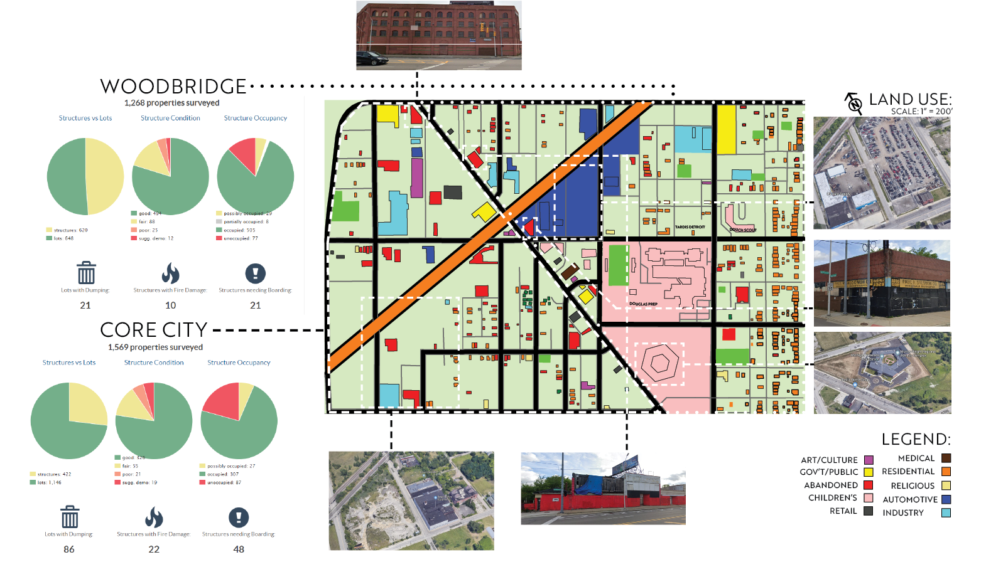

APPENDIX B: FINAL PROPOSED INTERVENTION

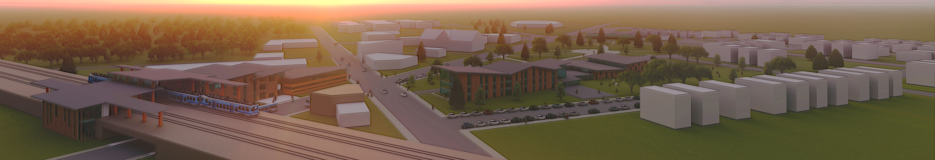
Rendering of Site

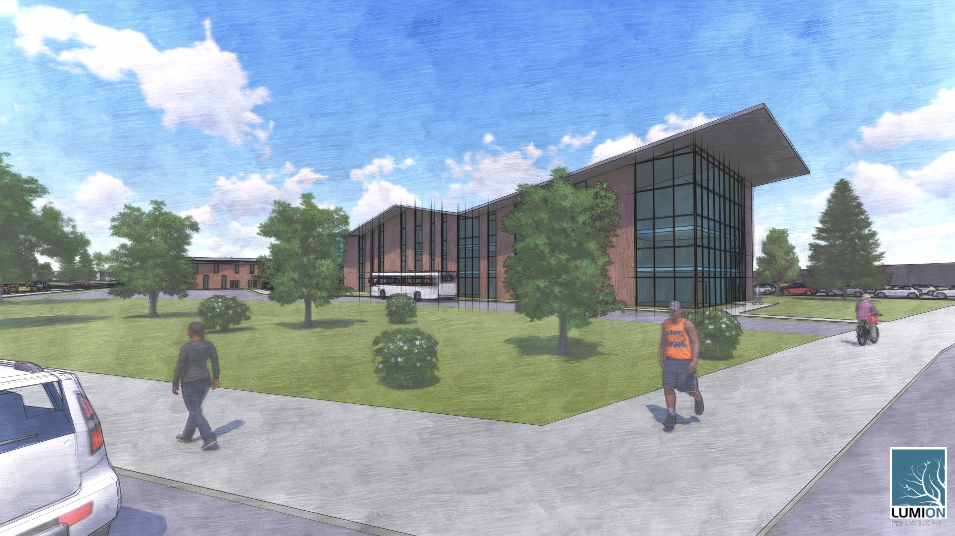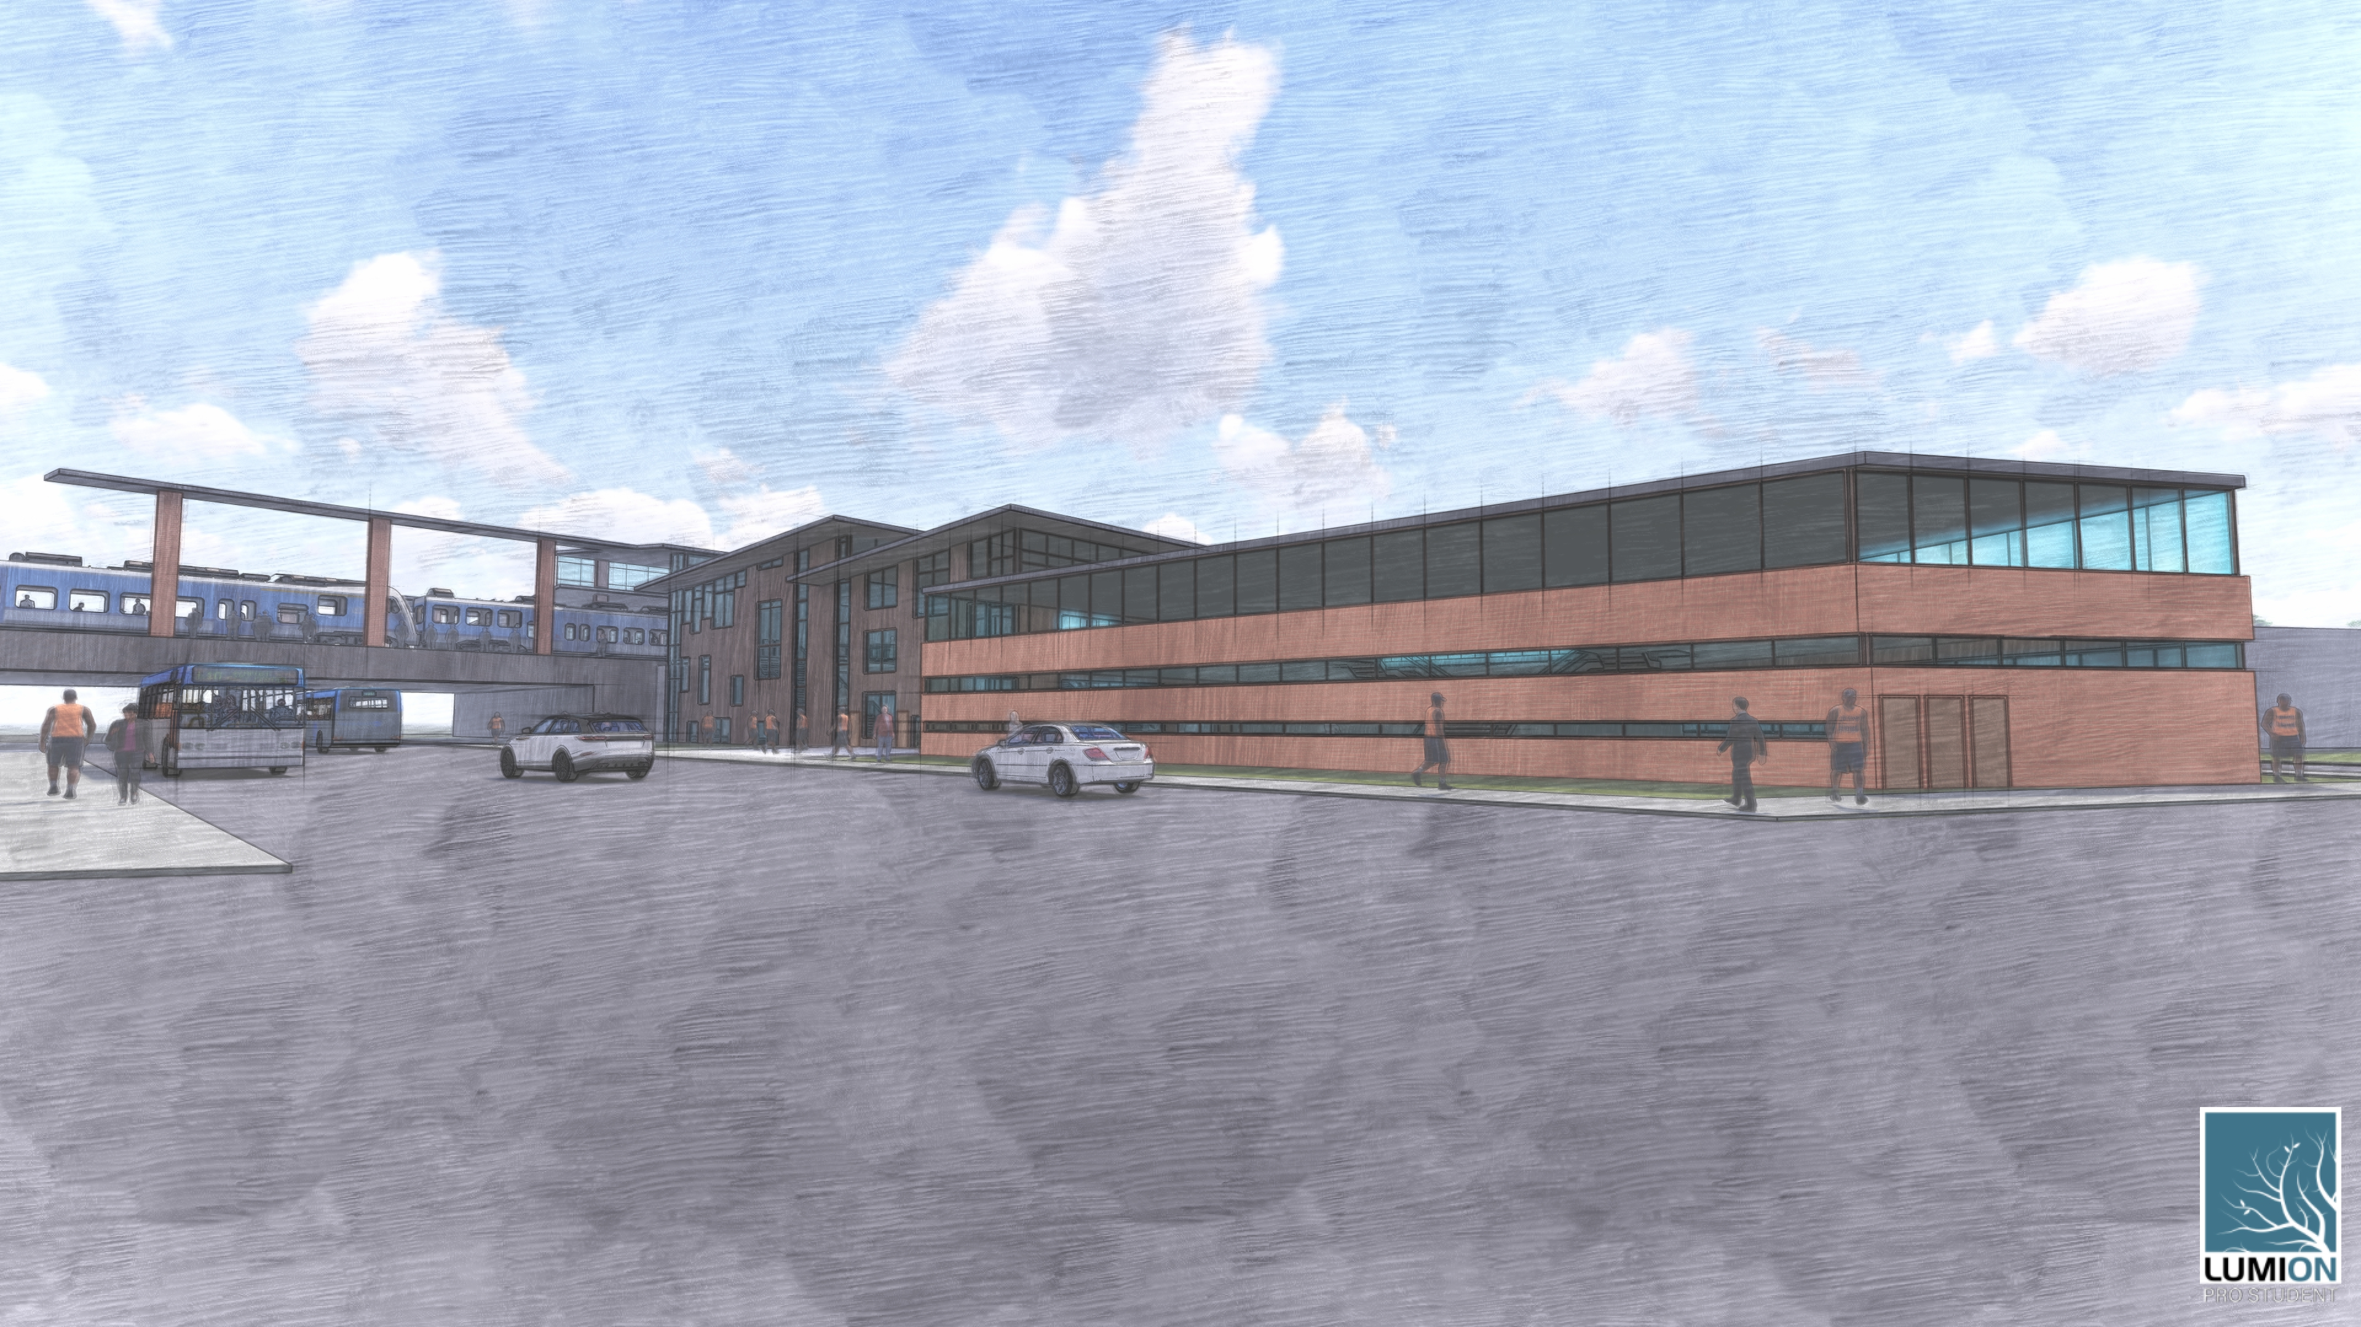
Rendering of Elementary School Rendering of Train Station

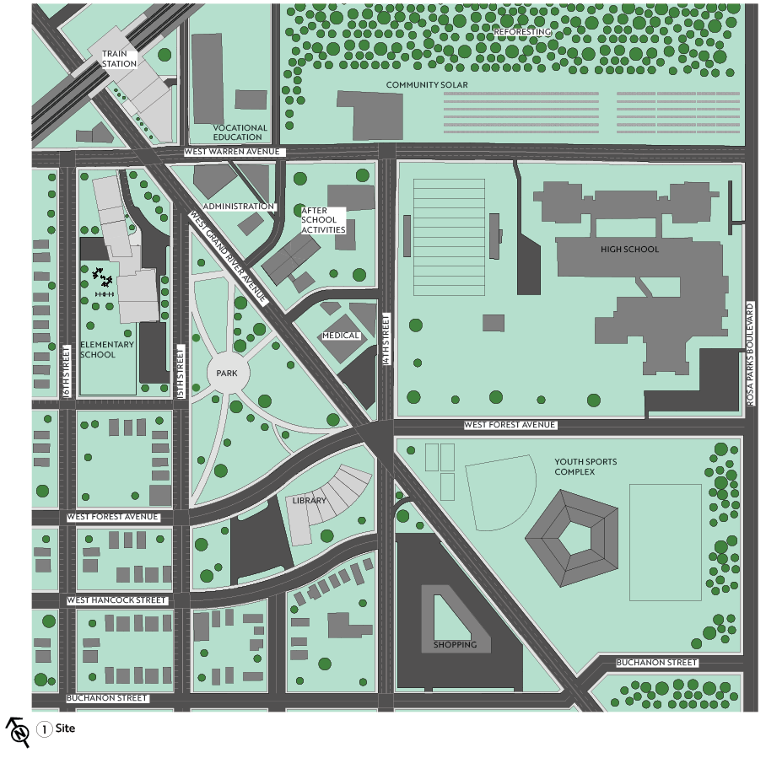
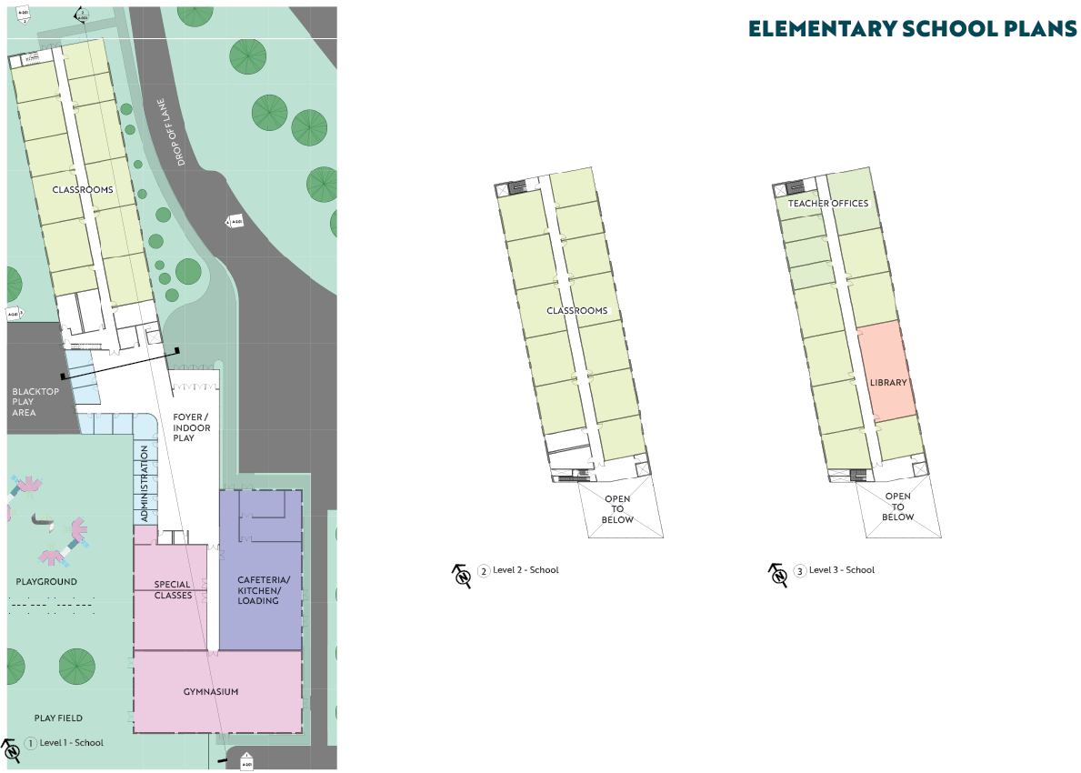
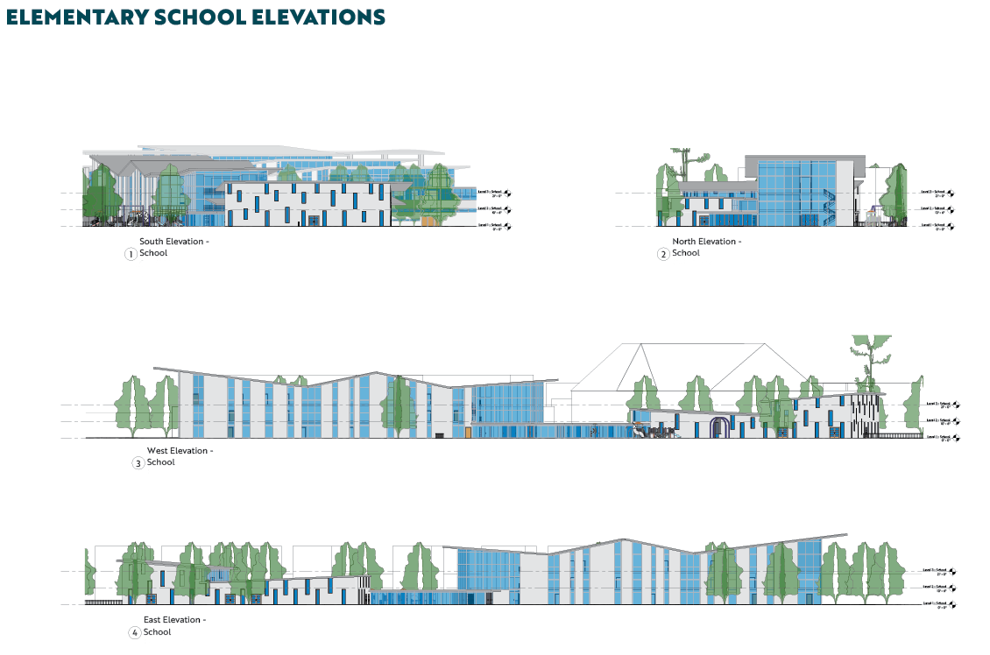
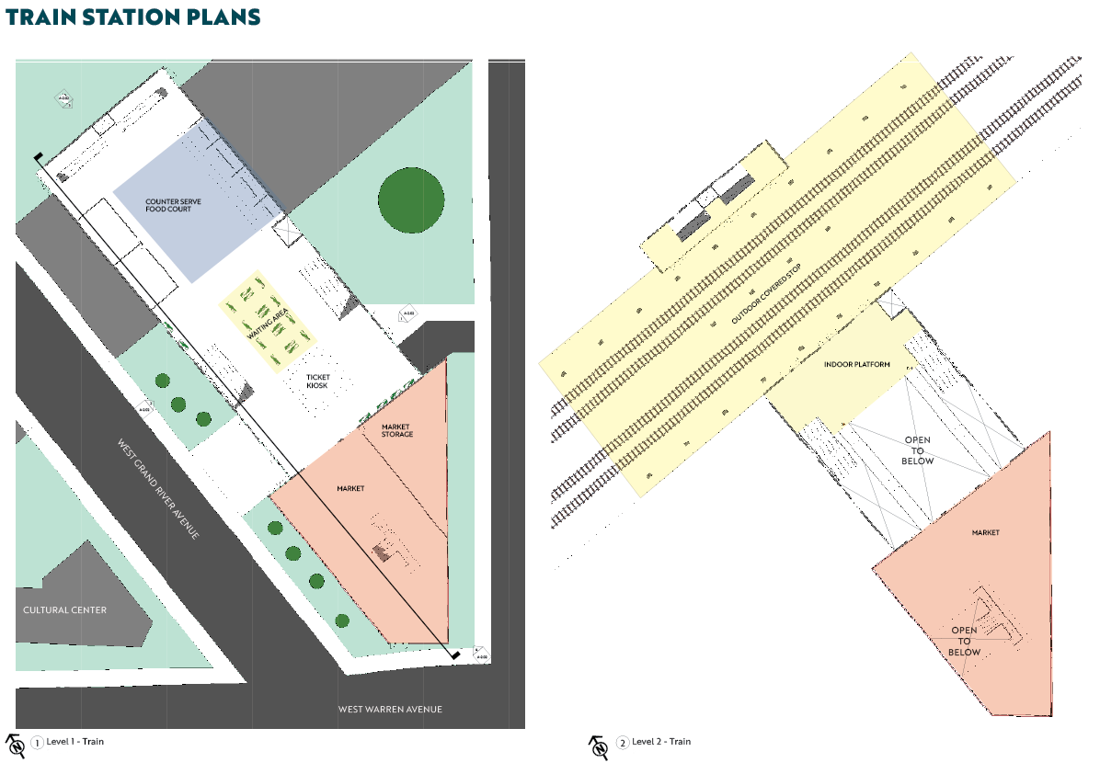
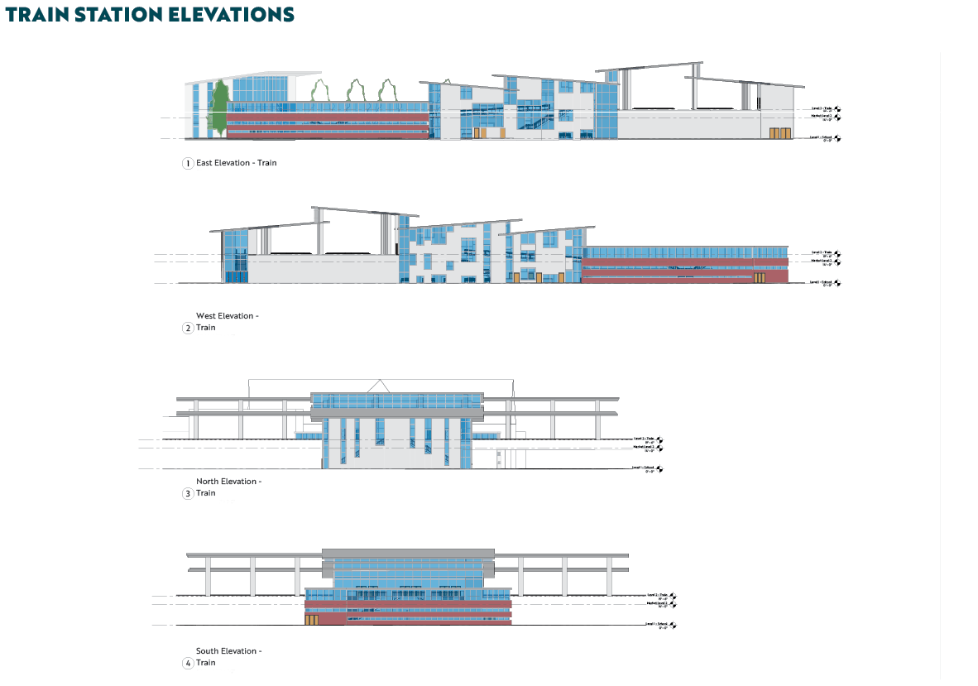
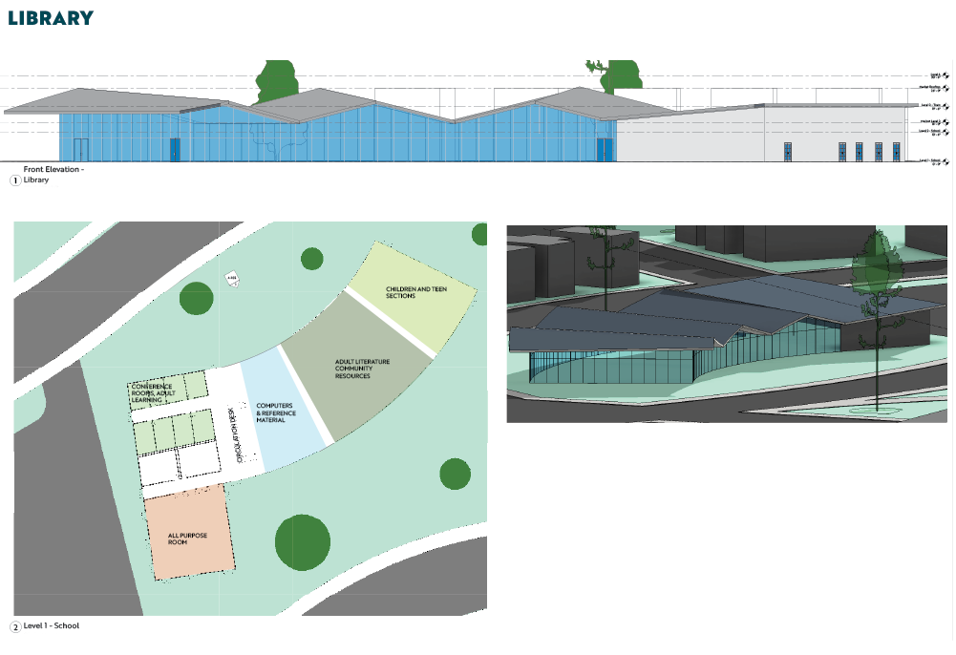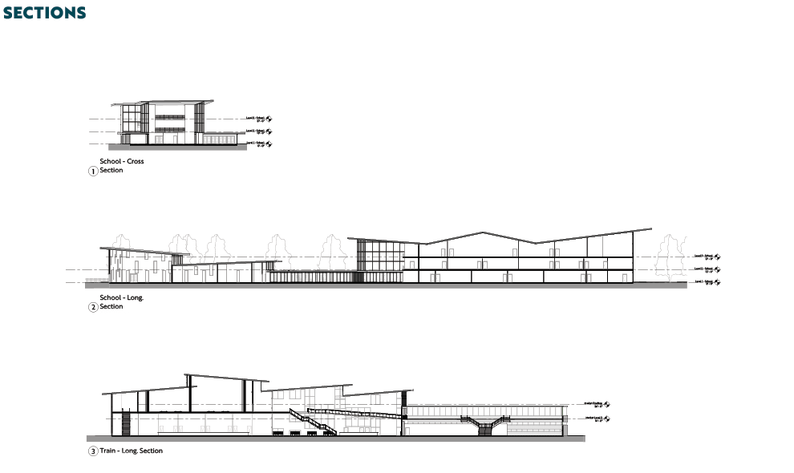

BIBLIOGRAPHY
“20 Photos Showing How Nature Is Reclaiming Detroit.” Detroit Metro Times Galleries, July 2, 2019. https://photos.metrotimes.com/20-photos-showing-how-nature-is-reclaiming-detroit/?slide=1&nature-overcomes_1262.

Armborst, Tobias, et al. The Arsenal of Exclusion & Inclusion. Actar Publishers, 2017.

BARROW, HEATHER B. HENRY FORDS PLAN FOR THE AMERICAN SUBURB: Dearborn and Detroit. Place of publication not identified: NORTHERN ILLINOIS UNIV PR, 2018.

Bridge Magazine, and Michigan Radio. “Expert Testifies Gerrymandering in Michigan Is Worse than Almost Anywhere.” Detroit Journalism Cooperative, February 6, 2019. https://www.detroitjournalism.org/2019/02/06/expert-testifies-gerrymandering-in-michigan-is-worse-than-almost-anywhere/.

Boucher Jean Léon, and Jukka Heinonen. Sustainable Consumption, Promise or Myth?: Case Studies from the Field. Newcastle upon Tyne: Cambridge Scholars Publishing, 2019.

Calame, Jon, and Esther Ruth. Charlesworth. Divided Cities: Belfast, Beirut, Jerusalem, Mostar, and Nicosia. Philadelphia, PA: University of Pennsylvania Press, 2012.

Calthorpe, Peter, and William B. Fulton. The Regional City: Planning for the End of Sprawl. Washington, DC: Island Press, 2001.

Clarke, Kayla, and Nick Monacelli. “Detroit's West Riverfront Park Design Renderings Revealed.” WDIV, October 17, 2018. https://www.clickondetroit.com/news/detroit-s-west-riverfront-park-design-renderings-revealed.

Creswell, William. Flickr Collection. https://www.flickr.com/photos/crackdog/sets/72157600420726192

Dayton, Eric. “OPINION EXCHANGE: A Farewell to Skyways: The Case for Bringing Them Down.” Star Tribune. Star Tribune, April 21, 2017. http://www.startribune.com/a-farewell-to-skyways-the-case-for-bringing-them-down/420124113/.

“DETROITography.” DETROITography. Accessed October 2, 2019. https://detroitography.com/.

“Detroit Riverwalk.” Great Runs, November 24, 2016. https://greatruns.com/detroit-riverwalk/.
Eviction Lab. “The Eviction Lab.” Eviction Lab. Accessed October 2, 2019. https://evictionlab.org/.

FAQ - English. Accessed October 4, 2019. https://buildingdetroit.org/faq/.

Farley, Reynolds, Sheldon Danziger, and Harry J. Holzer. Detroit Divided. New York: Russell Sage Foundation, 2002.

“Feasibility Study of Hartford's XL Center OK'd.” Hartford Business Journal. Accessed October 4, 2019. https://www.hartfordbusiness.com/article/feasibility-study-of-hartfords-xl-center-okd?fbclid=IwAR1DLfWRPbYgsM14c334R2EpF1u5q5E13-UKRum6gHqurJyFiBEmzHZIZ_A.

Gosselin, Kenneth R. “A Downsized XL Center Renovation Plan Focuses on Targeted Improvements.” courant.com. Hartford Courant, December 11, 2018. https://www.courant.com/real-estate/property-line/hc-biz-xl-center-downsized-renovation-plan-20181206-story.html.

Hagan, Susannah. Taking Shape: A New Contract between Architecture and Nature. Oxford: Architectural Press, 2001.

Hartford, the City and the Region: Past, Present, Future: a Collection of Essays. West Hartford, CT: University of Hartford, Division of Adult Educational Services, 1979.
Hilburg, Jonathan. “Michael Valkenburgh Associates, David Adjaye selected to design Detroit’s West Riverfront Park.” The Architect’s Newspaper. Apr. 10, 2018. https://archpaper.com/2018/04/michael-van-valkenburgh-associates-david-adjaye-design-detroits-west-riverfront-park/#gallery-0-slide-0

“HISTORY IS BUNK, SAYS HENRY FORD; What Difference Does It Make, He Asks.” The New York Times. The New York Times, October 29, 1921. https://www.nytimes.com/1921/10/29/archives/history-is-bunk-says-henry-ford-what-difference-does-it-make-he.html.

Hunter, George. “Police Commissioner Wants Answers on Response Times.” Detroit News. The Detroit News, February 5, 2019. https://www.detroitnews.com/story/news/local/detroit-city/2019/02/04/detroit-police-response-times-questioned/2744186002/.

“I Like Big Bytes.” ACS Commute Map. Accessed October 4, 2019. http://bigbytes.mobyus.com/commute.aspx.

Liptak, Adam. “Supreme Court Bars Challenges to Partisan Gerrymandering.” The New York Times. The New York Times, June 27, 2019. https://www.nytimes.com/2019/06/27/us/politics/supreme-court-gerrymandering.html.

Livengood, Chad. “JPMorgan Chase's Detroit Investment Growing to $200 Million.” Crain's Detroit Business, June 26, 2019. https://www.crainsdetroit.com/economic-development/jpmorgan-chases-detroit-investment-growing-200-million.

Lower East Side Museum Celebrates Its Black History Roots. Leonard Greene - https://www.nydailynews.com/new-york/ny-tenement-black-history-20191016-2pf42hroarbrbecwotvvkto7em-story.html

Maclean, Alex S. “Detroit by Air.” The New York Times, The New York Times, 6 Dec. 2014, www.nytimes.com/interactive/2014/12/07/opinion/sunday/exposures-detroit-by-air-alex-maclean.html.

“Maps.” Maps - Curbed Detroit. Accessed October 2, 2019. https://detroit.curbed.com/maps

Meinhold, Bridgette. “Nation's Oldest Indoor Shopping Mall Being Renovated Into Micro Apartment Building.” Inhabitat Green Design Innovation Architecture Green Building, Inhabitat, 18 Feb. 2013, inhabitat.com/nations-oldest-indoor-shopping-mall-being-renovated-into-micro-apartment-building/?variation=c.

“Minnesota Experience - Jim Crow of the North: Trailer.” Twin Cities PBS. Accessed October 4, 2019. https://www.tpt.org/minnesota-experience/video/long-lead-jiyjix/.

“Penske on Grand Prix Controversy: Belle Isle ‘Never Looked Better.’” WDET. Accessed October 4, 2019. https://wdet.org/posts/2019/05/30/88240-penske-on-grand-prix-controversy-belle-isle-never-looked-better/.

“Redistricting Case Study.” Caliper Mapping Software and Transportation Software, www.caliper.com/map-software/case-studies/california-crc-redistricting.htm.

Regional Planning Authority of Southeast Michigan. “2045 Vision, Summer 2019.” Retrieved from: http://www.rtamichigan.org/

Reinan, John. “Super Bowl Planners Ready to Help Visitors Navigate the Minneapolis Skyways.” Star Tribune. Star Tribune, December 28, 2017. http://www.startribune.com/super-bowl-planners-ready-to-help-visitors-navigate-the-minneapolis-skyways/466886943/.

Roche, Julia La. “JP Morgan CEO Jamie Dimon Once Told Elizabeth Warren to 'Hit' Him with a Fine Because the Bank Could 'Afford It'.” Business Insider. Business Insider, March 31, 2015. https://www.businessinsider.com/jamie-dimon-said-he-could-afford-fines-2015-3.

Romero, Simon. “Deep in Brazil's Amazon, Exploring the Ruins of Ford's Fantasyland.” The New York Times. The New York Times, February 20, 2017. https://www.nytimes.com/2017/02/20/world/americas/deep-in-brazils-amazon-exploring-the-ruins-of-fords-fantasyland.html.

Runyan, Robin, and Aaron Mondry. “Mapping Detroit's Construction Boom.” Curbed Detroit. Curbed Detroit, August 16, 2019. https://detroit.curbed.com/maps/detroit-construction-development-map.

Sands, Gary. “Opinion: Detroit is booming. Too bad residents aren’t getting jobs. Retrieved at: https://www.bridgemi.com/detroit/opinion-detroit-booming-too-bad-residents-arent-getting-jobs

SOLOMON, LEWIS D. DETROIT: Three Pathways to Revitalization. Place of publication not identified: ROUTLEDGE, 2017.

Space and Money: the redivision of Paris. Accessed October 4, 2019. https://www.mtholyoke.edu/courses/rschwart/hist255-s01/mapping-paris/Paris_econ_space.html.

Sugrue, Thomas J. The Origins of the Urban Crisis: Race and Inequality in Postwar Detroit. Princeton: Princeton University Press, 2014.

“The Great Scrap-Metal Scrap.” The Economist. The Economist Newspaper, February 19, 2015. https://www.economist.com/united-states/2015/02/19/the-great-scrap-metal-scrap.

“The Green Building: Sustainable Design and Architecture: US Green Building Council: Solar Panels.” The Green Building | Sustainable Design and Architecture | US Green Building Council | Solar Panels. Accessed October 4, 2019. http://www.thegreenbuilding.net/.

Thompson, Derek, and Derek Thompson. “What on Earth Is Wrong With Connecticut?” CityLab, July 6, 2017. https://www.citylab.com/life/2017/07/what-on-earth-is-wrong-with-connecticut/532842/.

“Use Data.” Data Driven Detroit. Accessed October 2, 2019. https://datadrivendetroit.org/toolbox/.

Warshaw, Chris, and Christopher J. Warshaw. “Christopher S. Warshaw.” Christopher S. Warshaw. Accessed October 4, 2019. http://www.chriswarshaw.com/.

Wines, Michael. “Judges Rule Michigan Congressional Districts Are Unconstitutionally Gerrymandered.” The New York Times, The New York Times, 25 Apr. 2019, www.nytimes.com/2019/04/25/us/michigan-gerrymandering.html.

Yoos, Jennifer, Vincent James, and Andrew Blauvelt. Parallel Cities: the Multilevel Metropolis. Minneapolis: Walker Art Center, 2016.

George Hunter, Police commissioner wants answers on response times, (The Detroit News, 2019)
Gary Sands, Detroit is booming. Too bad residents aren’t getting the jobs. (Bridge Michigan, 2019)
Reynolds Farley et. al., Detroit Divided p. 15
Ibid. p. 27
Leonard Greene. “Lower East Side museum celebrates its black history roots.” (NY Daily News, 2019)
Creswell, William. Flickr Collection.
Thomas Sugrue. Origins of the Urban Crisis, p. 5
Heather Barrow. Henry Ford’s Plan…, p. 94-106.
Farley, pp. 45-48.
Farley, 149-152.
Jim Crow of the North. (PBS, 2019).
Ford’s Plan for American Suburb. pp. 120-130
Ford’s Plan for American Suburb. pp. 139-144
Ford’s Plan for American Suburb. pp. 139-144
Ford’s Plan for American Suburb. pp. 139-144
History is Bunk, Says Henry Ford. (The New York Times, 1921)
Simon Romero. Deep in Brazil’s Amazon, Exploring the Ruins of Ford’s Fantasyland (The New York Times, 2017)
Ibid.
Ibid.
Simon Romero. Deep in Brazil’s Amazon, Exploring the Ruins of Ford’s Fantasyland. (The New York Times, 2017)
Farley, pp. 93-96
Farley, pp. 158-162.
Sondra Astor Stave. Hartford, City and Region. pp. 75
Sugrue, pp. 145-149
Ibid.
Sugrue, pp. 193-196
Sugrue, pp. 196-199
Ibid.
Solomon, pp. 65-72
Ibid. pp. 65-72
Ibid., pp. 6-9
Alex Maclean. Detroit By Air. (The New York Times, 2014)
Arsenal of Exclusion and Inclusion, pp. 151-152
Ibid.
“Read Previously Undisclosed Republican Emails...” (Bridge Michigan, 2019)
“Maptitude for Redistricting Software Overview.” https://www.caliper.com/mtredist.htm
“Redistricting Case Study”
Ibid.
Ibid.
“Read Previously Undisclosed Republican Emails...”
Ibid.
Chris Warshaw. Personal Website.
Joel Kurth. “Expert testifies gerrymandering in Michigan is worse than almost anywhere
Adam Liptak. “Supreme Court Bars Challenges…”
“Detroit Land Bank Rules – English”
Michael Wines. “Judges Rule Michigan Congressional Districts…”
Solomon, pp. 3-9
Niewuwenhuis, p. 52-54
Ibid. p. 52
Ibid. p. 58-60
Photo by Philip Fite, personal collection.
Detroit Historical Society
Detroit Documentary: A Story of the People
“The great scrap-metal scrap.”
Detroit Documentary: A Story of the People
“Mapping Detroit’s construction boom.”
Great Runs, “Detroit Riverwalk.”
“Detroit’s West Riverfront Park design renderings revealed.”
“Penske on Grand Prix Controversy…”
Ibid.
Ibid.
Crain’s Detroit: “JP Morgan Chase’s Detroit Investment…”
La Roche. “JP Morgan CEO Jamie Dimon…”
I Like Big Bytes. http://bigbytes.mobyus.com/commute.aspx
RTA 2045 Vision for Public Review, Summer 2019
Calthorpe: “About Us.”
Calthorpe, 2001: 43
"Clarence Stein and the Greenbelt Towns Settling for Less."
The Green Building (Website)
Calthorpe, 2001. p. 49
Calthorpe, 2001. p. 54
Calthorpe, 2001. p. 55
Ibid., p. 56
Ibid., p. 56
Calthorpe, 2001. p. 59
Calthorpe, 2001. p. 59
Ibid., p. 60
Ibid., p. 60
Parallel Cities
Eric Dayton, “A Farewell to Skyways…”
Parallel cities
John Reinan, “Super Bowl Planners…”
Hartford, City & Region
City Lab. “What on Earth Is Wrong With Connecticut?”
Hartford Courant. “Historically Low Attendance…”
Hartford Courant. “As Host of NCAA tournament, Hartford XL Center scores…”
Hartford Courant. “As Host of NCAA tournament, Hartford XL Center scores…”
Hartford Courant. “A Downsized XL Center Renovation Plan…”
Hartford Business. “Feasibility study of Hartford’s XL Center OK’d.”
Steve Neavling “20 Photos showing…”
RTA Papers

